Introducing LOCALIZED Solutions - Energy – Food - Water
Addressing Vulnerability of our National Resources
New Solutions to old problems | ALL solutions require energy
JMCC WIND Generator  Scalable to replace nuclear and coal power plants  “Distributed Energy”  Our national wind energy  is a constant  No batteries required  No Government Subsidies  1/10th cost of traditional wind  Wind supplies 95% base load  Supplement 5% Natural Gas  THE FUTURE OF ENERGY | The Jet Age of Wind Energy  2018 XPRIZE  “Technology Innovation Achievement Award”  High efficiency Extraction of energy from wind
Localized Food Production
Create high concentration food production facilities
Converting vacant land, ware- houses & shopping centers
Retrain relocate people
High Concentration Food
“Vertical Grow Towers”
95% less water – 1/3 grow time
1/10th space – all season
Water Filtration AT THE HOME  Localized clean water  The only solution is filtration at the house or point of use  GF Filters remove all pollutants | 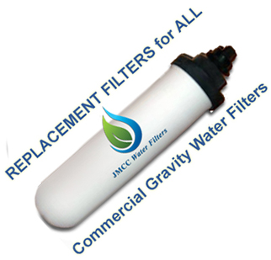
We can forsee big problems – Energy – Food – Water -
We have simple inexpensive solutions – The 5 YEAR “LOCALIZE” plan
Vulnerable Resources | The cost if not fixed | The Solution
National Grid  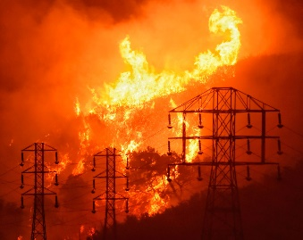 | there are 20+ reasons for Grid failures – we do not have failsafe or redundancy – past solutions (e.g. Smart Grid) are shams | The Tesla Grid was designed for EMPs …reinforce the GRID as designed with Shunts/diodes/Breakers  LOCALIZE power with  JMCC WING Generators
Nuclear Power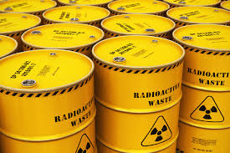 | 96 US Nuclear Plants are aging & leaking Biscayne Bay FL is irreversibly polluted  no place for spent fuel | Decommission all Nuclear Power Plants - 20% of our energy comes from nuclear – replace with JMCC WING Generators
Coal  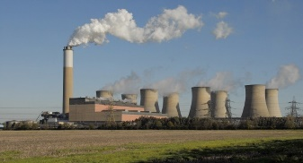 | Economic Phase out Coal is happening now we have to retrain coal workers / reclaim land | Replace Coal Plants with JMCC WING Generators - use same GRID connection infrastructure
Natural Gas | Excessive Use of this valuable resource | Reduce use of NG with JMCC WING Generators save for future generations
Solar &  3 Blade Wind Turbines | Failed Industries still need gov subsidies | Solar/wind failed industries  Stop subsidies these will die
National Food Supply  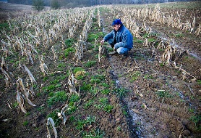 | There are 20 reasons why our national foods supply failure | Localized high concentration Food production  Convert vacant land & Shopping centers into food growth and point of sale
Water  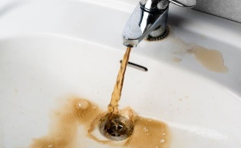 | Our National Water supply is polluted - toxins come from pipe infrastructure  National Water Program | High Standard Water Filtration at Point of Use less than $100 per house  !! National Rain/Water Management Program !!!!!
Contact: www.jmccsci.com – VM 612 232 6651 jmccanney@usinternet.com business only please

