11 June 2020
Open Letter to the President
Leverage NSA, Clean Up Wall Street, Engage Authentic Black Leaders
Mr. President,
It is my good fortune to be a former spy and also good friends with Bill Binney and known to Mike Flynn. It has taken me months to arrange for Bill Binney to speak on the record, in a sixteen minute video at https://tinyurl.com/NSA-10-30-100. With ten people in thirty days Bill can deliver all the data you need to confiscate, through civil and criminal forfeiture, $100 trillion (or more) in assets acquired by varied Wall Street financial criminals among whom Goldman Sachs is by far the largest, using naked short selling and money laundering to steal from all.
On the next page are four cartoons from Ben Garrison that I commissioned to help explain to the American people – and to remind you – that the greatest criminals in America are the banks, not the bank robbers. Wall Street has destroyed over 10,000 companies, thousands of innovations, and millions of jobs through its criminal financial practices, all condoned and enabled by the Senate Banking Committee, the Department of Justice (notably the Holder Memorandum taking jail off the table), the FBI, and the SEC.
By combining data from NSA, from a forced audit of the Depository Trust & Clearing Corporation (DTCC) that has spit on our laws since its inception, and data from ShareIntel, a company ripe for acquisition by DoJ, you can completely by-pass all Wall Street lawyers and the decades of delay that come with lawyers, and begin confiscating stocks of gold and silver, art, waterfront mansions, condos all over the world, super yachts, private airplanes, private islands, and more. You were deceived when you were told that $17 trillion was all you could get. Bill Binney and I can find you another $100 to $200 trillion to help Make America Great Again.
Furthermore, once you finish eradicating financial crime on Wall Street, all my experts tell me that the stock market will explode as everyone smart enough to stay away now comes back to the capital markets. America will experience a BOOM of innovation and entrepreneurship. There is legislation you could sponsor that would receive bi-partisan support: we need to restore the $25 million IPO and break up the too big to hold accountable funds. We need to end flash trading, enforce good laws on settlement, and put integrity back into banking.
I believe NSA has been rolling you and the Attorney General. By now, had Bill Binney been there, you would have every traitor, every elite pedophile, every #RESIST and Antifa terrorist funder and organizer, and most crooked judges and prosecutors lined up for justice.
Separately I have arranged for the top authentic Black leaders of America – not to be confused with celebrities or those who have been “made” by the white system – to reach out to you. They all condemn the protests, which they have not organized; they are all ready to support you contingent on your hearing them out and being responsive to their suggestions.
My varied memoranda in the past do not appear to have reached you. You will find my best and latest memorandum at https://tinyurl.com/POTUS-5.
I have done all one man can do. Be assured of my vote in November 2020, but also be assured that it causes me great distress to see you betrayed every day by people who are in service to foreign powers, who are not loyal to you nor to America the Beautiful, and who continue to prevent you from being the greatest President ever. I am local (Oakton, Virginia). I would like to help you build an Open Source Agency that includes Web 3.0, a Trump Studio, and Truth Channel, and “the President’s Own” Open Source Intelligence (OSINT) service.
Semper Fidelis,
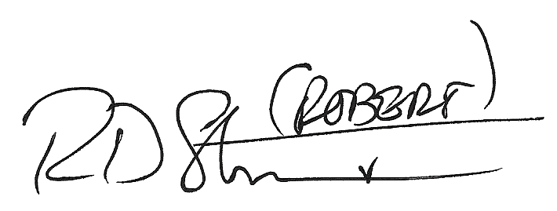
Robert David Steele

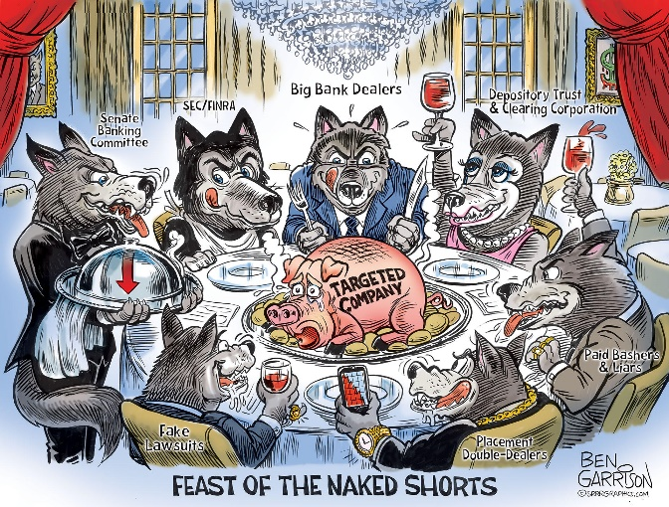 | 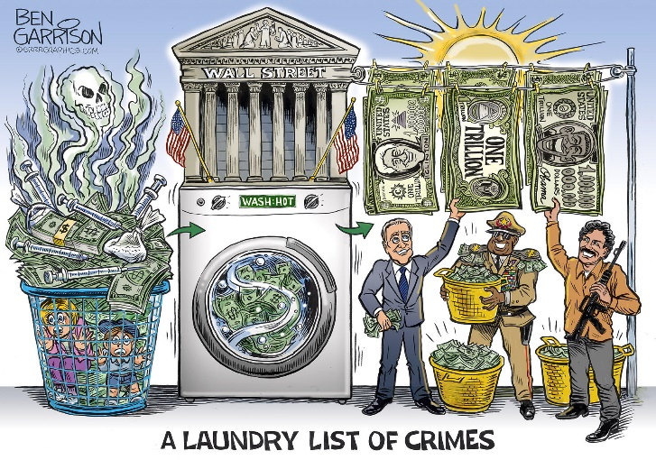
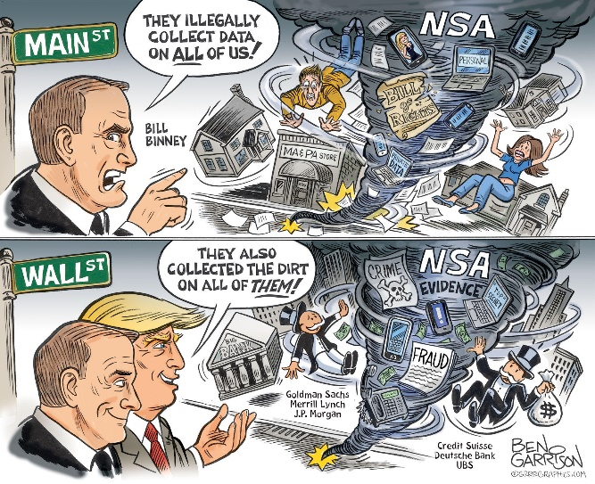 | 