Holodomor – USA 2020 to 2021 – The Communist Manifesto comes to the USA

James McCanney - July 16, 2020
I am reading on my show this week (July 16, 2020) the yellow highlighted parts (see attached below “Holodomor”) with commentary ... you can see the same game plan happening here ... defund the local police and then as the people cry out for “protection” create the national police (foreign in the case of Ukraine and the Holodomor 1932 starvation genocide) ... this was the same game plan as in pre WWII Germany with the full intention of eliminating parts of the population … not only jews but any and all opposition especially intellectuals who were deemed enemies of the state … the data bases had been kept for years prior to 1934 when the Gestapo was officially formed including neighbors turning in neighbors for political favors …this is all exactly as is happening in the USA today ... the deep state at the hands of kerry and biden etc did the same thing to ukraine in recent history taking over its resources following the same play book ... but read the yellow highlighted parts in the article at the end of this discussion and just look at the USA today ... the Communist Manifesto game plan is being played out here EXACTLY including the stoppage of food which is already underway ... starvation is already occurring around the world and no one is reporting it … starvation starts in the poorest countries ... then will move to 1st world countries as they throw more "pandemics" at the public … it is already fully underway as Canadian and USA farmers cannot get their produce to market due to “confirmed covid19 cases” using the fake covid19 PCR test … they are cutting the supply chain ... i am fully expecting biden to “win” this fall with the game plan with the potential for hillary finally worming her way into pres without actually winning an election (remember it was "her turn" in 2016) ... whatever happens … they have no intention of losing this time … don’t set on your laurels thinking that if enough people “get out and vote” then we will win again ... the 2016 election loss was a lesson to the deep state and their foreign investors … they are not going to let that happen again … their hearts and minds are filled with absolute hate with every action to overturn that election failing to date ... the election fraud is growing with a vengeance … no amount of voter turnout will alter their election fraud this time … the roger stone, michael flynn and other political kangaroo court actions only spell what is in store for the rest of the "patriots" … the real foreign control and their loyal minions in the USA will not rest until every true American is in a prison camp … sealing the fate of this country into the distant future … I doubt if many of you understand the level of hatred bearing down on you and your family ... tribunals will bring people who are just now being banned from social media to court for "hate crimes" and spreading false propaganda as decided by the politburo using the internet, NSA and recorded media as a data base …. Yes you will all be guilty as charged … you and your family and any contacts will be targeted in the “tracing” follow up to covid19 scam just like the brown shirts and gestapo did in pre WWII Germany … the same as in the ukraine … and as with every other place this agenda has been activated … like the Russian police in the ukraine during the 1932 Holodomor ... watch as the schools this fall will be filled with pandemics to close them down … those that manage to remain open will be filled with propaganda unlike anything ever thrown at kids before … kids will be taken from their homes and put into camps (in some cases directly from the schools where parents will never see them again) … all for the common good ... expect no food especially through the winter ... the Ukraine starvation peaked the following spring … so next spring 2021 the planned starvation in the USA will peak with political malice … your proof of vaccination will play a roll in who gets a "food ration card" to buy food … and of course based on political affiliation and allegiance to “the party” as at that time there will only be one party ... this is the SAME communist game plan … the is why you see many politicians cowering at taking a stand on anything … because they see this coming and want to be “on the side that’s winning” ... and last but not least expect everything including the kitchen sink being thrown at you by september with full crescendo in october prior to the 2020 election … the country will be in total turmoil … this summer is just a prelude of what is yet to come … setting the stage for the fake election with the main stream media flying the victory banner high … I have been predicting that even NASA and the NOAA (national weather service) will coordinate a false flag event (one scenario would be to bring down the power grid from a false flag CME and controlled weather events) as the final nail in the coffin (something joe stalin or adolph hitler would have salivated over if they had this at their disposal) … and don’t forget the CIA who owns all the major news media outlets … when Hillary lost in 2016 … in a rage the first person she blamed for the loss was George Bush Sr. … why ??? because the CIA was supposed to have assured her election through massive cheating programs (see my 2016 PRESIDENTIAL ELECTION VOTER CHEATING WHITE PAPER) … George Bush Sr was still very much steering the CIA ship … the CIA was behind every attempt to bring down and nullify the 2016 election as they did in the fake “Russian dossier” to influence prior to the 2016 election … the CIA and their foreign bosses also assured that many political races all the way down to mayor and county clerk and SHERIFF went to liberal left America haters who were meant to be the local arm of taking down the USA … you can see many of these busy bees at work through the ongoing fake covid19 pandemic … like I said they do not plan on failing this time … read the yellow part of attached below and yes The Communist Manifesto and a modern day Holodomor is happening here right now … remember that true to the Communist Manifesto it is inherently Atheist and must crush two things to be successful … those that believe in a divine creator (an allegiance that is higher than the state) and the family as the core of society and also destroying the history … this was paramount in all prior applications of the Communist Manifesto and today in the USA is no exception … the USA was founded on Christian principles, the family and natural law which puts the person above the state … these core values are being crushed today in the USA under the feet of the Communist Manifesto … One might imagine that the traditional enemy of Christians and the “west” would be Russia … but it is as once stated .. the enemy is within our own country … Russia in fact has completely turned to become a bastion of orthodox Christianity whereas the Vatican has turned out to be a completely controlled center of communism world wide through its banking front agency the World Bank … republics and democracies exist in name only (including the USA) … it was this same entity that created and supported the Bolsheviks and Joseph Stalin who created the genocide called the Holodomor … please read the following yellow highlighted passages and compare to what is happening in the USA today … as my uncle Ben used to say … “Open up your big brown eyes and see what is happening around you in the world” ... James McCanney

-----------------------------------------------------------

Holodomor
Ukrainian history
WRITTEN BY
Anne Applebaum
Anne Applebaum is a historian, journalist and a foreign policy columnist for the Washington Post. She is also a Professor of Practice at the London School of Economics where she runs Arena, a program on...
See Article History
Alternative Titles: Famine of 1932–33, Great Famine of 1932–33
Holodomor, man-made famine that convulsed the Soviet republic of Ukraine from 1932 to 1933, peaking in the late spring of 1933. It was part of a broader Soviet famine (1931–34) that also caused mass starvation in the grain-growing regions of Soviet Russia and Kazakhstan. The Ukrainian famine, however, was made deadlier by a series of political decrees and decisions that were aimed mostly or only at Ukraine. In acknowledgement of its scale, the famine of 1932–33 is often called the Holodomor, a term derived from the Ukrainian words for hunger (holod) and extermination (mor).
- 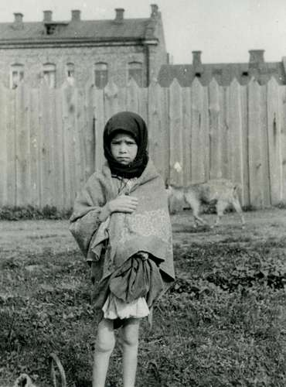
- 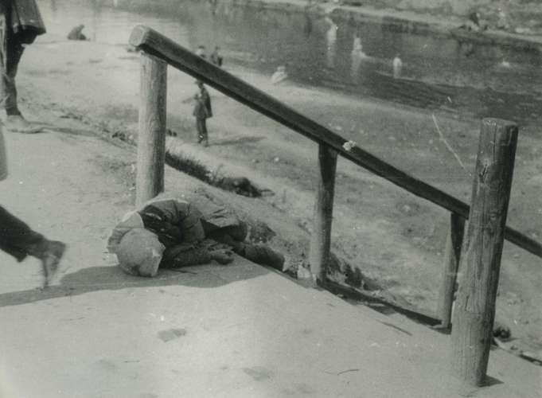
HolodomorA young child, showing obvious signs of starvation, during the Holodomor, Kharkiv, Ukraine, photo by Alexander Wienerberger, 1933.Diocesan Archive of Vienna (Diözesanarchiv Wien)/BA Innitzer
HolodomorDead child on the streets of Kharkiv, Ukraine, during the Holodomor, photo by Alexander Wienerberger, 1933.Diocesan Archive of Vienna (Diözesanarchiv Wien)/BA Innitzer

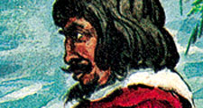
BRITANNICA QUIZ
Criminality and Famous Outlaws
In what year were Bonnie Parker and Clyde Barrow, the famous American outlaws and robbers, killed?

Causes Of The Famine
The origins of the famine lay in the decision by Soviet leader Joseph Stalin to collectivize agriculture in 1929. Teams of Communist Party agitators forced peasants to relinquish their land, personal property, and sometimes housing to collective farms, and they deported so-called kulaks—wealthier peasants—as well as any peasants who resisted collectivization altogether. Collectivization led to a drop in production, the disorganization of the rural economy, and food shortages. It also sparked a series of peasant rebellions, including armed uprisings, in some parts of Ukraine.
- 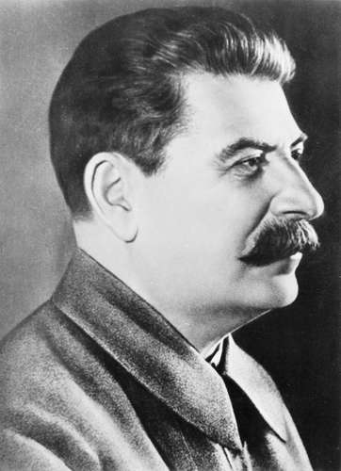
- 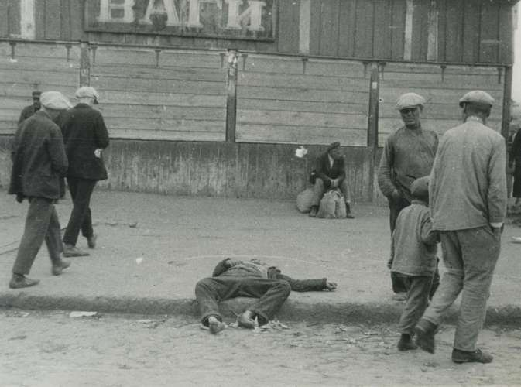
Joseph StalinJoseph Stalin.Library of Congress, Washington, D.C. (neg. no. LC-USW33- 019081-C)
HolodomorVictim of the Holodomor lying on a sidewalk in Kharkiv, Ukraine, photo by Alexander Wienerberger, 1932 or 1933.Diocesan Archive of Vienna (Diözesanarchiv Wien)/BA Innitzer
The rebellions worried Stalin because they were unfolding in provinces which had, a decade earlier, fought against the Red Army during the Russian Civil War. He was also concerned by anger and resistance to the state agricultural policy within the Ukrainian Communist Party. “If we don’t make an effort now to improve the situation in Ukraine,” he wrote to his colleague Lazar Kaganovich in August 1932, “we may lose Ukraine.” That autumn the Soviet Politburo, the elite leadership of the Soviet Communist Party, took a series of decisions that widened and deepened the famine in the Ukrainian countryside. Farms, villages, and whole towns in Ukraine were placed on blacklists and prevented from receiving food. Peasants were forbidden to leave the Ukrainian republic in search of food. Despite growing starvation, food requisitions were increased and aid was not provided in sufficient quantities. The crisis reached its peak in the winter of 1932–33, when organized groups of police and communist apparatchiks ransacked the homes of peasants and took everything edible, from crops to personal food supplies to pets. Hunger and fear drove these actions, but they were reinforced by more than a decade of hateful and conspiratorial rhetoric emanating from the highest levels of the Kremlin.
- 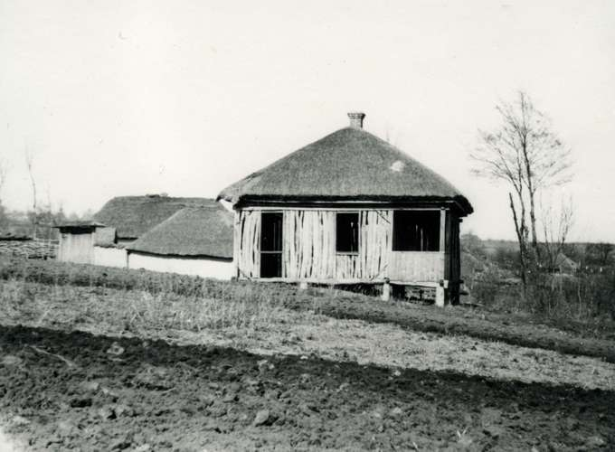
- 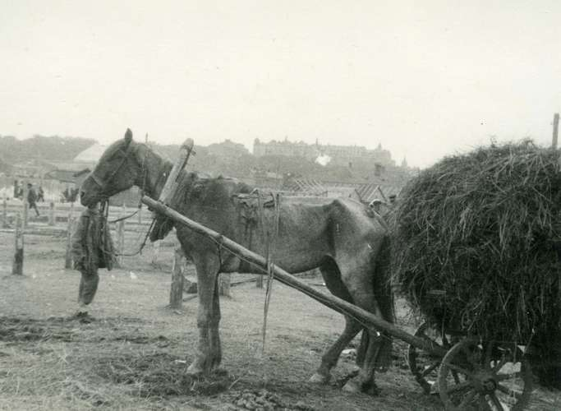
HolodomorEmpty village in the Kharkiv region, Ukraine, photo by Alexander Wienerberger, 1933. Its population either succumbed to the effects of the Holodomor or left in search of food.Diocesan Archive of Vienna (Diözesanarchiv Wien)/BA Innitzer
HolodomorEmaciated horse during the Holodomor, photo by Alexander Wienerberger.Diocesan Archive of Vienna (Diözesanarchiv Wien)/BA Innitzer

From Famine To Extermination
The result of Stalin’s campaign was a catastrophe. In spring 1933 death rates in Ukraine spiked. Between 1931 and 1934 at least 5 million people perished of hunger all across the U.S.S.R. Among them, according to a study conducted by a team of Ukrainian demographers, were at least 3.9 million Ukrainians. Police archives contain multiple descriptions of instances of cannibalism as well as lawlessness, theft, and lynching. Mass graves were dug across the countryside. Hunger also affected the urban population, though many were able to survive thanks to ration cards. Still, in Ukraine’s largest cities, corpses could be seen on the street.
- 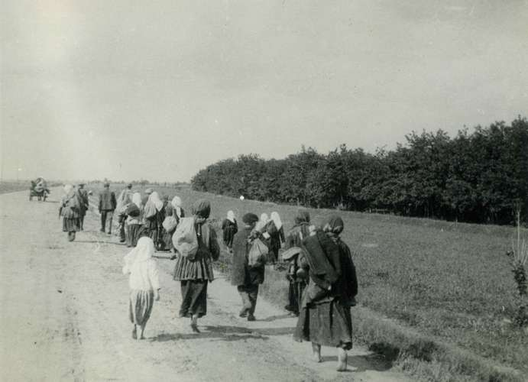
- 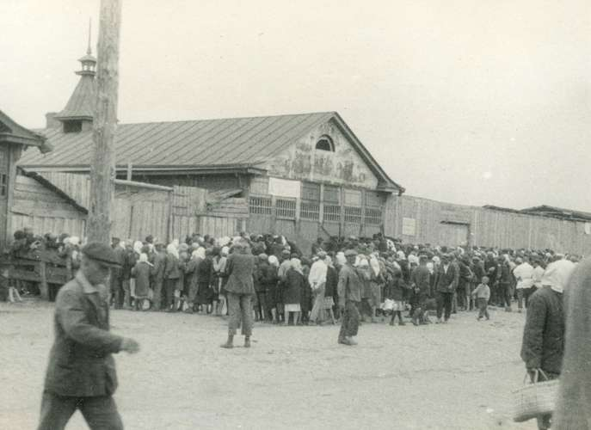
HolodomorHungry Ukrainian peasants in search of food during the Holodomor, photo by Alexander Wienerberger.Diocesan Archive of Vienna (Diözesanarchiv Wien)/BA Innitzer
HolodomorUkrainians lining up to trade valuables for bread at a state-run “Torgsyn” shop, photo by Alexander Wienerberger.Diocesan Archive of Vienna (Diözesanarchiv Wien)/BA Innitzer
Get exclusive access to content from our 1768 First Edition with your subscription.Subscribe today
The famine was accompanied by a broader assault on Ukrainian identity. While peasants were dying by the millions, agents of the Soviet secret police were targeting the Ukrainian political establishment and intelligentsia. The famine provided cover for a campaign of repression and persecution that was carried out against Ukrainian culture and Ukrainian religious leaders. The official policy of Ukrainization, which had encouraged the use of the Ukrainian language, was effectively halted. Moreover, anyone connected to the short-lived Ukrainian People’s Republic—an independent government that had been declared in June 1917 in the wake of the February Revolution but was dismantled after the Bolsheviks conquered Ukrainian territory—was subjected to vicious reprisals. All those targeted by this campaign were liable to be publicly vilified, jailed, sent to the Gulag (a system of Soviet prisons and forced-labour camps), or executed. Knowing that this Russification program would inevitably reach him, Mykola Skrypnyk, one of the best-known leaders of the Ukrainian Communist Party, committed suicide rather than submit to one of Stalin’s show trials.
- 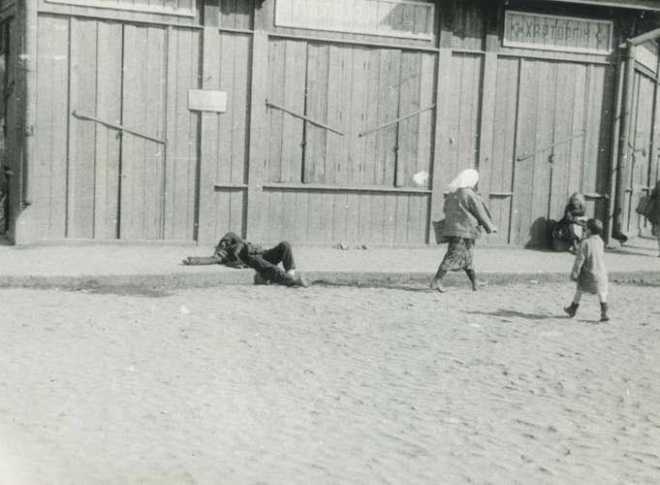
- 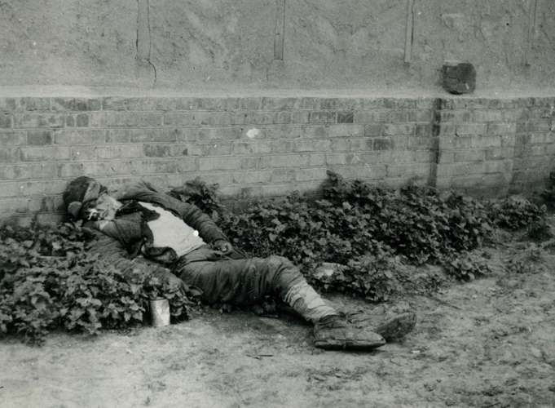
HolodomorVictim of the Holodomor, Kharkiv, Ukraine, photo by Alexander Wienerberger, 1933.Diocesan Archive of Vienna (Diözesanarchiv Wien)/BA Innitzer
HolodomorVictim of the Holodomor, Kharkiv, Ukraine, 1933, photo by Alexander Wienerberger.Diocesan Archive of Vienna (Diözesanarchiv Wien)/BA Innitzer
As the famine was happening, news of it was deliberately silenced by Soviet bureaucrats. Party officials did not mention it in public. Western journalists based in Moscow were instructed not to write about it. One of the most famous Moscow correspondents at the time, Walter Duranty of The New York Times, went out of his way to dismiss reports of the famine when they were published by a young freelancer, Gareth Jones, as he “thought Mr. Jones’s judgment was somewhat hasty.” Jones was murdered under suspicious circumstances in 1935 in Japanese-occupied Mongolia. Stalin himself went so far as to repress the results of a census taken in 1937; the administrators of that census were arrested and murdered, in part because the figures revealed the decimation of Ukraine’s population.
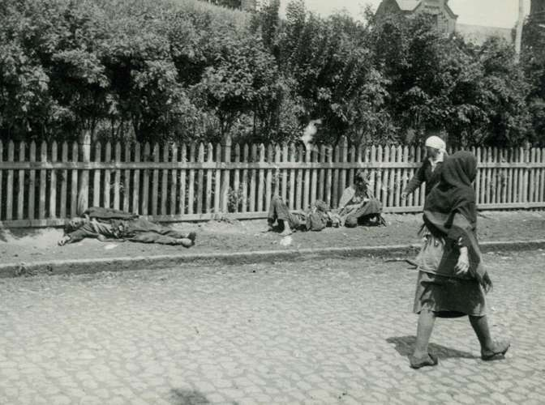
HolodomorVictim of the Holodomor, Kharkiv, Ukraine, photo by Alexander Wienerberger.Diocesan Archive of Vienna (Diözesanarchiv Wien)/BA Innitzer
Although the famine was discussed during the Nazi occupation of Ukraine in World War II, it became taboo again during the postwar years. The first public mention of it in the Soviet Union was in 1986, in the aftermath of the Chernobyl nuclear power plant disaster. That disaster too was initially kept secret by Soviet authorities.

Assessment
Because the famine was so deadly, and because it was officially denied by the Kremlin for more than half a century, it has played a large role in Ukrainian public memory, particularly since independence. Ukrainian poet Ivan Drach was the first to speak publicly about the famine, in 1986, after the Chernobyl disaster, citing it as an example of how damaging official silence can be. Monuments commemorating the Holodomor have been erected by the Ukrainian government as well as by the Ukrainian diaspora, and Holodomor Remembrance Day is observed around the world on the fourth Saturday of November. Ukraine has also invested in research on the famine.
- 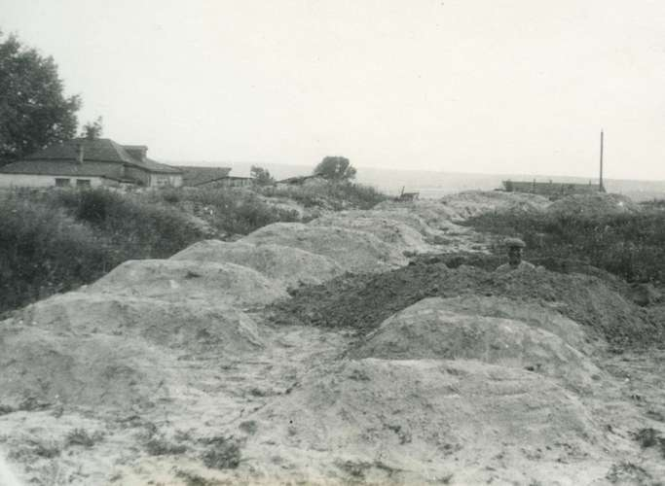
- 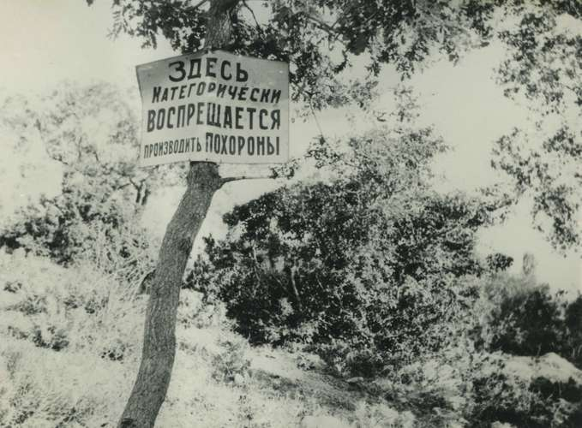
HolodomorMass graves filled with victims of the Holodomor, Kharkiv, Ukraine, photo by Alexander Wienerberger, 1933.Diocesan Archive of Vienna (Diözesanarchiv Wien)/BA Innitzer
HolodomorSign in Russian that reads, “The burying of people is strictly prohibited here,” photo by Alexander Wienerberger. The Holodomor claimed so many lives that the interment of the victims became an issue.Diocesan Archive of Vienna (Diözesanarchiv Wien)/BA Innitzer
By early 2019, 16 countries as well as the Vatican had recognized the Holodomor as a genocide, and both houses of the United States Congress had passed resolutions declaring that “Joseph Stalin and those around him committed genocide against the Ukrainians in 1932–1933.”
Anne Applebaum

LEARN MORE in these related Britannica articles:

