Pelosi referred to last week's storming of the Capitol by a mob of Trump supporters that prompted Democrats to begin efforts to remove him from office, one week before President-elect Joe Biden's swearing-in.
"We know that the president of the United States incited this insurrection, this armed rebellion against our common country. He must go," Pelosi said, calling Trump "a clear and present danger to the nation we all love."

https://www.npr.org/sections/trump-impeachment-effort-live-updates/2021/01/13/956462352/opposing-remarks-pelosi-and-jordan-give-their-parties-opening-statements

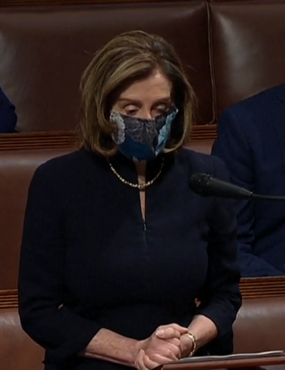
Pelosi impeachment speech was scattered with only one thought in mind. “I am God. I count, the rests can go to hell”.