https://townhall.com/tipsheet/townhallcomstaff/2021/01/06/live-trump-addresses-save-america-rally-n2582661?utm_source=breakingemail – CENSORED BY Youtube

addresses-save-america-rally-n2582661?utm_source=breakingemail – from fox news

The original recording of this speech was censored by YouTube. Fox news has kept this very important speech “ALIVE” for the people. The speech contains the evidence that the MSM is deliberately denying.

Many people are concerned about the President because he is being delibaately maligned. His voice indicates that he is strong and muti-tasking about this mess. His emotions are strong dealing with information that is supportive to people in need. His voice is most like Ron Paul before O’Bama’s people ruined his Tea Party run in 2008. Ron Paul’s voice is one of the most honest voices I’ve ever evaluated.

His print indicates:
Emotions in support of people’s rights
A concern about the future and what others think of America
A concern for the future of the people
A foundational concern that his words will not be heard
Full competence and awarness of many perspectives simultaneously.
He is telling the Truth and is open to hearing others.

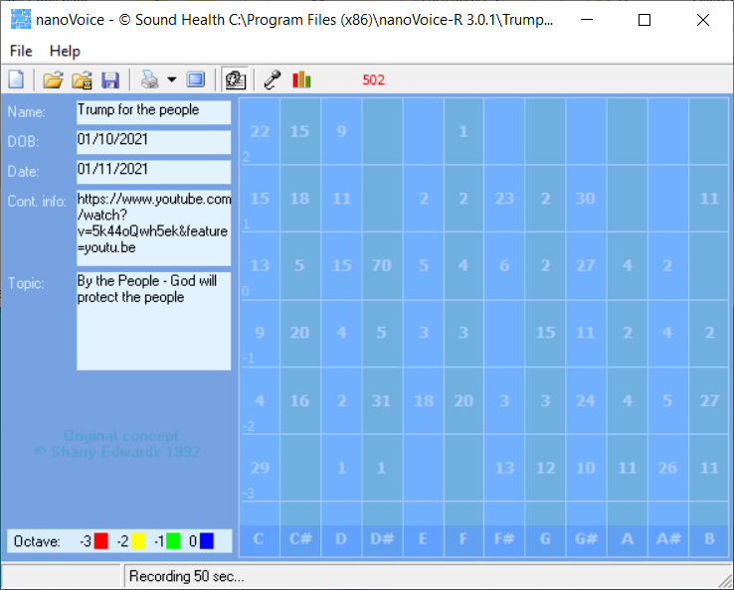
Trump for the people

DOB: 01/10/2021

Recording Date: 01/11/2021

Subject/Topic: By the People - God will protect the people

Points of Importance, Attention and Consequence

You have a high degree of intuition when it comes to listening to what people are not saying. Others see you as having leadership potential but they may resent you for the same reason. You can be fussy about your physical space. It needs to satisfy you and no one else. Sometimes you spend a lot of energy trying to get even the smallest detail right the first time.

Your highest note is associated with seekers of internal Truth. The balance between self expression and self worth resides with this note. Your highest note is associated with the expression of self power. The issues of circulation and stamina reside with this note. Your highest note is associated with the expression of physically prioritizing. Personal control over what happens in your physical environment resides with this note.

Being able to prioritize what needs to be done emotionally is not always easy for you. Your metabolism shows to be a weak point in your vocal print. Ideas come to you in very odd moments when you are distracted by a required task. You can sometimes do too much for others in the hopes of helping them change.

Points of Communication, Complications and Complaints

You understand that trust should be earned but often trust without reservation. It is particularly bothersome when people use or borrow your property without permission. You work well with others and are often put in a leadership position.

You would like to have more time to spend on spiritual things. You have a hard time prioritizing what you want to do first. You wish someone could understand you without demanding a lot of conversation. You know how to get things done but don't always have the time to deal with the details.

