Robert David Steele

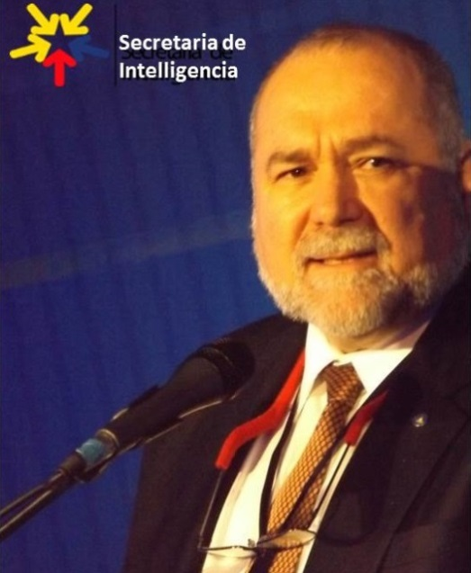 | Robert David Steele is a holistic strategic analyst and educator of individuals and organizations – governments, corporations, non-governmental organizations, and universities in particular. He is competent at all-source collection management (know who knows); geospatially-based visualization of complex data; multidisciplinary and multilingual analytics; and compelling interaction with decision-makers facing painful choices and confusing opportunities. A former senior intelligence professional for the USA, an honorary hacker, and the #1 Amazon reviewer for non-fiction, reading in 98 categories, he has been CEO of a for-profit company, Open Source Solutions Network, Inc., and is today CEO of an accredited educational non-profit, Earth Intelligence Network. Robert is known for his proponency of Open Source Intelligence (OSINT), teaching 7,500 mid-career officers from across 66 governments (NATO/PfP, others) and is the leading proponent for Applied Collective Intelligence, which integrates Holistic Analytics, True Cost Economics, and Open Source Everything, an engineering and information management approach that is affordable, interoperable, and scalable.
The two most recent books by Robert Steele are entitled THE OPEN SOURCE EVERYTHING MANFESTO: Transparency, Truth, & Trust (North Atlantic Evolver Editions, 2012), and INTELLIGENCE FOR EARTH: Clarity, Diversity, Integrity, & Sustainability (Earth Intelligence Network, 2010). He has been recognized as a thought leader since 1994 when he was featured by Alvin Toffler in a chapter on “The Future of the Spy” and listed by Microtimes as an unsung hero striving to change the world for the better. Only recently has the larger public, shocked by Climate Change, Ebola, and rampant destabilization across Central Asia, the Middle East, and North Africa, begun to understand that we must achieve foresight through informed future-oriented hybrid governance, an original concept developed by Steele along with Applied Collective Intelligence. He is a mentor for those seeking to create organizations that are rooted in ethical evidence-based decision support. His motto, “the truth at any cost lowers all other costs,” is one that can help any organization thrive in times of chaos by achieving foresight and shaping their future.
Robert Steele’s vision for the future of intelligence is clearly “internationalist” in nature. It focuses on regional partnerships…and on the value of open source intelligence collection.

Rear Admiral Dr. Sigurd Hess, DE N(Ret), Former Chief of Staff, Allied Command Baltic Approaches

Accomplishments |  | Education & Experience
- Designer of the Open Source Everything Hub  - Funded architecture for World Brain & Global Game  - Created global practice of Open Source Intelligence  - Author, NATO, DIA, SOF OSINT Handbooks  - Primary OSINT contractor to SOF 1996-2007  - Created four strategic analytic models  - 2006 Earth Knowledge – Six Bubbles  - 1988 World Model – 144 Factors  - 1979 Cultural Intelligence Analysis Model  - 1976 Predicting Revolution – 12 Domains  - Most published intelligence pioneer in English  - Eight books, two with Forewords by Senators  - Curate 80+ strategic foresight bloggers @ Phi Beta Iota |  | Academic Visitor, Loughborough University (UK)  Research Adjunct, Strategic Studies Institute (SSI)  CEO (pro bono), Earth Intelligence Network (501c3)  CEO, Open Source Solutions, Inc. (C Corporation)  USMC Intelligence, 2nd ranking civilian at the time  CIA, top human and technical operations performer  USMC, infantry, intelligence, S-1/Adjutant  Naval War College (Defense Economics)  MPA University of Oklahoma (Strategic Information)  MA Lehigh University (Predicting Revolution)  AB Muhlenberg College (Multinationals Gone Wild)  Other Languages: Native Spanish, elementary French  21 years in Asia, Caribbean, Central & South America
Robert is passionate about helping organizations shape their future with the practice of ethical evidence-based decision-support for future-oriented hybrid governance that creates peace and prosperity for all.

