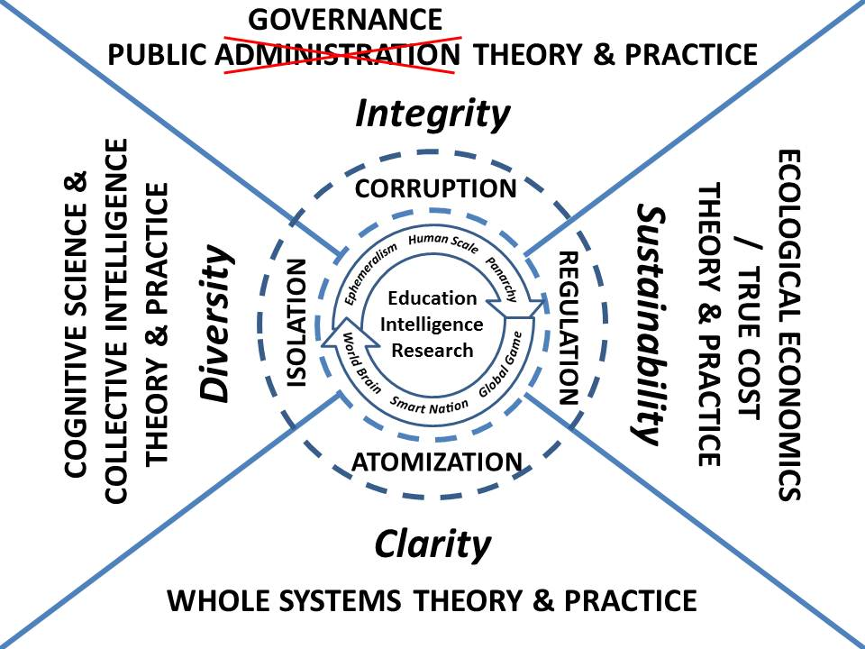 | “The righter we do the wrong thing, the wronger we become. When we make a mistake doing the wrong thing and correct it, we become wronger. When we make a mistake doing the right thing and correct it, we become righter. Therefore, it is better to do the right thing wrong than the wrong thing right. This is very significant because almost every problem confronting our society is a result of the fact that our public policy makers are doing the wrong things and are trying to do them righter.” (Ackoff 2004)
ABSTRACT
Neither the State/Government with its penchant for abusing secrecy and funding violence nor the discipline of Public Administration in their present forms are central to the future of humanity in the 21st Century—both are now on the margins.
The emergence of information and information technology as a public good has changed the game and hence all of the rules. Hybrid forms of governance based on shared information and shared sense-making are the new normal, within which government is the least important of eight major sense-making communities, and informed non-violent civil resistance and orchestrated crowd-sourcing and crowd-funding are the new arbiters of public power.
The eight communities that will share information and sense-making to achieve hybrid governance are academic; civil society including labor and religions; commerce; government at all levels; law enforcement; media; military; and non-governmental/non-profit.
In the 21st Century the public will be the one constant, and the seamless integration of education, intelligence, and research across all boundaries will enable Panarchy empowered by Ephemeralism—connecting all minds to all information all the time: direct democracy at every level with tailored information being a substitute for land, labor, capital, and time.
Public Administration must evolve to integrate Cognitive Science & Collective Intelligence, Whole Systems, and Ecological/True Cost Economics. In so doing, it must restore integrity as the central attribute of humanity, leveraging clarity and diversity to achieve sustainability. It should more properly be defined as Public Governance—its method will be a mix of Open Source Everything (OSE) and Multinational, Multiagency, Multidisciplinary, Multidomain Information-Sharing and Sense-Making (M4IS2).
The new discipline will be radical—it will among other things call into question--challenge for re-examination--the US Constitution, all other Constitutions less that of Iceland, and the process and form of every public corporate charter ever written. If the discipline fulfills its potential, the outcome will be Smart Nations at Human Scale in the context of a World Brain and Global Game…Utopia. In the interim, one word will have to suffice....INTEGRITY.
Embodied in a single World Brain Institute that sponsors the Global Game and nurtures Centres for Public Intelligence around the Earth, this endeavor will reintegrate the sciences with the humanities.

