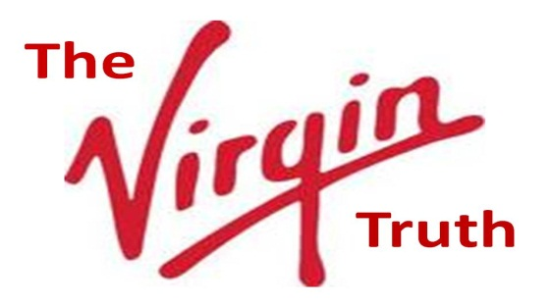 | The failed war on drugs is a classic example of corruption and disinformation enabling governments to betray the public interest by doing the wrong thing for the wrong reason. The Industrial Era has been rooted in information asymmetries that reward both short-term thinking and outright lies to the consumer. The Internet now makes it possible to document the true cost of all costs and services, and to enable individuals as well as organizations to leverage truthful information to group advantage. “The truth at any cost lowers all other costs.” We propose a global ICT project, The Virgin Truth.
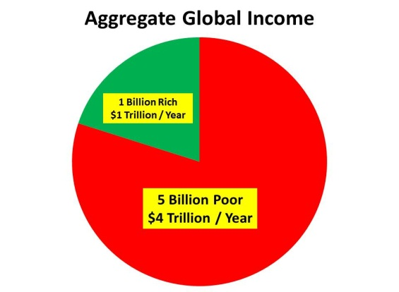 | C. K. Prahalad, author of The Fortune at the Bottom of the Pyramid: Eradicating Poverty Through Profits, has pointed out that the one billion rich have a global annual aggregate income of one trillion dollars, while the five billion poor have a global annual aggregate income that is four times larger: four trillion dollars. With capitalism including travel, telecommunications, and other services still focused on the one billion rich, this means that 80% of the marketplace is lying fallow for a first-mover advantage. Our proposed project meets the needs of this market for the ICT equivalent of micro-loans. By being the sole aggregator of locational as well as substantive data for this marketplace, Virgin will dominate both ICT and micro-need intelligence.
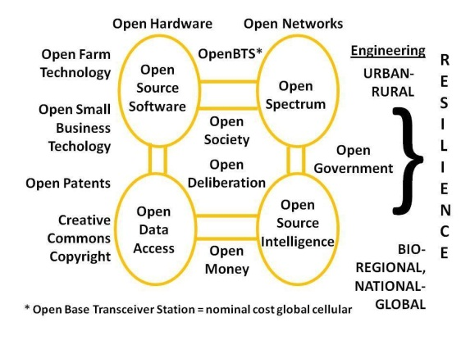 | Proprietary information technologies do not scale and do not play well with others. The existing Virgin investments in telecommunications can be increased in scope and profitability by being the first to go “all in” on Open Source Everything (OSE). OpenBTS (Open Base Transceiver Station) as developed by Range Networks is making possible virtually free hand-held devices, with cost of service for full access to what should be Open Spectrum now estimated at $2 per person per month. Combining call centers built with Open Cloud, Open Hardware, Open Software and Open Standards opens other possibilities. The Virgin Truth gains first-mover advantage with OSE – delivering public knowledge faster, better, cheaper while earning profit.
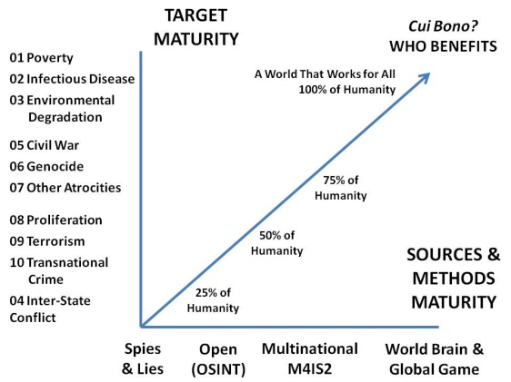 | Our proposal of free cells phones for the five billion poor is intended to capture them as both customers and sources for life while also directly educating them—not just on drugs but on small choices that eradicate poverty, improve health, avoid conflict, reduce crime, all while helping them to increase earnings of which Virgin receives a modest percentage that is huge (on the order of $80 billion a year at 1%). Our intent is to create and monetize the World Brain and Global Game, offering free education to the poor while creating the world’s first holistic commercial intelligence (decision-support) service. We will harness distributed intelligence of the poor while elevating global public intelligence with The Virgin Truth as the gold standard.
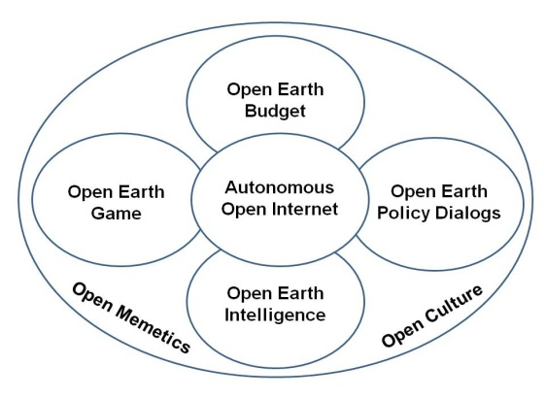 | As governments and corporations centered on the needs of the rich continue to fail, hybrid forms of governance are emerging in which shared information enables disparate parties to agree on collaborative investments and behaviors. For each of the ten high-level threats facing humanity (poverty, infectious disease, environmental degradation, inter-state conflict, civil war, genocide, other atrocities, proliferation, terrorism, and transnational crime) there is no offering that is central to collecting, processing, analyzing, and sharing public intelligence in the public interest. We propose to create that global network – The Virgin Truth will help eradicate the 50% that is fraud, waste, and abuse, and profit from being the hub for an educated public.

