Chapter 4: Strategy

A. Integrity Is a Grand Strategy 35
B. Grand Strategy 37
C. Strategy 37
D. Threats, Goals, Priorities 38
E. Whole of Government Management 39
F. Affordable Coherent Acquisition 40
G. Just Enough Just in Time Operations 41
H. Strategic Education 41
I. Strategic Intelligence 42
J. Strategic Research 42

Reader’s Guide
Grand Strategy is everything, always. Strategy is everything, always within one particular domain. Strategy is how humans can orchestrate means (revenue), ways (capabilities and actions) and ends (goals and outcomes). Most human organizations, including governments, corporations, and very wealthy foundations, are oblivious to the importance and value of strategy. If threats are not properly, persistently, and comprehensively understood, the strategy will be inappropriate and unsustainable. If opportunities are not appreciated, societies are mis-directed and fail to advance to the next level. Corruption among those in power is generally the cancer that prevents authentic strategies from being conceptualized, fleshed out, and implemented. Absent Whole of Government management, affordable coherent acquisition, and the ability to dramatically reduce the cost of government operations by eradicating fraud, waste, and abuse while carrying out very agile “just enough just in time” operations. By the end of this book and the course if taught with this book, you will understand that INTEGRITY is the foundation for everything else—that legitimacy and trust create infinite wealth for all—and that education, intelligence, and research are the brain, heart, and soul of any organization from family to state to religion to global diaspora of individuals with intelligence and integrity who feel betrayed by all of their organizations, and are striving to connect, creating a new global network that is truly Of, By, and For We the People.

A. Integrity Is a Grand Strategy
I considered a separate chapter on integrity and chose not to isolate it in that manner for two reasons. First integrity must be pervasive. Any loss of integrity at any level on any issue for any duration of time is like sand in the gears of a very complex system.
Second, integrity, in and of itself, is a grand strategy. If the truth at any cost lowers all other costs, then a commitment to transparency, truth, and trust is an ethos – a fundamental attribute of the entire body politic, body social, body economic.
Below is an illustration of a strategy that embraces an ethos of integrity.

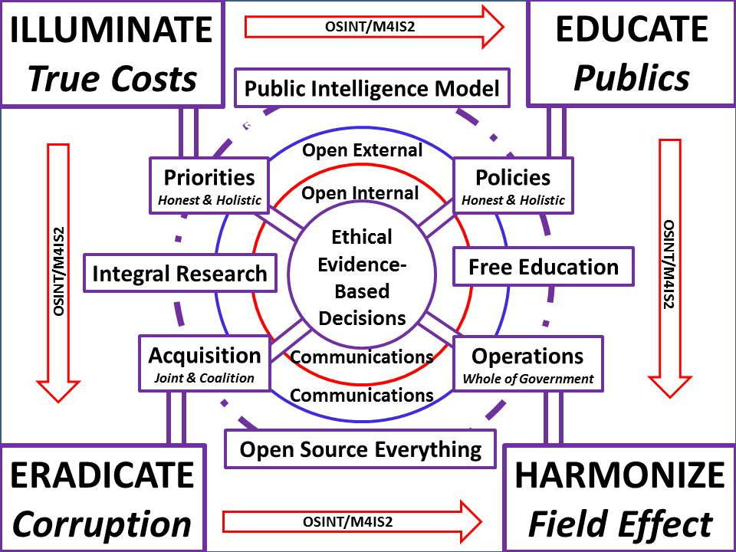
Figure 8: A Strategic Ethos of Integrity
Strategy comes before policy, acquisition, and operations if and only if there is integrity in governance. If policies are devised on the basis of special interest corruption to arrive at pre-determined financial outcomes without regard to ethical evidence-based decision-making, then all parties associated with those “orphan” policies are inherently corrupt, more likely to be excessive in cost, more likely to be excessive in negative side effects (e.g. toxins), and less likely to be sustainable or successful.

B. Grand Strategy
Grand Strategy is about long-term threats, goals, and interests – it goes far beyond any single political administration or any single generation of corporate or other leadership. Grand Strategy is about the balanced integration of all of the resources and instruments of national or organizational power (Steele 2008). Stewardship of existing resources—including the population and its education, is part of Grand Strategy. Balance, flexibility and frequent adjustments are part of Grand Strategy – “stay the course” is an inherently corrupt concept, as is an excessive investment in the military alone (Johnson 2004). A true Grand Strategy is focused on opportunities as well as threats, on keeping the peace as well as being prepared for war. Debts and deficits have no place in a Grand Strategy – they are a burden on future generations and inherently corrupt (Kennedy 1992).
Morality (an attribute of the nation, organization, tribe, or group) and legitimacy (the perception of the nation or other human organization by others) are central to Grand Strategy. On the basis of their multi-volume The Story of Civilization, Will and Ariel Durant draw a number of conclusions in their capstone The Lessons of History. Among those lessons: morality is a priceless strategic asset (Durant 1968). In other words, legitimacy is a priceless objective (Manwaring et al 2003).
The very worst thing any nation or organization can do is to alienate everyone else. When US policy and spending antagonizes everyone else, this is a Grand Strategy blunder, what Chalmers Johnson calls “sorrows of empire” (Johnson 2004, Paret et al 1986).
Grand Strategy must be holistic, and security strategy is not about security capabilities alone, but rather demands a holistic approach and the rather renaissance capability of managing a multiplicity of capabilities – diplomatic, economic, cultural, military, psychological, information – in a balanced manner and under the over-arching umbrella of a strategy (Gray 1999).
Grand Strategy and Strategy are not to be confused with technology or spending. Technical innovation and excessive spending are not a strategy and more often than not will undermine any Grand Strategy by distracting, diverting resources, or bankrupting the society in question (Gray 1999, Gray 2004).
Grand Strategy requires coherent management of Whole of Government (Abshire 1989). As long as the Executive Office of the President (EOP) and the Office of Management and Budget (OMB) do not “manage,” the USA will be unable to plan, program, and budget at a Grand Strategy level (Steele 2012 IG).
Lastly, Grand Strategy demands a deep understanding of reality as best as it can be known. There are three ways to tri-sect reality: first, absorb all history in all languages; second, cast a very wide net, in all languages; and third, practice Multinational, Multiagency, Multidisciplinary, Multidomain Information-Sharing and Sense-Making (M4IS2)…and that is a Grand Strategy.

C. Strategy
Strategy is an over-arching concept that is devised to achieve specific mid-tern objectives, and generally entails planning, programming, and budgeting that in turn funds acquisition and operations. Acquisition in theory is the implementation of a force structure designed with some relation to both reality (external) and policy objectives (internal).
Strategy demands focus – it demands a specific person or group able to take responsibility for the whole, integrate the views and concerns of the elements, and devise a plan, a program, and a budget that is executable.
Below is a really excellent graphic from one of the very best books on strategy (de Wit and Meyer 2004).
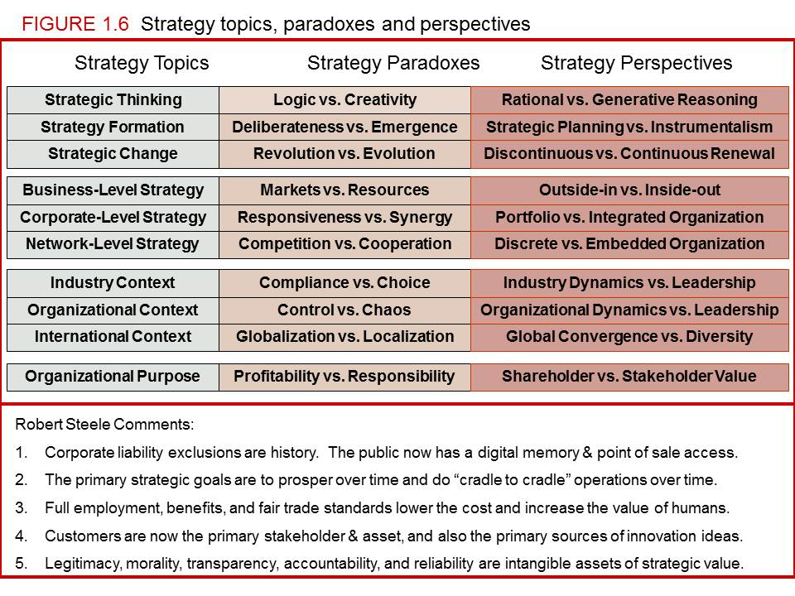
Figure 9: Strategy Topics, Paradoxes, & Perspectives
Integrating plans, programs, and budgets from the elements is not strategy nor is it management. This is the primary reason that the US Government needs an Open Source Agency (OSA) that includes Tony ZInni’s National Monitoring and Planning Center (NMPC); a Deputy Director for Management in OMB that actually manages; and a restructuring of the White House and how the President in supported in executive-level decisions (Steele 2009, Steele 2011, Zinni 2007). Below the Grand Strategy level, multiple strategies can co-exist, but they should be deconflicted and harmonized in relation to the Grand Strategy.

D. Threats, Goals, Priorities
The absolute greatest encapsulation of where threats fit with strategy and everything else comes from Senator Sam Nunn (D-GA), then serving as Chairman of the Senate Armed Services Committee (SASC):
I am constantly being asked for a bottom-line defense number. I don’t know of any logical way to arrive at such a figure without analyzing the threat,; without determining what changes in our strategy should be made in light of the changes in the threat; and then determining what force structure and weapons programs we need to carry out this revised strategy. (Steele 2000, p. 3)
Integrity is required in both the intelligence community and the governance community, if threats are to be honestly and objectively evaluated. In the USA, the threat has been manufactured, if not by bankers seeking to fund both sides of any war including the Civil War (which was actually a war of secession), then by the military-industrial complex. The record is quite clear: the Cold War was fiction created by Lockheed and its corrupt allies in the US Congress and the US Executive. The damage we have done to the rest of the world at taxpayer expense has been genocidal in scale and an eternal dishonor to the Republic (Hartung 2012, Leebaert 2003).
Once the threats are established and accepted – today the threats have been established but not accepted by any government as a national priority, then goals can be established, and priorities enumerated in relation to those goals. We will discuss these in detail in Chapter 10.
In the USA, poverty has increased dramatically since the year 1970, at the same time that the government continues to both absolve Wall Street of all of its crimes against humanity both at home and abroad, and continues to “bail out” the very people that exploded the US and the global economy (Glassmeier 2005, Taibbi 2010). All ten of these threats are not being addressed in a serious professional manner that uses strategy to sort out means, ways, and ends.
We are in grid-lock right now, largely because the public is uninformed by a captive corporate media, legislators are corrupt, and executive agency leaders are focused on serving the special interests who receive the taxpayer’s revenue, rather than on the public interest. Needed badly is public intelligence in the public interest: a framing of the threats, goals, and priorities such that a “gold standard” is established against which individual legislators can be held to account, at the same time that decision-support on all of these threats is made available to the executive, the public, and the media, as well as corporations, non-governmental organizations, and civil society organizations.
Missing today from governance is intelligence with integrity. That is our strategic objective.

E. Whole of Government Management
Holistic means whole, as in the whole is greater than the sum of the parts. When parts fit together well, they operate without friction, with great efficiency. When one part of government goes in one direction while another part of government goes in the opposite direction, they cancel each other out. Below is an illustration of a properly managed government in which policies, acquisition, and operations are aligned across all elements at all four levels of effort.
In order to do data-driven strategic management (which is to say, manage the whole at all four levels, across all policy areas, across all elements of the US Government, three things have to happen:
1. Data needs to be ingestible into a government-wide cloud
2. All data needs to have both a date time stamp and a geospatial attribute
3. Machine speed near-real-time (NRT) processing is done of all data from all sources

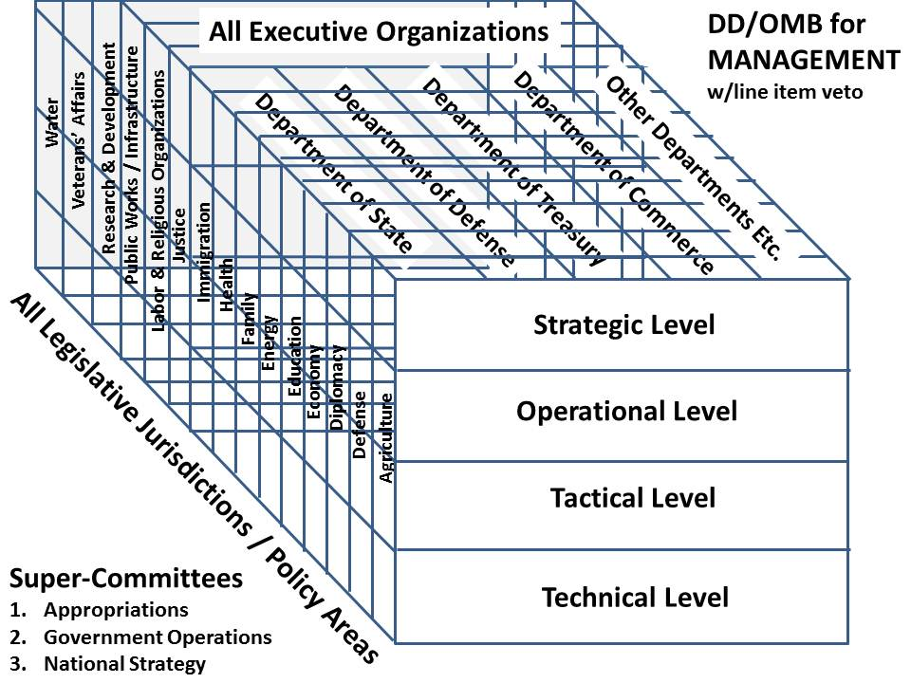
Figure 10: Data-Driven Whole Of Government Management
An Open Source Everything (OSE) strategy can make this possible within a few years. In the interim, OMB and Congress can orchestrate a series of joint Executive-Legislative Briefing Books, and also restructure both branches to better align jurisdictions, oversight, and implementation.

F. Affordable Coherent Acquisition
Acquisition is similar to sail racing in some respects – you can win or lose the race before your boat ever hits the water. By this I mean that the US today is operating an acquisition process that is so totally corrupt in all possible respect that is assured failure. Here I list just a few of the fundamentals that the government as a whole, but the Department of Defense in particular, simply do not embrace.

1. Have a grand strategy that prevents war and humanitarian crises from occurring – prevention really is cheaper that reactive remediation. This means you have to invest in all of the instruments of national power, not just the one that consists of big expensive systems we do not need and cannot afford. When a country has more military musicians than it has diplomats, this is a clue that something is terribly wrong at the highest levels of US government thinking.
2. Engage in Whole Systems design – it makes no sense for the US Army to create a vehicle or weapons system that is not air-liftable or air-transportable. From the new jeep that will not into most CH-46 helicopters to the Striker armored personnel carrier that has to be broken down into multiple aircraft loads, to Marine Corps tanks that displace entire truck companies from the traditional amphibious landing craft, it is clear that DoD acquisition is out of control and incoherent. At the same time, it is vital that systems be interoperable with interchangeable parts (e.g. for ground transport systems across services).
3. Buy many small less expensive systems than a few very large very expensive systems. Redundancy, portability, and presumed losses are all important.
4. Be totally honest about total cost of ownership from cradle to grave, and stop the many existing forms of corruption that include lying to Congress, concealing true costs, front-loading programs with sunk costs, and failing to budget for communication, intelligence, and logistics supportability.
We will discuss Acquisition in more detail in Chapter 6. Here we simply summarize the strategic level of acquisition thinking, something that OMB does not get involved in, and should.

G. Just Enough Just in Time Operations
A huge responsibility at the strategic level is summed up by Sun Tzu’s often-quoted but rarely respected “The acme of skill is to defeat the enemy without fighting.” Or in Gandhi’s terms, “Make love, not war.” The whole point of grand strategy is the be a good steward for the nation or tribe or organization; to avoid making enemies; to be resilient in the face of disasters; and to prosper, elevating the whole while avoiding the cost in blood, treasure, and spirit of war. And if you do go to war, do so with just enough, just in time, not, as we do now, with a military so complex that we have lost the ability to do precision interventions with good effect.

H. Strategic Education
Will Durant’s 1916 doctoral thesis, now easily available as Philosophy and the Social Problem, Annotated Edition (2008) has this to offer (from my Amazon review):
Durant defines duty not as unquestioning submission to the group but rather individual excellence in thinking and action--for a modern presentation of this, see Integral Consciousness and the Future of Evolution.
From Socrates to Spinoza and on, Durant finds that morality is not about freedom of will or individual purpose, but rather about how the group and the individuals as part of the group relate means to ends (or we could say now, means (revenue) to ways (policies) to ends (endless war or peace, distributed prosperity or concentrated wealth and broad slavery).
I find guidance and solace in Durant's rendition of Plato, and am just blown away by how we must give the best to education, that until we do so, until we give our best brains to education, no amount of money will reduce our social ills. Here is the quote:
"When Plato says that the office of minister of education is 'of all the great offices of state the greatest,' and that the citizens should elect their very best man to this office (Laws 765-6), he is not pronouncing a platitude, he is making a radical, revolutionary proposition.”
Durant draws out (mostly from Spinoza) the importance of not having a standard government-defined education, of making education fun, exploratory, diverse, and open-ended. I cannot help but recall how the author of Orbiting the Giant Hairball: A Corporate Fool's Guide to Surviving with Grace suggests we beat the creativity out of children by the fourth grade, and how my hacker friends consider schools to be prisons.
My own evolution of Durant’s ideas are offered up in my article (1995) and book (2006) by the title of Creating a Smart Nation.

I. Strategic Intelligence
This entire book is about intelligence, so here I want to make just three points:
1. At the strategic level of decision-making, intelligence with integrity is the only resource. If BOTH the intelligence community and the political-policy community lack integrity, they will be arrogant, corrupt, and ignorant – persistently betraying the public trust at great expense.
2. Regardless of how good your intelligence might be, and how strong the integrity of your intelligence professionals, IF the intelligence is only secret in nature such that it cannot be shared with the public, media, and Congress; AND the political leadership lacks integrity, the intelligence, however good, will be ignored.
3. Regardless of how much integrity the political and policy leadership might have, if the intelligence community lacks integrity in the holistic sense, and persists in only doing secret collection against Hard Targets, and refuses to do Global Coverage, it will stink at culture, history, language, and will have no contextual understanding as well as no forecasting ability worthy of notice.

J. Strategic Research
There is nothing strategic, transformative, or inspiring about the current national Science & Technology (S&T) research & development (R&D) program in the USA today. For 2013, at $140.8 billion, at least a third of which will be waste, this is simply not serious – nor is it harmonized by OMB or anyone else (OSTP 2012). It also does not address R&D in the humanities. While the US does participant in a number of multinational endeavors, and the Earth Science information-sharing initiatives is one of the most brilliant and needed initiatives sponsored by the White House, the US does not have a national much less a global open data access and open repository strategy, and there is no serious attention being given to – for example – assuring public access to all of the information collected at indirect taxpayer expense by the Specialized Agencies (SA) of the United Nations (UN).
We will discuss systems thinking, true cost economics, the ten high-level threats, and twelve core policies in subsequent chapters. Then we will begin to understand how to do the right thing, instead of what we are doing now, the wrong thing righter (Ackoff 2004).

TERMS OF REFERENCE

Acquisition
Balance
Budgeting
Capabilities
Culture
Data-Driven
Date-Time Stamp
Education
Ends
Evidence-based
Flexibility
Force Structure
Geospatial Attribute
Grand Strategy
History
Holistic
Implementation
Integrity
Intelligence
Jurisdictions
Language
Legitimacy
M4IS2
Machine Processing
Means
Morality
Near-Real-Time
Orphan Policy
OSINT
Oversight
Planning
Population
Programming
Reality
Research
Resources
Specialized Agencies (SA)
Stewardship
Strategy
Ways
Whole of Government
Whole Systems

READINGS
2012 Reflections on Inspectors General, PBI (28 September)
2011 Open Source Agency: Executive Access Point, PBI (25 August)
2010 Reflections on Integrity UPDATED + Integrity RECAP, PBI (28 September)
2009 Fixing the White House & National Intelligence, PBI (16 July)
2009 Politics & Intelligence–Partners Only When Integrity is Central to Both, PBI (13 October)
2009 Worth a Look: Book Reviews on Strategy, PBI (17 January)
2008 Graphic: Medard Gabel’s Cost of Peace versus War, PBI (15 August)
2008 Rebalancing the Instruments of National Power–Army Strategy Conference of 2008 Notes, Summary, & Article, PBI (9 May)
2008 “Paradigms of Failure,” ELECTION 2008: Lipstick on the Pig. Oakton, VA: Earth Intelligence Network
2001 Threats, Strategy, and Force Structure: An Alternative Paradigm for National Security, Chapter 9: “Threats, Strategy, and Force Structure: An Alternative Paradigm for National Security, pp. 139-163 at PBI
1992 “E3i: Ethics, Ecology, Evolution, & intelligence” Whole Earth Review (Fall) at PBI
Abshire, David (1989). Preventing World War III: A Realistic Grand Strategy. New York, NY: Harpercollins.
Barney, Gerald (1982). The Global 2000 Report to the President: Entering the Twenty-First Century. New York, NY: Penguin.
De Wit, Bob and Ron Meyer (2004). Strategy: Process, Content, Context--An International Perspective. Cincinnati, OH: South-Western College Publishing.
Durant, Will and Ariel Durant (1968). The Lessons of History. New York, NY: Simon & Schuster.
Durant, Will (1916) Philosophy and the Social Problem: Annotated Edition (2008), Frisco, TX: Promethean Press.
Glassmeier, Amy (2005). An Atlas of Poverty in America: One Nation, Pulling Apart 1960-2003. Oxford, UK: Routledge.
Gray, Colin (1999). Modern Strategy. New York, NY: Oxford University Press
Gray, Colin (2004). Strategy for Chaos: Revolutions in Military Affairs and the Evidence of History. Oxford, UK: Routledge.
Hartung, William (2012). Prophets of War: Lockheed Martin and the Making of the Military-Industrial Complex. New York, NY: Nation Books.
Kennedy, Paul (ed.) (1992). Grand Strategies in War and Peace. New Haven, CT: Yale University Press.
Leebaert, Derek (2003). The Fifty-Year Wound: How America's Cold War Victory Has Shaped Our World. New York, NY: Back Bay Books.
Manwaring, Max, Edwin Corr and Robert Dorff (eds.) (2003). The Search for Security: A U.S. Grand Strategy for the Twenty-First Century. Santa Barbara, CA: Praeger.
Meadows, Donella, Dennis Meadows, and Jorgen Randers (1972). Limits to Growth. White River Junction, VT: Chelsea Green.
Office of Science and Technology Policy, “Innovation for America’s Economy, America’s Energy, and American Skills: The FY 2013 Science and Technology R&D Budget,” 13 February 2012.
Paret, Peter, Gordon Craig, Peter Gilbert (eds.) (1986). Makers of Modern Strategy from Machiavelli to the Nuclear Age. Princeton, NJ: Princeton University Press.
Rischard, Jean Francois (2003). High Noon 20 Global Problems, 20 Years to Solve Them. New York, NY: Basic Books.
United Nations (2004). A More Secure World: Our Shared Responsibility (Report of the. High-Level Panel on Threats, Challenge, and Change). New York, NY: United Nations.
Zinni, Tony (2007). The Battle for Peace: A Frontline Vision of America's Power and Purpose. Basingstoke, UK: Palgrave Macmillan.
ASSIGNMENT
Read a substantive review from each link above. Do this quickly. We will craft a coherent strategy.
QUESTIONS
1. Has any Administration in the USA in recent memory had a “Grand Strategy?”
2. Has any country anywhere had a Grand Strategy? Which one and what have been its consistent objectives?
3. What are the instruments of national power? Corporate power? Religious power? Criminal power? Can organizations other than states have a Grand Strategy?
4. You are going into hearings for confirmation as the Secretary of State. What three ideas would you take in with you?

Since this anecdotal story was first told around 2007, the Department of State has fudged its numbers upwards, counting Foreign Service Specialists with its Foreign Service Officers to reach a count of 13,000 when actual FSO’s are probably no more than 5,000 in number; and the Department of Defense has obscured its numbers, generally believed to be around 5,000. What is known is that the Marines spend $50 million a year on military musicians, and the US Army spends at least $200 million a year. Assuming a total of $500 million for all of DoD, at $100,000 each, that tends to support the 5,000 number.

