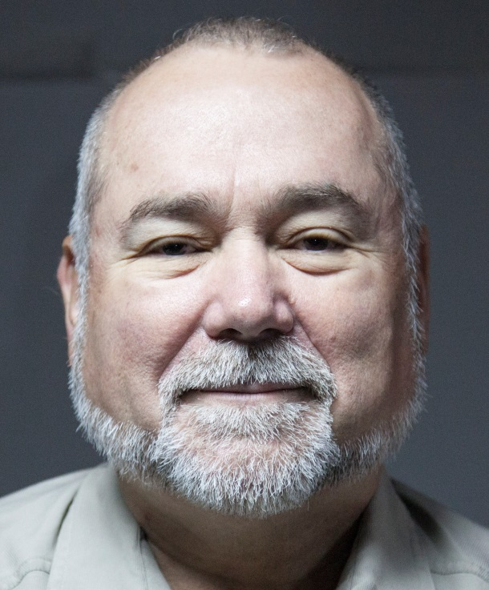
Robert David Steele is a true American patriot. Former Marine, former CIA operations officer (spy) in South America and elsewhere, co-founder of the Marine Corps Intelligence Center, graduated in political science, international relations, public administration and national defense, he has advocated for the last 25 years the concept of open source intelligence, of which he is the modern pioneer, has written numerous books on the subject of intelligence and governance reform, and has personally trained more than 7,500 officers across more than 66 countries including all of the NATO members. His latest book is entitled: The Open Source Everything Manifesto, Transparency, Truth & Trust – a translation into Quebecois is pending. This is an iconoclastic and authentic revolutionary and a friend of Quebec and its culture.
Pierre Cloutier
Q - Robert Steele, it is past time since we met at my request, in office in Quebec of Bernard Landry, who was at the time, Minister of International Affairs and Deputy Prime Minister of Quebec. How things have evolved for you since then?
For a time, governments were paying attention and trying to do the right thing (using open sources to achieve decision-support that could be shared with Parliaments and the public) but the military-industrial complex quickly realized that implementing my ideas would eradicate the 50% that is waste and also threaten the many corrupt deals to create capabilities that are not needed so I was marginalized. My clearances (access to Top Secret information) were stripped away, which had the result of ending my contracts and destroying my business that was grossing $1.7 million with one employee (myself) in 2007. I have been unemployed – less a few months here and there in Afghanistan, with the United Nations, and in other small jobs – since 1 January 2008. This does not mean that I have stopped thinking. I have published books and tried to help those that have asked for help. Today there is a bright spot, I have been appointed Academic Visitor to Loughborough University in London, and it may be that I will spend my final twenty years creating a School for Future-Oriented Hybrid Governance and a World Brain Institute. I was too trusting of governments – now I realize that Buckminster Fuller was right, I should have been focused on empowering the public the whole time, not on trying to fix corrupt dysfunctional governments.
Q - It's a shame that the project to give Quebec an open source intelligence agency has not been possible as we would have liked and for various reasons. What would have been your contribution to Quebec and how it could it better serve the objectives of independence from the government of Quebec?
I deeply admire the culture of Quebec and its central role in keeping alive the values that go with that culture. As someone else wrote recently, if you want to avoid being an “American Lite,” move to Quebec. Now I have to say that Canada has been good to me – I single out Brigadier James Cox then Deputy for Intelligence at NATO, and Professor Walter Dorn of the Royal Military College of Canada (RMC) – but neither Canada nor the UK have done what they should have done, said “no” to an out-of-control US Government that takes us to war on the basis of lies, and approves activities in energy and health and other areas that are toxic to humanity. In my view Quebec is emblematic of God’s grace – it is in the North safe from climate change and it has water beyond measure as well as good values. I would like to see Quebec become a beacon of light for the world, creating a Quebec Intelligence Network that is able to integrate education, intelligence as decision-support, and research so that it is possible to both know the best available truth about any matter, and make this so public that governments and corporations can no longer get away with the many lies that they tell and that the corporate media repeat, while sycophantic think tanks and academics bow low and do not question the lies. Certainly there is a need for a local to global capability to divine the truth, in French (or Quebecois), and this could be one way for Quebec to become the new axis for sustainable development across Africa, where French is still the primary language for elites, academics, and international commerce.
As we all now know, the Canadian Supreme Court has validated Quebec’s right to declare independence if and when it chooses to do so. Something similar is happening in the USA with Hawaii, and I anticipate that Alaska and Vermont and perhaps Maine and New Hampshire might also seek independence in the next ten years. The federal government borrows a trillion dollars a year, one third of its budget, using that to pay for programs that are known to be 50% waste. The Canadian government has always struck me as more effective and less wasteful and I do not have a voice or a vote on the matter of independence, only an opinion: if you want to be free – whether within a federal relationship or completely independent – it is essential to have a Quebec Intelligence Network that is better informed, more agile, and able to educate multiple publics – its own and others – with the truth.
Intelligence is decision-support: understanding what we need to know; knowing or discovering who knows; discriminating all that can be known in relation to our objective; and then presenting that distilled tailored knowledge to the specific decision-makers, in a timely useful manner. This is not what government intelligence agencies do today – they spend money on technologies and secrets, and they provide very little decision-support and certainly not comprehensive holistic decision support across all policy domains.
Q - Twenty years later, with all the experience you have gained throughout the world, do you feel that you could today be more than useful for Quebec and if so, why and how?
Yes. I would like very much to see Quebec fund a School of Future-Oriented Hybrid Governance and a World Brain Institute and become the local to global authority for culture, intelligence, and values in the French language. The European “great powers” have grown weak and intellectually as well as culturally deficient. The BRICS – Brazil, Russia, India, China, and South Africa – are rising, along with wild cards such as Indonesia and Iran and Malaysia. My concept is shown in the graphic below.
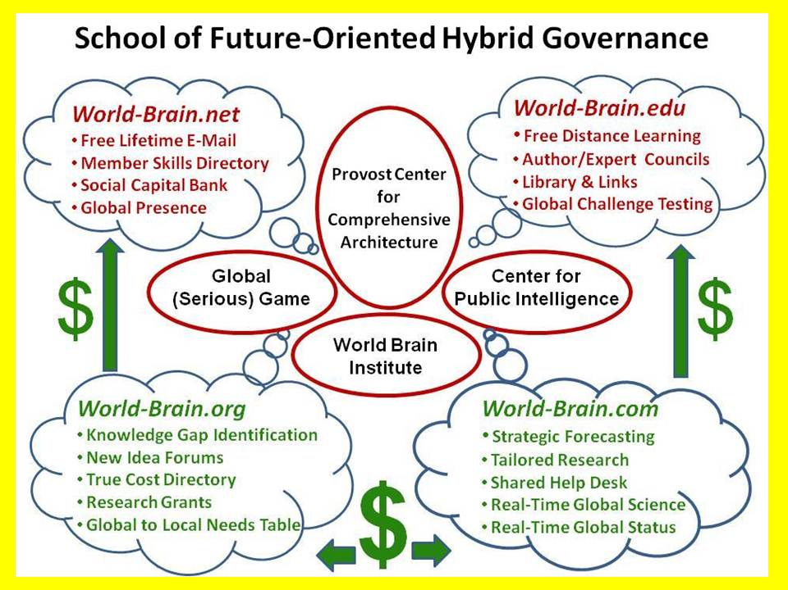
At the same time threats from radical Islam funded by Saudi Arabia, Qatar, and the United Arab Republic are subverting Western countries and creating an underground “fifth column” that is terribly dangerous. The Spanish evicted the Muslims and the Jews in 1492 for good reason – they would not assimilate, they refused to be loyal or respectful of local culture and values, and they sought to actively undermine the host country. If I have learned one thing these past twenty years, it is that counterintelligence --- ruthless, pervasive, secret counterintelligence effective in all languages necessary – is the foundation for an open society that is able to preserve its culture and values. Immigrants who assimilate and are not subversive are a huge positive diversity factor – those that do not should be rejected.
Q - I have read most of your books, but one in particular caught my attention is the one on The Smart Nation Act. Could we implement this legislation in Quebec and if so, how would it have been helpful?
I developed the concept of a Smart Nation for an article in Government Information Quarterly in 1996. It had two ingredients then, I have added two more since. The original two ingredients were an Open Source Agency that was able to collect, process, analyze, and publish intelligence – decision-support – on all threats and all policies, using only open legal ethical sources of information (in all languages, not something that Canada or the US can do today). The second ingredient of the original concept was that of the eight information “tribes” or networks. This is very important because government is the least informed and least effective of the eight information tribes. The eight are Academic, Civil Society including Labor and Religion, Commerce, Government, Law Enforcement, Media, Military, and Non-Government/Non-Profit. It is vital that all eight tribes be able to share information and share the burden of making sense about all topics, together, all the time. Today the tribes are separated by iron curtain, organizations within each tribe are separated by wooden walls, and individual within organizations are separated by plastic curtains.
Most recently I have added True Cost Economics and Open Source Everything to the original concept. I now realize that one reason that governments and corporations are able to loot the public treasury so easily is that the public is not aware of the “true cost” of any given policy, product, service, or behavior. The Canadian tar sands project, for example is corrupt idiocy. It used clean fresh water that is in very short supply to flush tar to create a massive mess, all to feed legacy refineries in Texas that want to export fuel to Europe – the US does not need the tar energy, everything being said about this project is an outright lie. Open Source Everything is even more interesting. What this means is that Open Data or Open Government are a fraud if pursued in isolation. To achieve an Open Society one must have all of the opens, a sampling of them illustrated below. In particular, for Open Data to have its good effect, it must be accompanied by Open Cloud, Open Hardware, Open Software, and Open Spectrum.
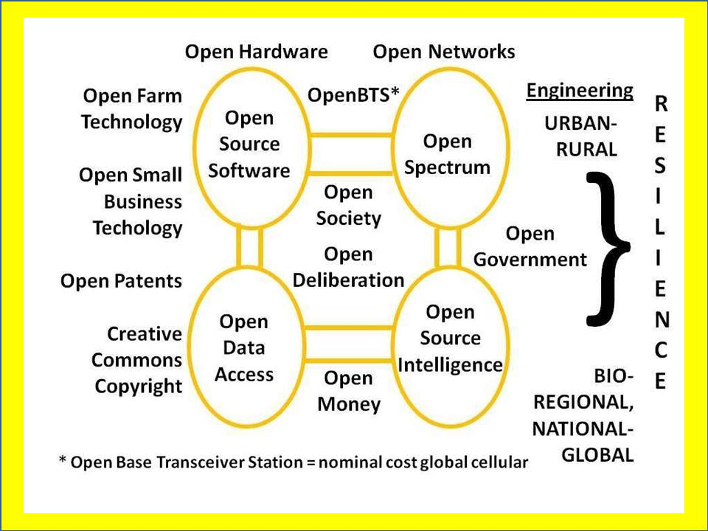

Montreal has always been a leader in the area of free wi-fi for the public, I would like very much to see Montreal be a model Smart City but not in the IBM sense of devices talking to one another, but in the sense of reengineering the city and then the province to become a shining example of what Buckminster Fuller called “ephemeralism” or doing more with less. Here is a diagram that could influence the economy of Quebec in a very deep manner.
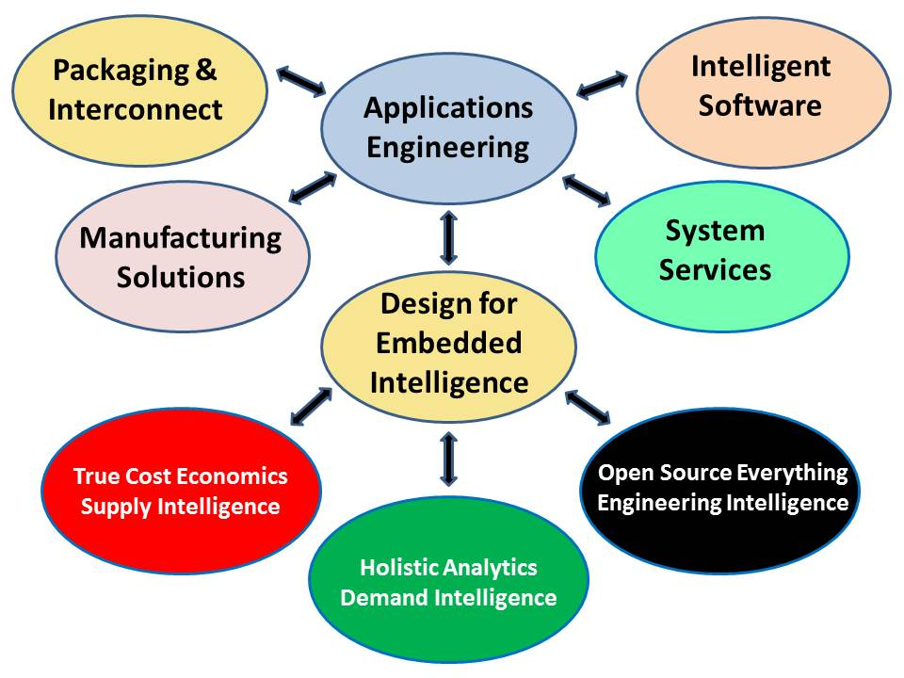
Q - You told me one day: "If I ever go into exile from my homeland, it's in Quebec that I would go, because you have water." Can you explain to our readers why you said that and how important is this issue?
I have always been sensitive to the importance of clean water fit for drinking. There was one time in my life when I went without drinking water for close to twelve hours and it was memorable. In 2006 when I created the Earth Intelligence Network, a 501c3 (non-profit), I led 23 others in creating a global analytic model that combined the ten high-level threats to humanity as identified by the United Nations in 2004, and twelve core policy domains that experience has shown must be managed together, both listed below for the convenience of your readers, along with the twelve major demographic and cultural powers that will in my view define the future, and could be an economic gold mine for Quebec.
10 High-Level Threats |  | 12 Core Governance Policies |  | 12 Powers of the Future
Poverty  Infectious Disease  Environmental Degradation  Inter-State Conflict  Civil War | Genocide  Other Atrocities  Proliferation  Terrorism  Transnational Crime | Agriculture  Diplomacy  Economy  Education  Energy  Family | Health  Immigration  Justice  Security  Society  Water | Brazil  China  Cuba  India  Indonesia  Iran | Malaysia  Nigeria  Russia  South Africa  Turkey  Venezuela

All of these must be managed together. In 2010 I was hired by UNESCO to review a number of books on water, and my published summary of several of these books is easily available online, Water: Soul of the Earth, Mirror of Our Collective Souls (Huffington Post). Quebec is blessed with an abundance of clean water as well as the energy that such water makes possible; I hope that blessing will never be taken for granted. Certainly Quebec should be worrying now about the irresponsibility of the Canadian and US governments with respect to clean water, as the day will come when Quebec is overrun with “water refugees” from those two countries, if solutions are not implemented today to ensure that ample desalinated clean water is available to meet the needs of the populations in those two countries. In the US West, entire towns are running out of water and dying.
Q - Your latest book The Open Source Everything Manifesto is a load at full speed against predatory capitalism, the devastation of the planet, the betrayal of politicians and financial elites, the culture of secrecy and corruption. You say that the only way to stop all this is to give the people the power through access to knowledge, to useful decision-making information, transparency in all areas of life social, economic and political. Can you explain that and also tell us if the model you're proposing would be easier to achieve in a small nation like ours, which is unique in North America?
Integrity is the one essential ingredient, and yes, I find that integrity is easier to find and maintain in a small nation that is very confident of its culture and values. The last book I wrote before this one was entitled INTELLIGENCE FOR EARTH: Clarity, Diversity, Integrity, & Sustainability (2010).
To implement my ideas requires only ONE great leader, ONE great institution be it a financial or academic or provincial government organization. Once started it will take on a life of its own. The world is engulfed in war and poverty today because the 1% profit from war and the concentration of wealth has made them addicted to war and instability. In fact peace is far more profitable, but the profit is distributed evenly across the entire population, it is not concentrated. What has happened is the public in the USA has abdicated its right to vote criminals out of power, at the same time that Wall Street has found it so very easy to bribe Presidents and Congress to do their bidding. No one holds these criminals accountable. The US Government has made it clear that it does not want my ideas, they are too threatening to the corruption that is so entrenched in Washington. Quebec would be an ideal implementation platform, with the added advantage of being quickly portable to Africa, China, and perhaps Viet-Nam.
Q - Professor of Economics and French law Étienne Chouard, see here: http://etienne.chouard.free.fr/Europe/ mentions that true democracy does not exist, that we live under an oligarchic regime and plea for a constitution calls for citizen whose members will be drawn, written by and for ordinary people according to their needs. What do you think of this idea and is the American constitution that allows so much inequality should not be rebuilt from the ground up?
Professor Chouard is in my view totally correct. I had to run for President in the United States, accepted as a candidate for the Reform Party nomination in 2012, in order to learn that we have eight accredited political parties in the USA, not two. We live in a two-party tyranny that blocks half the public from any voice or vote at all, and deceives the other half with theater. The other six parties are the Constitution, Green, Libertarian, Natural Law, Reform, and Socialist parties. I wrote about the lessons I learned here, How I Tested the Boundaries of the Two-Party Tyranny (Reality Sandwich). It is not the US Constitution that is flawed, what is flawed is the willingness of our government officers – including decorated military officers – to accept illegal orders and to be complicit in the telling of many lies, whether about the economy (the real unemployment rate in the USA is 22.4% not 7%) or war or health or whatever.
I like to say that there is nothing wrong with America the Beautiful that cannot be fixed, and fixed quickly, by restoring the integrity of the electoral process and hence the integrity of the government. It is the public that has gone wrong, allowing itself to be dumbed down and drugged up. I am quite certain that an alarmed educated public could quickly restore integrity. However, there is a huge difference between the many preconditions of revolution that exist in the USA, and a precipitant, such as the Tunisian fruit seller that started the Arab Spring. What is missing in the USA is that spark for revolution, some incident that is so compelling, so outrageous, that it wakes the public up and puts them into the streets demanding the wholesale resignation of our corrupt Congress and a clean new start.
Below, of possible interest to your readers, are the preconditions of revolution I conceptualized in 1976 for my first graduate thesis, with those existing in the USA today in red.
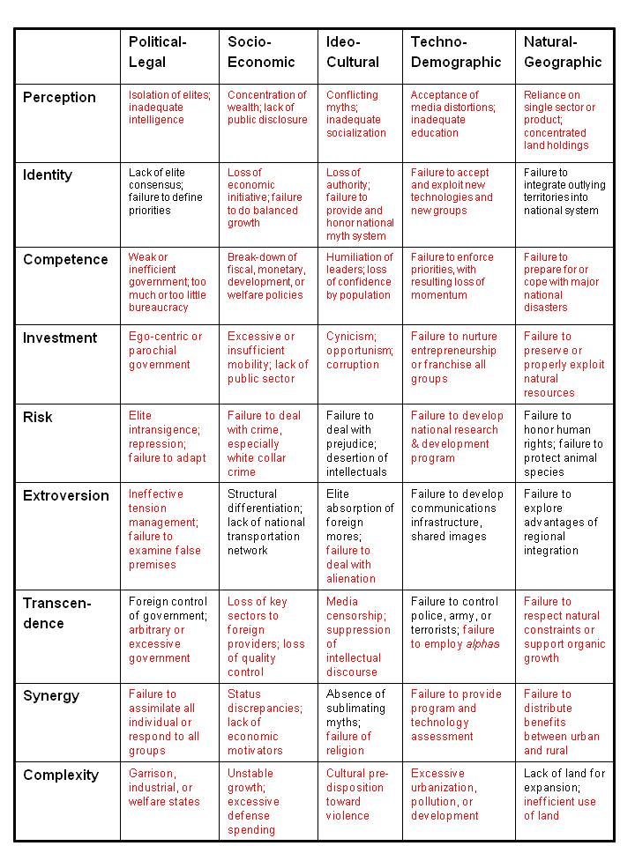
Q - Are you pessimistic or optimistic about the future of our planet and freedom?
I am very optimistic. There is some sort of cosmic convergence going on, I have noticed a major change in public consciousness in the past six months. It is noteworthy that the public stopped a US invasion of Syria despite many lies told by the government and repeated by the corporate media. It is noteworthy that the public appears to be aware of the many lies the US Government is telling about the Ukraine, where a corrupt fascist government has replaced a corrupt community government. Outside the US Government, I am seeing some breathtaking advances in collective intelligence, integral consciousness, and spiritual enlightenment. It is as if God is producing angels – turning more and more of us into angels of mercy – at a rate much faster than in the past. There are not enough guns on the planet to suppress the public, and the US Government is just now starting to figure that out, having recently abandoned its plans to seize 5,000 activists in a single overnight raid and to use the concentration camps that FEMA had Halliburton build. The Earth is alive. We the People are a part of that living ecology. Our governments are artifacts. There is absolutely no question in my mind but that a living public will outlast a dead government every time.
Learn more at Phi Beta Iota the Public Intelligence Blog (“the truth at any cost lowers all other costs”), where Robert Steele curates contributions from over 800 international thinkers, with about 20 of them active now.

