An American Grand Strategy – Evidence-Based, Affordable, Balanced, Flexible

Robert David Steele

Table of Contents
Preface 2
Introduction 4
Formula for Building the Force 6
What Is the Threat? 6
What Is Our Grand Strategy? 9
A Starting Point 10
Overview of the “Good Peace” Strategy 11
Strategic Transformation 13
White House and Congress 13
Intelligence & Covert Actions 15
Diplomacy & Development 17
Army, Air Force, Navy & Marines 19
Operational Transformation 24
White House and Congress 24
Intelligence & Covert Actions 25
Diplomacy & Development 28
Army, Air Force, Navy & Marines 28
Tactical Transformation 31
White House & Congress 31
Intelligence & Covert Actions 32
Diplomacy & Development 32
Army, Air Force, Navy & Marines 33
Technical Transformation 34
White House & Congress 34
Intelligence & Covert Actions 35
Diplomacy & Development 36
Army, Air Force, Navy & Marines 36
Conclusion 37
Epilogue 38
Glossary 42
Endnotes 44

Preface
This is the first of three monographs focused on the future of the US Army as an expeditionary force in a complex world that is rapidly decentralizing while also facing major development challenges. This first monograph seeks to answer five questions at a high level of generality:
01 Is there a Grand Strategy that would provide for both deterrence and defeat of Russia, Iran, North Korea, and China, without the enormous expense and political exposure of a US Army based overseas?
02 Is there a Grand Strategy that would put an end to the proposition that the US Army is the de facto first line of defense for our allies in Europe and Asia?
03 Is there a Grand Strategy that would balance a globally-dispersed Navy and light naval infantry (the Marine Corps) with a home-based heavy (armored) Army capable of both expeditionary and peer warfare, as well as a long-haul Air Force, and a mix of engagement means?
04 Is there a Grand Strategy that would allow the modernization of the Department of Defense (DoD); a reexamination and rebalancing of roles and missions among the five services (inclusive of the US Coast Guard that operates in a virtual state of perpetual war), such that the US Army can rapidly assemble high lethality/low density fighting forces for deployment via air and sea for integration with aerospace and naval precision strike capabilities while also performing most of its own Close Air Support (CAS)?
05 Finally, is there a Grand Strategy that can cultivate Congressional support for change by devising both an Army transformation program as well as a complete make-over of DoD that is home-based and job, as well as, revenue neutral from district to district and state to state?
The second monograph provides an Overview of Planning and Programming Factors for Expeditionary Operations in the Third World. Rooted in the original work of the Marine Corps Intelligence Activity (MCIA) in 1988-1990, the second monograph responds to US Army interest in being more expeditionary, and itemizes military, civil, and natural-geographic “strategic generalizations” essential to creating an Army that is effective and affordable across the full spectrum of conflict and particularly so in relation to non-permissive environments with sophisticated anti-air and anti-sea weaponry.
The third monograph, building on the combination of a Grand Strategy and Global Reality, first reviews the many thoughtful past recommendations for a future Army, and then develops the concepts and recommendations inherent in the first two monographs to propose an Army that is able to wage peace with a standing peacekeeping brigade that can serve as a hub for multinational, inter-agency stabilization and reconstruction campaigns, and also to wage war with a totally integrated joint reconnaissance and strike construct.
The “fleshing out” of the summary recommendations made in this document occurs in the third monograph – this monograph is by its nature a “broad brush” overview of the possibilities.

Introduction
The monograph series is inspired in part by Secretary of Defense Ash Carter’s focus on D3 Innovation – D3 stands for Defense, Diplomacy, and Development – and the recognition implied in the call for D3 Innovation that the U.S. Armed Force must both strike a better balance between reactive military engagement and what General Al Gray, then (1989) Commandant of the Marine Corps, called “peaceful preventive measures.” These measures promise to radically accelerate the American Military’s embrace of open source technologies that substantially reduce cost (by as much as 90%), time to build and field (by at least 50%), multinational interoperability, and dual use possibilities.
Grand strategy is the highest form of strategy because it integrates military power with national diplomacy, technology, economic development and culture to produce policies that operate for decades or, in the case of continental powers like Russia, China or German, for centuries. The importance of developing a strategic framework to guide the control and management of the United States’ resources including its armed forces with the goal of protecting and enhancing its vital interests cannot be overstated. The last complete Grand Strategy review was commissioned by President Dwight D. Eisenhower. The review was called, “Project Solarium.” Eisenhower was acutely sensitive to the simple truth that securing the nation’s interests against enemies, actual, potential or presumed involves far more than the application of military power. Consequently, Eisenhower’s Review examined fifteen distinct sets of questions, assumptions, and policy alternatives during the summer of 1953 with the goal of achieving in Eisenhower’s words, “both security and solvency.”
If we are to better understand the possibilities for a notional grand strategy that is evidence-based, affordable, balanced, and flexible, it is helpful to acknowledge the following points:
- that we do – or allow others to do – some things, from support to regimes repressing their own societies to covert and overt regime change operations to predatory economic and financial attacks on entire economies. U.S. foreign and defense policy has been too fixated on minimizing change and maintaining stability in a narrow-minded, short-term sense without realizing that the collapse of the Soviet State System in 1989 and U.S. Military interventions over the last 25 years set forces in motion that make a simplistic “return to status quo ante bellum” totally unworkable. The contemporary world is returning to its natural state with a resurgence of great, medium and small powers pursuing their specific interests.
- that the more Washington intervenes in the affairs of others with the goal of maintaining stability or suppressing change, the more military power we need to intervene yet again, ad infinitum. Meanwhile, declining American economic strength, changing domestic priorities and the American public’s growing disinterest in the United States’ muddled military commitments overseas combine to constrain Washington’s ability to perpetually intervene with its military and economic power
- that we do not conduct holistic analytics or true cost economics, and therefore may not have the best possible grasp of how we might better manage both national and global responses to all high-level threats to humanity, by intelligently harmonizing investments across all policy domains from Agriculture to Water;
- that we are not trained, equipped, and organized to conduct “Whole of Government” (WoG) strategy, policy, acquisition, and operations, and that we are inclined to substitute spending on military technologies in place of all other possibilities;
- that we tolerate “budget-share” rather than enshrine strategy as the driving force in Service design and Service operations, thus, failing to address the documented waste that runs from 45% in weapons acquisition to 75% in Afghanistan; and finally;
- that we have not been agile in the embrace of new, but mature, proven technologies – especially open source technologies – that promise a better return on investment (ROI) because they can significantly reduce cost, weight, be rapidly fielded and improve versatility, among other factors.
A formal Grand Strategy review is needed. Such a review would harness the distributed intelligence of our national networks. With these points in mind, this monograph is a “strawman” for reflection on what such a new Grand Strategy review might offer a new Administration. In this sense, the monograph is not prescription, but rather a provocation.

Formula for Building the Force
Senator Sam Nunn (D-GA), then Chairman of the Senate Armed Services Committee (SASC), whose quote guides this work:
I am constantly being asked for a bottom-line defense number. I don’t know of any logical way to arrive at such a figure without analyzing the threat; without determining what changes in our strategy should be made in light of the changes in the threat; and then determining what force structure and weapons program we need to carry out this revised strategy.
Senator John McCain (R-AZ) and Representative Max Thornberry (R-TX) together with their respective committees are focused on defense reform, with a particular eye on the “broken” acquisition system. At the same time, they are equally concerned with the U.S. Armed Forces inability to achieve global mobility and sustainable influence. Thus, the time is right for us to not only re-invent the U.S. Army, but also to begin re-inventing everything else.
These points notwithstanding, in the absence of a Grand Strategy that comports with global and fiscal reality it is not possible to re-invent the US Army nor is it possible to meet the inexhaustible demands for U.S. Army ground forces. The lesson of history is unambiguous: he who defends everywhere wins nowhere. The U.S. Army cannot and should not be expected to be everywhere and do everything. At this writing, the U.S. Army has 187,000 soldiers deployed in 40 countries. In view of the Army’s reduced size of roughly 475,000, this means that very few ready, deployable formations exist in a state of readiness to fight beyond America’s borders. In practice, this dissipation of Army manpower suggests there is no ground fighting force-in-being, a dangerous condition given the emergence of a threat environment that diverges sharply from the last 25 years. When combined with a very expensive and often very dysfunctional contractor force (from two to six times the number of uniformed soldiers, with many of the contractors being virtual slaves) this translates into a hollow Army that cannot fight without a massive private sector support infrastructure.

What Is the Threat?
The current Army perspective is that of Two, Two, Two, and One. This description is shorthand for two heavyweights (China and Russia), two middleweights (North Korea and Iran), two networks (al-Qaida and transnational organized crime) and one domain (cyber).
Perhaps because of World War II and the strong relationship between that war and how we shaped our instruments of national power in its aftermath, the American tendency has been to view the concept of national security in either strategic nuclear or purely conventional military terms. In contrast to many of our potential opponents and strategic partners, we tend to ignore the emphasis that Hans Morgenthau, among others, placed on the public – the population – its education, its fitness, its virtue – as the center of gravity for national security. We also fail to think in terms of training, equipping, and organizing inter-agency forces able to wage peace.
The ten high-level threats to humanity as identified by Dr. Brent Scowcroft, Lt. Gen. USAF (Ret), then serving as a member of the United Nations (UN) High Level Panel on Threats, and Challenges and Change (and the other members of the panel) are as follows, in priority order:
01 Poverty  02 Infectious Disease  03 Environmental Degradation  04 Inter-State Conflict  05 Civil War | 06 Genocide  07 Other Atrocities  08 Proliferation  09 Terrorism  10 Transnational Crime
Figure 1: Ten High-Level Threats (2004)
The first senior military leaders in postwar to grasp the reality that they could not limit their mission and roles to armed uniformed forces was that of the Republic of Singapore. Severe Acute Respiratory Syndrome (SARS) that originated in China between November 2002 and July 2003, was their wake-up call. They realized that their ability to detect and contain unarmed civilians infected with SARS was a national military mission.. This revelation altered the way they trained, equipped, and organized henceforth, devising a national military strategy of “total defense.”
In prior decades, the Strategic Studies Institute (SSI) sought to inspire reflection on asymmetric versus symmetric threats, and on whether the U.S. Army and the other services should continue to plan and program with the underpinning assumption of two Major Theater Wars (MTW). SSI also set out to inspire reflection on the need to rebalance the instruments of national power.
In 1989, General Al Gray, Commandant of the Marine Corps, reached similar conclusions and sounded an alarm. He pointed to the difference between conventional threats and emerging threats; to the importance of the counter-narcotics mission as a “type” of threat, and to the need for Whole of Government planning and programming with sufficient funds to execute “peaceful preventive measures. Below is the core element of his first high-level call for restructuring the force.
Conventional Threat  - Governmental  - Conventional/Nuclear  - Static Orders of Battle  - Linear Development  - Rules of Engagement (ROE)  - Known Doctrine  - Strategic Warning  - Known Intelligence Assets | Emerging Threat  - Non-Governmental  - Non-Conventional  - Dynamic or Random  - Non-linear  - No constraints (ROE)  - Unknown doctrine  - No Established I&W  - Unlimited 5th column

Figure 2: Conventional vs. Emerging Threats (1989)
In 1992 additional work was done at the Marine Corps University, as depicted below, but it was not introduced to the Army’s annual strategic conference until 1998:
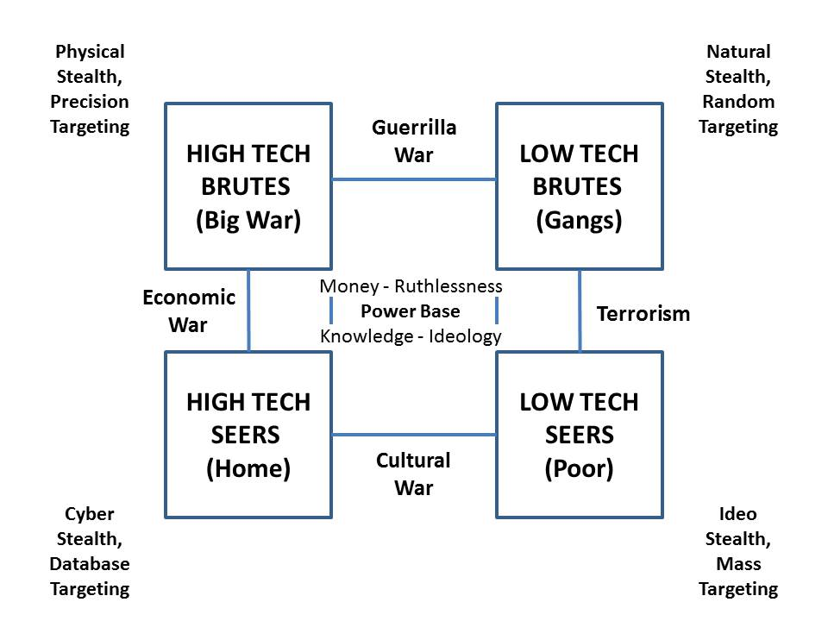
Figure 3: Four Threat Classes (1992)
Originally created as part of teaching nuanced intelligence sources and methods at the Marine Corps Command & Staff College, the intent of this graphic was to show that indications & warnings are profoundly different depending on which of the four threats (or any mix of threats in hybrid form) was/were being considered. The implication is obvious: do we need four forces after next?
Put another way, there are four main antagonists in the world today: nation-states, banks & corporations, gangs, and publics defined by neighborhood, ethnicity, ideology or religion. The “deep state” is a hybrid gang, a parasite living within the nation-state host.
This, then, is the context for further reflections on both grand strategy as a device for marshalling ends, ways, and means intended to address all threats to the homeland and its global interests, and for devising how we plan and program not just military, but WoG force structure and capabilities.

What Is Our Grand Strategy?
For most of their history, the English-speaking peoples on the North American continent did not need a Grand Strategy. Americans lived remote from the wars and intrigues of Europe and Asia. As De Tocqueville noted, American social, political and economic development was a “bottom up” phenomenon. Washington played a minor role inside American society and almost none abroad. Beyond America’s borders, Mexico was a periodic irritant, but the weakness of Mexican society meant that it could not present an existential threat to the United States. This condition is changing. Not only do Mexico and the rest of Latin America have the highest rate of criminal violence in the world, Latin America also has the highest level of impunity for homicide. The “Rule of Law” is weak to nonexistent.
These points notwithstanding, certainly in the aftermath of World War I, the USA always has had at least the outlines of grand strategy. In this connection, Richard D. Hooker of the National Defense University (NDU) posited a national strategic framework with at least four enduring or core interests:
1. Defense of American territory and that of our allies
2. Protecting American citizens at home and abroad
3. Supporting and defending our constitutional values and forms of government
4. Promoting and securing the US economy and standard of living.
Hooker’s aforementioned core interests are not necessarily consistent with the reality of American foreign and defense policy, but Hooker does provide a useful distinction between the ends, means and ways of grand strategy. Keep in mind that our goal is to explore what a genuine evidence-based grand strategy might yield in the way of a re-invented Army and, eventually, the reinvention of everything else.
Hooker’s key points are below:
Means of Grand Strategy  Strong alliances  Bilateral security agreements  Survivable nuclear deterrent  Balanced powerful military  Intelligence services  Powerful economy  Industrial base  Military reserve  Educated skilled population  Democratic political system | Ways of Grand Strategy  Meet threat far from homeland  Forward presence  Economic assistance  Military assistance  Treaties  Coalitions of the willing  Use all instruments of power
Figure 4: Means and Ways of Grand Strategy
For the purposes of our exploration, Hooker points out that a successful grand strategy will often help avoid the need to resort to the use of force. Stated differently, “Military force is credible only to the extent that the will that uses it is credible. Since self-doubt is always obvious to an enemy, it can negate the effect of superiority.” Obversely, a military that is used with abandon to do regime change and other operations having more to do with manipulating private sector markets (e.g. for oil) and little to do with vital national interests worthy of our national blood, treasure, and spirit, is unlikely to effective or sustainable.
This insight makes the case for significant investments in strategic nuclear weapons, whether sea-based missiles or manned bombers.
These points help to explain why credible military power is inextricably intertwined with robust diplomacy. Thus, in theory, , for strategic action to be truly effective and influential, the White House and Congress must at least agree on the interests that underpin Grand Strategy before beginning the Planning, Programming Budgeting System & Execution (PPBSE) cycle that trains, equips, and organizes the D3 “total” force. However, difficult it may be to articulate them, national interests are the wellspring of valid national objectives that define what our nation is trying to do. Agreement on these interests is difficult to reach in all open societies, but agreement on what they are constitutes the foundation for an American Grand Strategy.
Having long since reached the end of the “peace dividend” years, it seems timely to define a new national strategy that is not driven by financial stakeholders (the “Military Industrial Congressional Complex” or MICC), ideology (the neoconservatives), or political convenience, but instead is focused on creating a “Good Peace” in the public interest, firmly rooted in evidence-based decision-support. Given the financial constraints in the wake of 2008’s financial crisis, in practice, such a Grand Strategy should also be both affordable and, therefore, sustainable over time.

A Starting Point
Below is a starting point that is intended to be as holistic as possible, while also provocative, with the intent of eliciting intellectual and moral aid from the rich diversity of minds that belong to the SSI network and the larger US Army and joint military and civilian communities. The strategy that follows is focused on achieving peace and prosperity at home and abroad. It is designed to be notional “big picture” first pass for the purpose of provoking discussion.
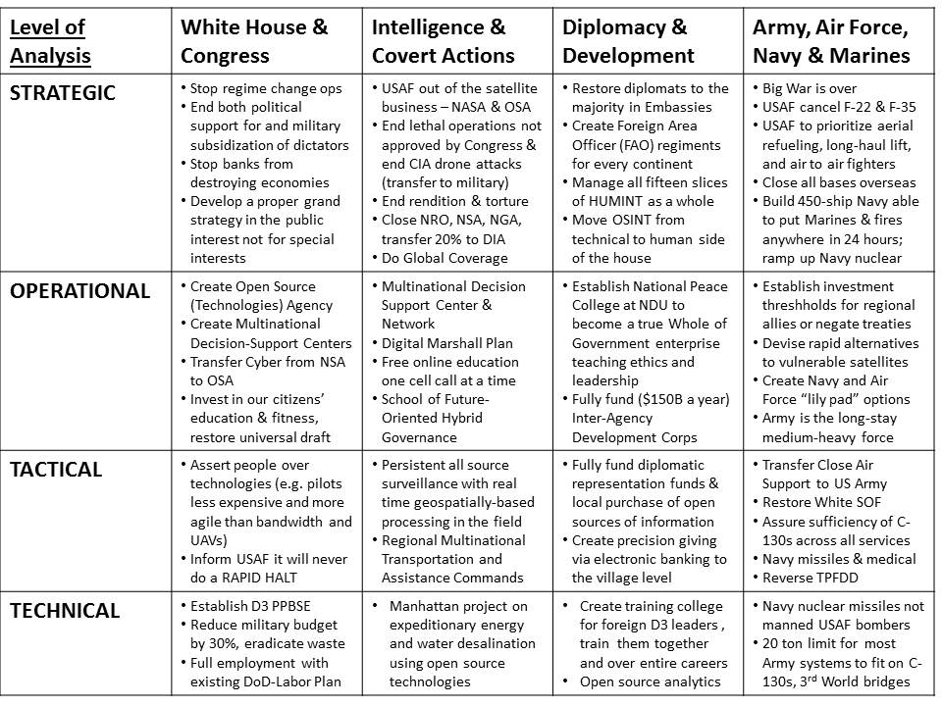
Figure 5: Operationalizing the “Good Peace” Strategy

Overview of the “Good Peace” Strategy
This exploratory work uses the traditional four levels of analysis popularized by Edward N. Luttwak, to facilitate a “quick look” at four major stove-pipes impacting on the formulation of national security capabilities: the White House and Congress, Intelligence & Covert Operations, Diplomacy & Development, and the Armed Forces.
Properly executed, a national Grand Strategy review would pay equal attention to the threats, policies, true costs, and public interest across all of the Cabinet domains – this monograph focuses only on the D3/intelligence aspects of what should constitute integrated national strategy that is balanced between domestic and foreign requirements and capabilities – between meeting the needs of the public at home (education, energy, health, housing, infrastructure and so on) and the needs of the nation abroad (commerce, culture, defense, development, diplomacy and more).
Transformation is not modernization. Right now a number of deeply expensive and inappropriate programs are on “automatic pilot.” Among these are Air Force strategic bombers and the J-35 “multi-role” fighter, Navy big ships, and all Army vehicles that weigh more than 20 tons fully-loaded with crew, ammunition, water, fuel, and add-ons. In restructuring our forces, we need better, not bigger, and certainly not more of the same.
Transformation is also not exclusively technical or human or financial or conceptual. It is a total package that must, as Luttwak argues , integrate radical changes at all four levels of analysis, across all service and civilian boundaries, and perhaps most importantly – my addition – in the arena of moral and intellectual understanding of both changes in the domestic and foreign environments, changes in the nature of all instruments of national power including the public and the private sector, and changes in the art of the possible. In brief, transformation is more about thinking than it is about technology.
Below is a concept for a more intellectually agile government able to think in time and space across all boundaries, with one major caveat: it is not possible to have an affordable sustainable military “grand strategy” in isolation from an integrated national “grand strategy” that calibrates all threats, all policies, all costs, across all of the Cabinet departments. It simply cannot be done. Anything less than a comprehensive “all in” approach is by definition not a “grand” strategy.
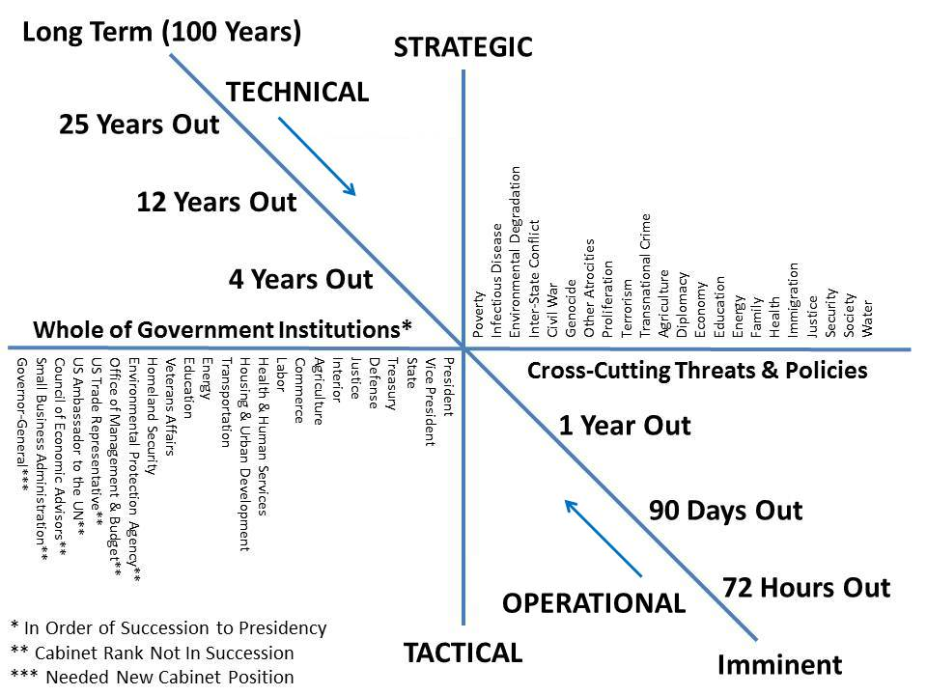
Figure 6: Holistic Governance at All Four Levels over Time and Space

Strategic Transformation

White House and Congress
At the strategic level, one First Principle should clearly be “do no harm.” At the political level and senior civil service and uniformed levels our leaders do not share a holistic, affordable (sustainable) vision. Senior leaders in and out of uniform are not under pressure to develop any form of true cost accounting in the public interest. According to General Wesley Clark, USA (Ret.), former Supreme Allied Commander Europe (SACEUR), a foreign policy coup is said to have occurred.Regardless of whether the administration is Republican or Democrat, , “regime change” is the order of the day, and our foreign military assistance programs continue at full strength. While there is something to be said for authoritarian governments that support our national security interests, if they are producing vast numbers of unemployed and angry young men, a few million of whom migrate to the USA and Europe as illegal immigrants, then we may wish to consider our embrace of dictators..”
I predicted the massive illegal immigration problem Europe is experiencing today, in 2002. As long as we subsidize dictators and engage in elective ways while sanctioning predatory economic networks, we will be creating millions of potential insurgents we cannot defeat with conventional military capabilities. At the same time, we should have little sympathy for European countries that refuse to protect their own borders.
In addition to exporting democracy (imposing our will) at gunpoint, Washington removed many controls on the US banking industry, elements of which then willfully collapsed the economics of Greece, Ireland, Portugal, and Spain, while imposing severe economic hardships on everyone else. It must be clearly stated: the City of London and Wall Street manipulated interest rates (the London Interbank Offered Rate or LIBOR scandal) with impunity. In the USA, Wall Street has paid fines in the low billions for multi-trillion dollar crimes, while receiving taxpayer bailouts on the political notion that banks are “too big to fail.”
Two points merit emphasis in this strategic context, but before presenting them, let me first offer this wisdom from a global corporate leader:
When things are not going well, until you get the truth out on the table, no matter how ugly, you are not in a position to deal with it.
Point One: the fact is that the rest of the world – as well as US citizens – have legitimate grievances associated with USG policies and practices that favor dictators, banks, and corporations over public health and human rights as well as the spread of democracy and distributed prosperity for all.
Point Two: we seem to have difficulty speaking truth not just to power, but to the American public. From unemployment to inflation to our subversion of the Ukraine and Syria to the real reason for the Keystone Pipeline to the secret clauses of the Transpacific Trade Partnership (TPP), the truth is difficult to come by for a citizen. Neither academics nor the media nor think tanks appear disposed to stray from the approved narratives, at the same time that no one is held accountable, at the political or professional level, for deep misinformation. To get to an affordable, balanced, flexible grand strategy, we need to start with the truth about both the outside world, and the home front.
As now trained, organized, and equipped, the US national secret intelligence community is not helpful – the bulk of its money is spent on contractors creating and managing technical collection systems where less than 1% of what is collected is actually processed, at the same time that the community severely underfunds human and open sources of information, analysis, and multinational information-sharing and sense-making.
The absence of an existential military threat to the United States means that nothing like NSC 68 exists to guide defense spending.
NSC 68 framed the Truman Doctrine, a policy inspired by George Kennan’s strategic concept of containment. The Truman Doctrine pledged the U.S. would not only contain communism, but also act to drive back Communist influence wherever it appeared and "foster the seeds of destruction within the Soviet Union.” As a result, NSC 68 provided the strategic rationale for significant military spending; spending designed to give the U.S. "superior overall power… in dependable combination with other like-minded nations." It also described an American military capable of the following tasks:
- Defending the Western Hemisphere and essential allied areas in order that their war-making capabilities can be developed;
- Providing and protecting a mobilization base while the offensive forces required for victory were being built up;
- Conducting offensive operations to destroy vital elements of the Soviet war-making capacity, and to keep the enemy off balance until the full offensive strength of the United States and its allies could be brought to bear;
- Defending and maintaining the lines of communication and base areas necessary to the execution of the above tasks; and
- Providing such aid to allies as is essential to the execution of their role in the above tasks.
These commitments were made when the United States’ gross national product represented half the world’s economic output. Today, that condition no longer holds.
Today, only tasks 1 “Defend the Western Hemisphere” and 5 “Provide aid to allies” are certainly valid if “maintaining lines of communications” is included under 5. The rest are currently superfluous and defense spending designed to keep the nation in a state of perpetual conflict is unaffordable.
In the absence of a true existential threat, and in the context of a poorly-educated public, an entertainment-oriented mass media, and a political leadership more concerned with keeping power than making evidence-based decisions, a Grand Strategy is not likely to be forthcoming, nor will our national military strategy ever amount to anything more than “dishonest platitudes.” We need either a very small group of very bright thinkers empowered by – to take one example, the Chairman of the Senate Armed Services Committee – and/or a national conversation led by a charismatic leader who is authentic in opposing special interests and defining the public interest.

Intelligence & Covert Actions
Intelligence includes all of the satellites, not only those that are used to collect technical information (imagery, signals), but those that provide sensitive communications and geospatial positioning information upon which we have become very dependent. All of those satellites are at risk today from a combination of anti-satellite weaponry, and the relative ease of wrecking ground antennas and external power supplies while also attacking the software with a variety of techniques and tools including hacking and electromagnetic pulse bombs. The USAF is responsible for many of these satellites and has never placed enough emphasis on survivability and security. It may be time to re-evaluate where responsibility is placed for satellite operations – a combination of the National Aeronautics & Space Agency (NASA) and a new Open Source (Technologies) Agency (OSA) may offer rapid remediation not available from the USAF or the National Security Agency (NSA).
The lethal targeting of terrorists by the Central Intelligence Agency (CIA) is done without legal due process, and results in a collateral damage ratio of 24 to 1 – for every alleged (rarely proven) terrorist CIA kills, CIA also kills 24 women, children and non-belligerent men. At a minimum this overt warfare capability should be transferred to the military. Kidnapping, rendition, and torture by the CIA and its contractors as well as select allies has aroused world-wide condemnation and been denounced in the USA by intelligence and counterintelligence professionals including Admiral Stansfield Turner, former Director of Central Intelligence (DCI).
Apart from regime change, drone operations and rendition and torture operations (the latter perhaps much reduced now), CIA is said by China, Russia, and alternative media to be sponsoring hundreds of Uighur and Chechen terrorists to send back from Syria to operate against and strive to destabilize China and Russia – an act of war not approved by Congress. Apart from “stop the bad stuff” there is the matter of whether the US intelligence community is providing actionable full-spectrum decision-support to all of our political and professional leaders. Probably not. Should another First Principle be “Get a grip on reality!”? This topic has been written about for a quarter-century. Suffice it to say that General Tony Zinni, USMC, then Commanding General (CG) of the US Central Command (USCENTCOM) and engaged in 2 wars and 12 forward-deployed task forces, is on record as saying that while he was CG of USCENTCOM, he received, “at best,” 4% of what he needed to know from secret sources and methods.
In my view, the critical missing link in reaching informed consensus between our political and professional leaders in relation to creating a grand strategy that promotes peace and prosperity over time, is intelligence with integrity. We do not have it. We must demand it. Harking back to one of the best ideas the National Ground Intelligence Center (NGIC) ever had, GRANDVIEW, Military intelligence cannot be produced in a vacuum and cannot be restricted to military factors. As with most veterans of the CIA, we must conclude that if DoD wants to achieve intelligence with integrity for the development of strategy, policy, acquisition, and operations, it needs to forget about relying on CIA for anything and clean house within defense intelligence.
DIA should become a four-star billet, and assume responsibility for expanded commercial imagery procurement, sharply delimited foreign signals intelligence, and a completely new open source geospatial baseline married to a massive multi-level security relational database. Once DIA is ready to absorb the 20% that is worth saving from the National Reconnaissance Office (NRO), the NSA, and the National Geospatial Agency (NGA), all three can be closed down. This one new four-star billet is proposed in the context of a larger strategy that seeks to eliminate half to two-thirds of all flag and senior executive billets across DoD and the IC.
The OSA as proposed and discussed in this monograph, will address 80% or more of our intelligence needs in the near-term, and help achieve a transformation of defense, diplomacy, and development (D3) intelligence and D3 innovation, while offering dual-use possibilities on the home front for neighborhood and domestic economic development.

Diplomacy & Development
The commitment of the Secretary of Defense (SecDef ) to the D3 concept is clearly documented in his recent (September 2015) sponsorship of the D3 Innovation Challenge. How seriously these exhortations to innovate will be taken is as yet unclear.
However, we know that our Country Teams overseas are dysfunctional. Diplomats are in the minority, have no money for representational activities or the purchase of legal ethical open source information services, and are surrounded by a mélange of singleton representatives from all the other government agencies that do not have faith in the ability of the Department of State (DOS) to be our lead agency overseas. The only US Government (USG) personnel operating overseas who have money to spend – and they spend a great deal – are the spies who only recruit those prepared to betray their employers along very narrow lines. One study has shown that the average Country Team as a whole connects to perhaps 20% of the relevant information available to them, and in the process of sending it back to Washington, usually in the diplomatic pouch so as to avoid the coordination required for electronic communications, spills 80% of that information. Washington is operating on 2% of the relevant information. The dysfunctionality of American intelligence persists in part because it is not considered relevant to the exercise of power as we now practice the exercise of power in Washington, DC. This from Henry Kissinger:
Intelligence is not all that important in the exercise of power,
and is often, in point of fact, useless.
As long as the exercise of political and professional power is divorced from reality, not informed by intelligence (decision-support), and lacking in integrity, we will continue to build the wrong things at great expense. We will also continue to add to the millions of refugees and disabled or wounded veterans – Iraq and Afghanistan have produced – together with the toll of dead and wounded – several thousand amputees, hundreds of thousands of disabled veterans, and contribute to a veteran suicide rate that is at least 50% higher than that of those who have not served. At the strategic level, if we are to be effective at D3 operations, we need to reinforce our diplomats with funds and WoG expertise that reaches out into the provinces of each country where they represent our interests; we need to create Foreign Area Officer (FAO) regiments for each country so as to achieve a deep bench in at least 34 languages; and we need to manage all fifteen slices of Human Intelligence (HUMINT), shown below, as a whole. The human domain matters!
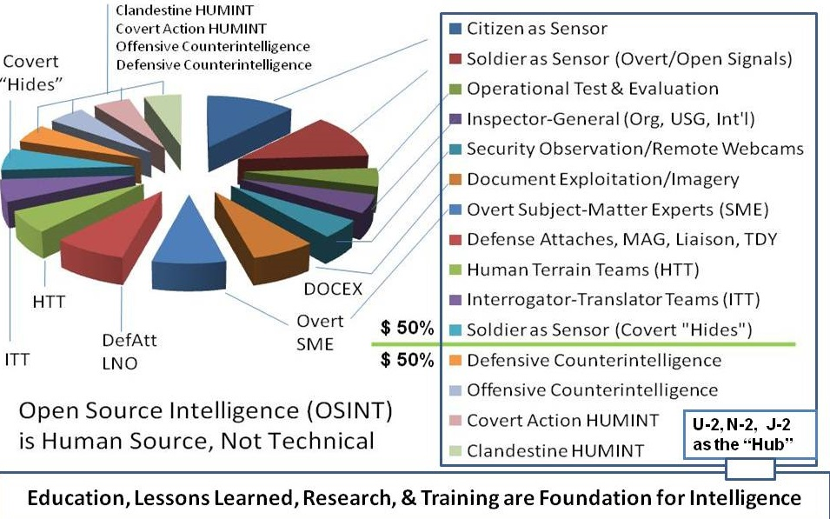
Figure 7: The Unappreciated Human Intelligence Domain
OSINT is not a “technical” discipline. OSINT is HUMINT. Both the Undersecretary of Defense for Intelligence (USDI) and the Director of National Intelligence (DNI) – who was himself USDI – have mis-directed OSINT. This is such an important issue, below BGen Jim Cox, CA, who as Deputy J-2 for the North Atlantic Treaty Organization (NATO), who commissioned the NATO Open Source Intelligence Handbook in 2000 offers this new insight about our mis-steps:
The process, to my mind, simply stopped at “OSINFO” and never got to “OSINT.”
Even today, I think this is still a problem in most ‘modern’ intelligence staffs. People think that simply collecting open source info – although now from a wider range of sources – is OSINT, when I say it is not. It’s like collecting satellite pictures and calling them IMINT … the job isn’t done until they are analyzed and an assessment made.
If I was king of the world, I would build an OSINT organization to rival existing national SIGINT organizations (CSEC in Canada, NSA in US) and HUMINT organizations (CSIS in Canada, CIA in US). This OSINT organization would be in a number of big buildings around the country, tapped into all the sources you have long written about (media, experts, academia … all tribes) AND they would produce magnificent ‘single source’ OSINT products that could be added to SIGINT, HUMINT, IMINT etc. products at the national level.
Given the power and range of today’s global communications, I suspect OSINT products would be more complete and powerful than any other single source product.

Army, Air Force, Navy & Marines
We now turn to the strategic role of the Armed Forces. At the strategic level there are several possibilities for consideration. Below are listed just a few of them along with supporting references.
1. Big War is over. We are not going to engage China or Russia in a land war on their home ground, nor are we likely to engage them in Europe or the Southeast Asia peninsula. We need to deliberately and advisedly set aside the two MTW budget-building objective. We do need heavy armored forces for non-permissive environments.
2. In a defensive strategic confrontation, it will be strategic nuclear forces – ideally missiles not bombers – that will be the deterrent. The Navy with mobile strategic submarines, not the USAF with fixed bases, should be the primary nuclear deterrent force as well as – when necessary – the first strike capability.
3. Closing all of our bases overseas is the single best thing we could do to diffuse global tension while simultaneously pressuring our so-called allies into providing adequate investment and capabilities thresholds for their own defense. Our Army should be the strategic reserve for our allies; it should not be expected to carry the entire war on its own. Defense must be our focus. Mandating a home-based defense is a leadership forcing function. As long as our Army is based in Germany, Japan, and South Korea, it will be their Army, not ours.
4. What we need now that we do not have is an Army designed for both rapid force closure via air and sea as well as a central role as a hub for full-spectrum and WoG multinational state and non-state operations; an Air Force sufficient to do long-haul quick force closure as well as, aerial superiority in expeditionary operations; a 450-ship Navy that is globally distributed and able to put a platoon of Marines with Cobras overhead anywhere in the world within 24 hours; and the critical complementary capabilities of a fully-funded diplomatic and development corps along with a multinational decision-support capability.
Below is a dated summary (but still the best visual depiction available) of how the Air Force allocates its budget core mission capabilities, all of which are nearing end-of-life: Intercontinental Ballistic Missiles (ICBMs), air-air fighters, long-haul lift and aerial tankers.
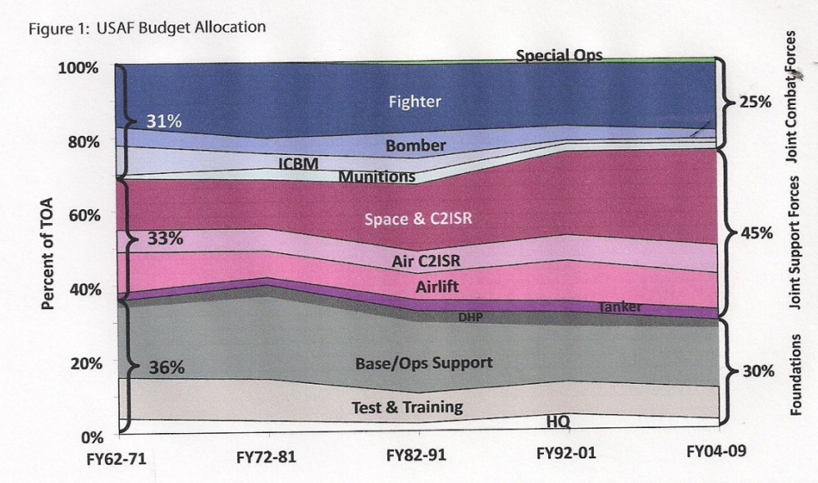
Figure 8: USAF Spending Overview -- Out of Balance
We need not get into the failure of the Air Force in the Space and C2ISR arena in this summary document, but this is a major problem for the Army and on balance there appears to be a case toward taking satellites away from the Air Force, refocusing them on a secondary nuclear role rooted in Intercontinental Ballistic Missiles (ICBM), long-haul transport, and air superiority at the theater level but without all of the gold-plated base construction.
Although further reflection is needed in relation to the needs of the Army for rapid force closure, three points have become clear from the preliminary look at the Air Force:
01 The Air Force has plenty of tankers for long-haul support because of their original reliance on fighter escorts for long-range bombers, both of which required constant refueling – whatever the age issues, there is no lack of tankers for long-haul lift refueling enroute.
02 The real constraint on moving the Army is not Air Force cargo capacity, but rather the weight and size of existing Army systems, combined with the Maximum on Ground (MOG) limitations at the Aerial Point of Delivery (APOD). The Expeditionary Environment is characterized by MOGs of 1 and 2 instead of the preferred MOG used in thinking about the Interim Brigade Combat Team (IBCT) of 6-8.
03 The Air Force has an adequate number of fighters for establishing air superiority, but it does not have a sufficiency of A-10 Close Air Support (CAS) aircraft, and has been doing everything possible to bury the A-10. AC-130 gunships numbers appear low – they are particularly essential when the Army is forced to make do without its complete artillery capabilities.
Below is a table of the Air Force inventory of key aircraft as of 2000, since then such tables are not available – for simplification the command and control and other miscellaneous aircraft have been left off this table. It merits emphasis that neither Congress nor the Air Force acknowledge in their budget documents that the effective operational availability of the claimed inventory is actually 60% of the force at 60% availability. This table shows that reality.
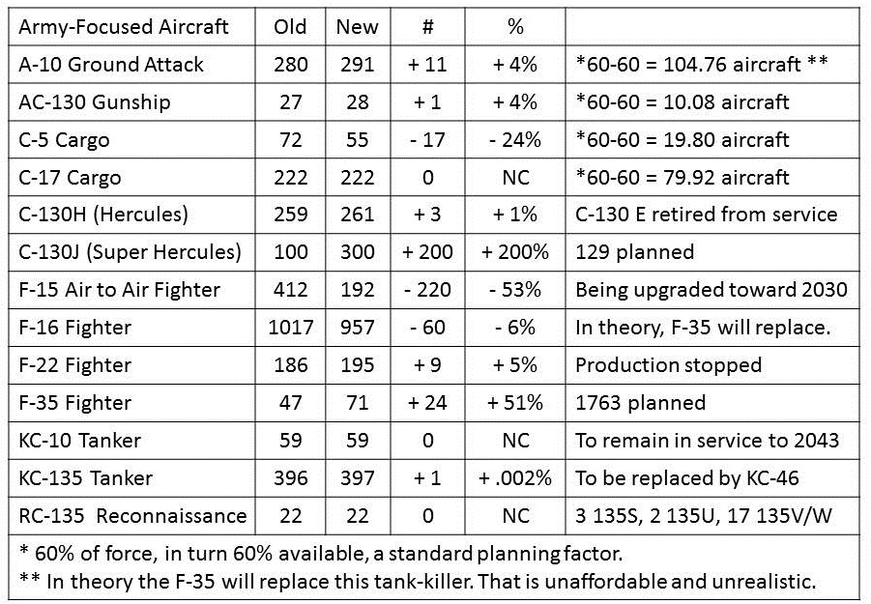
Figure 9: USAF Attack, Cargo, Fighter, &Tanker Inventory
The above has two implications that are touched on in the Tactical Transformation overview sections:
First, from an infantry perspective, the A-10 is sacrosanct, at least for permissive environments. Not only does the Air Force have to be told the A-10 is inviolate, but an attack follow-on is required – the F-35 will not do. If the Air Force is not prepared to meet this demand, the time has come to revisit the Key West Agreement and transfer CAS – both the A-10 and the AC-130 gunships – to the Army. The minimalist investment in the AC-130 Gunship, only 10 of which are 100% available at any given time, is also a major concern. As of 2016 the USAF plans to divest the A-10 entirely between FY 2018 and FY 2022 – now is the time for the US Army to work with Congress to have this precious aircraft – and all of its pilots and ground crew and other support personnel – transferred from the Air Force to the Army. The time has also come for the Army – and the Marine Corps – to get serious about designing aircraft for expeditionary operations in hot and humid climates where dust and often rock grit is ever present. There needs to be a deep study of CAS options in non-permissive environments where non-state actors armed with Russian anti-air systems can shred any aircraft flying below 15,000 feet. For non-permissive environments a mix of stealth drones impervious to electromagnetic barriers, and tracked artillery combined with current geospatial information (NGA is ten years out of date on cultural features for just about everywhere) should be considered.
Second, the Army has to come to grips with MOG 1-2 conditions. This is a size and weight issue. The US Army got it right on the concept for the Stryker Brigade – a 20 ton weight-limit – and totally wrong on the implementation – not only is the vehicle oversized so as to require a waiver from the Air Force, but it has to be broken down and transported on two C-130s instead of one. The requirement should have been “consistent with USAF loading guidelines, the Stryker with all ammunition, fuel, water, and crew as well as passengers, will be transportable via a C-130 taking off under hot humid conditions, and able to drive on / drive off in full combat readiness.” There is work to be done, but Army started out with the right concept. Today we have to recognize the proliferation of non-permissive environments – it may be that a 32 ton tracked vehicle in the minimal necessary platform, and more C-141s are needed. The time-distance-weight challenge needs serious study.
As of FY 17 the Air Force plans to begin drawing down its inventory of C-130 aircraft. These also should be considered for transfer to the US Army, and funding requested to make all US Army C-130 variants capable of being refueled while in flight.
If the Air Force is the primary force at the strategic level (complementing naval nuclear missiles), and the Army is the primary force at the tactical level, the Navy & Marines are the operational force that bridges the gap. Below is one possible approach to creating the 450-ship Navy. This proposed fleet was developed in 1992 on the basis of the first-ever review of global reality – this is a number the Chief of Naval Operations (CNO) finally embraces.
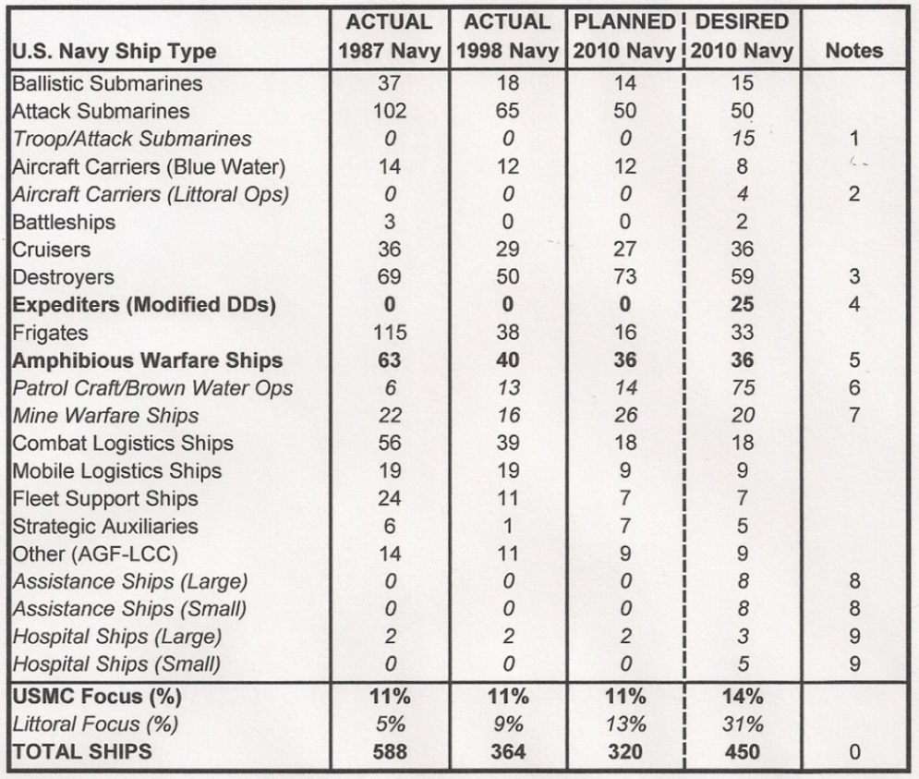
Figure 10: A 450-Ship Navy, Globally Distributed, with a Peace Fleet
The above Navy provides the ability to put a platoon of Marines with Cobras overhead anywhere in 24 hours; a company with Harriers overhead anywhere in 48 hours, and a Battalion Landing Team (BLT) anywhere in 72 hours – at the same time that it maintains substantially increased and broadly distributed humanitarian assistance capabilities. The graphic below shows one notional deployment vision.
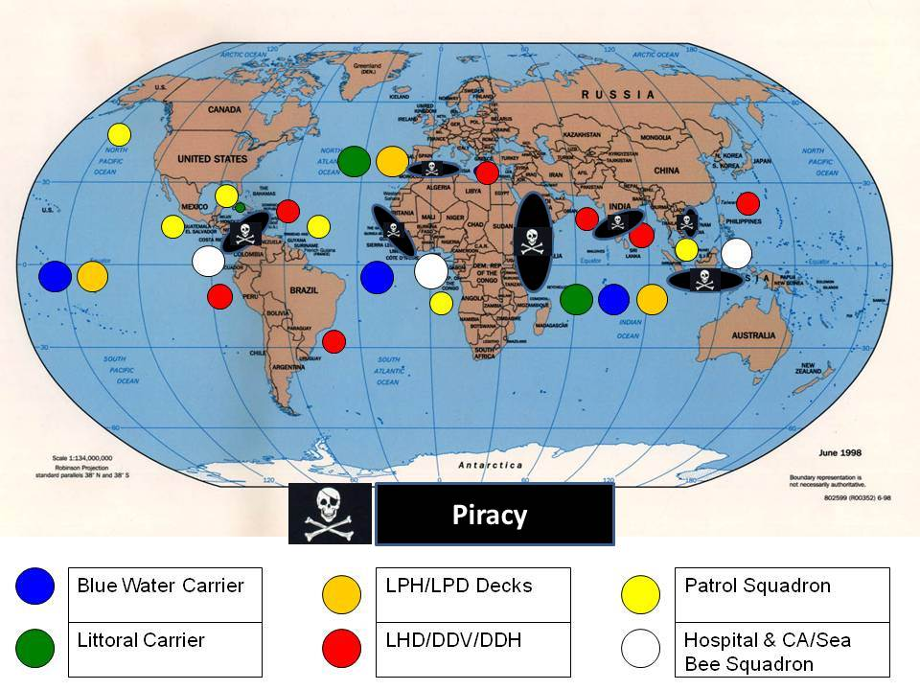
Figure 11: Notional Distribution of a 450-Ship Navy with Sustained Global Presence

Operational Transformation

White House and Congress
At the operational level there are two things the White House and Congress can do to radically accelerate the transformation of our government, our D3 capabilities, and our home front.
First, create the OSA that simultaneously solves the WoG and multinational information-sharing and sense-making challenge, and serves as a foundation for D3 Innovation, and offers localities across the USA opportunities to develop localized energy, water, food, and shelter solutions, as well as digital access solutions, helpful to the re-creation of the middle class. Below is a representation of some – not all – of the open source technologies relevant to the D3 innovation imperative.
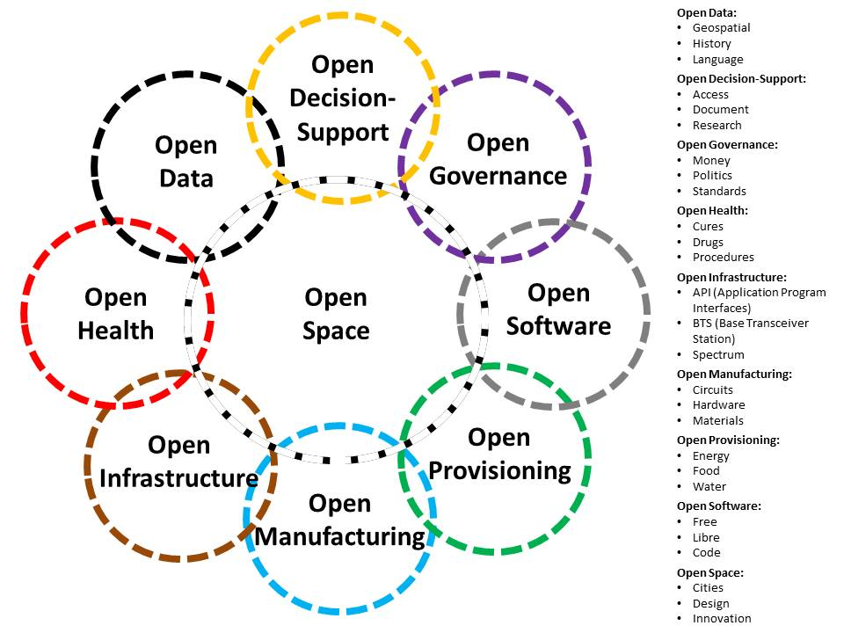
Figure 12: Open Source (Technologies) Agency for D3 Innovation
Second, launch a national transformation initiative in citizen education and citizen fitness. An honest evaluation of our education and food systems would rapidly conclude that our existing educational system does not meet our needs for citizen-soldiers in the 21st Century, and that 7 out of 10 of our young people are not qualified for military service because of the prevalence of obesity and diseases stemming from decades of unhealthy foods being approved by the government for liberal sale as well as serving in schools. Universal Service is in my view essential and not only at the beginning of one’s adult employment career, but at mid-career also, and for a smaller group, at the senior executive level as well. The country – the public – has lost touch with the US military and vice versa. We need to get back to the military as a shared experience that underlies our belief in the equality of all without regard to race or creed or financial status.

Intelligence & Covert Actions
A radical shift – which is to say a transformation – is needed in how we approach intelligence. We need to shift from an obsession with technical collection of digital secrets and bi-lateral information-sharing as well as dependence on individual foreign services for HUMINT “hand-outs,” and move instead toward a robust multinational information-sharing and sense-making system that includes a Multinational Decision-Support Center (MDSC) that is part of a global to local United Nations Open-Source Decision-Support Information Network (UNODIN); augmented by a similar MDSC integrated into the North Atlantic Treaty Organization (NATO) Transformation Command; other regional centers such as Nordic Inter-Agency Intelligence Centre; and a global open source information capture network that is able to access all information in all languages across all boundaries. Below are listed the eight “tribes” of information that we must integrate into a universal local to global system.
01 Academic*  02 Civil Society*/**  03 Commerce especially small business  04 Government especially local | 05 Law Enforcement  06 Media including Bloggers  07 Military including Gendarme  08 Non-Government/Non-Profit*
* Absolutely off-limits to clandestine services - ** Includes labor unions and religions
Figure 13: Achieving Universal Open Source Information Access
Thomas Jefferson, among several Founding Fathers, understood that “A Nation’s best defense is an educated citizenry.” Making the leap to free education (as well as free energy creating clean and desalinated water) is the linchpin for global stabilization that has been posited in writings for SSI in the 1990’s suggesting that we urgently needed a Digital Marshall Plan. While some are beginning to understand this, we are still far from appreciating what I tried to put forward decades ago, to wit, information peacekeeping is the purest form of war – and how we defeat the enemy without fighting.
The OSA should fund the Digital Marshall Plan, free online education in 33 languages, and a School of Future-Oriented Hybrid Governance, perhaps to be based at the NDU and playing a central role in a new National Peace College (NPC) that trains multinational WoG leaders as well as leaders from the private sector, civil society, and non-governmental organizations.
We need not belabor the lack of analytic models in the USG, but it must be noted that we are frighteningly ignorant about the specific pre-conditions of revolution. This is something defined in 1976; the USG is still severely deficient in this area.
A Grand Strategy that puts people – the public – first would systematically address each of the pre-conditions for positive, revolutionary change as illustrated in the graphic below. Actions to address these points would ensure that we are solid on the home front before we ever contemplate intervening beyond the water’s edge.
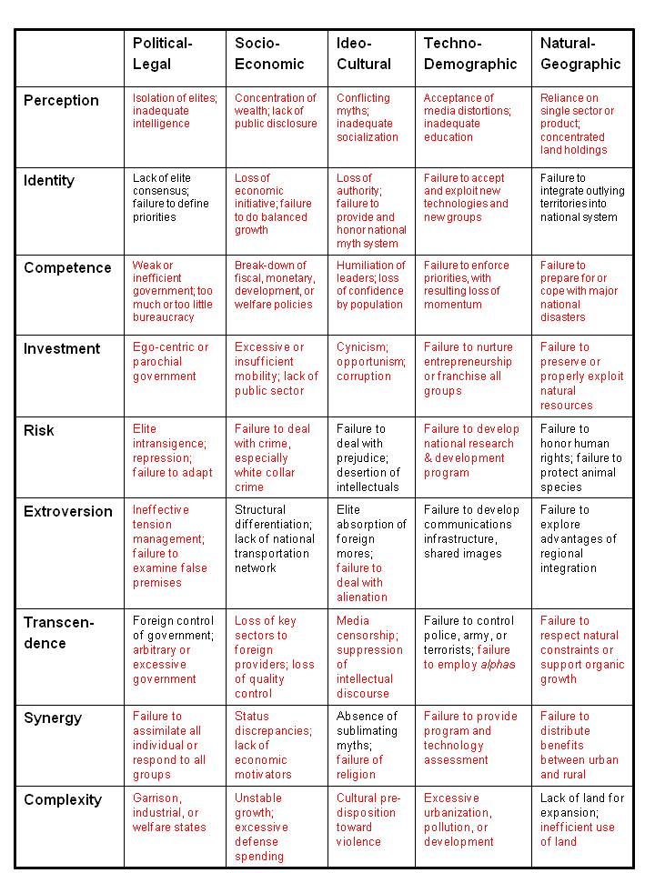
Figure 14: Pre-Conditions of Revolution in the USA Today?

Diplomacy & Development
As intelligence is transformed away from secret technical collection that is very expensive and of limited utility to commanders and their staff, and toward open source information sharing and sense-making with multinational value, diplomacy and development become subject to transformation as well.
Holistic intelligence that addresses all threats and can document the true costs of neglecting threats such as poverty, infectious disease, and environmental degradation will make the case for substantially increased investments in diplomacy and development. This is what General Al Gray and I were saying in 1989-1990, and this is what the White House, DoD, and the secret intelligence world have chosen not to do, with the inevitable result: trillions in wasted spending and an inability to create an effective integrated national defense.
One additional training and human resource initiative is needed: we must begin training our D3 officers as an inter-agency group, at the entry-level, at mid-career, and upon entrance to the Senior Executive Service (SES) and flag rank, using the NPC proposed above. Second, we must transfer $150 billion a year from Program 50 to Program 150. This has been discussed for decades. The present SecDef appears to have the vision necessary to make this happen, it will change everything about how we wage peace and war – a major legacy. On balance these ideas are best developed by the J-7 in tight partnership with NDU which should be restored to a three-star billet. We should consider the conversion of USDI into an Undersecretary of Defense for Development (USDD), to be complemented by the simultaneous conversion of the Undersecretary of State for Public Diplomacy into an Undersecretary of Defense for Peace, and the liberation of the US Agency for International Development (USAID) from the direct oversight of the Department of State (DoS).

Army, Air Force, Navy & Marines
At the operational level, the Navy & Marines become the central force for ad hoc power projection under the 96 hour/4 day timeline, and the Army becomes the primary force for both Operations Other than War (OOTW) and medium-weight interventions including anti-access operations, that require sustainable capability beyond 90 days, as well as direct support to D3 operations using the Army as the hub for WoG and multinational operations.
While respecting our existing treaty operations, the time has come to end the free ride we have giving Europe and Japan. South Korea to its credit has taken its military obligations most seriously. Along with withdrawing all our forces and turning over all our bases to the host governments, we should set minimum threshold standards for host country investments in military capabilities as well as diplomacy and development.
The new joint force concept of operations should emphasize a globally-distributed Navy capable of providing the sea-basing and sea-based “lily pad” functions needed to do light and medium weight joint, multinational, and WoG mission support, while the Air Force restores its ICBM capabilities and increases its long-haul capacity. Satellite vulnerability is now critical. The US military grinds to a half – goes deaf, dumb, and blind – if the satellites are lasered out of service.
This is the point at which the Army needs to consider a transformation away from “one size fits all” full spectrum forces, toward specialized brigades or “four Armies after next” as was suggested to the Marine Corps in 1992 and to the Army in 1998. The difference between the thinking then and now is that now we can see how vital it is to distinguish between “light” forces such as the Marine Corps represents with its wheeled vehicles incapable of cross-country engagement, and “heavy” tracked and armored vehicles that are both survivable and off-road capable .
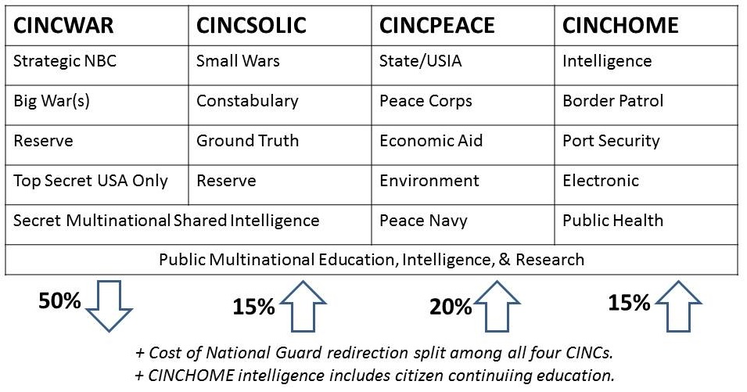
Figure 15: Four "Type" Forces Specified in 1992
In the above graphic created in 1992, called One Plus Triple Eye (1+iii), the 50% reduction of Big War force structure includes the eradication of the waste that is now documented at between 45% in weapons acquisition toward 75% in Afghanistan.
We still need an Army – the Marine Corps is too light. We appear to need an Army of three million soldiers with no contractors (instead of what we have now, an Army of one million soldiers and six million contractors) and we most certainly need an Army that can field a heavily-armored strike force with integrated air defense and CAS.
In other words, we seek to keep the same budget, but spend it more effectively across a range of complementary D3 capabilities. Perhaps paradoxically, setting aside the need for a Big War Army does not reduce the importance of the Army or its need to develop new capabilities with new funding. Below is my depiction of how important the Army can be in the 21st Century.
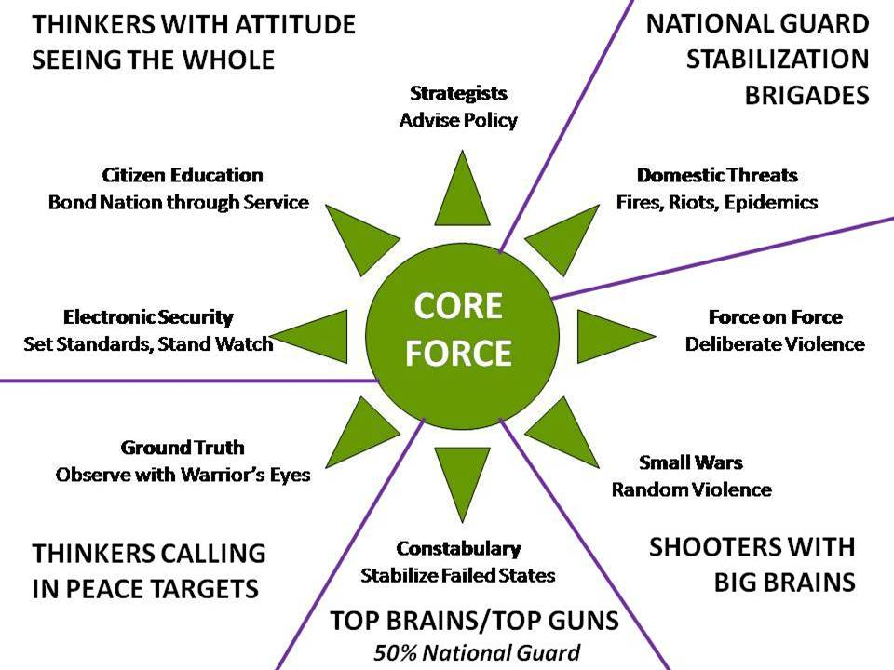
Figure 16: US Army as Core Force at Home and Abroad
The Army actually becomes central to a transformed D3 approach in which the Army is the hub both at home in elevating the fitness and educational maturity of our citizens, and abroad, where it becomes the hub for integrated WoG operations over the long-haul with very substantial “thinker” roles as well as ground truth roles not now met by the secret intelligence world or conventional diplomatic and commercial and defense attaches.
In keeping with my original four Armies after next concept, we must fund and maintain:
01 A professional force in being of three million soldiers with no contractors able to go anywhere, do anything, and survive – armored, tracked, and impervious to anti-access technologies in the hands of both state and non-state actors;
02 A professional peacekeeping forces able to serve as the hub for multinational and inter-agency development, stabilization, and reconstruction endeavors;
03 A professional homeland defense force – the National Guard is uniquely qualified in that it can hold law enforcement credentials at the same time that it is a military force in being; and
04 A universal educational, employment, and fitness experience for all citizens.

Tactical Transformation

White House & Congress
At the tactical level the White House and Congress need to acknowledge that we have gone over the cliff and are in free-fall with respect to over-investment in technologies that deprive us of resources needed for human domain development and balanced D3 operations abroad as well as home front reconstitution and strengthening. Our highest priority should be to avoid and resolve conflict, rather than seeking elective wars for corporate profit.
John Poole, Tom Mangold, and James G. Zumwalt among others have illuminated how Third World armies with almost no technology have defeated us and will continue to defeat us if we stay on this course of substituting expensive unsustainable technology for human intelligence and willpower. The US Army must reach back into the Native American tradition and begin a transformation of how it ingests, trains, and nurtures humans as the central element in waging peace and war. Shades of the First Earth Battalion!
At the tactical level, we need to challenge Air Force claims associated with RAPID HALT. Airpower is not going to stop anything by itself, particularly since our secret intelligence community is incapable of providing targeting information for fast-moving low-intensity conflicts.
Put another way, the Air Force will be central at the strategic level, the Navy & Marines will be central at the operational level, and the Army will be central at the tactical level. In relation to permissive and non-permissive environments, the Navy and Marine Corps will excel in the permissive environments, the Air Force and the Army must gear up and train up to excel in the non-permissive environments.
At the tactical level, thinkers must become co-equal with shooters. The FAO regiments, deeply immersed in culture, history, and language – with cumulative (sustained recurring long-term) face to face relationships of trust across all eight “tribes” of information in their region (as itemized in Figure 12 above) – will become the commander’s “continuity of operations” backbone across the full spectrum of conflict from peaceful preventive measures to total war.
In the intelligence domain, tactical is strategic and strategic is tactical. Global Coverage – a deep appreciation of culture, history, and language -- has long known to be the most severe deficiency in national intelligence. This has been the greatest failure of the USG at the strategic level – the inability to provide Global Coverage and decision-support across all Cabinet domains, compounded by a lack of professional development: the intelligence community today lacks the ability to do holistic analytics; compute true costs of every policy, behavior, product, and service; or explore the enormous possibilities of Open Source Everything Engineering (OSEE) that looms large as the fastest cheapest way to achieve the Sustainable Development Goals (SDG) within a decade at 10% of the cost of all industrial era donor paradigm “solutions” that are a proven failure. Achieving the SDG goals is the fastest way to win without fighting.

Intelligence & Covert Actions
At the tactical level our greatest need is for processed all-source decision-support on the one hand, and deep dives into culture, history, language, politics, and sociology on the other.
At the tactical level we continue to lack 1:50,000 combat charts (maps with contour lines and cultural features) for most of the world – in Somalia we are still using 1:100,000 Soviet-era military maps for our daily operations.
At this level, and given the implicit commitment to do more with open sources and more with multinational engagement, the OSA becomes a central player in providing information assurance, multinational information-sharing security and sense-sense-making tools, and public information assistance including innovation blueprints helpful to Diplomacy and Development. Cyber-security will be built in, along with the rights of anonymity, identity, and privacy.
Regional multinational Transportation Commands (TRANSCOM) should be established, and all information gathered to enable multiple allies to come together in any given region to manage rapid force closure including humanitarian assistance flights, such that available big airports and ports are all used to the fullest extent possible as intermediate delivery points. We need to become proficient at breaking down big cargoes into small cargoes, and doing the final miles with a mix of C-130s, landing craft, and precision parachute drops using the now relatively mature Joint Precision Airdrop System (JPADS).
Regional multinational Intelligence Centres and networks are needed that can provide integrated air, ground, and sea intelligence – real-time intelligence – to allied inter-agency forces.

Diplomacy & Development
At the tactical level there are two implementation initiatives.
First, we need to empower the diplomats with the discretionary funding needed to harvest all open sources of information relevant to our interests. The secret world refuses to take open sources seriously, and within DoD, OSINT is treated as a technical “surf the web” money hole rather than as the human face to face global scout function that is was meant to be when the alarm was first sounded in 1988 out of the Marine Corps Intelligence Activity (MCIA).
Second, we need to see the wisdom of Ashraf Ghani, now President of Afghanistan, and his co-author Clare Lockhart, who understand that the central obstacle to fixing failed states is the fact that 80% or more of all donor funds get syphoned off by intermediaries before ever reaching the target population. Their signal recommendation: electronic banking down to the village level, thus eliminating all intermediaries and exposing any corruption or misallocation.
This recommendation is best implemented within a Digital Marshall Plan organized by the OSA that simultaneously provides open source tools for multinational information-sharing and sense-making; open source innovation blueprints particularly for Open Source Provisioning (renewable energy, clean water, pressed brick shelter, composting, and aquaponics); and Open Source Infrastructure including open spectrum, mesh networks, and electronic banking possibly excluding conventional banks and instead creating community banks at the village level.

Army, Air Force, Navy & Marines
As we have seen over and over again, most recently at Kunduz in Afghanistan, the Air Force simply does not do CAS and it is culturally incapable of meeting Army needs. The manner in which the Air Force has sought to decommission the A-10, the one CAS platform that works as intended and is both inexpensive and reliable, should be sufficient to confirm this finding. The A-10 as well as the AC-130 gunships should be transferred to the US Army, and the Air Force should be put on notice with well-documented Army needs for paratroop transport, long-haul lift of light and medium brigades, and intra-theater transport.
For its part – this is explored in the final monograph of this series – the Army needs to re-design itself from the bottom up, to including shedding as much as 50% if not more of the weight it has put on since SLA Marshall first wrote The Soldier’s Load and the Mobility of a Nation.
The role of Special Operations Forces (SOF) requires a complete re-examination. Just as the Marines must reconnect with the Navy, so also must Special Forces reconnect with the Army. The conversion of SOF during the Global War on Terror (GWOT) into a global network of hunter-killer teams – the blackest side of SOF – has in my view radically reduced the utility and value of SOF over-all. “White” SOF, the hearts and minds and the through, with, and for aspect of SOF, has been completely marginalized. SOF needs a resurrection, and perhaps a modest restructuring to include a new Deputy CG for White SOF and a general agreement that White SOF should be at least two thirds of SOF at all times, with Black SOF sharply delimited.
At the tactical level, the US Navy should be able to provide missiles and naval gunfire support, at least one hospital ship, and communications and geospatial positioning “lily pad” as well as regional surveillance services (sea-based drones to piloted air breathers) if needed in the event of a loss of satellite capability, to any deployed Army brigade.
It is at this level that we can also revitalize the concept of Pathfinders and develop a capability to do Reverse TPFDD (Time-Phased Force Deployment Data). In an era where we face “complex and seemingly ‘headless’ challenges,” the ultimate balance and flexibility does not come from pre-planned streamed capabilities but rather from the combination of a smart human with excellent situational awareness and secure communications being able to call in “just enough, just right, just in time” capabilities delivered on 6, 12, and 24 hour cycles, generally by air inclusive of JPADS. Reverse TPFDD is both a preventive and reactive practice.
In the related D3 arena, Open Source Ecology (OSE) and Earth Intelligence Network (EIN) have been developing a “village in a box” concept that when dropped via precision parachute, opens up to provide everything needed in the way of open source technologies to set up solar energy, water desalination, pressed-brick shelters, a local mesh network with free cellular and a satellite uplink for the Internet, and everything needed for aquaponics. SOF and the FAO regiments must be tightly connected to SecDef’s larger D3 vision and practice.

Technical Transformation
Technical transformation will be the hardest form of transformation to achieve because our entire system is “rigged” in favor of undocumented and untested investments in technologies, whose true cost has never been calculated.
The Marine Corps concluded in 1987 that by their very nature the Joint Strategic Capabilities Plan (JSCAP) and the theater Operational Plans, which were supposed to be determining priorities, were always “worst case least likely” scenarios. They also tended to assume “best case” lift and logistics. This bias was pervasive within both the intelligence and the planning and programming communities. These problems persist today. We are simply not as professional as we pretend to be.

White House & Congress
As others have suggested as far back as 1997 in my own memory, we need to do D3 PPBSE across WoG, with a special emphasis on better integrating how we plan and program for defense in tandem with diplomacy and development. Ideally we should do WoG PPBSE.
If the Inter-Agency Development Corps (IADC) is funded as proposed at the operational level, then this becomes, as Army Special Operations Forces (ARSOF) has envisioned, the left hand end of the spectrum focused exclusively on human terrain. However, it also becomes a persistent partner across the full-spectrum of conflict, able to operate during low, medium, and high-intensity conflicts with a mix of fit, trained expeditionary civilian professionals, and multinational, non-governmental, and contractor elements as needed.
Peace | Non-State War | Low War | Medium War | High War
IADC | Primary | Supporting | Supporting | Supporting
SOF/FAO | Supporting | Primary | Supporting | Supporting
Army | Supporting | Supporting | Primary | Supporting
Figure 18: Inter-Agency Multinational Operating Environment
Like it or not, the reality is that “total war” has morphed from “all in” on conventional violence and massed military forces to “all in” on cyber, cultural, and economic WoG. In this context, a Grand Strategy and WoG PPBSE are the essential foundation for being both resilient at home and victorious abroad. This is not about soft power – this is about integrated power.
The White House has sought a 30% cut in the defense budget. A contrarian Congress continues to undermine the effectiveness of the military by forcing unwanted big ticket items into the budget, and watering down if not eliminating the testing and evaluation needed to prevent dubious technologies from moving forward in the acquisition milestone process.
Congress can stop a strategic make-over – or mandate such a make-over – with ease. One approach to gaining Congressional support would be to recognize that Congress has a legitimate interest in jobs and revenue, and to show specific Members of Congress how D3 as well as home front needs can be met with job and revenue neutrality from district to district. We should create an Industrial Base Plan and do deliberate strategic PPBSE so that specific companies and entire industries can be transformed in partnership with D3 needs, assuring Congress of job and revenue neutrality from district to district. Given the major investments that are required on the home front across all policy domains, an integrated national strategy should easily allow for striking a balance with Congress, particularly if we emphasize the human domain and mobilize voters accordingly. The value of open source technology for home front innovation and development can also be pitched to Congress. The strategic elegance here is in changing what we build and buy while achieving savings by eliminating waste – savings that can be put into domestic needs including public education, energy and water desalination projects, and infrastructure as well as full employment re-training.
Full employment is a topic that must be considered by a Grand Strategy. Many jobs have been exported, and many other jobs have been made redundant by a combination of automation and the Internet. During the Reagan Era a truly excellent plan was drawn up jointly by the Departments of Defense and Labor, “Building a Post-Cold War Workforce for the 21st Century: Our Manpower Peace Deficit.” The time has come to dust off that plan, update it, and use military training facilities to retrain the American workforce, giving precedence to veterans.

Intelligence & Covert Actions
At the technical level, we should be focusing on discovering, sharing, advancing, and implementing open source everything engineering (OSEE). A particular emphasis, ideally one funded by those with the most to gain, the Arab countries, should be placed on a “Manhattan Project” to establish a scalable replicable open source solution to the combination of solar energy and water desalination. Now that it is established that OSEE generally reduces costs to 10% of the existing industrial price, we should be able to build a water desalination plant producing 5 million gallons of water a day for $2.5 million instead of $25 million – and then we should rapidly build over 150 of them along all coastlines including those of the USA, where Texas has over 30 towns in imminent danger of their aquifer sources going totally dry.

Diplomacy & Development
At the technical level we need to recognize that in-country training, particularly in strife-torn areas, is not working. Technical training colleges are needed, and long-term plans need to be fully funded for bringing out of each country a cadre from across all eight information “tribes,” to be trained as entry-level, mid-career, and senior executive cohorts. This could even be developed as an international civil service corps with cross-fertilization among United Nations, Non-Governmental Organization (NGO) and other bodies. Especially important will be the training of military and police officials with civilian officials, building up trust over time.
We must finally achieve the vision so brilliantly articulated but then abandoned by the Defense Advanced Research Projects Agency (DARPA), as tested in STRONG ANGEL. More recently in Afghanistan the same team created UnityNet with support from NDU. There is an urgent need for an open source analytic tool-kit that enables secure information sharing across all boundaries, and shared sense-making across all boundaries.

Army, Air Force, Navy & Marines
The Air Force may need to give up the idea of billion dollar long-range bombers and invest instead in updating its ICBMs and ensuring that they actually work. Long-haul lift suitable for moving entire Army divisions, air superiority at a regional level using only expeditionary airfields, and a prompt exit from the space and cyber arenas, are also recommended.
The Navy & Marines need to reconnect to their excellent idea, “From the Sea…” while correcting several major short-falls in naval capabilities. The lack of naval gunfire, with the Navy 5” consistently out-gunned even in the Third World, calls for a new 8” standard. Missiles must be replenishable at sea. The Marine Corps – intended to be an amphibious force rather than an expeditionary forces – should be examined in relation to its fundamental naval character. Robert Work, currently Deputy Secretary of Defense, observed that “the Navy-Marine team will never contemplate littoral maneuver until an enemy’s battle network, capable of firing dense salvos of guided weapons, is suppressed. Consequently, the initial phase of any joint theater-entry operation will require achieving air, sea, undersea, and overall battle-network superiority in the amphibious objective area. . . . Thus far we have only argued that some capability to conduct theater-entry operations and littoral maneuver must be retained. But it is fair to ask how much amphibious capacity is needed.” The question is how large a Marine Corps does the Nation really need?

Conclusion
This first monograph in the three-monograph series set out to answer – at a high level of generality, five questions:
01 Is there a Grand Strategy that would provide for both deterrence and defeat of China, Iran, North Korea, and Russia, without the expense and political exposure of a US Army based overseas?
Yes. Not only is a US Army widely distributed overseas less able to maneuver and mass its capabilities as needed to augment allies being threatened by these countries, but the existing bases – over 1,000 of them including 44 around Iran alone – seem unnecessarily expensive and provocative. Intended to reduce the time/distance challenge and allow for the pre-positioning of heavy military systems, they have become an Achilles’ heel that a blinds us to unfair and unsustainable treaties in which we bear most of the burden, and that leave our forces broadly distributed and less able to be employed with the precision and in the order needed.
A strategy that mixes a strong naval submarine capability that can deliver both nuclear and convention munitions (ideally at hypersonic speeds) with allies who take responsibility for their own defense and can be reinforced by an air-mobile Army, is the best complement to a grand strategy of what Congressman Ron Paul calls A Foreign Policy of Freedom: Peace, Commerce, and Honest Friendship.
The “defeat” of peer competitors is a political, cultural, and economic challenge, not a military challenge. A Grand Strategy review will make that clear, and show that the Return on Investment (RoI) for creating a coherent political, cultural, and economic “Order of Battle” or OOB, is substantially greater than our present strategy of spending 16% of the entire federal budget – 61% of the disposable federal budget – on a heavy metal military.
02 Is there a Grand Strategy that would put an end to the proposition that the US Army is the de facto first line of defense for each of our allies in Europe and Asia?
Yes. The existing military force structure and overseas basis are serving the interests of the MICC, not of the public. It is possible to cut the Pentagon budget by at least a third while demanding off-setting investments from all other countries, against a cancellation of mutual self-defense treaties if they refuse to bear their own defense burden.
03 Is there a Grand Strategy that would balance a globally-dispersed Navy with naval infantry (the Marine Corps) with a home-based Army, a long-haul Air Force, and a mix of preventive and post-stabilization development investments?
Yes. A 450-ship Navy with embarked Marines is the minimum necessary force structure to be able to reach a US Embassy or vessel anywhere in the world within 24 hours; in combination with a long-haul Air Force that can deliver air-mobile Army units of any size anywhere in the world within 24-72 hours, this is all the force projection we need. The focus of effort within the new Grand Strategy should be on a $150 billion a year diplomacy and development program that demands matching investment from all allies, and strives to achieve the SDG goals within a decade using OSEE at one tenth the cost of the dysfunctional industrial-era donor “solutions.” Achieving the SDG goals is how we win wars without fighting.
04 Is there a Grand Strategy that would allow the modernization of all elements of the Department of Defense; a rebalancing of roles and missions among the five services (inclusive of the US Coast Guard the USA being in a virtual state of perpetual war), such that the US Army can be air mobile while also assuming responsibility for Close Air Support (CAS)?
Yes. This monograph did not seek to review alternative strategy propositions such as have been offered by Colin Gray, Richard Bailey et al, so much as to suggest that the US desperately needs to have a Grand Strategy summit and sort out all these issues. In the context of a balanced budget and a refreshed appreciation for human-technical and military-civilian, unilateral-multilateral trade-offs, everything should be on the table.
05 Finally, and quite important in the political and financial domains, is there a Grand Strategy that can overcome Congressional resistance to change by devising a transformation program that is home-based and job as well as revenue neutral from district to district and state to state?
Yes. The idea of making all changes to our military and civilian programs job and revenue neutral from district to district and state to state is a huge step forward in dealing with Congress. If combined with the closure of all overseas bases such that all our people – and their wallets and the infrastructure spending that has been invested overseas – come home, the benefits at the state and local levels increase even more. The same concept can be used with contractors that pay for lobbying – the major companies can be told in a very straight-forward manner that they can adjust and continue to receive commensurate levels of investment less the eliminated waste, or not.
The above is nothing more than a starting point for a broader discussion. The time/distance challenge must be joined by the weight/energy challenge, with the lethality challenge and the fiscal challenge always present. We can no longer afford to pretend to be strong. We can no longer afford to accept Congressional largesse that detracts from our ability to create real capabilities needed in the real world. We can no longer accept “budget share” as the foundation for defense allocations. We can no longer afford to short-change diplomacy and development. We can no longer afford to make decisions lacking in intelligence and integrity.
We need an American Grand Strategy that is affordable, evidence-based, flexible, and sustainable. In my view, the US military should not wait for the election – DoD J-7 should sponsor a D3 Grand Strategy Summit at NDU, and we should get our own house in order in full partnership with the Senate and House Armed Service Committees and their distinguished Members.
Part of our problem is that OSD has never thought it was responsible for determining the need for a new weapon system just as it has never thought it was responsible for determining the need for any particular force structure or mix of forces. They have always deferred to the services or the joint staff. In effect, informed and responsible civilian oversight is lacking. We desperately need a functional military command and staff structure that subordinates the services to strategic coherent leadership – unity of command.

Epilogue
I have not addressed the severe burden the military places on both the discretionary budget and the total budget. We know that military spending is 54% of discretionary spending in 2015, 61% if counting Veterans’ Benefits. Within the total budget the military is 16%, roughly four times the percentage characteristic of China and Russia, and eight times that of other nations. We also know that for one third of what the world spends on all militaries, we could rapidly meet all of the United Nations Sustainable Development Goals (SDG), with particular reference to the eradication of destabilizing poverty and a sharp reduction in disease and environmental degradation.
The question has to be asked: at what point does an irresponsible budget become the greatest threat to the security and prosperity of the United States of America?
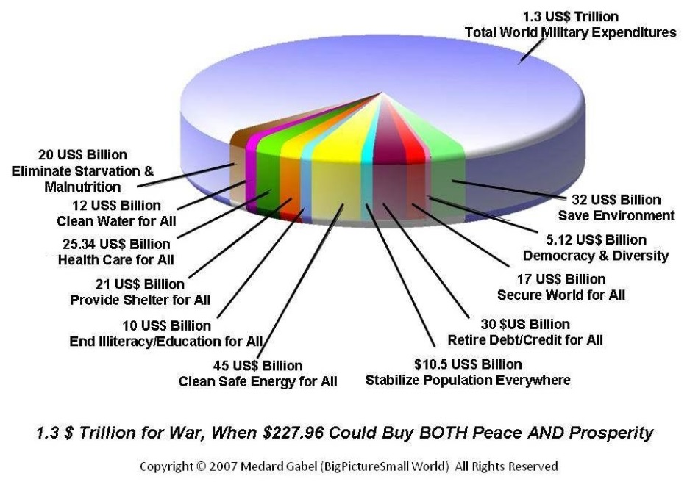
Figure 19: Cost of Peace & Prosperity in Contrast to Cost of War
There is another obvious geographically-based context for any discussion of Grand Strategy. Given where the USA is located in relation to the rest of the world, should our general priorities be in some way related to our location?
Below is a depiction created some years ago while thinking about how much we have neglected the Americas, to the point that the Union of South American Nations (UNASUR) is now a direct alternative to the Organization of American States – essentially, the South has thrown out the North.
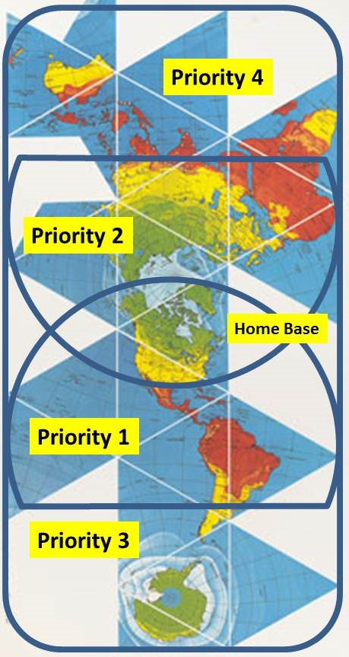
Figure 20: A Proposed Regional Prioritization Schema – The Hourglass
This depiction suggests that apart from Homeland Defense (and prosperity) our first priority should be the Americas followed by Europe, China, Russia, the Middle East and North Africa, with protection of the Antarctic and Australia, South Asia, and South Africa as our fourth and last priority.

Glossary
AFPAM Air Force Pamphlet
AGF Miscellaneous Command Ship
APOD Aerial Point of Delivery
ARSOF Army Special Operations Forces
CAS Close Air Support
CG Commanding General
CIA Central Intelligence Agency
CNO Chief of Naval Operations
COSPO Community Open Source Program Office
CSEC Communications Security Establishment Canada
CSIS Canadian Security Intelligence Service
D3 Defense, Diplomacy, Development
DARPA Defense Advanced Research Projects Agency
DCI Director of Central Intelligence
DD Destroyer (US Navy)
D-GA Democrat-George
DIA Defense Intelligence Agency
DMA Defense Mapping Agency (today NGA)
DNI Director of National Intelligence
DOCEX Document Exploitation
DoD Department of Defense
EIN Earth Intelligence Network
FAO Foreign Area Officer
FIRCAP Foreign Intelligence Requirements and Capabilities Plan
FPBLSE Force Projection Battle Lab Support Element
HTT Human Terrain Team
HUMINT Human Intelligence
I&W Indications & Warning
IADC Interagency Development Corps
IBCT Interim Brigade Combat Team
IC Intelligence Community
ICBM Intercontinental Ballistic Missile
IMINT Imagery Intelligence
ITT Interrogator-Translator Team
JPADS Joint Precision Airdrop System
JSCAP Joint Strategic Capabilities Plan
LCC Landing Command Ship
LHA Landing Helicopter Assault (Ship)
LHD Multipurpose Amphibious Assault (Ship)
LIBOR London Interbank Offered Rate
LNO Liaison Officer
LPD Amphibious Transport Dock (Ship)
MAG Military Advisory Group
MC&G Mapping, Charting & Geodesy
MCIA Marine Corps Intelligence Activity
MDSC Multinational Decision-Support Center
MICC Military-Industrial-Congressional Complex
MOG Maximum on Ground
MPS Maritime Prepositioning Ships
MTW Major Theater War
NASA National Aeronautics & Space Agency
NATO North Atlantic Treaty Organization
NDU National Defense University
NGA National Geospatial (Intelligence) Agency
NGIC National Ground Intelligence Center
NGO Non-Governmental Organization
NIMA National Imagery and Mapping Agency (today NGA)
NPC National Peace College
NRF Naval Reserve Force
NRO National Reconnaissance Office
NSA National Security Agency
OOB Order of Battle
OOTW Operations Other Than War
OSA Open Source Agency
OSE Open Source Ecology
OSEE Open Source Everything Engineering
OSINT Open Source Intelligence
PPBSE Planning, Programming, Budgeting Systems & Execution
R-AZ Republican-Arizona
Ret Retired
ROE Rules of Engagement
RoI Return on Investment
R-TX Republican-Texas
SACEUR Supreme Allied Commander Europe
SARS Severe Acute Respiratory Syndrome
SASC Senate Armed Services Committee
SDG Sustainable Development Goals
SecDef Secretary of Defense
SES Senior Executive Service
SIGINT Signals Intelligence
SME Subject Matter Expert
SSI Strategic Studies Institute
TDY Temporary Duty
TPFDD Time-Phased Force Deployment Data
TPP Transpacific Trade Partnership
TRANSCOM Transportation Command
UAV Unmanned Aerial Vehicle
UN United Nations
UN United Nations
UNODIN UN Open-Source Decision-Support Information Network
USA US Army or United States of America
USAF US Air Force
USAID US Agency for International Development
USCENTCOM US Central Command
USDD Undersecretary of Defense for Development
USDI Undersecretary of Defense for Intelligence
USG US Government
USMC US Marine Corps
USSOCOM US Special Operations Command
USSP Undersecretary of State for Peace
VSTOL Vertical Short Take-Off and Landing
WoG Whole of Government

Endnotes
Digital addresses are provided only for those sources not easily found online via title search.

A useful timeline is provided by “Defense Innovation Initiative,” Preceden, undated, covering the period November 2014 to January 2016. The Secretary’s call for inputs to the Defense Innovation Summit took place in the fall of 2015.
Al Gray, “Global Intelligence Challenges in the 1990’s,” American Intelligence Journal, Winter 1989-1990.
Raymond Millen, “Eisenhower and US Grand Strategy,” Parameters, 44(2), Summer 2014, pp. 35-47.
As read in Senate Armed Services Committee (SASC) papers while serving at Headquarters US Marine Corps (HQMC). The only published citation is in Robert Steele, ON INTELLIGENCE: Spies and Secrecy in Open World, Fairfax, VA: Armed Forced Communications and Electronics Association, 2000, p. 3. Senator David Boren (D-OK), past Chairman of the Senate Select Committee on Intelligence (SSCI) wrote the Foreword to this book.
Cf. “ REMARKS BY SASC CHAIRMAN JOHN McCAIN ON TOP DEFENSE PRIORITIES FOR 114TH CONGRESS AT CENTER FOR STRATEGIC & INTERNATIONAL STUDIES,” Senator John McCain (Official Website), March 26, 2015; and “House defense committee chair proposes acquisition system reforms,” American Society of Military Comptrollers, March 27, 2015.
Rachel Zissimos, “Why the U.S. Army’s Readiness Crisis is So Terrifyingly Real,” National Interest.Org, 25 October 2016.
“Two, Two, Two, One” is the force structure (often mistakenly called a strategy) conceived by then Chairman of the Joint Chiefs of Staff, General Martin Dempsey, USA. It refers to two heavyweights (China and Russia), two middleweights (North Korea and Iran), two networks (al-Qaida and transnational organized crime) and one domain (cyber). Cf. Daniel Goure, “General Dempsey’s “Two, Two, Two, One” Strategy,” Lexington Institute, May 13, 2014. Transnational crime is not actually an Army mission less support to counter-narcotics programs; it is possible this was mis-stated. Varied other sources suggest that Al-Qaeda and the Islamic State of Iraq and the Levant (ISIL) are the intended networks to be confronted.
Hans J. Morgenthau, Politics Among Nations: The Struggle for Power and Peace, New York, NY: Alfred A. Knoph, 1963, passim. At a strategic level, a universal draft provides both a moral and physical baseline for the entire population via the shared training experience that need not be only military – it could include branches into homeland first responder and foreign peace corps options – and a moral and intellectual baseline for preventing elective wars that serve the elite but do little for the public at large.
United Nations High-Level Panel on Threats, Challenges, and Change, A More Secure World: Our Shared Responsibility, New York: NY, United Nations, 2004. Published as a book, also available free online as a PDF.
“Total Defence,” Ministry of Defence, Republic of Singapore, available from www.mindef.gov.sg/imindef/key_topics/total_defence.html.
Lloyd J. Matthews (ed.), Challenging the United States Symmetrically and Asymmetrically: Can America be Defeated?, Carlisle, PA: Strategic Studies Institute, US Army War College, 1998; and Steven Metz (ed.), Revising the Two MTW Force Shaping Paradigm. Carlisle, PA: Strategic Studies Institute, US Army War College, 2001.
In 2008 the annual Army strategy conference focused on the need to rebalance the instruments of national power. My notes and a summary article are at “2008 Rebalancing the Instruments of National Power (Full Text Online for Google Translate),” Phi Beta Iota Public Intelligence Blog, 12 October 2008.
Supra Note 2 (Al Gray).
Robert D. Steele, “The Transformation of War and the Future of the Corps,” Intelligence: Selected Readings—Book One, Quantico, VA: Marine Corps University, AY 1992-1993.
Counterintelligence done professionally is more than adequate to eliminate the deep state, but absent political will and public consensus, the deep state will draw down on the moral and financial resources of the legal state until the latter implodes. Cf. Peter Dale Scott, The American Deep State: Wall Street, Big Oil, and the Attack on US Democracy, New York, NY: Rowman & Littlefield, 2014; and Michael S. Lofgren, “Anatomy of the Deep State,” Huffington Post, February 24, 2014.
“A third of the world’s 450,000 murders each year occur in Central and South America and the Caribbean, though the region is home to less than a tenth of the population. Fourteen of the top 20 countries in a ranking of murder rates are in Latin America.” Jonathan Watts, “Latin America leads world on murder map, but key cities buck deadly trend,” The Guardian, May 6, 2015, drawing on statistics from the United Nations Office for Drugs and Crime as processed by the Homicide Monitor.
R. D. Hooker, Jr., The Grand Strategy of the United States, Washington, DC: Institute for National Strategic Studies, National Defense University, October 2014.
Cf. David M. Edelstein and Ronald R. Krebs, “Delusions of Grand Strategy: The Problem with Washington’s Planning Obsession,” Foreign Affairs, November / December 2015; Niall Ferguson, “We need to relearn the arts of war and grand strategy,” Financial Times, September 25, 2015. An excellent review of past US attempts to formulate grand strategy, generally failed less Ike Eisenhower's Project Solarium, is provided by Ionut C. Popescu and Dallas D. Owes, “American Grand Strategy After War,” Carlisle, PA: Strategic Studies Institute, February 26-28, 2009.
In 1998 I presented my early reflections on this topic to the annual US Army strategy conference, subsequently published as “Threats, Strategy, and Force Structure: An Alternative Paradigm for 21st Century Security,” in Steven Metz (ed.), Revising the Two MTW Force Shaping Paradigm, Carlisle, PA: Strategic Studies Institute, US Army War College, April 2001. My recommendations included a call for a Digital Marshall Plan. Today the White House is finally realizing there are vast swaths they call “digital deserts,” where digital development assistance could yield stabilization of populations that will otherwise produce illegal immigrants including criminals and terrorists. I anticipated the illegal immigration “break-out” in The New Craft of Intelligence: Personal, Public, and Political, Oakton, VA: Open Source Solutions, Inc., 2002, pp. 95-100 inclusive of Figures 24 and 25.
Michael Ignatieff, Virtual War: Kosovo and Beyond, New York, NY: Picador, 2001, p. 203.
For instance, we could consider the retirement of the fixed-site ICBM element of the deterrent if we had a more reliable means of communicating with the nuclear submarines (SSBNs) on patrol or kept long-range cruise missile-carrying bombers on airborne alert in orbits within reach of their strategic targets. The former is mainly prevented by politicized environmental concerns about the effects of extremely low frequency (ELF) transmission and a very minor increase in costs. The latter would be substantially more expensive than the current intercontinental ballistic missile (ICBM) force and in some ways less secure and more destabilizing. Yet, devising the solution inevitably involves judging whether or not the outcome will be viewed as credible in the minds of potential opponents.
Supra Note 16 (Popescu & Owes). While the Office of Management and Budget (OMB) could in theory supervise the implementation of a grand strategy across all levels of analysis and across all boundaries, two factors are essential in achieving the desired end states: the President or Vice President must personally supervise the strategy dialog and development because no one else in the Executive is “above” all the Cabinet elements; and Congress must see that the strategy can be implemented in a job and revenue neutral fashion from district to district or Congress will oppose reform as occurred to the National Security Act of 1992, when a single Senator was able to terminate all prospects of intelligence reform because he saw that jobs would be lost in his state.
Because of 9/11 and how that event was politically exploited, the “peace dividend” era has been interrupted by two invasions of Iraq, the occupation of Afghanistan, and hundreds of individual land force missions into many countries including Somalia. Our objective is to avoid future events like 9/11, while also avoiding strategic mis-steps.
Cf. Ron Paul, A Foreign Policy of Freedom: Peace, Commerce, and Honest Friendship, Lake Jackson, TX: Foundation for Rational Economics and Education, 2007. A Grand Strategy should be rooted in respect for the US Constitution and the values associated with the Constitutional commitment to individual freedom in America. See also Ron Paul, Liberty Defined: 50 Essential Issues That Affect Our Freedom, New York, NY: Grand Central Publishing, 2012. Just as we should stop arming dictators, so also should we stop militarizing our police across 18,000 jurisdictions.
I diverge from the conventional Pentagon commentaries on strategy across multiple points. First, roles and missions are not settled – we need a new Bottom-Up Review. Second, the intelligence pillar is dysfunctional. Less than 1% of what we collect is producing relevant decision-support and we are neither doing Global Coverage nor supporting Whole of Government strategy and policy and acquisition and operations. Third, the “crown jewels” are all one laser away from being neutered, and all the unmanned stuff is unaffordable (not only is bandwidth more expensive than pilots, but bandwidth is too easily corrupted, manipulated, and interdicted). Cf. Joint Staff J-7 Future Joint Force Development Observations and Insights Report, US Army War College 25th Annual Strategy Conference, “Balancing the Joint Force to Meet Future Security Challenges,” Carlisle, PA, 8-10 April 2014. I would add that in the aftermath of Chernobyl and Fukushima, I believe nuclear signaling to be back on the table – a single low-yield nuclear weapon is greatly cheaper – and hopefully more reliable – than a fleet of billion dollar bombers with their attendant billion-dollar supporting forces.
Edward N. Luttwak, Strategy: The Logic of War and Peace, Revised and Enlarged Edition, Cambridge, MA: Belknap Press, 2002.
Cf. Steve Metz and Frank Hoffman, “Restructuring America’s Ground Forces: Better, Not Bigger,” Policy Analysis Brief, The Stanley Foundation, September 2007. See also Ronald O’Rourke, Defense Transformation: Background and Oversight Issues for Congress, Washington, DC: Congressional Research Service, April 16, 2007 (27 pages) and also November 9, 2006 (49 pages); Christopher Bolkcom, Air Force Transformation, Washington, DC: Congressional Research Service, January 18, 2006; and Ronald O’Rourke, Naval Transformation: Background and Issues for Congress, Washington, DC: Congressional Research Service, April 10, 2007.
Supra Note 22 (Luttwak).
“An Interview with Acting Director, DoD Office of Force Transformation, Terry J. Pudas,” Joint Force Quarterly, Issue 42, 3rd Quarter, 2006, pp. 32-35. He called transformation a “new logic.”
The 2015 US Army Strategy conference focused on “First Principles for the 21st Century” but accepted the centrality of military investment and capabilities as a given – it did not question, as this work questions, whether we ourselves might not be creating many of our own challenges, and whether we might first look to changing our own behavior and investments before seeking to impose coercive military measures on others.
I am reluctant to get into revisionist history in this first quick look, but at some point we have to come to grips with the reality that we created the MICC and the Cold War, and with CIA’s being a very negative factor in relation to both domestic national security policy with its wholesale importation of Nazis, and global peace and prosperity. Among many other books, see William D. Hartung, Prophets of War: Lockheed Martin and the Making of the Military-Industrial Complex, New York, NY: Nation Books, 2012, and Tim Weiner, Legacy of Ashes: The History of the CIA, New York, NY: Anchor Books, 2008. Just published is David Talbot, The Devil’s Chessboard: Allen Dulles, the CIA, and the Rise of America’s Secret Government, New York, NY: Harper, 2015, which is best understood by first reading Sterling and Peggy Seagrave, Gold Warriors: America's Secret Recovery of Yamashita's Gold, New York, NY: Verso, 2005; Jonathan Nashel, Edward Lansdale’s Cold War, Amhurst, MA: University of Massachusetts, 2005; and Glenn Yeadon, The Nazi Hydra in America: Suppressed History of a Century, San Diego, CA: Progressive Press, 2008. Other literatures on the inter-mingling of banking, crime, and the pathologies of select religions, also merit consideration along with the literature on the deep state and false flag operations generally. Note 41 provides references associated with information pathologies that subvert ethical evidence-based decision-making.
Wesley Clark, “Wes Clark - America's Foreign Policy "Coup," YouTube (8:14), available at youtu.be/TY2DKzastu8, accessed October 28, 2015.
This is less about the money – $11,381 billion in 2014, $12,540 estimated in 2015 – and more about our priorities and our logic. Numbers from OMB Copy of Outlays by Function.
Mark Palmer, Breaking the Real Axis of Evil: How to Oust the World's Last Dictators by 2025, Lanham, MD: Rowman & Littlefield Publishers, 2005.
“2002: Robert Steele Graphic Predicting Illegal Immigration Break-Out” is easily found online; it appeared as Figure 25 in Robert David Steele, The New Craft of Intelligence: Personal, Public, & Political–Citizen’s Action Handbook for Fighting Terrorism, Genocide, Disease, Toxic Bombs, & Corruption, Oakton, VA: Open Source Solutions, 2002, p. 98.
Matt Taibbi, Griftopia: A Story of Bankers, Politicians, and the Most Audacious Power Grab in American History, New York, NY: Spiegel & Grau, 2011.
James McBride, Christopher Alessi, and Mohammed Aly Sergie, “Understanding the Libor Scandal,” New York, NY: Council on Foreign Relations, available at www.cfr.org/united-kingdom/understanding-libor-scandal/p28729.
David McLaughlin, Tom Schoenberg, and Gavin Finch, “Six Banks Pay $5.8 Billion, Five Guilty of Market Rigging,” Bloomberg Business, May 20, 2015.
Bob Seelert, Chairman of Saatchi & Saatchi Worldwide (New York). The quotation was confirmed with his public relations department.
Cf. “Legitimate Grievances,” in Robert D. Steele, ELECTION 2008: Lipstick on the Pig, Oakton, VA: Earth Intelligence Network, 2008. Among many books covering this topic, see especially Mark Hertsgaard, The Eagle’s Shadow: Why America Fascinates and Infuriates the World, New York, NY: Farr, Straus and Giroux, 2002; Meic Pearse, Why the Rest Hates the Rest: Understanding the Roots of Global Rage, Downers Grove, IL: IVP Books, 2004, and three classics, Chalmers Johnson, The Sorrows of Empire: Militarism, Secrecy, and the End of the Republic, Metropolitan Books, 2005; William Blum, Killing Hope: US Military and CIA Interventions Since World War II - Updated Edition, London, UK: Zed Books, 2016; and Robert Pape, Dying to Win: The Strategic Logic of Suicide Terrorism, Random House, 2006.
“Lie to the President if you can get away with it is “Rule One” in Morton Halperin, Bureaucratic Politics and Foreign Policy, Washington, DC: Brookings Institution Press, 2006. More recently, see Leonard Wong and Stephen J. Gerras, Lying to Ourselves: Dishonesty in the Army Profession, Carlisle, PA: Strategic Studies Institute, US Army War College, February 17, 2015. Information pathologies are so legion as to have inspired a diverse literature. See for example Charles Lewis, 935 Lies: The Future of Truth and the Decline of America’s Moral Integrity, New York, NY: PublicAffairs, 2014; Larry Beinhart, Fog Facts: Searching for Truth in the Land of Spin, New York, NY: Nation Books, 2006; Roger Shattuck, Forbidden Knowledge, From Prometheus to Pornography, New York, NY: Mariner Books, 1997; Robert Parry, Lost History: Contras, Cocaine, the Press & ‘Project Truth’, San Francisco, CA: Media Consortium, 1999; Edward Herman and Noam Chomsky, Manufacturing Consent: The Political Economy of the Mass Media, New York, NY: Pantheon, 2002; Jacques Ellul, Propaganda: The Formation of Men’s Attitudes, New York, NY: Vintage, 1973; Jim Marrs, Rule by Secrecy: The Hidden History That Connects the Trilateral Commission, the Freemasons, and the Great Pyramids, New York, NY: William Morrow Paperbacks, 2001; Bill McKibben, The Age of Missing Information, New York, NY: Random House, 2006; Sheldon Rampton and John Stauber, Weapons of Mass Deception: The Uses of Propaganda in Bush's War on Iraq, New York, NY: Tarcher, 2003; and Weapons of Mass Instruction: A Schoolteacher's Journey Through the Dark World of Compulsory Schooling, Gabriola Island, BC, New Society Publishers, 2010.
Among the eight books and many articles and chapters I have published on this topic, see particularly “Intelligence for the President – AND Everyone Else,” CounterPunch, March 1, 2009. There has been no fundamental change in the secret world’s focus or incapacity in a quarter-century – it simply spends more money. My original critique “Intelligence in the 1990’s: Recasting National Security in a Changing World,” American Intelligence Journal, Summer/Fall 1990, pp. 29-36, remains acutely valid – the six fundamental flaws identified then are with us today – an illustration is provided online at “Graphic: US Intelligence Six Fundamental Failures Over 25 Years – $1.25 Trillion,” Phi Beta Iota Public Intelligence Blog, January 22, 2013.
Pauline Jelinek, “Panetta: What Is the Army of The Future?” Associated Press, 12 October 2011.
Lee Edwards, "Congress and the Origins of the Cold War: The Truman Doctrine," World Affairs, Vol. 151, 1989.
“Provide aid to allies” assuming the United States specifies "essential allied areas" as the English-speaking nations: Australia, Canada, Great Britain, and selected European allies. The United States’ commitments to Japan and Korea are certainly valid if “maintaining lines of communications” is included under 5.
Among many articles and think tank reports, see for example, Bill Gertz, “China, Russia Planning Space Attacks on US Satellites,” Free Beacon, March 16, 2016; David Axe, “Space War Game Wasted US Satellites,” The Daily Beast, April 16, 2016; and John Grady, “US Dependence on Space Assets Could be a Liability in a Conflict with China,” US Naval Institute News, January 29, 2014. On the vulnerability of geospacial positioning satellites == not just from attack but from aging -- see for example “GPS is a Time Bomb,” Locata, undated, accessed July 1, 2016; and “Global Navigation Space Systems: reliance and vulnerabilities,” London, UK: Royal Academy of Engineering, March 2011.
Cf. Jeremy Scahill, “The Drone Papers,” The Intercept, October 15, 2015.
Spencer Ackerman, “41 men targeted but 1,147 people killed: US drone strikes – the facts on the ground,” The Guardian, November 24, 2015. This is an improvement on the previous tally of 49 to 1. The cost of this program to date has been $11.8 billion, or roughly $10 million for each individual human target. Berto Jongman, “US Drone Strike Death Numbers — At What Cost? + Drone Meta-RECAP,” Phi Beta Iota Public Intelligence Blog, October 17, 2012.
“Former CIA Director, Former CIA Counterterrorism Director, 31 Other Intelligence Experts Announce Support for McCain Anti-Torture Amendment to Defense Bill,” Human Rights First, December 9, 2005, and “Veteran Intelligence Professionals Challenge CIA’s “Rebuttal” on Torture,” WashingtonsBlog, September 14, 2015. While not publicly documented, there are grapevine stories about how angry the Joint Special Operations Group (JSOG) has been about the lack of rigor in the CIA’s target list, such that they end up killing bus drivers and café waiters rather than terrorists.
Among the sources, all but one outside of the Mainstream Media (MSM) are Christina Lin, “Obama’s ‘regime change’ in Syria: effort to destabilize China, Russia?,” Asia Times, November 2, 2015; Brandon Turbeville, “From Syria To Asia To Russia – Terror Network Organized By NATO and Turkey,” Activist Post, October 1, 2015; Tony Cartalucci, “Turmoil in Hong Kong, Terrorism in Xinjiang: America’s Covert War on China,” New Eastern Outlook, October 21, 2014.
My varied publications, most free online, can be viewed via http://robertdavidsteele.com/publications/. My most recent future-oriented publications are easily accessed via http://www.phibetaiota.net/2015/11/creating-the-future-recent-core-work-by-robert-steele/. Prior seminal works include “The Evolving Craft of Intelligence,” in Robert Dover, Michael Goodman, and Claudia Hillebrand (eds.). Routledge Companion to Intelligence Studies, Oxford, UK: Routledge, 2013; and “The Ultimate Hack: Re-inventing Intelligence to Re-engineer Earth,” in U.K. Wiil (ed.), Counterterrorism and Open Source Intelligence, Berlin: DE, Springer-Verlag, 2011.
“If you know the enemy and know yourself, you need not fear the result of a hundred battles. If you know yourself but not the enemy, for every victory gained you will also suffer a defeat. If you know neither the enemy nor yourself, you will succumb in every battle.” Sun Tzu, The Art of War, Minneapolis, MN: Filiquarian, 2007.
Supra Note 42 (Steele).
Cf. “Graphic: Tony Zinni on 4% “At Best,” Phi Beta Iota Public Intelligence Blog, December 7, 2010. See also sources in Notes 42 and 51.
I remember Tim Hendrickson with admiration. So many pioneers tried so hard in the 1990’s to inspire reflection at the highest levels. They were all, without exception, ignored. I did not understand why until 2008 when I asked both the Navy and USSOCOM why they did not act on the CENTCOM J-2P memorandum on Somali piracy that I produced in 2005, using commercial imagery and commercial intelligence to identity the specific villages, families, docks, and boats that should be targeted to stop that source of instability at sea. Their identical answer was “it was not an expensive enough problem.” Money drives policy and practice, not the public interest or evidence. A Grand Strategy review is the first step toward achieving an affordable, effective national budget in the national interest.
My Memorandum proposing this to the Vice President of the United States, copied to the Secretary of Defense among others, is online ” Robert Steele: Open Source (Technologies) Agency,” available at www.phibetaiota.net/2015/10/usa-open-source-technologies-agency/.
Secretary of Defense, “Department Participation in the October 2015 Defense, Diplomacy, and Development Innovation Summit Pitch Challenge,” Memorandum, September 11, 2015.
Robert D. Steele, National Security C3I3H3–Command, Communications, & Computing, Inter-Agency, Inter-Disciplinary, Inter-Operability, Heuristics of the Community Intelligence Cycle, Master of Public Administration Thesis, Norman, OK: University of Oklahoma, May 1987.
As cited by Michael C. Thomsett and Jean Freestone Thomsett, War and Conflict Quotations, Jefferson, NC: McFarland, 2008, with source credit to Esquire, June 1975.
Duncan Wallace, “Trends in traumatic limb amputation in Allied Forces in Iraq and Afghanistan,” Journal of Military and Veterans Health, Vol. 20 No. 2, April 2012.
“Annual Disability Statistics Compendium,” DisabilityCompendium, undated, available at disabilitycompendium.org/compendium-statistics/veterans.
Stacy Bare, “The Truth About 22 Veteran Suicides a Day,” Task and Purpose, June 2, 2015.
When my company surveyed online terrorist, insurgent, and opposition websites for the US Special Operations Command in 1997, we found it essential to operate in 29 languages. Today I consider 34 languages essential: Arabic (11 core variations), Aramaic, Berber, Catalan, Chinese, Danish, Dari, Dutch, English, Farsi, Finnish, French, German, Hindi (a continuum of dialects), Indonesian, Irish, Italian, Japanese, Korean, Kurdish, Kurmanji, Malay, Norwegian, Pashto, Polish, Portuguese, Punjab, Russian, Serbian, Spanish, Swedish, Tamil, Turkish, Urdu. Arabic variations (CIA often falls prey to its dependence on Lebanese Arabs, and the FBI has similar issues): Andalusi Arabic (extinct, but important role in literary history); Egyptian Arabic (Egypt) Considered the most widely understood and used "second dialect"; Gulf Arabic (Gulf coast from Kuwait to Oman, and minorities on the other side); Hassaniiya (in Mauritania); Hijazi Arabic; Iraqi Arabic; Levantine Arabic (Syrian, Lebanese, Palestinian, and western Jordanian); Maghreb Arabic (Tunisian, Algerian, Moroccan, and western Libyan); Maltese; Najdi Arabic; Sudanese Arabic (with a dialect continuum into Chad); and Yemeni Arabic. The primary purpose of creating FAO regiments is NOT to provide translators, but rather to provide persistent depth of attention to culture, history, literature, politics, and sociology, in the native language against native language sources not common to the secret intelligence world or the normal Whole of Government policy world, with commensurate mission area knowledge.
Robert Steele, Human Intelligence: All Humans, All Minds, All the Time, Carlisle, PA: Strategic Studies Institute, US Army War College, June 3, 2010. As with all my publications touching on sensitive intelligence matters, this was cleared prior to publication, and in this instance, cleared by both CIA and DoD. We need to move Open Source Intelligence (OSINT) away from technical collection and back toward face to face contacts between human beings at the local level, in their own language, everywhere. Cf. Robert D. Steele, “Open Source Intelligence,” in Loch Johnson (ed.), Strategic Intelligence: The Intelligence Cycle, Westport, CT: Praeger, 2007, Chapter 6 pp. 96-122. Two briefings on OSINT, one for leaders and one for staff, were prepared in 2009 by myself and Joe Markowitz, former Chief of the Community Open Source Program Office (COSPO), they are available at www.phibetaiota.net/2009/09/dod-leadership-and-staff-briefings/.
Cf. Steven Metz, Strategic Landpower Task Force Research Report, Carlisle, PA: Strategic Studies Institute, US Army War College, October 3, 2013. The report integrates a wide number of deep references that in the aggregate suggest we need to elevate the human domain to at least a warfighting discipline, if not our central planning factor. The NATO Transformation Command and especially the Innovation Hub there, have done some extraordinary work on the Human Factor. “Round-Up: The Human Factor” at Phi Beta Iota Public Intelligence Blog is a portal page the relevant online references.
As posted at “2017 Robert Steele: OSINT Done Right,” Phi Beta Iota Public Intelligence Blog, 7 February 2016. At this page the reader can find all of the material associated with the invited funded lecture to the Danish Defence College, also delivered informally to representatives of the Norwegian Defence University in Oslo, on “OSINT Done Right.” It is now being realized by many that we have been doing it wrong since I started the OSINT revolution and it was mis-directed by those driven by financial and technical incentives rather than public need.
Supra Note 65 (Metz), citing Nathan P. Freier, The New Balance: Limited Armed Stabilization and the Future of US Landpower, Carlisle, PA: Strategic Studies Institute, US Army War College, 2009; Thomas X. Hammes, The Sling and the Stone: On War in the 21st Century, Minneapolis, MN: Zenith, 2006; John J. Mearsheimer, “Imperial by Design,” The National Interest, January-February 2011, pp. 16-34; Steven Metz and Raymond A. Millen, “Intervention, Stabilization, and Transformation Operations: The Role of Landpower in the New Strategic Environment,” Parameters, Spring 2005, pp. 41-52; Rupert Smith, The Utility of Force: The Art of War in the Modern World, London, UK: Allen Lane, 2005; and Martin Van Creveld, The Transformation of War: The Most Radical Reinterpretation of Armed Conflict Since Clausewitz, New York, NY: Free Press, 1991. See also Ronald O’Rourke, A Shift in the International Security Environment: Potential Implications for Defense—Issues for Congress, Washington, DC: Congressional Research Service, September 24, 2015, which includes a stellar literature survey as well. Defensive technologies now over-shadow offensive platforms by a factor of at least ten if not one hundred – a Russian or Chinese or Iranian supersonic missile – or a Chinese submarine with a German diesel engine – can now waste a US aircraft carrier with impunity. Cf. David Tweed, “China’s Supersonic Ship Killer Is Making US Navy’s Job Harder,” BloombergBusiness, October 30, 2015; Mark Gaffney, “The Sunburn – Iran’s Awesome Nuclear Anti-Ship Missile,” Rense.com, November 2, 2004. I am aware of the alleged success of Raytheon’s SeaRAM anti-ship missile system and do not believe it. The SUNBURN zig-zags at Mach speed and is inexpensive enough to permit multi-point firing solutions.
Now that Chernobyl and Fukishima have shown the “tolerance” for major nuclear attacks on society and the environment, the launch of a single nuclear missile – hoping that it actually works (we have never tested a nuclear missile operationally)—will ring the bell. This relieves the US Army of the need to plan and program for a Big War force.
In passing the US Navy has been much too complacent about the reality that its submarines are now easier to detect than ever before, nor have we put enough time and money into making hypersonic missiles that do not provide a six-hour in-flight announcement of their projected time of impact.
David Vine, Base Nation: How US Military Bases Abroad Harm America and the World, New York, NY: Metropolitan Books, 2015.
Cf. William R. Ward, Strategic Airlift and the Interim Brigade Combat Team, Fort Leavenworth, KS: School of Advanced Military Studies, US Army Command and General Staff College, January 2001 and Jean M. Mahan et al, “Quick Strategic Force Closure Sensitivity for Multiple Scenarios,” Scott AFB, IL: US Transportation Command, August 19, 2002.
As the Study Director for Overview of Planning and Programming Factors for Expeditionary Operations in the Third World, Quantico, VA: Marine Corps Combat Development Command, March 1990, I had in mind a requirement to be able to put a platoon of Marines with Cobras overhead anywhere in 24 hours, a company with Harriers in 48 hours, and a Battalion Landing Team (BLT) Minus with organic air in 72 hours. This was the requirement that led to a 450-ship distributed small-ship Navy. Later I published “Muddy Waters, Rusting Buckets: A Skeptical Assessment of US Naval Effectiveness in the 21st Century,” Marine Corps Gazette, 1999, and updated this in 2012 as “US Naval Power in the 21st Century: <24 Hours to Anywhere, Peace from the Sea,” Phi Beta Iota Public Intelligence Blog, November 10, 2012. The second monograph in this series will present the strategic generalizations developed by that study, all highly relevant to “re-inventing” the US Army.
James C. Ruehrmund Jr. and Christopher J. Bowie, Arsenal of Airpower: USAF Aircraft Inventory 1950-2009, Washington, DC: Mitchel Institute Press, 2010, p. 4. See also “US Air Force,” 2015 Index of Military Strength, The Heritage Foundation, 2015, available at index.heritage.org/military/2015/chapter/us-power/us-air-force/. The “Fiscal Year 2016 Air Force Posture Statement” is the official summary and contains no hard data. A search for more current versions of this graphic has been fruitless.
The closure of all bases overseas is a deliberate aspect of this notional Grand Strategy. American “exceptionalism” is a questionable premise that has been used to justify elective wars that enrich the 1%. In combination, the universal draft and the closure of all bases overseas help ensure that future US military commitments are validated by the public, by Congress, and by a sufficiency of allies necessary to support global reach from home and within a democratic public decision-making process.
MOG is a critical reality showstopper. On MOG see Marshall T. Morrison, “Estimating Airfield Capacity for AMC Operations,” Patterson AFB, Ohio: Air Force Institute of Technology, Air University, November 1996 and Air Mobility Planning Factors, USAF (AFPAM 10-1403), December 12, 2012. There are many updates and follow-on studies, the bottom line is that except for major airports in capital cities – ideally with civilian flights diverted to provide exclusive use of the airfield – we cannot deliver more than one or at most two fully loaded military aircraft anywhere, at one time. Although he focused largely on the broken acquisition system, Chuck Spinney has always been “Ref A” on the Plans/Reality Mismatch, see his still relevant Franklin Spinney, Defense Facts of Life: The Plans/Reality Mismatch, Boulder, CO: Westview Press, 1985.
Winslow Wheeler and Chuck Spinney, with contributions from Pierre Sprey (who designed the A-10, the last holistically designed requirements-based aircraft in the USAF inventory) have done an excellent job of following USAF attempts to delete this vital aircraft from inventory. USAF General James Post telling his people that telling the truth to Congress is equivalent to treason stands out as a strong indicator of where USAF leadership is on this critical Army issue. A range of articles across time on the A-10 and its future are online, available at www.phibetaiota.net/?s=A-10.
Drawn from “List of active United States military aircraft,” Wikipedia, undated, available from en.wikipedia.org/wiki/List_of_active_United_States_military_aircraft, accessed July 3, 2016.
Supra Note 73 (Riehmund & Bowie), for the 60% of 60% calculation, citing Rick White, Mobility Analyst with Force Projection Battle Lab Support Element (FPBLSE), email to cited author, November 24, 2000.
For background on the original Key West agreement see Frederic A. Bergerson, The Army Gets an Air Force: Tactics of Insurgent Bureaucratic Politics, Baltimore, MD: The Johns Hopkins University Press, 1980. We must of course remember that the USAF was originally part of the US Army.
Annual Aviation Inventory and Funding Plan, Fiscal Years (FY) 2017-2016, Department of Defense, March 2016, p. 7. Accessed July 2, 2016 at http://ec.militarytimes.com/static/pdfs/2016-Annual-Aviation-Report.pdf.
John Pike, “Stryker Armored Vehicle,” GlobalSecurity.org, undated, available at www.globalsecurity.org/military/systems/ground/iav.htm.
Steele, Robert with BDM Corporation, Overview of Planning and Programming Factors for Expeditionary Operations in the Third World, Quantico, VA: Marine Corps Combat Development Command, March 1990. The color briefing slides and the strategic generalizations summary document can be viewed online at “1990 Expeditionary Environment Analytic Model,” Phi Beta Iota Public Intelligence Blog, March 15, 1990. The second monograph in this three-monograph series will present a summary of that information tailored to Army needs but not a substitute for a fresh new study by the Army for the Army.
Kris Osborne, “CNO Tells Congress the US Needs a 450-Ship Navy,” Military.com, March 12, 2014. Elsewhere I have been severely critical – as has Winslow Wheeler – of naval mis-representation and poor planning, to include sacrificing most logistics ships as part of mid-directed budget proposals. What we are lacking in the USA is open hearings in which the various evaluation elements including particularly the Congressional Research Service (CRS) and the Congressional Budget Office (CBO) receive the respect they merit, and the services are held accountable for holistic evidence-based PPBSE.
Note 1: 15 Los Angeles SSNs modified pending new design. Note 2: 4 carriers with air wings dedicated to VSTOL/gunships, Marines, and anti-mine work. Note 3: Keep every destroyer alive as gap fillers. 84 vice 73-25 (Note 4) = 59. Note 4: 25 SPRUANCE DD’s converted to DD963/DDH (aviation onboard) pending new class. Note 5: Achieve better balance between large LHA/LPD and enhanced WHIDBEY-class LHDs. Note 6: Extend program, create 25 three-ship squadrons, 1 VSTOL, 1 Marines, 1 Fire Support. Note 7: Achieve savings and spread capability by focusing on distributed helicopter assets. Note 8: Create MPS Civic Action variant with integrated field hospital, engineers. Note 9: Get serious about continental-level diseases, configure for bio-chemical recovery. Note 0: Totals include Cat A NRF and Cat B Mine Warfare and Hospital Ships. See also Supra Note 27 (O’Rourke, Naval).
Supra Note 56 (Steele) for the Memorandum proposing the OSA, and Supra Note 42 for various articles and chapters putting the OSA in the larger context of successfully addressing all UN SDG goals within a decade at 10% of the cost as calculated by the existing industrial-donor paradigm.
Nolan Feeney, “Pentagon: 7 in 10 Youths Would Fail to Qualify for Military Service,” TIME, June 29, 2014. Congress is also worried about this. Section 570 of House Resolution 1735 as passed by the House on May 15, 2015 demands of SecDef an assessment of civilian education needs necessary to assure students are prepared for military service. Supra Note 27 (O’Rourke, Defense), p. 19. See also “School Diet Change Brings Improved Behavior, Healthier, More Focused Students,” WantToKnow.info, undated.
Cf. my invited white paper, Beyond Data Monitoring – Achieving the Sustainability Development Goals Through Intelligence (Decision-Support) Integrating Holistic Analytics, True Cost Economics, and Open Source Everything, Earth Intelligence Network, October 14, 2014. I expanded on the import of these open multinational information and intelligence capabilities in “Open Source Everything Engineering (OSEE) – Achieving the SDG Goals in a Fraction of the Time at a Fraction of the Price,” Phi Beta Iota Public Intelligence Blog, February 16, 2016, as submitted to the UN Sustainable Development Goals (SDG) Global Report 2016.
“Threats Strategy and Force Structure, an Alternative Paradigm for 21st Century Security,” in Steven Metz (ed.) Revising the Two MTW Force Shaping Paradigm, Carlisle, PA: Strategic Studies Institute, US Army War College, 2001.
“Information Peacekeeping: The Purest Form of War”, in Lloyd J. Matthews (ed.), Challenging the United States Symmetrically and Asymmetrically: Can America be Defeated? , Carlisle, PA: Strategic Studies Institute, US Army War College, 1998, pp. 143-171.
A current starting point on my work and its relevance to global stabilization is provided by Nafeez Ahmed, “The open source revolution is coming and it will conquer the 1% -- ex CIA spy,” The Guardian, June 19, 2014. See also “Thinking About Revolution,” Quantico, VA: Marine Corps University, 1992, and Theory, Risk Assessment, and Internal War: A Framework for the Observation of Revolutionary Potential, Bethlehem, PA: Lehigh University, 1976.
Support to Military Operations (SMO) has made some commendable contributions, but the fact is that the Intelligence Community (IC) has remained mired in the past, shirking its responsibilities in relation to clandestine human intelligence, non-digital (i.e. human) open sources, and commercial imagery and geospatial information. The national signals capabilities while capable of some extraordinary accomplishments in relation to individual cell phone numbers, are out of control and need radical restructuring in the context of an integrated defense intelligence capabilities matrix.
My own early version of this was included in the revision to the National Security Act of 1947 that I proposed in 1997 and formally published in 2000, in which no less than 75% of all foreign military assistance funds were redirected toward a peace and development fund. Supra Note 4, pp. 304-334 and especially p.331.
Supra Note 57 (Carter).
The concept of sea-based lily pads for short-duration missions and longer-term support to D3 missions ashore is distinct from the existing lily pad concept of having over a 1,000 bases world-wide from which we launch intrusive combat patrols and drone assassination missions. For a critique of the latter, see David Vine, “The Military’s New Lily-Pad Strategy,” The Nation, July 16, 2012.
This is our most critical vulnerability, and one that also suggests that our reliance on unlimited bandwidth between CONUS and forward forces has become an addiction that must be broken. Bandwidth is more expensive than pilots. Our forces in the field need to be able to cut the satellite umbilical cord and operate in non-permissive cyber-environments. We have been “conscious” of this vulnerability since at least 2005, see Robert K. Ackerman, “Space Vulnerabilities Threaten US Edge in Battle,” SIGNAL, June 2005; and more recently, Yasmin Tadjdeh, “New Chinese Threats to US Space Systems Worry Officials,” National Defense, July 2014 and also “Critical US Satellites Vulnerable?,” CBS News, April 24, 2015. Winn Schwartau and I and officers at the Air War College were all over our cyber-vulnerabilities, publicly, from 1988-1994. No one, least of all the White House, wanted to hear it. Cf. Robert Steele with James Anderson, William Caelli, and Winn Schwartau, “Correspondence, Sounding the Alarm on Cyber Security,” McLean, VA: Open Source Solutions, Inc., August 23, 1994.
Supra Note 19 (Steele). See also Andrew Feikert, Does the Army Need a Full-Spectrum Force or Specialized Units? Background and Issues for Congress, Washington, DC: Congressional Research Service, January 18, 2008.
One of America’s most consistent observers and students of US military strategy and its capabilities in the face of a constantly changing world is Dr. Steven Metz, Director of Research at the Strategic Studies Institute of the US Army War College. His recent article, “Reimagining the US Military for Today’s Security Environment,” World Politics Review, October 30, 2015, offers the idea of shifting how we organize our military from a domain basis (air, land, sea) to a mission basis (strike, stabilization, homeland). I have also been greatly influenced by the work of Col (Ret) and Dr. Doug Macgregor, particularly Breaking the Phalanx: A New Design for Landpower in the 21st Century, New York, NY: Praeger, 1997; Transformation Under Fire: Revolutionizing How America Fights, New York, NY: Praeger, 2003; and his most recent, Margin of Victory: Five Battles that Changed the Face of Modern War, Annapolis, MD: Naval Institute Press, 2016 – all are relevant to re-inventing the US Army with intelligence and integrity.
The monograph will not focus on the true cost of elective wars or the extraordinary waste that is built into the US military by Congress, the services, and poor practices. If we can achieve intelligence with integrity and show Congress how to rebalance our forces in a job and revenue neutral context, we can address both challenges ably. A few current articles include Charles Tiefer, “Huge Waste in $604 Billion Defense Bill Heads for Obama Veto,” Forbes, October 4, 2015; Peter Swarts, “Pentagon could waste $100 million overpaying for spare parts, watchdog says,” Air Force Times, June 5, 2015; Matthew Gault, “Here’s How the Military Wasted Your Money in 2014: New year, old problems,” Medium.com, January 1, 2014; Scot J. Paltrow, “Special Report: The Pentagon’s doctored ledgers conceal epic waste,” Reuters, November 18, 2013. It is noteworthy that it is now established that defense contractors cost three times as much as defense civilians, see Scott Amey, “DoD Contractors Cost Nearly 3 Times More than DoD Civilians,” PogoBlog, November 30, 2012. A useful graphic on weapons cost inflation and waste is provided by an info-graphic at “More Bucks, Less Bank,” Project on Government Oversight, undated, accessed July 3, 2016 at http://getinvolved.pogo.org/site/PageNavigator/weapons_infographic.html.
Others are beginning to be more vocal on this point, calling for both retrenchment and moderation. Do we need to control everything? Is the military the only instrument of national power ready to surge? Cf. Steven Metz, “Strategic Insights: America’s Strategic Debate – And Why It Matters To The Army,” Carlisle, PA: Strategic Studies Institute, US Army War College, September 25, 2014.
H. John Poole, Phantom Solider: The Enemy’s Answer to US Firepower, Posterity Press, 2001; Tom Mangold, The Tunnels of Cu Chi: A Harrowing Account of America's Tunnel Rats in the Underground Battlefields of Vietnam, San New York, NY: Presidio Press, 2005; and James G. Zumwalt, Bare Feet, Iron Will: Stories from the Other Side of Vietnam’s Battlefields, Jacksonville, FL: Fortis Publishers, 2010.
Cf. Yoda, “Indigenous Knowledge Systems,” Phi Beta Iota Public Intelligence Blog, October 18, 2015.
Every warrior would do well to study the vision of LtCol Jim Channon, USA, founder of the First Earth Battalion. Cf. Jim Channon, First Earth Battalion Operations Manual: Reprint of Original Manual from the 70’s, Seattle, WA: Amazon CreateSpace, 2009; and Jim Channon, FIRST EARTH BATTALION The Real Story, YouTube, May 17, 2008.
I don’t want to waste ink on the long history of expensive air power failures. There is a broad compelling literature easily available.
The US Intelligence Community, ostensibly one of the four pillars for Joint Transformation, remains incapable of keeping up with fast-moving forces in Third World conflicts. Cf. Robert Scales, Firepower in Limited War: Revised Edition, New York, NY: Presidio Press, 1997. Despite claims of being able to do “persistent surveillance” anywhere and everywhere, the reality is that less than 1% of what is collected in processed, and all of this collection is irrelevant – not applicable to and even if it were, not exploitable in near-real-time as needed by fast-moving operations against unconventional forces.
The definitive statement on this deficiency was produced by Boyd Sutton, my former boss and a Senior Executive from CIA who also served as a Senior Executive at the NRO. The unclassified version easily found online is The Challenge of Global Coverage, Washington, DC: Central Intelligence Agency, July 1997. Commissioned by then Director of Central Intelligence (DCI) George Tenet with the expectation that it would conclude there was a need for a very large increase in funding for secret capabilities, the report concluded instead that $1.5 billion a year -- $10 million for each of 150 countries and “lower tier” topics not covered by secret intelligence capabilities – spent on open source and methods, the secret world could become a true “all source” community capable of covering all topics. This study directly supported the equivalent finding of the Aspin-Brown Commission where my testimony in the “Burundi Exercise” was so compelling as to lead the Commission in its final report to recommend that open sources be a top priority for DCI attention and a top priority for funding. No action was taken on either report, a fact noted by Senator David Boren (D-OK) in his Foreword to Steele, ON INTELLIGENCE, Supra Note 4. Commission on the Roles and Capabilities of the US Intelligence Community, Preparing for the 21st Century: An Appraisal of U.S. Intelligence, Washington, DC: Government Printing Office, March 1, 1996.
The blimps and the drones generate huge bandwidth feeds whose daily take cannot be processed nor combined with other feeds at speed in part because the IC has very old infrastructure with limited through-out. For example, a single day’s feed from a single blimp would take three years to transmit from one agency to another using existing data transmission pathways. The USG generally and the IC specifically are simply not serious about big data, a geospatial foundation for machine speed all-source integration, or an open source all-source analytic tool-kit such as we called for in 1986-1989. Cf. “Graphic: Persistent Surveillance Stoplight Chart,” Phi Beta Iota Public Intelligence Blog, May 16, 2014.
Together with Col Mike Pheneger, USA, then J-2 of USSOCOM, I was the primary proponent for challenging the Defense Mapping Agency (DMA) and then the National Imagery and Mapping Agency (NIMA) about the need for 1:50,000 combat charts in the Third World, something the Russian excelled at because of their interest in the wars of national liberation. I led the charge, as the second-ranking civilian in Marine Corps intelligence, to get Mapping, Charting, & Geodesy (MC&G) added to the Foreign Intelligence Requirements and Capabilities Plan (FIRCAP), and provided the 3-7 priority ratings for the countries in the Expeditionary Environment once MC&G became an IC requirements line. Today we still do not have adequate MC&G support from the National Geospatial Agency (NGA), in part because the shuttle mission came back as Swiss cheese, in part because they refuse to leverage the Soviet maps completely in hand via EastView Cartographic, and in part because they really don’t “get” why contour lines and cultural features at the 1:50,000 scale are essential – or why paper maps that continue to operate with a bullet hole in them, are preferable to laptops that are fragile, heavy and demand constant artificial energy.
Haiti remains a case study in doing it wrong. Putting in 20,000 troops with their logistics tail was unnecessary. We also allowed our mind-sets to choke on one major airport, without seeing that we could have used over six major airports in the region to break cargoes down to C-130 sizes. We also failed to see how we could move the population to desired safe zones by air dropping water, food, and shelter materials to draw them onward. Haiti inspired the Reverse TIPFSS concept and its affiliate, “Peace Jumpers,” see “Reference: Reverse TIPFID for Haiti,” Phi Beta Iota Public Intelligence Blog, January 18, 2010 and “Journal: Haiti Earthquake CAB 21 Sequence of Events,” Phi Beta Iota Public Intelligence Blog, January 12, 2010. Haiti is also an excellent example of why WoG PPBSE must include a strong counterintelligence element focused on non-governmental elements. Both the Red Cross and the Clinton Foundation have been accused of stealing billions of dollars raised for Haiti. Cf. Justin Elliott, “How the Red Cross Raised Half a Billion Dollars for Haiti ­and Built Six Homes,” ProPublica, June 3, 2015, and Jerome R. Corsi, “Clinton Foundation ‘Fraud Began with Exploiting Earthquake,’” WND, October 28, 2015. Haiti is a case study of how one must be able to “see” the entire battlefield (not just the military elements) and understand all the actors (not just the military actors), and also calculate and monitor and ensure the integrity of all the dollars (not just the US aid dollars).
Although OSINT was recognized as a needed new discipline, it was very quickly corrupted by the tendency to treat every problem as something that could be addressed by throwing money at technology and contractors. What we have today in the way of OSINT capabilities is largely waste. OSINT is at root face to face HUMINT and best done in the local language.
Ashraf Ghani and Clare Lockhart, Fixing Failed States: A Framework for Rebuilding a Fractured World, Oxford, UK: Oxford University Press, 2009. A number of excellent YouTube discussions are offered by the authors, available at www.google.com/?gws_rd=ssl#q=YouTube+Ashraf+Ghani+Fixing+Failed+States.
Chuck Spinney, “Analysis of Kunduz Hospital Bombing—Is the USAF Incapable of Doing Close Air Support (CAS)?,” Phi Beta Iota Public Intelligence Blog, October 28 2015, in turn citing David Evans, “Key questions unasked in the news about the US attack on Kunduz Hospital,” Fabius Maximus, October 22, 2015.
Among the public highlights are this statement by General James Post, USAF: who told his officers that anyone “passing information to Congress about A-10 capabilities is committing ‘treason,’” per Maggie Ybarra, “James Post, two-star Air Force general, under investigation for controversial comments.” Washington Times, January 28, 2015. A variety of headlines including commentary from Chuck Spinney and Winslow Wheeler can be found at this URL: http://www.phibetaiota.net/?s=A-10.
S.L.A. Marshall, The Soldier’s Load and the Mobility of a Nation, Quantico, VA: Marine Corps Association, 2004. This standard reference was first published in 1950. This is a foundation reference for any DoD re-structuring.
Memorandum for the Chairman of the Joint Chiefs of Staff: Secure Balance and Flexibility in Future Joint Forces Insights from the 25th Annual Strategy Conference “Balancing the Joint Force to Meet Future Security Challenges,” Carlisle, PA: Strategic Studies Institute, US Army War College, June 2014, p. 4.
The Marine Corps Intelligence Activity (MCIA) was established by the Commandant of the Marine Corps because the larger services were procuring aircraft and ground systems without regard to operational geography and real world constraints. For example, the average aviation day in the Third World is hot and humid, not warm and unhumid – this means that aircraft carry half as much half as far and loiter half as long as the book says they will. See Note 72 to access the Strategic Generalizations from the MCIA Study published in 1990, one of which pertains to aviation atmospherics.
My detailed critiques of both military strategy today, and defense intelligence today, can be read at “The National Military Strategy: Dishonest Platitudes,” CounterPunch, 6 July 2015 and “On Defense Intelligence: Seven Strikes,” CounterPunch, 2 July 2014.
Cf. Philip A. Odeen et al, Transforming Defense: National Security in the 21st Century, Washington, DC: National Defense Panel, December 1997. This brilliant endeavor included a well-rounded focus on the need to plan for inter-agency PPBSE, an industrial base and infrastructure, and the institutionalization of innovation.
An excellent summary is provided by LtGen Charles T. Cleveland, “2014 Green Book: ARSOF 2022: The future of Army SOF,” Washington, D.C.: US Army, September 30, 2014, available at www.army.mil/article/134915/.
Ben Shapiro, “Obama's Historic Defense Cuts Spell Disaster,” Breitbart.com, February 24, 2014. Secretary of Defense Chuck Heigel ended up resigning effective February 17, 2015. One can only speculate about the deeper reasons for the resignation – there was clearly a conflict between the desire to cut the Pentagon budget, and the many forces pressing for US engagement – some would say overreach – with regime change, elective wars, and other costly foreign adventures of questionable value to the public interest.
The plan was developed by Del Spurlock, Assistant Secretary of the Army for Manpower and Reserve Affairs, and then Deputy Secretary of Labor, and is available at www.oss.net/dynamaster/file_archive/120125/704eed9f151af1a380c30a41209eab4d/Reagan%20Era%20Labor%20Resurrection%20Plan.pdf.
Eric Aasen, “Modern Dust Bowl: In Severe Drought, Some Texas Cities Could Run Out Of Water,” Kera News, May 22, 2014.
“Foreword,” in Stephen E. Arnold, CyberOSINT: Next Generation Information Access, Harrods Creek, KY, Arnold Information Technology, 2015.
Robert Work and F. C. Hoffman, “Hitting the Beach in the 21st Century,” U.S. Naval Institute Proceedings 136/11/1 (2010): 293.
Cf. “Graphic: US Military 61% of 2015 Disposable Budget,” Phi Beta Iota Public Intelligence Blog, February 12, 2016, drawing from NationalPriorities.org.
Cf. Colin Gray, Strategy and Politics, Oxford, UK: Routledge, 2016; The Future of Strategy, Cambridge, UK: Polity, 2015; or Richard Bailey et al (eds.), Strategy: Context and Adaptation from Archidamus to Airpower, Annapolis, MD: Naval Institute Press, 2016.
Cf. “Defense Budget by Country,” GlobalFirepower.com, available at www.globalfirepower.com/defense-spending-budget.asp.
Received from Medard Gabel, co-creator with Buckminster Fuller of the analog World Game and reprinted with permission. His latest book is Designing a World that Works for All: Solutions & Strategies for Meeting the World's Needs: Tenth Anniversary Edition, Seattle, WA: Amazon Create Space, 2015.

