Robert Steele: Saving Civilization – Time & Truth Matter
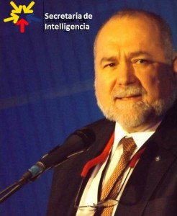
Robert David Steele Vivas
The tide has clearly turned against the techno-financial paradigm that disregards natural capital costs and exploits the 99% in favor of the 1%. Even a few billionaires have figured this out.
Time, however, is not on our side, nor is truth easy to find in today’s severely corrupt information environment where all eight tribes of information — including self-absorbed “progressive” activists — operate on no more than 2% of the relevant information and ignore the three things that I consider essential to saving civilization and creating a prosperous world at peace, a world that works for all: holistic analytics, true cost economics, and open source everything engineering.

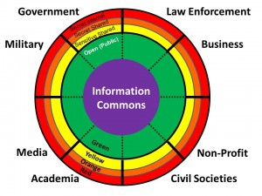
I was asked recently to sum my life’s work up in an “elevator speech.” Below is an early attempt to do exactly that:
The truth at any cost lowers all other costs. We have been living a lie across all domains from government and corporate to academia, media, and non-profits, consuming natural capital and concentrating financial capital for the benefit of the few at the expense of the many. As Lady Lynn Rothschild (Inclusive Capitalism) and others (Redemptive Capitalism) are now realizing, nature bats last and a public uprising of the 99% is inevitable on our present course. To achieve the Sustainable Development Goals and stabilize the world — both protecting the existing wealth of the 1% and creating infinite new wealth for the 99% while stopping the suicidal paths we are on with unilateral militarism, predatory capitalism, and virtual colonialism, requires one simple but total change: a migration toward the truth as the new currency, manifested in holistic analytics, true cost economics, and open source everything engineering.
In this short post I will explain each of these three terms, and conclude with the specific institutional and local to global networks I believe we can and must build now if we are to achieve our potential as homo sapiens.

THREE CONCEPTS
Holistic Analytics. The problem with all efforts by all tribes — without exception — is that none of them attempt to define and study all threats simultaneously with all policy domains against all demographics. Below is an illustration of one holistic approach, there are others. Noteworthy below is the reality that corrupt governments, led by the US Government, focus on inter-state conflict and terrorism — threats of our own making — while ignoring the fundamentals. They do this because an apathetic dumbed-down public does not realize that peace and prosperity are vastly more profitable for the whole, and failing to keep government honest — the point of democracy — is a form of social suicide.
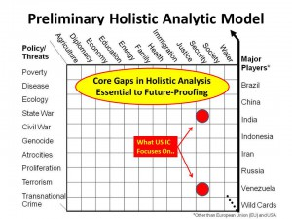
True Cost Economics. We are close to but not yet at a point where everyone appreciates true cost economics as pioneered by Herman Daly and a few others. True cost economics refers to the actual natural capital cost of specific policies, produces, services and behaviors. Buckminster Fuller is reputed to have said that most Western jobs are not worth the petrol required to get the worker to and from their factory job or cubicle job. Today some of us understand the human cost, the social cost, the long-term economic and political cost, of truly insane choices including elective wars and legalized financial crime — what Matt Taibbi calls Griftopia, but this has not become mainstream. Also lacking is the ability to track true costs with geo-tagging of supply and use chains so that we can get to the exact amount of virtual water, fuel consumption, toxins generated, child labor, regulatory violation, and tax avoidance.
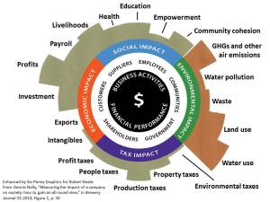
Open Source Everything Engineering. Two of over 2,000 non-fiction books I have read capture for me the essence of our dilemma. The first, by Peter Linebaugh, STOP THIEF! The Commons, Enclosures, and Resistance, head-slaps every politician, corporate leader, and non-profit pontificator. The second, by Charles Bednar, Transforming the Dream: Ecologism and the Shaping of an Alternative American Vision, goes to the educational and ethical roots of our current impasse — the divide between people with power and money, and those with knowledge and ethics. My own awakening came from my experience as the senior civilian creating the Marine Corps Intelligence Activity, spending millions on access to all our secrets only to find out that the secret world knows, “at best,” 4% of what one needs to know to make intelligent ethical decisions about strategy, policy, acquisition, and ethics. I started the Open Source Intelligence (OSINT) revolution in 1988, and have been sad to see trillions of dollars and millions of lives wasted over a quarter century because of the refusal of the US Government to be serious about holistic analytics, true cost economics, and OSINT. In 2012 I expanded my vision with The Open Source Everything Manifesto: Transparency, Truth, and Trust, and I now understand that the greatest enemies of humanity are bankers, lawyers, and politicians — they serve the 1%, not the 99%, and enable recurring crimes against humanity. The solution, one I devised with some counsel from Marcin Jakubowski of Open Source Ecology and the Global Village Construction Set, and Michel Bauwens, founder of the Peer to Peer (P2P) Foundation, is shown below. We must abandon the proprietary world that seeks to fence knowledge as the physical world has been fenced, and move immediately to an Open Source Everything approach to everything from Smart Cities to Sustainable Defense.
FIVE INSTITUTIONS & NETWORKS
It has been my great privilege to learn from giants in the Collective Intelligence arena, such as Tom Atlee and Francis Heylighen, as well as the 2,000 plus non-fiction authors I have reviewed at Amazon, and the 7,500 adult students that have attended my international conference and small training sessions. Below are the five institutions and networks I want to build over the next twenty years.
Open Source (Technologies) Agency (OSA). My memorandum to Vice President Joe Biden — certified as delivered to the White House but evidently not read — makes the three-page case for this $2 billion a year new agency that the Office of Management and Budget (OMB) has twice approved. This agency would be an innovation engine for the country and the world. With two bureaus, a D3 (defense, diplomacy, development) Information Bureau and a D3 Innovation Bureau, it would accelerate the availability of free solar and other forms of renewable energy along with unlimited desalinated water, pressed brick construction with composing, free cellular and Internet access, and aquaponics. Naturally the legacy systems see this as a threat, one reason I have been focused on the need to restore integrity to our electoral and governance processes. This agency is needed to stabilize and reconstruct the world — not just “over there” but here at home where over 30 Texas towns are about to run out of water, in Kansas were unethical leaders have allowed fracking to threaten their entire society and economy, and beyond.
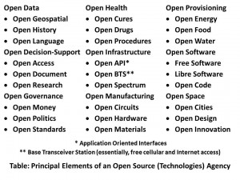
United Nations Open-Source Decision-Support Information Network (UNODIN). Despite my grave reservations about the United Nations (UN) stemming in part from the corruption across all of the specialized agencies that are not subject to the authority of the Secretary-General, I do consider the UN a local to global vehicle with great potential, provided it can out-grow its inherently ignorant approach to information and its very unsophisticated dependence on statistics about the past instead of pro-active decision support shaping the future. My invited white paper for the UN, delivered to the Secretary General but evidently not read, Beyond Data Monitoring: Achieving the Sustainability Development Goals through Intelligence (Decision-Support) Integrating Holistic Analytics, True Cost Economics, and Open Source Everything is not as detailed as some might wish, but it is a starting point. If the UN wishes to achieve the SDG goals in a fraction of the time at a fraction of the cost, this white paper explains how to do that. As with the OSA, there are many entrenched interested that would rather protect the 80-90% of donor dollars they are able to steal while going through the motions. This too demands integrity in leadership.
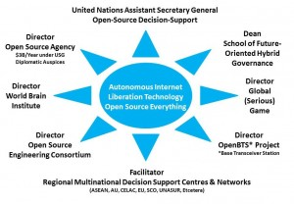
Within this larger UNODIN, or separate from it if we cannot get funding for the OSA and UNODIN, are three critical civilization-saving elements.
Multinational Decision-Support Centre. The current governance and corporate paradigm is based on lies and a lack of accountability for willful malfeasance. The reliance upon secrecy and bi-lateral information exchanges instead of open multi-lateral information sharing and sense-making makes everything worse. The 935 lies that were told to justify a US invasion of Iraq stand out as worthy of an International Tribunal and a lesson for the future. Never again must any international body allow itself to be lied to in this fashion. In order for Europe, and the Union of South American Nations (UNASUR) and the African Union and others — Brazil, China, India, Russia, South Africa (BRICS) to be effective at detecting and confronting American lies in the future, they must have their own decision-support centres and those centres must be open and multination. We still need some spies and we need something we do not have now, ruthless pervasive counterintelligence against financial, ideological, and religious traitors, but 95% of our needs can be met with open multinational decision-support processes and we are irresponsible to ignore this fundamental fact.
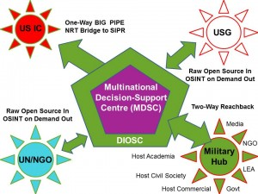
School of Future Oriented Hybrid Governance. No one, anywhere, is bringing together all of the disciplines (we pay lip-service to multidisciplinary studies, and are generally mono-lingual at that) and all eight tribes of information to design a future that is sustainable, ephemeral, and human-centric. Our schools do not teach holistic analytics, true cost economics, and open source everything engineering innovation as a whole. There is a need for a new PhD program, perhaps the first “meta” PhD, one I would like to create, teach, and earn.
Such a School would embody the above meta concepts while implementing the below practical forms of developing, testing, and promulgating Applied Collective Intelligence.
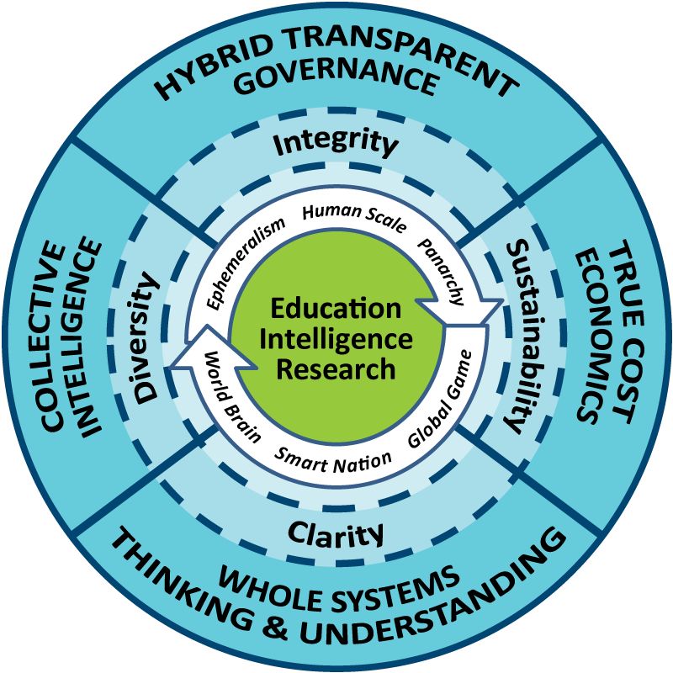 | 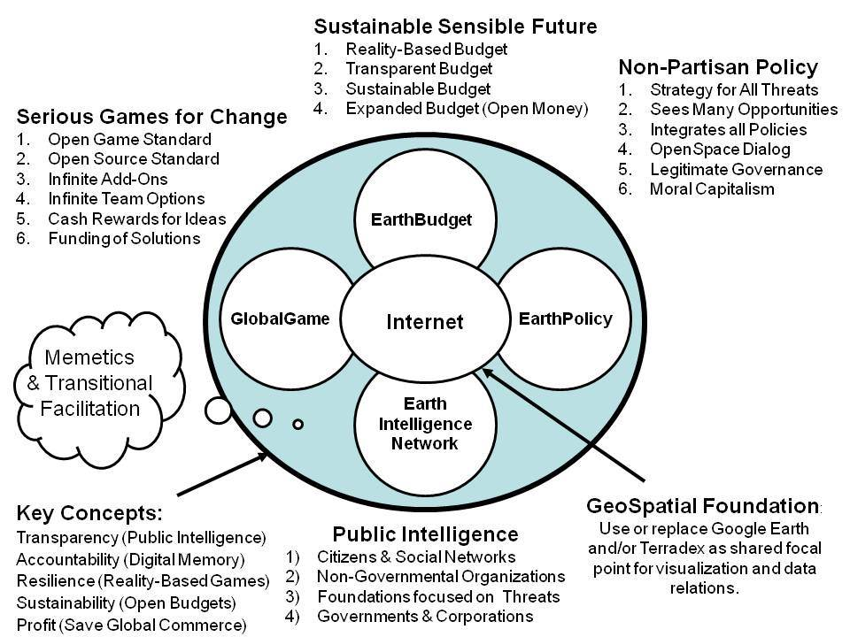

World Brain Institute. Finally we come to something I have long felt the need for (and I in fact own the domain names, World-Brain.net, World-Brain.org, and World-Brain.com, lacking only World-Brain.edu). As the concepts for collaborative and sharing economics develop, we are finding that fifty percent or the “profit” is to be found in the eradication of corruption and waste across every domain from agriculture to education to energy to family to health to the military and water and more. We are finding that Applied Collective Intelligence allows us to fully satisfy and nurture individuals with free energy, free water, free cellular, free Internet, and the makings of an aquaponics industry free of pesticides, for $500 each. We can achieve a prosperous world at peace, a world where a head of household need only work 60 days a year to support a family of five (as was the case with the Mayans prior to 1492). The balance of the time can be spent innovating for humanity and becoming worthy of more cosmic possibilities.
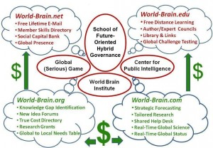
These are the ideas that need a home. Have brain, will travel.
See Also:
Applied Collective Intelligence
Robert Steele Professional Online Site

