BIOGRAPHY:
Robert David Steele is a Latino born in New York in 1952 – he has spent his life overseas as the son of an oil engineer, as a Marine Corps infantry officer, as a spy for the CIA, and as the CEO for a company that trained 7,500 intelligence officers across 66 plus countries, in Open Source Intelligence. He is the most published intelligence reformer in the English language, with eight books on this topic, two of them with Forewords from Senators who have been Chairmen of the Senate Select Committee on Intelligence. He is also the top Amazon reviewer for non-fiction, reading in 98 categories.
After 9/11, Robert turned his attention from intelligence reform to electoral reform, inspired by a mix of shock over how Dick Cheney got away with 9/11; the complete dishonesty of academic, media, and the intelligence community itself in failing to challenge the 935 lies that led us to an elective war on Iraq after 9/11; and the realization that no issue – whether climate change or gay rights or economic justice – would get an honest hearing from a two-party tyranny fronting for Wall Street.
He first wrote on electoral reform in 2002, in an essay inspired by Lee Iacocca’s book, Where Have All the Leaders Gone and was entitled “Citizen in Search of Integrity.” It is available free online. He began a program of non-fiction reading on the topic of democracy, reviewing over 300 books on this topic at Amazon, among which he particularly recommend Theresa Amato’s book, Grand Illusion: The Myth of Voter Choice in a Two-Party Tyranny. In 2011 he joined the Occupy Working Group on electoral reform – his six-minute video to that group went viral, making the front page of Reddit. Working with Jim Turner and others in 2011, he developed the first version of the integrated Electoral Reform Act with eight elements – Jim created the Electoral Integrity Pledge. In 2012 he was accepted by the Reform Party as one of three candidates for their presidential nomination, reached out to many people across the country who care about electoral reform including Richard Winger, author of Ballot Access News. His presidential web site, We the People Reform Coalition, is still online as a repository for reform ideas.
In 2013 he wrote an essay, “Democracy Lost”, backed up by 100 book reviews, this too is available free online. In 2014, working with other electoral reform activists, he expanded the Electoral Reform Act to 12 topics, and that is the version of the Act we will discuss today. He is the author of a Kindle book Open Power: Electoral Reform Act of 2015 – Open Source Activist Tool Kit, and a Kindle short, Democracy Riots! We are all black now – deal with it!

01 Before we get into electoral reform, let’s explore something else you are known for, your analysis of the preconditions of revolution that exist today in the USA. Popularized by The Guardian profile of you in June 2014 that has 73,000 shares today, I understand that this is the most popular graphic at Phi Beta Iota Public Intelligence Blog. Our listeners can find the graphic and more at http://tinyurl.com/Steele-Revolution.
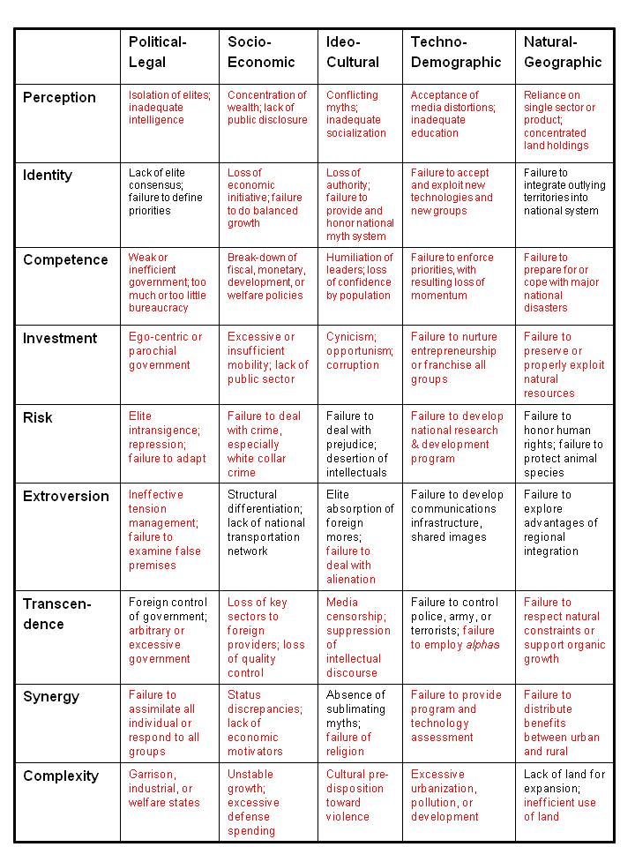

02 That’s some very scary compelling stuff. Now walk us through who votes now – did Barack Obama really win with only 26% of the eligible voters? What is the landscape of victory for someone like Gary Johnson or Jill Stein?
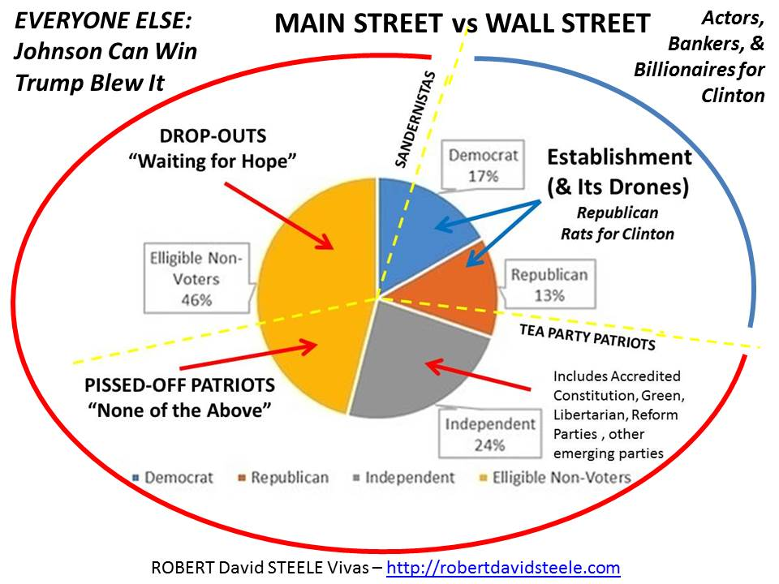
03 With that as warm-up – I agree that we have some huge issues that are not being dealt with by our government, let move to your perception of the current election cycle, focusing only on the presidential race. Stanford University says that multiple primaries were stolen from Bernie Sanders; you have told me Bernie Sanders blew you off eight times on electoral reform. Donald Trump says the system is rigged but you tell me that his staff has for over a year rejected your suggestion that Trump demand an Electoral Reform Act. Where are you on all this?
04 Is it too late to unrig the system in this electoral cycle? Distinguish between unrigging the presidential race, Congressional races, and any opening you see in the 20-30 vacated seats that do not have defending incumbents.
05 Walk us through the twelve elements of the Electoral Reform Act that you and others have put together – I understand that you believe this is a starting point, not a take it or leave it prescription, but that you feel strongly we need to implement all twelve reforms at the same time.
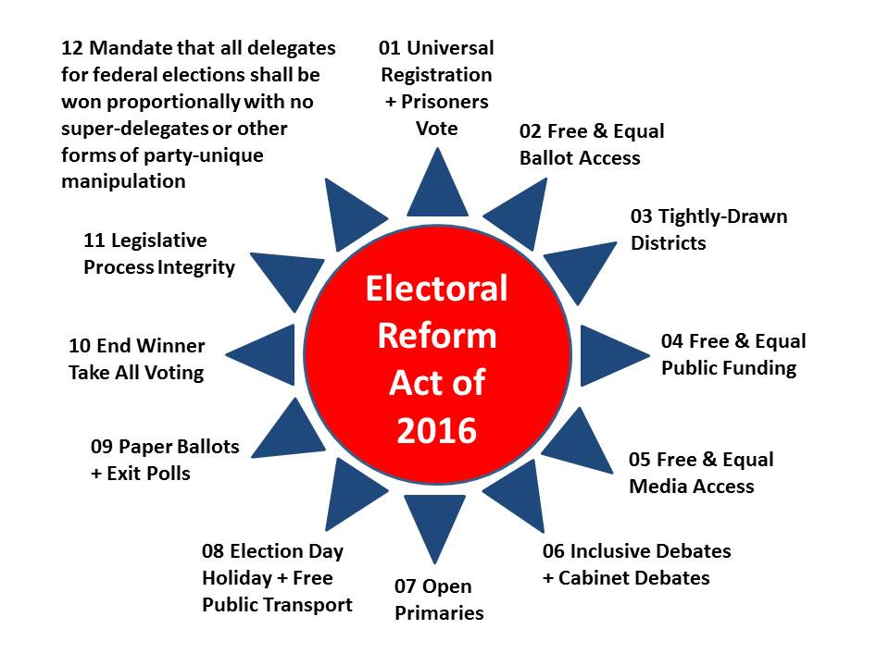
06 Say you succeed. Speaker Paul Ryan, a Tea Party populist, and Senator Rand Paul, a closet Libertarian, jam through the Electoral Reform Act with their two Republican majorities and some side deals with the Democrats. What will this do to the current presidential and congressional election cycle?
07 You are not a politician. Win or lose, beyond electoral reform, what do you want to do with your life going forward?
WEB SITE REFERENCE POINTS:
TWO VIDEOS:
6 Minutes: Robert Steele on Electoral Reform (Occupy, NYC)
14 Minutes: Robert Steele on Electoral Reform (Portland, OR)

TWO ONLINE ESSAYS:
2016 Robert Steele: Open Power – Democracy Riots – We are all black now, deal with it.
Open Power: Democracy Lost & Found Essay, Book Review Blurbs and Links [Updated 3 MAR 2015]

