Grand Strategy: No Candidate Is Serious…
To keep America safe we need to have a government (including military and police) that works as it should as well as a society that works for all; and to stop destabilizing the world while putting America – the 99% disenfranchised economically, politically, and socially – first. Getting there is not rocket science; it requires a Grand Strategy and intelligence with integrity.
The last modern Grand Strategy review was conducted at the direction of President Dwight D. Eisenhower in 1953 – Project Solarium. Everything since then, including our Quadrennial Defense Reviews and our National Military Strategy, has been a mélange of platitudes devoid of holistic analytics, true cost economics, or devotion to the public interest.
The military-industrial complex (and other complexes including the agricultural and pharmaceutical complexes – and the financial class set free to run amok when the Clinton Administration removed all legal restraints on what Matt Taibbi calls “Griftopia,” have together destroyed the heart and soul of America: its blue collar master class and white collar middle class.
A Grand Strategy would seek to restore the foundation of national power that Hans Morgenthau emphasized: a strong, healthy, fully-employed public. It would also seek to assure that industrial reform is job and revenue-neutral across every political jurisdiction (not as hard as it might sound). Most importantly, a Grand Strategy would ensure that every threat is addressed; that every policy is coherent and affordable; and that no demographic is left behind. Today the candidates and the intelligence community focus only on two of the ten high-level threats to humanity, war and terrorism – they ignore poverty, infectious disease, environmental degradation, genocide, other atrocities, proliferation, and transnational crime including Wall Street crime and non-profit charity crime. All four candidates are lacking in holistic policy development and not of them is capable of producing a balanced budget that eschews borrowing from banks, eliminates the average 50% waste, and is totally devoted to lifting up the 99% whose backs the 1% have literally broken en passant.
What Is To Be Done?
Since the 1990’s it has been my honor to be an External Researcher for the Strategic Studies Institute (SSI) of the US Army, one of the most honest, holistic enterprises in the strategy arena. No other organization would have had the integrity – and the liberty – to produce, for example, Lying to Ourselves: Dishonesty in the Army Profession (February, 2015).
I care deeply about the US military, and despite my past as a naval officer – a Marine Corps officer – consider the US Army the centerpiece around which we should build our national defense. It is a crime – strategically, financially, practically – to devote only 1% of the defense budget to the 4% of the force that takes 80% of the casualties, the infantry. It is a crime to have waste across defense documented at 45% (weapons acquisition) to 75% (Afghanistan). It is a crime to have a military that cannot win wars or (more often than not handicapped by politicians) impose peace. It is a crime for this dysfunctional military to consume 60% of the FY 2015 disposable budget and 16% of the total FY 2015 budget. The US military today – good people trapped in a bad system – is nothing more than a financial feeding trough from which corporations and banks feed at public expense.
Below is the central chart from the first third of my new work for SSI, Reinventing the US Army. Unlike past endeavors along these lines, many of them brilliant but handicapped by the false boundaries of the budget-share game, I don’t move the deck chairs on the Titanic, I embrace the sinking of the entire ship and start over with a 450-ship Navy, a long-haul Air Force, and a home-based Army that takes over Close Air Support (notably the A-10 tank killers and the AC-130 gunships). Such a force must be trained, equipped, organized, and utilized within a strategically coherent cost-effective White House & Congressional policy matrix, intelligence with integrity that eschews regime change while actually providing all-source decision-support to all Cabinet departments; and a $150 billion a year plus up to Diplomacy & Development, the long-neglected orphans of the D3 (Defense, Diplomacy, & Development) Construct, given some weight by Secretary Ash Carter in his call for D3 Innovation in September 2014.
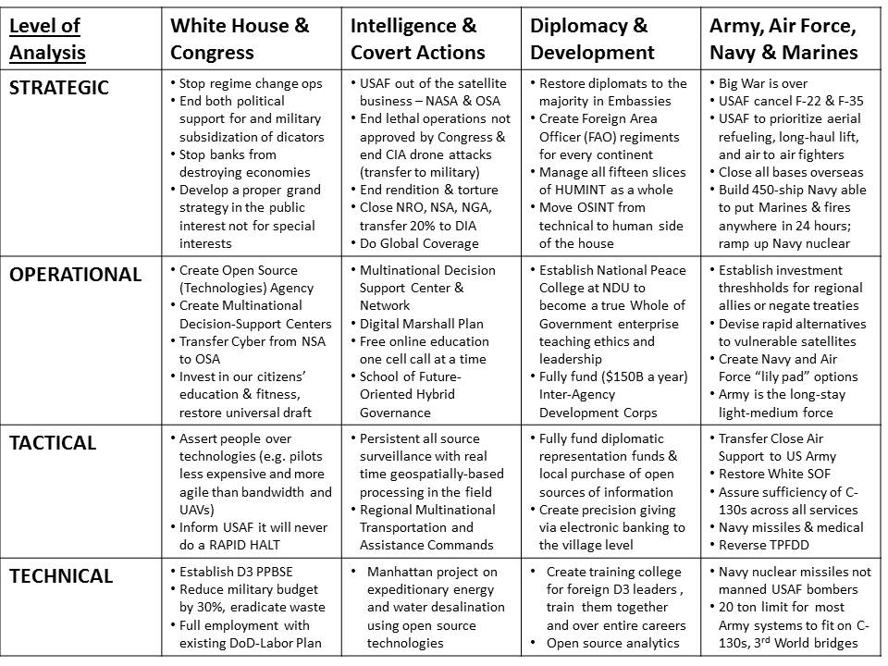
This first third of my Army monograph in author’s final draft is now available to the public as a Kindle Short at Amazon, and also free online. Forty-nine pages, no lies, just the plain truth. Will Grand Strategy be discussed in any presidential debate? Probably not – it is not theater.
Robert David Steele, CEO of Earth Intelligence Network, an educational non-profit, has spent forty years as an intelligence reformer focused on the need for strategic holistic coherence. In 2012 he was accepted as one of three candidates for the Reform Party presidential nomination. He is the author of ten books including Intelligence for Earth and The Open Source Everything Manifesto. His personal website is http://robertdavidsteele.com.

