MEMORANDUM
Seven National Security Talking Points for the Presidential Debate Cycle
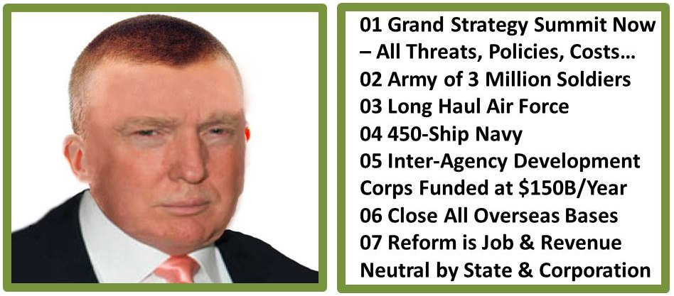
1. Grand Strategy. America does not have a Grand Strategy – a review of all threats and all policies and all costs – together. The last grand strategy review was Project Solarium under President and former General Dwight D. Eisenhower. What we have done since then is spend money without accountability. There are ten high-level threats to humanity starting with Poverty, Infectious Disease, and Environmental Degradation. Among the neglected critical policies are those dealing with Agriculture, Energy, and Water.
If I am elected President I will personally lead a Grand Strategy Summit.
2. We Need to Close All 1,000 Overseas Bases. Ron Paul and Dennis Kucinich and many others have it right. Our bases overseas, apart from being a form of occupation that is despised by many including citizens in Germany, Italy, Japan, and Korea, dilute our forces and make it more difficult to converge the right tailored forces when and where needed. We need to bring our troops – and their wallets – home to America.
If I am elected President I will close all US military bases overseas.
3. We Need a Joint Force That Can Win Wars. The Pentagon – and NATO – are nothing more than a spending bucket for the military-industrial complex. It is outrageous that our military costs 60% of the disposable budget – 16% of the total budget – and yet it cannot win wars. The Infantry, 4% of the force that takes 80% of the casualties, gets 1% of the budget. Everything else is pork, from the F-35 in the Air Force to the USS Gerald Ford in the US Navy to the many Army systems that have proven to be too heavy and too expensive. Reform can be job and revenue neutral for states and corporations -- the savings will go toward domestic needs.
If I am elected President I will build a 450-ship Navy, an air-mobile Army of no less than 3 million soldiers, and a long-haul Air Force.
4. We Need a National Security Strategy for Peace and Prosperity. Ash Carter is to be commended for focusing on D3 Innovation. D3 stands for Defense, Diplomacy, and Development. We spend too much on a heavy metal military and not enough on peaceful preventive measures.
If I am elected President I will transfer $150 billion a year from military spending to diplomatic and development spending to include an Inter-Agency Development Corps and an Open Source Agency that propagates free energy, unlimited desalinated water, free cellular and Internet access, hence education for all. We will create peace and prosperity for all as the fastest cheapest means of ending the global threat from tens of millions of displaced persons and illegal immigrants created by our support for dictators and elective wars.
5. We Should Not Be the Primary Force for Everyone Else. No one else spends as much as we do on military force in part because everyone else is relying on us – and laughing at us because we let them get away with it. There are four million Arab soldiers in the Middle East and yet they expect us to defeat 30,000 ISIS irregulars? I don’t think so. Yes, we will crush ISIS and yes we will support allies, but only if they take on the responsibility for arming themselves and training their militaries to our standards. Part of my justification for an Army of three million – 1% of our adult population – is to create a new global grid of by with and through human engagement – we will export tough big-hearted American soldiers on training missions that help avoid war, we will no longer engage in elective wars that enrich banks and create millions of illegal immigrants.
If I am elected President, we will stop trying to control the world at the point of a gun for the benefit of bankers and against the public interest.
6. Our Revitalized Military Can Revitalize Our Economy. Our weapons and mobility systems have gotten too complex and too expensive at the same time that we have neglected to train our soldiers and citizens in advanced technologies despite having substantial military training facilities that are under-utilized. I want to revive the plan created under President Ronald Reagan, a plan that called for using military training facilities to train our civilian workforce to do 21st Century jobs. I envision a return of manufacturing jobs to the USA; a radical increase in the number of US citizens who can do advanced information technology jobs at the same time that I reduce immigrant visas that lead to less work for US citizens; and the complete rebuilding of America’s physical and electronic infrastructure as well as people-centered neighborhoods.
If I am elected President, our military will stay home and help rebuild America while being ready to deliver great force with great precision anywhere in the world if necessary.
7. A Nation’s best defense is an educated, fit and happy citizenry. It troubles me that our country has lost its education edge and also lost its fitness edge. Too much of what we eat is bad for us; our economy is designed to create couch potatoes that consume poison without thinking. It also troubles me that we have a real unemployment rate of 23% and that over 40% of our adults are either unemployed or partly employed, most not receiving benefits. I am troubled as well by student and medical debt and other forms of financial predation on our citizens. I invite everyone in debt to sign the Debt Renunciation Pledge at [TBD].
If I am elected President I will assure the employment of every citizen who seeks a job, on a full-time basis with benefits; I will provide truthful information via a hand-held app to every citizen on what is actually in all these horrible products we are drinking and eating; and I will renegotiate student and medical and small business debt or I will declare a debt jubilee and give you all a presidential pardon while terminating the central banking power in the USA.
Rooted in a Grand Strategy, evidence-based national security planning, programming, and budgeting can eliminate waste, create enormous powerful military capabilities, and revitalize the economy by focusing on the public interest, not special interests.
This is my promise to you: elect me and I will represent the 99% not the 1%.
NOTE: A sanitized version of this memorandum has been provided to the Johnson, and Stein campaigns. The Clinton campaign is already committed to the status quo.
NOTE TO THE CANDIDATE: Slam the Optics, Show Your GO ARMY Short Hair Virtually…

