“Deep State versus Trump State: A Spy’s Perspective“
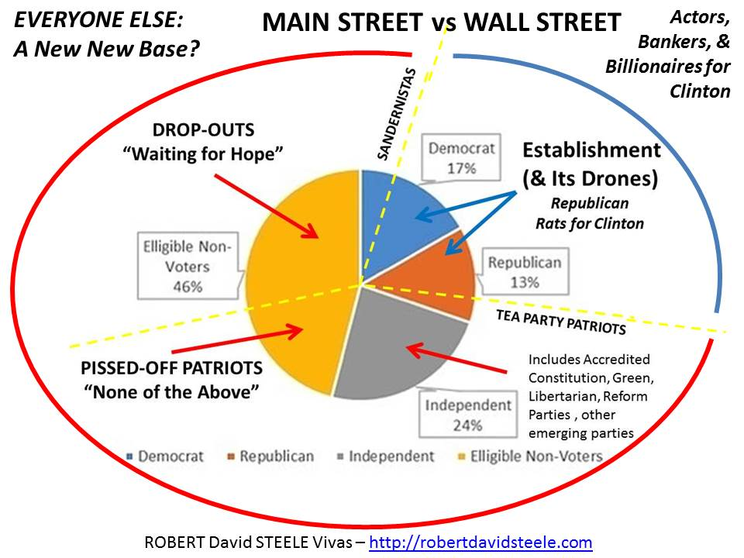
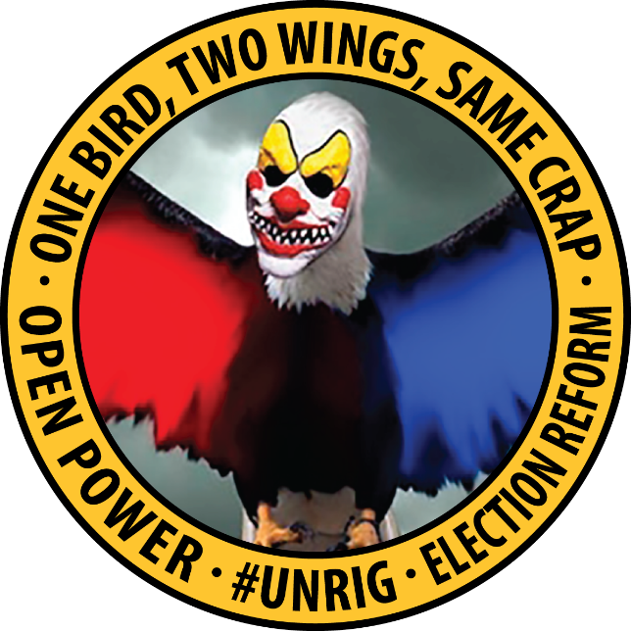 | 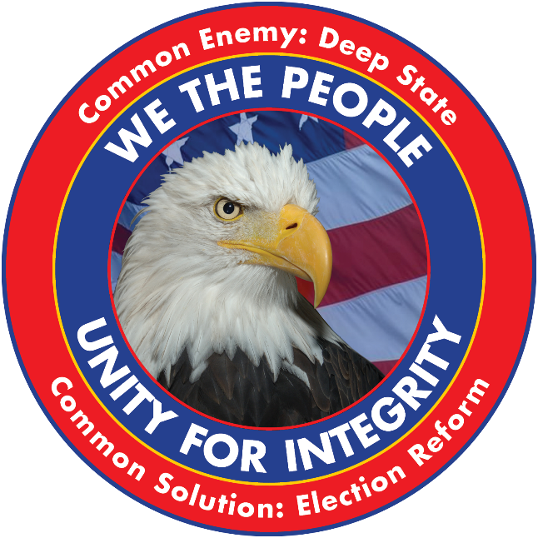
Donations can be made via http://paypal.me/EarthIntel or https://www.patreon.com/EarthIntel
Speech Outline on Reverse
Graphic & Papers on Revolution at https://tinyurl.com/Steele-Revolution

01 God Bless Donald Trump -- Playing the Long Game
-- US Political Landscape -- 17% D, 13% R, 24% Small/lnd, 46% Not Voting At All
-- Grand Strategy -- What Is It, Why Does It Matter?
02 Donald Trump, Accidental President, Under Siege
-- Electronic Ballot Tampering in 13 Primaries Stopped in General
-- Spies and Lies -- Brennan's Treason, Russians Did Not Hack Anything
-- #GoogleGestapo, Leftist Propaganda versus Fly-Over Common Sense
-- 3 Million Illegal Voters on the Left, 1 Million Suppressed Blacks on the Right
-- The $20B Question – Did Lynn Rothschild Bribe DT to Throw the Race?
03 Deep State from Bankers to Two-Party Tyranny to Spies and Media Shills ++
04 Donald Trump versus the Deep State – a Preliminary Evaluation
-- Precautionary appointments prior to Inauguration Day
-- Successes since Inauguration Day (despite being under siege)
-- Mistakes since Inauguration Day
-- Ignored Opportunities
---- Trump Channel with PollMole.Vote & Open Source Agency
---- Close NSA, Suspend CIA
---- Close All Bases Overseas, Leave NATO/UN, Tough Love DoD
---- Honest Health Care (Karl Denninger/Balances Budget)
---- Automated Payment Transaction Tax, Put Burden on Wall Street
---- Debt-Be-Gone, DT as Agent for 3 Trillion Owed by 150 Million
Robert David Steele is a former spy recommended for the Nobel Peace Prize in 2017. He was also recently appointed as a Commissioner to the International Tribunal for Natural Justice that is undertaking an inquiry into child trafficking and exploitation. He is a former Marine Corps infantry officer and author of many books including The Open Source Everything Manifesto: Transparency, Truth & Trust. As a spy he managed a false flag operation and is intimately familiar with the Deep State and the role of the CIA in supporting the Deep State. Mr. Steele ran briefly for the Reform Party presidential nomination in 2012 and became a proponent for the 12-point Electoral Reform Act. An honorary hacker praised by Alvin Toffler, Bruce Sterling and others, he wrote the first warning letter to the White House on cyber security in 1994 and is now organizing a new internet to counter Google's dominance. An early supporter of Donald Trump, he is the author of the Trump Revolution series at Amazon Kindle (titles are also free online). A prolific author, he is also the top Amazon reviewer for non-fiction, reading in 98 categories.
---- #UNRIG - Election Reform to Broaden Base, Survive GOP Collapse
-- All of the pre-conditions for a populist revolution exist now
05 RIGGED: Twelve Ways the Deep State Controls Elections
-- Voter Suppression & Voter Fraud FIX: Universal Registration
-- 70% Denied Ballot Access FIX: Free & Equal Ballot Access
-- Gerrymandering FIX: Tightly-Drawn Districts
-- 40 Billionaires Own Congress FIX: Public Funding of Campaigns
-- Corrupt Media & Polling FIX: Free & Equal Media Coverage
-- Debate Commission Stolen from LWV FIX: Restore LWV + Cabinet Debates
-- Rigged Primaries FIX: Open Primaries, End Super Delegates
-- Election Day "Inconvenience" FIX: Holiday, Free Public Transport
-- Electronic Ballot Fraud FIX: Paper Ballots Counted Publicly on Site, Exit Polls
-- Split Votes Elect Minority Choice FIX: Instant-Run-Off
-- Legislation is Pay to Play FIX: Posted in Advance with Change Tracking
-- Anti-Union/Federal Reserve FIX: Repeal Taft Hartley 14B, Nationalize Federal Reserve
06 Truth & Reconciliation – Rationale for 99% Mercy Toward the 1%
07 Beyond Trump, Beyond Sanders — A Second American Revolution?
-- Phase I: Beyond Ideologies and Issues with We the People - Unity for Integrity
-- Phase II: Creating a National Conversation about America the Beautiful
-- Phase III: Congress 2018 -- Alt-Left, Alt-Right, Deplorables Rising
-- Phase IV: Holistic Analytics, True Cost Economics, & Evidence-Based Governance
-- Phase V: Presidency 2020 -- Trump 2.0 or a Coalition Team?
-- Phase VI: Migrating Revolution to AU, CA, UK -- Future of English-Speaking Nations
-- Phase VII: A New World Order: 99% Rule, Open Source Everything Engineering (OSEE)

SPY IMPROV: Ask Me Anything – Questions will be welcomed on any topic.

++ Pedophilia, Child Murder, Child Harvesting of Body Organs and Bone Marrow

