The Open Source Way
Achieving the UN SDG Goals in 10 Years for 10% with OSEE

ROBERT David STEELE Vivas

Table of Contents
Dedication 2
Preface 3
Introduction 6
Creating the Future with 12
Open Source Everything Engineering (OSEE) 12
OSEE: The Nordic Manifesto 58
Proposed: An Open Source (Technologies) Agency 70
In Harmony with All Life: The Open Source Way 77
The Open Source Everything Manifesto 81
About the Author 85

Dedication
This collection of papers on Open Source Everything Engineering (OSEE) is dedicated to the six people on the planet who have the power among them to end war and waste by embracing the Open Source Way – the use of public open intelligence (decision-support) and OSEE to create a prosperous world at peace.
Donald Trump, President of the United States of America from 20 January 2017, enters office having already spoken about the need to end US sponsorship of regime change operations and other costly elective endeavors championed by the military-industrial complex. He also enters office with a sound appreciation for how the secret intelligence world is largely worthless and often dangerously provocative, as with the recent lies by the secret world in claiming that the Russians hacked the US election.
Mike Flynn, National Security Advisor to the President of the USA from 20 January 2017, reached out to me in 2014 and is fully aware of the enormous value to the President, the Cabinet, and the Congress as well as the public, which an Open Source Agency could render.
Antonio Guterres, the Secretary General of the United Nations (UN) from 1 January 2017, comes to his new task with a past as Prime Minister of Portugal, and as the UN High Commissioner for Refugees – more than most he understands that refugees are the single most costly product of war as a business model favored by banks.
Amina Mohammed, the Deputy Secretary General, leaves her post as the Minister of Environment for Nigeria where she has earned a reputation as one of the world’s foremost champions for addressing climate change. Prior to her cabinet appointment she served as a special advisor to the departing Secretary-General Ban Ki-Moon, and thus is deeply familiar with the realities of UN mis-management, including the unresponsiveness of the Specialized Agencies who view themselves as completely autonomous from the main body of the UN.
Narendra Modi, Prime Minister of India, is known for rising from humble beginnings. Throughout his political career he has focused on economic growth, privatization, and making India a global manufacturing center. He has been criticized for not doing enough to alleviate poverty – the ideas in this collection can eliminate poverty in India and everywhere else while also helping him cleanse the Ganges with Open Source Everything Engineering (OSEE).
Nikki Haley, the incoming US Ambassador to the United Nations, is the former (and first female) Governor of South Carolina. Born to Sikh immigrants, she is perfectly positioned to engage India and other countries in support of a larger vision in which the US and the UN work together to end war and waste by embracing “the open source way” toward peace and prosperity for all.

Preface
In 1988, as the senior civilian responsible for creating the Marine Corps Intelligence Activity (MCIA), I discovered that the secret world does not know very much about the real world – the spies obsess on a few hard targets or peer competitors in the military sense – China, Iran, Russia, for example – and ignore everything else – Burundi, Haiti, Poverty, for example.
I started the Open Source Intelligence (OSINT) revolution in 1988. From 1988 to 1994 I recognized that we should not send spies where schoolboys can go; that we need intelligence (decision-support) for all policy domains, not only national security; and that OSINT is faster, better, and cheaper than spying for 90% of the topics we need to understand.
Beginning in 1994, when I was invited to be the opening speaker at Hackers on Planet Earth (HOPE) and met Richard Stallman, the father of the Free/Libre/Open Source Software (FLOSS) movement, I realized that there were more opens – open source software, open source hardware to start with – and I started keeping a list.
In 2007 I was invited to open Gnomedex in Seattle, and my presentation, “Open Everything: We Won, Let’s Self-Govern,” added multiple other opens and for the first time connected the open source way to the ten high-level threats to humanity identified by the United Nations High-Level Panel on Threats, Challenges, and Change – and the twelve core policy areas from Agriculture to Water within which the open source way could enable a prosperous world at peace.
By 2012, when I published The Open Source Everything Manifesto: Transparency, Truth, Trust, my list had grown to over 60 opens. Shortly thereafter, collaborating with Michel Bauwens at Peer to Peer Foundation, we created Category:Open Source Everything with nine major open categories, each with three priority development areas.
In 2015 I proposed an Open Source (Technologies) Agency to support two objectives: the development of a local to global public intelligence (decision-support) capabilities such that we can eliminate war and waste while creating a prosperous world at peace for all; and the nurturing of Open Source Everything Engineering (OSEE) toward the achievement of the United Nations (UN) Sustainable Development Goals (SDG) within 10 years at 10% of the cost that would be required under the prevailing – and failing – industrial, proprietary, donor paradigm.
I was inspired by Marcin Jacubowski, founder of Open Source Ecology, whose actual experience in creating the Global Village Construction Set (GVCS) has documented that tractors and other key artifacts essential to creating wealth among the five billion poor can be built and maintained at 10% to 25% of the cost of a John Deere tractor with all its complexity and need for expensive maintenance.
It was not until I was appointed a Visitor at Loughborough University by Rob Dover, commissioned to create a concept for an OSEE Innovation Centre, and in the course of that work consulted Bojan Radej of Slovania, that I realized that the first half of our success lay in revealing to the public the waste – the true economic cost – inherent in legacy artifacts – and that from there lay a path that allowed public intelligence to stop governments and corporations from favoring war and waste as an economic model in which the few profit at the expense of the many.
In 2016, invited to lecture in Copenhagen and Oslo, my vision, a quarter-century in development, matured further when my Nordic Manifesto was well received, and I was then commissioned to create a three-monograph series for the US Army Strategic Studies Institute (SSI), with the first monograph being a new Grand Strategy that leverages public intelligence to stop the forces of war that are so prevalent in the United States of America – the military-industrial complex denounced by Martin Luther King, Chalmers Johnson, William Blum, and so many others.
This publication is one of three in the UN series – the first, Beyond Data Monitoring – Achieving the Sustainability Development Goals Through Intelligence (Decision-Support) Integrating Holistic Analytics, True Cost Economics, and Open Source Everything, was submitted to the UN in 2014 and ignored – the UN is a bureaucracy with deeply vested interests that are as committed to war and waste as is the military-industrial complex. Refugees are a profit center for too many so-called “non-profit” organizations, and we have not developed the public intelligence capabilities needed to demonstrate that peace is more profitable for the many than war is for the few – the difference is that war concentrates profits that can be used to bribe governments, while peace spreads the profits across billions who seek only to prosper as families and communities.
The third publication, created for an organization seeking to support the Prime Minister of India in his grand vision, is available free online as The Ultimate Hack – Resilient Villages, Smart Cities, Prosperous Nations at Peace — and Unlimited Clean Water, and also as a Kindle Short.
I predicted the displaced persons challenge facing Europe today, in 2002. As we welcome a new Secretary General of the UN, Antonio Guterres of Portugal, and a new Deputy Secretary General, Amina Mohammed of Nigeria, and we prepare for the Inauguration of Donald Trump, a man who understands the terrible flaws of the secret intelligence world and the evil forces that have been arrayed against him – the same forces that General Wesley Clark identified as having achieved a foreign policy coup, the same forces that told 935 now-documented lies to justify multiple elective wars from Afghanistan to Iraq to Libya to Syria to Niger and eventually Nigeria – we have an opportunity.
The Open Source (Technologies) Agency is something that Donald Trump can include in his 100-day plan; it is something the Secretary General of the UN can ask Donald Trump to add to his 100-day plan; and it is something that if implemented as I envision, can allow the Secretary General to cut the UN budget and UN staffing by 50% over ten years, while achieving the SDG goals in 10 years at 10% of the cost as previously understood.
We start with solar energy and water desalination and we ask India, Indonesia, and Nigeria to take the lead in creating OSEE innovation centres.
This is how I wish to spend the final 20 years of my life.
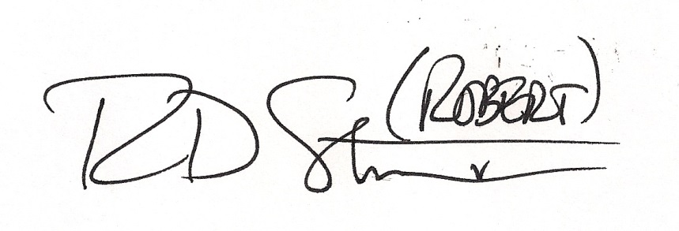

Robert David STEELE Vivas
Earth Intelligence Network
http://robertdavidsteele.com

Introduction
Open Source Everything Engineering (OSEE)
Achieving the SDG Goals in a Fraction of the Time at a Fraction of the Price
Salient Points:
- The Sustainable Development Goals (SDG) are not achievable using the prevailing paradigm of donors, intermediaries, and industrial-era proprietary technologies and costs.
- The SDG goals can be achieved at a one-time cost per person of $500 if the United Nations (UN) will embrace Open Source Everything Engineering (OSEE) as the central method.
- OSEE includes nine major categories – four are known to the UN (Open Data, Open Decision-Support, Open Governance, Open Software), five are largely ignored and their potential not understood (Open Health, Open Infrastructure, Open Manufacturing, Open Provisioning, Open Space).
- An Open Source (Technologies) Agency funded at $2 billion a year by the USA, has been proposed to Vice President Joe Biden and pre-approved in principle by the Office of Management and Budget (OMB) contingent on VP request or Secretary of Defense (SecDef) approval as part of the D3 Innovation Initiative (D3: defense, diplomacy, development).
- A direct inquiry from and engagement by the Secretary General in the very near term could yield an advance on SDG accomplishment unimagined by anyone else.
- More on these salient points, and other related documents charting a path toward achievement of the SDG goals within the decade, is at http://tinyurl.com/Steele-Future.
- - - - - - - - - - - - - - -
The United Nations (UN) could lead and incentivize the achievement of the Sustainable Development Goals (SDG) by and across the five billion poorest in a fraction of the time at a fraction of the cost, if it would embrace the combination of holistic analytics, true cost economics, and Open Source Everything Engineering (OSEE).
Imagine one million Somalis moved from the varied UN camps in Ethiopia, Uganda, and elsewhere, and happily resettled on the northeast coast of Somalia – an uncontested area with nothing more that dirt, seawater, and sunlight – while able to rapidly create a vibrant self-sustaining community with free solar energy, unlimited desalinated water, pressed-brick shelters with compost solutions, free cellular and Internet access, and a thriving aquaponics food industry – all at a one-time cost per person of $500. This is possible. The calculations are online at http://tinyurl.com/500-Civilization. Below is an illustration.

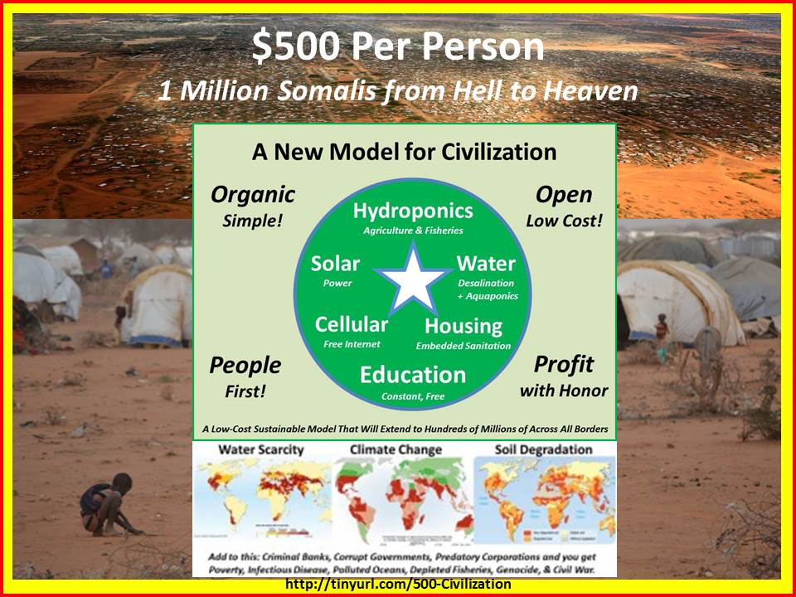

The UN leadership appears unaware of the fact that a new agency, the Open Source (Technologies) Agency, or OSA, has been proposed to the Vice President of the United States of America, and has been pre-approved by the Office of Management and Budget (OMB) at a Final Operating Capability (FOC) budget of $2 billion a year. This agency, inspired by the Secretary of Defense D3 (Defense, Diplomacy, Development) Innovation Summit, would fully fund a D3 Open Source Information Bureau and a D3 Open Source Innovation Bureau. A copy of the Memorandum can be viewed at http://tinyurl.com/VP-OSA.
Were the UN leadership to inquire of the Vice President his views on this new agency, they would discover that the memorandum was not delivered because the staff erroneously concluded that no new agency should be considered this late in the second term. In fact another new agency was just created, to handle security clearances, and there is no better time in modern history for the UN leadership to combine both a new grasp of how OSEE can radically accelerate achievement of the SDGs, and how a direct approach to the Vice President could “free up” $2 billion a year for an OSA with which to achieve the SDG goals quickly and inexpensively.
Among the information-sharing and sense-making elements that the OSA would fully fund for UN coherence and competency are a United Nations Open-Source Decision-Support Information Network (UNODIN), a Multinational Decision-Support Centre, a Global (Serious) Game, a School of Future-Oriented Design & Hybrid Governance, and a World Brain Institute.
Possibilities are illustrated below, drawn from a briefing for the Open Data Institute available at http://tinyurl.com/Steele-Hack. The upper left features the ten high-level threats to humanity identified by the UN’s own Panel, but ignored by most governments and others. The upper right shows how the UN could, using UNODIN, finally begin to harness all that is known across the eight information “tribes” – information without boundaries, if you will.
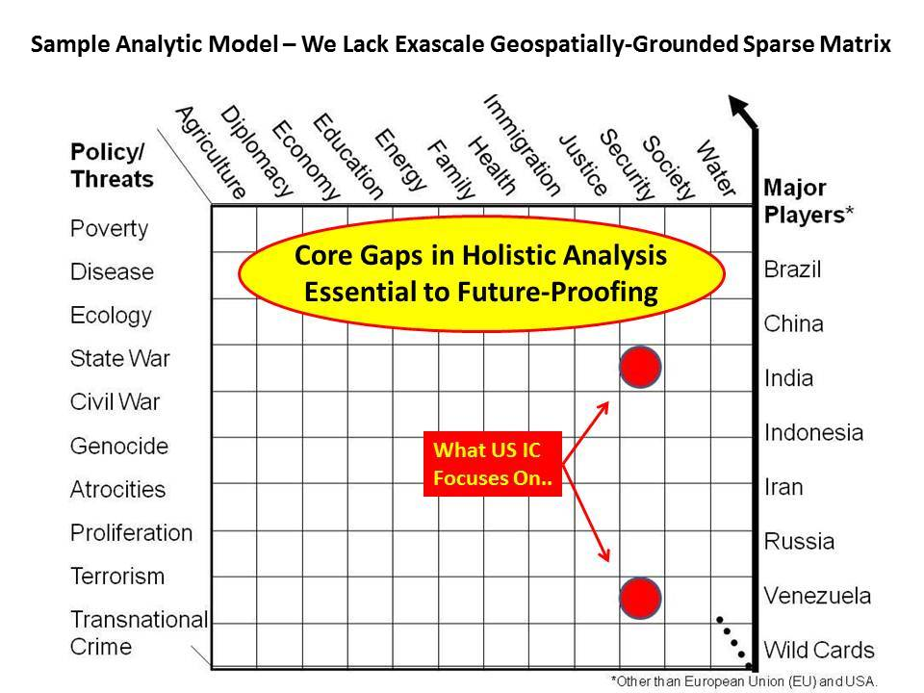 | 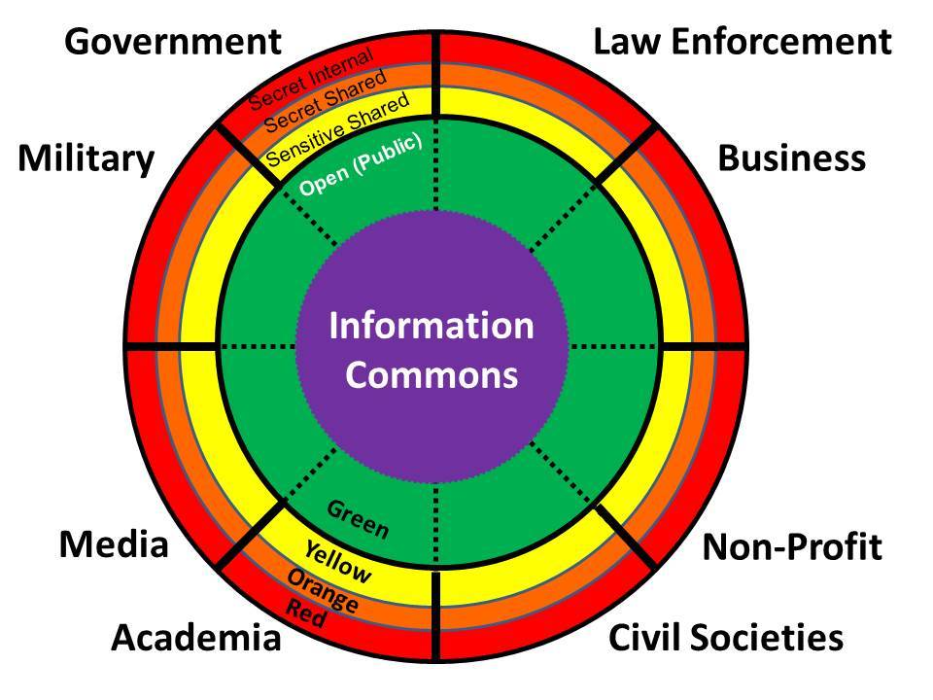
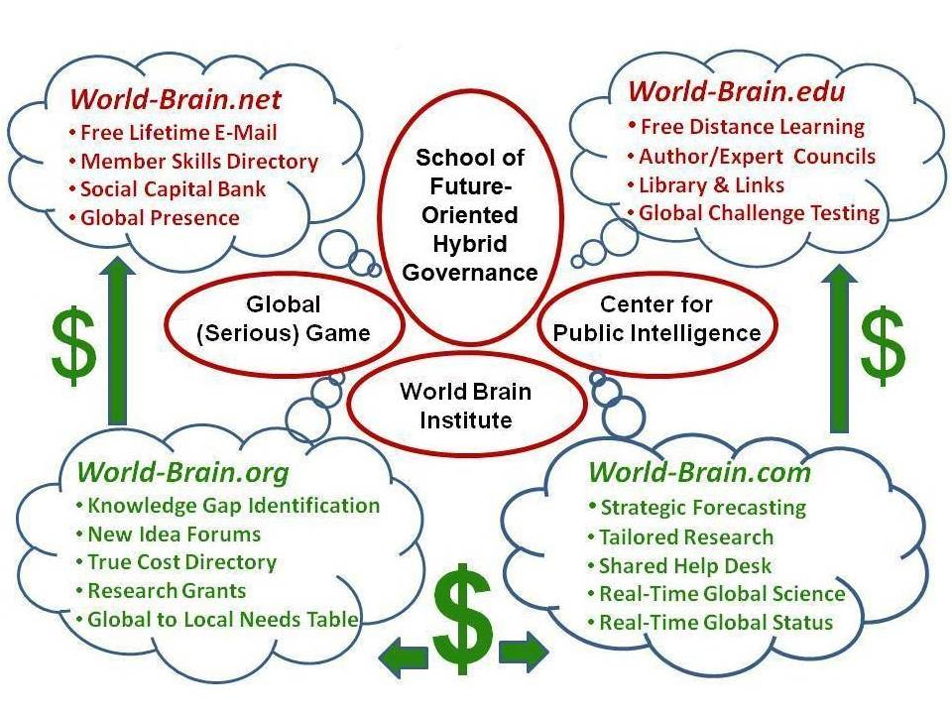 | 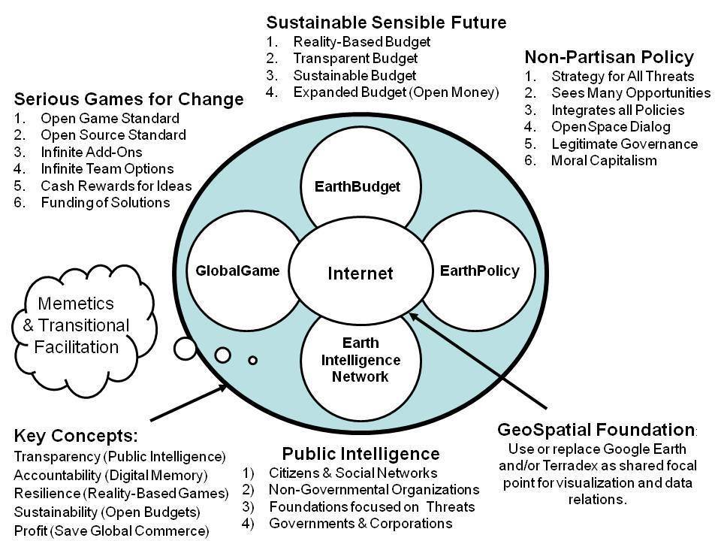

The two graphics in the lower row above depict on the left the four domains that the World Brain Institute could organize, achieving free universal education “one email or cell call at a time;” while on the right are the “organs” of a global mind facilitated by the UN – the key is not just data accessibility, but exascale processing, geospatial registry of all data, and true cost economics. More information on these elements can be found at http://tinyurl.com/Steele-Saving.
The innovation divisions – nine of them – would cover the nine major OSEE domains with three local to global project networks within each, as shown below.

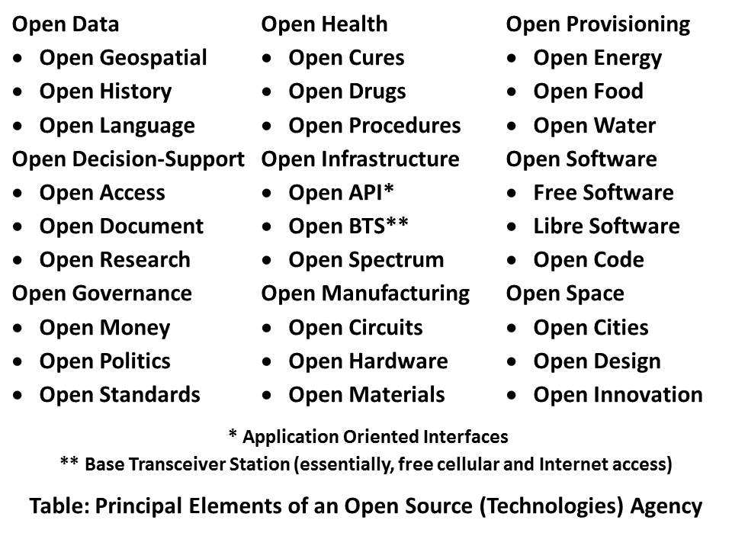

The UN leadership should pay special attention, within the above construct devised by Robert David Steele, author of The Open Source Everything Manifesto: Transparency, Truth, & Trust, to Open Health, Open Infrastructure, Open Manufacturing, and Open Provisioning. The advances that can be made in these four areas by the five billion poor are world-changing at speed and at fractional cost.
The rapid prototyping of open source solutions – this is already happening locally around the world – if embraced by the UN and the sharing of knowledge as well as micro-cash payments made to the village level, by-passing the cumbersome, expensive, and often corrupt bureaucracies of the industrial era – would make possible the creation of a prosperous world at peace among the five billion poor, precisely where we need to achieve affordable, inter-operable, and scalable solutions at very low cost. OSEE does this.
Below are two diagrams – on the left, a tiny selection of the existing open source “hacks” that are available for very rapid distribution in the form of knowledge, materials, and seed money; and on the right, the economic triangle with its priorities inverted – the five billion poor are the “green” center of gravity.
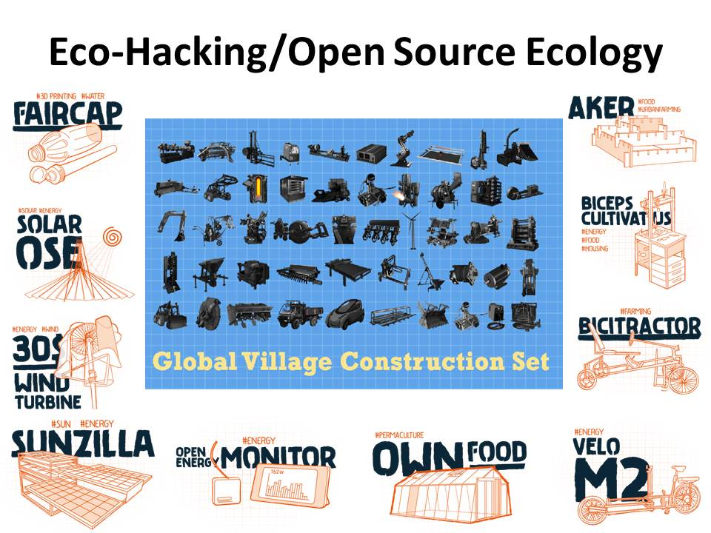 | 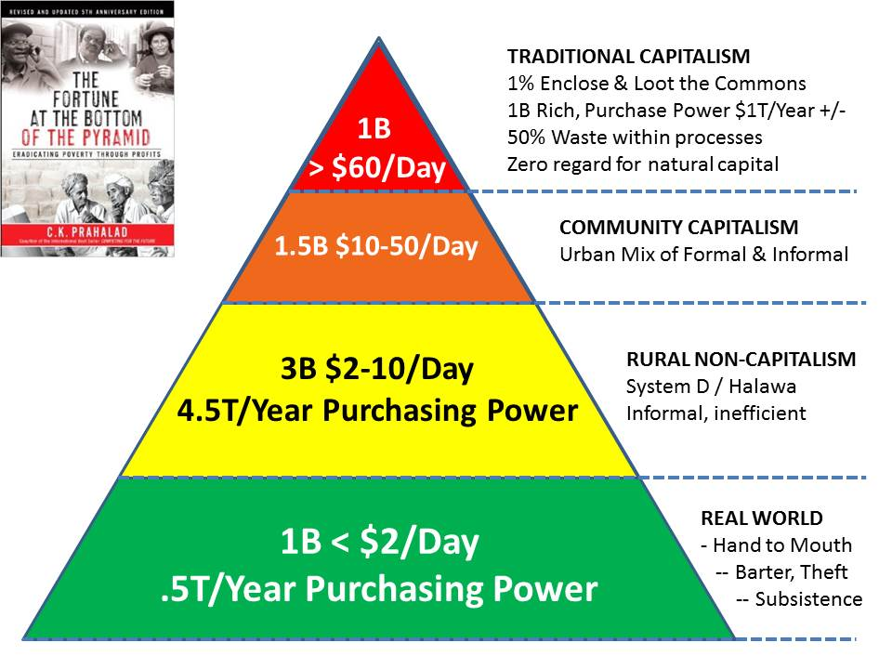

The above ideas have been under development for over a quarter century by a diversity of pioneers lacking one thing to go global: UN leadership and the publicity that comes with a blessing from UN leadership.
It should also be possible to engage The Most Holy Father and the Pontifical Academy of Sciences toward a continent-wide pilot program led by the President of Ecuador and the Society of Jesus, offering “liberation technology” to every person in the Southern Hemisphere and then rapidly branching into the Middle East and Central Asia.
It could be that this concept might appeal to the new development authority and new financial authority of the BRICS (Brazil, Russia, India, China, South Africa) as well as Indonesia and Iran. It could and should be offered to Saudi Arabia, Qatar, and the United Arab Emirates as a solution they can implement in Yemen and Somalia.
It is only now, as such distinguished figures as Lady Lynn Rothschild contemplate the need for “Inclusive Capitalism,” that leaders in general are realizing we have failed, and on our present course have limited prospects of achieving the SDG goals prior to a general collapse of politics, economics, and society. The above ideas in combination, at a cost to the US taxpayer of $2 billion a year, but in service to the UN and to all those the UN seeks to help at the bottom of the pyramid, are immediately executable. All the Secretary General has to do is ask.
Robert David Steele
Short URL for this Memorandum online: http://tinyurl.com/SDG-OSEE
Short URL for collected recent works & interviews: http://tinyurl.com/Steele-Future
Robert Steele’s Biography & Publications: http://robertdavidsteele.com

Creating the Future with

Open Source Everything Engineering (OSEE)
Open Source Everything Engineering (OSEE)
Creating the Academy, Economy, Government, and Society of the Future

ABSTRACT
I have decided to focus on the possibilities of integrating Holistic Analytics, True Cost Economics and Open Source Everything Engineering (OSEE) into a new discipline, Applied Collective Intelligence.
This concept is human-centric, rooted in advanced digital information management including new concepts for embedded intelligence and big data at a world brain scale, and is a commitment toward enabling and empowering social enterprises within a national and international collaborative economy meant to serve the 99%.
I present here my preliminary findings my hope that a hub might be created in London or New York City, with mirrors in China, India, and elsewhere as interest is generated and funding acquired.
Among the products of this new endeavor would be an OSEE analytic toolkit and OSEE big data cloud able to do exascale near-real-time processing, the full integration of OSEE into the varied scientific and engineering disciplines being taught at all universities and – eventually – a School of Future-Oriented Hybrid Governance and a World Brain Institute as well as a new PhD/DBA degree in integral business and economic decision-support to open source everything processing and production.
As the City of London and E.J. Rothschild advance the concept of “inclusive capitalism,” I venture to offer a solution that addresses their concerns while making possible the creation of a prosperous world at peace, a world that works for all, without waste
Table of Contents
State of World 14
The End of the Industrial Era 15
Emerging Economic Concepts and Practices 18
True Cost Economics in Earnest 21
Holistic Analytics – Multidisciplinary, Multilingual, Multilevel 23
Open Source Everything 24
Embedded Intelligence 27
The Way Ahead 28
A New Knowledge Paradigm 29
Open Source Analytic Toolkit 31
Big Data Obstacles and Opportunities 32
Waste – the Near Frontier 34
Human-Centric Values-Based Society 35
The Collaborative Economy & The Social Enterprise 36
Future-Oriented Hybrid Governance 37
Creating the World Brain 39
A New Discipline – the PhD/DBA in Embedded Open Source Intelligence 41
Unifying the Eight Information Communities or Networks 46
Conclusion – Next Steps 47
Bibliography 48

Table of Figures
Figure 1: Ten High-Level Threats to Humanity 14
Figure 2: Twenty Global Programs 15
Figure 3: Eight Forms of Organization or Information Network 16
Figure 4: Evaluating All-Round Mutuality Between the Enterprise and All Others 20
Figure 5: The Open Source Everything Innovation Hub Concept & Sought-After Effects 21
Figure 6: Representative True Cost Information for a Single Product 22
Figure 7: Fragmented Web of Science 23
Figure 8: Analytic and Knowledge Management Deficiencies 24
Figure 9: Selected Elements of the Open Source Everything Ecology 24
Figure 10: Enhanced Approach to Embedded Intelligence 27
Figure 11: Context for Multidisciplinary Multilingual Whole Systems Analytics 28
Figure 12: Grand Strategic Design for Integral Education, Intelligence, & Research 29
Figure 13: Proposed Integrated Open Source Analytic Workstation Elements 32
Figure 14: Computing Paradigm Shift Demanding Open Source Response 33
Figure 15: Human Stakeholders in the Sustainable Enterprise 35
Figure 16: Human-Centric Holistic Mind-Shift 36
Figure 17: Industrial versus Indigenous (Restored) Decision Processes 38
Figure 18: Elements of the School of Future-Oriented Hybrid Governance 39
Figure 19: Eight Information Networks Empowered and Unified by Open Source Everything 46

State of World
We consider the Earth – and humanity at large – to be extraordinarily resilient. We are optimistic about the future in part because our proposals – if implemented by a multiplicity of nations and publics – will enable all of us to focus on creating a future that works for all, instead of going through the motions of forecasting a future in which all of the negatives persist without substantive challenge.
Here we will provide just two points of reference: the ten high-level threats to humanity as identified by the United Nations High-Level Panel on Threats, Challenges and Change (2004) and the twenty global problems identified by Jean-Francois Rischard, then Vice President for Europe of the World Bank (2003).

Ten High Level Threats
These are the ten high-level threats to humanity. They are in priority order. They are useful as a means of measuring the degree to which any particular government’s policies and programs are relevant to protecting their respective populations and promoting prosperity.
01 Poverty  02 Infectious Disease  03 Environmental Degradation  04 Inter-State Conflict  05 Civil War | 06 Genocide  07 Other Atrocities  08 Proliferation  09 Terrorism  10 Transnational Crime
Figure 1: Ten High-Level Threats to Humanity
These ten high-level threats are also a helpful starting point for any university, government, or other organizations seeking to be genuinely multidisciplinary in its strategic, operational, tactical, and technical processes and programs.

Here below are the twenty global challenges in three groups as devised by Jean-Francois Rischard.
Group 1: Sharing Our Planet  - Global Warming  - Biodiversity & Ecosystem  - Fisheries Depletion  - Deforestation  - Water Deficits  - Maritime Safety & Pollution | Group 2: Sharing Our Humanity  - Poverty  - Conflict Prevention  - Education for All  - Infectious Diseases  - Digital Divide  - Natural Disasters | Group 3: Sharing Our Rulebook  - Reinventing Taxation  - Biotechnology  - Global Financial Architecture  - Illegal Drugs  - Economic Competition  - Intelligence Property  - E-Commerce  - International Labor & Migration
Figure 2: Twenty Global Programs
There have been many other important contributions (Ahmed 2010, Brown 2009, Glenn 2014) but for our elementary purposes, these two very informed and widely-accepted summaries of the state of the world and our shared challenges will do. Our intent is to devise an academic program useful to governments, banks, corporations, and other organizations – to nations and publics as a whole – for rapidly and affordably addressing these challenges intelligently and simultaneously.

The End of the Industrial Era
Charles Mann, in 1491 (2008) is among many who have documented the broad accomplishments of indigenous populations prior to incursions by Western powers. Others such as Philip Allott (2002) have documented the profound negative effects of varied forms of Western colonialism and militarism upon indigenous societies previously in harmony with nature. It is not our intent to focus on the many complaints about capitalism (Perkins 2004, Klein 2008, Taibbi 2011, inter alia). Our focus is more on the fundamental divorce of Western forms of organization and information management from reality. While some conflate the industrial era with “the manufacture of evil” and point particularly to wage slavery and the separation of humanity from networks of kinship and trust (Tiger 2000), and others lament the enclosing of the commons and the criminalization of what used to be natural behavior by individuals (Linebaugh 2014), the real issue for us, here and now, is this: to what extent have the primary forms of Western organization met or failed to meet the needs of humanity as a whole?
I identify eight specific forms of organization in alphabetical order.
Academic  Civil Society | Commerce  Government | Law Enforcement  Media | Military  Non-Government
Figure 3: Eight Forms of Organization or Information Network
Here I offer simple snap-shots of generic failure.
Academic. The commercialization of the universities (Bok 2004) along with the perpetuation of a rote system of education intended to create docile factory workers (Gatto 2010) have resulted – in combination with the distortion of economies caused by the export of middle class jobs and the emphasis on financial profiteering (extracting value instead of creating value) – in growing numbers of poorly educated individuals unsuited for disappearing old jobs and unable to create new jobs for themselves. The academic emphasis has been on reductionism and the past.
Civil Society. Labor unions and religions are included in this domain, as well as citizen activist groups. What I see are labor unions that have failed to responsibly represent labor (Dine 2007); religions that have become fragmented and belligerent (Ashby 2006, Lerner 2007); and civil activists that are unable to come together in mass, all too easily splintered or bought off with hand-outs.
Commerce. Lee Iacocca has lamented the disappearance of real leaders, ethical leaders (2008). Despite the heroic efforts of small businesses that comprise the bulk of the commercial sector, the failure of the banks and major corporations that substitute lobbying and government subsidies for commercial intelligence and effectiveness have led to a situation in which financial manipulations have produced appreciations of seventeen times, versus hard asset appreciation of five times (Grieder 2003).
Government. Representative democracy has failed in large part because elected individuals have been self-serving and responsive to special interests rather than their own constituencies, while a usually standard two parties have leveraged their power to block all others from the ballot – in the US, disenfranchising close to half the public (Amato 2009).
Law Enforcement. The LIBOR scandal can be seen as a failure of law enforcement at the strategic level, along with the failure of the US Government to control its own banking community that was able to collapse the economies of Greece, Ireland, Portugal, and Spain, among others --- and of course including the US economy (Taibbi 2011, Taibbi 2014). Given that law enforcement as a concept only works when the majority of the population considers the government legitimate, in the context of an economic and social collapse, this is the most vulnerable of the eight networks.
Media. Many books document the failure of the traditional media, which has abandoned its role as a provider of independent information to the public, and instead become a combination of corporate profit centers (with five major owners across the US media) and co-conspirators with governments intent on lying to their publics. The ease with which the US Administration under Bush-Cheney was able to lead the world to war on the basis on 935 now-documented lies (Lewis 2014) – lies supported by the UK Government – suggests the complete failure of the “mainstream” corporate media.
Military. The US military, spending as much as the next 20 nations combined, is the poster child for expensive inefficacy, constantly losing wars and failing to combat terrorism precisely because it is a heavy-metal military and its budget leaves no money for diplomacy, commerce, or alternatives such as waging peace. The plans/reality mismatch (Spinney 1985) and the constancy of the US military-industrial complex (St. Clair 2005) continue to create a hollow military stretched too thin. As General Robert Scales, USA (Ret) has documented, the US infantry – 1% of the force – takes 80% of the causalities and receives
Non-Government. Ashraf Ghani and Clare Lockhart (2008) have documented the failure of the non-government domain, and particularly international assistance. It is now known that out of any given amount – say Sterling 1 billion – less than 20% and often less than 10% and sometimes as little as 1% -- actually gets to the village level in Afghanistan or anywhere else. When combined with the poor decision-making and poor spending by governments and corporations, the failure of this element is particularly catastrophic.
Taken together, the failure of all eight of these domains using the Industrial Era approach to information and to management – an approach that neglects the vast majority of the relevant information, much of it locally known and in languages we do not speak – offer us all an opportunity for change.
I believe that the charge to society of these eight failures together is on the order of 50-75% of gross domestic product (GDP).
This is to say, across each discipline from agriculture to energy to health to the military to water, 50% or more of our natural and human and financial resources are being wasted due to poor information and decision practices.
I further believe that advanced in embedded intelligence and the adoption of open source everything, true cost economics, and holistic analytics, will allow us to devise an alternative academy, economy, governance, and society within which the six billion poor can aspire to Western standards of living without Western waste. We can, with intelligence and integrity, create a world that works for all.

Emerging Economic Concepts and Practices
For the past half-century financial capitalism has reigned over the affairs of men and been a master of governments, universities, and all other forms of organization. This has led to a diminution of the influence of ideas and those who specialize in education, intelligence (decision-support), and research. This has also had the perhaps unintended effect of severely handicapping entrepreneurship and innovation by mis-directing emphasis toward paths chosen for their short-term financial exploitability, while withholding funds for holistic analytics and true cost economics, the only relevant foundation for achieving sustainable profit – profit that does not externalize costs to others while privatizing profit to an ever smaller segment of society but instead produces ever-increasing sustainable profit for the many.
Now, in 2014 and in the aftermath of a failure of integrity and process in global banking a number of new forms of economy, some in gestation for decades, are emerging to be considered by the lords of banking and the captains of commerce. Of enormous potential is the fact that the City of London and E.J. Rothschild have themselves coined the term “Inclusive Capitalism” and sponsored a first conference on this topic (Conference 2014). They know they are in trouble. They do not know how to migrate away from their unsustainable position. We can show them the way.
There seem to be good prospects for a favorable hearing in relation to the substance of this proposal to create a banking, business, education, engineering, information management, governance, and scientific alternative that is explicitly intended to protect existing wealth among the 1% while creating infinite wealth among the 99% with an Open Source Everything approach to all disciplines.
Language remains an issue – there is a great deal of confusion, some overlap, and many bits of unclear thinking in relation to varied terms associated with emerging economic practices. Terms include circular (Lovins et al 2014), collaborative (Lowitt 2013, Schwartz 2014), ecological (Daly 2010) ethical (Arvidsson and Peitersen 2013) , free (Sirico 2012), gift (Eisenstein 2011), happiness (Anielski 2007, Frey 2010), inclusive (Scott 2013), mutuality (Roche 2014, Badger et al 2014), new (Kelly 1999), open source (Lerner and Tirole 2002, Benkler 2005, Steele 2012), purpose (Hurst 2014), peer-to-peer (Bauwens 2011), regenerative (Tillman, 1996), redemptive (Rinaldi 2014), resilient (Briguglio et al 2006), sharing (Botsman and Rogers 2010, Gansky 2012)), and solidarity (Davidson 2010). Other terms in vogue include cognitive surplus (Shirky 2011), conscious manufacturing (Kutz 2007), direct economic democracy (Boik 2014), social enterprise (Frankel and Bromberger 2013), and the triple-bottom line (Savitz 2013). This is a partial list, merely the most prominent among the descriptors.
I have chosen to focus on the Collaborative Economy as the best over-all term, with Social Enterprise as the organizational manifestation, and our four process elements, Open Source Everything, True Cost Economics, Holistic Analytics, and Embedded Intelligence, as the method. I specifically embrace Mutuality Economics as one of the best-developed foundations for the Collaborative Economy and single out the Mars Family in the USA and the varied contributions to the January 2014 issue of The Brewery (Badger et al) as a most helpful starting point for both researchers and practitioners.
Below I draw on this seminal work to conclude this section on the economic context for our innovative ideas that we hope to implement through any participating University.
Dr. Arlo Brady, Managing Editor of the Corporate Practice at freuds and fellow at Judge Business School, Cambridge University, tells us:
We need to consider how we can breed more ‘hero businesses’ that have a more mutual relationship with their full range of stakeholders – businesses that recognize and act upon the implied social contract as much as any formal commercial arrangements and which accept environmental and civic issues as part of their basic model of trade. These are the businesses that would have thrived in ancient Greece, and will succeed today.
From Philip Dilley, Group Board Chairman of Arup, an employee-owned company, writing under the title of “Putting a premium on value creation over value extraction:”
If capitalism is to continue to be viewed as one of the greatest engines the world has ever seen for reducing poverty and driving innovation, it simply has to be designed to work for, and with, a broader range of social stakeholders and not just in its own self-interest.
From Dennis Nally, Chairman of PriceWaterhouseCoopers International (PWCI), writing under the title “Measuring the impact of a company on society: how to gain an all-round view,” addressing the trust deficit, comes the below graphic.
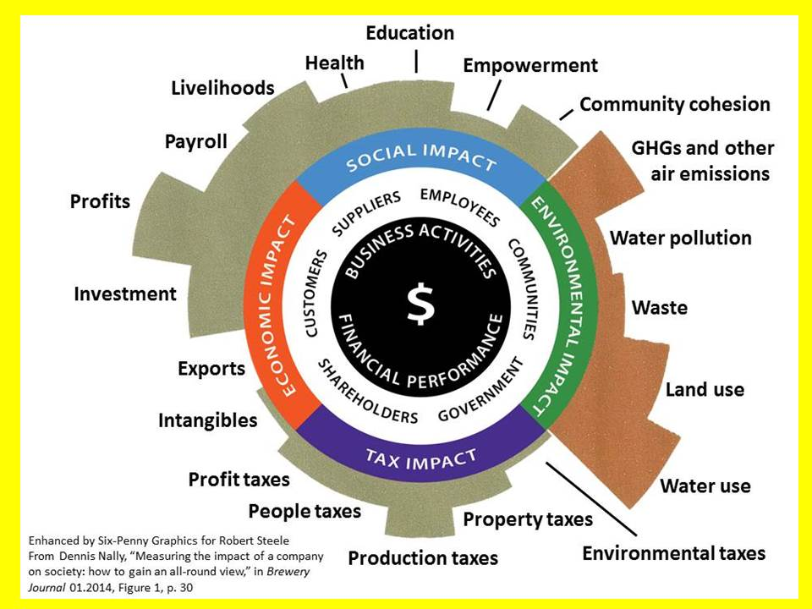
Figure 4: Evaluating All-Round Mutuality Between the Enterprise and All Others
The above has been brought together by PWCI personnel based in London under what they are calling Total Impact Measurement and Management (TIMM).
From Dr. Pamela Hartigan, Director of the Skoll Centre for Social Entrepreneurship at Said Business School, University of Oxford:
The challenge of innovation in the 21st Century is therefore about reshaping societies to be not only tolerant, but actually welcoming of innovators – particularly of the disruptive kind.
When Mutuality Economics reaches its end-state, the Social Enterprise, the primary purpose of the firm is to do good, with profit as a secondary (but still essential) value (Roche 2014).
The term “social enterprise” is used within the UK and around the world to recognize businesses that are explicitly structured, organized, and led so as to apply the power of business to achieve social and environmental change. In this rendition of the term, financial profit is secondary, and when earned, is generally reinvested back into the enterprise and its social or environmental capacities.
Among the champions to be respected in this arena are Social Enterprise UK, which has published a number of useful guides for local authorities, local enterprise partnerships, and organizations desiring to embrace the Public Services Act.
The below graphic depicts our vision for creating a university-based process that impacts most constructively on the UK economy and eventually the local to global economy everywhere.
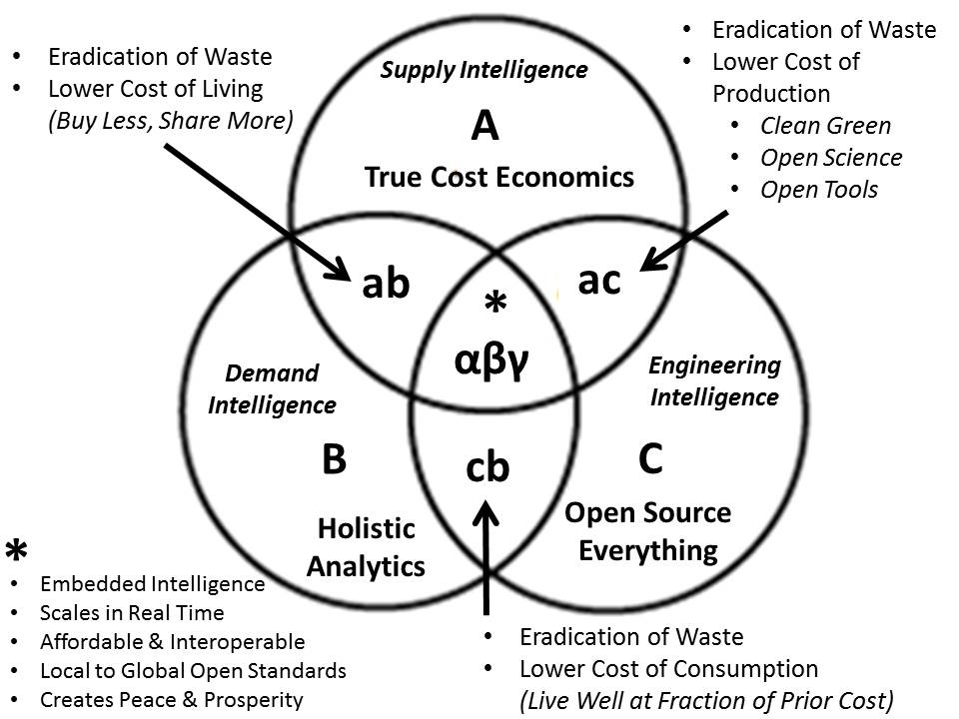
Figure 5: The Open Source Everything Innovation Hub Concept & Sought-After Effects

True Cost Economics in Earnest
True cost economics, sometimes also called the “triple bottom line” (Savitz 2013), seeks to integrate not just the well-understood financial costs established by contract and convention, but also the less well defined social and ecological costs. Ecological economics (Daly 2010) is the foundation, still in gestation.
Below is a depiction of some, not all, of the true costs of a single cotton T-Shirt (Liszkiewicz, 2011).
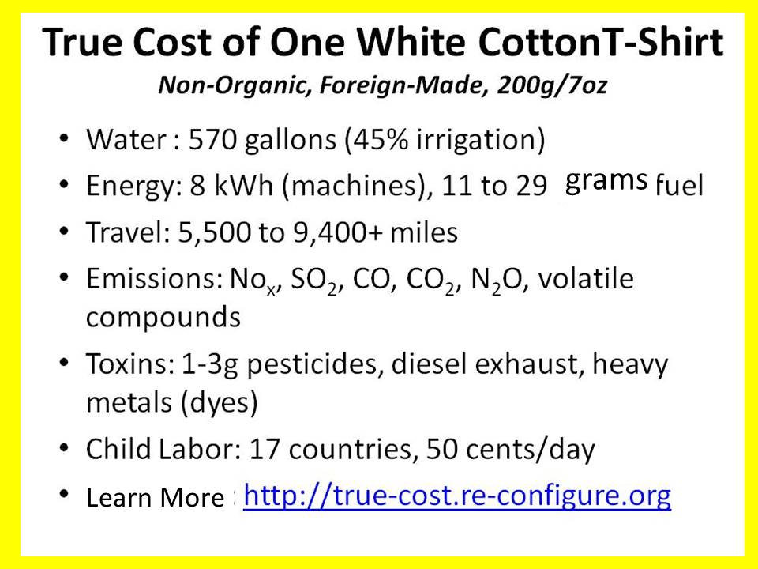
Figure 6: Representative True Cost Information for a Single Product
When fully developed, the practice of true cost economics will be multidisciplinary in nature, as individual scientific and social scientific disciplines and sub-disciplines develop new means to calculate with precision the inputs such as energy and water that each of their objects of observation consume, and the outputs in the form of toxins and other negative externalities and diseconomies.
It is our hope to develop a standardized process as well as an open database in the open cloud for all potential contributors and stakeholders, such that over time, each discipline within each university – and others including non-profit and for-profit organizations as well as government laboratories – can begin documenting the actual true costs of every product, process, service, and policy.
I have in mind a cellular application that shows the true cost of any item, if available, in easy to understand green, yellow, and red circles, while also suggesting alternatives products with lower true costs, should that be of interest to the consumer. Our total offering will be Open in every way, but with legal protection against its corruption or mis-use. I are acutely conscious of the degree to which open access has been tainted by predatory parties. While not addressed in this preliminary overview, I have already given substantial thought to assuring the integration of anonymity, identity, privacy, and rights into the emerging ecology of Open Source Everything. Our intent is to create a rigorous new architecture that is robust in every aspect.

Holistic Analytics – Multidisciplinary, Multilingual, Multilevel
Below I share a depiction created by Maps of Science (Klavans and Boyack 2007), showing the dysfunctional fragmentation of the varied scientific disciplines and their sub-disciplines. If one adds to this the fragmentation inherent in the separation of those doing research in any of 33 core languages, our point should be irrefutable. Beyond this, we are simply not being serious about research –less than 1% of what is done is published (Stockstad, 2014).
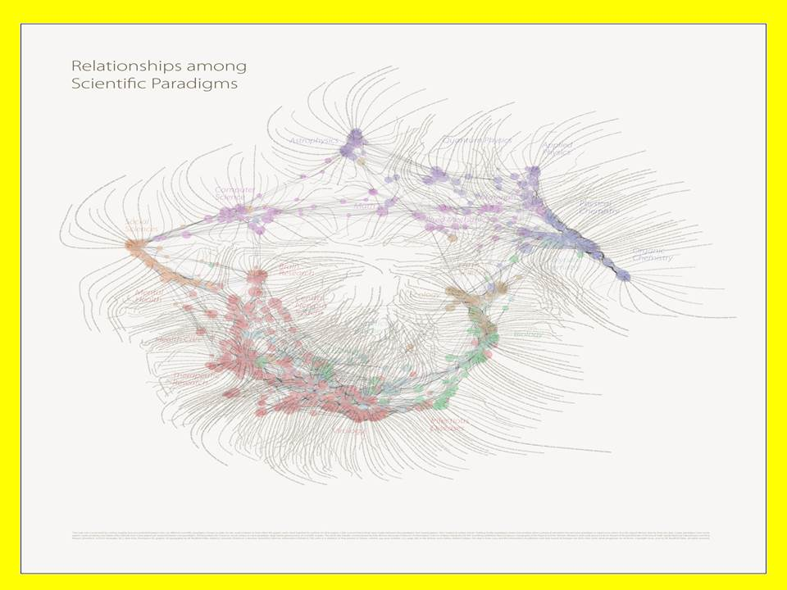
Figure 7: Fragmented Web of Science
Add to this scientific fragmentation the separation of the humanities from the sciences, a matter of concern to E. O. Wilson (1999), and compound that with the isolation of quantum everything including new consciousness movements, and one has a rather poor representation of what humanity is capable of doing if it were to be coherent to the extent of which we are all capable if we work together.
The analytic situation is worse when one examines specific deficiencies and separations in the process of knowledge management. Here for this preliminary concept I will simply list eight deficiencies and four separations together (Steele 2014, Steele 2008).
Analytic Foundations – Eight Deficiencies |  | Four Information Separations
Source Diversity  Source Integrity  Processing Big Data  Processing Desktop | Analyst Education & Training  Analyst Outreach  Analyst Access to Decision-Makers  Decision-Maker Integrity | Knowledge Management/Data Mining  Collaborative Work Tools for Sharing  External Information Access Tools  Organizational Intelligence Capabilities
Figure 8: Analytic and Knowledge Management Deficiencies
Our total thrust is firmly focused on creating a new gold standard for information sharing and sense-making. Our intent is to elevate individual and collective intelligence qua decision-support across all boundaries, connecting all minds to all relevant information within an open information architecture.

Open Source Everything
Open Source is not, as many assume, simply a legal and technical concept referring primarily to software and increasingly also to hardware, denoting that the software or hardware is freely available and open to both redistribution and modification without substantive encumbrance.
Open Source Everything (OSE) is a meme, a mind-set, and a philosophy of education, intelligence (decision-support), and research. The below diagram is representative.
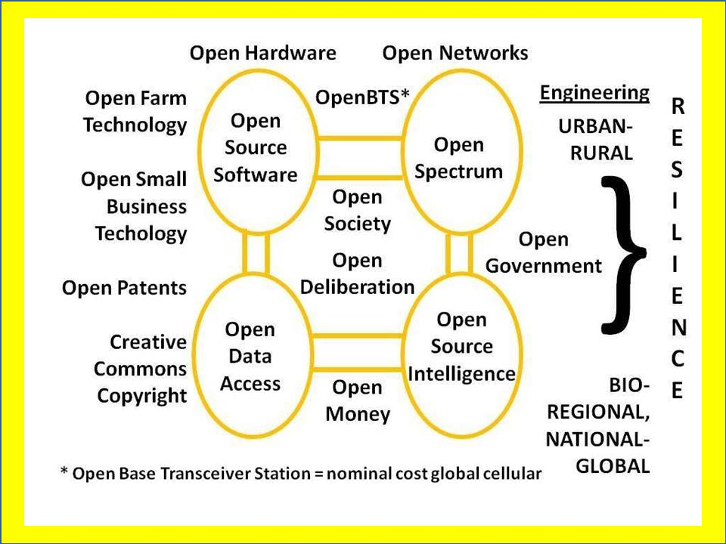
Figure 9: Selected Elements of the Open Source Everything Ecology
In commercial terms, OSE is a means of harvesting the Cognitive Surplus of a broadly distributed, self-motivated network. Of particular note is that OSE is the only technical approach that is affordable, inter-operable across all boundaries, and scalable toward the 6 billion comprising humanity today.
OSE is the ethical, intellectual, commercial, and legal underpinning for the emergent new economy that is collaborative, ethical, inclusive, and sharing in nature.
The essence of financial profit within this new economy lies in a mix of free education combined with licensing, services, and the monetization of transactions. OSE can be licensed in multiple forms using Creative Commons designations, such that the code, to use a software example, is open to modification and redistribution, but cannot be used to collect financial remuneration without engaging the originator.
Creative Commons is a viable legal construct but not yet fully established in law or in technology to the extent that it actually protects social enterprises and their intellectual right (Lessig 2014).
OSE is the underpinning for local to global information-sharing and sense-making, allowing for the efficient harvesting and harnessing of cultural, historical, and linguistically specific information across all boundaries, human, financial, and technical. The term of art for the human aspect is Multinational, Multiagency, Multidisciplinary, Multidomain Information-Sharing and Sense-Making (M4IS2). In combination with OSE, a predominantly technical term of art, the two define a virtual World Brain in which all minds eventually are connected to all information in all languages and domains, all the time and – this is really important – all humans have information tools with which to make sense of it all.
Of note: Computational Science and Computational Mathematics appear to be making possible order of magnitude advances in the near term. Add to this the emergence of credible thinking in relation to FemtoTech Atomic Scale Manufacturing (Garis 2014) and we can perceive both a crisis – are we moving fast enough in advancing our information management concepts and capabilities? – and an opportunity.
We are all fortunate to have had pioneers such as Richard Stallman (2010) laboring for a quarter century to reach this year, 2014, when it has been said that open source finally went mainstream. According to one report (Jurin 2014), albeit focused on the USA, in 2014:
- $60 billion saved collectively by US businesses per year due to open source software
- 50% of all purchases of software will be open source in 5 years
- 2 million open source projects in 2014 – twice the number in 2012
- 80% increase in open source venture investment in US from 2011 ($307M) to 2012 ($553M)
- $2 billion estimated open source software sales in 2013
- 1.47 million open source-related software jobs in US by 2018
- 41.6% of people plan to deploy an open source solution in 1-2 years

Across both government, especially local governments of which there are over 100,000 of them in the USA alone and business, the high cost of proprietary software – both licensing and maintenance – has become a top issue for information managers (Dixon 2014). As one summary puts it, between inherent quality, functionality and ease of deployment on the output side, and new people, new technologies and new economics on the input side, open source software and hybrid cloud offerings are exploding (Deans 2014).

Open Cloud – and specifically OpenStack – is said to have made major gains in 2014, with Oracle relenting and joining, and Hewlett Packard announcing a billion dollar investment to “make its entire portfolio a pure open source play” (Shalom 2014, Deans 2014). We must of course be very cautious about industry claims, since a great deal of what is alleged to be open source turns out to be merely open core – a portion, not the whole, is open source. The validation of offerings in terms of purity of open source, and the identification of gaps needed “true” open source alternatives, remain important. An ability to do this across all forms of information, mechanical, and other technologies could be a world-changer. This is precisely one of our objectives at the engineering level of detail –for the first time there will be a provider of validation and integration for all opens, rather than the existing scattering of opens isolated from one another. I anticipate accelerative value in this service from the university.

It merits strong comment, our objective being full employment for our graduates, that open source is a labor-intensive industry. Free code is a calling card – in the ideal it leads to perpetual employment.

Embedded Intelligence
Among recent initiatives at Loughborough University have been the creation of a Centre for Doctoral Training in Embedded Intelligence, with fifteen scholarships being offered in the 2014-2015 academic year.
Embedded Intelligence is characterized as the ability of a product, process or service to reflect on its own operational performance, usage load, or in relation to the end-user or environment in terms of satisfactory experience. This self-reflection is facilitated by information collected by sensors and processed locally or remotely to derive insight. These aspects must be considered from the design stage such as to enhance product lifetime and performance, increase quality of process or service delivery, or ensure customer satisfaction and market acceptance (Centre 2014).
The below graphic combines our original concept focused on the manufacturing aspect, with the new concepts in this paper focused on the decision-support of design aspect.
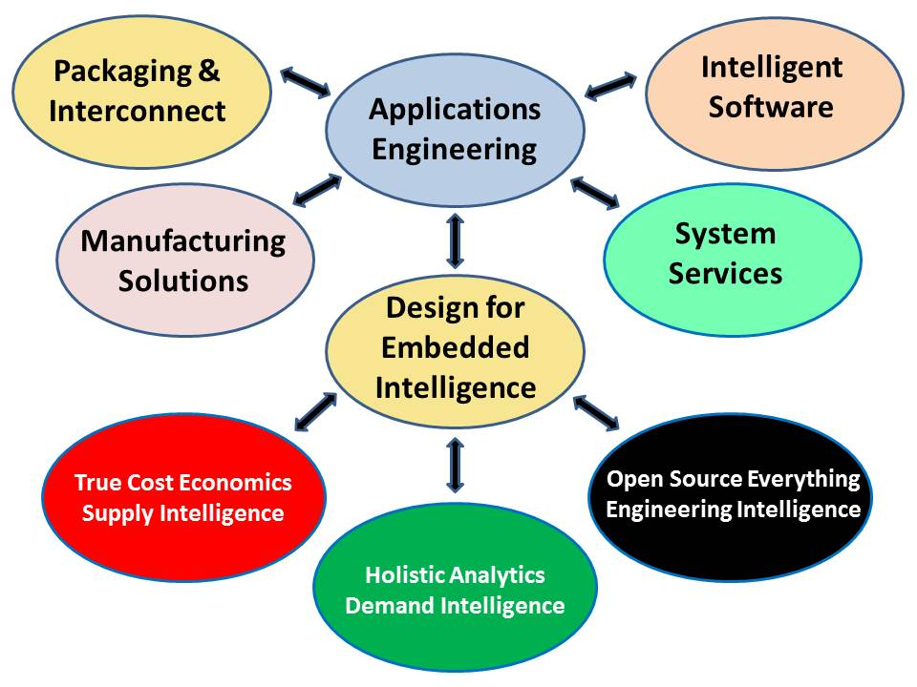
Figure 10: Enhanced Approach to Embedded Intelligence
The prevailing approach to EI is that of IBM and its “Smart Cities” concept. This is an example of doing the wrong things righter (Ackoff 2004). Doing the right think would involve adding True Cost Economics as Supply Intelligence, Holistic Analytics as Demand Intelligence, and Open Source Everything as Engineering Intelligence. Taking this approach will, I believe, create a new gold standard for both the emergent discipline of embedded intelligence, and the emerging discipline of integral decision-support. As shown in Figure 5 on page 8, I am going far beyond devices merely talking to one another and feeding industrial era big data concepts. My focus is on a complete re-design of the academy, the economy, government, and society, to embed intelligence in what we build, how we build it, and how we use it.

The Way Ahead
It is helpful, as I begin to outline our preliminary thinking – with responses most earnestly solicited – to remind ourselves that we live in a system of systems world where feedback loops are loaded with useful information, and yet, as shown in Figure 7 on page 10, we are operating in a scattered, badly fragmented and largely incommunicative environment in which there are iron curtains between industries, wooden walls between organizations, and plastic barriers between individuals. Our challenge is to optimize what we can know, when we can know it, and what we can do with what we know, about the below world that we inhabit with some rather deep ignorance persistent on our part.
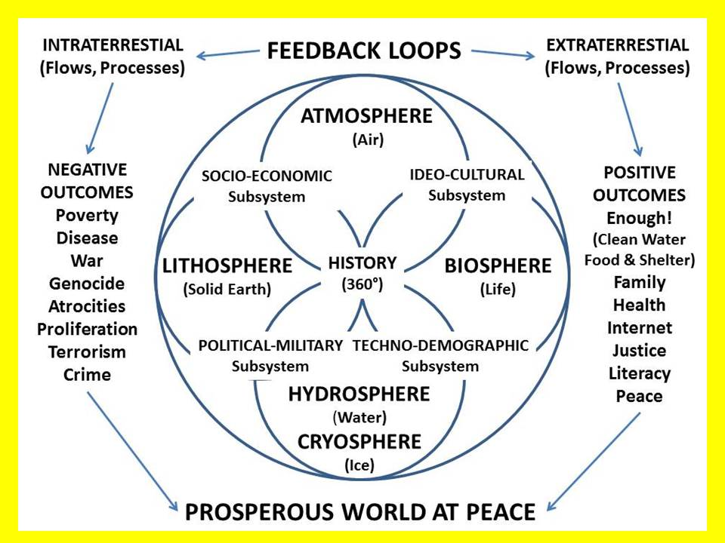
Figure 11: Context for Multidisciplinary Multilingual Whole Systems Analytics
While any given university is capable of championing multidisciplinary education, intelligence (decision-support), and research on our own and in partnership with other universities and external stakeholders in the UK, the multilingual and multicultural aspect – including proper discovery, documentation, and integration of historic indigenous best practices, for example in relation to water management – demands that our vision be considered and hopefully embraced by other universities abroad, particularly those in Brazil, Russia, India, China, and South Africa (BRICS) as well as potential wild cards such as Bolivia, Ecuador, Uruguay and Venezuela in South America; Nigeria and Turkey in the Near East and North Africa, and Brunei, Indonesia, Malaysia, and Viet-Nam in the Far East – and of course anyone anywhere.
While I do not address the geospatial factor in this preliminary discussion, it is ever-present in my thinking. I conceptualize an open variation of Google Earth that integrates Crisis Mappers and OpenStreetMap, with a sparse matrix and an open variation of Keyhole Markup Language (KML) such that all information in all languages and mediums can be plotted across time and space henceforth.

A New Knowledge Paradigm
I have concluded that education, intelligence (decision-support), and research are now badly trained, equipped, and organized. Changes must be made. Our intent is to make it possible for every government element, every other organization, and individuals, to access information relevant to their mission or interest across all boundaries, while being able to aggregate and exploit that information rooted in geospatial and time-date visualization, aggregated by threat or policy domain, and further separable for consideration at each level of analysis: strategy, operational, tactical, technical.
This graphic (Steele 2014c) has been embraced as a foundational concept for our new initiative.
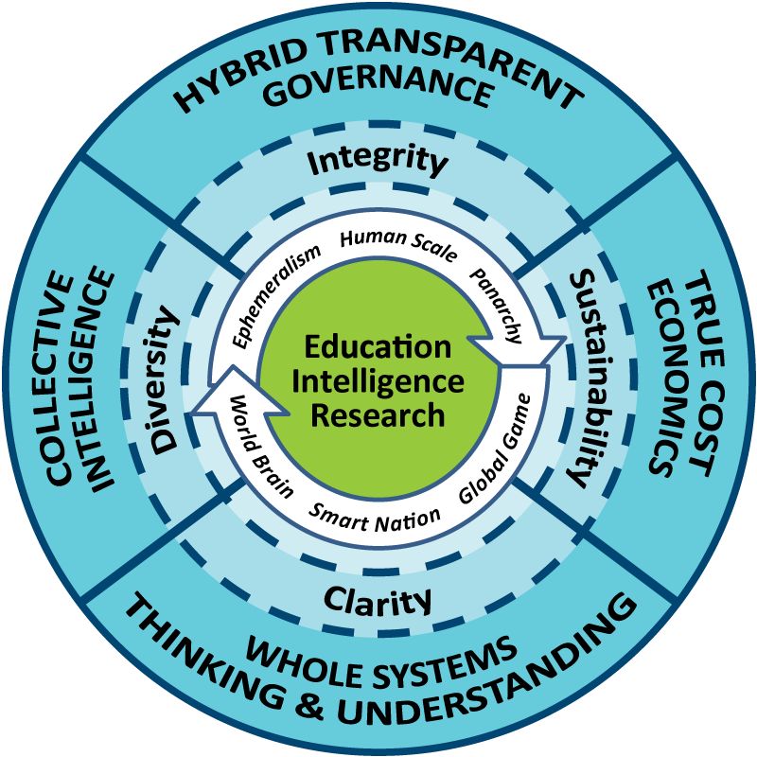
Figure 12: Grand Strategic Design for Integral Education, Intelligence, & Research
This vision integrates all forms of knowledge with particular emphasis on the integration – for life – of education – teaching, intelligence (decision-support to government and business), and research. This restores the primacy of the human being, both as an individual and in community so as to do more with less – ephemeralism – while re-establishing the human as master of comprehensivity and synergetics (Fuller 1982a 1982b 2008). The implementing bodies should fully integrate true cost economics across all disciplines, industries, products, services, and behaviors; a Smart Nation in which all eight information communities are transparent to one another and fully engaged in sharing information and sense-making; and a global creative commons (or World Brain) that enables all minds to access all information in all languages all the time. The four core values are clarity, diversity, integrity, and sustainability, each manifested as shown in the outer ring above.
I believe that education is on the verge of being transformed – Massive Open Online Courses (MOOC) have been a wrong turn with their 4% completion rates (McKendrick 2013). I offer an alternative.
Intellectually and morally this innovation reinstates the university as the center – the hub – for society, commerce, and governance, assuring that a majority of the individuals in any given community are afforded the opportunity to continue learning – both free and for fee – over the course of their lifetime.
Put in a more mercenary fashion, and adopting the approach of some medical and scientific career paths, traditional educational degrees will have expiration dates and require annual, repetitive renewal through refresher training and structured engagement with new knowledge relevant to the individual, their employer, and the community at large.
An Open Source Everything Innovation Hub is a means of providing affordable, inter-operable, scalable education for life while striving to double the revenue earning potential of the University as a whole.
Here are four broad implementation ideas.
01 Education & Skill Training for life “one cell call at a time.” This is a mix of free daily prompts to the hand-held device with elementary education or new knowledge, together with clear answers to any question anytime from a mix of volunteers and sponsored call center personnel, as well as on-demand short videos for any skill element in any trade or profession…if none exists, it will be created as needed.
02 Citizen & Executive Decision Support (Commercial Intelligence) “on demand.” Commercial intelligence (CI) or decision-support (DS) require mastery of multi-disciplinary sources and methods, as well as mastery of constantly changing information technologies. For the majority of businesses in any economy, it is neither intellectually nor technically feasible to establish “in-house” capacity. This is a major opportunity for increasing ethical revenue for the university.
C. Hybrid Intelligence. There is an immediate market, local to global, for decision-support to hybrid governance of agriculture, education, energy, health, and water, to name just a few policy areas where the gap between those with power and those with knowledge is now catastrophic. A London-based School of Future-Oriented Hybrid Governance could develop new educational constructs, educate cadres of customers, and serve as a consulting enterprise as well.
03 Multidisciplinary Research Over Time and Space. The Center approach is not working. To achieve true multidisciplinary research one must be able to identify all credible voices – both published and unpublished – in all languages, far back in time as well as the most recent. An Open Source Hub that includes an Open Cloud as well as an Open Analytics suite of tools for local to global information-sharing and sense-making makes its sponsor the incontestable center of global knowledge.
04 Open Source Everything Platform for Universities, Small Businesses, and Others. Substantial revenue and innovation potential are to be found in the creation of a platform and process for education, intelligence, and research that could be leased to other universities while creating the first truly national – and then international – web of science and social science, humanities, philosophy, ethics, linking all of this to real world actors. Our intent is to create a globally scalable open source information technology platform, and a structure for harmonizing multidisciplinary research and data while enabling real-time science and near-real-time exascale computational science and engineering.

Open Source Analytic Toolkit
Consistent with our view that OSE demands an “all in” approach, one of our first priorities will be to create a completely open source laptop – all open source hardware (Waid 2014), all open source software – with one huge advantage: the world’s first all-source analytic desktop workstation with eighteen long-known but still neglected functionalities in one kit. The below graphic depicts the requirements defined by the Directorate of Intelligence of the Central Intelligence Agency as early as 1986, but still not available today in proprietary software, much less open source software (Webb 1989).
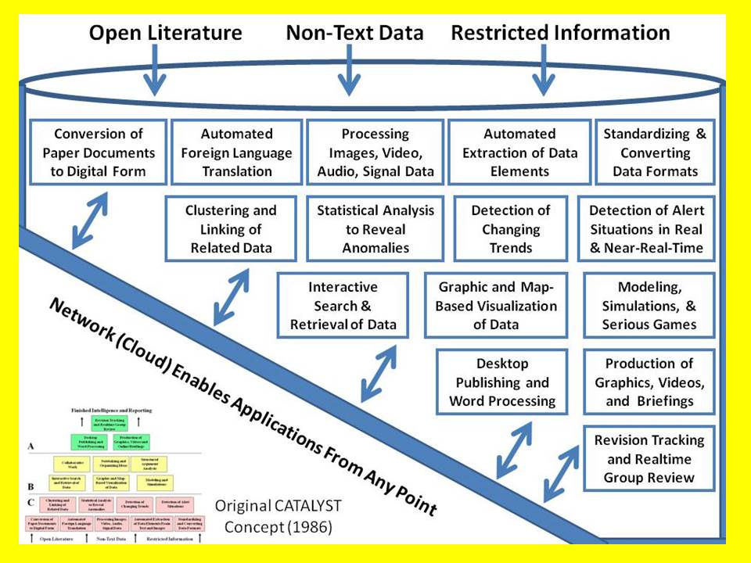
Figure 13: Proposed Integrated Open Source Analytic Workstation Elements
I must stress that the open source analytic workstation is merely a starting point for a much greater open source and multidisciplinary approach to both the treatment of information in all forms and from all sources, and with regard to design, engineering, and sustainable maintenance across all disciplines.
This means that the open source mind-set would be applied from raw data collection to final engineering production of resilience-enhancing innovations. When combined with varied other opens, but most especially Open Cloud, Open Data, and Open Spectrum, startling possibilities appear for affordable, interoperable, and rapidly scalable local to global information-sharing and sense-making.
Our intent – working in collaboration with innovators in India and elsewhere striving to create very low-cost laptops as well as free cell phones (OpenBTS) and Open Spectrum or free Wi-Fi – is to enable both on-demand education, the harnessing of distributed intelligence, and the eradication of waste.

Big Data Obstacles and Opportunities
We must begin with the fact that less than 1% of all big data is actually analyzed (Meeker 2014).
Let us add to that the reality that most legacy databases were created in by-gone eras, are non-standard, tend to be heavy, and cannot be ported electronically (the pipes are in the 10MB to 100MB range while the data is in the TB to PB range), and also cannot be accessed for simultaneous processing at most data centers because they lack the excess processing capacity (Arnold et al 2014, Hruska 2013).
Add to this the reality that relational databases were never designed for an era of big data, and the carriers have all been lazy about investing in dark fiber (Newby 2014) and you have digital grid-lock. 21st Century multidisciplinary big data requires a soup to nuts design make-over.
Below is a single graphic (Hruska 2013) illuminating the tsunami of change coming to communications and computing -- this is nothing less than an opportunity for an Open Source Hub able to mobilize the full human, financial, and technical resources of a great university and everyone else that it can engage.
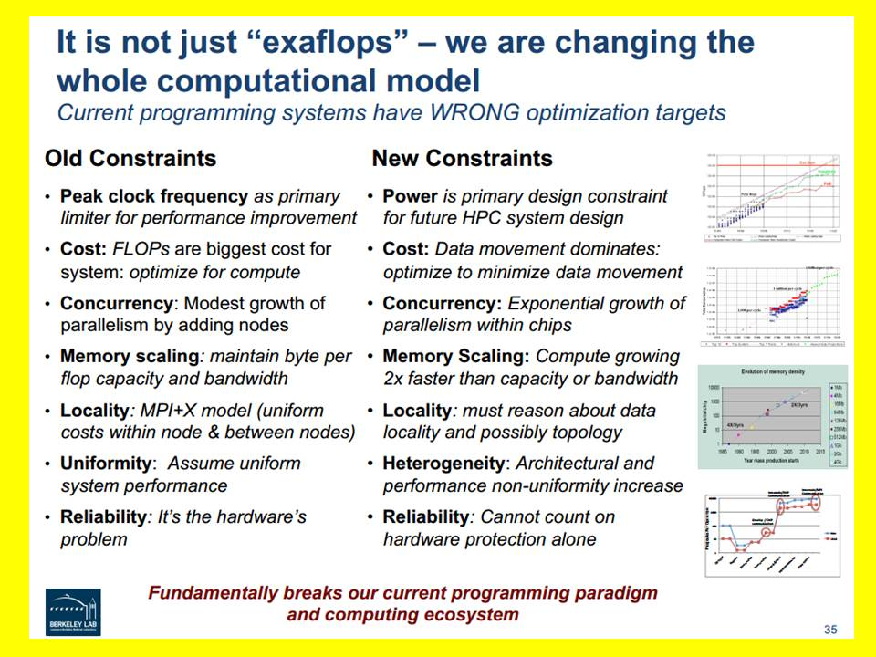
Figure 14: Computing Paradigm Shift Demanding Open Source Response
I believe the Open Source Innovation Hub can sweep past Industrial era obstacles provided we go “all in” across all the opens, and are able to engage economic, government, and social partners in this quest.
Here again I must stress the human factor – in contrast to computers costing trillions to date, the human brain has petaflop and higher speeds, is less than a liter in size, and requires only ten watts of power (Bamford 2002). Our innovation hub is centered on empowering billions of human brains with OSE information technology and leveraging OSE manufacturing tools and processes.

Waste – the Near Frontier
Waste is an educational opportunity and an information management challenge. Waste addressed in a timely and thoughtful manner – this is to say, a multidisciplinary manner with collaboration across all institutional boundaries – can yield savings on the order of 40-50% (Gray 1999, Rhodan 2014, Wilson 2003).
Agriculture. In 2012 there was a spate of attention to the loss of 40-50% of food from its production to its processing to its distribution to wholesale and retail vendors, to the home, and thence into the trash (Gunders 2012, Arumugam 2012). This waste is apart from that associated with water and fuel waste associated with mega-agriculture and inefficient mega-processing, storage, and transport systems, and also excludes the true costs to society of genetically modified foods that range from suicidal to pesticide resistant to being the cause of sterility in test animals by the third generation.
Energy. While it has been known for some time that close to 50% of the energy generated in a centralized and fossil fuel-based system is “spilled” in the process of migrating down to the end-user at the socket level, the cost of renewable energy has not been sufficiently attractive to warrant national-level attention sufficient to overcome the lobbying of the legacy industry. In 2013 based on 2012 data the headline was “US Wastes 61-86% Of Its Energy” (Fischer 2013). As with agriculture, this is strictly waste as defined by the traditional analysis model without regard to externalized costs imposed on society, such as earthquakes and contaminated aquifers from fracking.
Health. In 2008 PriceWaterhouseCoopers conducted an original survey whose findings remain relevant to any multidisciplinary endeavor seeking to address behavioral, clinical, and operational waste in the health industry. Their research concluded that US$1.2 trillion out of US$2.2 trillion – 54% – of every health dollar was waste (Galper et al 2008). Their methodology is a helpful model for rapidly evaluating waste in other policy domains.
Military. The US military is the gold standard for waste in all possible forms (Paltrow 2013). At the strategic level it spends more than then next 8 countries combined (SIPRI 2014), and is used so badly as to inspire rage rather than resolve disputes, at the same time that its waste deprives diplomatic and commercial and informational capabilities of proper funding. In acquisition it is now known to not be able to build effective ships or aircraft, and to have wasted up to 70% of all dollars spent in Afghanistan (Chiaramonte 2014). When one adds elective wars based on 935 now-documented lies (Lewis 2014) – wars that suck the UK and others in – the cost of a military as now equipped and utilized appears catastrophic.
Water. The water cycle cannot be owned, but it can be destroyed. It is the ultimate manifestation of why we must, as a human species, achieve conscious evolution and get a grip on the true cost of our wanton ways with water. We must understand that only 1% of the water on earth is potable; that corporations are consuming 70% of it led by Nestle and Coca-Cola; and that once an aquifer is depleted and fills with salt water, it can never be restored (Steele 2011).
Corruption is waste – as we make all processes transparent, we will begin to eradicate corruption.

Human-Centric Values-Based Society
Although I place great emphasis within this innovation endeavor on information technology as well as the science and engineering associated with applications engineering, manufacturing solutions, and system services, I find it helpful, as the Industrial Era collapses from a lack of ethics and respect for humanity, to emphasize the human factor, human scale, and human values.
It is in this context that I find the Mars Family emphasis on all of the human stakeholders itemized below, a persistent foundation for sustainable enterprise (Mars 1947, Badger 2014).
Consumers  Distributors | Competitors  Suppliers | Governmental Bodies  Employees & Shareholders
Figure 15: Human Stakeholders in the Sustainable Enterprise
I wish to make possible a holistic mind-shift across the academy, economy, government, and society. Below, based on work by Monica Anderson (2010), is a unifying depiction of where I hope to help our community – local to global – advance, rooted in Open Source Everything, True Cost Economics, and Holistic Analytics.
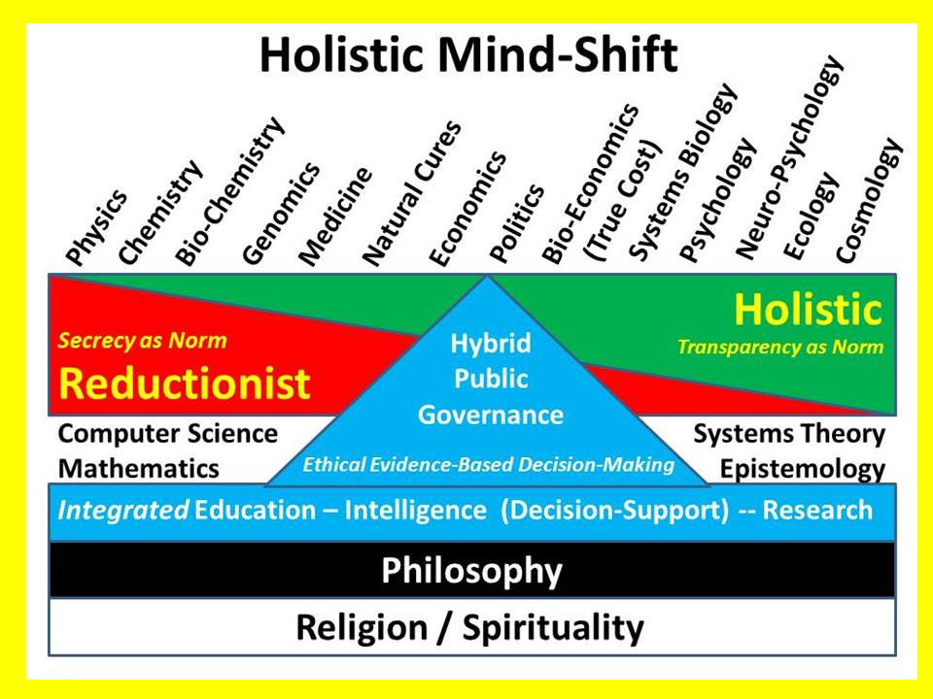
Figure 16: Human-Centric Holistic Mind-Shift
Science is – like any artifact – as good as or as bad as the human intentions and human hands that wield the power that science gives. Science is also stunted in the absence of the humanities (Saul 1993, Wilson 1999), of philosophy (Durant 2008), and religion (Kung 2008, Molben 2011). I strive to connect all minds to all information in all forms, confident that the human factor will surprise us time and again.

The Collaborative Economy & The Social Enterprise
The Collaborative Economy
The collaborative economy is defined by Jeremiah Owyang (2013) as the convergence of three ideas: the sharing economy, the maker movement, and the “co-innovation” movement. In relation to a research university focused on community service and enterprise outreach, this translates into an opportunity to fully integrate design, information management, engineering, and each of the disciplines in turn.
Design translates into accelerated production, performance, and adoption. Information management can change the marketplace by changing public understanding of the true cost of specific products, services, policies, or behaviors. Engineering can dramatically reduce cost by rejecting the last fifty years in which the Americans have substituted “cost plus government specification” engineering for the more brilliant engineering that optimizes design to dramatically reduce total costs across an entire life cycle and is repeatable across different mission areas. The simplified designs and shared components characteristic of the Global Village Construction Set are a real-world achievement worthy of emulation across many disciplines. Central concepts in gestation include these four below.
The Social Enterprise
A helpful definition of Social Enterprise is offered by the Centre for Social Enterprise of Canada:
Social enterprises are revenue-generating businesses with a twist. Whether operated by a non-profit organization or by a for-profit company, a social enterprise has two goals: to achieve social, cultural, community economic or environmental outcomes; and, to earn revenue. On the surface, many social enterprises look, feel, and even operate like traditional businesses. But looking more deeply, one discovers the defining characteristics of the social enterprise: mission is at the centre of business, with income generation playing an important supporting role.
The signal flaw in both of the above concepts is their neglect of the three innovations that I propose to bring together in order to accelerate the collaborative economy and the social enterprise.
However good the intentions might be, a lack of intelligence with integrity (Steele 2010) is still a fatal debility. Changing the objective of the enterprise (from pure profit to social good) does not change the underlying information and manufacturing processes in any substantive manner.
As Figure 5 on page 8 shows, I believe that in combination, True Cost Economics, Holistic Analytics, and Open Source Everything will help eradicate waste while radically lowering the cost of living (buy less, share more), the cost of production (open green, open science, open tools), and the cost of consumption (billions more will live well at a fraction of the prior cost).
One might say that I wish to enable intelligent social enterprise and fully-informed collaborative economics. This could be the advance that makes possible a metamorphosis of our academy, economy, government, and society away from war and profit for the few, toward peace and prosperity for the many.

Future-Oriented Hybrid Governance
The question must be asked: what does it mean to be a smart nation? I offer a preliminary answer rooted in our view that collective information sharing and sense-making firmly grounded in past history and deeply respectful of our ability to both harm and help the future, is the starting point. This is in fact the original approach of our indigenous forebearers and it diverges sharply from our current practice of fragemented, hierarchical decision-making by the few, often without accountability due to secrecy. I find that secrecy prevades all eight of the information networks, not only elements of banking, commerce, and governance (Long 2008, Marrs 2001, Moran 2013, Wilkinson 2009, Young 2012).
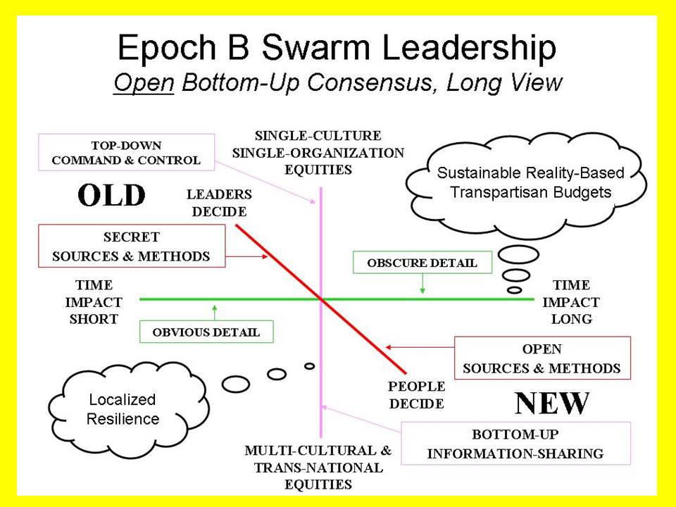
Figure 17: Industrial versus Indigenous (Restored) Decision Processes
More broadly, I find that there are numerous information pathologies that prevent – hinder – the establishment of public understanding and consensus on vital matters in the public interest. A few titles merit mention, in alphabetical order: Fog Facts (Beinhart 2006), Forbidden Knowledge (Shattuck 1997), Lost History (Parry 1999), Manufacturing Consent (Chomsky and Herman 2002), Missing Information (McKibben 2006), Propaganda (Ellul 1973), Weapons of Mass Deception (Rampton and Stauber 2003), and Weapons of Mass Instruction (Gatto 2010).
Within individual disciplines, notably those associated with agriculture, energy, and health, there are further pathologies associated with a mix of corruption, ignorance, and public inattention. Within individual communities, from local to provincial, from national to regional, there are further biases, distortions, absences of understanding, and even malicious underminings of the public interest.
It is not for us – any any outsiders – to directly address the persistent information pathologies that hold back disciplines and communities. What I seek to do is create an architecture for information-sharing and sense-making that is affordable, interoperable, and scalable. Open Source Everything, True Cost Economics, Holistic Analytics, and Embedded Intelligence are the means by which we empower citizens and communities in every clime and place.

Creating the World Brain
I envision – for discussion and in a preliminary manner seeking commentary – a new school with four integrated information management elements, and a multiplicity of open source endeavors.
The School for Future-Oriented Hybrid Governance would bring together cadres from all eight of the information networks into annual classes at three levels: junior, mid-career, and senior. Bringing human beings together, face to face, is the primordial role of this element, which should eventually be replicated within every university that wishes to be an effective catalyst for 21st Century peace and prosperity, and thus internationalize the concepts and practices. Within the School, a Global (Serious Game) – the preliminary work has been done (Gabel 2006, Gabel 2014) would put big open data and the open cloud in the service of the public in an interactive issue-oriented manner, augmented by a university-wide Provost Center for Comprehensive Architecture, a prototypical Center for Public Intelligence, and a World Brain Institute to manage a global network of human and data resources.
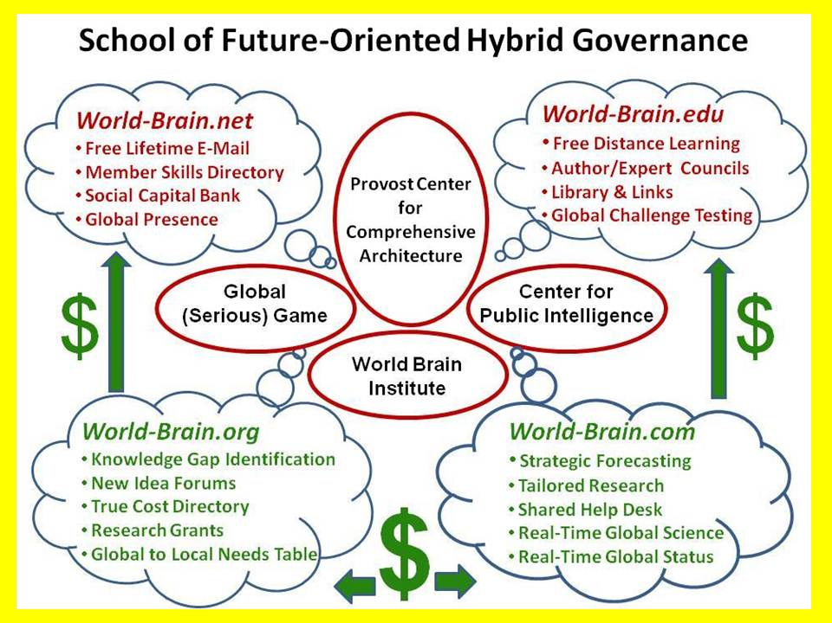
Figure 18: Elements of the School of Future-Oriented Hybrid Governance
School of Future-Oriented Hybrid Governance. This is envisioned as a new residential school at the main campus of Loughborough University, with an extension program for non-resident students at LUiL, as well as a very robust program of faculty and student exchange, joint investigations, shared online databases, and other forms of outreach to universities, governments, corporations and non-governmental organizations around the world. While proposed as contingent on earmarked funding, the School could nevertheless be started as a virtual entity from existing human, physical, and financial resources. A new building and green village complex are envisioned with twelve wings – one each for each of the eight information networks or tribes as well as the four Centers shown above.
Our intent is to create a model that can be replicated – and adapted – to any local circumstance.
1) the Provost Centre for Comprehensive Architecture where all of the schools and departments might form an intellectual, data-sharing, and methods council – the new high table of academia.
2) the Global (Serious) Game as the interactive manifestation of the Open Source Everything Innovation Hub applied to real world challenges using real world information.
3) the World Brain Institute as the local to global proponent for extending the platform to every organization world-wide, while empowering individuals via the four online domains.
a) World-Brain.Net strives to register as many as wish to in a manner that both validates their identities when such validation is essential to the process and they opt-in; while also providing them with reliable anonymity & privacy, as well as means of reserving rights related to any knowledge or data they share. This is not a revenue producer, but this creates a first to market and barrier to entry for all others, capturing billions of human minds that can be monetized through the other three online networks.
b) World-Brain.Edu strives to be the platform for persistent pervasive free online education for life, while also serving as a foundation for any individuals and organizations who wish to organize localized face to face and both physical and online human to human educational options. This will take testing and tutoring as well as team learning to entirely new levels of excellence and effectiveness.
c) World-Brain.Org is a revenue-producer and makes LUiL and the larger University the hub for M4IS2 world-wide at all levels of practice from local to global. From knowledge gap identification to research funding and new forms of co-investment (including the harnessing of cognitive surplus and crowd-sourcing) to new forms of quality control that eradicate plagiarism and optimize Creative Commons credit and compensation, this aspect seeks to double or triple the return on investment of the existing research base while cleansing it of waste from redundancy and corruption related to plagiarism and poor sources and methods.
d) World-Brain.Com is a revenue producer implementing the Herring Triangle of shared monitoring, shared help desk, tailored decision-support, tailored strategic forecasting (Herring 2004) with its local to global online structured and validate information commons (displacing the erratic and shallow archipelago of unreliable and biased sources today), its local to global distributed network of help desks (reference librarians without borders augmented by information brokers, private investigators, investigative journalist, citizen activists, and so many others), and of course as a central registry for commercial intelligence with each source having a validated record of past performance.
4) the Center for Public Intelligence as the model that can be replicated at any level anywhere by anyone using free open source software and hardware that in turn enables localized free open cloud to open spectrum public agency. The value of the whole is found in its clarity, diversity, integrity – and the sustainability it enables (Steele 2010).
As Figure 18 on page 23 illustrates, two of the four World Brain elements generate revenue – I anticipate substantial revenue, more than sufficient to amply fund the implementation of these ideas.

A New Discipline – the PhD/DBA in Embedded Open Source Intelligence
If implemented as envisioned, whatever refinements may emerge, this proposal will allow for the award of the world’s first PhD/DBA in holistic analytics, true cost economics, and open source everything. The PhD would be those seeking to devote their life to research in a university setting; the DBA would be for those seeking to take as much from the academic experience as possible, and then apply it in an entrepreneurial form in any of the eight networks that comprise the totality of the OSE/M4IS2 local to global network: academia as an administrator, civil society as an activist leader, commerce, government, law enforcement, media, military, and non-government/non-profit.
Organizations are all well and good, but in the end a great university must offer substance in a process that yields a tangible outcome – graduates in demand because of what they know and how they use what they know. Central to the design of a PhD/DBA to be offered by the School of Future-Oriented Hybrid Governance is the concept of eight information networks – each of the eight networks must provide members of the oversight board as well as varied mentoring networks; there must be practitioner involvement in the design and teaching of the course and the testing of the students; and finally, the student must exit the program not only being in great demand within their chosen network, but so versatile and skilled at leveraging the other seven networks they are destined for rapid advancement at all levels from local to global.
Course Intent
There is a need for a multidisciplinary mind-set, process, and constellation of best practices drawn from across all the disciplines, on a sound business footing. There is a need for a PhD/DBA that is neither about managing a business nor about economics, but rather about the totality of knowledge as it applies to creating wealth and managing resources on the basis of ethical open sources and methods. This is a meta-degree, a meta-process, creating a tangible web of knowledge across all boundaries.
In our view, the time has come for a normative discipline of Public Intelligence that is the proponent for both Multinational, Multiagency, Multidisciplinary, Multidomain Information-Sharing and Sense-Making (the human solution) and the adoption of Open Source Everything (the technical solution). International Relations, Public Administration (dramatically advanced into a new sub-discipline of Public Hybrid Governance), and a variety of other primary university disciplines would converge in this School. Neither parastatals nor narrow public-private partnerships encompass the larger human-centric data-driven vision that this project seeks to actualize.
This PhD/DBA degree proposal is tentatively bracketed on the one hand by technopolitics or digital activism, striving to study, design, test, and then promulgate a theory and practice of grassroots multi-stakeholder decision-support and decision-making (two completely different processes) – and by Smart Nations, Smart Cities, Smart Enterprises on the other – helping achieve ephemeralism (doing more with less) while also dramatically enhancing the prospects of creating prosperity and peace for all. Three "what if" questions are proposed for consideration by the Open Source Everything Steering Group (a university-wide body assuring that all schools and departments are part of the program).
WHAT IF OSE/M4IS2 were to make the evolving craft of intelligence (decision-support) its central focus, such that a new norm is established in which politics is evaluated in relation to its ability to engage in deep multi-cultural history and holistic analytics that are public in nature and inclusive of all eight tribes of public hybrid governance (academic, civil society, commerce, government, law enforcement, media, military, non-government/non-profit)?
WHAT IF OSE/M4IS2 enhanced its scientific credentials by embracing Whole Systems True Cost Economics as a foundational multi-disciplinary science with data indexed geospatially and in time? This would create a more grounded landscape of financial, social, and ecological opportunity and threat -- a basis for being a normative discipline.
WHAT IF OSE/M4IS2 recognized that in the Age of Information no discipline can be credible without the ability to collect, process, analyze, and share information affordably, inter-operably, and universally, which is to say, in an Open Source Everything fashion? This restores agency to the public – we put the public back into politics, but this time we connect all minds with all information in all languages.
The value proposition for the University and the community is that in today’s world, if the both the public and individual enterprises across each of the eight information networks can be provided with free information tools and access to all relevant information, the academy, the economy, government, and society, all change for the better.
At a practical individual PhD/DBA student level, this is a three-part challenge that many students aided by staff, will conquer:
a) create an “application” for decision-support that anyone can use;
b) create a model for assuring that true cost economic metrics are considered within the decision-support application; and
c) leverage existing open source information technology and encourage development of needed new open source information technology applications to empower citizens and enterprises of every size with tools for thinking, communicating, and mobilizing effectively not just on one issue at a time, but on all issues all of the time.
Course Design
Track 1: Holistic Analytics. Every discipline has its means of teaching sources and methods, how to think, how to investigate hypotheses, how to validate and present findings. Track 1 would devise an integrated multi-disciplinary course of instruction drawing on the best that various disciplines have to offer, in order to produce a PhD/DBA level leader in their chosen discipline who is fully familiar with alternative investigative schema across multiple disciplines, and able to credibly organize, oversee, evaluate, and exploit very large scale inquiries and projects that depend on evidence-based decision-support across the most complex combinations of challenges and circumstances.
Among the many skills that I wish to make standards in this new program are:
a) Citation Analytics. A new standard for literature reviews must be established, one that not only finds and evaluates best in class contributors in all languages and disciplines, but learns to go beyond the published literature to identify best in class practitioners at the field and practitioner level.
b) Time & Space Analytics. There is a growing body of thought that suggests we have been too dismissive of indigenous practices and wisdom prior to 1491, and still today in many areas where tribal practices and communal ownership are still flourishing. At the same time, geospatial analytics is in its infancy, but with some very promising advances being made both in the laboratory and in the field, the latter with open source humanitarian technologies and crowd-sourcing. A major university-wide value of this sub-track will be the development of new open standards and methods for integrating information across all of the disciplines in near real time and over great spans of time.
c) True Cost Analytics. The Earth and our children as well as future generations have no voice in politics and economics today. We are far past due for a radical change in the narrative at all levels, such that the true cost of every product, service, policy, and behavior can be researched, taught, and appreciated. A major university-wide value of this sub-track will be the development of a university-wide capability – unique at first and then replicated around the world – to determine trues costs for all processes and products, discipline by discipline. Cross-fertilizations inspiring of innovation should result.
Track 2: True Cost Economics. Although the concept is well established – and its pioneering economist, Dr. Herman Daly, is available to serve as an Emeritus member of the oversight board and mentoring network, no one, anywhere, is known to have gone “all in” on actually doing true cost economics across any single discipline, much less all disciplines. A major university-wide value of this track is the immediate establishment of the university as the “world bank” for validated data about the true cost of any product, service, policy, or behavior.
Track 3: Open Source Everything. All business processes and products – not only those dealing with information – are in urgent need of ephemeralism. Open Source Everything is how we help them achieve this goal. At a minimum the graduate will fully understand how to integrate all of the opens having to do with communications and computing. Ideally – and assuredly in their chosen network and practice sub-set, they will understand how to apply the Open Source Everything mind-set and method to any given set of business products and processes.
Track 4: Hybrid Governance (Threats, Policies, Demographics).
If there were one word lacking in the vocabulary of most college graduates today, that word is “context.” In the face of massive ignorance, obfuscation, and as often as not outright lies from the pinnacles of all eight information networks, our young adults entering the white collar workforce are sadly disadvantaged. They are ready for a life in cubicles that are no longer available for occupation. They are not ready to make their own way, to be entrepreneurial on their own or their employer’s behalf.
The first three tracks focus on self-development; the fourth track focuses very specifically on creating jobs, healing communities, and generating sustainable profit in a collaborative economy.
As the United Kingdom pursues policies intended to create Smart Cities, as varied cities, councils, and boroughs pursue “hack days” in relation to their data streams and their varied challenges, I believe that our integration of open source everything, true cost economics, and holistic analytics offers the academy, the economy, the government, and society an opportunity to accelerate innovation in a manner not previously considered and yet imminently affordable, interoperable, and scalable. Below is our graphic in relation to where tenders tend to be today, showing how our practical implementation offers alternatives that are superior to the current state of mind.
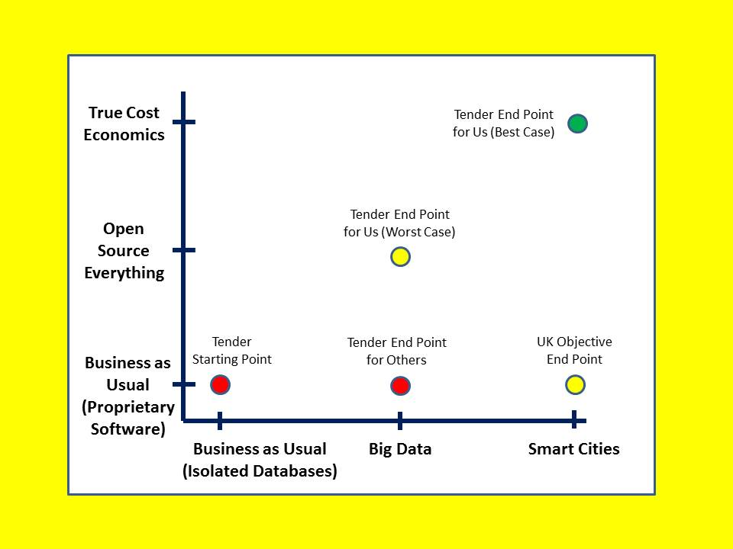
Figure 19: Beyond Big Data and Smart Cities
Open Source Everything is how we enable local to national and then international governments, universities, and all others to share data while respecting anonymity, identity, privacy, and rights. This is the only affordable, interoperable, scalable solution. Those that limit themselves to Open Data are destined for failure, and more rapidly so when corporations refuse to share their own data with the government.
True Cost Economics is how we transform the entire data ecology of any given community – all stakeholders and not only the government – so as to radically reduce waste and achieve design and engineering efficiencies simply not contemplated nor realized beforehand.

Unifying the Eight Information Communities or Networks
Hybrid governance, thoughtfully addressed by a few (Ostrom 1990, Reinicke 1998), requires that all possible stakeholders be able to share all possible relevant information and interact with one another to bring forth the perspectives and insights that have not been published. It is not enough to share information! There is a process of Co-Intelligence (Atlee 2010), Peer-to-Peer engagement (Bauwens 2011) and Dynamic Facilitation (Rough 2014) that is essential to these ideas being implemented and useful. The human face to face element and the creation of human bonds of trust across all boundaries and mission areas cannot be understated.
Below is a graphic that symbolizes the role I hope to see Open Source Everything – with embedded intelligence, holistic analytics, and true cost economics – in bringing together these eight information network for the greater good of humanity.
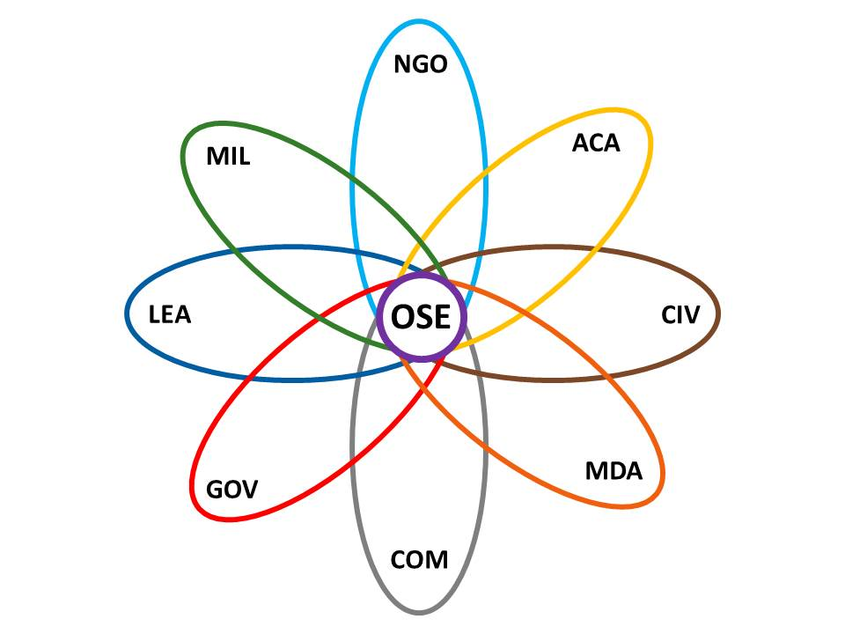
Figure 20: Eight Information Networks Empowered and Unified by Open Source Everything
This may become the logo of the generic innovation hub, protected by a Creative Commons license, and used to “badge” individuals belonging to organizations that make the commitment to go “all in” on Open Source Everything.

Conclusion – Next Steps
We are at the very beginning of a complex process intended to change for all time how we as a species make decisions about every matter at every level.
There are some small tangible steps that I propose for any interested university – indeed I dare hope that these small steps might result in a first class for the new PhD/DBA of 64 students – eight from each of the eight information networks – as well as a first tranche of fund-raising to better initialize the innovation hub.
Preliminary Outreach
In the early months I shall be engaged in systematic outreach, both within , and among elements of the eight information networks across the host country.
Regulatory and Legal Workshop
My initial impression is that Open Source Everything has failed to advance as rapidly as it might in part because of confusion and ignorance among regulatory agencies, and laxity in enforcing Creative Commons legal protections necessary to protecting rights to commercial exploitation and revenue.
Implementation Plan (Academic)
Working across all of the elements of host, I anticipate the rapid creation of an implementation plan for a PhD/DBA to be offered over four years full-time, with MA/MS options.
Implementation Plan (Financial)
It is clear to me, based on our initial survey, that some of the wealthiest families on Earth are now focused on the urgency of devising a sustainable alternative to what some have called Vampire Capitalism. I have a concept for raising and obligating no less than Sterling 100 million.
Creating a Social Enterprise as a Laboratory
I see a need for a model social enterprise that can be empowered with Open Source Everything and all relevant information it needs with respect to True Cost Economics and Holistic Analytics. As best I can tell, no enterprise anywhere has ever been created and operated with this kind of foundation.
Conference
I am proposing a conference to take place in within six months of program inception. I hope to engage – apart from the eight information networks in the UK – the same networks in several countries starting with India. Our objective in December 2014 is to validate, refine, and document these ideas in partnership with a broader range of contributing authors, publish a book quickly, and secure approval for establishing the new PhD/DBA in time to accept students for matriculation in October 2015.

Bibliography
Ackoff, Russell (2004). “Transforming the Systems Movement,” RLA Conference Paper (26 May 2004)
Ahmed, Nafeez (2010). A User's Guide to the Crisis of Civilisation: And How to Save it (London, UK: Pluto Press)
Allott, Philip (2002). The Health of Nations: Society and Law beyond the State (Cambridge, UK: Cambridge University Press)
Amato, Theresa (2009). Grand Illusion: The Myth of Voter Choice in a Two-Party Tyranny (New York, NY: New Press)
Anderson, Monica (2010). “Science Beyond Reductionism,” Syntience.com
Anielski, Mark (2007). The Economics of Happiness: Building Genuine Wealth (Gabiola Island, BC: New Society Publishers)
Arnold, Stephen E. et al (2014). “Big Data” Search term results, Phi Beta Iota (24 August 2014)
Arumugam, Nadia (2012). “UN Says Europe Wastes 50% of Fruit and Vegetables – and America Isn’t Must Better,” Forbes (4 October 2012)
Arvidsson, Adam and Nicolai Peitersen (2013). The Ethical Economy: Rebuilding Value After the Crisis (New York, NY: Columbia University Press)
Ashby, Muala (2006). The Limits of Faith: The Failure of Faith-based Religions and the Solution to the Meaning of Life (Miami, FL: Sema Institute)
Atlee, Tom (2010). The Tao of Democracy: Using Co-Intelligence to Create a World that Works for All (Cranston, RI: Writers Collective)
Badger II, Stephen M. (2014). “Editorial,” The Brewery Online PDF (London, UK: freuds)
Badger II, Stephen M. et al (2014). “Exploring Mutuality,” The Brewery Online PDF (London, UK: freuds)
Bamford, James (2002). Body of Secrets: Anatomy of the Ultra-Secret National Security Agency (New York, NY: Anchor Books)
Bauwens, Michel (2011). “Michel Bauwens: A Peer-to-Peer Economy,” PaperLi (30 November 2011)
Beinhart, Larry (2006). Fog Facts: Searching for Truth in the Land of Spin (New York, NY: Nation Books)
Benkler, Yochai (2005). “The new open-source economics,” TED (July 2005)
Boik, John (2014). Economic Direct Democracy: A Framework to End Poverty and Maximize Well-Being (Seattle, WA: CreateSpace)
Bok, Derek (2004). Universities in the Marketplace: The Commercialization of Higher Education (Princeton, NJ: Princeton University Press)
Botsman, Rachel and Roo Rogers (2010). What’s Mine is Yours: The Rise of Collaborative Consumption (New York, NY: HarperBusiness)
Briguglio, Lino et al (2006). “Conceptualizing and Measuring Economic Resilience,” Economics Department, University of Malta
Brown, Lester (2009). Plan B 4.0: Mobilizing to Save Civilization (New York, NY: W. W. Norton & Company)
Centre (2014). “PhD Studentships,” Centre for Doctoral Training in Embedded Intelligence, Loughborough University
Chiaramonte, Perry (2014). “War on waste: Pentagon auditor spotlights US billions blown in Afghanistan,” Fox News (28 July 2014)
Chomsky, Noam and Edward Herman (2002). Manufacturing Consent: The Political Economy of the Mass Media (New York, NY: Pantheon)
Conference (2014). “Conference on Inclusive Capitalism: Building Value, Renewing Trust,” Inclusive Capital Initiative of the City of London and E. F. Rothschild (27 May 2014).
Daly, Herman (2010). Ecological Economics: Principles and Applications 2nd Edition (Washington, DC: Island Press)
Davidson, Carl (2010). Solidarity Economy: Building Alternatives for People and Planet (Lafayette, CA: ChangeMaker Publications)
Deans, David (2014). “Why Mainstream Businesses Depend on Open Source Software and Hybrid Cloud Offerings,” LinkedIn (30 April 2014)
Dine, Philip (2007). State of the Unions: How Labor Can Strengthen the Middle Class, Improve Our Economy, and Regain Political Influence (New York, NY: McGraw-Hill)
Dixon, Michael (2014). Face to face discussion with Robert Steele based on direct IBM surveys of over 100,000 local governments across the USA (4 August 2014)
Durant, Will (2008). Philosophy and the Social Problem (Frisco, TX: Promethean Press)
Eisenstein, Charles (2011). Sacred Economics: Money, Gift, and Society in the Age of Transition (Berkeley, CA: North Atlantic Books Evolver Editions)
Ellul, Jacques (1973). Propaganda: The Formation of Men's Attitudes (New York, NY: Vintage)
Fischer, Barry (2013). “US Wastes 61-86% Of Its Energy,” CleanTechnica (26 August 2013)
Frankel, Carl and Allen Bromberger (2013). The Art of Social Enterprise: Business as if People Mattered (Gabriola Island, BC: New Society Publishers)
Frey, Bruno (2010). Happiness: A Revolution in Economics (Cambridge, MA: MIT Press)
Fuller, Buckminster (1982a). Critical Path (New York, NY: St. Martin’s Press)
_____ (1982b) Synergetics: Explorations in the Geometry of Thinking (New York, NY: Macmillan)
_____ (2008) Operating Manual for Spaceship Earth (Zurich, CH: Lars Muller)
Gabel, Medard (2006). “EarthGame 1.0 Version 3.3-1,” Earth Intelligence Network (Fall 2006)
_____ (2014). Designing a World that Works For All: Solutions & Strategies for Meeting the World's Needs - 2005-2013 Labs (Seattle, WA: CreateSpace)
Galper, Michael et al, “The price of excess: Identifying waste in healthcare spending,” PriceWaterhouseCoopers (April 2008).
Gansky, Lisa (2012). The Mesh: Why the Future of Business is Sharing (New York, NY: Portfolio Trade)
Garis, Hugo de (2014). “Innovating Beyond the Nanoscale: Femtometer Scale Technology,” YouTube 17:54 (uploaded 4 August 2014)
Gatto, John Taylor (2010). Weapons of Mass Instruction: A Schoolteacher’s Journey Through the Dark World of Compulsory Schooling (Gabriola Island, BC: New Society Publishers)
Ghani, Ashraf and Clare Lockhart (2008). Fixing Failed States: A Framework for Rebuilding a Fractured World (Oxford, UK: Oxford University Press)
Glenn, Jerome et al (2014). 2013-2014 State of the Future (Washington, DC: The Millenium Project)
Gray, Colin (1999). Modern Strategy (Oxford, UK: Oxford University Press)
Greider, William (2003). The Soul of Capitalism: Opening Paths to a Moral Economy (New York, NY: Simon & Schuster)
Gunders, Dana, “Wasted: How America is Losing Up to 40 Percent of Its Food from Farm to Fork to Landfill,” National Resources Defense Council (August 2012)
Herring, Jan (2004). “Graphic: Jan Herring’s Triangle for Decision-Support,” Phi Beta Iota (13 August 2011)
Hruska, Joel (2013). “Supercoming director bets $2,000 that we won’t have exascale computing by 2020,” ExtremeTech (17 May 2013)
Hurst, Aaron (2014). The Purpose Economy: How Your Desire for Impact, Personal Growth and Community is Changing the World (Boise, ID: Elevate)
Iacocca, Lee (2008). Where Have All the Leaders Gone? (New York, NY: Scribner)
Jurin, Barbara (2014). “InfoGraphic: 2014 – The Year of Open Source?,” GoGrid (8 April 2014)
Klavans, Dick and Kevin Boyack (2007). “Relationships Among Scientific Paradigms,” Maps of Science, replicated in SEED Magazine (7 March 2007).
Kelly, Kevin (1999). New Rules for the New Economy (New York, NY: Penguin)
Klein, Naomi (2008). The Shock Doctrine: The Rise of Disaster Capitalism (New York City, NY: Picador)
Kung, Hans (2008). The Beginning of All Things: Science and Religion (Grand Rapids, MI: Wm B Eerdmans Publishing Co)
Kutz, Myer (2007). Environmentally Conscious Manufacturing (New York, NY: Wiley)
Lerner, Josh and Jean Tirole (2002). "Some Simple Economics of Open Source". The Journal of Industrial Economics Vol 50 No 2 (June 2002), pp. 197-234.
Lerner, Michael (2007). Left Hand of God, The: Healing America's Political and Spiritual Crisis (New York, NY: HarperOne)
Lessig, Lawrence (2014). “A message from Larry: A new CEO and a challenge to the CC community,” Creative Commons (14 May 2014)
Lewis, Charles (2014). 935 Lies: The Future of Truth and the Decline of America’s Moral Integrity (New York City, NY: PublicAffairs)
Linebaugh, Peter (2014). Stop, Thief!: The Commons, Enclosures, and Resistance (Oakland, CA: PM Press)
Liszkiewicz, JZ “ Graphic: True Cost of a Cotton T-Shirt,” Phi Beta Iota (16 April 2011)
Long, Pamela (2004). Openness, Secrecy, Authorship: Technical Arts and the Culture of Knowledge from Antiquity to the Renaissance (Baltimore, MD: Johns Hopkins University Press).
Lovins, Amory and Michael Braungart (2014). A New Dynamic: Effective Business in a Circular Economy (Cowes, UK: Ellen MacArthur Foundation Publishing)
Lowitt, Eric (2013). The Collaboration Economy: How to Meet Business, Social, and Environmental Needs and Gain Competitive Advantage (New York, NY: Jossey-Bass)
Lyle, John Tillman (1996). Regenerative Design for Sustainable Development (New York, NY: Wiley)
Mann, Charles (2008). 1491: New Revelations of the Americas Before Columbus (New York, NY: Vintage)
Marrs, Jim (2001). Rule by Secrecy: The Hidden History That Connects the Trilateral Commission, the Freemasons, and the Great Pyramids (New York, NY: William Morrow)
Mars Sr., Forrest (1947). “The Company’s Objective,” Personal Note in Badger (2014).
McKendrick, Joe (2013). “Only Four Percent Complete Massive Open Online Courses: Setback or Growing Pains?,” SmartPlanet (15 December 2013)
McKibben, Bill (2006). The Age of Missing Information (New York, NY: Random House)
Meeker, Mary (2014). “Internet Trends 2014,” Kleiner Perkins Caufield Byers (28 May 2014)
Molben, James (2011). God and Science: Coming Full Circle? (Seattle, WA: CreateSpace)
Moran, Christopher (2013). Classified: Secrecy and the State in Modern Britain (Cambridge, UK: Cambridge University Press)
Newby, Hunter (2014). “Hunter Newby: Infrastructure Peering — A Physical Layer Understanding of Net Neutrality,” Phi Beta Iota (25 May 2014)
Ostrom, Elinor (1990). Governing the Commons: The Evolution of Institutions for Collective Action (Cambridge, UK: Cambridge University Press)
Owyang, Jeremiah (2013). “The Collaborative Economy,” Altimeter Group Network on Slideshare
Paltrow, Scot (2013). “Behind the Pentagon’s doctored ledgers, a running tally of epic waste,” Reuters (18 November 2013)
Parry, Robert (1999). Lost History: Contras, Cocaine, the Press & 'Project Truth' (San Francisco, CA: Media Consortium)
Perkins, John (2004). Confessions of an Economic Hit Man (New York, NY: Plume)
Radej, Bojan (2014). “Social Complexity: Operational Definition,” Slovenian Evaluation Society Working Papers 7/2 (June 2014)
Rampton, Sheldon and John Stauber (2003). Weapons of Mass Deception: The Uses of Propaganda in Bush's War on Iraq (New York, NY: Tarcher)
Reinicke, Wolfgang (1998). Global Public Policy: Governing without Government? (Washington, DC: Brookings Institution Press)
Rhodan, Maya (2014). “Delay Action on Climate Change by 10 Years and Costs Rocket 40%: Report,” TIME (29 July 2014)
Rinaldi, Bo (2014). “Redemptive Capitalism,” electronic communication with Robert Steele, 20140823
Rischard, Jean-Francois (2003). High Noon: 20 Global Problems, 20 Years To Solve Them (New York, NY: Basic Books)
Roche, Bruno (2014) “The Economics of Mutuality,” Online PDF (Universite Catholique de Louvain)
Rough, Jim (2014). “Dynamic Facilitation and Wisdom Council,” ToBe.Net (25 August 2014)
Saul, John Ralston (1993). Voltaire’s Bastards: The Dictatorship of Reason in the West (New York, NY: Vintage)
Savitz, Andrew (2013). The Triple Bottom Line: How Today's Best-Run Companies Are Achieving Economic, Social and Environmental Success - and How You Can Too (New York, NY: Jossey-Bass)
Schwartz, Ariel (2014). “The Collaborative Economy is Exploding, and Brands That Ignore It Are Out of Luck,” FastCoExist.com, 3 March 2014
Scott, Leonard (2013). Inclusive Capitalism: What It Looks Like in Practice (Seattle, WA: CreateSpace)
Shalom, Nati (2014). “Notes from the OpenStack Summit: open source cloud hits the mainstream,” (BusinessCloudNews (23 May 2014)
Shattuck, Roger (1997). Forbidden Knowledge: From Prometheus to Pornography (New York, NY: Mariner Books)
Shirky, Clay (2011). Cognitive Surplus: How Technology Makes Consumers into Collaborators (New York, NY: Penguin Books)
Sirico, Robert (2012). Defending the Free Market: The Moral Case for a Free Economy (Washington, DC: Regnery Publishing)
Spinney, Chuck (1985). Defense Facts of Life: The Plans/Reality Mismatch (Boulder, CO: Westview Press)
Stallman, Richard (2010). Free Software, Free Society (Boston, MA: Free Software Foundation)
St. Clair, Jeffrey (2005). Grand Theft Pentagon: Tales of Corruption and Profiteering in the War on Terror (Monroe, ME: Common Courage Press)
Steele, Robert (2008). “Graphic: The Four Quadrants of Knowledge,” Phi Beta Iota (15 August 2008)
_____ (2010). Intelligence for Earth: Clarity, Diversity, Integrity, & Sustainability (Oakton, VA: Earth Intelligence Network)
_____ (2011) “Water: Soul of the Earth, Mirror of Our Collective Souls,” Huffington Post (7 January 2011)
_____ (2012). The Open Source Everything Manifesto: Transparency, Truth, & Trust (Berkeley, CA: North Atlantic Books Evolver Editions)
_____ (2014a). “2014 Robert Steele Appraisal of Analytic Foundations,” Phi Beta Iota (1 May 2014)
_____ (2014b) “Proposal: Open Source Everything Innovation Hub: Concept for a Human-Centric Digital Information Management Foundation for Ethical Evidence-Based Collaborative Economics and Social Enterprises,” Working Paper, Glendonbrook Institute for Enterprise Development, Loughborough University (Version 3.7 dated 17 August 2014)
_____ (2014c) “Method Graphic” within “2014 Robert Steele – An Open Letter,” Phi Beta Iota (3 February 2014)
Stockholm International Peace Research Institute (2014). “The US spends more on defense than the next eight countries combined,” Peter G. Peterson Foundation (13 April 2014)
Stockstad, Erik (2014). “The 1% of scientific publishing,” Science Magazine (11 July 2014)
Taibbi, Matt (2011). Griftopia: A Story of Bankers, Politicians, and the Most Audacious Power Grab in American History (New York, NY: Spiegel & Grau)
Taibbi, Matt (2014). The Divide: American Injustice in the Age of the Wealth Gap (New York, NY: Spiegel & Grau)
Tiger, Lionel (2000). The Manufacture of Evil: Ethics, Evolution, and the Industrial System (London, UK: Marion Boyars Publishers)
Waid, Christopher (2014). Chief Executive Officer of ThinkPenguin.com. Personal conversation with Robert Steele, Hackers on Planet Earth in New York City (19 July 2014)
Webb, Diane et al (1989). CATALYST: A Concept for an Integrated Computing Environment for Analysis (McLean, VA: Central Intelligence Agency)
Wilkinson, Nicholas John (2009). Secrecy and the Media: The Official History of the United Kingdom's D-Notice System (Oxford, UK: Routledge)
Wilson, E. O. (1999). Consilience: The Unity of Knowledge (New York, NY: Vintage)
_____ (2003). The Future of Life (New York, NY: Vintage)
Young, Mary Alice (2012). Banking Secrecy and Offshore Financial Centers: Money laundering and offshore banking (Oxford, UK: Routledge)
United Nations (2004). A More Secure World: Our Shared Responsibility--Report of the Secretary-General's High-level Panel on Threats, Challenges and Change (New York, NY: United Nations)

OSEE: The Nordic Manifesto

Open Source Everything Engineering (OSEE) is affordable, inter-operable, and scalable to the five billion poor now neglected by industrial-era engineers. Data-driven, a design revolution could enable the achievement of the Sustainable Development Goals (SDG) within a decade – two at most – at 1/10th the cost of the current paradigm. An Open Source (Technologies) Agency is proposed as a starting point for the second industrial-informational revolution.

DOING THE RIGHT THING
Engineering – the practical application of scientific knowledge to real-world challenges – could be on the verge of a data-driven design revolution equal to and surpassing the industrial revolution. Obstacles to our advance include scientific reductionism, “government specification cost plus” contracting, and an average waste factor across most domains of roughly fifty percent. Other obstacles include legal and financial regimens that perpetuate engineering models devoid of accountability and oblivious of true cost economics. On a positive note, the information revolution has made possible data-driven design innovation, and the emergence of Open Source Software has spawned an ecology that now encompasses all forms of engineering, the term of art being Open Source Everything Engineering (OSEE).
Openness provides higher efficiency, effectiveness, and – in the face of complexity – adaptability. An Open Source (Technologies) Agency (OSA) is proposed as a starting point for the second industrial-informational revolution. Including a World Brain Institute, a Global Game, a School of Future-Oriented Design & Hybrid Governance, and a United Nations Open-Source Decision-Support Information Network (UNODIN), the OSA aspires to re-boot the crafts of intelligence (decision-support) and engineering (the heart of civilization) in order to achieve all of the Sustainable Development Goals (SDG) within a decade (two at the most) at 1/10th the cost of the current industrial-era processes.
THE CHALLENGE—SHIFTING FOCUS
The challenge is one of focus and scale. Engineering today is centered on the one billion rich whose annual aggregate income is roughly one trillion dollars. Largely neglected by engineering today are the five billion poor, whose annual aggregate income is four times larger – four trillion dollars a year. However, the poor need – and can only afford – micro-solutions. Instead of a complex refrigerator requiring reliable electricity, they need a ceramic jar combination to be buried in the ground so as to keep meat fresh for five days. Four times the money, five times the number of customers, but with different (micro) needs. There is a massive vacuum – a massive opportunity – right here right now.
The United Nations (UN) has identified seventeen engineering challenges – the Sustainable Development Goals (SDG) – that no one is taking seriously in part because the current industrial-financial paradigm is not suited to address those challenges. The donations are not materializing; the bulk of the donor money – 80% on average – is spent on intermediaries rather than reaching the village level; and our Western solutions are too expensive, and too wasteful, to scale.
Our challenge is to make engineering relevant to the five billion poor, first at the subsistence or provisioning level, then at the communications and education level, and finally – our master stroke – at the advanced level, creating a global quality of life rooted in peace and prosperity for everyone.
WASTE ERADICATION IS PRIORITY ONE
On a scale of 1 to 100, with 1 representing total waste and 100 representing total efficiency or zero waste – what Buckminster Fuller called “ephemeralism” or doing more with less – the craft of engineering – no matter the type whether chemical, electrical, mechanical, or other – would appear to be at or below the 50% mark, since 50% is the documented average waste across the major engineering domains from agriculture to energy to health to housing to security to water, and beyond.
Figure 1 illustrates the importance of three concepts and practices that seek to help engineers eradicate waste by integrating Holistic Analytics, True Cost Economics, and OSEE. The “sweet spot” or the acme of skill, is achieved by embedding intelligence (evidence-based decision-support) into every policy and process and product and behavior such that our scientific achievements are affordable to all, interoperable across all disciplines, and scalable to every point on the planet. A new PhD program – the first “meta” engineering and public administration PhD – is proposed to pursue these possibilities.
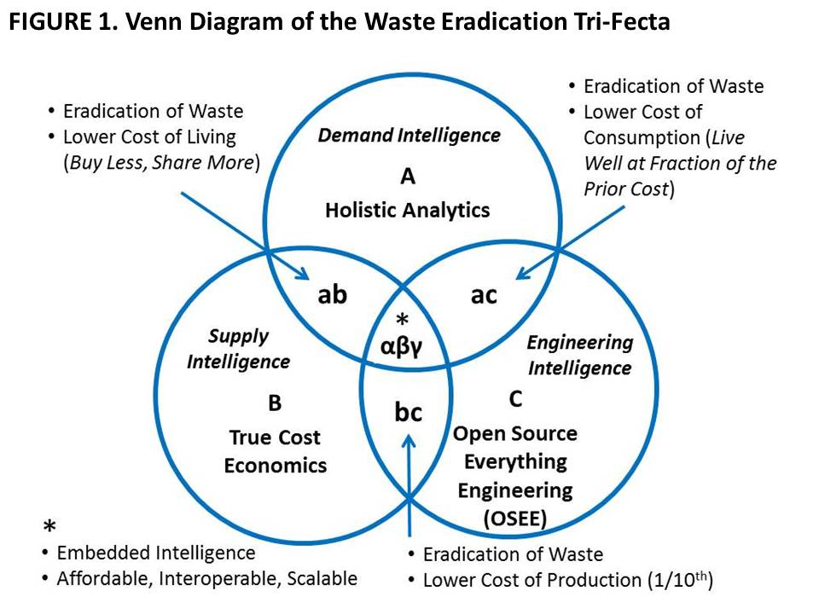
Holistic analytics. The problem with all current endeavors is that none of them attempt to define and study all threats simultaneously with all policy domains against all demographics. From an engineering stand-point, we must stop doing the wrong things righter – solving problems in isolation, for contrived markets that are fooled into wanting the solution we have decided to sell them regardless of true cost.
We must recognize that we live within a constellation of complex systems that interact in obscure and unpredictable ways, with multiple failure points that will in turn interact in obscure and unpredictable ways, with failure scaling faster than we can devise solutions as long as we persist in reductionist thinking and unethical engineering. Hence, a necessary pre-condition for doing holistic analytics and true cost economics in support of OSEE is the achievement of 100% access to all knowledge in relation and in real-time, instead of the 1% to 4% that is prevalent today.
If governments and other organizations do not do evidence-based decision-making rooted in holistic analytics of true cost economics with the objective of creating affordable, interoperable, scalable engineering solutions – which is to say, open source solutions now known to cost one tenth what proprietary closed engineering costs, we will soon go well past the tipping points for catastrophic failure across multiple domains including bio-chemical and nuclear accidents, vanishing aquifers, and pandemics. Elective wars destroying entire societies, and the millions of illegal immigrants spawned by those wars are modest challenges, in this larger context. Acts of Man – not Acts of God – are changing the Earth for the worse at an accelerating rate – changes that once took 10,000 years now take three years or less.
Table 1 offers three related perspectives on how best to define our local to global engineering agenda with the observation that today’s governance and financial paradigms over-spend on war at the national level to the detriment of peaceful development engineering that can stabilize the billions of poor, many of them living under repressive regimes that concentrate wealth within a very small elite.

TABLE 1. Earth Intelligence Network Outline – A Preliminary Holistic Analytic Model
Ten High-Level Threats | Twelve Core Policy Domains | Selected SDG Challenges
01 Poverty | 01 Agriculture | 01 No Poverty
02 Infectious Disease | 02 Diplomacy | 02 Zero Hunger
03 Environmental Degradation | 03 Economy | 03 Good Health & Well-Being
04 Inter-State Conflict | 04 Education | 04 Quality Education
05 Civil War | 05 Energy | 05 Gender Equality
06 Genocide | 06 Family | 06 Clean Water and Sanitation
07 Other Atrocities | 07 Health | 07 Affordable and Clean Energy
08 Proliferation | 08 Immigration | 10 Reduced Inequalities
09 Terrorism | 09 Justice | 11 Sustainable Cities and Communities
10 Transnational Crime | 10 Security | 13 Climate Action
 | 11 Society | 14 Life Below Water
 | 12 Water | 15 Life on Land
Challenges to holistic analytics include the fragmentation of knowledge workers, the fragmentation of knowledge by domain, language, and medium; and the lack of tools for information-sharing and sense-making across all domains.
Making all information openly available – accessible to and exploitable by the public – is essential if we are to govern the commons with the deep wisdom and understanding that only an engaged informed collective can provide. Top-down hierarchies steeped in secrecy and privilege do not work.
True Cost Economics. We are close to but not yet at a point where everyone appreciates true cost economics as pioneered by Herman Daly and a few others. True cost economics refers to the actual natural capital cost of specific policies, produces, services and behaviors. Today some of us understand the human cost, the social cost, the long-term economic and political cost, of choices including elective wars and legalized financial crime, but this has not become mainstream. Also lacking is the ability to geo-tag all elements of supply and use chains so that we can get to the exact amount of virtual water, fuel consumption, toxins generated, child labor, regulatory violation, and tax avoidance. Table 2 offers a model for thinking about true costs – what is lacking across the board is the actual data for every policy, product, service, and behavior.
TABLE 2. PriceWaterhouseCoopers (UK) Model for Measuring the All-Around Impact of a Company on Society
Economic Impact | Social Impact | Environmental Impact | Tax Impact
Payroll  Profits  Investment  Exports  Intangibles | Livelihoods  Health  Education  Empowerment  Community cohesion | GHGs and other emissions  Water pollution  Waste  Land use  Water use | Profit taxes  People taxes  Production taxes  Property taxes  Environmental taxes
PwC has provided a superb starting point, mindful that the data does not exist and most organizations will be reluctant to take on the burden of collecting data absent a public boycott of products that fail to provide true cost economic information at the point of sale.
A tangible data example – one that took a year to compile – for one particular white cotton T-shirt (true costs will vary for the same product depending on which factory, which time of year, and other conditions including weather) is offered here:
- Water: 570 gallons (45% irrigation)
- Energy: 8 kWh (machines), 11 to 29 grams fuel
- Travel: 5,500 to 9,400+ miles
- Emissions: Nox, SO2, CO, CO2, N2O, volatile compounds
- Toxins: 1-3 g pesticides, diesel exhaust, heavy metals (dyes)
- Child Labor: 50 cents a day in any of 17 countries
A more recent example of a true cost not yet grasped by the public is the documentation of why wheat grown in the USA is poisoning humans – it’s not “gluten allergy,” it’s a reaction to a herbicide containing the deadly active ingredient glyphosate being used as a desiccant just prior to the harvesting of the wheat.
Open Source Everything Engineering (OSEE). OSEE is in many ways a return to the indigenous peoples’ approach to civilization-building – one for all and all for one. OSEE is not necessarily “free” nor does it reject the concepts of intellectual property, revenue, and profit. What OSEE does is take “liberation technology” to the next level – achieving more with less (ephemeralism) – while extending the blessings of engineering across the rural environment occupied by the five billion poor.
FIGURE 2 depicts the nine core domains, each of which has three or more sub-domains itemized in TABLE 3. The opens reinforce one another – Open Data is impoverished without Open Software which is strengthened by Open Governance and Open Infrastructure, and so on. Perhaps even more pointedly, absent an extension of the open source mind-set and practice into Open Infrastructure, Open Manufacturing, and Open Provisioning, we will not achieve the SDG goals and elevate the five billion poor.
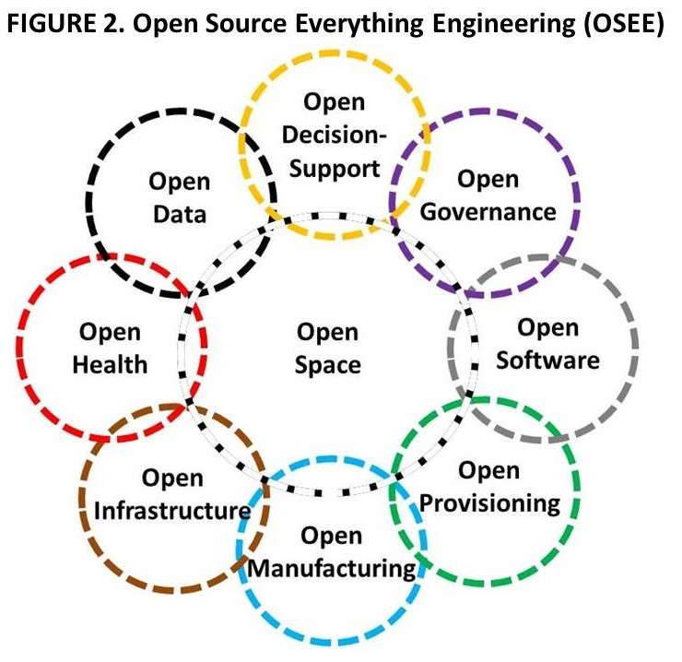
The next big leap in engineering – the ultimate hack if you will – could be a series of applications that are infinitely scalable at near zero cost, thus impacting most favorably on billions of people in quick time.
A “village in a box” could provide, for example – and at a cost estimated to be no more than $500 per individual – solar power fields for water desalination; potable water tanks and trickle piping; aquaponics start-up kits; several pieces of equipment from the Global Village Construction Set providing the ability to dig and move dirt and create pressed-brick structures; regional cell towers and free cellular phones along with neighborhood wireless mesh kits and one laptop per household; and bits and pieces for composting home sewage, gray water treatment, and so on. After the first wave of boxes dropped by precision-parachute, specialty boxes could be delivered – a solar field box, a water desalination box, a hospital box, a university box, a governance and law enforcement box, etcetera. In approaching the needs of the five billion poor we have it backwards – instead of bringing our infrastructure to them, we should be delivering the fundamentals in open form so as to unleash the unlimited brainpower and energy they have in hand. This would empower them to build out and up as innovators, nor merely be “customers” for Western offerings that are inappropriate, too expensive, and unsupportable in austere environments.
TABLE 3. Open Source Everything Engineering (OSEE) Building Blocks
Open Data | Open Geospatial | Open History | Open Language
Open Decision-Support | Open Access | Open Document | Open Research
Open Governance | Open Money | Open Politics | Open Standards
Open Health | Open Cures | Open Drugs | Open Procedures
Open Infrastructure | Open API* | Open BTS** | Open Spectrum
Open Manufacturing | Open Circuits | Open Hardware | Open Materials
Open Provisioning | Open Energy | Open Food | Open Water
Open Software | Free Software | Libre Software | Open Code
Open Space | Open Cities | Open Design | Open Innovation
* Application Program Interface ** Base Transceiver Station
EMBEDDED INTELLIGENCE
Embedded Intelligence (EI) is a term of art for a vision that stops short. As with the original concept of “Smart Cities,” it assumes that merely adding IT to existing artifacts, or using IT to enhance existing design, packaging, manufacturing, and system services, somehow embeds intelligence in Applications Engineering. 21st Century thinking brings to bear the tri-fecta of Holistic Analytics, True Cost Economics, and Open Source Everything Engineering (OSEE) so as to eradicate waste in every form. Some waste can be eradicated through consumer and decision-maker education, to include the provision of true cost economic facts at the point of sale; some waste can be eradicated by process engineering that squeezes out the virtual water, excess fuel, toxin creation, and with commercial intelligence, identifies and shuts out actors who are guilty of using child labor, violating environmental and other regulations, or simply avoiding their civic, social, and taxation obligations. Figure 3 illustrates this concept.
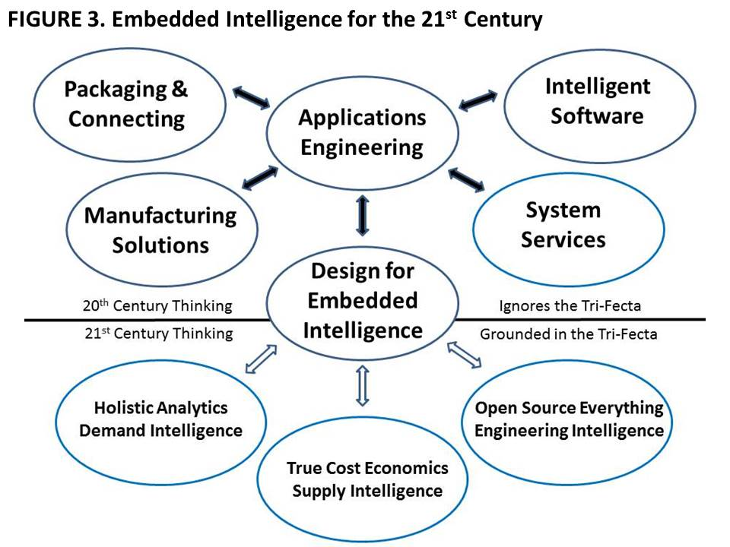
BEYOND WASTE TO WEALTH CREATION
The eradication of waste is the first step toward data-driven design in which solutions are devised that are completely natural and sustainable. We cease drawing down on natural capital, we cease poisoning humanity and the Earth, and we begin the second industrial revolution, this time living up to our ethical precepts to include doing nothing further to endanger the public or the environment.
The human brain is the one infinite resource we have.
Our first priority should be to create at least one Open Source (Technology) Agency that could in turn inspire replicates in other countries. Such an agency, with a clear mission to support Defense, Diplomacy, & Development (D3), would be divided into a D3 Information Bureau and a D3 (Engineering) Innovation Bureau.
Among its elements would be a shared global World Brain Institute; a Global Game allowing all citizens in all locations voice and vote over all issues and investments; a School of Future-Oriented Design & Hybrid Governance; and ideally, a United Nations Open-Source Decision-Support Information Network (UNODIN) – if the latter cannot be achieved immediately, then a Nordic Intelligence Centre devoted to inspiring peace instead of war, prosperity instead of predatory capitalism, should be considered.
Our second priority must be the combined goal of achieving free energy with unlimited water desalination on the one hand, and the elimination of all elective toxins in our present processes on the other.
Our third priority should be the restoration of the roles of education (learn to think), intelligence (inform), and research (investigate and innovate for the good of all). A new “meta” doctoral level program with master and bachelor level feeds is needed, one that offers the above tri-fecta as three tracks, with candidates choosing one track as their major.
The key component of this vision is openness – transparency, truth, & trust are the Holy Trinity.
- - - - - - - - - - - - - - - - - - - - - - - - - - -
Robert David Steele is the founder and pro bono Chief Executive Officer of Earth Intelligence Network, an accredited non-profit educational association. He has forty years’ experience across most aspects of diplomatic, informational, military, and economic (DIME) operations. View his complete biography and most publications online at http://robertdavidsteele.com. Contact him at robert.david.steele.vivas@gmail.com.

Proposed: An Open Source (Technologies) Agency
8 October 2015

MEMORANDUM FOR VICE PRESIDENT OF THE UNITED STATES OF AMERICA
SECRETARY OF STATE
SECRETARY OF DEFENSE
DIRECTOR, OFFICE OF MANAGEMENT AND BUDGET
ADMINISTRATOR, US AGENCY FOR INTERNATIONAL DEVELOPMENT

SUBJECT: Supporting the President’s Interest in 2015 Defense, Diplomacy, and Development Innovation – the Open Source (Technologies) Agency, Digital Deserts, & Global Stabilization

Inspired by the Secretary of Defense and his 11 September 2015 internal call for ideas related to the convergence of technological innovation with defense, diplomacy, and development objectives, an Open Source (Technologies) Agency is proposed. This agency, twice discussed during the past fifteen years within the Office of Management and Budget (OMB) (in an earlier information-focused incarnation), is now proposed as a comprehensive innovation engine that addresses nine distinct open source technology groups itemized below:

Open Data
Open Decision-Support
Open Governance
Open Health
Open Infrastructures
Open Manufacturing
Open Provisioning
Open Software
Open Space

The Problem: At a meta-scale, the common defense, diplomacy, and development (D3) challenge is the “digital deserts” that are also coincident with energy, water, and food scarcity while being a primary point of origin for illegal immigrants inclusive of criminals and terrorists.

At the intermediate scale, our defense, diplomacy, and development efforts cannot achieve their full potential, both within our Whole of Government context and multinationally, for lack of affordable, inter-operable, scalable and secure information-sharing and sense-making tools that allow holistic analytics, true cost economics, and open source everything engineering (OSEE) to be applied to the ten high level threats to humanity.

At a strategic scale, despite some excellent thinking in relation to Sustainable Development Goals (SDG) and related US initiatives, the reality is that donor promises are insufficient and often fail to materialize, and the current development paradigm – inherently bureaucratic with little accountability or coherence, cannot do the job – less than 20% of the funds and often as little as 1% -- actually arrive at the village level. The current industrial-scientific paradigm is not affordable, not inter-operable, and will not scale to address the needs of the five billion poorest in time to avoid a climate change collapse that makes today’s illegal immigration look like the thin stream that it is – we envision tens of millions of displaced persons moving north – many of them violent --in our future, absent a radical change in how we do the business of D3.

The Idea: An Open Source (Technologies) Agency funded by defense, under diplomatic auspices, and focused on a mix of Whole of Government and multinational information-sharing and sense-making with a digital Marshall Plan emphasizing Open Source Provisioning (energy, water, shelter, food) as well as Open Infrastructures (free cellular and Internet), will quickly and radically enable leap-frog innovation that stabilizes and reconstructs at a local to global scale.
This idea is directly responsive to both past Defense Guidance, and to the State-USAID Joint Strategic Plan 2014-2017, particularly goals 1.2 (inclusive economic growth reducing extreme poverty and improving food security), 3.2 (clean energy helping transition to a cleaner global economy), and 5.1 (enable more effective influence operations). With respect to digital deserts, this idea would for the first time aggregate research, development, and implementation of all the opens relevant to connecting, empowering, and stabilizing the five billion poor.

Two implementation elements are proposed, to be co-located on the South-Central Campus adjacent to the Department of State, the U.S. Institute for Peace, and George Washington University, with additional nodes to be funded elsewhere (NYC, Nairobi, etc.) by others:

D3 Information Bureau. This multinational information-sharing enterprise would be manifest in a United Nations Open-Source Decision-Support Information Network (UNODIN) that makes it possible to collect other people’s open source information and harmonize other people’s money at the village level (eliminating the 80% lost to intermediaries) while delivering open source innovation blueprints. Led by a US Ambassador as Assistant Secretary-General for Decision-Support, it would include a World Brain Institute with a Multinational Decision-Support Center (MDSC), a School of Future-Oriented Hybrid Governance, and a Global Game with embedded true cost economics information for testing each innovation idea. In combination this information bureau will enable free public education one cell call at a time, and begin the process of engaging the world public in sustainability thinking, ultimately eradicating the average of 50% waste to be found across all policy areas from Agriculture to Energy to Water.

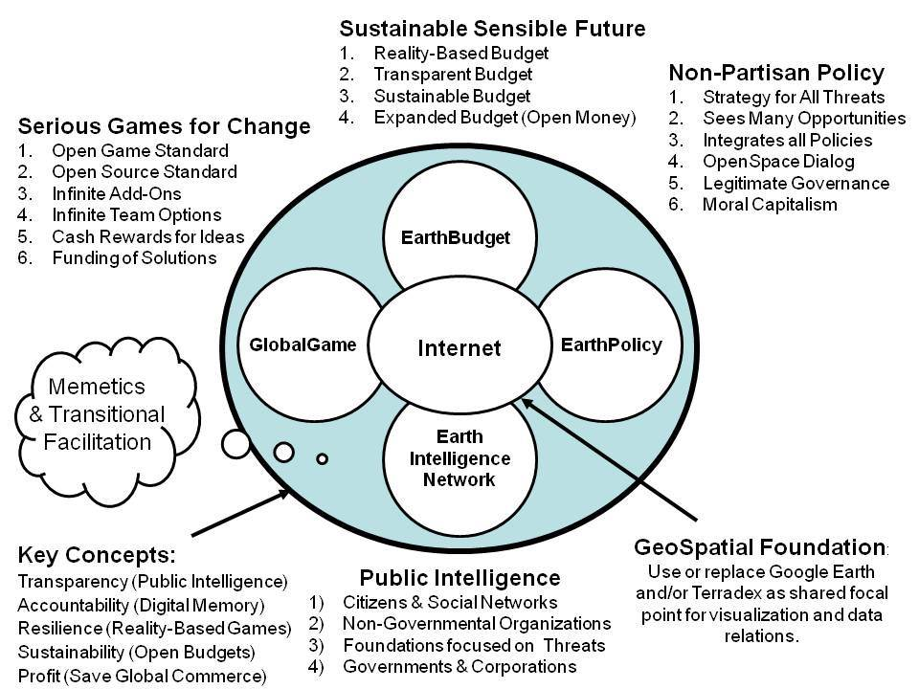

D3 Innovation Bureau. This multinational open source everything engineering center (with a global network of applied scientists and engineers including many volunteers) would have a division for each of the nine open technologies categories, with initial emphasis to be placed on Open Provisioning – free energy, unlimited desalinated water using free energy, the rapid completion and global deployment of the Global Village Construction Set including pressed-brick shelters (the ultimate affordable housing), decentralized composting, and aquaponics – sustainable agriculture without pesticides. The existing “village in box” idea, for example, would enable the resettlement of one million Somalis now in UN resettlement camps across the region to be moved to northeastern Somalia (uncontested territory with unlimited dirt, sunlight, and seawater) at a cost of $500 per person, inclusive of transport, free cellular, and aquaponics.
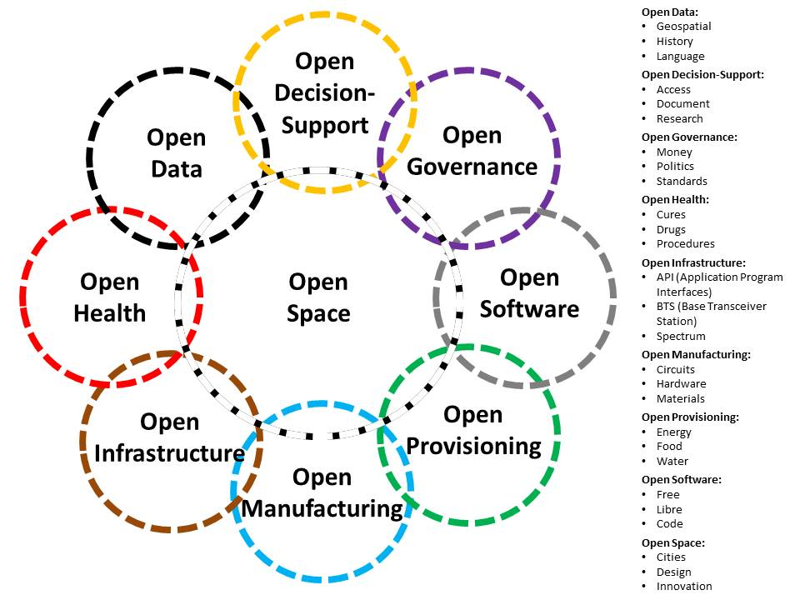

The specific early focus of the entire program will be Somalia, Syria, and Yemen, with a collaborative multinational executive including all of the stakeholders in the current emergency situation in the Middle East that is creating the mass migration to Europe. Our intent is to demonstrate how quickly and inexpensively Open Source Everything Engineering (OSEE) can advance the D3 capabilities in unconventional threat environments.

Resource Requirements: In the earlier information-focused incarnation, twice discussed in the past fifteen years within OMB (always contingent on the White House or a Cabinet Secretary endorsing the idea) the proposed funding was IOC $125M toward FOC $2B. This substantially enhanced variation of the idea, focused on sixty technology areas in nine groupings, is recommended for IOC $125M toward $3B, and would serve as the centerpiece for mobilizing and guiding over one trillion dollars in other people’s money toward achieving the SDGs.

Critical Next Steps: A single conversation among the principals to whom this memorandum is addressed should suffice to set this idea in motion. The Vice President would be ideal as chairman of the oversight board, with the new agency to be established as a sister agency to the Broadcasting Board of Governors (BBG), using non-reimbursable funding from DoD. A Smart Nation – Safe World Act is available as concise implementing legislation. The leadership team should be given full independence – this will fail if it is subordinate to any existing bureaucracy.

Changing Public Diplomacy & Development with Science & Technology: In combination, the D3 Information Bureau and the D3 Innovation Bureau will change both public diplomacy and development by an order of magnitude. The D3 Information Bureau will enable free public education world-wide one cell call or hand-held screen at a time in 183 languages while providing tools for progressive activists to share information and practice extreme democracy – this will eliminate the “digital deserts” of concern to the White House. The D3 Innovation Bureau will make all science and technology “open” thus accelerating the elevation of the five billion poor with resilient villages, smart cities, and prosperous nations at peace, all able to eliminate the 50% waste – and the legacy legal barriers to innovation – characteristic of Western development.

In Harmony with All Life: The Open Source Way
Kosmos Journal for Global Transformation, 1 November 2016
We do not need a new paradigm but rather a return to the original indigenous paradigm that treated the Earth as a sacred Mother and understood that God was all of us, in harmony with one another and the cosmos, living by one principle (do no harm) and one practice (seventh generation thinking).
The Industrial Era has been both a blessing and a curse. It has radically altered the quality and diversity of life for a billion humans but it has also come at a great cost: the repression in extreme poverty of the other five billion; the eradication of thousands of species; and the destruction almost to a tipping point of the Earth. Changes to the Earth that used to take ten thousand years now take three years or less. In combination, colonialism, militarism, and capitalism have squandered the wealth of the Earth, creating an elite 1% that profits from the misery, enslavement, and deception of the 99%.
A revolution is in the making, aided by the Internet. Pockets of cultural and ecological wisdom, both indigenous and modern, are now connected at the same time that the lies—such as the 935 lies that led us into the elective war on Iraq—more easily detected.
Still absent is a precipitant of revolution—our Tunisian fruit seller—and a groundswell of demand for the fundamentals of conscious evolution, the tools for information-sharing and sense-making as a collective, a new civilization, one without corruption and waste, both made possible by transformative politics, which is to say politics with integrity, based on evidence, and in the public interest.
How are we to achieve this mass elevation of humanity in the face of what some call the looming ‘sixth extinction?’ I offer three visual interventions for reflection.
Electoral Reform
With a humble apology to all of those fighting for climate change and other worthy causes, I will tell you what I told Tom Steyer: no amount of money or protest will lead to an honest hearing for any single issue as long as we continue to have a rigged system in which two parties control the public treasury and 70% percent of all eligible voters are disenfranchised. While I speak of the US in this instance, the same conditions apply in most countries, where virtual dictatorships and virtual fascism (control by banks) is the common standard.

Electoral Reform Act of 2016
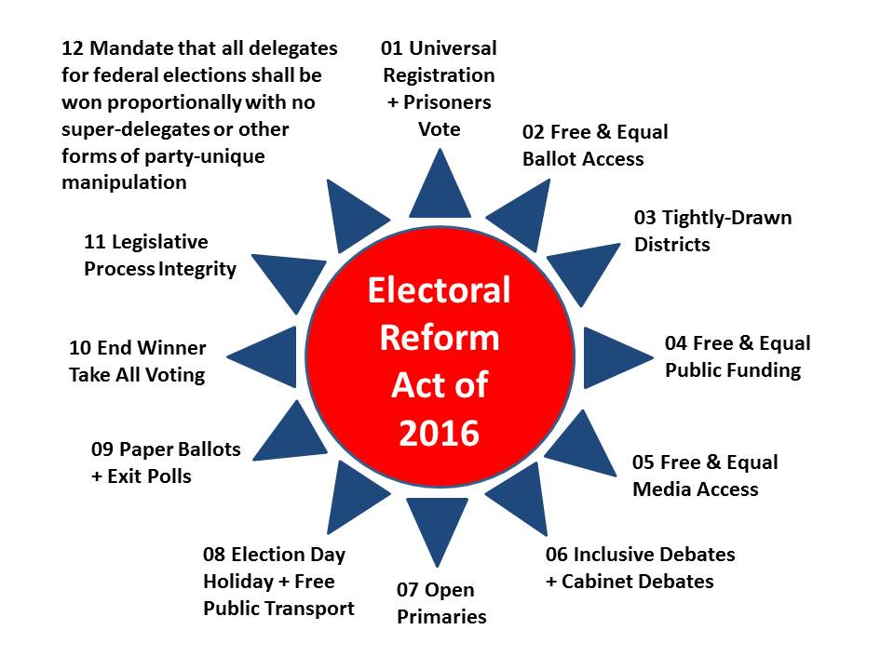
I tried eight times over two years to connect with Bernie Sanders. Note that point twelve would have assured him the nomination and he, not Hillary Clinton, would be facing off against Donald Trump today, at the same time that Gary Johnson and Jill Stein would be viable nominees given the Instant Run-Off reform (point ten) as well as all the others.
The current effort to re-ignite a race war in the US, with leftist billionaires funding Black Lives Matter protests and fascist billionaires funding white paramilitary shooters killing cops and seeking to place the blame on blacks, will fail. To their credit, black leaders have identified the twin elements of this strategy. The race war is intended to distract us from the fact that it is now clear to most that we are in a fight between the 1% who have destroyed the Earth and the hopes of humanity for their own selfish profit, and the 99% capable of creating infinite wealth.
Open Source Everything Engineering (OSEE)
I wrote the book itemizing over sixty opens, The Open Source Everything Manfesto: Transparency, Truth, and Trust, and subsequently developed, with Michel Bauwens and Marcin Jakubowski, the below starting point for radically expanding public appreciation for what an open source everything mindset can accomplish.
Open Source Everything
Using this approach, I was able to document how one million Somalis could be moved from ghastly United Nations resettlement camps in Ethiopia, Kenya, and Uganda, back to an uncontested portion of Somalia (the northeast) with three things only in abundance: dirt, sunlight, and seawater. For a one-time cost per person of $500 (i.e., $500 million total), I documented how we could provide them all with free energy, water, housing, food, and communications.
End All Waste
We can not only lift up the five billion poor, we can eradicate waste, now documented at 50% on average across agriculture, energy, housing, health, and security, among the one billion ‘rich.’ The below diagram shows how we do that, with a tip of the hat to co-creator Bojan Radej of Slovania.
The Waste Eradication Tri-Fecta
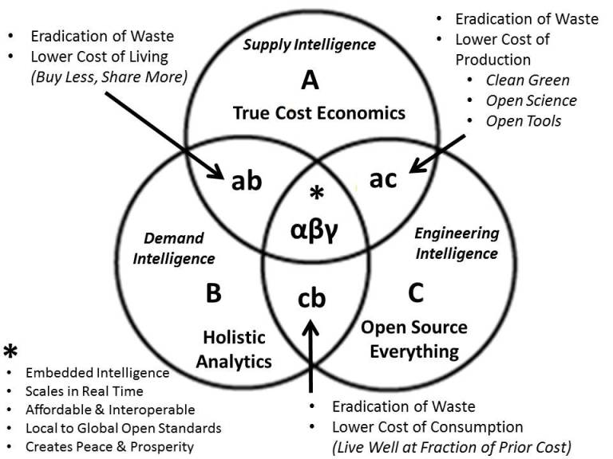
We do not lack for money on Earth. We lack for applied collective intelligence with integrity. We lack the precipitating event that will spark the revolution in which we all say “ENOUGH!” to predatory capitalism, unilateral militarism, and virtual colonialism.
What we have in abundance, what we have repressed for centuries, is the human imagination. Electoral Reform and Open Source Everything Engineering are the twin pillars of our liberation.

The Open Source Everything Manifesto
Reality Sandwich, 13 June 2012.
The following is excerpted from The Open-Source Everything Manifesto: Transparency, Truth, & Trust published in 2012 by Evolver Editions, an imprint of North Atlantic Books.
The circumstances underlying this manifesto are stark and compelling: We are at the end of a five-thousand-year-plus historical process during which human society grew in scale while it abandoned the early indigenous wisdom councils and communal decision-making. Power was centralized in the hands of increasingly specialized “elites” and “experts” who not only failed to achieve all they promised but used secrecy and the control of information to deceive the public into allowing them to retain power over community resources that they ultimately looted.
In the beginning, there was the commons. Over vast stretches of prehistoric time, tribal cultures evolved in tandem with the natural environment. They did this without creating private property or hierarchical relationships of control and dominance that led to consumption of nature as a resource. Open-source culture provided for community sharing and community development. With the rise of patriarchy, empire, and systems of egoic control and empowerment, this open-source approach to community was destroyed. Over the course of the last centuries, the commons was fenced, and everything from agriculture to water was commoditized without regard to the true cost in non-renewable resources. Human beings, who had spent centuries evolving away from slavery, were re-commoditized by the Industrial Era.
The corruption of the commons led to the loss of integrity between and among individuals, organizations, and community. Artificial paradises made up of objects and possessions were substituted for true community based on authentic heart-to-heart relationships. Secular corruption is made possible by information asymmetries between those in power and the public. In the absence of transparency, truth, and trust, wealth is concentrated and waste is rampant.
We, Homo sapiens, are defined by what we know in the context of the Cosmos and the Earth — larger Whole Systems.
We, Homo sapiens, were in harmony with the Cosmos and the Earth during earlier centuries when indigenous wisdom prevailed. The evolution of social forms and technology toward ever-greater levels of complexity is part of our human development toward deeper consciousness and self-awareness. The technosphere, as José Argüelles and others have realized, is the necessary detour that takes us from the pristine biosphere to the psychically collectivized state of the noosphere.
We live in a constellation of complex systems. It is impossible for any single person or even any single organization or nation in isolation to understand complex systems.
Collective intelligence — multinational, multiagency, multidisciplinary, multidomain information-sharing and sense-making — is the only means of obtaining near-real time understanding of complex systems sufficient to achieve resilience in the face of changes. Many of these changes, including biospheric ones such as climate change and depletion of planetary resources, are the result of human activity and industry in the last three centuries.
As our technological capacities continue to increase and our environment becomes ever more fragile and endangered, we find that changes to the Earth that used to take ten thousand years now take a fraction of that. We must rediscover and reintegrate indigenous wisdom in order to come back into harmony with larger whole systems, and do so in a manner that allows for application of appropriate technologies and science, open-source intelligence gathering, and real-time self-governance.
This means that we cannot afford to address our complex world with industrial-era hierarchies in which information travels laboriously up the chain to the top, some elites deliberate — lacking much of the information they need, and often lacking ethics as well — and then micro-management instructions go back down. All this takes time, and the instructions are invariably wrong. Instead, we harness the intelligence at the edge of the network — at the point of impact — and the individual who is face to face with a problem in a microcosm is the tip of the human spear, able both to reach back to all other humans for assistance, and to act on behalf of all humans in the moment.
It is in this light that we must recognize that only a restoration of open-source culture, and all that enables across the full spectrum of open-source possibilities, can allow humanity to harness the distributed intelligence of the collective and create the equivalent of heaven on Earth — in other words, a world that works for all.
History is a narrative we construct and a tool we can shape. Our model of history has been corrupted by “information pathologies” that include weapons of distortion and deception; suppression of alternatives and repression of inconvenient knowledge; and manufactured consent, propaganda, secrecy, and outright ideologically justified lies that go unchallenged by most journalists and scholars.
Knowledge has fragmented due to academic specialization, which supports an elite culture of secrecy and allows for control of populations by the wealthy few, who maintain surveillance and information-gathering operations. The sciences are divorced from the humanities and from religions; disciplines are divorced from one another; within disciplines the sub-disciplines have become tiny cultures in isolation from all other knowledge clusters.
We find ourselves at the end of centuries of isolation and alienation. We are at the beginning of the Great Awakening. The evolution of social technologies and communications media appears to align with prophecies of indigenous cultures like the classic Maya, who looked toward our epoch as the end of one great cycle and the beginning of another. It’s a window of opportunity for us, potentially the threshold of transformation of humanity into a new psychic collectivity, a new global civilization that can attain galactic citizenship. We have the potential to achieve a radical evolution and expansion of our consciousness as a species, once we put aside all lesser goals.
Sharing, not secrecy, is the means by which we realize such a lofty destiny as well as create infinite wealth. The wealth of networks, the wealth of knowledge, revolutionary wealth — all can create a nonzero win-win Earth that works for one hundred percent of humanity. This is the “utopia” that Buckminster Fuller foresaw, now within our reach.
Context matters. Context creates coherence and restores the missing connections that the fragmentation of knowledge into academic specializations has caused. Economy needs to be reimagined in terms of a whole systems approach-the “true costs” of human action need to be measured holistically, in terms of effects on the regenerative capacity of the biosphere as a whole. If we as Homo sapiens fail to connect the dots and make decisions on the basis of truthful, true-cost information, we will self-destruct.
Clarity (transparency) is the means by which we nurture the recognition and sharing of truth.
Diversity is how our human species will achieve ongoing abundance by liberating human innovation.
Integrity is how we enter into a “state of grace” and become “one with God,” however you choose to define and understand these broad terms. This manifesto defines “God” as an experience of collective solidarity that extends from the human realm to the universe as a whole.
Sustainability can only be achieved through mass collaboration and the achievement of panarchy — a constellation of co-equal hybrid systems of self-governance in which all individuals freely choose where they wish to be heard, and have full access to all relevant information.
Culture is the soul of the community, the “glue” that keeps the lessons of history alive, that demands clarity, that unifies diversity, that nurtures and demands integrity, and thus sustains the community.
A model for public intelligence is proffered in this book, ideally providing a means for every citizen to be a collector, producer, and consumer of public intelligence (decision-support).
A model for informed democracy also is proffered here — it provides a means for achieving panarchy, enabling every citizen to have access to all relevant information and to participate constructively in an infinite number of self-selected communities of interest.
Organized people will defeat organized money every time. We must all come together to begin a new era that restores the sovereignty of the public in the aggregate over all other forms of organization and influence.
Panarchy is the end-state, Radical Man is the soul, Reflexive Practice is the process, and Web 4.0 — all people connected to one another and all information in all languages all the time — is the means whereby we create and actualize a World Brain and Global Game, a noosphere, and achieve evolutionary collective consciousness.
The goal is to reject money and concentrated illicitly aggregated and largely phantom wealth in favor of community wealth defined by community knowledge, community sharing of information, and community definition of truth derived in transparency and authenticity, the latter being the ultimate arbiter of shared wealth.
When we relate and share knowledge authentically, this places us in a state of grace, a state of “win-win” harmony with all others, and establishes trust among all.

About the Author

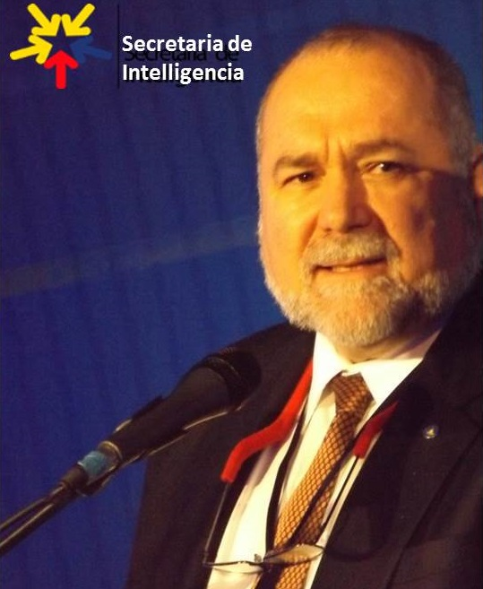
Robert David Steele is a holistic strategic analyst and educator of individuals and organizations – governments, corporations, non-governmental organizations, and universities in particular. He is competent at all-source collection management (know who knows); geospatially-based visualization of complex data; multidisciplinary and multilingual analytics; and compelling interaction with decision-makers facing painful choices and confusing opportunities. A former senior intelligence professional for the USA, an honorary hacker, and the #1 Amazon reviewer for non-fiction, reading in 98 categories, he has been CEO of a for-profit company, Open Source Solutions Network, Inc., and is today CEO of an accredited educational non-profit, Earth Intelligence Network. Robert is known for his proponency of Open Source Intelligence (OSINT), teaching 7,500 mid-career officers from across 66 governments (NATO/PfP, others) and is the leading proponent for Applied Collective Intelligence, which integrates Holistic Analytics, True Cost Economics, and Open Source Everything, an engineering and information management approach that is affordable, interoperable, and scalable.
The two most recent books by Robert Steele are entitled THE OPEN SOURCE EVERYTHING MANFESTO: Transparency, Truth, & Trust (North Atlantic Evolver Editions, 2012), and INTELLIGENCE FOR EARTH: Clarity, Diversity, Integrity, & Sustainability (Earth Intelligence Network, 2010). He has been recognized as a thought leader since 1994 when he was featured by Alvin Toffler in a chapter on “The Future of the Spy” and listed by Microtimes as an unsung hero striving to change the world for the better. Only recently has the larger public, shocked by Climate Change, Ebola, and rampant destabilization across Central Asia, the Middle East, and North Africa, begun to understand that we must achieve foresight through informed future-oriented hybrid governance, an original concept developed by Steele along with Applied Collective Intelligence. He is a mentor for those seeking to create organizations that are rooted in ethical evidence-based decision support. His motto, “the truth at any cost lowers all other costs,” is one that can help any organization thrive in times of chaos by achieving foresight and shaping their future.
Among his accomplishments are the design of the Open Source (Technologies) Agency; the funding and definition of an architecture for a World Brain & Global Game; the creation of the global practice of Open Source Intelligence; the writing of the NATO, DIA, SOF OSINT Handbooks while also being the primary OSINT contractor to U.S. Special Operations Forces 1996-2007; the creation of four strategic analytic models (2006 Earth Knowledge – Six Bubbles; 1988 World Model – 144 Factors; 1979 Cultural Intelligence Analysis Model; 1976 Predicting Revolution – 12 Domains); the most published intelligence pioneer in English with eight books, two with Forewords by Senators and many articles and chapters as well as presidential and congressional testimony; and the curation of 80+ strategic foresight bloggers @ Phi Beta Iota.
His education and experience includes:
Academic Visitor, Loughborough University (UK)
Research Adjunct, Strategic Studies Institute (SSI)
CEO (pro bono), Earth Intelligence Network (501c3)
CEO, Open Source Solutions, Inc. (C Corporation)
USMC Intelligence, 2nd ranking civilian at the time
CIA, top human and technical operations performer
USMC, infantry, intelligence, S-1/Adjutant
Naval War College (Defense Economics)
MPA University of Oklahoma (Strategic Information)
MA Lehigh University (Predicting Revolution)
AB Muhlenberg College (Multinationals Gone Wild)
Other Languages: Native Spanish, elementary French
21 years in Asia, Caribbean, Central & South America
Robert is passionate about helping organizations shape their future with the practice of ethical evidence-based decision-support for future-oriented hybrid governance that creates peace and prosperity for all.
Bio & Publications: http://robertdavid.steele.com Core Recent Work: http://tinyurl.com/Steele-Future.

As submitted to the UN SDG Global Report 2016 on February 16, 2016.
This paper emerged from a funded effort in support of Dr. Rob Dover, then Associate Dean of the Loughborough University in London endeavor. I am indebted to him for his many thoughtful suggestions but this work is my own.
We thank Bojan Radej (2014) for his assistance in conceptualizing this view.
This graphic builds on a graphic from the Centre for Embedded Intelligence at the University of Loughborough, adding the three intelligence bubbles to the engineering perspective in the original.
BTS: Base Transceiver Station)
Academic, civil society, commerce, government, law enforcement, media, military, non-government/non-profit.
This paper was presented informally in Copenhagen and Oslo in association with the invited lecture on Open Source Intelligence (OSINT) Done Right, April 2016.
Cf. Monica Anderson, “Science Beyond Reductionism,” SpaceCollective, 14 June 2010, the commentary “Yoda: MIT Hypes Artificial Intelligence – All Ying, No Yang,” Phi Beta Iota Public Intelligence Blog [hereafter PBI] 20 October 2015, and the broad literature on reductionism.
Chuck Spinney, “Defense Dependency,” TIME (Battleland), 13 November 2012, elaborated upon in “Killing America – Government Specifications Cost Plus,” PBI, 14 November 2012.
Agriculture: Nadia Arumugam, “UN Says Europe Wastes 50% of Fruit and Vegetables – and America Isn’t Much Better,” Forbes,4 October 2012, Dana Gunders, “Wasted: How America is Losing Up to 40 Percent of Its Food from Farm to Fork to Landfill,” National Resources Defense Council, August 2012; Energy: Barry Fischer, “US Wastes 61-86% Of Its Energy,” CleanTechnica, 26 August 2013; Health: Michael Galper et al, “The price of excess: Identifying waste in healthcare spending,” PriceWaterhouseCoopers, April 2008; Military: Scot Paltrow, “Behind the Pentagon’s doctored ledgers, a running tally of epic waste,” Reuters, 18 November 2013, Stockholm International Peace Research Institute, “The US spends more on defense than the next eight countries combined,” Peter G. Peterson Foundation, 13 April 2014, Perry Chiaramonte, “War on waste: Pentagon auditor spotlights US billions blown in Afghanistan,” Fox News, 28 July 2014; Water: Robert David Steele, “Water: Soul of the Earth, Mirror of Our Collective Souls,” Huffington Post , 7 January 2011.
Matt Taibbi, Griftopia: A Story of Bankers, Politicians, and the Most Audacious Power Grab in American History, Spiegel & Gau, 2011. See also John Bogle, The Battle for the Soul of Capitalism, Yale University Press, 2006; and William Greider, The Soul of Capitalism: Opening Paths to a Moral Economy, Simon & Schuster, 2003. True cost economics was pioneered by Herman Daly with Ecological Economics: Principles and Applications, Island Press, 2003 and has spawned an entire literature. The broader term includes human and social costs. Two compelling cases for changing our economic and engineering paradigm are offered by Peter Linebaugh, Stop, Thief!: The Commons, Enclosures, and Resistance, PM Press, 2014, and Charles Bednar, Transforming the Dream: Ecologism and the Shaping of an Alternative American Vision, State University of New York, 2003.
Robert David Steele, The Open Source Everything Manifesto: Transparency, Truth, & Trust, North Atlantic Books Evolver Editions, 2012. There are over sixty opens itemized in book.
Robert Steele, Memorandum for the Vice President, Supporting the President’s Interest in 2015 Defense, Diplomacy, and Development Innovation – the Open Source (Technologies) Agency, Digital Deserts, & Global Stabilization, PBI, 8 October 2015.
C. K. Prahalad, The Fortune at the Bottom of the Pyramid: Eradicating Poverty Through Profits, Wharton School Publishing, 2009; Clayton Christensen, The Innovator's Dilemma: The Revolutionary Book That Will Change the Way You Do Business, HarperBusiness, 2011.
Sustainable Development Goals: 17 Goals to Transform Our World, United Nations, 25 September 2015.
Charles Lwanga Ntale, “Where does aid money really go – what is it spent on,” CNN, 9 October 2013. Justin Elliott, “How the Red Cross Raised Half a Billion Dollars for Haiti and Built Six Homes, Pro Publica, 3 June 2015.
This illustration was created for me by Bojan Radej after reading some of my early work. See also his paper, Social Complexity, Slovenian Evaluation Society, Working paper 7/2 (June 2014), also published at PBI, 12 June 2014.
The countries whose population mass will define the future include Brazil, China, India, Indonesia, and Russia, with countries such as the Congo, Iran, South Africa, and Turkey having substantive potential in their own right.
Russell Ackoff, “Transforming the Systems Movement,” RLA Conference Paper, 26 May 2004.
Mary Meeker, Internet Trends Report 2014, KPCB, 28 May 2014; Erik Stokstad, “The 1% of Scientific Publishing,” Science, 11 July 2014; Yoda, “Google—By Its Own Admission—Indexes Less Than 0.04% of the Internet,” PBI, 10 December 2010, citing James Bruce, “18 Fun Interesting Facts You Never Knew About the Internet,” MakeUseOf, 10 December 2010; “Graphic: OSINT and Missing Information,” PBI, 24 January 2010.
Marcin Jacubowski, “Global Village Construction Set,” Open Source Ecology Wiki, 2016. Since stating there “The cost of making or buying our machines is, on average, 8x cheaper than buying from an Industrial Manufacturer” he has confirmed in personal communications that savings are now approaching 10X.
Charles Perrow, The Next Catastrophe: Reducing Our Vulnerabilities to Natural, Industrial, and Terrorist Disasters, Princeton University Press, 2007; Joseph Thornton, Pandora’s Poison: Chlorine, Health, and a New Environmental Strategy, MIT Press, 2001.
Chalmers Johnson, The Sorrows of Empire: Militarism, Secrecy, and the End of the Republic, Metropolitan Books, 2005; William Blum, Killing Hope: US Military and CIA Interventions Since World War II - Updated Edition, Zed Books, 2014; James Risen, Pay Any Price: Greed, Power, and Endless War, Houghton Mifflin Harcourt, 2014.
Ted Steinberg, Acts of God: The Unnatural History of Natural Disaster in America, Oxford University Press, 2006; Eugene Linden, The Winds of Change: Climate, Weather, and the Destruction of Civilizations, Simon & Schuster, 2006.
Column 1 is from United Nations High-Level Panel on Threats, Challenges, and Change, A More Secure World: Our Shared Responsibility, United Nations, 2004; Column 1 is from Earth Intelligence Network Flyer, 2012, drawing in turn on various presidential transition teams; Column 3 is from Supra Note 7.
Robert David Steele, “SPECIAL FEATURE: Creating a Smart Nation–Strategy, Policy, Intelligence, and Information,” Government Information Quarterly, pp. 159-173. Eight “tribes” that do not share information well: academic, civil society including labor unions and religions, commerce especially small business, government especially local, law enforcement, media including specialty press, military, and non-government/non-profit.
Micah Sifry, The Big Disconnect – Why the Internet Hasn’t Transformed Politics (Yet), O/R Books, 2014; Robert David Steele, “Foreword,” in Stephen E. Arnold, CyberOSINT: Next Generation Information Access, Harrods Creek, KY: Arnold Information Technology, 2015.
Elinor Ostrom, Governing the Commons: The Evolution of Institutions for Collective Action, Cambridge University Press, 1990; Tom Atlee, The Tao of Democracy: Using Co-Intelligence to Create a World that Works for All, The Writers’ Collective, 2010. There are too many books on the pathologies of secrecy to be listed here. Secrecy is a form of engineering cancer – it distorts or withholds truth from those who need it to do good engineering.
The table is based on a graphic from Dennis Nally, “Measuring the impact of a company on society: how to gain an all-round view,” Brewery Journal, January 2014, Figure 1, p. 30. An improved version of the graphic is online.
Jason “JZ” Liszkiewicz, “Graphic: The Cost of a Cotton T-Shirt,” PBI, 16 April 2011.
Sarah (sic), “The Real Reason Wheat is Toxic (it’s not the gluten), The Health Home Economist, November 2014. The author notes that the practice of using RoundUp is refused by the beer, pea, and lentil marketplaces, and that the Soil Association has called for an end to this practice.
Michel Bauwens, founder of the Peer to Peer (P2P) Foundation and its Wiki, is one of the foremost proponents for new approaches to community-centric economics including the sharing economy. He created the original Category:Open and the new Category:Open Source Everything. His own initiatives, the Commons Transition and Open Cooperativism, merit study by engineers interested in shaping the future.
Robert David Steele, “$500 Million to Resettle 1 Million on a Moonscape with Sun, Dirt, & Salt Water….Exploring the Practical Edge of Intelligence with Integrity — 2.0 Habitat Cost Sheet Posted,” PBI, 25 June 2013.
As designed and created by Dr. Marcin Jakubowski, founder of Open Source Ecology; the fifty industrial devices sufficient to create a small sustainable civilization, can be seen at Global Village Construction Set.
The upper half of Figure 3 was inspired by the Centre for Doctoral Training in Embedded Intelligence at Loughborough University in the United Kingdom.
The India Smart Cities Challenge originated as a plan to make broadband the defining characteristic of a smart city, but has evolved rapidly toward finding and adapting all good ideas across all domains.
The 20th Century portion of this graphic was accessed at the online page for Centre for Doctoral Training in Embedded Intelligence at Loughborough University in 2014 where the author was very briefly an applicant for their PhD program. Superb as far as it goes, it represents a typical engineering perspective that “assumes” there is no need for holistic analytics, true cost economics, or open source everything alternative engineering.
IEEE Code of Ethics, accessed 14 April 2016.
“Graphic: Jim Bamford on the Human Brain,” PBI, 28 December 2009.
Additional materials by the author can be found at The Future: Recent “Core” Work by Robert Steele, PBI. See in particular 2016 Robert Steele: The Ultimate Hack – Resilient Villages, Smart Cities, Prosperous Nations at Peace — and Unlimited Clean Water.
The top three authorities on Open Source Everything are Robert Steele, author of The Open Source Everything Manifesto: Transparency, Truth, & Trust (North Atlantic Books, 2012); Dr. Marcin Jakubowski, founder of Open Source Ecology and the Global Village Construction Set, and Michel Bauwens, founder of the Peer to Peer Foundation. Their consensus on the nine open source categories within which sixty open source technologies are organized can be found at http://p2pfoundation.net/Category:Open_Source_Everything.
Education, Decision-Support, and Research comprise Applied Collective Intelligence. The term decision-support is used to distinguish this category of information-sharing and sense-making across all boundaries, from Open Data, which is focused on raw multidisciplinary, multidomain, and multilingual data digitization at source. While decision-support is a synonym for “intelligence” in its proper construct of outputs rather than inputs, as used here the term is in no way associated with secret intelligence sources and methods. While the new agency would radically increase the amount of open source data and open source information that could be immediately provided to the high side, the information bureau focus is on creating open source technologies that enable local to global sharing of information among eight major information-producing and consuming “tribes:” academic, civil society including labor and religions, commerce especially small business, government especially local, law enforcement, media including alternative media and bloggers, military, and non-government/non-profit.
LtGen Dr. Brent Scowcroft, USAF (Ret) was the US member of the UN High-Level Panel on Threats, Challenges, and Changes that reported out with A More Secure World: Our Shared Responsibility (United Nations, December 2004) with the following ten threats in the following priority order: 01 Poverty 02 Infectious Disease 03 Environmental Degradation 04 Inter-State Conflict 05 Civil War 06 Genocide 07 Other Atrocities 08 Proliferation 09 Terrorism 10 Transnational Crime. Our current information sharing and policy making capabilities are severely skewed toward threats 04 and 05, while neglecting all the others, particularly in relation to true costs over time and returns on investment. No one anywhere is focusing on integrated open source everything engineering.
The UN White Paper is entitled Beyond Data Monitoring – Achieving the Sustainability Development Goals Through Intelligence (Decision-Support) Integrating Holistic Analytics, True Cost Economics, and Open Source Everything (Earth Intelligence Network, October 2014) online at http:tinyurl.com/EIN-UN-SDG.
Agriculture: Nadia Arumugam, “UN Says Europe Wastes 50% of Fruit and Vegetables – and America Isn’t Must Better,” Forbes (4 October 2012), Dana Gunders, “Wasted: How America is Losing Up to 40 Percent of Its Food from Farm to Fork to Landfill,” National Resources Defense Council (August 2012); Energy: Barry Fischer, “US Wastes 61-86% Of Its Energy,” CleanTechnica (26 August 2013); Health: Michael Galper et al, “The price of excess: Identifying waste in healthcare spending,” PriceWaterhouseCoopers (April 2008); Military: Scot Paltrow, “Behind the Pentagon’s doctored ledgers, a running tally of epic waste,” Reuters (18 November 2013), Stockholm International Peace Research Institute, “The US spends more on defense than the next eight countries combined,” Peter G. Peterson Foundation (13 April 2014), Perry Chiaramonte, “War on waste: Pentagon auditor spotlights US billions blown in Afghanistan,” Fox News (28 July 2014); Water: Robert David Steele, “Water: Soul of the Earth, Mirror of Our Collective Souls,” Huffington Post (7 January 2011).
An informal cost study is available. The point is that for the first time, someone actually thought through with modest precision what it would take to convert dirt, sunlight, and seawater into a habitat using an integrated approach to energy, water, shelter, food, and connectivity.
The author’s biographies, testimonials, profiles, and production can be viewed at http://robertdavidsteele.com. A new web site funded by the Shuttleworth Foundation, Open Source Everything for the 21st Century – Creating a Prosperous World at Peace, was created on 1 December 2015 at http://ose-21.org.
After publication of Robert Steele’s submission to the UN SDG Global 2016 Report, visible at http://tinyurl.com/SDG-OSEE, a major India-based NGO met with Robert Steele and after discussion a new briefing was produced that has been sent to India for consideration, visible at http://tinyurl.com/EIN-BRICS-OSEE. Separately one European foreign minister and one European defence minister are being asked to inquire of their counterparts as to the status of this memorandum. In the ideal, the USA would create an OSEE “hub” that would then interact with regional multinational-development OSEE hubs, achieving the SDG within a decade.

