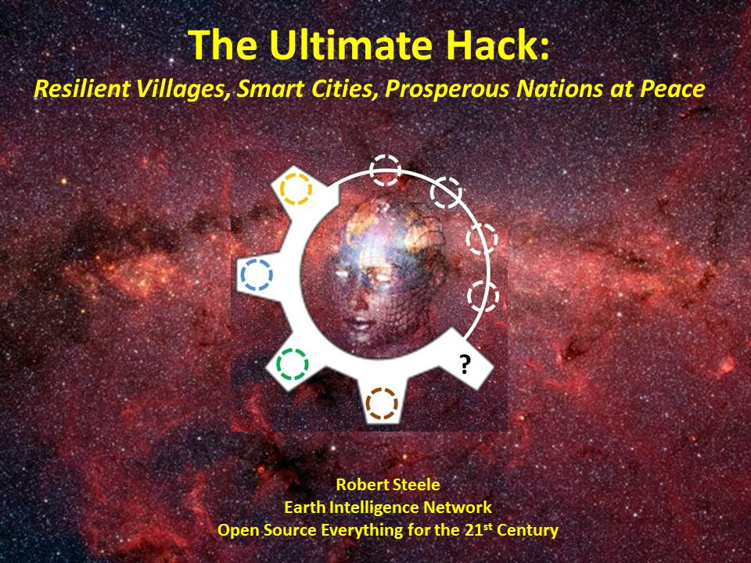
This briefing has been prepared for the BRICS + Indonesia and Iran -- and other nations such as Brunei, Malaysia, and the United Arab Emirates (UAE) -- as a means of fostering a conversation about the future of Earth and humanity -- there are solutions that are affordable, interoperable, and scalable.

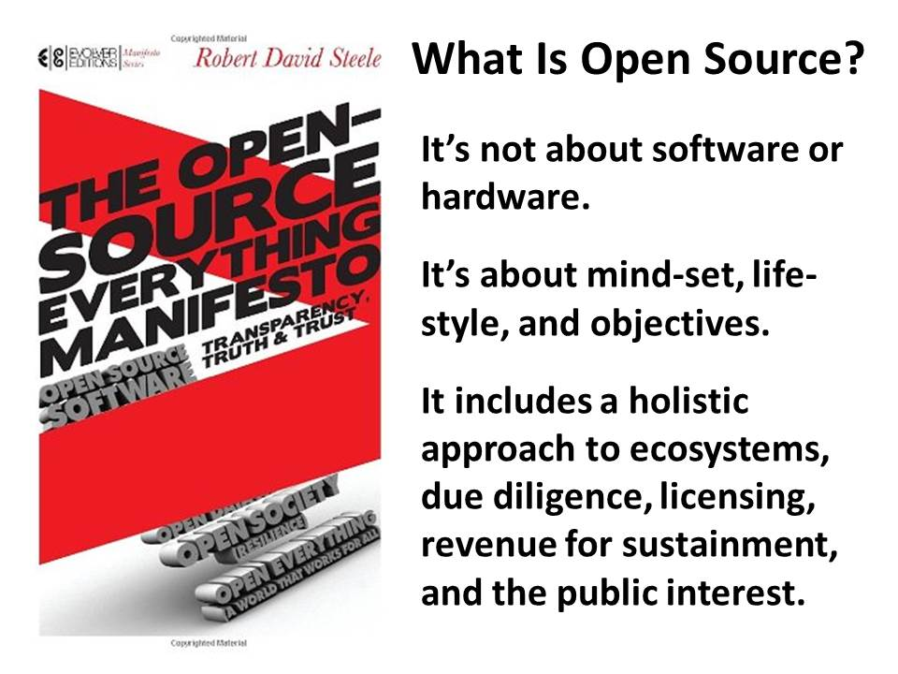
The greatest realization that I achieved in writing this book was that Open Source is not about software or hardware.
Open Source is a mind-set, a life-style, a return to the practices of our indigenous forbearers.
Open Source is holistic and is absolutely committed to the well-being of the larger public.

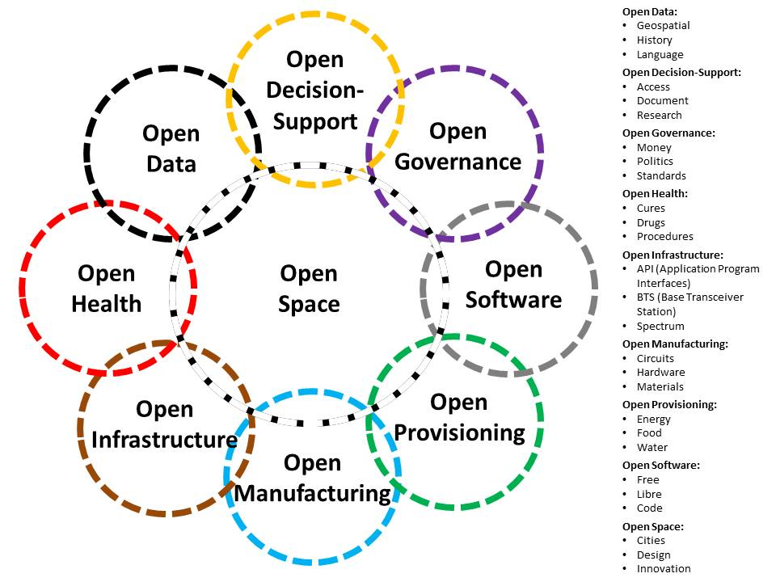
In 2012 there were over 60 opens listed in The Open Source Everything Manifesto: Transparency, Truth, & Trust. All of these have been and remain stove-piped, not cross-fertilizing. In 2015 a Category:Open Source Everything was created at the Peer to Peer Foundation founded by Michel Bauwens, and a concept was advanced, of Open Source Everything Engineering (OSEE). This concept makes possible the creation of smart, affordable products, policies, services, and behaviors – resilient villages and smart cities.
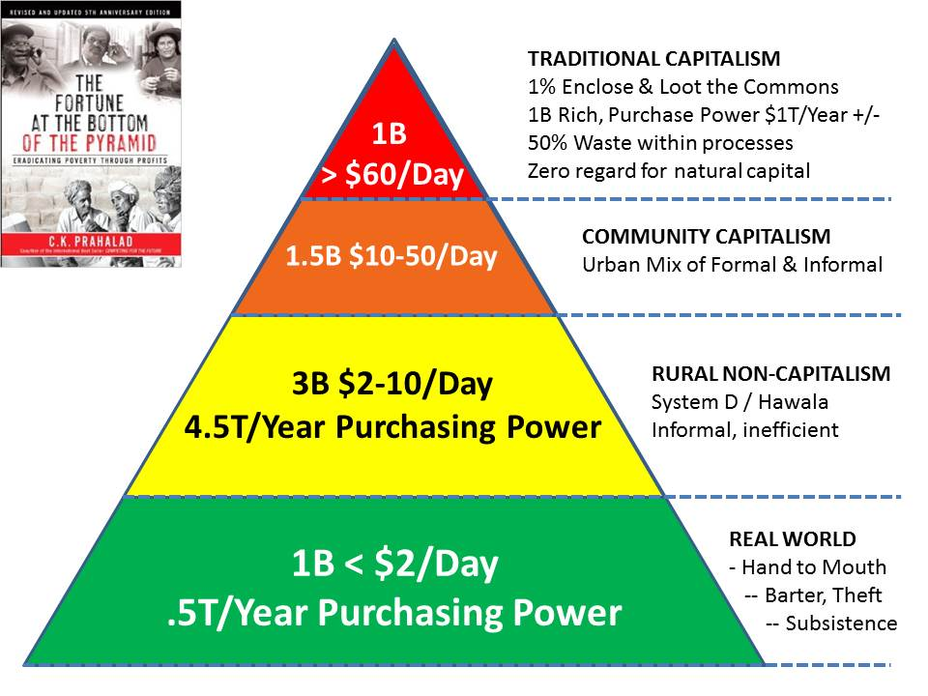
C. K. Prahalad (RIP) has shown us the way. It is possible to make four times the profit at the bottom of the pyramid, but one must offer different products and services. Open Source solutions are roughly eight to ten times cheaper than industrial-era solutions, and this refers only to the financial cost – when savings from waste elimination are calculated, a gross estimate is that open source solutions are one hundred times cheaper than industrial era solutions.

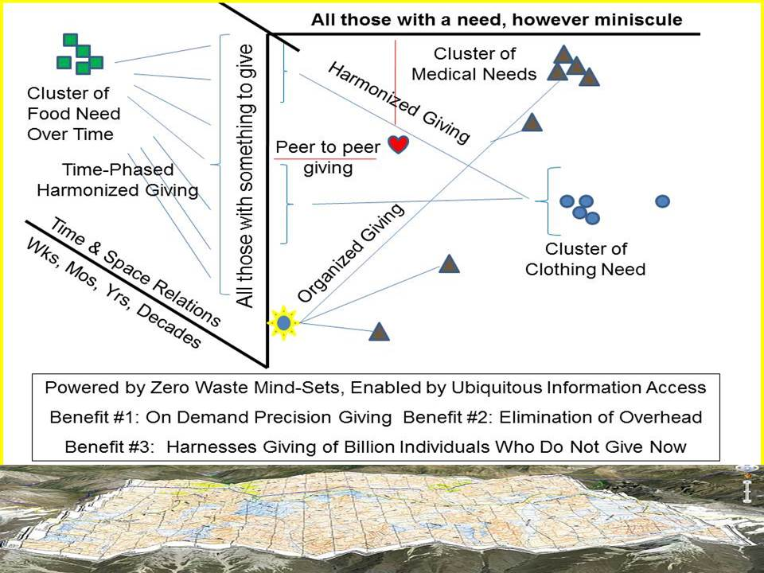
We have now entered an era in which data-driven strategy, policy, acquisition, and operations can create a prosperous world at peace. We can eradicate the 50% waste that is common to industrial-era domains from agriculture to energy to health to housing to security to water and more. We can deliver just enough just in time assistance to the village level in the form of micro-cash and micro-education. We can harness the hearts, minds, and donations of all world citizens, allowing the one billion rich to help the five billion poor with "just enough, just in time" while enabling national governments and international organizations to work smarter, faster, and cheaper.
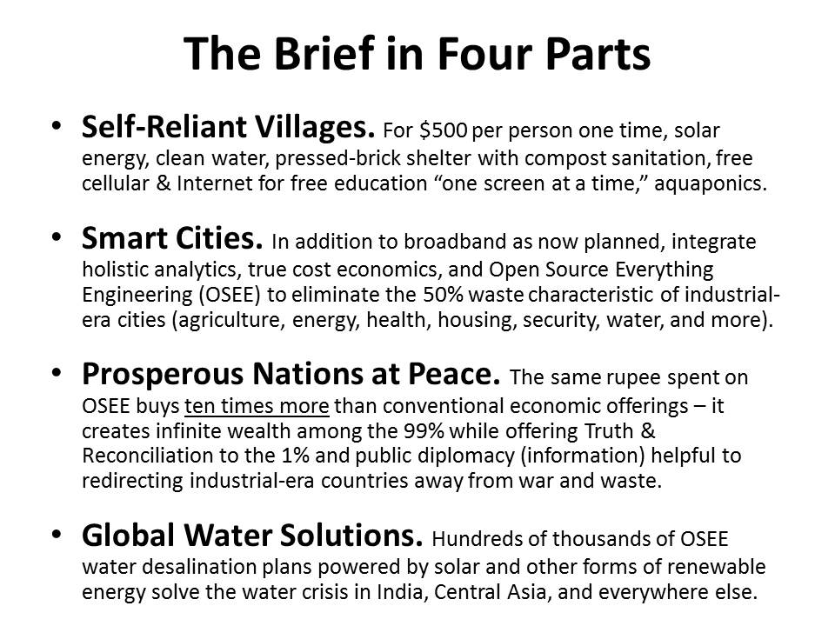
The calculations have been done. They require checking and refinement but the bottom line is clear: for less than $500 per person paid one time, we can create self-reliant resilient villages everywhere. Smart cities can go beyond broadband to bottom up design that eliminates all waste. Nations can leverage Open Source Everything Engineering (OSEE) to foster peace and prosperity. Finally, we can solve our water crisis -- $300 million can create 146,000 open source water desalination points powered by solar energy.
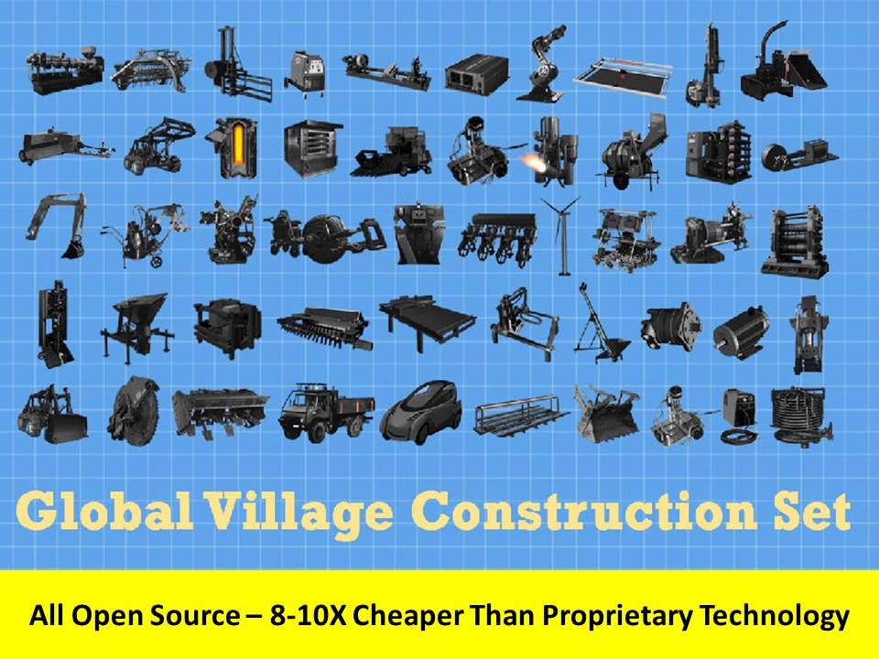
I am honored to be an adviser to Open Source Ecology (OSE), founded by Dr. Marcin Jakubowski to create the Global Village Construction Set (GVCS). With that disclosure, I have no qualms in suggesting that I believe his ideas should be embraced and accelerated by the BRICS, with India being of particular interest to me, combining its brilliant universities with its needy villages to achieve a very affordable, scalable solution within the year. Within the year. I also envision a new tool that recycles plastic into roof sheeting and water pipes, as well as pieces of the GVCS that are not load-bearing.

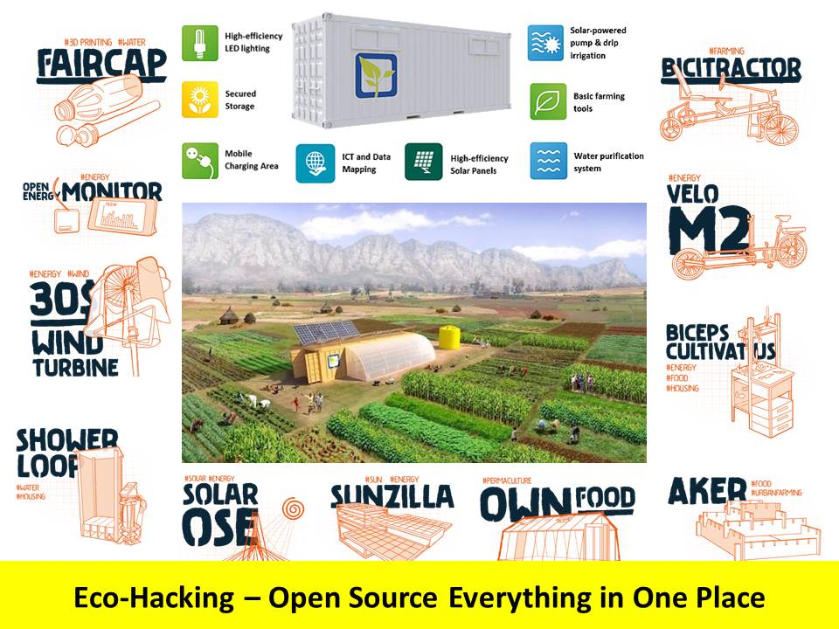
Eco-Hacking is now a term of art. Farm from a Box is especially impressive in part because it has made the leap from just farming to integrating information technology, energy, and water solutions. Add the Global Village Construction Set, free cellular communications and Internet access, and unlimited desalinated water, and you have a resilient civilization. Permaculture must also be widely introduced, as Sepp Hasslberger has pointed out, because it uses terrain configuration and tree planting and micro-management to avoid any water waste; done on a large enough scale, it changes climatic conditions, bringing more rain.
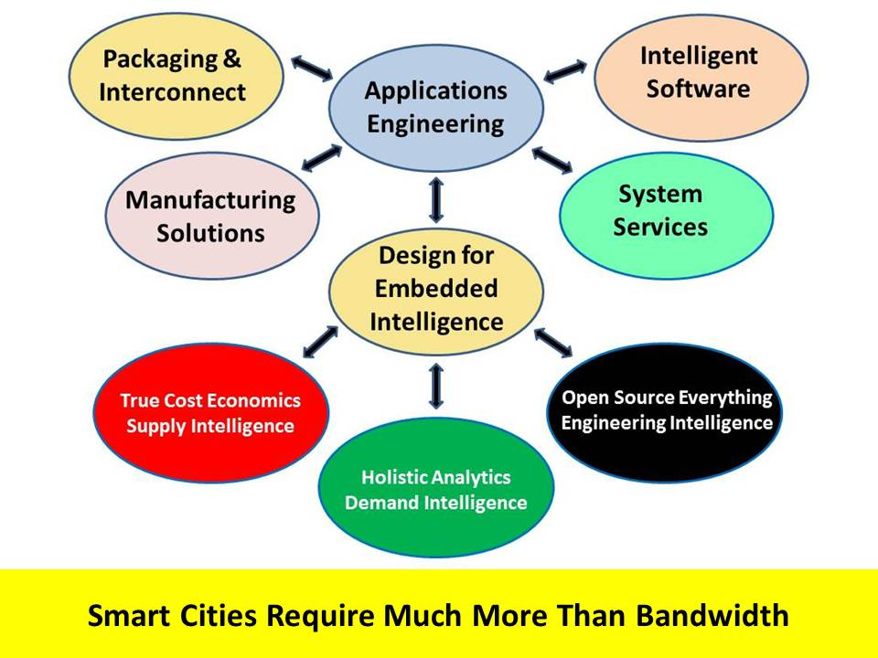
As we flirt with the "sixth extinction" because of our scientific reductionism and industrial-era practices of waste and toxicity, there is useful discussion of the need to create smart cities and to embed intelligence into all products and practices. This important discussion has not yet grasped the need for a foundation in holistic analytics, true cost economics, and Open Source Everything Engineering (OSEE). Smart Cities, in my view, must be designed from the bottom up so as to achieve what Buckminster Fuller called "ephemeralism" -- doing more with less. Melissa Sterry talks about the Bionic City -- a city as if nature had designed it.
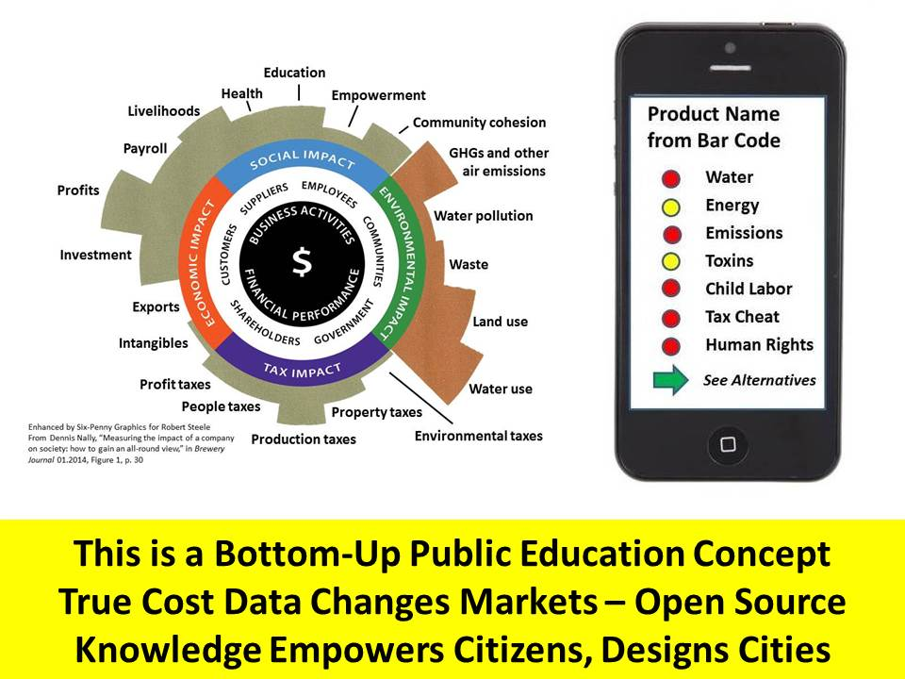
While we can build resilient villages and smart cities by offering them "top down" assistance, the real revolution -- the only lasting revolution according to Will and Ariel Durant, authors of multi-volume Story of Civilization, writing in The Lessons of History, the only real revolution is in the minds of men and women. Education -- and ideally constant "just enough just in time" education one cell call at a time, one smart phone screen at a time -- is how we make this revolution across billions of minds. We can create infinite wealth among the five billion poor by making true costs transparent.

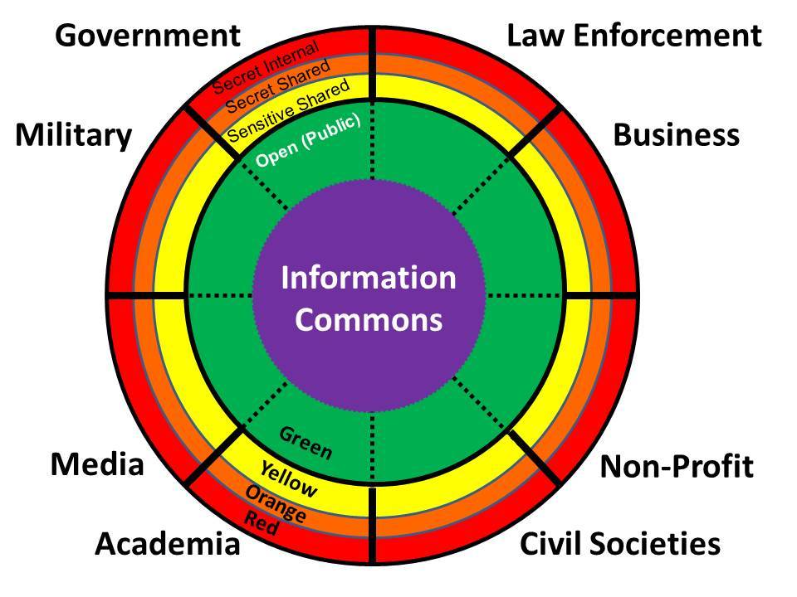
Government is the smallest of the eight information tribes, and sadly also the least informed. As we move forward it is absolutely essential that we establish means of assuring that all citizens have access to all information in all languages all the times. A vital starting point is to be found in recognizing that there are eight major "tribes" or networks of information creation, collection, processing, and analysis. Today we do not share information between tribes, between organizations, and between individuals, in an effective manner.
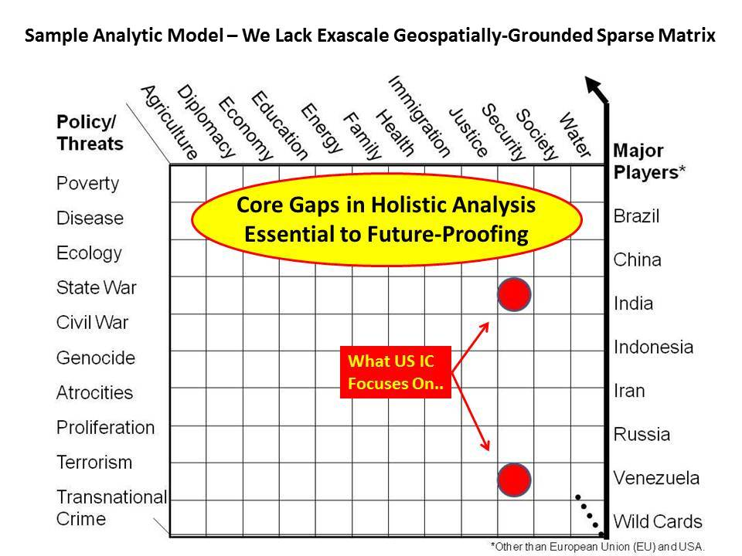
The fastest least expensive way in which to create infinite wealth among the five billion poor is to leverage the craft of intelligence -- the combination of holistic analytics, true cost economics, and INTEGRITY. There is nothing secret about the craft of intelligence -- it merely requires respect for the whole -- in this graphic, one can see the ten high-level threats to humanity as rank ordered by the United Nations in 2004; the twelve core policies that comprise the essential intervention points for any society; and perhaps most importantly, the eight plus demographic powers that will define the future with their populations. The BRICS plus Indonesia and Iran and wild cards such as the Congo, are the center of gravity going forward.

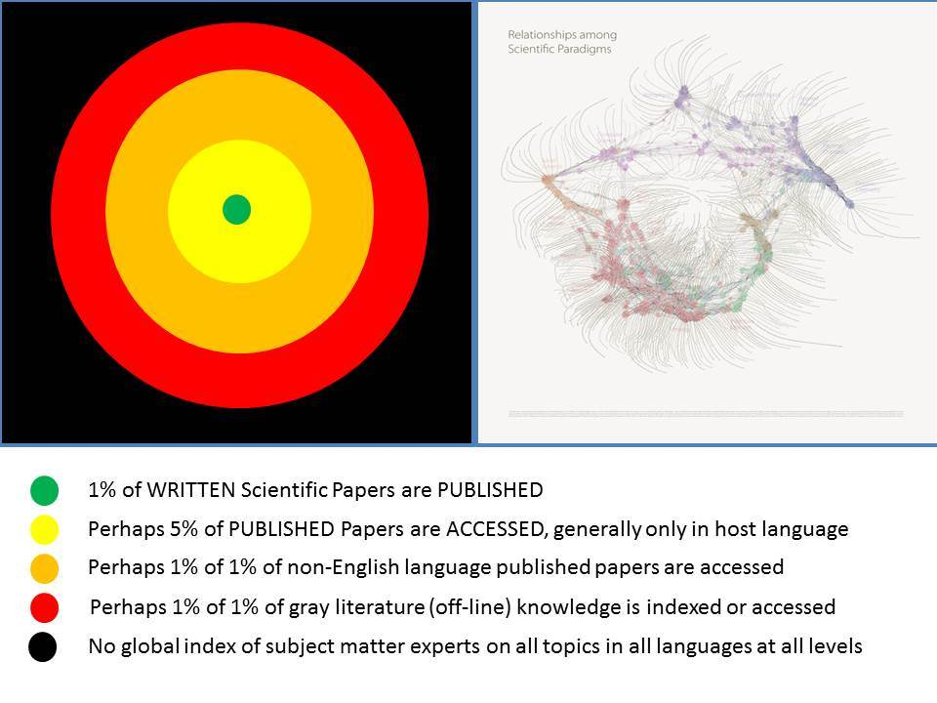
Most people -- including the most senior leaders of governments, corporations, and non-governmental organizations -- as well as the leaders of universities -- do not appear to understand that we are working with -- as best -- 1-2 percent of the relevant information. It is now known that we process less than 1% of the digital Big Data we have in hand, and that no more than 1% of all scientific papers written are in fact published and thus "visible." If one adds to that the virtual non-existence of tools for data ingestion, information sharing, and collaborative sense-making, one quickly recognizes that we are not taking advantage of the single most important resource on Earth -- our collective intelligence. On right is a map of science showing its fragmentation -- add to this the general neglect of spiritual, philosophical, and humanities knowledge, and one can see that we have a huge opportunity should we seek to create a World Brain.

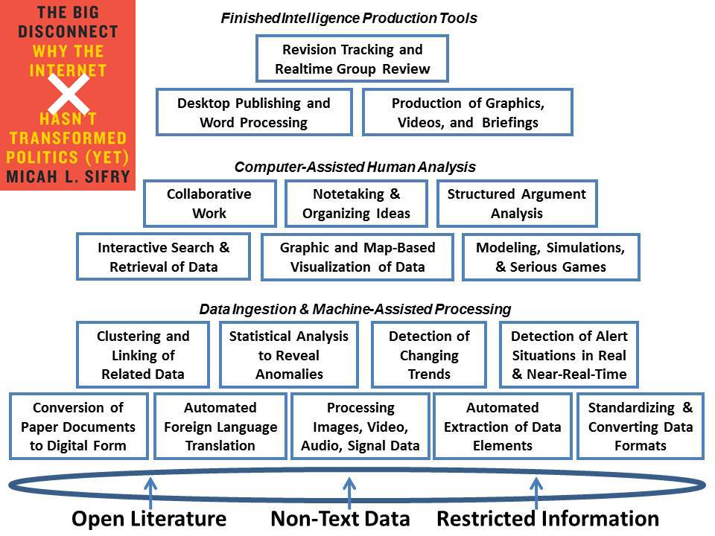
These eighteen tools do not exist today in one integrated package, neither proprietary nor open source. They were identified as needed in 1989 by Diane Webb and others in the Office of Scientific and Weapons Research at the Central Intelligence Agency. I credit Micah Sifry and his new book, The Big Disconnect, for outlining why this matters now more than ever before. If Open Data is to be fully exploited, we need to develop this open source tool-kit and it must be free to the five billion poor.

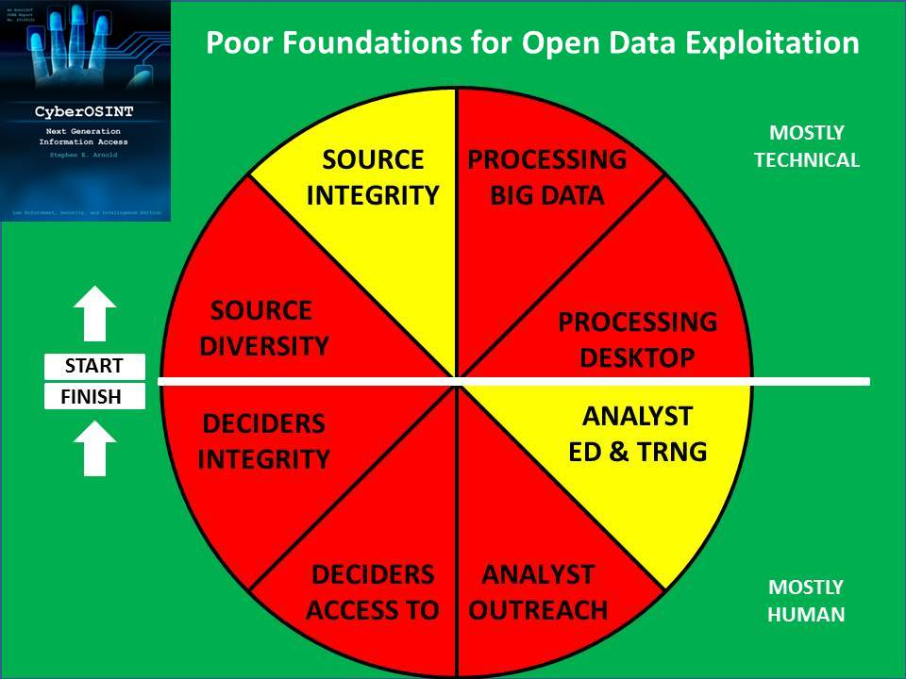
Having tools for sharing and thinking, while essential, is a small part of a larger mosaic. There are four major technical foundations and four major human foundations for being able to do intelligence (decision-support) with integrity -- tools without data, data without human intelligence, and decision-support without a customer that will listen -- are all largely irrelevant. To create the World Brain and infinite wealth on Earth -- a prosperous world at peace -- we must honor, master, teach, and employ the craft of intelligence, with integrity. I address each of these aspects in my Foreword to Stephen E. Arnold's book, on CyberOSINT: Next Generation Information Access.

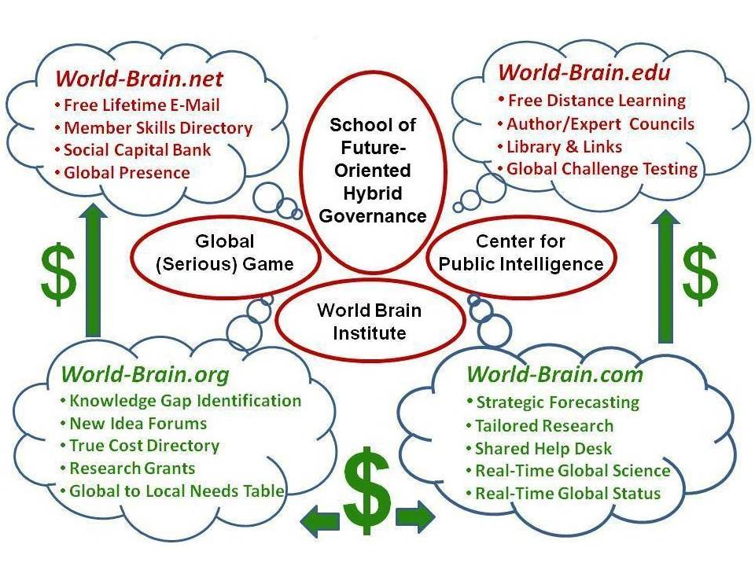
Earth Intelligence Network, an accredited non-profit, brought together 24 people in 2006-2008 to conceptualize how to implement a World Brain -- by no means an original idea, but now that the Internet exists, a near-team possibility. Here are shown the four Internet domains and what each would offer -- note that the bottom two domains can be monetized so as to support the upper two free domains -- and that central to the development of the World Brain are a School of Future-Oriented Hybrid Governance; a Global (Serious) Game that enables all citizens to play themselves on all issues all the time; a prototypical Center for Public Intelligence that can be replicated everywhere using Open Source Everything Engineering (OSEE); and the administrative and political outreach node, a World Brain Institute.

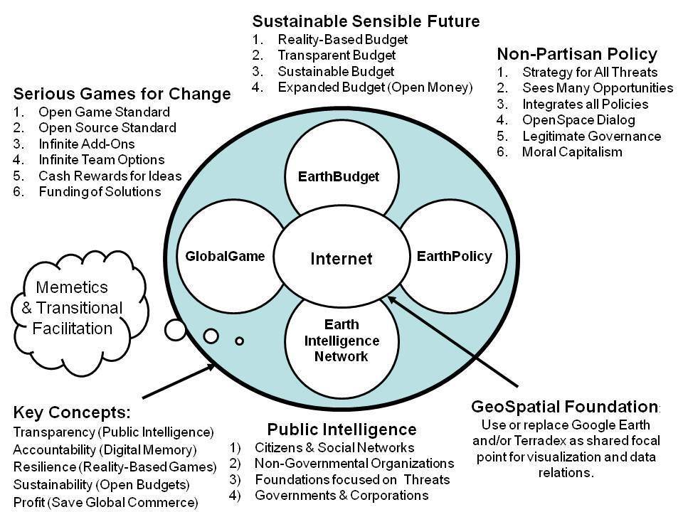
A Global Game storing all true cost and other data, accessible by all citizens to the extent each is authorized to access and share, is the enabling element for an Earth Intelligence Network, an Earth Policy Network, and an Earth Budget. By making transparency, truth, and trust the root elements of how we relate to one another, we make possible a prosperous world at peace. This is not as easy as it sounds -- it requires exascale processing, an open source world map at 1:20,000 or better, and distributed blockchain data -- but it is do-able beginning immediately.

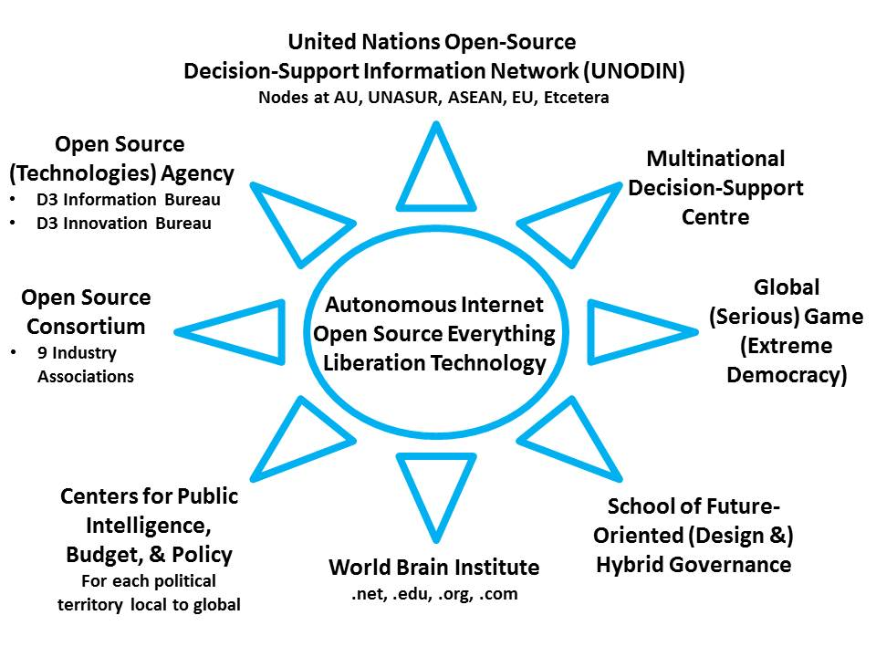
These are the pieces as I envision them, all immediately implementable at relatively low cost, all offering a return on investment that can barely be grasped -- on the order of a thousand to a million times their financial cost. The Open Source (Technologies) Agency has been proposed to Vice President Joe Biden but little noted -- an expression of interest from various governments and the UN as well as the Vatican, would be helpful. Each of these elements help make intelligence (decision-support) with integrity central to how we self-govern and achieve resilience from the village to the province to the state to the continent to the world.

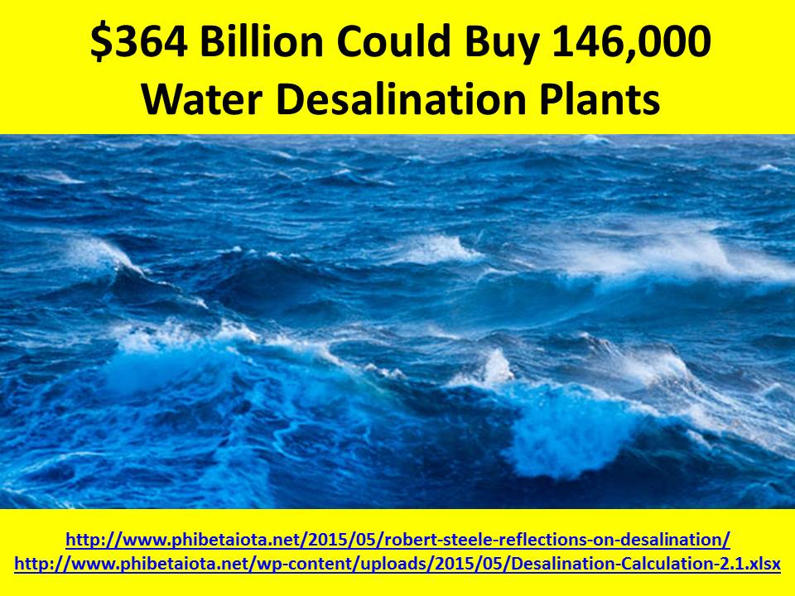
It costs $25 million today to create a water desalination plant capable of producing 5 million gallons per day (MGD) of potable water. Using the emerging standard price reduction characteristic of Open Source Everything Engineering (OSEE), this means that we can aspire to a price of $2.5 million for each plant -- this is inclusive of the solar energy collection and energy storage, and the neutralization of the 3.5% of the salt water that is brine and must be converted to sodium bicarbonate. Accepting that the sea is rising by 3mm a year, this means that to keep the ocean level we must harvest 738 billion gallons per day -- this translates into 146,000 plants each doing 5MGD. From Australia and Indonesia to China, Japan and Viet-Nam to all countries in the Americas and Africa to a joint India-Iran project to pipe water into Central Asia as well as their own countries, this is the modern equivalent of space travel -- our greatest near challenge and the most beneficial to humanity and all other living species as well as Mother Earth herself. 364 billion one time - a third of what we spend on war each year.

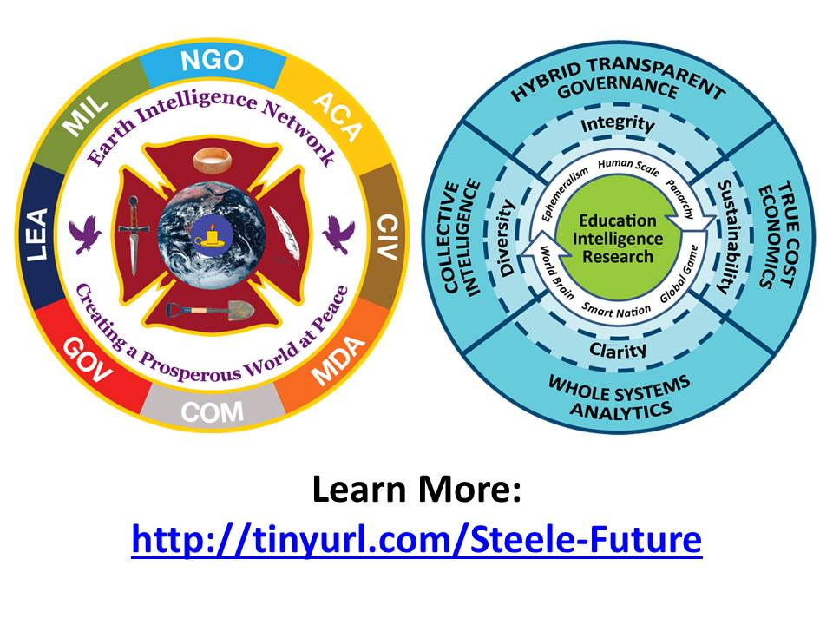
It has taken a quarter century for the Open Source world to mature from open source software and open source intelligence to open source everything – or the new term of art, Open Source Everything Engineering (OSEE). As these two logos depict, we must bring together all that the eight information tribes know, and we must integrate education, intelligence and research – it is in the mind, heart, and soul of each individual that this battle is to be fought. Thank you.

