Robert Steele: Trump Triumph in 3 Moves UPDATE 8 WH 4.0, Trump 2.0, #UNRIG 3.9
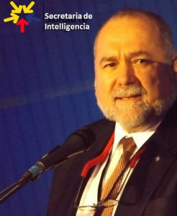
SHORT URL:
http://tinyurl.com/TrumpTriumph
Published 20171026, update 20190203
The loss of the House is both threatening and an opportunity. Despite growing Democratic scandals (including Mossad control of Debbie Wasserman Schultz to spy on Members with Pakistani patsies and Democratic funding of the false dossier by Christopher Steele (no relation)) and Clinton Foundation charity fraud connected to the sale of US uranium to Russia and of Syria and Yemen to Saudi Arabia) this subjects the President to being impeached and general grid-lock. Tom Steyer and Michael Bloomberg among others continue to spend toward $200 million against the President.
The President can triumph in three moves:
MOVE 1: Eject the press corps from the White House -- the most precious real estate on the planet is being wasted. Repurpose that space to house the three elements shown in the graphic below -- this will give the President -- overnight -- what his existing team and the scattered alt-right ecology cannot do: by-pass all intermediary organizations and open a two-way channel between the President and every eligible voter in the USA -- all 200 million of them.
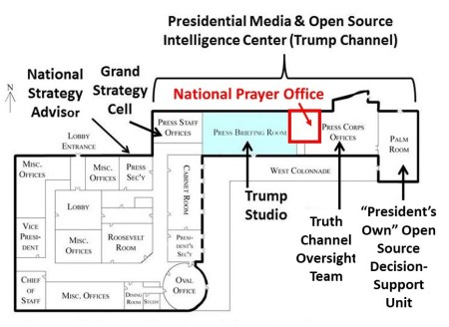
There are three sub-moves:
01 create a Trump studio and government-wide architecture for seven minute videos (a Truth Channel) from the President and every branch of government providing factual information to the public about everything.This includes a two-way vehicle for communicating to every citizen and for receiving from all citizens tweets, emails, images, and other materials processed into a presidential dashboard that allows the President and surrogages to "drill down" by issue, demographic, even budget line item. What we have now is dysfunctional -- the new ecology will protect all voices and make it impossible to censor, manipulate and digitally assassinate ("de-platform") anyone;
02 create a National Prayer Office and appoint a Chaplain of the Republic who shall lead a daily national prayer and serve as a focal point for ensuring that the President and his efforts -- and his communications to the public -- are fully supported by prayer and reflection. Sarah and Mike Huckabee could find peace here; a leading black pastor should be included, on the next go around we should be mobilizing the black churches as well as black Muslims across America;
03 create an Open Source Decision-Support capability within the Executive Office of the President (EOP) to provide the 96% of the decision-support not now available to the President -- or anyone else -- from the dysfunctional secret intelligence community that refuses to be serious about holistic analytics; true cost economics, and open source everything engineering (OSEE) alternatives to our current pay to play system.
MOVE 2: Utilizing the Trump Channel created in Move 1, FIRST sponsor a national conversation about election reform possibilities, and THEN introduce the Election Integrity Act as Presidentially-sponsored legislation, and inform every Member of Congress they can either vote for it and qualify for a matching Presidential pardon if they give up their current bribers and blackmailers to a 90 day Presidential Task Force separate from the FBI, or face the wrath of the President and the deplorables in 2020.It is vital for the President to inform the public that HR 1 For the People, ostensibly an election reform act, is a scam and fraud -- it Dieboldizes the drawing of Congressional district lines, and sets the stage for non-citizens to vote. This move will do two things: expand the Trump Movement toward 70% of the voters, more than the two party tyranny can muster together; and end the possibility of one party controlling either chamber of Congress -- evidence-based decision-making will replace pay to play legislative earmarks.

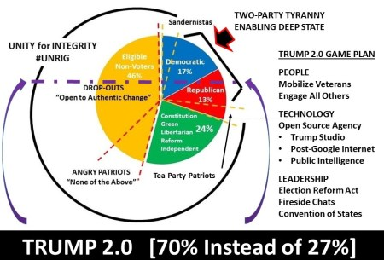
There are two sub-moves:
01 Utilize the graphic below to urge every Member of Congress to sponsor a town hall meeting with constituents on this topic, and GO DIRECT and poll EVERY eligible voter via every means including direct mail, urging them to OPT IN to the Trump Channel and approve or modify each of the twelve points. MANY will not like prisoners keeping the vote, or open primaries -- a national conversation is how we qualify those, e.g. parties can still have closed primaries but at their own expense.
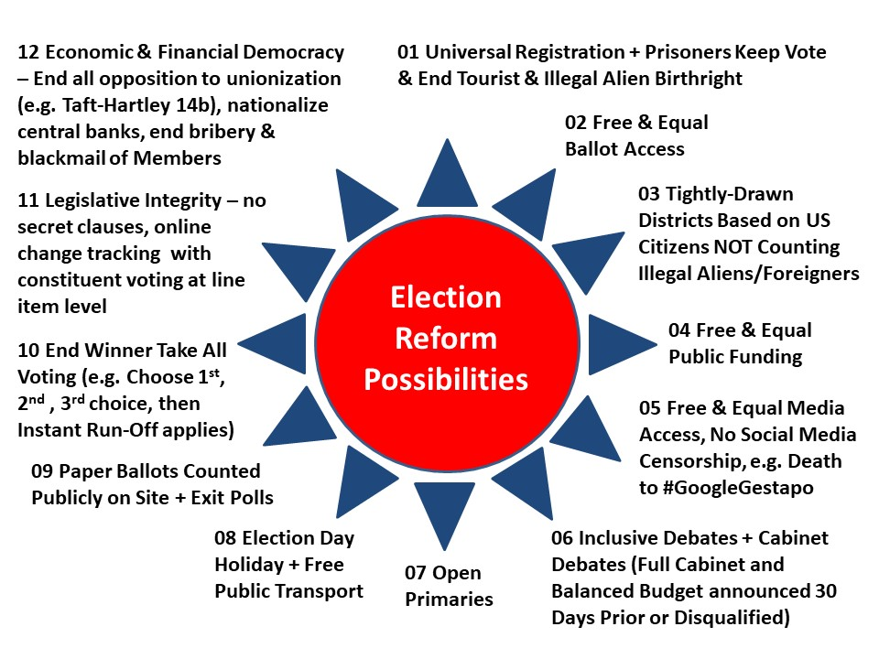
02 After using a 30 day national conversation period -- also a pilot project to establish how the president can reach out to voters directly to make every major policy issue (such as closing US bases overseas) a direct referendum -- introduce the Election Integrity Act of 2019 and give Congress to the end of the year to pass it. 2019 should be the year in which the President leads ALL citizens, and can muster more votes across all boundaries than the two-party tyranny (what survives of it). Combine this with the precinct-level ideas of Dan Schultz, and you have a restoration of democracy across America the Beautiful and a reinstatement of integrity within the U.S. Government.
MOVE 3: Make strategy, not security as defined by the banks and the military-industrial complex -- the central aspect of the Trump Presidency. This is the only way to Make America Great Again.

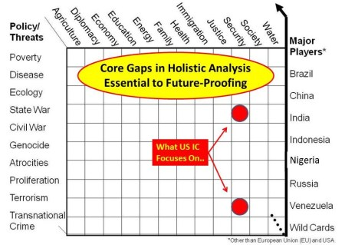
There are two sub-moves:
01 abolish the National Security Council (NSC), the primary means by which the financial-military-intelligence complex manipulates and lies to the President each day, and create in its place a much smaller Strategy Advisory Group (SAG) that works closely with the Deputy Director for Management (DDM) in the Office of Management and Budget (OMB) to address all threats, all policies, all costs in a coherent future-oriented manner;
02 convene a Grand Strategy Summit that is live-streamed to the public, requiring every US Government agency and department to participate in devising a grand strategy -- and a balanced budget with incremental cuts toward 50% of what we spend now -- addressing all ten high level threats to the USA, across all policy domains, with true costs shown for alternative courses of action. The President gains enormous power over Congress because line-items can be put to the larger public and direct polling done such as no Senator or Representative can match.
3 moves.
Greatest President Ever.
Make America Great Again.
3 moves.

