#UNRIG
Beyond Trump & Sanders

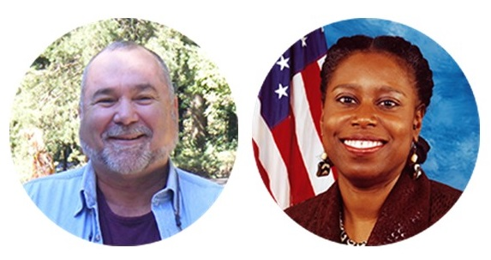

Robert David STEELE Vivas
With a Foreword by Cynthia McKinney

On 1 May 2017 Cynthia McKinney, Ellen Brown, and Robert Steele agreed to launch We the People – Unity for Integrity.
This is the User’s Guide to the 2nd American Revolution.

Death to the Deep State.

Occupy Congress.

Demand the Election Reform Act of 2017

God Bless Donald Trump & Bernie Sanders.
Both failed to honor their base but both opened the door to liberty.

Foreword
I have known Robert Steele since 2008 when I accepted the Green Party nomination to be their candidate for President, and read his first political book, ELECTION 2008: Lipstick on the Pig, which is free online as well as at Amazon.
I watched his first video on election reform, six minutes in 2011 during which he presented his ideas to the Occupy Working Group on Politics & Electoral Reform – after the video was linked to from the front page of Reddit it went viral.
I took notice when he ran briefly as one of three candidates for the Reform Party presidential nomination, and appreciated the decisive manner in which he deferred to Andre Barnett after just six weeks. His website, http://bigbatusa.org, is going to be home for We the People.
We met in Denver in 2009 at the American Citizen’s Summit organized by Joseph McCormick, which was an effort to encourage Americans to rise above party identities and work for the greater good of the US and the world. Since that Summit, Robert and I have been in regular touch. We appeared together on the Alex Jones show and we share the view that there is nothing wrong with America the Beautiful that cannot be fixed and fixed quickly, simply by restoring integrity to our government.
When Robert published his second political book, Open Power: Electoral Reform Act of 2015 – Open Source Activist Tool Kit, I began to feel, for the first time, that a solid set of solutions was being brought forward, but I also understood that the “two-party tyranny,” as Therese Amato calls it in her book, Grand Illusion: The Myth of Voter Choice in a Two-Party Tyranny, was never, ever, going to allow the six other accredited small parties (Constitution, Green, Libertarian, Natural Law, Reform, Socialist) or the emerging parties (Justice, Working Families) or the Independents (or even the small “i” independents) to gain ballot access.
Then Donald Trump and Bernie Sanders exploded into being, each tapping into deep anger across what are now called the Alt Right and the Alt Left. While each has failed to fulfill their potential as liberators, I join Robert in asking for God’s blessing of each of these two individuals. Donald Trump denounced the rigged system and helped each citizen understand that the Deep State owns the two-party tyranny or Establishment, and that fake news and false flags are the norm so long as the Deep State controls the government and rules in secrecy.
Robert’s blinding flash of genius came recently – after he realized Donald Trump was not going to honor all his campaign promises while Bernie Sanders set out to create Sheepdog 2.0 – the People’s Party subservient to the Democratic Party. He and I realized in conversation together that many thought leaders in the Black community are finally ready to leave the Democratic Party, and that there is a clear path for Alt Right and Alt Left to come together, with smaller political parties, Blacks, Latinos, and Independents as the center of gravity for a 2nd American Revolution. Here, I will clarify with more accurate language suggested by my friend, civil liberties attorney King Downing; what we are talking about is the POP(ulist) Left and the POP Right coming together to transform politics in the US, and hence, the globe.
The essence of Robert’s idea is simple: if we can agree that the Deep State is our common enemy, and agree that the restoration of integrity to our government is the only means by which the needs and beliefs of the 99% can triumph over the 1% that own and control the Deep State, then we mark that out as our common ground and come together to demand, during the summer recess, that every Member sign the Integrity Pledge.
The Integrity Pledge, when signed, commits the Member to co—sponsoring and voting for the Election Reform Act of 2017 in September when Congress returns to Washington, DC after the summer recess.
If passed in September, October, or November 2017, the Election Reform Act of 2017 would free all Members from the bonds of blackmail and bribery to which they are subject now, and enable Greens, Libertarians, and Independents among others, to be elected to the House of Representatives and the Senate.
While I disagree with Robert that election reform is “enough,” I am willing to embrace his energy as a first step in our project of transformation. Honestly, I even introduced the Voter’s Choice Act while I was in Congress because it became clear to me that the US system of election administration is far from “democratic.” Any system that awards 100% of the power for gaining only 50%+1 of the vote (and mostly that is from only 30%--oftentimes, even less-- of the electorate even bothering to vote) cannot in any seriousness be considered “democratic!” Moreover, recently, I’ve begun to investigate direct democracy as a systemic solution that restores individual sovereignty and displaces the folks whose names and faces we mostly don’t know and that rule over us in the interstices of state power. Direct democracy, also embraced by former US Senator Mike Gravel, truly gives the power to the people. But this is another discussion for another day.
Unfortunately, the ineptitude of the Trump Administration, to date, is almost certain to reinvigorate the Democratic Party--a political party that, in my opinion, given its undemocratic arguments, even put forward today in US Court defending its treatment of Hillary Clinton challenger Bernie Sanders, and its unwillingness to usher in real leadership and values change, renders it a party that exists beyond its usefulness. Even so, I agree with Robert’s assessment that absent a strong movement of We The People, the Democratic Party stands a good chance of retaking the House of Representatives and maybe even the Senate. Thus, the explosive information contained in the Clinton/Podesta/DNC emails will go unaddressed and business as usual will resume in the criminal governance of the US. Even more, this positions the Deep State to decisively win by totally compromising Trump; he becomes a caricature of himself or he is impeached--rendering the same result: neutralization.
My role in all this is clear: I wholeheartedly embrace – with urgency – the importance of bringing together the Alt Left and the Alt Right (the populist or POP Left and the populist or POP Right) as a political force. I have always said that to get a different result, we have to do what we’ve not done before. I want the investment that Blacks make in the political system to be reflected in policy outcomes. These policy outcomes will improve the quality of life in the Black community and in the American community. If Donald Trump would deliver POLICY to communities of color: if he would endorse community control of police departments, strengthen the financial viability of Historically Black Colleges and Universities (HBCUs), attack the red-lining of Black communities that occurs through gentrification and for bankster profiteering, there is absolutely no question in my mind that Donald Trump will have delivered what no Democratic Administration in recent memory has delivered: peace of mind to a community under siege and under active occupation. Many residents of Black communities in the US feel as oppressed as the Palestinians in Palestine. If Donald Trump would actually deliver to this community, he could begin the policy transformation that US voters actually voted for in 2016; he could upend the current two-party tyranny, and because of doing good works, bring out more voters in 2020 that would truly put the US on the road to dignity again.
This is a big if. I know what my goals and values are; I have never compromised on them. That is why I’m out of Congress, kicked out by the very Deep State that is running rings around Trump and his inexperienced staff right now. But, here’s the thing: that same Deep State is not stronger than all of us working together. That’s why it spends untold hours scheming mightily at dividing us. I think it’s about time that we turn the tables on this strategy and allow our knowledge of the Deep State’s criminal and otherwise nefarious behavior to actually bind us.
The Deep State is our common enemy. Election Reform is one of our common goals. By working together, I’m sure we will find even more common goals. I am ready to join with every citizen willing to step forward and fight the 2nd American Revolution.
Cynthia McKinney, PhD

The Two-Party Tyranny

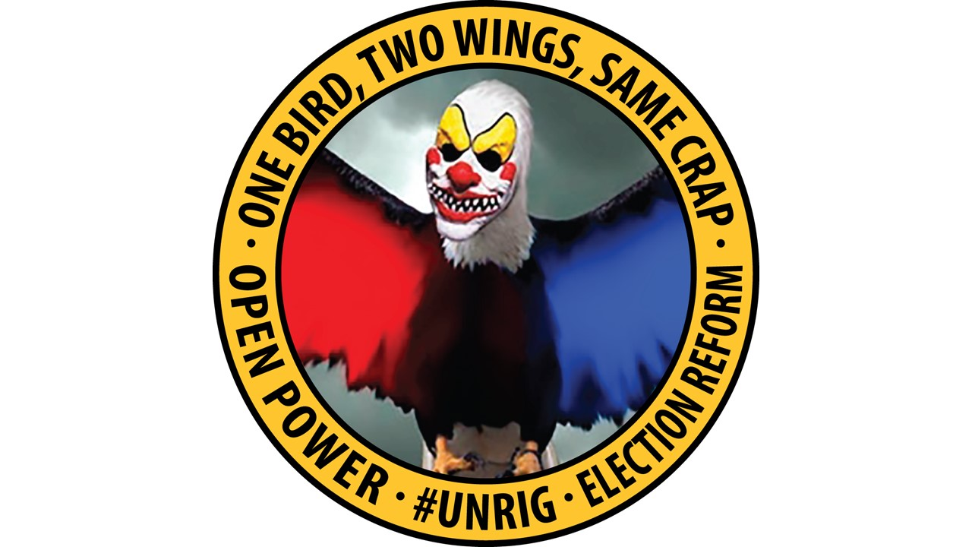

Above is our attack logo depicting the current reality that a two-party tyranny – one bird, two wings, same crap – controls the Congress on behalf of the Deep State. The Deep State starts with the Rothschild Family and the Vatican, who control all of the central banks that are private banks manipulating foreign exchange and interest rates against the public interest, and also control each government by excluding the majority of the public from participation in politics.
Destroying the two-party tyranny is the fastest way to destroy the Deep State.

The US Political Landscape

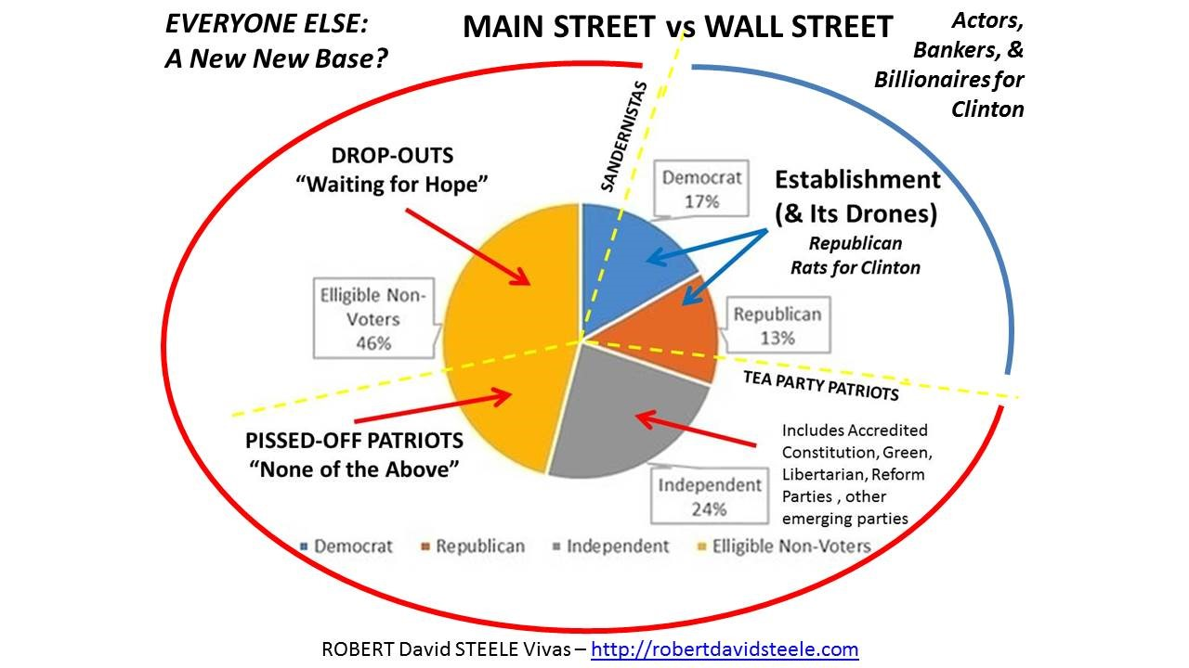

The fact is that the two-party tyranny only controls 30% of the eligible voters. Fully 70% are either Independent or associated with small parties such as the Libertarian Party. If we can all come together, we can restore integrity to our government by destroying the two-party tyranny’s grip on legislative power, first at the federal level and then at the state and local levels.

We the People – Unity for Integrity

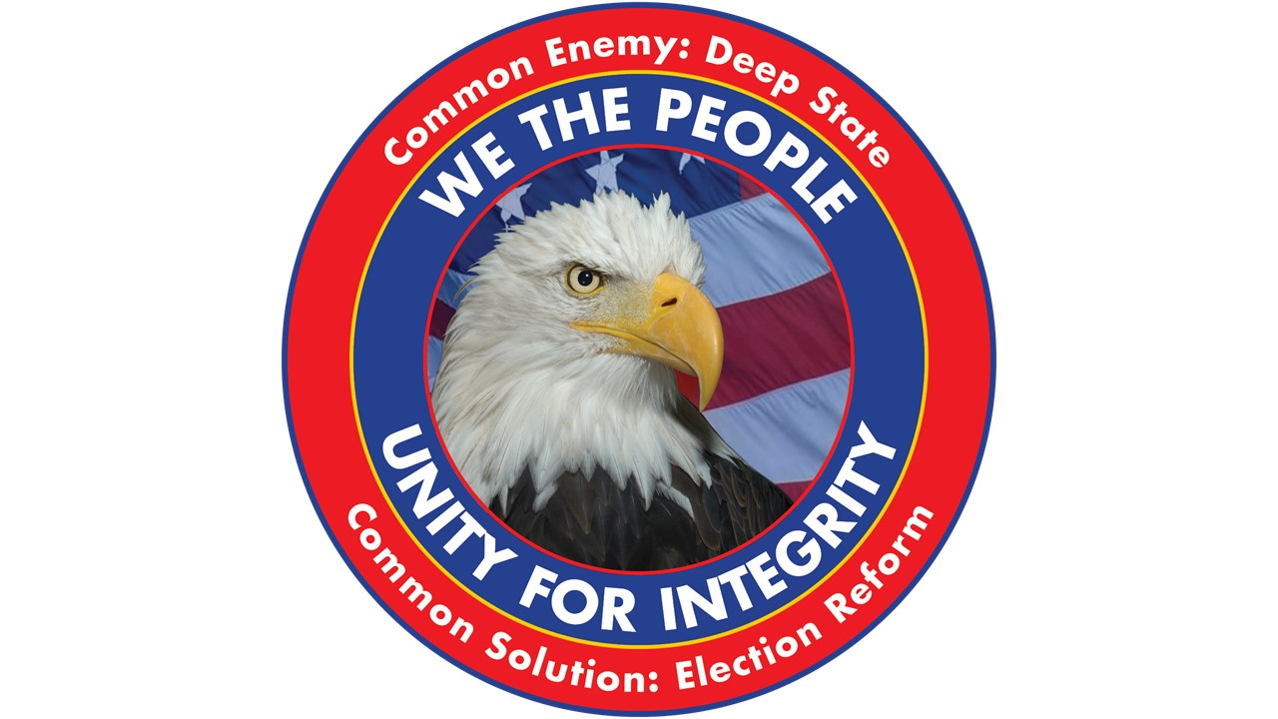

This is our solutions logo, urging one and all to come together in Unity for Integrity. Our common enemy is the Deep State. If the enemy of my enemy is my friend, and we can set aside all ideological and issue differences for the common goal of Election Reform, we can restore integrity to our government and thereafter have civil conversations leading to evidence-based decision-making. This ends the control by the 1% of our government, economy, and society, and places the 99% in charge.

Election Reform Act of 2017

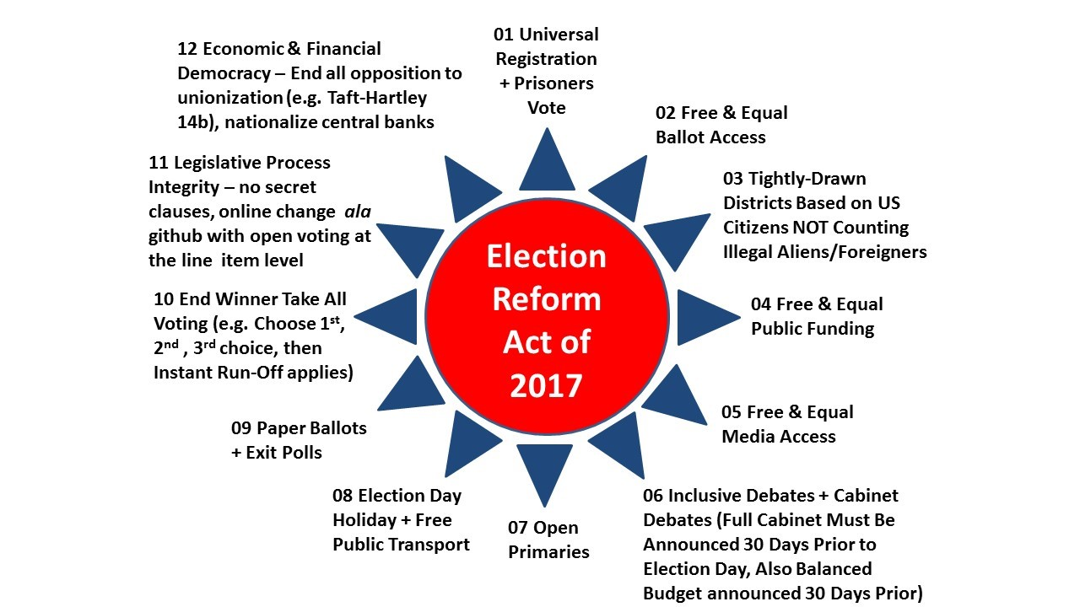

Thousands of people over the years have labored to identify the specific elements of the rigged system that need to be unrigged. It is simply not good enough to do one or two of these – such as campaign finance reform or an end to gerrymandering. Restoring integrity to our government requires a holistic comprehensive approach.
The good news is that this summer, We the People have the power to occupy the home offices and front lawns of every Senator and every Representative, to demand that each sign the Integrity Pledge – a pledge to co-sponsor and vote for the Election Reform Act of 2017 when Congress reconvenes in September. Those that refuse to sign the pledge can face the enduring wrath of their constituents.

The Integrity Pledge

The Election Reform Integrity Pledge is designed to bring constituents together with the individual Representatives, one Congressional District at a time (435 in all, separately from 100 Senators), both to present the Statement of Demand and the outline of the Electoral Reform Act of 2017 in advance of forceful demands from Summer 2017 onward–and to give each Representative an opportunity to “come back to We the People” by signing the Pledge and immunizing themselves from the very strong anti-Congress, anti-bi-opoly sentiments that will characterize the November 2018 Elections. Using this pledge, a national scoreboard will be created, marking each Representative Green, Yellow, or Red. Those that are not Green by 4 July 2018 should anticipate near-universal rejection at the polls.
Election Integrity Pledge [2.0]
I, ________________________________, pledge to the people of the _____ district of the State
of _______________________ and to the American People that I will
actively engage with all of my constituents during the summer recess of 2017, to discuss the twelve elements of the proposed Election Reform Act of 2017, and refine those elements in so far as my constituents desire to do so; and
co-sponsor and vote for the Election Reform Act of 2017 such that it is passed no later than 7 November 2017 but preferably in September 2017 when Congress reconvenes.

Signed |  |  | Date
Witness |  |  | Witness

Optional: NOTARY PUBLIC

Statement of Demand

Statement of Demand [3.4]
Whereas the two entrenched political parties have excluded any alternative parties and displaced democracy – organized people – with a form of plutocracy – organized money;
Whereas the U.S. Government, irrespective of which of the two entrenched political parties has been “in power,” has failed to represent We the People and instead legalized theft by Wall Street and various special interests across all policy domains;
Whereas the U.S. national budget is out of control and being used by the two entrenched political parties to reward speculators who contribute to re-election campaigns (with 5% of the taxpayer-funded earmark being the standard “contribution”);
We the General Assembly and all those who place citizenship and the common good above party, and who place integrity above the now-standard corrupt practices of both the U.S. Government and the varied corporations that have hijacked not only the U.S. economy but the global economy,
Demand
No later than 7 November 2017, that the President of the United States of America and the Congress of the United States, shall introduce and then pass the Election Reform Act of 2017.
The elements of this Act once confirmed by the public during the summer of 2017, are not negotiable. The Act will include all twelve of the provisions as set forth in the Act as it has been presented for public review, discussion, validation and, as desired, revision and extension.
If the U.S. Government fails to enact the Election Reform Act of 2017 by 7 November 2017, a nationwide General Strike will be called, and We the People will immediately begin to work toward the impeachment, recall, and/or public disenfranchisement of each Senator and each Representative failing to support the passage of the Election Reform Act.

Notional Coalition

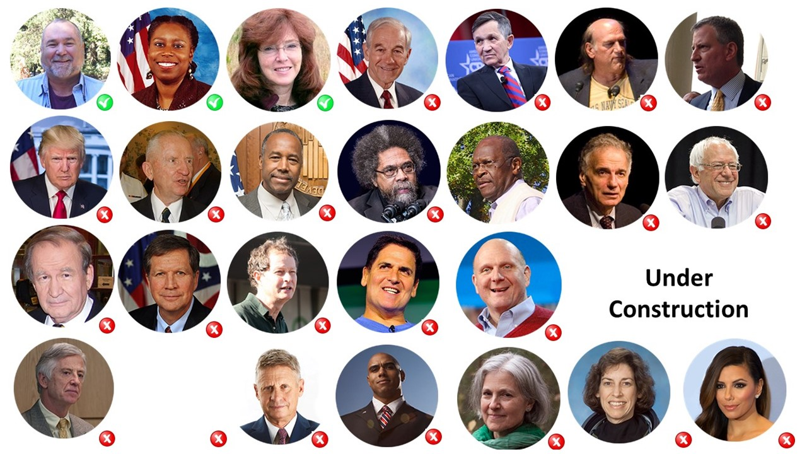

Above is a notional national coalition. Each of these individuals will be invited to embrace the mission of We the People – Unity for Integrity, and publicize the opportunity we have to come together and restore integrity to our government.
God Bless Donald Trump and God Bless Bernie Sanders. They opened the door for liberty. We can and must finish the job.
References

2017
Steele, Robert. THE SPEECH [Annotated Edition] – Can Donald Trump Triumph Over the Deep State? Amazon Kindle, March 12, 2017
Steele, Robert. World War III has started – the public against the Deep State — everywhere: Can Donald Trump Defeat the Deep State and Lead a Global Revolution? Amazon Kindle, March 12, 2017.
Steele, Robert. EMERGENCY: Memorandum for the President & A Spy’s Christmas Message for Donald Trump, Amazon Kindle, February 17, 2017.
Steele, Robert. “Trump Intelligence: Sometimes Really Big Lies Are Good – When Seen to Be Lies!,” Global Research, January 18, 2017.
Steele, Robert. “The Soft Coup Collapses – CIA Bluffing, Russia Did Not Hack, Blackmail Revealed – What Next?,” Global Research, January 9, 2017.
Steele, Robert. “The Russians Did Not “Hack” the US Election – a Few Facts from a Former CIA Spy,” Global Research, January 8, 2017.
Steele, Robert. The Soft Coup Collapses – Blackmail Revealed – What Next?: CIA was bluffing, produced no evidence – Russians did not “hack” the election. Is this the beginning of the end of the Deep State in the USA?, Amazon Kindle, January 7, 2017.
2016
Steele, Robert. Donald Trump, The Accidental President, Under Siege!, Amazon Kindle, November 11, 2016.
Steele, Robert, “In Harmony with All Life: The Open Source Way,” Kosmos: Journal for Global Transformation, November 1, 2016.
Steele, Robert. RIGGED: Twelve Ways the Two-Party Tyranny Rigs the US Electoral System to Block Out Independents, Small Parties, and 70% of the Eligible Voters, Amazon Kindle, October 23, 2016, 31 pages, $0.99.
Steele, Robert. DEPLORABLES RISING! Trump Can Win with a Debt Jubilee and Electoral Reform, Amazon Kindle, October 11, 2016, 9 pages, $0.99.
Steele, Robert. “Open Source Everything Engineering (OSEE) — a Nordic Manifesto,” Phi Beta Iota Public Intelligence Blog, April 15, 2016.
Steele, Robert. “Open Source Everything Engineering (OSEE) – Creating the Academy, Economy, Government, and Society of the Future,” Phi Beta Iota Public Intelligence Blog, April 5, 2016.
Steele, Robert. Democracy Riots! We are all black now – deal with it!, Amazon Kindle, March 22, 2016, 24 pages, 99 cents.
Steele, Robert. REVOLUTION!: How Donald Trump Can Win and Govern by Championing Electoral Reform, a Coalition Cabinet, a Balanced Budget, and a Constitutional Convention in 2018, Amazon Kindle, March 16, 2016, 111 pages, 99 cents.
2015
Steele, Robert, with Daniel Araya. “Interview: Former CIA Officer Robert Steele Discusses Why We Need an Open Source Revolution,” Futurism, December 2, 2015.
Steele, Robert. “Counter-Coup: How Trump Can Win,” CounterPunch, August 14, 2015.
Steele, Robert. “A Fantasy: On the Seventh Day,” CounterPunch, June 12, 2015.
Steele, Robert (2015). Open Power: Electoral Reform Act of 2015, Open Source Activist Tool-Kit, Amazon Kindle, February 24, 2015. 216 pp. $2.99.
2014
Steele, Robert. “Where Is Jesse Ventura When You Need Him?,” CounterPunch, November 20, 2014.
Steele, Robert with Nafeez Ahmed. “The open source revolution is coming and it will conquer the 1%,” The Guardian, June 19, 2014.
2013
Steele, Robert with David Balaban. “Open Everything – Interview with Robert David STEELE Vivas,” Privacy PC, April 2-8 2013, in six parts.
2012
Steele, Robert. “Testing the Two-Party Tyranny and Open Source Everything — The Battle for the Soul of the Republic,” New York, NY: Hackers on Planet Earth, July 13-15, 2012.
Steele, Robert. “How I Tested the Boundaries of the Two-Party Tyranny,” Reality Sandwich, May 24, 2012.
Steele, Robert. “The Battle for the Soul of the Republic,” Reality Sandwich, April 10, 2012.
2011
Steele, Robert. “Occupy Wall Street Electoral Reform Proposal,” New York, NY: Occupy Wall Street Electoral Reform Working Group, October 2011.
2009
Steele, Robert, “Intelligence for the President–AND Everyone Else,” CounterPunch, March 1, 2009.
2008
Steele, Robert (2008). Election 2008: Lipstick on the Pig (Substance of Governance; Legitimate Grievances; Candidates on the Issues; Balanced Budget 101; Call to Arms: Fund We Not Them; Annotated Bibliography), Earth Intelligence Network, September 23, 2008. Re-Issued in 2015 as Kindle and CreateSpace.
2007
Steele, Robert. “Open Everything: We Won, Let’s Self-Govern,” Seattle, WA: Gnomedex, August 10, 2007.
2005
Steele, Robert. “E3i: Ethics, Ecology, Evolution, Collective Intelligence, & Information Peacekeeping — Making the Revolution (1 part moral, 1 part conceptual, 1 part technical, 1 part cultural), Carlisle, PA: Strategic Studies Institute, US Army War College, April 18, 2005.
2002
Steele, Robert. “9-11, U.S. Intelligence, & the Real World,” Denver, CO: Office of Personnel Management, Western Management Development Center, 2002+.
Steele, Robert. “9-11, U.S. Intelligence, and the Real World,” Washington, DC: American Committee on Foreign Relations (ACFR), 2000+, 19 cities across America.
1996
Steele, Robert. “SPECIAL FEATURE: Creating a Smart Nation–Strategy, Policy, Intelligence, and Information,” Government Information Quarterly, pp. 159-173
1995
Steele, Robert. “Creating a Smart Nation: Strategy, Policy, Intelligence, & Information,” Washington, D.C., Fourth International Symposium on Global Security & Global Competitiveness: Open Source Solutions, November 7-9, 1995, Proceedings, pp. 290-306.
1993
Steele, Robert. “National Intelligence and Open Source: From School House to White House,” American Intelligence Journal, Spring/Summer 1993, pp. 29-32.
Steele, Robert. “God, Man, & Information: Comments to Interval In-House,” Palo Alto, CA: Interval, March 9, 1993. At the invitation of Rob Tow.
1992
Steele, Robert. “E3i: Ethics, Ecology, Evolution, & Intelligence,” Whole Earth Review, Fall 1992, pp. 74-79.
Steele, Robert. “Thinking About Revolution”, Intelligence Program Reader, Quantico, VA: Marine Corps University, AY 1992-1993.

