A New Banking Era & Autonomous Zones
Reconciliation with Japan, Exit Strategy for the Zionists, Solution for the Kurds?

Robert David Steele
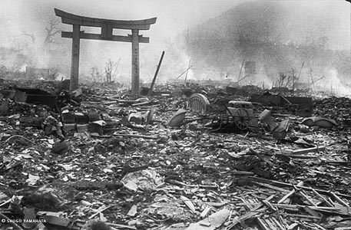
Princess Kaoru Nakamaru, Chair of the International Affairs Institute for World Peace, royal family liaison to the leadership of North Korea, and Donald Trump’s biggest fan in Japan, called me yesterday, not only to confirm the 12 June date for the meeting between President Donald Trump and Supreme Commander Kim Jong-un in Singapore (all negative remarks in the media are posturing for domestic consumption in both countries), but to tell me two things I did not know: first, that Donald Trump will be visiting Japan after his Singapore meeting; and second, that China has made preparations to offer the Zionists an autonomous zone in Manchuria as part of a much larger peace settlement in the Middle East.
Reconciliation with Japan & A New Banking Era
While she would not tell me more about the reasons for President Trump’s visit to Japan, my broader understanding allows me to posit two possible reasons for Donald Trump to be visiting Japan in June 2018:
Most obvious: to publicly acknowledge the US atomic bombings of Nagasaki and Hiroshima as crimes against humanity that should never have happened, and to commit the United States of America (USA) to the denuclearization of the world, ultimately including Israel and the USA itself. Most US citizens are also not aware that the USA attacked Japan eight times prior to Pearl Harbor, which was not a surprise. Franklin Delano Roosevelt (FDR) betrayed the public in many ways to include being complicit in the Great Depression as an attack on America’s growing middle class; allowing US banks to fund Adolf Hitler’s war of, by, and for the cabal; and waging covert war on Japan in order to elicit his “9/11.”
Less obvious: to confirm the role of Japan (along with Korea and Indonesia and the Philippines) in a deal long in the making, the transfer of the Gold Collateral Accounts (GCA) from serving as a foundation for the 1% Cabal comprised of the Rothschilds, the Vatican, and the Chabad Supremacist Cult, to serving as a foundation for a new jointly managed post-Western economic system that shuts down the Bank for International Settlements (BIS), nationalizes all Central Banks, and replaces the Society for Worldwide Interbank Financial Telecommunication (SWIFT) system now used to move fictitious and stolen wealth with impunity.
I have no direct knowledge but my direct sources in London and elsewhere are saying that a gold-backed US dollar looms on the horizon; that the US Government (USG) is going to stop borrowing money from the banks; that Donald Trump may have succeeded in getting back perhaps $15 trillion in “credits” from the $23-43 trillion now known to have been stolen by the banks; and – most importantly for the American public – that sometime in June 2018 over a trillion dollars will be released into the US economy through trusted stewards – normal people many of them veterans – to inspire a jobs creation and new construction boom such as we have no seen since the aftermath of World War II (WWII). The massive investments in mostly black inner cities and mostly white impoverished rural areas are part of this deal, which include the creating of a telecommunications platform for direct democracy that puts the President in two-way communications with 200 million eligible voters should they choose to opt-in.
Autonomous Zones – From China and Russia to the Middle East
I was initially baffled by the idea of an autonomous zone for Jews in Manchuria, until I discovered that the Jewish Autonomous Oblast in Russia is contiguous to Chinese Manchuria, and that the Chinese and Russians have spent $355 million on a railway bridge and additional funds on a highway bridge, both to be completed in October 2019, that links the existing Jewish Autonomous Oblast in Russia with the proposed Jewish Autonomous Zone in Manchuria.
WHOA! Add to this the two million vacant housing units that China has ready in this area to offer free to incoming Jewish migrants and the projected growth of the area’s prosperity at the intersection of processing Russian minerals, integral farmland, and trade with Japan, and one sees a very attractive value proposition for the Jewish squatters now illegally occupying Palestinian land.
Below I illustrate elements of this strategic project – all that is missing is a path to the sea and a new port on what is now North Korean land, one that would complement the port at Lianyungang / Haizhou Bay that completes the One Belt One Road maritime network. Either there needs to be a land grant from North Korea, or an accommodation with the port of Vladivostok – the Chinese being quite independent of the Russians, a new port on the Chinese side of the border with Russia, leveraging North Korean land, appears to be the more likely “finishing touch” on this proposed Jewish Autonomous Zone in Manchurian China.
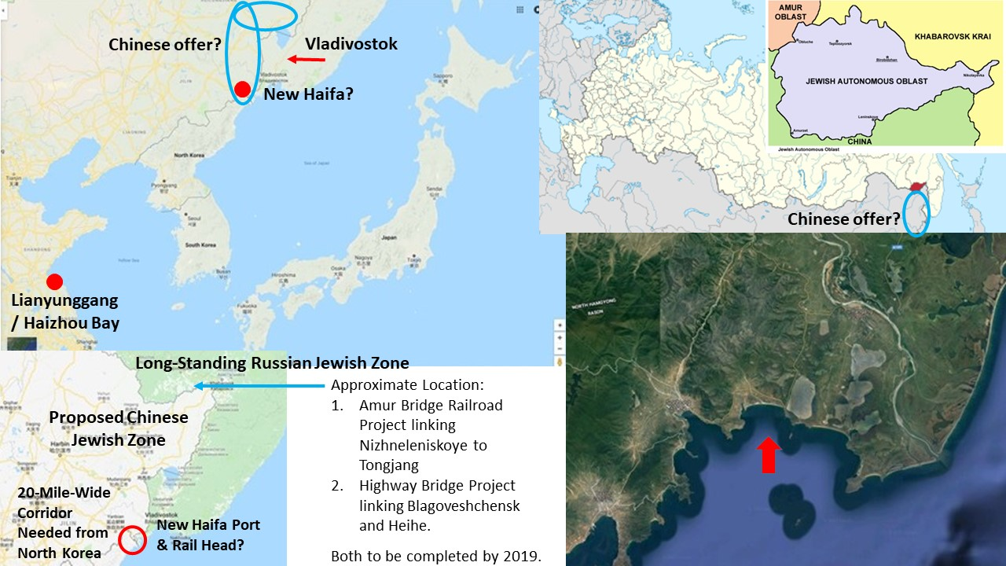
What is most interesting to me – apart from the elegance of long-term Chinese thinking about the development of Manchuria as a trade zone with Japan and the Koreas and the alignment of a solution for Jews with an existing Russian autonomous zone for Jews – is the applicability of this concept to the Kurds who are distributed as shown below.
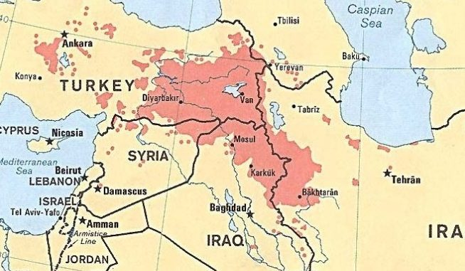
It is immediately apparent that the creation of an autonomous zone for the Kurds, one that respects the existing national borders of Turkey, Iran, Iraq, and Syria but creates a clear and culturally distinct Kurdish administration, could be a most beneficial complement to simultaneous settlements of the Palestinian question, and the long-standing divide between the Sunni and Shia communities of faith. Here also, a path to the sea, along the inside of the Turkish border toward Cyprus, is recommended.
The denuclearization of Israel and Iran, the restoration of Palestine, and the creation of a Kurdish confederacy and three of the eight major issues that must be addressed in any comprehensive Middle East peace plan. The other five issues that I have discussed elsewhere include:
1. Peace between the Sunnis and the Shi’ites
2. Jerusalem and perhaps Mecca as international cities
3. Repatriation of all unemployed Muslims from Europe back to Arabia, and reparations for Iraq
4. Creation of a post-Western post-fossil fuel economy with unlimited desalinated water
5. Creation of a regional Open Source Agency and network with information and engineering bureaus sufficient to create prosperity for all at 10% the cost of the failed Western economic paradigm.
As an observer of world history, I have the most positive view of the near future. China is clearly going to be a major player in the Middle East now that they are taking over the Iranian oil fields from the French and accelerating its high-speed rail construction integrating Central Asia with the Middle East via Iran, and it is clear to me that as the era of Zionism based on lies – as the Zionist illicit occupation of Palestine is challenged world-wide – as the boycott of Israel expands and Zionist agents of influence in the USA are challenged in court (the Anti-Defamation League or ADL is ripe for bankruptcy once lawsuits against MeetUp, YouTube and others move toward settlements and jury trials), a new era is beginning.
No one ever thought the Koreas would be united and denuclearized. That is going to happen.
No one ever thought the USA would apologize to Japan for its perfidy in attacking Japan eight times prior to Pearl Harbor, and then using atomic weapons on two Japanese cities with no good reason.
No one ever thought Zionist myths and misbehavior could be checked by public opinion, or that Palestine could be restored to the Palestinians.
No one ever thought that the leaders of China, Russia, and the USA could one day work together as a team, to take down the Deep State and end the destitution and looting of Earth by the 1%.
All of this is happening, is inevitable, and represents the triumph of good over evil in my lifetime.
Praise be to God.
IMAGE CREDITS:
1. Thome Review, 20140324
2. Author’s collage from multiple open sources
3. Central Intelligence Agency (unclassified) via SOF News 20181004
Notes

A meeting has been requested but not publicly confirmed as of this writing. Editors, “Japan seeks visit by Trump after his meeting with Kim Jong Un,” The Asahi Shimbun, 14 May 2018.
President Harry Truman, not FDR, ultimately dropped the bombs but they were created at the direction of FDR. It was well-known that Japan was on the verge of surrender and the bombs need not be dropped. In fact the bombs were dropped as a raw demonstration of power, and two bombs were dropped because there were two different military-industrial groups (one based on uranium and on plutonium) competing to dominate the post-war nuclear program, and both had enough influence to insist that “their” bomb be dropped. Cf. Editor, “The Atomic Bombing of Japan – A Necessary Evil,” Thome Review, 24 March 2014; Stanley Goldberg, “General Groves and the atomic West: The making and meaning of Hanford,” in Bruce Hevly and John Findlay, eds., The Atomic West (University of Washington Press, 1998), 39-89 as cited by Alex Wellerstein, “Why Nagasaki,” The Nuclear Secrecy Blog, 9 August 2013.
Wayne Jett, The Fruits of Graft: Great Depressions Then and Now (Launfal Press, 2011); a summary review is available free online.
Editors, “FDR provoked the Japanese attack on Pearl Harbor,” RationalRevolution.net, undated, accessed 23 May 2018. See also Editors, “McCollum Memo,” Wikipedia, undated, accessed 23 May 2018.
“Jewish Autonomous Oblast,” Wikipedia, undated, accessed 23 May 2018; “Amur Bridge Project,” Wikipedia, undated, accessed 23 May 2018.
Gary Fields, Enclosure: Palestinian Landscapes in a Historical Mirror (University of California Press, 2017). A summary review is available free online.
Andrew Korybko, “Lianyungang is the Missing Link That Completes the New Silk Road,” SputnikNews, 25 September 2015.
The author has written several articles on peace in the Middle East: “Peace in the Middle East: Denuclearizing Israel, Restoring Palestine, and More,” Russian International Affairs Council, May 18,2018; “Eradicating Zionism with Truth – A Plan for Peace and Prosperity for All,” American Herald Tribune, May 6, 2018; “Koreas Unite, Denuclearize: Middle East Next – after a Global Financial Re-Set – Ideas for Iran,” Russian International Affairs Council, May 2, 2018; “Is Zionism Over? From Korea to Syria to the Latest #GoogleGestapo Purge, President Donald Trump’s Divorce from Zionism Appears Increasingly Possible,” American Herald Tribune, March 4, 2018.
Editors, “China to the Rescue: CNPC Reportedly Plans to Replace Total in Iran's South Pars,” SputnikNews, 19 May 2018.
Zheng Yanpeng, “New rail route proposed from Urumqi to Iran,” China Daily, 21 November 2015; Sudha Ramachandran, “Iran, China and the Silk Road Train,” The Diplomat, 30 March 2016; Marjon Sheikhi, “China ready to invest in Iran’s high-speed rail projects,” MEHR News Agency, 12 February 2018; Editors, “China’s Sinomach to build $845 million railway in western Iran,” Reuters, 20 March 2018.
The thirteen strikes of Zionism (not Judaism) within the USA – it’s sole major supporter -- and not counting Zionist participation in the assassination of US President John F. Kennedy – include: STRIKE #1: USS Liberty STRIKE #2: 9/11 STRIKE #3: S. 720 Israel Anti-Boycott Act STRIKE #4: 23 States Demanding Israel Loyalty Oath STRIKE #5: Las Vegas False Flag STRIKE #6: Netanyahu dismissed American Progressive and Reform Jews STRIKE #7: Syrian False Flag #1, Lies to the President Lead to Missiles into Syria STRIKE #8: US SecState and SecDef clearly owned by Israel, calling for occupation of Syria STRIKE #9: Zionist demonization of Iran via US channels, while offering Saudis nuclear weapons STRIKE #10: Announcement of US Embassy moving to Jerusalem STRIKE #11: US Supreme Court kills laws favoring Israel STRIKE #12: Bill Maher as a Zionist agent of influence STRIKE #13: Debbie Wasserman Schultz, Diane Feinstein, Chuck Schumer, Arnon Milchan and more will be associated with Strike 13. Robert Steele, “Zionism in America – Steven Strikes & Counting…,” Veterans Today, 14 December 2017; Paul Adams, “Zionism in America – Strike 8, Strike 9,” Phi Beta Iota Public Intelligence Blog, 30 January 2018; Henry Siegman, “Zionism Strike 10 – The Implications of President Trump’s Jerusalem Ploy,” Phi Beta Iota Public Intelligence Blog, 1 February 2018; Editors, “Zionism Strike 11: Supreme Court Kills Laws Favoring Israel,” Phi Beta Iota Public Intelligence Blog, 2 February 2018; Mongoose, “Is Bill Maher a Zionist Agent of Influence? Is This Zionism Strike 12?” Phi Beta Iota Public Intelligence Blog, 4 February 2018.

