Bobby
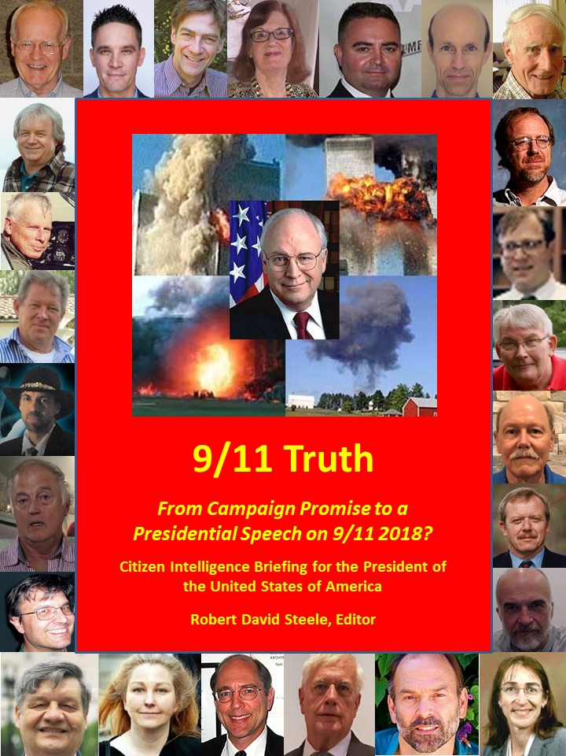
9/11 Truth
From Campaign Promise to a Presidential Speech on 9/11 2018?

Citizen Intelligence Briefing for
Donald J. Trump
President
United States of America

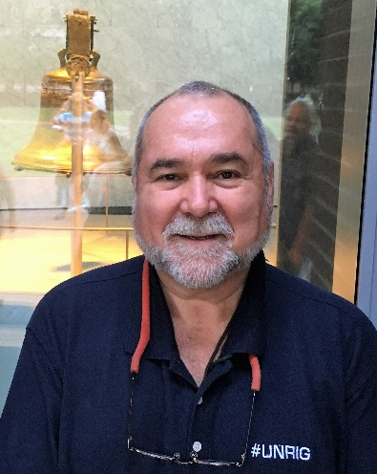
Robert David Steele
Editor
Earth Intelligence Network

All Memorandums
Previously Published Free Online
http://tinyurl.com/911-POTUS

The dates on each memorandum have been eliminated to avoid the distraction – the memorandums have been reordered to communicate a narrative: who, why, how. The original dates can be seen at the above link and within the downloadable individual memorandums themselves.

Table of Contents
Donald Trump Makes A Promise About 9/11 5
Robert David Steele: Letter of Transmittal 6
Overview & Call for Presidential 9/11 Truth Summit 11
David Ray Griffin: Proposal for a Presidential 9/11 Truth Summit 11
Eric Hufschmid: Please Find the Courage to Declare 9/11 a False Flag Operation 13
James Fetzer: Three Proofs We Have Not Been Told the Truth About 9/11 15
Sander Hicks: 9/11 Truth Can Unite the Public Against the Deep State 17
Andrew Kreig: U.S. Attorney Has Received a Petition Demanding 9/11 Investigation 19
Robert Steele: 9/11, Domestic False Flag Operations, and Your Legacy 21
Who? Who Planned and Executed and Covered-Up 9/11? 23
Christopher Bollyn: 9/11 - Israel’s History of False Flag Operations against the U.S.A.* 23
Victor Thorn: The Zionist Role in Planning, Funding, and Controlling 9/11 27
Steve De’ak: 9/11 Who Knew What When? The New York City Cover-Up… 29
Nicholas Kollerstrom: 9/11 an Inside Job, Osama Bin Laden Framed, FBI Aware 34
Why? What Exactly Motivated the 9/11 Mass Casualty Event? 36
Tom-Scott Gordon: 9/11 WTC Towers Condemned Before 9/11, Known to Rudy Giuliani 36
Fred Burks: Evidence 9/11 Used to Launder $240 Billion in Covert Securities* 39
How? How Could A Mass Atrocity in Three Acts Be Carried Out? 41
Peter Dale Scott: 9/11, Dick Cheney, & The Hijacking of the U.S. Government* 41
Susan Lindauer: CIA’s Advance Knowledge of 9/11 Date Including Nuclear Possibilities* 43
Ed Jewett: 9/11 – The Zionist-Rothschild Use of Agents –Carter and Zelikow Particularly 45
Scott Bennett: Memorandum for the President: How 9/11 Was Funded* 48
Kevin Barrett: Muslims Were Framed for 9/11 – Fake News MSM Silences Us* 50
Richard Gage, AIA: 9/11 Explosive Evidence As Identified by AE911Truth Not Addressed 52
T. Mark Hightower: 9/11 Twin Towers Cannot Be Explained by Nano-Thermite Alone 56
Barbara Honegger: 9/11 Pre-Planted Explosions 8 Minutes Prior to Alleged Impact* 58
Gordon Duff: 9/11 NYC Was a Nuclear Event Crafted by Israel Overseen by Dick Cheney 61
Joe Olson: 9/11 Twin Towers “Clean Nukes”, WTC 7 Conventional Demolitions 63
Judy Wood by Robert Steele: 9/11 Twin Towers Vaporized by Directed Energy Weapons 65
John Lear: 9/11 Illusions of Airplanes from Hollywood or US Air Force Holograms? 68
John Lear: 9/11 Twin Towers Were Not Hit By Nor Destroyed By Two Airliners 70
Aeronautical Engineer: No Boeing 757 Hit the Pentagon 73
Epilogue 75
A. K. Dewdney: 9/11 Gratuitously False Narrative on Use of Cell Phones 75
Greg Felton: 9/11 Zionism’s Great Feeding Frenzy – The Parasite Eats the Host 77
References 80
The Zionist Plan – The “Greater Israel” or Yinon Plan 80
Remember the USS Liberty! 81
Review: Enclosure – Palestinian Landscapes in a Historical Mirror* 83
Zionism in America – 18 Strikes and Counting 87
CIA and the Deep State – A Threat to the President & The Republic* 88
Index of Names…………..…………………………………………………………………………………………………………………………99
* Published in the American Herald Tribune in addition to Phi Beta Iota Public Intelligence Blog.

Donald Trump Makes A Promise About 9/11
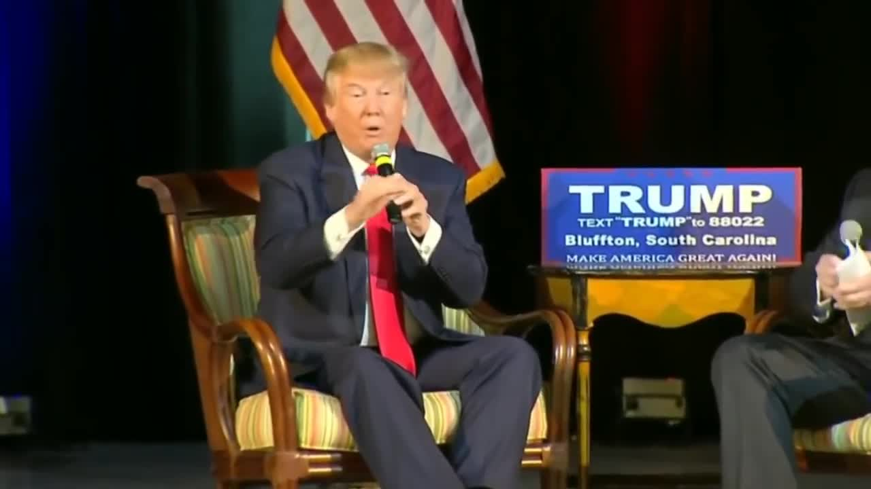

Tim Haines, “Donald Trump on 9/11: ‘You Will Find Out Who Really Knocked Down The World Trade Center’,” RealClear Politics, 17 February 2018.

Robert David Steele: Letter of Transmittal
Mr. President,
On 15 February 2016, speaking to a wildly enthusiastic crowd in Bluffton, South Carolina, you promised that under your watch, We the People would “find out who really knocked down the World Trade Center.” Throughout the campaign you were alone among prominent public figures to express skepticism on 9/11 by observing that the same builders who constructed the Twin Towers were now working for you and that the design of the buildings made it impossible for planes to have brought them down and that something else had to be involved, such as bombs. You were right on the mark!
It is now known that the 9/11 Commission was a complete cover-up, similar to the Warren Commission in the aftermath of the assassination of John F. Kennedy by a multiplicity of actors including Zionists, led by Lyndon Baines Johnson with the collaboration of the leaders of the CIA, FBI, and the Secret Service.
As the Deep State begins to panic in the face of your successful domestic and foreign initiatives that threaten to overturn fifty years of atrocities in our name and the looting of our treasury by the 1%, there is one major step you can take to educate the 99%, earn the confidence of the 73% who did not vote for you (47% not voting at all), and smash the fake news media that continues to parrot the 1% propaganda line accusing you of treason:
Deliver the truth about 9/11.
The memoranda that follow could not have been collected so quickly without the original disbelief of the Families of 9/11 of the false government narrative; the persistent efforts of Richard Gage and the Architects & Engineers for 9/11 Truth; the independent critical thinking of so many others; and the on-going outreach of Dr. (PhD) James Fetzer, former Marine Corps officer, who is perhaps the single most authoritative author on the topic of false flag operations (I myself have managed a false flag operation for CIA). His established access to half the contributing authors enabled this Briefing to be created in less than 30 days – an independent investigation could do much more in the 40 days remaining between now and 9/11 2018 when you plan a speech on the 17th anniversary of 9/11. Will that speech consist of platitudes? Or will that speech blow the lid off 9/11 and charter a deep long-term investigation that sets a new standard for truth in the public interest?
As Andrew Kreig points out in his memorandum, a petition for a criminal investigation was delivered on 10 April 2018 – just over three months ago – to U.S. Attorney Geoffrey S. Berman, Southern District of New York. Mr. Berman works for you. The fastest, cheapest way for you to fulfil your campaign promise to get to the bottom of 9/11 is to direct Mr. Berman to act rapidly on the petition and report his preliminary conclusions to you by 1 September 2018 – in time to impact on your planned speech for 11 September 2018 and arouse the greatest possible public outrage going toward the November elections.
9/11 was a false flag operation – an inside job planned by the Zionists and Saudis and executed with the complicity and complete protection of Dick Cheney and Donald Rumsfeld, among others. Emboldened by 9/11, the Deep State and Shadow Government have since executed a number of other false flag operations across America, all with an anti-gun agenda, while also seeking to increase funding for a militarized police state that engaged in unconstitutional mass surveillance and warrantless search.
To defend the 2nd Amendment, you must disclose 9/11 Truth.
The single most shocking memorandum in this collection, one that places Rudy Giuliani in the center of the conspiracy (along with Dick Cheney and the Bush Family as well as Zionists Larry Silverstein, Stephen Roth, and Charles Hurwitz) is that of Tom-Scott Gordon. 9/11 was at root a massive commercial insurance fraud covered up as a terrorist incident that in one day converted a $2B liability into a $7-12B insurance fraud bonus, while eliminating all asbestos claims against Kaiser Aluminum; it provided a pretext for war on Afghanistan to reboot the opium crop eradicated by the Taliban and war on Iraq to steal their oil; and it provided a cover for laundering $240 billion in off-budget gold used in the Gold War against Russia as organized by President George H. W. Bush and then Secretary of Defense Dick Cheney. The second most shocking memorandum is that of Fred Burks, summarizing what we know about the covert economic war – undeclared by Congress and unknown to the US public, against Russia.
President Vladimir Putin and the government of Russia are to be admired for their restraint but they made a mistake in not publicizing what they know about this Gold War from 1998-2001, an undeclared war with George Tenet, Buzzy Krongard and John Brennan at the Central Intelligence Agency (CIA) as its managers. As Martin Armstrong and I have recently outlined, William F. Browder is very likely a lead CIA asset for that Gold War, and the Magnitsky Act – as you and your family appear to realize – is a fraud based on lies advanced by long-time CIA asset John McCain and his loving sidekick, Lindsey Graham.
The Gold War concluded on 9/11 when by prior arrangement the Securities and Exchange Commission (SEC) suspended all oversight and documentation of individual trades despite having no impairment to its computers or operations, so that Vice President Dick Cheney and his cohorts could launder the $240 billion in off-budget gold assets into the legal economy.
The other memoranda – twenty-seven all told – make clear that airplanes were not the cause of anything; that pre-planted explosives brought down all three WTC buildings and blew up the Pentagon (the holes were blown from the inside out); and that this was without question an inside job in which Dick Cheney and Donald Rumsfeld, using the secret Continuity of Government (COG) program (part of the secret intelligence community that persists in threatening you with assassination, defamation, and impeachment); and that the Zionists did all the heavy lifting in persistently pressing their neo-conservative allies and servants in the USA, and then executing the plan. The Saudis simply provided logistical support and documentation for the patsies. This plan was a decade in the making, with over thirteen countries warning us in advance, and yet the entire US Government – the FBI particularly – either failed to do its duty, or was complicit in this pre-planned mass atrocity.
Not clear from these memorandums, but explored by a number of authoritative authors, is whether nuclear or directed energy was an aspect of the WTC catastrophe; who exactly planted the explosives in the Pentagon; who exactly controlled the fake news media with such absolute discipline as they repeated a false narrative over and over; why the insurance company and the City of New York were complicit in the immediate destruction of a crime scene; how the entire US Government was persuaded to lie about test results on everything from dust samples to debris forensics; why Louis Freeh resigned as Director of the Federal Bureau of Investigation (FBI) three months early; and why Robert Mueller, his replacement, spent his entire tenure covering up for Dick Cheney and all those who planned and executed the greatest deliberate mass catastrophe is US history….and so on.
These are questions for an independent investigative endeavor such as proposed by the Bobby Mcllvaine World Trade Center Investigation Act. A good starting point would be a deep interrogation with no exit for Dick Cheney, Larry Silverstein, and all the others mentioned by name in these memos.
It is my personal view that between now and November 2018 you should take four initiatives:
01 Direct Attorney General Jefferson Sessions to direct U.S. Attorney Geoffrey S. Berman, Southern District of New York to act with dispatch on the demand for a criminal grand jury, and report to you in a preliminary manner by 1 September 2018. Use that – and your direct calls to any of the authors in this volume all of whose direct cell numbers are being provided to you under separate cover – as a foundation for your speech on 9/11 2018 when we all hope you will commit to the Bobby McIlvaine World Trade Center Investigation Act and demand a Congressional vote on that act prior to the November 2018 election.
02 Clear the fake news scum out of the White House. Stop wasting real estate on liars who hate you. They are doing everything they can to undermine your authority and discredit your administration. Do not offer them the time of day, much less desks and accommodations to promote endless disinformation and propaganda contrary to the best interests of the American public.
03 In the space vacated by the press corps in the White House, install a Trump Studio and a new “truth channel” coordination team that allows you to dispense with Twitter and directly engage – with two-way communications – 200 million US voters. BitChute (based on BitTorrent which does not require data centers and cannot be censored or manipulated) is immediately available as the core for your new truth channel that integrates text messages, emails, videos, posts, shared documents, and polls – all impervious to #GoogleGestapo censorship, manipulation and the digital assassination of conservative and progressive voices now characteristic of Facebook, Google, MeetUp, Twitter, and YouTube.
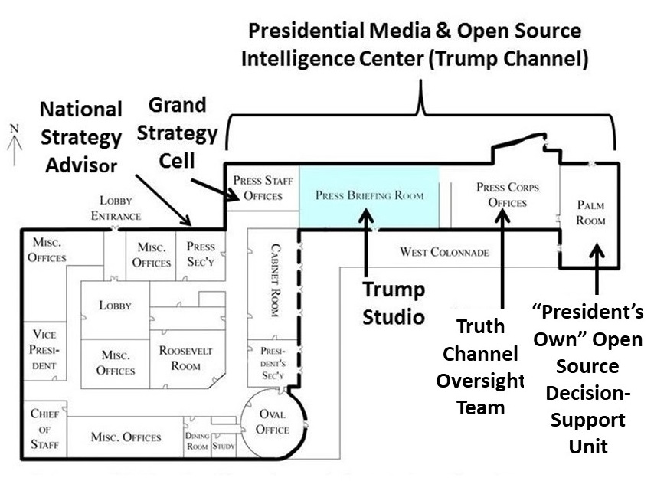

04 Introduce #UNRIG – The Election Reform Act of 2018 – whose twelve provisions illustrated below will give #WalkAway Democrats (there are also #WalkAway Republicans) viable options for being part of a new informed inclusive democracy under your direct leadership. People, not parties, are the heart and soul of your future success in Making America Great. If you do this I believe you will increase your base from 27% to 70% as shown in the second graphic. Herman Cain could work with Ron Paul, Dennis Kucinich, and Cynthia McKinney (no, she is not a communist nor a supporter of Islamic terrorism) to educate the public and help you force a vote on this Act prior to the November 2018 elections.
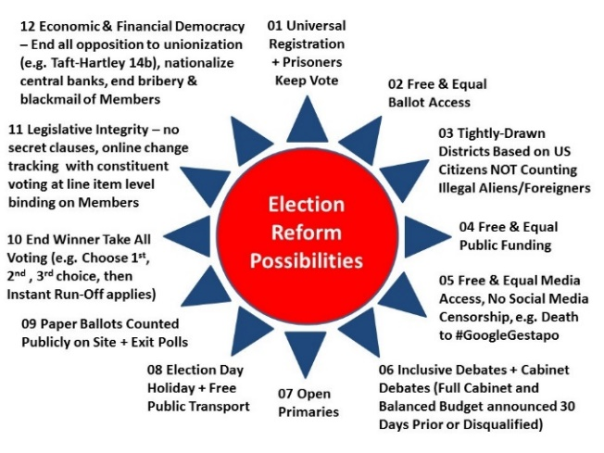 | 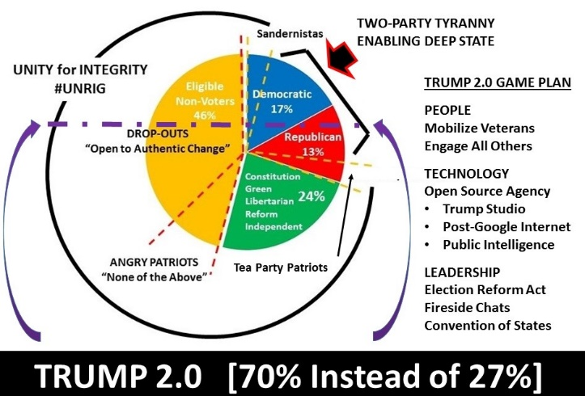
Mr. President, we are all rooting for you. The secret intelligence/counterintelligence community has failed you – General Tony Zinni, USMC is on record as pointing out that they provide “at best” 4% of what a president or major commander needs (and nothing for everyone else). Your Cabinet officers are generally clueless about the Deep State (if not betraying your behind your back in complicity with the Deep State) – Mike Pompeo, smart man that he is, is naïve on this point – you are all alone.
Take our hand, we beg of you. You’ve got the 1% on the run but you have not connected with nor empowered the 99% that are your reserve.
Disclose the truth about 9/11; create a truth channel that by-passes both the mainstream and social media controlled by the Deep State and their Zionist under-belly; and introduce the #UNRIG Election Reform Act of 2018.
Do these three things, now, and you will be the greatest president in modern history, making America great again at the same time that you do what no other US president has done in history: get us to full employment at home at the same time that you create perpetual peace abroad. War is a profit center for the 1% – peace is vastly more profitable but its benefits are widely distributed across the 99%. We cannot have prosperity for the 99% at home without peace abroad.
“The truth at any cost lowers all others costs.” The truth is your greatest weapon, Mr. President. 9/11 Truth is as good a starting point as you are going to have with the 73% who did not vote for you. Give them 9/11 Truth, a truth channel for everything else, and the #UNRIG Election Reform Act to guarantee them ballot access and a vote that counts, and you will be the greatest President ever.
Very respectfully,
Robert David Steele
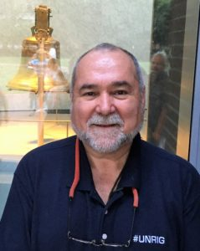
Robert David Steele is a former Marine Corps infantry officer and CIA spy who was recommended for the Nobel Peace Prize in 2017. A published author with many books on intelligence and election reform, some with forewords by US Senators and Congressmen, he is also the top English-language reviewer for non-fiction books, with over 2,500 substantive reviews posted across 98 categories of reading. Today the CeO of Earth Intelligence Network (non-profit) and Open Source Everything, Inc. (for profit), he is committed to creating a truth channel that cannot be censored, manipulated, or used to digitally assassinate conservative or progressive voices. He is the founder of #UNRIG, and also a Commissioner and the Chief Counsel for the Judicial Commission of Inquiry into Human Trafficking and Child Sex Abuse of the International Tribunal for Natural Justice.

Overview & Call for Presidential 9/11 Truth Summit

David Ray Griffin: Proposal for a Presidential 9/11 Truth Summit
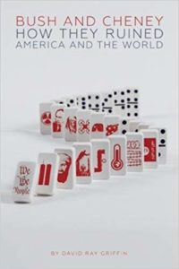
Dear President Trump:
In the opening chapter of my 2017 book, Bush and Cheney: How They Ruined America and the World, I wrote:
During the debate on September 16, 2015, Donald Trump made a criticism of George W. Bush, after which Jeb Bush said, “There’s one thing I know for sure: he kept us safe.”
Trump replied: “Say what you want, the World Trade Center came down during his time.”
As to why this fact could seem debatable, Jeb Bush and some commentators interpreted Trump’s statement to mean that he was blaming George Bush for 9/11. However, Trump’s basic statement was simply that the president had not prevented the attacks. “He was president, OK?” said Trump. “Blame him, or don’t blame him, but he was president. The World Trade Center came down during his reign.” As several commentators pointed out, Trump was obviously right on this point. (p. 19)
As to why the World Trade Center came down, you, as a builder, knew that the towers could not have come down without explosives. Rather than blaming Bush, you suggested that the hijackers’ planes had been equipped with explosives. However, the authorities had hidden from the public the fact that WTC 7 also came down just as quickly as the Twin Towers, although it was not hit by a plane.
Bush and Cheney argued that WTC 7 was brought down by fire. But as I pointed out later in my book, “the WTC 7 fires melted steel, iron, and even molybdenum, all of which have melting points far higher than ordinary building fires can reach.” Moreover, “the building came down in free-fall for over two seconds, which by physical principles could happen only if explosives and/or incendiaries had simultaneously removed all 82 steel support columns.” (p. 275)
It would be good if you would point out that the Bush-Cheney account is refuted by physics, thereby raising the question: Why did they lie?
Mr. President, America – and indeed the world – thirst for the truth about 9/11. As 11 September 2018 approaches and you reflect on what you might say on that day, I urge you to convene a televised presidential summit of truth-tellers; let America hear the truth under your leadership.
Yours truly,
David Ray Griffin
DOC (1 Page): 911 POTUS Griffin Truth Summit Needed
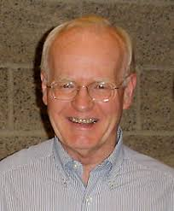
David Ray Griffin, featured in “Americans Who Tell the Truth,” has spent his life studying theology and striving to reconcile the pervasive divide between science and religion.
He is one of the most published authors on 9/11 and was nominated for the Nobel Peace Prize in 2008 and 2009 along with the 9/11 Truth Movement, for his objective analysis of this false flag event. Below are two quotes:
“There are literally dozens of problems in the official account of 9/11 sufficiently serious to show the official story to be false. But the clearest proof is provided by the video of the World Trade Center building # 7 coming straight down in absolute free fall. Even though this proof has existed in plain sight for all these years, the fact that 9/11 was an inside job, and hence a State Crime Against Democracy, has remained a hidden fact. “
“All the proffered evidence that America was attacked by Muslims on 9/11, when subjected to critical scrutiny, appears to have been fabricated.”
Phi Beta Iota: David Ray Griffin is the most prolific analyst of this event. Below are his books on 9/11 in reverse chronological order. He is also a theologian with many books of deep value to anyone of faith.
2018 9/11 Unmasked: An International Review Panel Investigation
2017 Bush and Cheney: How They Ruined America and the World
2011 9/11 Ten Years Later: When State Crimes Against Democracy Succeed
2010 Cognitive Infiltration: An Obama Appointee’s Plan to Undermine the 9/11 Conspiracy Theory
2009 The Mysterious Collapse of World Trade Center 7: Why the Final Official Report About 9/11 Is Unscientific and False
2009 Osama Bin Laden: Dead or Alive?
2008 9/11 Contradictions: An Open Letter to Congress and the Press
2008 The New Pearl Harbor Revisited: 9/11, the Cover-Up, and the Exposé
2007 Debunking 9/11 Debunking: An Answer to Popular Mechanics and Other Defenders of the Official Conspiracy Theory
2006 Christian Faith and the Truth behind 9/11: A Call to Reflection and Action
2006 9/11 and American Empire: Intellectuals Speak Out, Vol. 1
2004 The 9/11 Commission Report: Omissions And Distortions
2004 The New Pearl Harbor : Disturbing Questions about the Bush Administration and 9/11

Eric Hufschmid: Please Find the Courage to Declare 9/11 a False Flag Operation
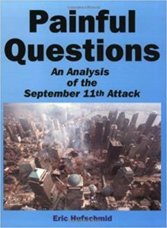
Mr. President,
Many attentive citizens and groups, including Architects and Engineers for 9/11 Truth, have provided ample evidence that Building 7 and the two World Trade Center towers were demolished with explosives, thereby proving that the 9/11 attack was a “false flag” operation, and that the US military started wars in the Middle East with people who had no responsibility for the 9/11 attack. However, our evidence is still being ignored or ridiculed by journalists, government officials, military officials, and school teachers.
There are three negative consequences for America if you, Mr. President, allow the lies about 9/11 – lies that justified a seven trillion dollar war across Central Asia and the Middle East that you yourself have said has given us nothing:
First, you will continue to be opposed by the Deep State that uses the lies of 9/11 to justify more and more money for both a police state at home and elective wars abroad – wars that create new terrorists when we are not funding, equipping, and training the terrorists directly, as with ISIS.
Second, those of your citizens who know the truth will continue to be marginalized, ostracized, and in many cases put out of work as the Deep State seeks to keep their voices from being heard.
Third, the majority of the public, most of whom did not vote for you in 2016, will continue to believe these lies and not see that you are our single best hope for taking down the Deep State and ending the “endless war” that they need in order to continue to loot the USA and the rest of the world.
I wrote one of the definitive books on 9/11, accompanied by a DVD, that others have described as “exhaustive.” There is no question but that 9/11 was an “inside job” but there is only one person, you, Mr. President, who can drive this point home when you give your 9/11 anniversary speech on 11 September 2018.
I, and many other people around the world, have been impressed over and over with your ability to stand up to incompetent and dishonest journalists and government officials. You have caused the expression “fake news” to become popular around the world, and your recent accusation that Maxine Walters has a low IQ is likely to inspire more people to complain about their incompetent government officials. If you would find the courage to make a public statement that the 9/11 attack was a false flag operation, you would be able to put an end to this abuse very rapidly because you would give credibility to the “crazy” conspiracy theories about the 9/11 attack. You would cause people around the world to start discussing an issue that the controlled journalists and think tanks continue to obscure with lies.
Very respectfully,
Eric Hufschmid
DOC (1 Page): 911 POTUS Hufschmid False Flag Inside Job
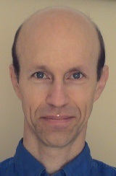
Eric Hufschmid has been the sole proprietor of a software development business since 1991. In January 2002 he came to the conclusion that the World Trade Center buildings were demolished with explosives, so he spent the next few months sending email messages to professors, scientists, and other people to ask them to look into the issue. Nobody seemed interested, so he decided to get involved. He produced the book, Painful Questions: An Analysis of the September 11 Attack, and then he created the video, Painful Deceptions. The biggest surprise to him was the resistance of the public to this information.

James Fetzer: Three Proofs We Have Not Been Told the Truth About 9/11
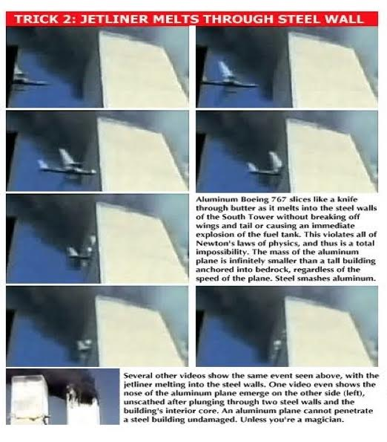
Mr. President,
The Impossible Entry. The footage of the South Tower hit exemplifies several anomalies, including a Boeing 767 flying at an impossible speed, an impossible entry into the building (in violation of Newton’s laws), and even passing through its own length into the building in the same number of frames it passes through its own length in air—which is impossible, unless this 500,000 ton, steel and concrete building posed no more resistance to its trajectory in flight than air. Some have claimed that this was a “special plane” that could fly faster than a standard Boeing 767, but no real plane could violate Newton’s laws. The structure of the building, moreover, meant that it actually intersected with eight different floors. Each of those floors consisted of steel trusses connected at one end to the core columns and at the other to the steel support columns, which would have posed massive horizontal resistance. Any real plane would have crumpled external to the building.
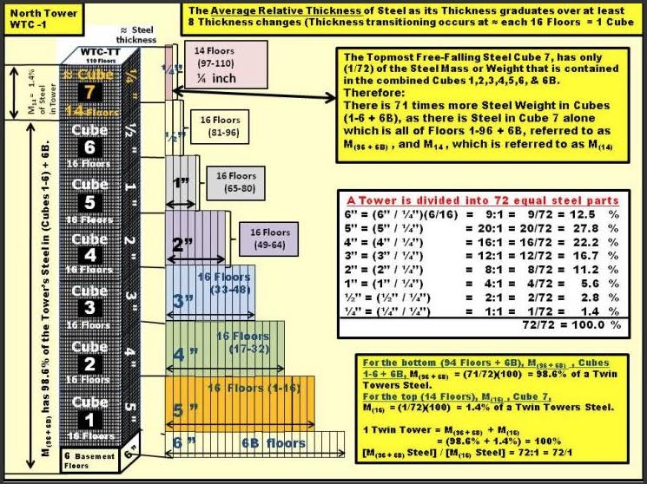
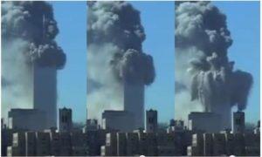
The Impossible Collapse As Chuck Boldwyn has shown, the thickness of the steel varied from six inches thick in the subbasements to a quarter-inch thick at the top, which meant that the overwhelming mass of the steel was below the level at which “the plane” is alleged to have hit the North Tower. By his calculation, the fourteen floors above the “hit point” represented 1.4% of the mass of the steel, where it is preposterous to suppose that its collapse could have overcome the 98.6% of the mass of the steel below it. Indeed, as John Skilling observed, the towers were built with a safety factor of 20, which means that each floor could support 20 times its expected live load (dead load + furniture, facilities and human personnel). The claim that the jet fuel from the plane strikes burned so intensely it caused the steel to weaken cannot withstand critical scrutiny. The steel used in the building was certified by Underwriters Laboratories, Inc., to 2,000*F for three to four hours without suffering any adverse effects. NIST studied 236 samples of steel and found that 233 had not been exposed to temperatures above 500*F and the other three not above 1,200*F. Plus the fires in the South Tower lasted less than an hour, in the North less than an hour-and-a-half. The fires burned neither long enough nor hot enough to affect the steel. It was physically impossible for them to collapse.
A Controlled Demolition (WTC-7) vs. Demolitions Under Control (The Twin Towers). As Jesse Ventura has observed, propane burns hotter than kerosene (the constituent of “jet fuel”), yet his camping stove, which is made of steel, does not melt when he uses it on a camping trip. Far from collapsing, both buildings are being blown apart in every direction by enormous sources of energy, where they are being converted into millions of cubic yards of very fine dust and, when destruction is complete, there is no massive pile of debris in their footprint, which is a classic sign of a building’s collapse. Unlike WTC-7, the Twin Towers did not collapse, which means that the official account characterizing them as having “collapsed” is another blatant fabrication and deliberate deception.
Unlike the Twin Towers, WTC-7 came down in a classic “controlled demolition” at 5:20 PM that day, about seven hours after the destruction of WTC-1 and WTC-2, which I prefer to refer to as “demolitions under control”, since they were clearly not classic controlled demolitions. You can see the penthouse kink, where all the floors fall at the same time and, after about 6.5 seconds, there is a stack of debris (mostly floors) equal to about 12% of the height of the original. By contrast, the floors of the Twin Towers remain stationary, waiting their turn to be “blown to kingdom come” (in the memorable phrase of Morgan Reynolds).
For a video overview of the science and politics of 9/11, see “9/11: Who was responsible and why”.
Very respectfully,
James Fetzer, PhD
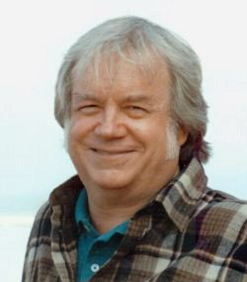
DOC (1 Page): 911 POTUS Fetzer Impossible
James H. Fetzer, PhD, is a former Marine who has received many leadership and distinguished teaching awards. A magna cum laude graduate in philos0phy of Princeton University, he earned his PhD in the history and philosophy of science from Indiana University. Today the Distinguished McKnight University Professor Emeritus for the University of Minnesota Duluth, he is the foremost author and holistic analyst for false flag operations from 9/11 to Sandy Hook and beyond, while continuing to write about human and computer intelligence, evolution and cognition, and the assassination of John F. Kennedy as a turning point in public access to truth versus Deep State control of the truth. He is the founder of Scholars for 9/11 Truth.

Sander Hicks: 9/11 Truth Can Unite the Public Against the Deep State
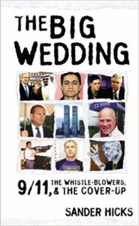
Mr. President,
An opportunity exists for you to unite the public by fulfilling your campaign promise to get to the bottom of 9/11 and disclose the truth. 9/11/18 is coming soon. Please use your speech on that day to finish the job of burying the Deep State.
As a long-time New Yorker, I saw with delight how you courageously stood up to Jeb Bush and the 9/11 cover-up, in the GOP race for President. Now that you are President, it’s time to show more independence from corrupt US intelligence agencies. Your comments in Helsinki will make more sense to more people if you can show that there really is a Deep State, and it is evil. The time has come for you to put your presidency on the line for the truth about 9/11.
As President, you have the authority to replace US Attorney Geoffrey Berman, who has since April 2018, failed to respond to a Petition for a Special Grand Jury regarding the mysterious building collapses of 9/11. This new legal action was undertaken by the 60-attorney strong “Lawyers Committee for 9/11 Inquiry.” The 54-page petition contains over 57 categories of strong evidence of serious crimes on 9/11. For Berman to ignore it is to perpetuate a cover-up. Absent evidence to the contrary, Berman works for the Deep State, not for you, or the public.
The 9/11 Cover-Up has produced the murder of righteous US citizen whistle-blowers, such as Barry Jennings, of the City of New York, and Dr. David M. Graham of Shreveport, Louisiana. Graham got close to two of the “19 Hijackers” and their Saudi handler, one year before 9/11, outside Barksdale Air Force Base. After numerous trips and conversations with local FBI, I believe Deep State components of US military intelligence were handling the hijackers before 9/11. Dr. Graham died of a mysterious poisoning, linked to Shreveport FBI, in 2006. He is survived by State Senator John Milkovich, who is a fan and a real ally of yours, Mr. President.
Your enemies, the Neoconservatives, will pay any price in our blood and treasure for Zionist ends. They appear to have enabled a joint Zionist-Saudi Arabian plan for 9/11, and then controlled the official investigations. The key 9/11 “hijackers” were protected by CIA and FBI as well as the Pentagon from its own DIA operation Able Danger. Surely this qualifies as obstruction of justice, if not treason! The key 9/11 “hijackers” Al-Hazmi and Al Mihdhar, lived with an FBI informant in San Diego before 9/11, and received wire transfers from “Bandar Bush,” Saudi Prince Bandar.
You promised us, Mr. President, on 15 February 2016, that you would “find out who really knocked down the World Trade Center.” Please, Mr. President, fulfill that promise now, in time to impact on this year’s midterm elections.
Very respectfully,
Sander Hicks

References:
Grand Jury Petition, Lawyer’s Committee for 9/11 Inquiry, 10 April 2018
Sander Hicks, The Big Wedding: 9/11 the Whistle Blowers, and the Cover-up (Drench Kiss Media, 2005)
Sander Hicks, Slingshot to the Juggernaut: Total Resistance to the Death Machine Means Complete Love of the Truth (Soft Scull Press, 2012)
DOC (1 Page): 911 POTUS Hicks 911 Truth Can Unite Public Against Deep State

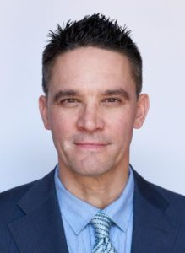
Sander Hicks is a lifelong peace activist and award-winning entrepreneur. A son of New York City, he started three innovative companies. He founded Vox Pop, a fair-trade coffee house which pioneered citizen education through purposeful entertainment. He has written two books on 9/11 and the value of truth to the future of the USA. He is a Quaker attendee, Rinzai Zen practitioner, and committed inter-faith activist, focused on conflict resolution. Today, he serves as a NYC facilitator of the Truth Action Project, dedicated to justice for the 9/11 Victims and their families. He is running for Congress as an Independent Progressive, in New York’s 12th Congressional District.

Andrew Kreig: U.S. Attorney Has Received a Petition Demanding 9/11 Investigation
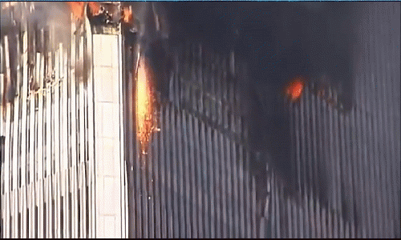
Mr. President,
On 10 April 2018 compelling 9/11 evidence was delivered to U.S. Attorney Geoffrey S. Berman, Southern District of New York. Mr. Berman works for you. The fastest, cheapest way for you to fulfil your campaign promise to get to the bottom of 9/11 is to direct Mr. Berman to act rapidly on the petition and report his preliminary conclusions to you by 1 September 2018 – in time to impact on your planned speech for 11 September 2018. Berman was a law partner of Rudy Giuliani's from 2016 until his appointment.
The 54-page petition and its 57 exhibits detail the evidence that explosives were used to destroy the WTC buildings during the attack on Sept. 11, 2001. The non-profit Lawyers' Committee for 9/11 Inquiry demands that the U.S. attorney's office for the Southern District of New York convene and submit the evidence in the petition to a grand jury. The petition's executive summary and full text are posted on the Lawyers' Committee website, as of April 9.
The petition seeks the first major criminal inquiry on the destruction of the Towers and WTC 7, which collapsed in near free-fall that afternoon even though it was not hit by any airplane. Official U.S. reports and the major media have blamed the attacks in New York and elsewhere on 19 airplane hijackers as well as overseas terrorists primarily linked to Al Qaeda.
The petition seeks a formal probe of the evidence, which it argues shows that pre-installed explosive devices caused the tower collapses, not two hijacked airplanes and related fires.
A grand jury can require document production and sworn statements by other suspects and witnesses.
Previous inquiries have generated considerable criticism. Former U.S. Senate Intelligence Committee Chairman Bob Graham (D-FL), for example, has protested that The Senate-House Intelligence Committee Joint 9/11 Inquiry that he had co-chaired had been given an unrealistic deadline in 2002 that prevented completion of its work. Later, a 10-member national commission, known as The 9/11 Commission, issued a report in July 2004 that left many serious researchers and 9/11 victims' family members complaining about many unanswered questions, especially after significant new evidence arose.
Civil litigation by victim's families and others has been repeatedly stalled or otherwise sidetracked. Hurdles include sovereign immunity claims, lack of subpoena power, and settlements, which can prevent litigants from continuing to seek evidence.
Mr. President, the families of 9/11, the first responders of New York City, and the public at large have been lied to for over sixteen years now. You promised to get to the bottom of 9/11. Directing that this petition be honored is something you have the power to do and it will take only one telephone call to the Attorney General, Jefferson Sessions. Can we count on you in this matter?
Very respectfully,
Andrew Kreig
DOC (1 Page): 911 POTUS Kreig Lawyers Petition for Criminal Investigation
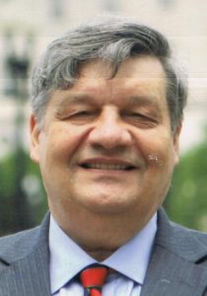
Andrew Kreig is longtime high-tech executive, global strategist, attorney, reporter and author currently focused on providing audiences with tools for better living. Author of two books, he currently directs the non-partisan Justice Integrity Project and serves on several boards of civic organizations after a long career in high-tech and law.

Robert Steele: 9/11, Domestic False Flag Operations, and Your Legacy
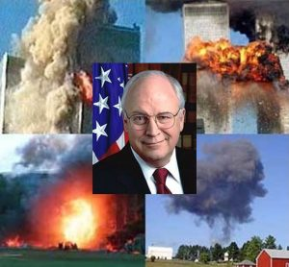
Mr. President,
The public needs to understand the truth about 9/11 and all of the follow-on domestic false flag operations organized by the Federal Emergency Management Agency (FEMA) as part of the larger police state / anti-gun agenda. The National Rifle Association (NRA), one of your strongest allies from the early days of your campaign, should be fully engaged as you continue to defend the Second Amendment.
Talking Points for the Public
01 False flag attacks originated in maritime warfare, where both pirates and conventional naval ships would fly the flag of their enemy so as to get close enough for a surprise attack. The USA has always excelled at wars based on lies (Spanish-American War, Mexican-American War) but actively embraced false flag operations when Ed Lansdale found how easy it was to fake guerrilla movements in order to elevate a CIA-controlled Army captain (Ramos) to the presidency. Since then false flag events have been a staple of CIA covert operations. I myself have managed a modest false flag operation for CIA.
02 9/11 was conceived by Israel, logistically-supported by Saudi Arabia, and both allowed to happen and made to happen under the direction of then Vice President Dick Cheney. Both the CIA under George Tenet and the FBI under Louis Freeh, Thomas Pickard, and Robert Mueller obstructed justice and conspired to shut down all early warnings such as ABLE DANGER, and then cover up the truth of 9/11.
03 Thirteen countries warned us months in advance of 9/11 – then Vice President Dick Cheney demanded they all keep their warnings secret, and months in advance of 9/11 scheduled a national counterterrorism exercise that would allow him to control the day. He moved the East Coast strip alert aircraft to Alaska, the FEMA command center was set up on the piers of NYC the night before, the evidence of how he contrived to execute 9/11 to justify foreign wars is voluminous, just hushed up.
04 In addition to its purpose in justifying a US invasion of Afghanistan to revive the drug crop and Iraq to control the oil fields, 9/11 was used to covertly liquidate $240 billion in gold assets that had been used to wage a Gold War against Russia from 1998-2000, under the day-to-day direction of Buzzy Krongard.
05 The first to question the official narrative were the Families of 9/11, some of whom had the integrity to refuse government “hush money.” Subsequently under the leadership of Richard Gage, Architects & Engineers for 9/11 Truth have completely demolished the false government narrative.
06 The false government narrative succeeded only because the mainstream media – including Fox News – was complicit in what has become the legal propagandization of the American public, and the success of what some call #GoogleGestapo at repressing Alternative Media views, especially conservative views.
07 Most if not all mass casualty events since 9/11, notably the Boston Bombing, Sandy Hook, Orlando, San Bernardino, and Las Vegas, have been false flag events. Those that actually died were patsies. The fastest way to de-legitimize the anti-gun agenda is to disclose the truth to the public about these events.
08 There are many people who can answer any questions you have, extemporaneously: Richard Gage, Webster Tarpley, James Fetzer, and Christopher Bollyn come to mind. Your advisors will tell you they are liars. Not so. A wealth of detail is available online at 9/11 @ Phi Beta Iota.
09 If you demand the disclosure of the truth, and then create a Trump Truth channel able to engage 200 million US voters directly – a two-way channel – you will Make America Great Again. The truth at any cost lowers all other costs. Throw in the Election Reform Act to give #WalkAway Democrats some options, and you win YUGE.
Very respectfully,
Robert David Steele
DOC (1 Page): 911 POTUS Steele Overview Domestic False Flag
Robert David Steele is a former Marine Corps infantry officer and CIA spy who was recommended for the Nobel Peace Prize in 2017. A published author with many books on intelligence and election reform, some with forewords by US Senators and Congressmen, he is also the top English-language reviewer for non-fiction books, with over 2,500 substantive reviews posted across 98 categories of reading. Today the CeO of Earth Intelligence Network (non-profit) and Open Source Everything, Inc. (for profit), he is committed to creating a truth channel that cannot be censored, manipulated, or used to digitally assassinate conservative or progressive voices. He is the founder of #UNRIG, and also a Commissioner and the Chief Counsel for the Judicial Commission of Inquiry into Human Trafficking and Child Sex Abuse of the International Tribunal for Natural Justice.

Who? Who Planned and Executed and Covered-Up 9/11?

Christopher Bollyn: 9/11 - Israel’s History of False Flag Operations against the U.S.A.*
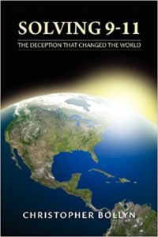
“We have spent $7 trillion – trillion with a T – $7 trillion in the Middle East. You know what we have for it? Nothing. Nothing.”
– President Donald Trump, April 28, 2018
Mr. President,
As you said very clearly, the United States is bogged down in a costly quagmire in the Middle East, engaged in covert military operations in countries where there is no real U.S. interest. We have gained nothing from 17 years of war in which untold thousands have been killed or maimed and entire nations have been devastated. Our Middle East policy is disastrous and must be changed. If we don’t change our policy we can only expect more of the same – millions more refugees, thousands more dead, trillions more wasted.
In order to correct our policy we need to understand who got us into this mess in the first place. The 9/11 event as a false flag operation and the War on Terror campaign were both conceived by Israeli military intelligence in the 1970s under the leadership of Menachem Begin, the self-proclaimed “Father of Terrorism” and founder of the Likud party who became prime minister in 1977. War on Terror doctrine was rolled out in July 1979 at a Netanyahu Institute conference in Jerusalem. The Israeli trick was to get the U.S. military to neutralize and fragment its enemies, most notably Iraq and Syria, under the pretext of fighting terrorism. Since 1979, this devious plan has been openly promoted by Benjamin Netanyahu. On 9/11, War on Terror proponent Netanyahu told the New York Times that the terror atrocity was “very good” for U.S.-Israeli relations.
The Israelis have a long history of using false-flag terrorism against the United States:
1954 JUL – The Lavon Affair: Israeli agents place bombs in U.S. and British libraries and institutions in Egypt in a false-flag operation meant to be blamed on the Muslim Brotherhood.
1967 JUN – Israeli aircraft and ships attack the defenseless USS Liberty, killing 34 and wounding 171, with the intention of sinking the ship – with no survivors – so that the blame could be assigned to Egypt.
1983 OCT – A truck bomb kills 241 Marines in their barracks in Beirut. Former Mossad agent Victor Ostrovsky says Mossad knew the details of the truck, the time, and location of the bombing, but only gave a general warning to the Americans. A nebulous “Islamic Jihad” group is blamed; Defense Secretary Caspar Weinberger says U.S. has no knowledge who really did the bombing. This occurred one month after a single Marine stopped an Israeli tank column – some former Marines believe Israel organized the attack.
1986 FEB – Mossad plants a radio relay device in an apartment in Tripoli, Libya, to send fake messages that appear to be from the Libyan government; U.S. intelligence is successfully tricked and President Reagan orders bombing of Libya.
1978 – Israeli agent Arnon Milchan‘s first film features a Boeing 747 crashing into the PanAm building. Months before 9/11 produces a film episode in which remote controlled airplanes hit buildings.
1979 JUL – Netanyahu Institute hosts conference on terrorism calling for U.S. military intervention in Middle East.
1979 – Isser Harel, founding chief of Israeli intelligence, predicts 9/11 attacks in New York City.
1982 FEB– Israeli Likud strategist Oded Yinon plan calls for the “dissolution of Syria and Iraq” and Balkanization of all Arab states.
1983 – Israel creates foe for War on Terror: Under Ehud Barak, Israeli military intelligence (AMAN) begins arming and training anti-Western Hezb-i-Islami terrorists in Pakistan, including Osama bin Laden.
1987 – Two of Isser Harel’s senior Mossad agents, Avraham Shalom Bendor and Zvi Malkin, get the security contract for World Trade Center; Port Authority cancels the contract when their criminal history is discovered.
1990 – Rejected by Port Authority due to criminal conviction in Israel, Shalom Bendor goes to work for Jules Kroll.
1993 FEB – Zionists manage prosecution of WTC bombing: Israeli-American Michael Chertoff, U.S. Attorney for New Jersey, plays key role in prosecution. Zionist Judge Michael Mukasey presides over case against “Blind Sheikh.” FBI informant Emad Salem is paid one million dollars for his testimony. Media leads public to believe that Muslims want to destroy the Twin Towers.
1993 – After first WTC bombing Kroll Associates gets security contract for the Port Authority and the WTC.
1994 – After losing Saudi and Pakistani support, the Israeli-trained “remainder of Hezb-i-Islami merges into al-Qaeda and the Taliban.”
1998 DEC – Philip Zelikow’s Catastrophic Terrorism Study Group publishes report “Imagining Transforming Event” in Foreign Affairs (CFR). Co-authors Ashton Carter and John Deutch work for Global Technology Partners, an exclusive affiliate of Rothschild N.A.
1999 – Hugo Neu creates a global trading division headed by two veteran ferrous metal traders from Marc Rich and Glencore AG in Switzerland. A lot of expense and effort is spent to prepare a network to export scrap iron to Asia while its price is at the lowest level in 50 years. Hugo Neu and the state share the costs of dredging the Claremont channel to allow large ocean-going ships to Asia.
2000 SEP – A Neo-Con group, Project for the New American Century (PNAC) suggests that “a catastrophic and catalyzing event – like a new Pearl Harbor” may be necessary to facilitate “the process of transformation” they call for in U.S. military policy. Ten signers of the PNAC document, including Dick Cheney, were in senior positions of the Bush administration in 2001.
2001 – Israeli Mossad company ICTS controls security screening at U.S. Airports on 9/11. Directors include Yair Shamir, son of notorious Israeli terrorist Yitzhak Shamir.
2001 – Israeli intelligence creates false histories for alleged hijackers. Israeli spies posing as “art students” live near hijacker patsies. Duplicate documents are used to create false histories, standard procedure for Mossad false-flag operations.
2001 – Ronald Lauder manages Governor George Pataki’s privatization scheme which includes WTC property. Lauder funds Lauder School of Government, Diplomacy and Strategy at Mossad center (IDC) where Israeli Major General Daniel Rothschild heads Institute for Policy and Strategy.
2001 JUL 24 – Larry Silverstein gets lease for World Trade Center. Silverstein obtains lease thru fellow Zionist agent Lew Eisenberg, chairman of the Port Authority. Silverstein and Eisenberg are both members of UJA board, major Zionist fundraising organization. Since 1996, Silverstein has close contact with Netanyahu; every Sunday afternoon Netanyahu calls Silverstein. Silverstein immediately raises rents by 40% for the few tenants he has.
2001 SEP 11 – Ehud Olmert, Israel’s deputy prime minister, is on an unreported visit in New York City. Why is it secret? While all civilian planes are grounded, at 4:11 p.m. an El Al Boeing 747 takes off from JFK bound for Tel Aviv. The flight is authorized by the direct intervention of the U.S. Department of Defense.
9/11 – Alex Brown, a firm with ties to Israeli military intelligence and Yair Shamir’s company Scitex has many of the suspicious “put” options. “Buzzy” Krongard, executive director of the CIA, headed AB until 1998. His wife works for Rothschild Asset Management.
9/11 – Israeli government receives the names of 4,000 Israelis believed to be in the area of the WTC or Pentagon on 9/11. Odigo, an Israeli messaging company, is used to send warning several hours before attacks. Four Israelis die at WTC.
9/11 – Five Israelis working for Urban Moving Systems are arrested on 9/11 after being seen photographing and celebrating the attack on the WTC. The fake moving company is later found to be a front for the Mossad. Two of the Israelis are known Mossad.
9/11 – Israeli military chief Ehud Barak interprets 9/11 on BBC and Sky News in London, blaming Osama bin Laden and calling for U.S. to “launch an operational, concrete, war against terror.” Barak is Netanyahu’s commander in the Sayeret Matkal, a covert commando force of Israeli military intelligence. Other Israeli commandos (e.g. Daniel Lewin) are involved in 9/11. Bin Laden denies responsibility for 9/11.
9/11 – Netanyahu praises 9/11 atrocity to NYT: “It’s very good… it will generate immediate sympathy.” In 2008, he says in Israel: “We are benefiting from one thing, and that is the attack on the Twin Towers and Pentagon, and the American struggle in Iraq.”
9/11 – An Israeli controls 9-11 investigation. John Ashcroft puts Israeli dual-national Michael Chertoff in charge of 9/11 investigation. “For day-to-day decisions, Chertoff has the last word.” Destruction of crucial evidence begins immediately.
9/11 – Two Zionist-owned junkyards manage hasty destruction and exportation of evidence using large ships bound for Asia able to load at Hugo Neu because the Claremont Channel has been dredged since 1999.
Post 9/11 – Zionist with conflict of interest presides over 9/11 lawsuit: Judge Alvin Hellerstein manages 9-11 tort litigation, while his son is lawyer in Israel with firm that represents ICTS, key defendant in 9/11 litigation. Hellerstein dismisses ICTS and every 9/11 case is settled out of court.
Post 9/11 – Zionists manage compensation funds: Kenneth Feinberg and Sheila Birnbaum oversee compensation settlements for 9/11 families. Not a single case goes to trial. No 9/11 discovery occurs in court.
2003 MAR – Zionists control 9/11 myth: Appointed director of 9/11 Commission, Philip Zelikow frames the agenda and decides what evidence the commission sees. A specialist in “public myths,” Zelikow comes to commission with complete outline of report – before staff even begins working.
Until 2011 – Israelis construct 9/11 memorial and legacy: WTC memorial is designed by Israeli Michael Arad, son of Moshe Arad, former Israeli ambassador to the United States.
Until today – Controlled media ignores crucial 9/11 questions and evidence. Media pushes false narrative about 9/11 and the War on Terror while ignoring evidence that disproves the official myth.
Very respectfully,
Christopher Bollyn
*Also Published As: Christopher Bollyn, “9/11 and the War on Terror: Israel’s History of False Flag Operations against the U.S.A.” American Herald Tribune, 7 July 2018.
DOC (3 Pages): 911 POTUS Bollyn Zionist Timeline & Names
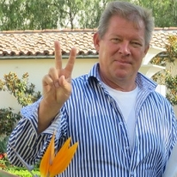
Christopher Bollyn is an American investigative journalist. He is the author of the Solving 9-11 set of books and The War on Terror: The Plot to Rule the Middle East (2017). He has a degree in history from the University of California at Santa Cruz with his focus on Israel and Palestine. He has written extensively about the Middle East, electronic vote fraud, the dangers of depleted uranium, and the history and geo-political background of the terror attacks of September 11, 2001. He has spoken about 9-11 in America and Europe and done several speaking tours across the United States.

Victor Thorn: The Zionist Role in Planning, Funding, and Controlling 9/11
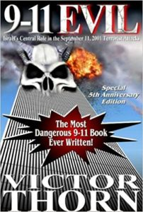
Mr. President,
In his book, 9-11 Evil: Israel’s Central Role in the September 11, 2001 Terrorist Attacks, Victor Thorn points his finger at the one entity that most other authors (even in the so-called 9-11 truth movement) prefer not to even mention: Israel.
Thorn makes a convincing case that Israel-firsters were responsible for the mysterious Pentagon stand-down that allowed the attack on America to proceed. Thorn also contends that Zionists infiltrated Air Force One and threatened President Bush on the morning of September 11, 2001 with electronic capabilities even more sophisticated than those of the NSA. Many patriots, who rightly dismiss the impossible official 9-11 explanation as a mere conspiracy theory, alas, are convinced that the real 9-11 plot was hatched with the selection or election of George W. Bush in 2000. In reality, writes Thorn, it is an integral part of a Zionist cluster of conspiracies going back at least to the 1960s, and Bush is merely a puppet playing his small part in the overall scheme.
In one gem from the book, the authors point out that a series of power-downs occurred in the WTC towers on the weekend prior to 9-11. With the electricity knocked out, the security cameras, electric locks and other security devices were disabled. This means an ideal opportunity existed for agents to go through the buildings, planting bombs. Thorn says the evidence for this comes from the statements of Scott Forbes, a computer analyst for WTC occupant Fiduciary Trust. Thorn adds that the first suspects arrested within hours of the attack were the Dancing Israelis, the Israelis on the roof of the buildings who were seen laughing and pointing to the WTC as it was falling. The man who eventually freed them was Michael Chertoff, whose family was involved in the creation of the state of Israel. Also involved is a demented wealthy-beyond-wealthy rabbi, Dov Zakheim, say Thorn and Giuliani. Zakheim, they tell us, is the man who filched more than $2 trillion (yes, that’s trillion) from the Pentagon, making him the biggest thief in history. Zakheim, former comptroller in the Office of the Undersecretary of Defense, was one of the architects, along with some other rabid Zionists, of a document called Rebuilding America s Defenses: Strategy, Forces and Resources for a New Century, published by the Project for a New American Century. This document, which has been dubbed the blueprint for the 9-11 attack, called for some catastrophic and catalyzing event like a new Pearl Harbor as being necessary to foster the frame of mind needed for the American public to finance and die in a war in the Middle East that would politically reshape the region for the benefit of Israel and Zionists in power in the United States.
Israeli firms were in charge of security at the WTC and airports on 9-11, writes Thorn. The media involved in covering everything up is dominated by Zionists. The lease on the World Trade Center complex had been purchased not long before the attack by Larry Silverstein, a Zionist, whose mortgage holder in turn was a Zionist. Silverstein had direct ties to two of Israel s most hawkish prime ministers: Ariel Sharon and Benjamin Netanyahu. The man who arranged the deal was a Zionist, plus the CEO of the Blackstone Group, which was heavily involved, was a Zionist. After reading 9-11 Evil which is dedicated to AFP correspondent Mike Piper it is hard to deny Israel s involvement in this act of state-sponsored terrorism. Thorn offers a crescendo of evidence demonstrating that 9-11 was not only an inside job executed by Israeli-loyal neo-cons within the U.S –John Tiffany – American Free Press, as published at Amazon.com.
Victor Thorn (RIP) via John Tiffany, Amazon Reviewer
Victor Thorn, 9-11 EVIL: Israel’s Central Role in the September 11, 2001 Terrorist Attacks (Sisyphus, 2006)
Robert Steele: The major failure of this book is its lack of attention to the role of Dick Cheney as the central figure enabling Zionist hijacking of all aspects of the US Government necessary to both allow 9/11 to happen, and make 9/11 happen to their specifications. 6 July 2018
DOC (1 Page): 911 POTUS Thorn Zionist General

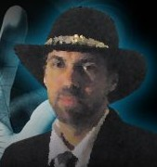
Victor Thorn is now deceased, allegedly a suicide. Thorn wrote for the American Free Press and was the author of books on the Clintons, including the trilogy Hillary (And Bill): The Sex Volume, Hillary (And Bill): The Drugs Volume, and Hillary (And Bill): The Murder Volume, as well as Crowning Clinton: Why Hillary Shouldn’t Be in the White House.
Thorn also penned volumes about the “entire holohoax industry,” such as The Holocaust Hoax Exposed and works such as 9-11 EVIL: Israel’s Central Role in the September 11, 2001 Terrorist Attacks and Made in Israel. In addition, he authored New World Order Assassins.

Steve De’ak: 9/11 Who Knew What When? The New York City Cover-Up…
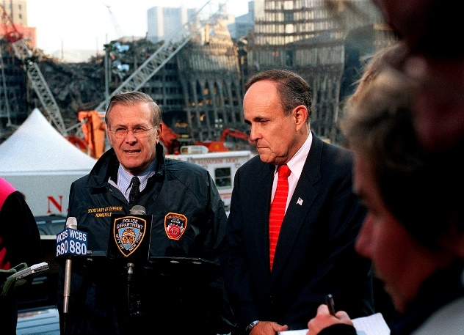
When plunder becomes a way of life for a group of men living together in society, they create for themselves in the course of time a legal system that authorizes it and a moral code that glorifies it.
–Frederic Bastiat
Mr. President,
After the WTC opened in 1973, it took less than twenty years for the owners – the Port Authority of New York and New Jersey (PANYNJ) – to realize that for the sake of the safety of everyone in the area, by 2007 the WTC would need to be dismantled. The decision to “privatize” the WTC – i.e. to convey that cost and risk to others – was made in 1998. It is highly unlikely that any responsible purchaser – much less an original builder – Larry Silverstein – would be unaware of the fact that the buildings had been condemned. Just over six months before 9/11 a bid was awarded to Vornado, which appears to have overbid by $600 million; their conditional bid with demands was rescinded, and the WTC was sold to Larry Silverstein on 26 April 2001, closing on 24 July 2001. It is beyond the realm of possibility to contemplate that everything that needed to be done to bring down all three buildings on 9/11 2001 was done in forty-seven (47) days.
An operation the size of 9/11 could only have occurred after years of planning, therefore a genuine investigation must start at the beginning. The WTC was conceived in the euphoria of the post-World War II years, with negotiations beginning during the “Camelot” period of the Kennedy administration; a time of growth and optimism. Nonetheless, the project was fiercely fought by local businesses and residents. International trade organizations already had well-established infrastructure and international trade accounted for only a small percentage of the Gross Domestic Product anyway, making it a tough sell to convince the City of New York it needed a new World Trade Center, and the legal fight dragged on for years.
Eventually after enough money had traded hands the Rockefellers and the PANYNJ won the court battles forcing out all the small-time businesses and residents in the construction zone, but the public outcry had cost them years in delays and by then it must have been obvious public support would be tenuous at best. By the time the first jackhammers began rattling the pavement in 1966 the PANYNJ had overstayed its welcome with the local crowd, and thanks to the war in Vietnam, corruption in Washington, and a slipping economy, the national mood was turning sour too. Since the end of WWII New York and been in the middle of an historic construction boom so the WTC must have seemed like a good idea at the time of conception, but as it was nearing completion the commercial real estate vacancy rates were reaching levels not seen since the Depression, largely blamed on overbuilding during the boom.
Corruption is the name of the game in the New York construction industry, as it is in every big and little city, therefore every construction project is subject to Mob-controlled labor, and the WTC was no exception. Every bridge, building, tunnel and airport was built with Mob-surcharges financed into the project and eventually paid for by the public.
The corruption of the PANYNJ has been making recent headlines but there’s nothing new about any of it, therefore an appropriate investigation of 9/11 would include a thorough investigation of the PANYNJ and the contractors involved with the construction of the WTC, specifically the concrete contractor Colonial Sand and Stone, from New Jersey. Colonial was run by the Pope family of New Jersey with connections to the Mob, to the media (they gave us The National Enquirer) and to the CIA. They were credited with pouring all 10,000,000 sq. ft. of concrete that the PANYNJ claims was at the WTC at the time of demolition.
The WTC was anything BUT a “Modern Marvel” as it was so advertised, with the Twin Towers being nothing more than poorly-built, snap-together tourist traps (think Eiffel Tower) that were admitted marketing gimmicks to lure-in new tenants. They were heavily advertised from the beginning as impressive feats of engineering but as can be seen in their architectural drawings, and not to mention their collapse videos, all it took was the right leverage to bring those buildings down. A proper investigation of what could have done such a thing would begin by verifying they were not everything they were touted to be, occupancy levels and all. Investigating whether or not all floors were installed and built-out (with electrical, HVAC, plumbing, etc.) on 9/11 would go a long way towards answering how they were demolished, so a complete investigation of the PANYNJ’s construction records, tenant occupancy, and a detailed financial history of all major stakeholders is necessary.
As you march through history you’ll find that Minoru Yamasaki, architect of the WTC, had deep ties to the defense industry and to the CIA, not to mention to the bin Laden family in Saudi Arabia. Investigations should also include the possibility that the towers were built to be destroyed. From the beginning it was known that they were dangerous fire hazards, and in the late 1980s it was leaked that the Twin Towers were real estate duds; White Elephants of which the aluminum cladding was in danger of falling off due to galvanic corrosion. Rumors were that the EPA wouldn’t allow to be demolished thanks to the asbestos fire retardant that had been sprayed on 60% of the steel in the North Tower. Besides, they were just too big. The fear was that the Twin Towers were gigantic asbestos bombs; therefore they could not be demolished; they would need to be dismantled at a higher cost than it took to build them. If I had the full power of the FBI at my disposal I would have them pay special attention to contractors who built the towers, and what plans were being made in the 1980s and early 1990’s to demolish them.
If demolition was indeed already decided-upon in the 1980s then the building owners would need to begin clearing out tenants, if for no other reason than to get access to the structural members of the buildings. The inter-office FBI memos during this time period surely have some interesting discussions that can shed light on the covert demolition of the WTC, and how the USA could benefit from the event. The intelligence services are expert at propping up patsies for their covert operations and it would help the investigation to verify whether or not they were working on setting up a patsy-nation, such as Afghanistan.
Once the Soviets invaded Afghanistan in 1979 the CIA immediately began arming anyone willing to fight them. After the Soviets were ousted that left the then well-armed extremists in charge, which brings us to Osama bin Laden. 1979 was also when the CIA allowed their puppet, The Shah of Iran, to be overthrown, losing control to the Mullahs. That same year El Salvador and Nicaragua erupted. Not long after that the Iran-Contra scandal shocked the nation with the CIA exposed as a global drug-smuggling/gun-running ring that imported cocaine into Mena, Arkansas destined for the U.S. market in exchange for unmarked guns destined for the Contras in Nicaragua. George H. W. Bush, ex-director of the CIA, was the Vice President of the United States and Bill Clinton was the Governor of Arkansas during this period. Researching the black-funds that fuel the Bushes, Clintons and the CIA is a critical step in this investigation, and the Contra drugs-for-guns scandal is just one example.
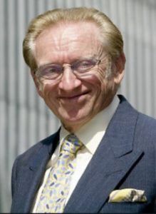
It was in 1987 that developer Larry Silverstein built the original WTC7, proving he was an inside man all along. If in 1989 the PANYNJ had been working on the problem of how to dispose of the WTC Twin Towers, then Silverstein was definitely aware of that before he built his building. In this light his “pull it” comment was almost certainly not a gaffe; 9/11 is like a Frank Herbert novel, with “plots within plots within plots.” To peel apart the layers of plots that comprise the 9/11 conspiracy, the investigation should dig deeply into Silverstein, designer Emery Roth & Sons, Tishman Reality & Construction, and since it was situated on top of a Con-Edison substation, Con-Ed should be included, as should Rudy Giuliani and his emergency command center leadership and his varied city inspectors and buildings archivists, Solomon Smith Barney, and other tenants. WTC7 collapse videos depict a classic implosion, therefore any legitimate tenants should be considered suspect as having knowledge of the planting of demolition charges.
The 1980’s ended with George H. W. Bush as president, but the 1990’s were all about Clinton, which was really all about continuity. HW had been in power as either vice president or president for 12 years and with Clinton in office he continued his meddling power behind the throne. During the 1990s, the planning for 9/11 appears to have occurred, with the bombing in 1993 being the “go-live” date when the PANYNJ probably bombed themselves as a way to force-out any remaining tenants only to be replaced with all the big-name firms that collected tens of billions from the 9/11 Victims Compensation funds. This bombing also set the stage for the WTC as being a target for Muslim extremists, providing a pretext for blaming Bin Laden specifically (he denied it) and Muslims generally, for 9/11. A complete investigation of the 1993 bombing and the ensuing repair work is crucial to understanding what happened on 9/11. That should be followed by exhaustive research into the tenants that filled-up the towers after that bombing and in the immediate aftermath of Larry Silverstein raising rents by 40%.
A little known fact about the Twin Towers was that they were built with a centrally controlled lighting system; something that annoyed the tenants because at a time when the country was trying to save energy by turning off unneeded lights they had to pay extra to install light switches that would allow them to do so. In 1995 Ogden Entertainment beat-out 11 other competitors for the entertainment contract for the WTC, and promptly invested millions in updated light shows. Ogden is more than just an entertainment firm though, conveniently enough they also do hazardous waste cleanup for the DoD. If anyone can shed some light into what preparations for 9/11 it would be the people who were working for Ogden in the latter years of the millennium.
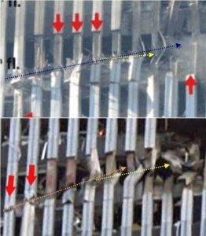
In the year 2000 Clinton passed the torch to Bush II and the rest is history. Other researchers have focused on the collapses, the money trail, reports of missing gold, and targeted offices within the Pentagon and the WTC, but an often underappreciated line of investigation is the evidence at the scene of the crime; the holes in the WTC.
A final suggestion to the investigative team is to examine the impact holes to the north and south towers, specifically the first nine columns from the left. In doing so you will find almost identical damage beginning with lightly-damaged (bent and scored) aluminum sheeting, followed by progressively worse-damaged steel bent in a completely different direction than the television plane was traveling, and on the ninth columns; inward-blasting holes that were nowhere near where the engine allegedly impacted. Solving the question of what caused this damage will answer who the most likely suspects are.
Investigating 9/11 is a gigantic task, but one that is long overdue and also something you promised during your campaign. Independent researchers with no access to classified information have been conducting their own investigations of the evidence available in the public domain, and although we all have different conclusions for what did happen, we all pretty-much agree that the official story is an abject lie.
In my opinion the clues mentioned above point to 9/11 being run not just from the pinnacle of power in the USA, but from any nation not calling it for what it was; a false flag operation. Surely the Chinese, Russian, Iraqi, North Korean and Iranian leaders, military minds and critical thinkers know the official story of 9/11 cannot be true and they allegedly have every reason for exposing it. But they don’t do that. This is not proof that the official story is true, but it is evidence of collusion at a level the public is not privy to. I can only assume this is because the Russians need an enemy to justify their actions just as badly as NATO needs an enemy to justify theirs, and the leaders have more in common with each other than they do with the people. Is it possible that during the recent Helsinki conference President Putin shared with you his understanding of who was responsible for 9/11 and how they did it?
If as the evidence indicates the most likely suspects are the people who control the world’s media, military, governments and academia, then it stands to reason that to prevent their being exposed they would use those tools to salt the well of information, muddy the waters, and ignore those clues that can expose them. Controlling the cover up is at least as important as the event itself. Sorting through all the misdirection and outright lies has been a challenge but if private citizens can accomplish so much on their own, the Government can do so much more.
9/11 affects all of our lives all the time but it has never been honestly investigated. If you do mandate a new investigation, I urge you to make it completely open to and accessible by the public – indeed, you may find that We the People have your back – we have done more to expose the cover-up of 9/11 than all of your official federal agencies combined, all of whom have been complicit in the 9/11 cover-up, without exception.
Very respectfully,
Steve De’ak
Reference sites:
http://yankee451.info
http://911crashtest.org
DOC (5 Pages): 911 POTUS Deak WTC Historical
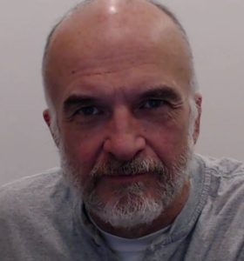
Steve De’ak has been investigating 9/11 from a layman’s perspective for a dozen years. His research can be found at http://yankee451.info. Tired of the infighting in the 9/11 truth movement and as a way to galvanize the resistance under one banner, in 2012 he began a peace project he calls 9/11 Crash Test (http://911crashtest.org) Steve has 57 years under his belt, works full-time in Information Technology and since 2014 has been building a house with his wife in Washington State.

Nicholas Kollerstrom: 9/11 an Inside Job, Osama Bin Laden Framed, FBI Aware
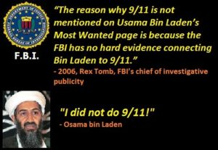
Mr. President,
Osama Bin Laden had nothing to do with 9/11. He died on or about 15 December 2001 after first denouncing the attack as the work of others, and then offering to turn himself in for trial outside the USA (the Taliban offered to turn him over to the USA provided evidence was produced with respect to his alleged culpability, none was forthcoming).
The last months of Bin Laden’s life, July to December, are of world-historical importance. In July 2001 he was residing for a week in an American hospital in Dubai to treat his kidney trouble, as reported by the French paper Le Figaro. He had an operation on the 4th. This story was reported in Le Monde and the Guardian on the 1st of November but denied by the CIA yet also reported by John Snow on Channel 4 News. Snow first confirmed the story with the British doctor in Dubai who treated Bin Laden: source Martin Summers, of the London 9/11 Sceptics and he there met CIA station chief Larry Mitchell on 12th of July. Many members of the Bin Laden family came to visit him – ‘There goes the story that he’s a black sheep!’ was Mike Ruppert’s laconic comment. He flew off on the 14th in a private jet. We do not hear about Bin Laden him again until September 10th, when he reappears in a military hospital in Rawalpindi in Pakistan – with some military protection – again for kidney dialysis (Nafeez Ahmed, The War on Freedom, How and Why America was Attacked September 11, 2001, 2002, p.223; Thierry Meyssan, 9/11 The big Lie, 2002, p. 107.)
On September 12th a Pakistani newspaper reported OBL’s first denial that he had been involved in the event of 9/11, then on the 16th OBL’s assistant Abdul Samad faxed a message to the Afghan Islamic Press (in Islamabad, Pakistan) that was broadcast by al-Jazeera in Qatar. In it OBL declared, ‘I categorically state that I have not done this,’ adding that he had an agreement with Mohammed Omar, chief Mullah of the Taliban in Afghanistan, that prohibited his involvement in such political activity. A week later, on 22nd September, he gave a longer set of replies to questions from the Pakistani newspaper ‘Ummaut’:
“I was not involved in the September 11 attacks in the United States nor did I have knowledge of the attacks. There exists a government within a government within the United States. The United States should try to trace the perpetrators of these attacks within itself; to the people who want to make the present century a century of conflict between Islam and Christianity. That secret government must be asked as to who carried out the attacks…. The American system is totally in the control of the Jews, whose first priority is Israel, not the United States … I have already said that we are not hostile to the United States. We are against the system, which makes other nations slaves of the United States, or forces them to mortgage their political and economic freedom.”
It is my view that the designation by US intelligence of Osama Bin Laden as the culprit is completely fabricated – as fabricated as the current US intelligence claims that the Russians hacked the election – and that this is one of many elements that a new independent investigation could address.
Very respectfully,
Nicholas Kollerstrom
Reference: Nicholas Kollerstrom, “Osama Bin Laden, 1957-2001,” James Fetzer Blogspot, 6 May 2011.
DOC (1 Page): 911 POTUS Kollerstrom Bin Laden Framed

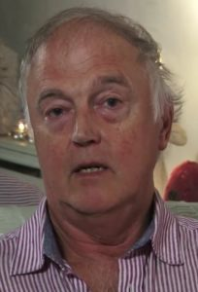
Nicholas Kollerstrom, PhD, is an English author and political activist. An elected fellow of the Royal Astronomical society, he earned his PhD from University College London with a thesis on lunar theory, and has subsequently published on the relationship between the lunar cycle and plant growth. He has also studied and written about lead and other hazards. As an activist he has been a very effective challenger to lies from governments, and founded the Legal Inquiry Steering Group to challenge the legality of the UK involvement in the Iraq War. He has studied and written about false flag terrorist events.

Why? What Exactly Motivated the 9/11 Mass Casualty Event?

Tom-Scott Gordon: 9/11 WTC Towers Condemned Before 9/11, Known to Rudy Giuliani
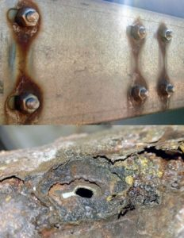
Mr. President,
As early as 1989, it was known to the owners of WTC that the buildings must be brought down before 2007 because the interior steel and exterior aluminum were both compromised and the buildings would be at risk of collapsing — the cost to dismantle them was estimated to be $2B (or more) in 2010 dollars, inclusive of asbestos remediation.
Of particular relevance is the realization that controlled demolitions were not an option because of the health hazards and collateral damage to the entire area that would result. Hence the choice was clear: spend $2B (some estimates are much higher) to take care of the problem; or fake a terrorist incident and in collaboration with a complicit insurance company and the leadership of NYC, take $7B or more in false claims for a contrived event.
The FBI — or Mossad officers pretending to be FBI — appears to have played a major role in the intimidation of all the architects, engineers, and photographers who spent years investigating the vulnerability of the buildings to uncontrolled collapse.
The planning for 9/11 appears to have started in earnest during the presidency of George H. W. Bush, from 1989-1993 at which time Dick Cheney was Secretary of Defense. It is possible the extraordinary attempts to ensure his son (and Vice President Dick Cheney) were elected in 2000 were in part motivated by the need to control the US Government when 9/11 inevitably occurred as planned.
Rudy Giuliani, Mayor of NYC from 1994 to December 2001, is believed to have been fully witting of the condition of the WTC buildings and the need to bring them down at great expense or by others means. None of this has been investigated by the 9/11 Commission.
Emery Roth and Associates, AIA, the Architects of Record, collected, analyzed, and disseminated all knowledge with respect to the condition of the WTC buildings – while they may have destroyed all records, there are over forty (40) living architects and engineers and photographers who can be interrogated under subpoena.
Below are highlights from the reference, an 18-page document based on direct personal participation as a member of the team that fully documented the need to condemn and dismantle the WTC buildings.
The structural integrity of the massive World Trade Center Towers was contingent upon the combined -value of both the internal, perimeter steel columns and the adjoining aluminum Fascia panels. Over the years, the process known as ‘galvanic corrosion‘ had structurally degraded these buildings beyond repair.
Through the continual effects of wind-shear and flex-fatigue this process had eroded the bolt-holds at roughly floors #7 through #25, that fulcrum-point where the lateral pressures were inherently sustained.
Supporting statements to this effect had been compiled, and were presented by the engineers to the building owners. Subsequently, both Mayor Giuliani’s Office, and the New York Port Authority, had allegedly received an order for the buildings to be completely dismantled, by 2007.
There is evidence warranting formal investigation that by the early 1990’s both the City of New York and the Zionist network in the USA, notably the Anti-Defamation League whose leader Stephen Roth bid $750M more than the next lowest bidder for the WTC, then withdrawing his bid to enable Larry Silverstein to buy the properties at an inflated price (setting the stage for a fraudulent insurance valuation while distancing a major Zionist organization from 9/11?).
A major Houston-based beneficiary of 9/11 was Charles Hurwitz, owner of MAXXAM who allegedly used junk bonds to buy Kaiser Aluminum International, an office that received the first-hit. Kaiser’s liabilities for their ‘asbestos’ cases were dropped after the WTC was deemed to have been destroyed by terrorists. Hurwitz was responsible for the demise of United Savings Association of Texas in 1988 (vis-a-vis, Michael Milken).
I note that the Bush Family connections to the security firm controlling WTC have never been properly investigated, which is particularly germane given the probability of prior knowledge if not actual complicity in the planning and execution of 9/11 by George H.W. Bush and Dick Cheney.
Mr. President, you have famously promised to get to the bottom of 9/11 and tell the American people the truth. I hope you mandate a new independent investigation into 9/11, and I urge you to mandate four particular lines of inquiry:
- Interrogation of all surviving engineers at Skillings Associates of Seattle, (Engineers of Record and former occupants of Kaiser Aluminum suite in WTC Tower One,) AND the partnership of architects, engineers and photographers from Emery Roth and Associates, AIA, the Architects of Record for WTC.
- Interrogation of all surviving employees of the Port or Authority and the City of New York – particularly Rudy Giuliani and all those who touched any aspect of the WTC lease, permits, safety inspections and more. Explicitly include the employees of the Department of Buildings who falsely claim that all records for WTC were destroyed at WTC – in fact plans, steel inspections, and more should still be on file.
- Interrogation of all surviving individuals who profited financially from the 9/11 event, including particularly Larry Silverstein, Charles Hurwitz, and all members of the Bush Family who played any role in WTC affairs including security.
- Interrogation of all FBI employees assigned to the FBI’s New York City office from 1989 to 2001, with respect to what was known by whom about the WTC’s condition and plans for its demolition.
Very respectfully,
Tom-Scott Gordon
Reference:
911 inside job (P), “WTC had to be dismantled by 2007 and implosions were ruled out,” Indybay.org, 16 August 2006, inclusive of posts by Tom-Scott Gordon and others.
DOC (2 Page): 911 POTUS Gordon WTC Commercial Insurance Fraud

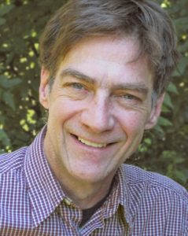
Tom-Scott Gordon has over two decades experience in design and complex architectural photography inclusive of engineering documentation, scale models, aesthetic and landscape perspective, and lifestyle studies. His passion and life-long interest is in organic and regenerative gardening methods culminating in nutrient-dense food. He is actively engaged in community planning, passive and active solar building design and educational partnerships linking local production entities from farm to table.

Fred Burks: Evidence 9/11 Used to Launder $240 Billion in Covert Securities*
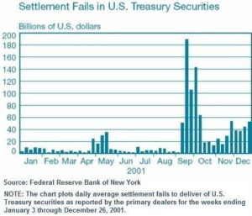
Mr. President,
There is strong evidence that 9/11 was used to facilitate a great financial crime – the laundering of $240 billion in covert securities.
The points below related to this crime are expanded upon in a 59-page white paper by E. P. Heidner, replete with endnotes, titled “Collateral Damage: U.S. Covert Operations and the Terrorist Attacks on September 11, 2001.” I’ve made a ten-page online summary of this important document, which I titled, “The 9/11 Attacks and the Black Eagle Trust Fund.”
The verifiable evidence in this document strongly suggests that 9/11 was used to as a cover-up for financial crimes being investigated by the Office of Naval Intelligence (ONI), whose offices in the Pentagon were destroyed on September 11th. The attacks were intended, at least in part, to cover-up the clearing of $240 billion dollars in securities covertly created in September 1991 to fund a covert economic war against Russia and the Soviet Union, during which ‘unknown’ western investors bought up much of the Soviet industry, with a focus on oil and gas.
On that fateful day, the Securities and Exchange Commission declared a national emergency, and for the first time in U.S. history, invoked its emergency powers under Securities Exchange Act Section 12(k) easing regulatory restrictions for clearing and settling security trades for the next 15 days. These changes would allow an estimated $240 billion in covert government securities to be cleared upon maturity without the standard regulatory controls around identification of ownership.
Evidence suggests the 9/11 attacks also served to derail multiple Federal investigations of crimes associated with this covert operation. Hundreds of billions of dollars of government securities had to be destroyed. A critical mass of brokers from the major government security brokerages in the Twin Towers had to be eliminated to create chaos in the government securities market. A situation needed to be created wherein $240 billion dollars of covert securities could be electronically “cleared” without anyone asking questions – which happened when the Federal Reserve declared an emergency and invoked its “emergency powers” that very afternoon.
Please read or at least skim the 10-page summary on this vital information, which can be verified using the links provided. As you seek to Make America Great Again, I believe that this aspect of 9/11 will be most helpful to you. We are hoping any remarks you make on September 11th this year might reference this information and lead all Americans toward understanding the deeper truths about 9/11 that have been concealed from the larger public.
With very best wishes,
Fred Burks
References:
P. Heidner, “Collateral Damage: U.S. Covert Operations and the Terrorist Attacks on September 11, 2001.”
Summary of the above with the title, “The 9/11 Attacks and the Black Eagle Trust Fund,”
* Also Published As: Fred Burks, “Evidence 9/11 Used to Launder $240 Billion in Covert Securities in a Covert Economic War,” American Herald Tribune, 8 July 2018.
DOC (1): 911 POTUS Burks Gold War on Russia

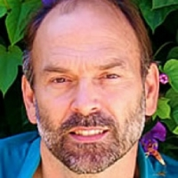
Fred Burks is an activist in an international network of courageous individuals dedicated to transformation toward peace and prosperity for all. During a career as a top interpreter for the US Department of State he participated in secret meetings that opened his eyes to deeper truths. His subsequent research enlightened him with respect to the complicity of rogue elements of intelligence services from around the world in deep state activities, false flag operations, and cover-ups. He serves today as the executive director of the PEERS network of websites and is the manager of WantToKnow.info.

How? How Could A Mass Atrocity in Three Acts Be Carried Out?

Peter Dale Scott: 9/11, Dick Cheney, & The Hijacking of the U.S. Government*
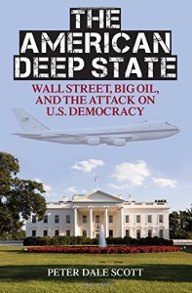
Mr. President,
As I outline in opening The American Deep State, I have been very concerned by the important and increasingly deleterious impact on American history of what I have called deep events: events, like the JFK assassination, the Watergate break-in, or 9/11, which repeatedly involve lawbreaking or violence, are mysterious to begin with, are embedded in ongoing covert processes, have consequences that enlarge covert government, and are subsequently covered up by systematic falsifications in media and internal government records.
One factor linking Dallas, Watergate, and 9/11, has been the involvement in all three deep events of personnel involved in America’s highest-level emergency planning, known since the 1950s as Continuity of Government (COG) planning, or more colloquially inside the Pentagon as “the Doomsday Project.”
The implementation of COG plans on 9/11 was the culmination of decades of such planning, and has resulted in the permanent militarization of the domestic United States, and the imposition at home of institutions and processes designed for domination abroad.
In short, the COG process – the ultra-secret COG process – has been used even against presidents.
Today, in 2018, I believe more strongly than ever that COG planning, or what the Pentagon called “the Doomsday Project,” is demonstrably the key to America’s response to 9/11: above all, Dick Cheney’s orders to President George Bush and Attorney General John Ashcroft to stay out of Washington, until Cheney and his Chief of Staff David Addington had finished implementing the COG plans Cheney and Donald Rumsfeld had helped develop secretly (even when not in the government) over the preceding two decades.
I believe further that those implemented COG plans, so secret that even responsible Congressional committees have been unable to review them, are the key to post-9/11 features of the deep state, such as warrantless surveillance, warrantless detention, and (as noted above), the permanent and perhaps illegal militarization of the domestic United States.
Very respectfully,
Peter Dale Scott
*Also Published As: Peter Dale Scott, “9/11, Dick Cheney and The Hijacking of the U.S. Government,” American Herald Tribune, 12 July 2018.
DOC (1 Page): 911 POTUS Scott COG As Secret Control Network
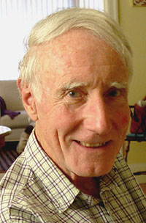
Peter Dales Scott is the original conceptualizer and chronicler of the Deep State (originally he called it Deep Politics) as it manifested itself in the assassination of John F. Kennedy by elements of the US Government, the private sector, and foreign powers. Although trained as a political scientist he has been a professor of English and a poet. Daniel Ellsberg considers his works on the Deep State the most accurate and comprehensive treatment available, making most other books “read like government propaganda written for children.” Kirkus Reviews calls his first book “staggeringly well-researched and intelligent.” He is the “dean” of non-fiction research on the Deep State and the Shadow Government, and particularly on the use of secret channels and capabilities to subvert the president and the normal processes of government.
His Political Science Books:
- The War Conspiracy (1972, OCLC 357579, out of print)
- The Assassinations: Dallas and Beyond (1976, co-editor)
- Crime and Cover-Up: The CIA, the Mafia, and the Dallas-Watergate Connection (1978)
- The Iran-Contra Connection: Secret Teams and Covert Operations in Reagan Era (1987, co-author)
- Cocaine Politics: Drugs, Armies, and the CIA in Central America (1991, 1998, co-author)
- Deep Politics and the Death of JFK (1993, 1996)
- Deep Politics Two: Essays on Oswald, Mexico, and Cuba (1995, 2007)
- Drugs, Oil, and War: The United States in Afghanistan, Columbia, and Indochina (2003)
- The Road to 9/11: Wealth, Empire and the Future of America (2007)
- The War Conspiracy: JFK, 911, and the Deep Politics of War (2008, 2013 reissue and expansion of 1972 edition)
- American War Machine: Deep Politics, the CIA Global Drug Connection, and the Road to Afghanistan (2010, 2014)
- Dallas ’63: The First Deep State Revolt Against The White House (2015, 2018)
- The American Deep State: Big Money, Big Oil, and the Struggle for U.S. Democracy (2017)

Susan Lindauer: CIA’s Advance Knowledge of 9/11 Date Including Nuclear Possibilities*
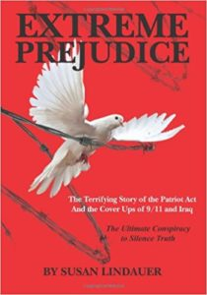
Mr. President,
Though it’s impossible for most Americans to grasp to this day, without question US Intelligence possessed advance knowledge of the 9/11 attack in its precise configuration. Sworn civilian testimony in the Southern District of New York Federal Court in June, 2018 by Dr. Parke Godfrey, professor of Computer Technology at York University in Toronto and Kelly O’Meara former Chief of Staff for GOP Rep. Andrew Forbes of Long Island, has confirmed the following:
- Godfrey testified under oath that in April, 2001, I shared a message from my CIA handler, Dr. Richard Fuisz. In precise detail, I told Godfrey, my closest friend in Washington, that the CIA expected a major terrorist attack involving airplane hijackings and/or airplane bombings to strike the World Trade Center, as a known target in New York. The attack – according to the CIA’s advance knowledge that was shared with me – could possibly include a mini-nuclear device to bring down the Towers. He testified that I told him the attack was expected in late summer or early fall of 2001.
- Godfrey testified that my warnings continued throughout the summer of 2001. In August, I warned the terrorist attack on the World Trade Center was “imminent.” I said his “family should stay out of New York until it was over,” because we expected “mass casualties.” “Thousands would die.” I told him “the attack would finish the cycle started in Iraq.”
- Godfrey testified that he informed the FBI in 2004 about my “highly accurate” 9/11 predictions.
- On 18 June 2008, in covering my appearance in court, the New York Times made no mention of the disclosure to the court of CIA’s advance warnings of 9/11—a significant FAKE NEWS betrayal of the paper’s New York readers. Nevertheless, Godfrey’s earlier testimony under oath makes the timing of the CIA’s advance knowledge of 9/11 irrefutable. The Agency has lost its deniability. Despite so much agitated buzz in the summer of 2001, no action was taken to stop the terrorists. Why? One could of course also ask why the New York Times continues to cover up all of the evidence relevant to 9/11 truth.
- Godfrey did not know, but in April and May, 2001, my CIA handler Dr. Fuisz demanded that I warn Iraqi diplomats in New York that Washington intended to declare War on Iraq if it was discovered that Baghdad possessed intelligence on the attack, but failed to deliver it to us.” He instructed me to use precise language, saying “the threat originated at the highest levels of government– above the Secretary of State and the Director of the CIA.” There are only three such people – President George Bush; Vice President Dick Cheney; and perhaps also Defense Secretary Donald Rumsfeld although he is not in CIA’s chain of command to the President.
Mr. President, I pray that you mandate a new independent commission that will hear the testimony of myself and others with respect to how the CIA chain of command – from me to George Tenet – was aware in advance of the details of 9/11, and very likely complicit in all aspects of 9/11.
Very respectfully,
Susan Lindauer
Reference: Susan Lindauer, Extreme Prejudice: The Terrifying Story of the Patriot Act and the Cover Ups of 9/11 and Iraq (CreateSpace, 2010).
*Also Published As: Susan Lindauer, “CIA's Advance Knowledge of 9/11 Date Including Nuclear Possibilities,” American Herald Tribune, 21 July 2018.
DOC (1 Page): 911 POTUS Lindauer CIA Advance Notice

Susan Lindauer is an American author who has been a journalist and press aide. She is a peace activist. She graduated from Smith College in 1985 and then earned a Master’s degree in public policy from the London School of Economics. Since the publication of her book, Extreme Prejudice, she has appeared regularly on selected television shows and in print media.

Ed Jewett: 9/11 – The Zionist-Rothschild Use of Agents –Carter and Zelikow Particularly
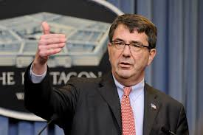
Mr. President,
I wish to do what no one else has done – including the 9/11 Commission – and focus on two personalities in particular, Ashton Carter and Philip Zelikow, both of whom I believe to have been witting agents of the Rothschilds and perhaps witting agents of the Zionist state of Israel. At the end I link to my nine-page analysis, “Ashton Carter – The Rothschild Agent Running the Pentagon,” as published in 2015 and more recently re-posted in support of this letter to you.
A careful study of Ashton Carter’s history suggests that he has been nurtured and cultivated by the Rothschild banking family for decades, to serve their interests. From his selection as a Rhodes Scholar (an estate originally administered by Nathan Rothschild) to his varied roles at Harvard and particularly the Belfer Center (“advised” by Nathaniel Rothschild) to his employment as a senior partner at Global Technology Partners, LLC (acquired by Rothschild North America) to his service as Undersecretary of Defense for Acquisition and then Secretary of Defense where he championed elective wars not approved by Congress, all of which were financially exploited by the Rothschilds, he appears to be at a very minimum a witting agent – an undeclared witting agent – of the Rothschild foreign banking family, and perhaps also a witting agent – an undeclared witting agent – of a foreign power, the Zionist state of Israel.
In 1998, as a senior partner at GTP, Carter co-authored an article with John Deutch and Philip Zelikow entitled “Catastrophic Terrorism: Tackling the New Danger.” Their 1998 Foreign Affairs article actually predicted that the complete destruction of the World Trade Center would give America its “New Pearl Harbor.”
Amazingly, two of the three authors who wrote the article on catastrophic terrorism went on to play key roles in the interpretation of and response to the events of 9-11.
As you may be aware, after the botched 1993 WTC bombing, which was perpetrated by corrupt elements of the FBI, WTC security was “tightened” to the point that the only people with a reasonable shot at even attacking the WTC, much less seriously damaging it, much less demolishing it, were the people who controlled that security apparatus.
Others have shredded the official narrative with respect to the how it all happened. My intent here is to focus your attention on the who. I strongly endorse the memorandum to you by Christopher Bollyn. That memorandum addresses the largely external personalities and the decades-long timeline of Zionist false flag activities and Zionist calls for a catastrophic terrorist event in the USA.
What no one has done is properly investigate Ashton Carter, Philip Zelikow, Larry Silverstein, the executives of the complicit insurance company that paid out without investigation, and the many individuals across New York and within the US Department of Defense, all led by Vice President Dick Cheney, who allowed 9/11 to happen and made 9/11 happen.
Philip Zelikow, Carter’s co-conspirator in foreseeing the 9/11 event, let the cat out of the bag. On September 10th, 2002 – the eve of the first anniversary of 9/11 – Zelikow, speaking to a crowd at the University of Virginia, admitted that the real purpose of the “New Pearl Harbor” was to spur the United States to defend Israel:
“I’ll tell you what I think the real threat [is] and actually has been since 1990 – it’s the threat against Israel. And this is the threat that dare not speak its name, because the Europeans don’t care deeply about that threat, I will tell you frankly. And the American government doesn’t want to lean too hard on it rhetorically, because it is not a popular sell.”
Unlike Philip Zelikow, Ashton Carter is not Jewish. Why would he help orchestrate a “New Pearl Harbor” designed to create a whole-new-world in which the US bankrupts itself, morally and fiscally, by waging permanent war against Israel’s enemies?
The answer appears to be that although Carter is not Jewish, he is a “kosher gentile.” Carter has made a career of serving as token goy in groups of hard-line Jewish Zionists. For example, he is the token goy (alongside kosher co-authors Dennis Ross and Michael Makovsky) behind JINSA’s Carter-Makovsky-Ross Report railing against the Iranian nuclear program.
Ashton Carter is such a close associate of Paul Wolfowitz, the 9/11 mastermind who began working on the New Pearl Harbor project while studying under Leo Strauss in the 1960s, that Carter’s appointment as SecDef has been called “the second coming of Wolfowitz.”
You yourself have pointed out that we have spent trillions in the Middle East and have nothing to show for all that money spent. What you have not yet done is called a spade a spade, and in defense of both an American First national security strategy abroad and American gun-rights at home, come out forcefully on the matter of false flag attacks and how they are being used to manipulate the American public and US national security policy and spending.
The exploitation of America by Zionist Israel is continuing on two fronts during your administration:
- They continue to lie about Iran’s nuclear program while refusing to admit they have a nuclear program ten times larger funded by the US taxpayer; and they are funding terrorist groups and false flag fake Sarin gas attacks to further destabilize Syria; and
- They continue to work with neo-conservative allies and traitors across the US homeland security front, to sponsor false flag school and club shootings in support of the liberal left’s anti-gun agenda.
As you consider your speech to be made on 9/11 2018, I urge you to prepare by mandating a deep investigation, including the pulling of all NSA stored data – emails and telephone calls – for the top two dozen from Dick Cheney to Larry Silverstein to Ashton Carter to Philip Zelikow – and others mentioned in other memorandums especially that by Christopher Bollyn.
I believe you already know the truth of 9/11. I beg of you, lead the American public to the truth of 9/11, and in this way, set America free from the Zionist / Rothschild scourge against all humanity.
Very respectfully,
Ed Jewett
Reference: Edwin Jewett, “Ashton Carter – The Rothschild Agent Running the Pentagon,” Phi Beta Iota Public Intelligence Blog, 10 July 2018; first published 30 October 2015.
DOC (2 Pages): 911 POTUS Jewett Zionist Agents Carter and Zelikow
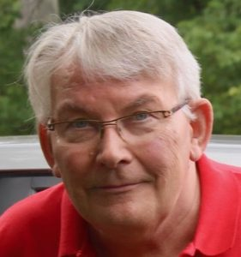
Ed Jewett has spent decades in the Emergency Medical Services (EMS) arena as a technician, instructor, systems planner, regional systems administrator, and as the association executive for a state chapter of emergency physicians, He has done pioneering work in disaster and mass casualty incident management and training including digital simulations. He has edited and written on situational awareness, simulation gaming, and edited a 20-chapter e-book on performance psychology.
See Especially:
Christopher Bollyn: Memorandum for the President: 9/11 and the War on Terror: Israel’s History of False Flag Operations against the U.S.A.

Scott Bennett: Memorandum for the President: How 9/11 Was Funded*
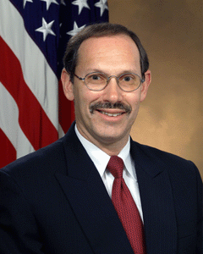
Mr. President,
As a military officer and also contractor for Booz Allen Hamilton, I was assigned to the Joint Interagency Operations Center at U.S. Central Command, where I identified, tracked, and reported on terrorists, their financial donors, networks, banks, and activities.
Part of my mission was to investigate, discover, and expose all acts of “waste, fraud, and abuse” by Terrorist Financing Operations Director Dov Zakheim who was my senior supervisor. It was believed that Dov Zakheim had secretly arranged for $2.3 trillion dollars to be mis-appropriated through Pentagon channels when he had been the Pentagon Comptroller.
I was assigned the task of penetrating Dov Zakheim’s terrorist financing operations, which involved his son Roger Zakheim (a lawyer at the House Armed Services Committee), an Iraqi named Abdullah Azziz (with close ties to Rudy Gulliani) and the law firm Covington and Burling.
The auditors investigating this matter were conveniently killed in a missile strike upon the Pentagon Office of Naval Intelligence on September 11, 2001. This missile strike was concealed as a “plane attack”, which was a deception operation.
I briefed your attorney Michael Cohen about these matters in 2015 and 2016—which may be one of the reasons he has been targeted by Deep State Shadow Government loyalists.
Evidence and expert testimony confirm without a doubt that the attacks on September 11, 2001 against the Pentagon (as well as the World Trade Center and the Solomon Building in N.Y.) were a well-planned, well-financed, psychological operation – a false flag attack on American soil – designed to trigger and manipulate the American people, the Congress, and the U.S. Military into a full-scale war-mobilization posture with the intent of overthrowing, scattering, and re-making the Middle East and Africa for the direct political, cultural, and economic benefit of the Zionist state of Israel.
9/11, although seemingly coherent, has led to a multi-trillion dollar nightmare for Americans. Because of your success in attacking the Deep State with your sealed indictments and other measures, and because of the failure of the DNI-CIA-FBI-DOJ “Russian Hoax” as well as great fear that your forthcoming summit with President Vladimir Putin will be a great success, I fear for your life and pray for your safety.
You are our Chief Law Enforcement Officer, not just our Commander-in-Chief. It is my hope that this memorandum, combined with the other memoranda you are receiving from other informed patriots, will be helpful to you during the Helsinki summit, where I and many others hope that you and President Putin will share intelligence on 9/11 – who did it, how they did it, why they did it – face to face.
I believe that your leadership in placing the truth about 9/11 before the public will finish the job of taking down the Deep State and the Shadow Government – it will help you shut down the pernicious Zionist/Saudi penetration and subversion of the US economy, government, and society and it will help you demonstrate to the larger public, most of whom did not vote for you, that under your leadership, the US Government can be trusted to clean house and tell the truth.
Very respectfully,
Scott Bennett
*Also Published As: Scott Bennett, “How 9/11 Was Funded: The Man behind the Missing $2.3 Trillion,” American Herald Tribune, 11 July 2018.
DOC: (1 Page): 911 POTUS Bennett Zionist Agent Zakheim
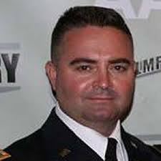
Scott Bennett, a U.S. Army Psychological Operations Officer, worked at U.S. Central Command’s Joint Interagency Operations Center. Bennett was assigned to “Terrorist Threat Financing” and tasked with discovering terrorist financing networks (domestic and foreign), instruments, and bank accounts being used to fund Islamic terrorists, working with multiple U.S. and foreign military and government agencies. He also worked at U.S. Special Operations Command as the Liaison Officer at the State Department Coordinator for Counterterrorism Office, and prior to joining the Army, the Bush Administration from 2003-2008. He has also worked for Booz-Allen-Hamilton. He is the author of Shell Game: A Whistleblowing Report (CreateSpace, 2016).
Web: www.shellgamewhistleblower.com
Phi Beta Iota: Our best guess is that 9/11 only cost $10 billion, inclusive of the $7 billion used to cover the insurance fraud in which the insurance company was assuredly complicit. The rest was simply stolen. Who exactly benefitted remains to be properly investigated. Our operating assumption is that both Dick Cheney and Donald Rumsfeld were a party to the fraud and the theft and should be properly investigated to include a total take-down of all of their communications known to be held in copy within NSA unprocessed databases.

Kevin Barrett: Muslims Were Framed for 9/11 – Fake News MSM Silences Us*
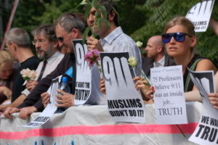
Dear Mr. President,
During your presidential campaign you made some courageous statements about 9/11. You demolished Jeb Bush’s campaign by implying that George W. Bush deserved blame, not praise, for 9/11, which happened while he was president – he did not “keep us safe.” You derided “those people who knocked down the World Trade Center” and said such people wouldn’t have been there if you were president. And most interestingly of all, you told us to elect you so we “will find out who really knocked down the World Trade Center.”
You also made statements that, taken at face value, were egregiously false and libelous. You repeatedly claimed that Muslims danced and celebrated in New Jersey as the Towers came down. As the fake news MSM reported (correctly, for once) that was just not true. But if you had substituted Israelis for Muslims your statement would have been true. A team of Israeli spies was indeed arrested after they were caught wildly celebrating the completion of their successful operation. There is also some evidence, including a police audio tape, that other Israeli operatives were caught red-handed trying to blow up bridges and tunnels in New York on the morning of September 11, 2001.
During the first two years after 9/11, I may have been the only one of the more than 2,000 Muslims in Madison, Wisconsin who did not firmly believe that 9/11 was a false flag operation designed to smear Muslims and Islam. Certainly all of my Muslims friends and acquaintances believed this. Most of them were terrorized into silence by surprise visits from the FBI. It wasn’t until late 2003 that I seriously investigated 9/11 and learned that my co-religionists – and many other Christian and even Jewish 9/11 “truthers,” were right. Muslims were framed for 9/11, with malice aforethought.
Polls show that the vast majority of Muslims, worldwide and in America, knows or suspects that 9/11 was a false flag event. Yet this fact is almost never reported; and articulate Muslims representing the Muslim-majority view of 9/11 are never allowed to make their case in mainstream media, academia, think tanks, or other institutions of power in America or in Europe.
You have said “I think Islam hates us” and tried to ban Muslims from entering the US. These misguided remarks and policies are based on the false and libelous official story of 9/11, and the equally false and libelous official stories of the many other Israeli-sponsored false flag operations that have continued to drive the bogus “war on terror” (i.e. the hoax war that Israel uses to suck blood, treasure, and spirit from the USA).
Right now you are not managing our Middle East policy – and especially our policy toward Zionist apartheid Israel with its massive covert nuclear arsenal funded by the US taxpayer – on the basis of evidence, truth, or even a semblance of respect for the public interest. To your great credit, you have stated that we have gotten nothing for our seven trillion dollars spent in the Middle East. I totally support your view on that.
I beg of you, as a US-born citizen, please keep your campaign promise and make sure the American people find out who really “knocked down” the three World Trade Center towers. One participant, WTC owner Larry Silverstein—a close friend of Benjamin Netanyahu—has already admitted to participation in the demolitions – and briefed his plans for a 2002 re-build a year before 9/11. Please have each of the 103 people on this list http://www.whodidit.org/cocon.html properly investigated, including proper analysis of all stored NSA data on their network of calls and emails in the year prior to 9/11, and give America a chance to know the truth, to be liberated from the Deep State and its Zionist underbelly, to see that you mean it when you say we will find out who really planned, executed, and then covered up the 9/11 atrocity on US soil that murdered over 2,000.
Very respectfully,
Kevin Barrett, PhD
* Also Published As: Kevin Barrett, “Muslims Were Framed For 9/11: Fake News MSM Silences Us,” American Herald Tribune,” 11 July 2018.
DOC (1 Page): 911 POTUS Barrett Muslims Framed

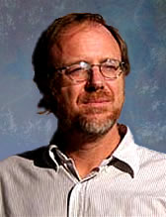
Dr. Kevin Barrett, a Ph.D. Arabist-Islamologist, is one of America’s best-known critics of the War on Terror. He is Host of TRUTH JIHAD RADIO; a hard driving weekly LIVE call in radio show. He also has appeared many times on Fox, CNN, PBS and other broadcast outlets, and has inspired feature stories and op-eds in the New York Times, the Christian Science Monitor, the Chicago Tribune, and other leading publications. Dr. Barrett has taught at colleges and universities in San Francisco, Paris, and Wisconsin, where he ran for Congress in 2008. He currently works as a nonprofit organizer, author, and talk radio host

Richard Gage, AIA: 9/11 Explosive Evidence As Identified by AE911Truth Not Addressed
Mr. President:
When you were campaigning for the presidency in Bluffton, South Carolina, on February 15, 2016, you told voters that under your watch they would “find out who really knocked down the World Trade Center.” And so we implore you, while you are now involved in exposing FBI corruption, to also investigate the agency’s reluctance to examine the explosive destruction of the three World Trade Center skyscrapers—namely, Buildings 1, 2, and 7—on September 11, 2001. As you know, the events of that day are responsible for much of the worldwide carnage that continues to this day. Thus, 9/11 remains an issue of grave importance to the United States of America.
I’m Richard Gage, a San Francisco Bay Area architect of 30 years, member of the American Institute of Architects (AIA), and one of 3,000 members of the non-profit organization Architects & Engineers for 9/11 Truth, which I founded in 2006.
The FBI has been made aware of the gross inadequacies of the investigations into 9/11 that have been carried out over the past seventeen years by various official entities, including the Federal Emergency Management Agency (FEMA), the National Institute of Standards and Technology (NIST), and the 9/11 Commission.
The FBI has also been made aware of the real investigative work being done by AE911Truth. In fact, in 2008 the then-assistant director of the FBI’s Counterterrorism Division, Michael Heimbach, praised our work, noting that it was “backed by thorough research and analysis.”
Yet ten years later, here we are, still with no credible WTC investigation—only a series of missteps and misstatements by FEMA and NIST, which we have documented in our 50-page booklet Beyond Misinformation: What Science Says About the Destruction of World Trade Center Buildings 1, 2, and 7.
When obtaining licensure, architects and engineers commit themselves to upholding their respective profession’s code of ethics. The 3,000 architects and engineers with whom I work are meeting this ethical obligation regarding 9/11: They are challenging the false assumptions and lies that have created an endless “post-9/11 era,” in which $5.6 trillion has been spent by the U.S. government on waging wars and implementing unconstitutional policies.
Here are some of the questions our architects and engineers are asking—questions that remain unanswered and ignored by officialdom to this day:
- How did the elevated building mass of the upper section of each Twin Tower (Buildings 1 and 2) destroy the 80,000 tons of structural steel at nearly free-fall speed, as if the steel framing weren’t even there?
- Given that open-air jet fuel fires burn at only about 600° F. (per manufacturers specifications) and that normal office fires burn at only 1,500° F or so and that the melting point of steel is above 2,700° F, what thermal energy source could have produced the several tons of molten metal observed flowing out of the South Tower shortly before its collapse? This lava-like flow of metal was also seen under the rubble for weeks in the aftermath of the Twin Towers and Building 7 destruction by numerous witnesses—even by the World Trade Center’s structural engineer, Leslie Robertson.
- What explains the chemical evidence of thermite, an incendiary material found on the ends of steel beams and in pools of molten iron in the World Trade Center debris? In Appendix C of its BPAT Report, FEMA documented “evidence of a severe high temperature corrosion attack on the steel, including oxidation and sulfidation with subsequent intergranular melting.” This is clearly not a feature of gravitational collapse, of hydrocarbon fuel, or of normal office fires. Yet NIST summarily dismissed this key evidence when its engineers took over the investigation from FEMA.
- What is the source of the billions of previously molten iron microspheres, which are well-documented in samples of the World Trade Center dust? Both the United States Geological Survey (USGS), in its “Particle Atlas of World Trade Center Dust Report,” and engineering consulting firm RJ Lee Group, Inc., in its December 2003 “WTC Dust Signature Report: Composition and Morphology,” document these once-molten droplets of iron. But neither of them explains how these microspheres got there! Importantly, the microspheres contain the chemical signature of thermite, an incendiary material used by the military to cut swiftly and cleanly through structural steel.
- Why did Building 7, the third WTC high-rise to collapse, descend at free-fall acceleration during its seven-second collapse? Video analysis shows the upper portion of the steel-framed structure accelerating at the maximum rate of gravity. Even NIST acknowledged this can only mean one thing: The structure below offered “no resistance.” And the only possible way there was no resistance, according to the laws of physics, is that the structure was “removed.” What removed it?
- What mechanism can account for the simultaneous failure of the critical number and distribution of columns required to produce this rate-of-gravity acceleration? NIST now attributes the catastrophic collapse of Building 7 to a new phenomenon called “thermal expansion” due to “normal office fires”—with little or no contribution from falling debris or from diesel fuel. Based on this outlandish claim by NIST, are we to suddenly accept that our understanding of fire science, building materials, and structural behavior has been deeply flawed all along? If so, then why has the International Conference of Building Officials (ICBO) steadfastly resisted all proposed post-9/11 changes to structural building codes?
On the subject of Building 7, please read the potent five-minute executive summary testimony by AE911Truth, titled Undisputed Facts Point to the Controlled Demolition of WTC 7 and delivered to NIST on a December 18, 2007, teleconference call in response to NIST’s preposterous new theory. Then watch our fifteen-minute, made-for-PBS documentary on the destruction of WTC 7, narrated by actor Ed Asner.
- Why did more than 100 FDNY first responders describe, in great detail, the sounds of explosions and flashes of light immediately before and during each tower’s collapse? Why did we not know about these thousands of pages of FDNY “oral history” evidence until August of 2005—and only then after a court order mandated their release? FDNY’s own chief of safety, Albert Turi, and its top chief, Ray Downey (who is the “premiere collapse expert in the country,” according to a fellow chief), both spoke of the presence of explosives in the towers prior to their failures. Why were 118 FDNY testimonials that referred to multiple, violent explosions ignored and unreported by the 9/11 Commission and by NIST and FEMA?
- What was the energy source that pulverized 400,000 cubic yards of concrete into a fine powder in mid-air? Through what mechanism was the energy source applied? Why did that powder blanket lower Manhattan as each of the three buildings was collapsing? Calculations show that the energy requirement for this pulverization and the rapid expansion of the subsequent dust clouds was far greater than the available gravitational potential energy of the structures. This simple energy imbalance alone proves the official explanation impossible. Is this the same energy source that is responsible for the vaporization of more than 10,000 steel file cabinets and of 1,100 human bodies that were never found, not even the smallest traces of DNA?
- How were four-ton steel members ejected from the Twin Towers at 70 miles per hour and why did they land up to 600 feet away? A simple gravitational collapse would only allow up to 100 feet of “drift,” so what provided the energy required for them to travel six times that distance?
- Why were virtually no floors found at the base of either Twin Tower? There were originally 110 floors in each Tower—each of them one acre in size. What could explain the disappearance of a total of 220 acres of four-inch thick concrete floors (180,000 tons of concrete) and of each floor’s steel decking and trusses?
- What caused the explosive ejections of pulverized building materials that appeared as many as 60 stories below the rapidly descending “collapse” of each Tower? These “squibs,” readily visible in all of the publicly available videos, indicate that building materials were being ejected at a speed of more than 160 feet per second.
- Why does the seismic evidence collected by Columbia University’s Lamont Doherty Earth Observatory corroborate the evidence that supports the explosive demolition theory instead of the official collapse theory?
- Why did NIST refuse to test for residue of explosives, citing the nonsensical, unscientific rationale that such tests “would not necessarily have been conclusive”? Meanwhile, an international team of scientists found and documented nano-thermitic explosives residue in the World Trade Center dust. The National Fire Protection Association’s NFPA 921 document, “Guide for Fire and Explosion Investigations,” requires such testing when there is “high order damage,” as there obviously was at the World Trade Center.
- Finally, how can we allow this September 2007 admission by NIST to go unexplained: “[W]e are unable to provide a full explanation of the total collapse [of the Towers]”? Inexplicably, NIST did not even attempt to “analyze the structural behavior after the initiation of collapse.”
We have carefully documented all of the above evidence in our video documentary 9/11: Explosive Evidence—Experts Speak Out, which uses basic physics and simple, rational forensic inquiry to expose the fraudulent nature of the official explanation of the World Trade Center destruction.
In addition, we have publicly presented the evidence of controlled demolition to audiences in well over one hundred U.S. cities and in dozens of foreign countries. The response at these presentations has been stunning. After hearing us recite the facts, at least eighty-five percent of attendees who initially believed the official story of “fire-weakened steel” change their minds, decide to support our theory of “explosive demolition with explosives/incendiaries,” and agree with our call for a new, independent investigation with subpoena power.
The body of clear, scientific evidence that we present has been vetted, to one degree or another, by our more than 3,000 building professionals, as well as by hundreds of physicists, chemists, and other science-based experts who have signed our general petition. So compelling is the evidence that we were invited to be interviewed on C-SPAN’s Washington Journal. Since its airing in August 2014, our 40-minute interview has become the most-watched video on the entire C-SPAN website, with more than one million views.
This deeply incriminating evidence raises urgent concerns for our country’s counterterrorism, law enforcement, and public safety professionals. Indeed, the evidence led Joel Hirschhorn, Ph.D., a senior staff member of the Congressional Office of Technology Assessment and an AE911Truth.org petition signer, to suggest, “First, let the technical truths emerge. Then, if necessary, cope with the inevitable political and conspiracy issues.”
Mr. President, AE911Truth’s top representatives are prepared to come to Washington, D.C., to meet with you. We are determined to fulfill our patriotic duty to obtain justice for the 9/11 families and to ensure the future safety of our fellow Americans. We have the technical expertise to defend your demand for the truth about the criminal destruction of all three World Trade Center towers on September 11, 2001. Humbly, we offer ourselves in service to your mission to Make America Great Again.
Very Respectfully,
Richard Gage, AIA
cc: Board of Directors, AE911Truth
DOC (4 Pages): 911 POTUS Gage 9-11 Anomalies Not Addressed
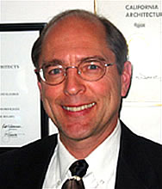
Richard Gage, AIA, is a San Francisco Bay Area architect of 28 years, a member of the American Institute of Architects, and the founder and CEO of Architects & Engineers for 9/11 Truth, a 501(c)(3)educational charity. In his architectural career, Gage designed most types of building construction, including numerous fire-proofed, steel-framed buildings. Most recently, he worked on the construction documents for a $400M mixed-use urban project with 1.2 million square feet of retail and 320,000 square feet of mid-rise office space, plus a parking structure, totaling some 1,200 tons of steel framing. Gage has delivered his live multimedia presentation 9/11: Blueprint for Truth more than 500 times in 37 foreign countries and 110 American cities to audiences ranging in size from 30 to 3,000. He has appeared in more than 550 radio and television spots.
Phi Beta Iota: A&E911Truth has earned over 3,000 signatures from those with verified academic degrees and professional licenses, and an additional 20,000 non-architects and engineers, all calling for a new, independent investigation–with full subpoena power–into the September 11, 2001 destructions of the World Trade Center Buildings, 1, 2, and 7. A&E911Truth has not focused on and takes no position on the Pentagon or the Shanksville, PA aspects of 9/11. A&E911Truth disputes the no planes, nuclear, and directed energy weapons theories; as others dispute their exclusive focus on thermite. Any independent investigation must consider all possibilities together.

T. Mark Hightower: 9/11 Twin Towers Cannot Be Explained by Nano-Thermite Alone
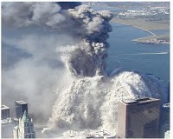
Mr. President,
Nano-thermite (a finely-granulated version of thermite, an incendiary long used to weld railroad tracks and to disable artillery using thermite grenades) has been oversold by those who claim that it holds the key to understanding how the Twin Towers were taken down. This thesis, promulgated by the lame stream media as the predominant if not exclusive “9/11 truth movement” view, is very easy to disprove, thus further confirming that what you call the “fake news” media is totally complicit in maintaining an official narrative that is false.
It is a law of materials science that, in order for an explosive to destroy a material, it must have a detonation velocity equal to or greater than the speed of sound in that material. Nanothermite does not satisfy that condition for either concrete or steel, which makes it a non-starter for this role.
The speed of sound in concrete is 3,200 meters/second and in steel 6,100 meters/second. The highest possible detonation velocity for nanothermite in the scientific literature is only 895 meters/second – 28% of what is required for concrete, and 15% of what is required for steel.
This means it would not be physically possible for nanothermite to have been responsible for blowing apart the Twin Towers insofar as it cannot blow apart either concrete or steel, the primary constituents.
While nanothermite may have been used in an auxiliary role (for the purpose of cutting through specific joints and trusses), its explosive force is only 1/13 that of TNT, which is the universal standard. It would have made no sense to use nanothermite in lieu of other more powerful explosives, which is revealed by the estimate of Neils Harrit, a proponent of the nanothermite hypothesis, that it would have taken from 29,000 to 143,000 metric tons of nanothermite for each tower. Q.E.D.
Other means – not at all investigated by the 9/11 Commission which appears to have been more of a cover-up Commission – were used to achieve the vaporization of the Twin Towers. It remains for you, Mr. President, to fulfil your campaign promise to get to the bottom of this, and give us a new independent 9/11 investigation on the who, why, how, and costs of the 9/11 atrocity.
Very respectfully,
Mark Hightower
Reference with additional facts and links: T. Mark Hightower, “Nanothermite: If it Doesn’t Fit, you Must Acquit!” James Fetzer Blog, 26 August 2011
DOC (1 Page): 911 POTUS Hightower Not Nanothermite Alone
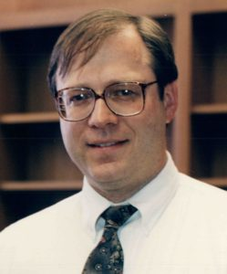
Mark Hightower holds both BS and MS degrees in chemical engineering from San Jose State University. His initial work experience was in the chemical industry, and then he worked for NASA where he retired in 2015 after 25 years of federal government service, where he worked on space life support systems for future long duration missions, hazardous materials management, arc jet testing of heat shield materials for spacecraft entry into planetary atmospheres, hyper velocity free flight aerodynamic testing of spacecraft and aircraft models in enclosed terrestrial ballistic range, facility water management including drinking water, storm water, industrial waste water, water conservation and reclamation, pollution prevention, above ground storage tanks, and climate change risk management.

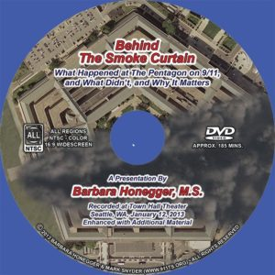
Barbara Honegger: 9/11 Pre-Planted Explosions 8 Minutes Prior to Alleged Impact*
Mr. President,
I was a White House Policy Analyst to President Ronald Reagan and for over a decade the Senior Military Affairs Writer for the Naval Postgraduate School, the leading science and technology graduate research university of the Department of Defense.
From years of one-on-one interviews with the highest ranking military officers and civilian Pentagon officials – all of whom I can identity to you by name – I can tell you with 100 percent certainty not only that the “Official Story” of who attacked this country and how they did it is a Hitleresque “Big Lie” but that there are dozens upon dozens of “Burning Facts” each of which standing alone proves that the Official Story is completely false and that 9/11 was an inside job made to happen.
My focus in this memorandum for you is the Pentagon attack, which most others tend to ignore. The Official Story of the Pentagon is false in every respect, including these key elements: when the attack happened (the first violent event was almost eight minutes prior to the “official time”); the source of the damage (major destruction was due to pre-planted explosives); and the aerial vehicle that was destroyed (a plane smaller than a 757, provably not Flight 77, and on a flight path different from the Official Story).
The first explosion went off inside the outer ring almost eight minutes before the Official Story says Flight 77 was anywhere near Washington. Key Pentagon witness April Gallop’s wristwatch was stopped by that explosion at 09:30 (the Official Story says the Pentagon was hit at 09:37:46). The digital clock embedded in the Doubletree Hotel security camera shows that the billowing black smoke began at 09:34:10 – well before the alleged impact more than three minutes later.
Many Pentagon witnesses – some of whose names I can provide to you – reported sequences of explosions “like firecrackers going off” inside the building before the wall collapse, conclusive evidence of pre-placed explosives. Multiple witnesses including Chief of the Joint Chiefs of Staff General Hugh Shelton reported the “overwhelming” smell of the explosive cordite, and literally hundreds of Pentagon employees shouted out to one another that “bombs” had gone off.
In addition to the above high-level challenges to the Official Story, below are four additional scientific & technical observations that are documented by multiple experts and sources:
1. At the Pentagon’s first press briefing of Sept. 12th there was no mention of Flight 77 or a 757. It wasn’t until its Sept. 15th press briefing – four days later — that the Official Story was put out, the day after the government allegedly ‘found’ the ‘black boxes’ — a Cockpit Voice Recorder (CVR) and Flight Data Recorder (FDR) — in the Pentagon rubble. But:
2. The NTSB report on the Cockpit Voice Recorder (CVR) the government claims was from Flight 77, an American Airlines 757, allegedly ‘found’ in the Pentagon rubble states that it was a ‘magnetic tape model’ but the airline quickly put out a press release that it could not have been from any of its American Airlines 757s whose CVRs were “the modern solid-state version”; and as the Flight Data Recorder (FDR) ‘found’ near the CVR had to have been from the same plane, as the two ‘black boxes’ are located near one another in the rear, the FDR also could not have been from any American Airlines 757.
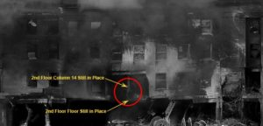
3. Absolute proof that the Official Story cannot be true is this Photo of what the Pentagon claims is the exact impact point of a massive 757 smashing at over 500 miles per hour into the red circle (Column 14 in Wedge One) — and yet the visible column in the dead center of that very ‘bulls eye’ where the maximum force of a plane would have hit is not only still in place, it’s still vertical:
4. There was massive destruction, fire and deaths in the two innermost rings of the Pentagon, the fourth-in B Ring and the fifth-in A Ring – two rings further in than the furthest the Official Story claims any part of a plane penetrated: only to the third-in C Ring (alleged) ‘Exit’ hole.
Others have focused on the anomalies at the WTC, including yourself. What has not yet been stated in these other Presidential memoranda is the fact that massive explosions went off in the basements of both WTC Towers before the plane impacts — 14 seconds before in the case of WTC 1 and 17 seconds before in the case of WTC 2. WTC 7, of course, was not hit by an aircraft at all and was an obvious controlled demolition. Fifty seven pages of “Burning Facts” — hard forensic evidence — proving that the Official Story is false — can be found in the Petition filed by the Lawyers’ Committee for 9/11 Inquiry demanding a Special Criminal Grand Jury to finally investigate the real cause of the collapses of WTCs 1, 2 and 7.
I produced the documentary “Behind the Smoke Curtain” that has been viewed by over half a million citizens. The facts in that video lead to the inescapable conclusion — explicitly stated in the final third which ‘names names’ — that 9/11 was an Act of War in service to a foreign power aided and abetted by a treasonous Fifth Column of dual U.S.-Israeli citizens and Israel-first loyalists placed in all of the key government and military positions to plan, execute and cover up the attacks by the then incumbent Vice President and Secretary of Defense — the true Axis of Evil of 9/11. The degree of complicity by the then incumbent President remains to be seen.
I urge you to fulfill your campaign promise and personally lead an independent investigation into 9/11 that finally properly interrogates — under oath and with no wiggle room — all of the key known ‘persons of interest’ and that finally presents the American public with The Truth. Only With The Truth Can You Make America Great Again.
Very respectfully,
Barbara Honegger, M.S.
*Also Published As: Barbara Honegger, “Pre-Planted Pentagon Explosives Went Off Almost Eight Minutes before Any Alleged Impact on the Building,” American Herald Tribune, 14 July 2018.
DOC (2 Pages): 911 POTUS Honegger Pentagon Truth I
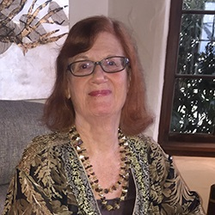
Barbara Honegger, MS, has served tours in the Ronald Reagan White House and at the Department of Justice. From 1995 to 2011 she was Senior Military Affairs Writer at the Naval Postgraduate School, the top U.S. military science and technology graduate research university. She is the author of October Surprise on the Iran side of the Iran/Contra scandal and has since 9/11 been among the leading researchers and public speakers documenting the falseness of the official narrative, producing, among other works, the YouTube documentaries Behind the Smoke Curtain and 9/11 Museum Virtual Walking Tour, and the white paper The Pentagon Attack Papers. Her work has been recognized by both U.S. and international Truth Movement organizations. She is a Board Member of the Lawyers’ Committee for 9/11 Inquiry and a founding member of Political Leaders for 9/11 Truth. She holds a BA from Stanford, an MS from JFK University, and masters level certification in national security decision-making from the Naval War College. Ms. Honegger has run twice for Congress in California.

Gordon Duff: 9/11 NYC Was a Nuclear Event Crafted by Israel Overseen by Dick Cheney
Mr. President,
9/11 was a nuclear event on the NYC end. On 9/11, employees of the DOE and IAEA visited ground zero in NYC. They were dressed as utility employees. Among their number was Jeff Smith, one of my volunteer editors (Veterans Today) and also an IAEA inspector. Jeff is a particle physicist.
Years after 9/11, I received documents that were allegedly a 2003 DOE report on 9/11. I contacted Jeff Smith and sent him the documents which he shared with colleagues at the DOE at Los Alamos. They confirmed they had penned the report which had been given to the White House, leaders of congress and the Pentagon. The report stated that some type of nuclear weapon was used and that the weapons had been made from material stolen from the Pantex facility in Amarillo, Texas.
I confirmed there had been an FBI/CIA/Pentagon investigation into nuclear smuggling and independently confirmed that this was also tied to an FBI investigation known as the AIPAC spying scandal. Veterans Today board member and advisor, Gwyneth Todd, then the head of the Middle East desk at the National Security Council and assistant to Condoleezza Rice took part in a sting operation that netted a top presidential advisor who was passing nuclear secrets to Israel. The investigation was quickly quashed, the FBI agents transferred and there was an attempt of Gwyneth’s life. She is now in hiding. Not only were nuclear pits stolen but the technical information allowing them to be “sorted” and remanufactured had been transferred to Israel by high ranking Bush and Clinton administration appointees.
9/11 appears to have been carried out by a joint Israeli/Saudi Arabian task force with help from within America’s highest political circles, and “cover” from many elements of the US Government led by Dick Cheney. The degree to which rogue elements of the US military and secret intelligence community were complicit at multiple levels from the Joint Chiefs of Staff down to individual watch standers has not been properly investigated.
Many countries warned us months in advance, and the US Government was literally at war with itself from the summer of 2001 onwards – White Hat elements centered on a joint task force out of Fort Lee, New Jersey, while Black Hat elements, including the director of the CIA and the three directors of the FBI (past, acting, and Mueller) were all engaged in trying to prevent ABLE DANGER and other White Hat elements from stopping the planned false flag event.
On 9/11, there were additional attacks on the George Washington Bridge and the Holland and Lincoln Tunnels. Those involved were arrested and the arrests made on the George Washington Bridge, armed Israeli nationals with thousands of pounds of explosives, was reported on national news. In all, the task force arrested over 80 individuals, both Saudi and Israeli nationals. All but 5 were turned over to “officials from Washington” and flown out of the country. While it was reported that the flight carried the bin Laden family “to safety,” in fact most on the flight were Mossad agents, Israeli citizens.
It is my understanding that documentation on both the fact of 9/11 being a nuclear event and the fact of 9/11 being an Israeli/Saudi false flag event with insider help from within the US Government, has been provided to the mainstream media, all of whom have refused to stray from the official narrative, which is a travesty.
It is my hope that you will honor your campaign promise, get to the bottom of this matter, and use your speech on 9/11 2018 to liberate America from the scourge of Zionist and Saudi Arabian influence.
Very respectfully,
Gordon Duff
DOC (1 Page): 911 POTUS Duff Nuclear Zionist Cheney

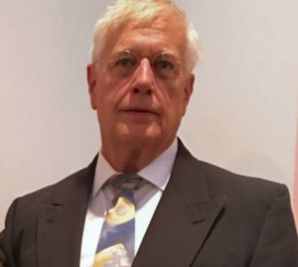
Gordon Duff is a Marine Corps veteran of the Vietnam War. He is a disabled veteran and has worked on veterans and POW issues for decades. Gordon is an accredited diplomat and is generally accepted as an accomplished global intelligence specialist. He manages the world’s largest private intelligence network and regularly consults with governments challenged by security issues. His business experience and interests are in energy and defense technology. He publishes frequently at Veterans Today and New Eastern Outlook.

Joe Olson: 9/11 Twin Towers “Clean Nukes”, WTC 7 Conventional Demolitions
Mr. President,
“Clean Nukes.” The Twin Towers and most of the World Trade Center (apart from WTC-7, which came down seven hours later in a classic controlled demolition) appear to have been demolished – much of it vaporized – using “clean nukes.”
The technical term is “minimum residual radiation” (MRR, also sometimes called “reduced residual radiation,” RRR). Residual radiation is what remains by way of radioactive contaminants after the initial radiation of the first minute has worn off. Because the fission products are the “dirty” part of the nuclear blast, two factors are central in order to keep the device as “clean” as possible: (1) the fission-fusion mix of the thermonuclear device, i.e., the share of the total yield delivered by the fission primary and fusion secondary, respectively; and (2) the conditions under which the nuke is fired, whether it’s an air burst, ground burst or underground explosion, and whether the underground explosion takes place in an unobstructed shaft and whether any structure stands on top of the shaft, i.e. the energy can be channeled. Actual MRR appears to have been a 400-ton equivalent requiring 4 pounds of uranium.
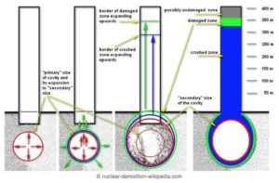
Construction Favoring Nuclear Effect & Containment. WTC 1 & 2 exemplified a novel tube-within-a tube design that created open office space with 47 massive core columns and 240 external support columns. This allowed the deeply buried nuclear devices to have their full force channeled upwards and destroy the inner tube from the bottom/up, but caused the external tube to blow apart from the top/down. The buildings were converted into millions of cubic yards of very fine dust (which is itself a signature of the use of nuclear devices) and, when it was done (about 9 seconds for South Tower, 11 for North), there was no stack of debris in their footprints, where the result of a classic controlled demolition would have been around 13.5 floors to debris (roughly, 12% of the height of the original 110 floors for each structure). Additional explosives may have been used as a supplemental means of destroying the buildings. Many floors appear to have been unoccupied – free of both occupants and furniture – prior vacancy rates having been accelerated by a 40% increase in rental rate to encourage tenants to vacate.
Radioactivity Indications in USGS Dust Studies. The contrast between the destruction of the Twin Towers and WTC-7, which collapsed about seven hours later as the effect of a classic controlled demolition, was striking. Instead of vaporization in every direction, all the floors of WTC-7 came down at the same time. There was no conversion into millions of yards of very fine dust. And, when it was done, there was a stack of debris of about 5.5 floors (or 12% of the original 47 floors). Studies of dust samples from 35 location in Lower Manhattan confirmed elements that, in their quantifies and correlations, were indicative of a nuclear event, including Barium, Strontium, Thorium, Uranium, Lithium, Lanthanum, Yttrium, Chromium and Tritium.
Nuclear Vaporization versus Thermite Melting. 0.13 pounds of thermite required to heat each pound of steel to its melting point. The decorative Aluminum Cladding + Iron Oxide + high heat = thermite spheres, which were residue. With 400,000 tons of missing steel and concrete – much of it vaporized – nuclear energy is posited. The directed force spared “the bathtub” any horizontal stress such that it continued to function as designed.
Very respectfully,
Joe Olson
Structural Engineer
Primary Reference: Tahil, William, Ground Zero: The Nuclear Demolition of the World Trade Centre (2006). See also: Andre Gsponer, Fourth Generation Nuclear Weapons: Military Effectiveness and Collateral Effects (2005).
DOC (1 Page): 911 POTUS Olson Nuclear
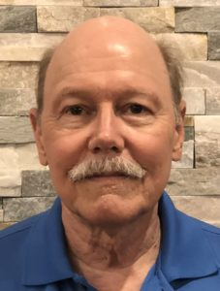
Joe Olson is attended the University of Houston and passed multiple Professional Engineer examinations. He has been self-employed since 1980, retiring in 2009, performing design services on hundreds of projects in multi-story, commercial properties in twenty states. He is the co-author of Slaying the Sky Dragon: Death of the Greenhouse Gas Theory, and author of over one hundred major web posted articles on science fraud in global warming, sustainable energy and peak oil, a partial bibliography is at FauxScienceSlayer. He has been a guest on Coast to Coast AM radio and interviewed with Dr. James Fetzer, “Unequivocal 9/11 Nukes” at RealDeal.blogspot, among others.

Judy Wood by Robert Steele: 9/11 Twin Towers Vaporized by Directed Energy Weapons

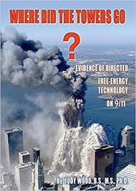
Mr. President,
The twin towers appear to have been destroyed by directed energy weapons. This is one of two possible explanations for the “vaporization” of most of the two towers which did not leave the standard 12% in building debris height as was the case with WTC 7, which was very obviously a simple controlled demolition. While A&E911 Truth challenges competing theories including directed energy, nuclear energy, and “no planes,” it is my view that all such theories must be properly investigated. This book cannot be ignored.
Dr. Wood is a former professor of mechanical engineering with research interests in experimental stress analysis, structural mechanics, optical methods, deformation analysis, and the materials characterization of biomaterials and composite materials; she lost her job over this book, and she may fear for her life, as she has gone silent on the matter. In her honor, I have prepared this memorandum because this possibility must be considered by a new investigation.
There are eight scientific and technical aspects – empirical verifiable evidence such as was deliberately not considered by the 9/11 Commission – that your new independent presidential task force could address with Dr. Wood’s help, as illustrated below:
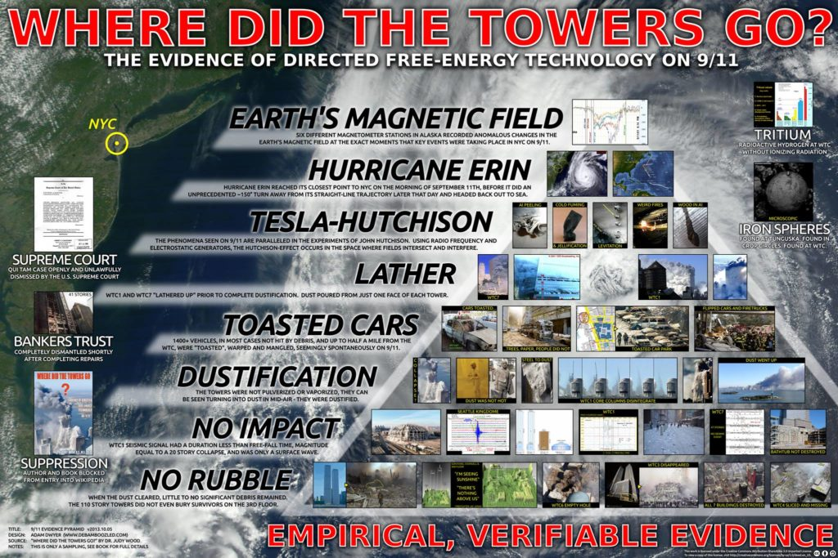
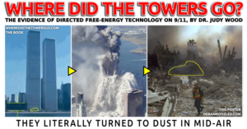
Customer reviews from before the book was bought up and made unavailable:
Dr. Wood’s legal whistle blowing suit against the National Institute of Standards and Technology (NIST) showed three factors: protection of corporations that produce directed energy weapons; NIST’s report was fraudulent and showed by omission the various psych operations used by those groups designed to confuse perceptions of citizens… scout
She presents multiple lines of evidence, which include: length-of-time from initiation to completion of collapse; size of debris field immediately afterward; the nature of collateral damage to adjacent buildings; the surface-area of the debris field (how far did most things scatter?); the almost astounding absence of any recognizable debris from building interiors, EXCEPT PAPER–of which there was a vast quantity, almost all of it with no sign of exposure to heat; the unusual behavior of the unfortunate building occupants before collapse; first-responder eye-witness reports; the very interesting collapse of WTC7; very peculiar patterns of vehicle fires, undamaged vehicles, vehicles which were flipped yet hardly damaged, and vehicles which appeared…well, melted in strange patterns, and without the expected indicators of high-heat fire; the quite bizarre damage patterns of what few intact support beams and struts could even be recovered; and importantly, what the seismographic records tell us about the events. I think that covers most of the categories. The book is chock-loaded with photographs and also diagrams. Karl Weaver
All evidence available to the public (and generally ignored or covered up by NIST and the 9/11 Commission) suggests that all three WTC buildings were wired with controlled demolitions, but in the case of the twin towers, there is clearly another larger force at work, one that can vaporize the buildings and not leave the debris field that was left by WTC 7. A new independent investigation with the personal interest of the President of the United States of America appears essential to the future of the Republic.
Very respectfully,
Robert David Steele
DOC (2 Pages): 911 POTUS Wood by Steele Directed Energy
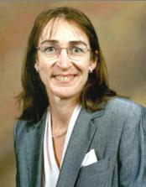
Dr. Judy Wood earned a Ph.D. Degree from Virginia Tech and is a former professor of mechanical engineering. She has research expertise in experimental stress analysis, structural mechanics, deformation analysis, materials characterization and materials engineering science. In the time since 9/11/01, she has applied her expertise in materials science, image analysis and interferometry, to a forensic study of over 40,000 images, hundreds of video clips, a large volume of witness testimony, analyses of dust samples, seismic data, and the analysis of other environmental evidence pertaining to the destruction of the World Trade Center complex. Dr. Wood has conducted a comprehensive forensic investigation of what physically happened to the World Trade Center site on 9/11. Based on her analysis of the evidence she gathered, in 2007, she filed a federal Qui Tam case for science fraud against the contractors who contributed to the official National Institute of Standards and Technology (NIST) report about the destruction of the World Trade Center towers. This case was filed in the US Supreme Court in Dec 2009. To this day, Dr. Wood’s investigation and body of evidence as compiled in her book is the only comprehensive forensic investigation in the public domain.
Phi Beta Iota: All of the major theories have their detractors. This theory is particularly opposed by A&E911Truth as well as those who support the nuclear explanation. All possibilities must be considered by any independent 9/11 Commission that is not controlled by the Zionists and US traitors.
See Especially:
FAQ: What is AE911Truth’s assessment of the directed energy weapon (DEW) hypothesis?

John Lear: 9/11 Illusions of Airplanes from Hollywood or US Air Force Holograms?
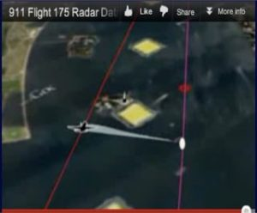
Mr. President,
A Hollywood producer told me about fifteen years ago, just after 9/11 had occurred, a story about the state of the art of hologram projection as it was known to Hollywood executives including Stephen Spielberg, in the early 1990’s. She explicitly endorsed the idea that no actual airplanes hit the Twin Towers, and that Hollywood special effects – or even more advanced capabilities available to the U.S. military – were used.
A radar study done by Richard D. Hall of the UK has established that the images of the aircraft that “melted” into the Twin Towers (a physical impossibility) had been projected from a plane flying 1,400 feet to the right of the projected image. Radar picked up the projecting aircraft but not the Flight 175 image, because it was not a physical object in space.
Any serious commission should be demanding a full briefing from the US military, the US Air Force particularly, which has an Airborne Holographic Projector. Although the most advanced capabilities are probably classified, a proper survey should rapidly confirm the state of the art in 2001.
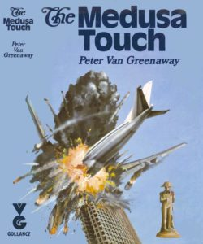
Also relevant to any new investigation might be the interrogation of Arnon Milchan, the long-standing fixer for the Mossad, whose film The Medusa Touch, released in 1978, featured an airline crashing into a building – over twenty years later, for a Fox series The Lone Gunmen filmed in 2000 and aired in early 2001, he appears to have applied the latest technologies to again show an airplane crashing into a building. Resident in New York City, Milchan would appear to be the perfect candidate to oversee the Hollywood theatrical effects (for example, the exploding flames from the pre-packed explosives within the Twin Towers) consistent with the cover story of this false flag operation.
Very respectfully,
John Lear
References:
- Richard D. Hall, “Flight 175 3-D Radar Study,” Check the Evidence, 3 August 2010.
- “1994: US Air Force Launches Top-Secret ‘Holographic Projector’ Research Program,” History Commons, undated, accessed 25 July 2018.
- Christopher Bollyn, “Arnon Milchan – ‘Mr. Israel’ and 9/11,” Bollyn.com, 4 October 2011.
DOC (1 Page): 911 POTUS Lear Holograms
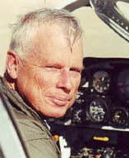
John Lear, a captain for a major US Airline has flown over 160 different types of aircraft, in over 50 different countries. He holds 17 world speed record in the Lear Jet and is the only pilot ever to hold every airline certificate issued by the Federal Aviation Administration. Mr. Lear has flown missions worldwide for the CIA and other government agencies. A former Nevada State Senator candidate, he is the son of William P. Lear, designer of the Lear Jet executive airplane, the 8-track stereo, and founder of Lear Siegler Corporation. Detailed aviation biography.

John Lear: 9/11 Twin Towers Were Not Hit By Nor Destroyed By Two Airliners
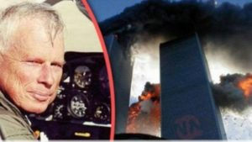
Mr. President,
The 9/11 Commission refused to take evidence from Pilots for 9/11 Truth, of which I am a member, with over 19,000 hours flight time, much of that flying covert missions for the CIA, and including 17 world speed records in a Lear Jet Model 24.
No Boeing 767 airlines hit either of the Twin Towers, as fraudulently alleged by the government, media, NIST and its contractors. All of the “evidence” to that effect, including video depictions, has been fabricated and can be forensically challenged.
You yourself, Mr. President, one of the most experienced property developers in New York City, have correctly observed that the buildings could only have been brought down by explosive as “planes would never be able to penetrate the steel beams”, had it exactly right.
I leave it to you to create a new independent commission to examine all possibilities including thermite, pre-planted explosives (TNT), directed energy weapons from above, and nuclear explosions from below.
My focus is on the physical impossibility of the specific alleged aircraft crashing into either of the twin towers.
In the case of UAL 175 going into the south tower, a real Boeing 767 would have begun “telescoping” when the nose hit the 14-inch steel columns which are 39 inches on center. The vertical and horizontal tail would have instantaneously separated from the aircraft, hit the steel box columns and fallen to the ground.
The engines – made of titanium and virtually indestructible — when impacting the steel columns would have maintained their general shape and either fallen to the ground or been recovered in the debris of the collapsed building.
No Boeing 767 could attain a speed of 540 mph at 1000 feet above sea level because ‘parasite drag doubles with velocity’ and ‘parasite power’ cubes with velocity. These are scientific facts.
The fan portion of the engine is not designed to accept the volume of dense air at that altitude and speed.
No significant part of the Boeing 767 or engine could have penetrated the 14-inch steel columns and 37 feet beyond the massive core of the tower without part of it falling to the ground.
The piece of alleged external fuselage containing 3 or 4 window cutouts is inconsistent with an airplane that hit 14-inch steel box columns, placed at over 500 mph: It would have crumpled.
The debris of the collapse should have contained massive sections of the Boeing 767, including 3 engine cores weighing approximately 9000 pounds apiece which could not have been hidden. Yet there is no evidence of any of these massive structural components from either 767 at the WTC. Such complete disappearance of 767s is impossible.
Instead of bodies, seats, luggage, wings and tail having fallen to the ground external to either building (which would have happened had real planes hit them), we have a component from a General Electric CF-6 engine, found at Church and Murray Streets under a rain canopy, which was neither torn nor damaged, which would have happened had it been thrown from an airplane crashing into the South Tower.​
Whoever placed it on the sidewalk, which would have been deeply gouged by something so massive having hit at high velocity (the sidewalk was pristine), did not know that only the American Airlines Boeing 767-300 uses General Electric CF-6 engines, which therefor cannot have come from United Flight 175. Planting evidence demonstrates by itself that 9/11 was an orchestrated and planned event.
The Boeing 767 has approximately three million FAA approved parts, each of which must be stamped or engraved with an FAA approved manufacturers identification and parts number. Not a single part of the 6 million parts from the two Boeing 767’s which allegedly crashed into the World Trade Center has been found.
The “crash” in Shanksville, PA is a bomb crater with a truckload of trash dumped into the hole. From sources at Boeing. the ACARS (Aircraft Communicating, Addressing and Reporting System), which transmits the position, altitude, speed and engine data of aircraft in the air via satellite to its respective operators (Boeing, UAL, P&W) it is quite certain that the flight alleged to have crashed there was in fact operating for a minimum of four hours after its alleged crash in Shanksville, PA, which was therefore also obviously fraudulent.
Mr. President, it is quite clear to all patriotic citizens that are paying attention that 9/11 was a false flag attack that framed Muslims, using patsies documented by Saudi Arabia, as part of a Zionist plan in which at a minimum Dick Cheney, Donald Rumsfeld, George Tenet at the CIA, and others in key US Government positions, were complicit.
The purpose of this false flag event was to draw the United States into perpetual war against the Arab states that served as a counter-balance to Israel’s domination of the entire region and to pave the way for the expansion of Israel in accord with the Yinon Plan (to create Greater Israel) – it is this plan and the Zionist culpability for 9/11 that needs to be a focus of attention as you seek the truth about 9/11.
I have spent years working with the Mossad and flying for CIA into and around the Middle East, to include being the pilot that delivered the arms and ammunition to Iran by order of President Ronald Reagan in return for the hostages.
I was friends with Salim bin Laden. I am quite certain that the 9/11 Commission Report is a pack of lies, an orchestrated cover-up similar to the Warren Commission cover-up that is now unraveling even further in the aftermath of your directed release of 50,000 more records.
America needs the truth about 9/11 and it is my view that your leadership on this matter, in time to educate America on the truth when you speak on 9/11 2018, can be the critical factor in “rebooting” public understanding of who our enemies are, both foreign and domestic.
Please, Mr. President, use the truth about 9/11 to accelerate your taking down the Deep State and its Zionist under-belly. May God Bless you, Mr. President, and may God Bless America.
Very respectfully,
John Lear

Reference:
John Lear’s Affidavit on the Non-Occurrence of Tower Hits on 9/11
DOC (2 Pages): 911 POTUS Lear on No Planes

John Lear, a captain for a major US Airline has flown over 160 different types of aircraft, in over 50 different countries. He holds 17 world speed record in the Lear Jet and is the only pilot ever to hold every airline certificate issued by the Federal Aviation Administration. Mr. Lear has flown missions worldwide for the CIA and other government agencies. A former Nevada State Senator candidate, he is the son of William P. Lear, designer of the Lear Jet executive airplane, the 8-track stereo, and founder of Lear Siegler Corporation. Detailed aviation biography.

Aeronautical Engineer: No Boeing 757 Hit the Pentagon
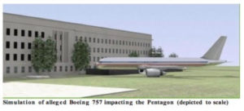
Mr. President,
According to The 9/11 Commission Report (2004), American Airlines Flight 77, a Boeing 757, was flown into the Pentagon at around 400 mph barely skimming the ground and taking out a series of lampposts on its approach. As a pilot and aeronautical engineer, however, that cannot be correct: high-speed flight in relatively close proximity to the ground is virtually impossible – in any fixed-wing aircraft.
An exception would be cruise-type missiles, whose flying surfaces are more akin to horizontal fins than wings, and thus have extremely high wing loadings (lbs/sf) — much higher even than of ground-attack fighter-bombers.
Commonly invoked photos of aircraft in flight close to the ground do not depict flight at anywhere near maximum speed; they are photos taken of craft flying at greatly reduced throttle settings – which is what actually happens during any landing!
An aircraft’s wing, basically, is an air deflector. As an aircraft moves forward, the wing essentially deflects the resultant airstream downward. This downward deflection of air causes an equal and opposite reaction upward. This upward reaction (equal to the weight of the aircraft when in level flight) is what is termed ‘Lift.’
This downward deflection of air, which occurs along the entire span of the wing, is also what constitutes downwash. This downwash ‘sheet’ has a vertical component that is normal (I.e., at a right angles) to the direction of flight.
When an aircraft flies in close proximity to the ground, it is this vertical component of Downwash that causes the ‘cushion’ of air between the wing and the ground.
This “cushion,” when sufficiently energized (by an aircraft’s high speed), behaves much like a pneumatic “spring,” and tends to resist any action against it — such as that caused by a pilot trying to force the aircraft down against it.
In the case of a Boeing 757, given its wingspan of 124 feet, this would equate to roughly 62 feet AGL. Sixty-two feet is a theoretical minimum; a practical minimum would actually be considerably higher.
In a real-world situation (such as allegedly at the Pentagon), a pilot — especially one as demonstrably inept as Hani Hanjour who could barely fly a trainer — probably could not have come within 100 feet of the ground in a Boeing 757 flying at 400 mph.
This means that the “official account” of the Pentagon hit cannot possibly be correct because it violates the laws of aerodynamics. The 9/11 Commission has been playing the American people for saps.
Very respectfully,
Aeronautical Engineer

Reference:
An Aeronautical Engineer, “No Boeing 757 hit the Pentagon”
DOC (1 Page): 911 POTUS AeroEng No Boeing 757 Hit Pentagon
Phi Beta Iota: The author desires to remain anonymous to the public. He is known by name and reputation to our team.

Epilogue

A. K. Dewdney: 9/11 Gratuitously False Narrative on Use of Cell Phones
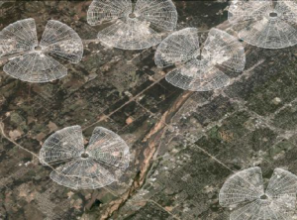
Mr. President,
The graphic to the left shows receptivity zones for cell towers as seen from approximately 5,000 feet.
As you consider how best to fulfill your campaign promise to get to the bottom of 9/11, I offer you the following commentary on one specific gratuitously false aspect of the official narrative.
Cellphone Technology: All cellphone communications take place between cell towers and cellphones, whether stationary or in a state of motion. Signals received by cell towers are retransmitted via cell towers to the cellphone being called. Critical to the operation of a cellphone network are the physical properties of cell towers and cellphones. As every cellphone engineer knows, cell systems were always intended for all-terrestrial communication and not for any extended vertical communication. The accompanying map shows a partial pattern of cell tower placements in an urban area. Each pancake-shaped structure surrounding these towers represents the size and shape off the zone of receptivity. Outside the zone of a given tower, no cellphone call will reach it with any reliability. The same thing is true for vertical distances, but these are generally much shorter due to the shape of the zone.
The Airborne Experiments: Three experiments were carried out to see to what extent a cellphone calling from an aircraft might reach a cell tower. The aircraft used were a Diamond Katana ultralight aircraft, a Cessna 127-R and a Piper Twin Apache. All three experimental flights flew patterns that guaranteed coverage by a variety of cellphone makes for calls from a cellphone expert using several current makes. All calls were received by an operator at a ground station. The operator recorded the time of a call (if received at all) as well as its duration and audio quality.
The Outcomes: When data from all three flights are put together, we find a straight line regression of failure probability with altitude. It must be stressed that the “messages” mentioned in this summary lasted only 10 to 20 seconds. Thus the “success” of such calls applies only to such messages, longer messages having a much higher probability of failure. The regression analysis reveals a 100% probability of success at 1000 feet, dropping linearly to 50% at 4000 feet and a 10% probability of success at 6000 feet — with only the analog phone succeeding in this case. These probabilities can be used as a basis for assessing the success of longer calls at the same altitudes. For example the success of a one-minute call may be viewed as a simple compound probability of, say five 20-second calls. Thus leads to a more realistic assessment for ordinary cellphone calls: 4000 feet—3%; 6000 feet — 0.001%, essentially impossible. At the altitudes normally flown by passenger aircraft the situation is completely hopeless. Feedback from many airline passengers who left cellphones “on” (not calling) during flight recall signal loss shortly after takeoff, at barely 1000 fee. The reason is that large passenger aircraft create signal attenuation caused by their large metal mass. We note in passing that the power output of a standard cellphone is 0.2 watts, whereas the power output of a passenger aircraft may be anywhere between 30 and 40 watts.
Conclusions: Accounts of “cellphone” calls made from aircraft allegedly used in the 9/11 attacks simply cannot possibly be true. Checks made of AT & T records for the day reveal no calls made from the back-of-the-seat phones either. All official and unofficial claims of cell phone calls from the allegedly hijacked aircraft are false.
Very respectfully,
A. K. Dewdney
Reference: A. K. Dewdney, “Project Achilles: Low Altitude Cellphone Experiments,” Physics911, 2003.
DOC (1 Page): 911 POTUS Dewdney Cell Phone False Narrative

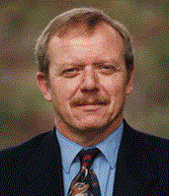
A. K. Dewdney is a Canadian mathematician, computer scientist, field biologist, author, and filmmaker. From 1981-1986 he was a regular computer columnist for Scientific American. Two of his films, The Maltese Cross Movement and Wildwood Flower, have been preserved by the Academy Film Archive. He has eleven published books dealing with at the intersection of computers, mathematics, science, and the universe.

Greg Felton: 9/11 Zionism’s Great Feeding Frenzy – The Parasite Eats the Host
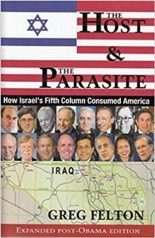
Mr. President,
The Host & The Parasite––How Israel’s Fifth Column Consumed America is a meticulously researched chronicle of the U.S.’s tragic slide from an independent republic into a client state of Israel – a shiksa in the vernacular you know so well.
This degeneration occurred over the last 50 years in full view of the American public and with the active complicity of American lawmakers.
The Zionization of America, a period of progressive subservience to Israel, began when President Harry Truman took a $2 million bribe to support the “creation” of the state of Israel so he could appeal to Jewish voters during the 1948 election, which he was expected to lose heavily. From this act, the Israel Lobby got its hooks into the U.S. government and made it complicit in the illegal Zionist occupation of Palestine and the murder as well as the dispossession of its native inhabitants.
Subsequent stages of Zionization would see the U.S. increasingly provide political and diplomatic cover for Israeli atrocities and even commit unprovoked aggression for Israel in Afghanistan, Iraq, Libya and Syria contrary to the national interest and U.S. law.
There is no rational explanation for the U.S. government acting against its own national interest unless one recognizes that the Israel Lobby effectively controls the U.S. and has forced its leaders to betray themselves to serve a foreign interest.
The most heinous instance was U.S. acquiescence in the pre-meditated Israeli attack on the USS Liberty The Johnson administration as well as every other president since has protected Israel by classifying the attack as an accident and threatening survivors with prison and loss of pension if they speak out.
Others have documented the specifics of the Zionist occupation of America; this is the big picture. Israeli parasitism plays itself out in various aspects of U.S. political culture.
First is the rise of the neo-conservative movement in the late 1960s and early 1970s in which the Zionists use money and propaganda to co-opt evangelical Christians, who share a common illiberality and opposition to the Great Society movement of the 1960s. This counterrevolution would reach fruition with the election of Ronald Reagan from which the descent into fascism can most reliably be dated.
Second is the mutation or creation of “think tanks” like the American Enterprise Institute and the Washington Institute on Near East Policy, which provide a steady stream of Zionist propaganda and a revolving door of loyal government servants to formulate policy for Israel.
Third, the invention under Bill Clinton of the great bogeyman “Islamic terrorism”—and Osama bin Laden as its great devil figure—was both designed to justify U.S. aggression against Afghanistan and Iraq serve Israel’s demonization of not only Palestinians and Arabs but now Muslims as a whole.
Fourth, the abject subservience of the U.S. to Israel is clearly seen in how Israelis are allowed to bypass security protocols to have free run of the Pentagon. If Israelis act as if they owned the place, it’s because they do.
Fifth, the climax of Zionist hegemony came in 2001 with the false flag attacks against the World Trade Centre and the Pentagon, attacks that could not have been carried out or covered up without the active complicity of, among others, the Vice President and the directors of the CIA and FBI. The complicity of the media – the fake news media as you label it – was another factor in this Zionist atrocity not being fully exposed. The Host & The Parasite leaves no doubt that Israel and the George W. Bush junta were responsible. (Junta is used throughout the book to highlight the illegitimacy of Bush’s election and the fact that those in his administration committed a coup d’état against the Constitution.)
This book shows that The USA PATRIOT Act, was drafted before, not after, the Sept. 11 attack, meaning that it was planned well in advance and the Sept. 11 attack was just a means to a pre-established end: turning the U.S. into a police state to censor pro-Palestinian political thought and prevent public opposition to a global war based on lies. The only beneficiaries of the invented “war on terror” is the invented state of Israel and the US military-industrial-intelligence complex.
Sixth, interspersed throughout the book is the history of petropolitics in Afghanistan and how the hypocrisy of the U.S. led to the bombing of that country, not over anything to do with the Sept. 11 attack, but because the Taliban government would not support the U.S./Saudi-led consortium’s bid to build a pipeline across the country is was invaded and bombed.
The Host & The Parasite is the first comprehensive analysis of the self-inflicted death of the U.S. and essential reading for any President who might wish to turn against the Deep State and its Zionist underbelly, as President Vladimir Putin has.
This book could be helpful in developing an educational series for the public, perhaps offered within a new “Trump Channel” that uses the truth about 9/11 as a catalyst for terminating Zionist influence over the U.S. economy, government, media (both mainstream and social), and society (Hollywood and the Christian Zionists).
Mr. President, all of us would benefit from your leadership in getting to the bottom of what happened on 9/11 – who did it, how, why, and at what cost to all of us and our future generations. Please count on me as a staunch supporter ready to assist you in any way possible as you lead us all toward a brighter future rooted in the truth.
Very respectfully,
Greg Felton
Reference: Greg Felton, The Host and The Parasite: How Israel’s Fifth Column Consumed America 3rd ed. (Money Tree Publishing, 2017).
Book Web Site: http://thehostandtheparasite.com/
DOC (2 Pages): 911 POTUS Felton Zionism as Parasite on USA
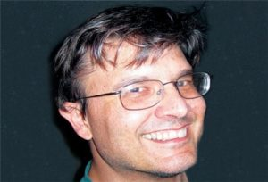
Greg Felton, born and raised in Vancouver, British Columbia, Canada, has been a journalist since 1993. He has won several awards for investigative reporting and column writing. Today he specializes in Middle East politics, Canadian politics, and anti-Arab / anti-Muslim media propaganda and language. For many years he wrote a column for the bi-weekly Arabic/English Canadian Arab News, and has been published in various publications. He holds a Bachelor’s degree in Russian Studies and a Master’s degree in Political Science, both from the University of British Columbia. In addition to The Host and the Parasite, he is the author of Exploding Middle East Myths — 15 Years of Fighting Zionist Propaganda.

References

The Zionist Plan – The “Greater Israel” or Yinon Plan
The Zionist plan for the Middle East, in some ways an extension of the failed British plan for colonizing the Middle East, calls for the Balkanization of the region into many smaller Arab states such that Israel becomes the regional super-power, able to impose its will – and its wanton theft of Arab lands far beyond Palestine. This plan was established in 1982. This plan cannot succeed without the parasitic exploitation of US blood, treasure, and spirit. 9/11 was a deliberately planned catastrophic terrorist event, a false flag event planned and implemented by Zionists with the full support of Saudi Arabia and neo-conservative traitors in the US Government led by Dick Cheney, to leverage the US to this end.
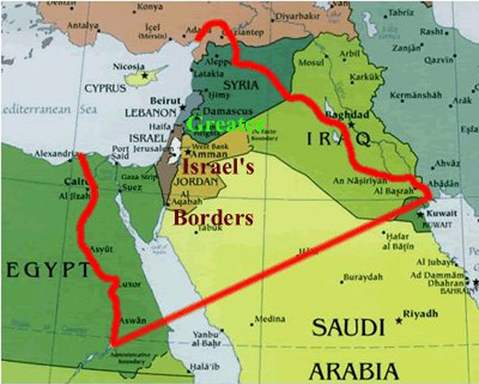
Sources
Stephen Lendman, “What Israel Fears Most: An Encroachment to ‘Greater Israel,’” GlobalResearch, 12 December 2017.
Israel Shahak and Michel Chossudovsky, “’Greater Israel’: The Zionist Plan for the Middle East,” with “The Infamous ‘Oded Yinon Plan’ Introduction by Michel Chossudovsky,” GlobalResearch, 3 March 2013

Remember the USS Liberty!
It was 51 years ago—June 8, 1967—when Israel did attack an unarmed and unarmored U.S. Navy ship in international waters, the USS Liberty (AGTR-5), killing 34 and wounding 174.
The only major difference is that the rescue aircraft—scrambled from two U.S. aircraft carriers around 15 minutes flying-time away from the Liberty—were recalled twice, first by the U.S. Secretary of Defense, and then by U.S. President Lyndon B. Johnson.
The Liberty was forced to languish for nearly 18 hours before the U.S. Sixth Fleet was allowed to assist the stricken vessel and its crew.
You know little or nothing about this because they don’t want you to know, they being not just Israel, but the U.S. government, who instituted and still maintains this cover-up.
Incredibly, the Liberty and her crew are the most decorated in U.S. Navy history for a single engagement, a fact every American schoolchild should know, but they’re not allowed to know, as “they” have erased this history from our books and movies, and defaced the men who were forced to endure the massacre.
The attack was—says Liberty survivor Phil Tourney—not just an attack against his ship and the U.S. Navy, but an attack against every American—past, present and future.
It was an act of war. And Israel was allowed to walk away, scot-free, the consequences of which the world is still suffering from today.
Find out why they want to keep this story buried.
The answer can change the world.
Learn more: http://www.erasingtheliberty.com/

Review: Enclosure – Palestinian Landscapes in a Historical Mirror*
Gary Fields, ENCLOSURE: Palestinian Landscapes in a Historical Mirror (University of California Press, 2017), Paperback, US$29.85, Kindle $16.17.
By Robert David Steele
This is easily a six-star work of history, political economy, human rights & atrocities, and cultural engineering.
On the one hand the author is “fair and balanced” in establishing that the enclosure of the commons and the dispossession of the freemen in the UK, and the genocide and dispossession of the Native Americans in the USA, are the antecedents for what the Zionists have done to the Palestinians. On the other hand, in a cold, rigorous, exquisitely detailed manner that integrates specific legal cases (most in violation of natural and common law), specific national policies and military actions, and specific acts of cultural and geographic “engineering” that include the re-naming of all points of the landscape, and an advanced form of archeological fraud inventing an entire history of Jewish presence out of thin air, this book is the modern equivalent of the Nuremberg Trials Prosecutor’s Handbook.
This book is a case study in occupation, dispossession, and a mix of moral, political, economic, military, and geospatial mendacity rooted in the evil practices of others, but imposed on the Palestinian people by the Zionists (not to be confused with Judaism), such that any unbiased observer can easily conclude that the Zionists have done to the Palestinians what they claim the Germans did to the Jews, easily co-equal in proportional terms to the worst of the other genocides in history from China to Russia and points south.
The book has been eleven years in the making, and the methodical, reasoned, and superbly-documented nature of this narrative easily shows the investment of time and energy and review by many others. The notes and the bibliography are extraordinary, with full credit to all who have explored and documented aspects of this long-running geospatial, ethnic, and cultural atrocity.
The core mental model of the Zionists – carefully described as identical to the core mental model of the colonial powers who considered “heathens” as non-persons – is rooted in the conception of land that is open (not enclosed) and not cultivated (never mind its organic productivity) as “vacant” and subject to claim, to cultivation, to enclosure, and therefore to EXCLUSION of those who have for hundreds of years been stewards of that same land, with documented title.
This books makes clear that the Zionist vision is rooted in five big lies and four big thefts.
Five Big Lies:
LIE #1: Palestine was “unoccupied” and consisted of “dead land.”
LIE #2: Zionists have earned, claimed, and are rightful owner of Israel not just by the contrived Balfour Declaration, itself a crime against humanity (this my opinion, the Balfour Declaration is mentioned only twice in 318 pages), but by virtue of Zionist patrimony – the cultivation of land, the building of settlements and the building of walls.
LIE #3: Every place in Palestine has a Hebrew name, with the Palestinian names that have been used for hundreds of years virtually assassinated – shades of Stalinism and historical revisionism. As Shlomo Sand has so carefully argued, Israel is an invented land, there is absolutely no basis in fact to its claims to Palestine. [It can also be said that both the Jewish and Catholic religions were invented as control mechanisms serving Caesar — I leave it to others to posit whether this might be true of other religions rooted in dogma.]
LIE #4: Every archeological site that can be found (or fabricated) is alleged to “prove” that Judaism has been deeply established across Palestine and particularly in Jerusalem, for hundreds of years. This is a lie. From allegedly serious history books to the Wikipedia comic book pages, the Zionists have fabricated history and done it so well – along with their broad ability to censor countervailing narratives – that loosely educated individual incapable of doing primary research believe the Zionist lies about heritage sites.
LIE #5: Poor little Zionists are a beleaguered people being attacked by Palestinians who are incapable of working hard or creating new settlements and farms and so on. It is impossible to read this book without feeling the deepest sense of outrage over what the Zionists have done to the Palestinians in their ambition to “settle” Israel at any cost. It merits comment that the “Jewish state” is by definition a racist, genocidal state precisely because it excludes the Palestinians and other non-Jews, and anyone that does not “get” that is stupid or bribed or blackmailed into embracing the Zionist narrative.
Four Big Thefts:
THEFT #1: The outright seizures of land to which the Palestinians have had varied forms of hereditary title, and the use of “national security” to jump from 10% legitimate Jewish ownership to 85% Zionist control regardless of the legalities, is a theft co-equal to that of the colonial powers against the indigenous peoples of the Americas and Africa, but unique for being so concentrated and persistent, and in the Middle East.
THEFT #2: The seizure of the Negev stands as a special case and is ably documented by the book. 90% of all Palestinians living there were EVICTED, turned into REFUGEES.
THEFT #3: The seizure of the Galilee stands as a special case and is ably documented by the book. In the course of discussing THEFT #2 and THEFT #3 the author makes it clear that “cultural engineering” is a modern term for genocide. The Bedouins specifically, the Palestinians generally, have been GENOCIDED to create the “Jewish” state.
THEFT #4: Not discussed in this book but very well documented by Chuck Spinney among others, is the Zionist theft of water from the Jordanians in particular – the “miracle in the desert” is rooted in theft – very long underground pipelines violating Jordanian sovereignty and depleting the Jordanian aquifers, presumably with the complicity of the ruling family of Jordan.
2004 (US) Spinney Water and the Arab-Israeli Conflict
The author is superb at explaining the intersection of Locke’s labor theory of value that perverted our understanding of the term – the “labor” of the indigenous is vastly more valuable because it does not destroy nature and impose what are now known as “true costs” – ecological and social costs – but by perverting the term, Locke justified the triumph of a factory and rent-seeking systems of labor over the kinship and stewardship model of labor.
The true cost of Western civilization – its many benefits not-with-standing – is waste and war and the destruction of cultural, ecological, ethnic, experiential, and linguistic diversity.
I have a note about two thirds of the way through the book, after the author discusses who the Zionists decided to act outside of God’s framework: Israel in its present formation is BLASPHEMY. It is a direct violation of God’s plan and timing, it is an act of man, it is Satanic evil incarnate.
It is of great import to me to learn through the author’s scholarship that the Zionists have had a written plan for the conquest of Palestine since 1899. To achieve their goals – which I hasten to add are in my view REVERSIBLE – they have reduced the original Palestinian population of 900,000 in 1947 by 750,000 – they have genocided, through displacement if not death, 83% of the Palestinian population.
The author discusses Jerusalem, without doing what Henry Siegman and others have done, which is to say, challenged the rights of the Zionists to Jerusalem.
Henry Siegman: Zionism Strike 10 — The Implications of President Trump’s Jerusalem Ploy
The author’s focus is on how the Zionists have used control of transportation to isolate the Palestinians clinging to Jerusalem, at the same time that they are building walls and using every tool they have including outright military theft of land, to eradicate the Palestinian presence in Jerusalem. In this I find the Arab leaders complicit, gutless, and culpable along with the Zionists for crimes against humanity associated with the occupation of the Holy City.
To end on a positive note, while weeping for the Zionist rape of Palestine: if President Donald Trump can unite the Koreas and denuclearize the North while eventually demilitarizing the South once the unification is completed, he can restore Palestine to the Palestinians. If there is to be a Jewish state, it must be a small Jewish state centered on Tel Aviv. From Gaza to Jericho the Palestinian nation must be restored. Jerusalem should become an international city with no Zionist military or official presence. All that is required to achieve this end is the complete cessation of US funding and support for Zionist atrocities: $30,000 a year for every man, woman, and child in Zionist Israel. ENOUGH!
Other books I recommend in relation to this particular treatment of Palestine include, and here I link to my reviews of these books that in turn link to each book’s respective Amazon page:
Review (Guest): The Invention of the Land of Israel: From Holy Land to Homeland
Review: The Invention of the Jewish People
Review: STOP, THIEF! The Commons, Enclosures, and Resistance
Review: The Manufacture of Evil–Ethics, Evolution and the Industrial System

Zionism in America – 18 Strikes and Counting
STRIKE #1: USS Liberty
STRIKE #2: 9/11
STRIKE #3: S. 720 Israel Anti-Boycott Act
STRIKE #4: 23 States Demanding Israel Loyalty Oath
STRIKE #5: Las Vegas False Flag
STRIKE #6: Netanyahu dismissed American Progressive and Reform Jews
STRIKE #7: Syrian False Flag #1, Lies to the President Lead to Missiles into Syria
STRIKE #8: US SecState and SecDef clearly owned by Israel, calling for occupation of Syria
STRIKE #9: Zionist demonization of Iran via US channels, while offering Saudis nuclear weapons
STRIKE #10: Announcement of US Embassy moving to Jerusalem
STRIKE #11: US Supreme Court kills laws favoring Israel
STRIKE #12: Bill Maher as a Zionist agent of influence
STRIKE #13: Debbie Wasserman Schultz, Diane Feinstein, Chuck Schumer, Arnon Milchan and more
STRIKE #14: 9% of All Members of Congress & Senior Executive Service Known to be Dual-Citizens
STRIKE #15: Haaretz decries Zionist Bigotry (previously asked if all Jews should be boycotting Israel)
STRIKE #16: Henry Kissinger predicts end of Israel by 2022 – moving US Embassy makes this inevitable
STRIKE #17 CNN (Little Cuomo) Challenges Netanyayu, Live, on Zionist Nuclear Program
STRIKE #18: Israel Passes Legislation Making It a Jewish State and All Jews Israelis
Selected References:
Steele, Robert. “Peace in the Middle East: Denuclearizing Israel, Restoring Palestine, and More,” Russian International Affairs Council, 18 May 2018.
Steele, Robert. “Eradicating Zionism with Truth – A Plan for Peace and Prosperity for All,” American Herald Tribune, 6 May 2018.
Steele, Robert. “Xi, Putin, and Trump for Life – A Few Thoughts — What If We Could Bury the Deep State & Create Peace & Prosperity for All?,” American Herald Tribune, 22 March 2018.
Steele, Robert. “Is Zionism Over? From Korea to Syria to the Latest #GoogleGestapo Purge, President Donald Trump’s Divorce from Zionism Appears Increasingly Possible,” American Herald Tribune, 4 March 2018.
Steele, Robert, “Zionism in America – Steven Strikes & Counting…,” Veterans Today, 14 December 2017.

CIA and the Deep State – A Threat to the President & The Republic*
CIA & The Deep State
Mike Pompeo is Totally Wrong – and Politico Totally Worthless
Robert David Steele
American Herald Tribune, 2 June 2018
On 23 May 2018 Politico featured a story, “Pompeo: No ‘deep state’ at State or CIA,” in which the Secretary of State, a few months ago and ever so briefly the Director of the Central Intelligence Agency (D/CIA), is quoted as being dismissive of the term “deep state,” and its applicability to the CIA or the Department of State. The author of the article, Louis Nelson, says this, not as a quote from Pompeo:
While there have been instances of career employees and officials caught at odds with the administration, there has been no proof of a systematic conspiracy to undermine the president.
I am reminded of the epic falsehood (richly deserving of a federal lawsuit) by The Daily Beast, which stated, in media hit piece against my colleague David Seaman of Pizzagate fame,
On March 25, a group of protesters will gather at Lafayette Square in front of the White House and demand an investigation into a nonexistent global satanic child-sex-trafficking operation.
In as much as I am not only a former spy, but also a Commissioner and Chief Counselor for the Judicial Commission of Inquiry into Human Trafficking and Child Sex Abuse, and easily able to testify, with many witnesses and documentation, that the global satanic child sex trafficking (and torture and murder and body parts and blood harvesting) operation is very real, I find Mike Pompeo statement as insanely wrong as that of The Daily Beast.
Is the Deep State also non-existent? Politico, barely one step up the ladder of evolution from The Daily Beast, would have us think so.
Mike Pompeo and Louis Nelson are both wrong. Below I will document various ways in which the CIA specifically is a creature of the Deep State; I will leave it to others to address the rest of the US Government but the evidence is compelling about the degree to which secret agencies, Cabinet departments, and the White House, are all being subverted by the “Deep State” and its Zionist sub-strata.
Before I begin, two side notes:
First, I communicated via email with the one senior Politico correspondent I know to discuss a follow-on correction to the record and learned that I was not considered a reliable source on this topic; that apart from dismissing my CIA experience and Amazon reading, my being so blatantly pro-Trump made me unmarketable as a source to Politico’s management, and finally, a confession: the correspondent self-identified as a Zionist.
Second, I took a look at Politico’s past reporting and immediately found Michael Crowley’s “The Deep State is Real,” and other published items. There are two take-aways: first, Politico does not do holistic analytics – every article is a tiny straw disconnected from everything else; and second, even when Politico acknowledges the existence of the Deep State, it gets it wrong – the coverage is superficial, contemporary, and generally worthless.
Let me begin where Pompeo and Politico should have begun: with history and the emergence of the term, with the early observation that modern interpretations of history are often themselves wrong. Too many believe that Deep State and Shadow government are synonymous. They are not. Below – with a respectful nod to Peter Dale Scott in the endnote, is my definitive appreciation of the two as first published in the American Herald Tribune on 4 February 2018, after a year of videos introducing the term to the pro-Trump Alt-Right movement.
The Deep State – also known as the Illuminati or Cabalist Satanists – is led by a tiny handful of individuals including the two ostensibly Catholic popes, the Rothschild pater familias, and the Rebbe of the Jewish supremacist cult, the Chabad. They use the upper ranks of the Freemasons and the Knights of Malta and a few other secret societies as their “fixers,” and the banks – Central Banks, Wall Street, and the City of London, as their “managers.”
The Shadow Government – in my direct experience – consists of politicians and their staffs (a high percentage of them gay and many also into pedophilia) who generally maintain a two-party system that disenfranchises seventy percent of the public -- and selected public officials at all levels (not just federal but state and local as well) inclusive particularly of judges, who are the enablers of Deep State control and Deep State theft from the public treasury. At the political level, bribery and blackmail, not ideology, rule – “pay to play” and pedophilia as both an initiation rite and form of leverage shut out any possibility for evidence-based governance in the public interest at all levels (federal, state, local).
Within the Shadow Government, the Fixers are the Freemasons and the Knights of Malta, and also dual citizens (e.g. Israeli-US) and other select groups (e.g. the Christian Zionists and Pentecostalists aligned with Israel, the Neo-Conservatives aligned with Israel), who in the aggregate manage alternative hierarchies of command and control that enable them to leverage the full capabilities of the state for illegal purposes – the smuggling of drugs, guns, gold, cash, and small children being of paramount importance. The secret intelligence agencies, at one time used by the Deep State to leverage the assets of government – especially military bases and transports – [appear to] have evolved to spy on and blackmail senior individuals directly, often in partnership with the Mossad (e.g. the Jeffrey Epstein pedophilia island and no-name hotels that entrap individuals having sex [with] and harming small children).
The Great Depression and most wars are examples of epic events in human history that are “decided” by the Deep State and then manufactured, with the complicity of Kings, Queens, Presidents and Prime Ministers. They are by definition acts of man, not God, and they are by definition based on many lies that are embraced by academics, celebrities, corporate leaders, journalists, and religious leaders among others – one could add to the above two definitions a third, let’s call them Fellow Travelers in the communist tradition – these are moral and intellectual sluts who go along with what they know to be lies, for personal advancement. They influence – keep quiet – the larger population that has been dumbed down and drugged up since at least the 1920’s.
Before I itemize the “seven sins” of the CIA in its relations with the Deep State, I wish to emphasize that I continue to believe in the essentiality of “central intelligence;” that I consider 90% of the people at CIA to be good people trapped in a bad system; and that I regard counter-intelligence in the USA to be a theatrical fraud – the Deep State has ensured that the Shadow Government and the 10% who are traitors, criminals, and pedophile pedopredators can continue to operate with impunity. This may change, but right now it includes way too many people in the Department of Justice (DOJ), the Federal Bureau of Investigation (FBI) and the Supreme Court as well as lesser courts who serve a Satanic master outside the rule of law, not the public within the rule of law. Neither CIA nor the FBI appear to have the integrity to clean house, but I wish to be clear: the Shadow Government consists of both individuals violating their oaths of office, and institutions as a whole, particularly in the secret intelligence world. Mike Pompeo appears to be an example of an unwitting servant of the Deep State, too ready to believe lies and not sharp enough to protect the President from the traitors within his own Department and his former fiefdom, the CIA.
As a general statement, I consider 10% of the CIA’s leadership to be completely corrupt and absolutely in the service of the Deep State, and the other 90% to be well-intentioned but so loosely-educated and morally adrift as to be de facto (not de jure) traitors to the Republic.
At root, in my opinion, CIA’s Deep State service is one largely enabled by corrupt individuals including Freemasons, members of the Knights of Malta and Opus Dei, and dual citizen Zionists, most often acting outside the rule of law and without the direct approval of the now generally clueless Director of CIA. The same is true of State, Defense, the FBI, and the Department of Homeland Security (DHS) which is the new “home base” for Zionist malfeasance across America, deepening Zionist penetrations of all federal, state, and local communications and computing systems.
It is totally plausible that Mike Pompeo – the top graduate in his class at West Point and therefore clearly a very intelligent and earnest individual – is simply naïve. It is very likely that Pompeo does not appreciate the degree to which he was routinely lied while serving as D/CIA. He is being lied to today by the elements of the Deep State – leavened with Zionists – who control the Department of State. The FBI is useless to him as a counterintelligence service, because the Zionists are bribing and blackmailing so many Members of Congress that Zionist traitors are “off limits” to the FBI as legitimate targets even when they so obviously engaged people like Debbie Wasserman Schultz and the Awan brothers (Pakistani “patsies”) to compromise Congressional computers – one is reminded of the CIA’s similar misbehavior under John Brennan.
CIA as a Creature of the Deep State – Seven Specifics
1. CIA was created by the Deep State.
David Talbot, in The Devil’s Chessboard – Allen Dulles, the CIA, and the Rise of America’s Secret Government, does what has been alluded to but never so ably documented among the three hundred other books on secret intelligence that I have reviewed: he conclusively documents the reality that the CIA was in fact the brainchild of Wall Street and designed by Wall Street from its inception to be the tool of the financial mandarins for the complete subversion of the Constitution and the USG, and the destabilization and looting of the rest of the world.
Roger Stone is correct when he suggests that John Brennan should simply chew cyanide now. I believe that a proper investigation will determine that Brennan is not only is absolute and utter violation of his varied oaths of office, but that he is also an undisclosed agent of at least one foreign power if not two or more.
The core lesson for our legitimately-elected President from this book (The Devil’s Chessboard) is that John F. Kennedy (JFK) did not purge deeply enough (in the secret world) or broadly enough (he left the bankers alone). For Donald Trump to survive he must BOTH take down the Federal Reserve and Wall Street AND cut the secret world by two thirds while freeing all Members of Congress from being blackmailed. All evidence suggests that he has done the first but is not yet properly briefed toward the second and third.
2. CIA has been pursuing “mind control” on behalf of the Deep State since the 1950’s.
CIA bought into the Nazi experiments in mind control, and funded Yale University and others to pursue all manner of approaches, initially with hypnosis and drugs, and over time with more esoteric methods including remote electromagnetic targeting that could impact in very specific portions of the brain and very specific organs and bodily functions. Most of the experiments and most of the applications are domestic in nature, far outside CIA’s charter under President Harry Truman’s original intention.
CIA is not alone in the mind-control arena. The National Aeronautics and Space Administration (NASA), which took as many Nazis in as did CIA (both in direct disobedience of President Harry Truman), and the US Department of Defense, have spent billions on both individual mind-control and mass mind-control, to the point now that entire books and websites suggest that individuals can be assassinated individually, and groups can be immobilized, using a mix of directed electromagnetic pulse weapons, cellular towers, and precision satellite targeting.
I believe that mind-control technology is now in the hands of Private Military Contractors (PMC) and migrating toward use of the new 5G networks, including in-home electronics such as Alexa, to surveil (Alexa is now broadcasting private conversations) and if necessary confirm target presence for eradication or neutralization.
There is no possible justification for a mind-control agenda within the elected, appointed, and commissioned US Government – along with geoengineering and other crimes against humanity, this is a Deep State program through and through.
3. CIA elements were central to the assassination of JFK.
Allen Dulles, after being fired as Director of Central Intelligence, indisputably organized the assassination of JFK. Vice President Lyndon Baines Johnson (LBJ), FBI Director J. Edgar Hoover (himself a pedophile), New York money, Texas energy, and the Zionists were all co-conspirators. Each party, with the possible exception of the Zionists, had its own shooter at the event as no one trusted the others to get it right. The perpetrators appear to have carried US Secret Service credentials probably created by co-conspirators in the CIA’s Office of Technical Services (OTS) which creates extremely good false documentation along with disguises, concealment devices, clandestine communications equipment, and the occasional trained animal.
4. CIA has been the critical enabler of elective banker’s wars (most not approved by Congress), regime change operations (acts of war also not approved by Congress), and outright assassinations.
No one has done a better job on this point than William Blum in Killing Hope: US Military and CIA Interventions Since World War II. The archtype condemnation of CIA by one of its own is provided by John Stockwell’s In Search of Enemies: A CIA Story.
Sixty countries suffering major interventions since WWII, none of them approved by Congress in proper Constitutional terms. Over forty major regime change operations and assassinations.
Special mention must be made of the Gold War against Russia managed by Buzzy Krongard at the direction of Dick Cheney from 1998 to 2001 – 9/11 was used in part to launder the $240 billion in offshore gold accounts and illicit proceeds from the economic war against Russia.
I am personally offended by CIA’s creation of black prison sites where torture was routine, and it’s engagement in the assassination of thousands using armed drones, with a documented collateral damage (death of innocents) ratio of 98% -- 98 innocents killed for every 2 notionally valid targets killed.
5. CIA appears to have special relations with Zionists, the Vatican, and Saudi Arabia, with specific individuals within CIA dealing outside the chain of command and outside the rule of law.
James Angleton, CIA’s counterintelligence chief and the person who most controlled all CIA interactions with the Mossad and the Zionists behind the Mossad, was, as one of his best biographers has stated, “an avatar of the Deep State.” Subsequently relations between the CIA and the Zionists have always been “special,” co-equal to relations with the United Kingdom and closely followed by relations with Saudi Arabia.
CIA’s ties with the Vatican are rooted in the experience of the Office of Strategic Services (OSS) and the Vatican’s role in skillfully playing both sides, assisting the Nazis and the Allies at the same time on any given day, with special prominence in the Italian arena. Catholics very quickly came to equal in numbers the original White Angle Saxon Protestants (WASP) from the Ivy League that were the preferred early operators chosen to create the OSS and then the CIA for Wall Street. The Vatican’s fierce anti-communism (which is say, the obverse of its pro-facism) made it a most welcome ally in the post-war period when anti-communism was the primary meme driving the national security state and US foreign policy inevitably shaped for the profit of the banks.
The Freemasons and the Knights of Malta are formidable global organizations fully able to get officers of the CIA and the KGB to collaborate to achieve ends of the Vatican against the best interests of their own agencies and own countries.
6. CIA – along with the FBI and NSA and Mossad – appears to be spying on and blackmailing US politicians.
If US politicians elected by the public – never mind that only 30% of the eligible voters in the USA have ballot access and any semblance of a vote that might count – can be bribed and blackmailed by secret intelligence agencies – then one can posit that the secret intelligence agencies, by virtue of the fact that they are suborning elected officials, do in fact represent a shadow government outside the rule of law, a shadow government serving a deep state above the government and outside the rule of law.
The original blackmailer was J. Edgar Hoover, the pedophile founder of the FBI. The CIA was the next – along with the Mossad – and in recent years NSA has become the more pervasive and prominent element of the secret intelligence community to spy on and then blackmail US politicians, judges, and others.
7. CIA appears to be smuggling gold, guns, drugs, cash, and small children on a global scale, completely outside the rule of law, with financial benefits for the Deep State.
CIA started its gold-dealing and smuggling of gold when Ed Lansdale was able to obtain a map of buried Japanese treasure across the Philippines, and enough treasure was unearthed to create the Black Lily covert operations fund, completely off the books and managed by the Secretary of the Treasury. This fund was used to restore fascist leaders in Italy, Germany, and Japan, and to fund dictators world-wide who would support the anti-communist crusade with hypocritical oblivion to the fact that the communists were supporting wars of national liberation by the 99% while the CIA was funding dictators and the 1%.
CIA learned to smuggle drugs and launder money in Viet-Nam, and later refined its sophisticated smuggling of guns and drugs and the related laundering of money in Central America, particularly Nicaragua. Afghanistan was a replay – zero opium when the Americans arrived, a bumper crop every year while they have been there.
CIA’s engagement in smuggling children is wrapped up in the smuggling of children from war zones, an activity that appears to fully integrate both professional military personnel and private military contractors.
A major factor in CIA’s ability to smuggle anything with impunity is its ability to conscript US military bases, aircraft, and other assets to do whatever it wants under the guise of national security.
My personal estimate is that two thirds of CIA’s illegal operations are institutionally mandated (but not necessarily approved by Congress or the White House and often based on very flawed information), while one third are carried out by CIA individuals responding to orders from Wall Street, the Vatican, the Zionists, or other external parties.
Conclusion
The White House and Congress have over time condoned crimes against humanity including elective wars, rendition and torture, drone assassination, regime change operations, and the smuggling of guns, gold, drugs, cash, and small children.
The question Mike Pompeo needs to ask and answer is this: is the US Government, when it does these things, acting on behalf of We the People and in the best interests of the Republic, or are these activities direct evidence of the existence of a Deep State and a Shadow Government that have together hijacked our government, our military, and our police?

Notes

Louis Nelson, “Pompeo: No 'deep state' at State or CIA,” Politico, 23 May 2018.
Jennings Brown, “The Self-Proclaimed ‘Publicity Whore’ and Fired Jezebel Intern Running Point on Pizzagate,” The Daily Beast, 24 March 2017. Non-existent? Did they not get the memorandum or – much more likely – do they feel that they can defame and lie with impunity? To learn more about the non-existent global Satanic child-sex-trafficking operations, start with the free online resource, Joachim Hagopian, Pedophilia & Empire: Satan, Sodomy, & The Deep State (Joachim Hagopian, free online and at Amazon Kindle, up to Chapter 17 going toward 25). I expect other plaintiffs to join David Seaman, and I expect The Daily Beast, like Gawker, to be put out of business by a jury award so large it will drive a stake into the heart of the fake news media.
As are the editors of Politico. A wave of federal lawsuits will be filed this summer against both mainstream media and social media organizations that have been both lying to the public and also in violation of Title 7, censoring, manipulating, and digitally assassinating both conservative and progressive voices that challenge the official “Deep State” narrative. Owners, managers, and editors are going to be held accountable for lies, for defamation, and for discrimination.
The single best and most original book on the Deep State is Peter Dale Scott, The American Deep State: Big Money, Big Oil, and the Struggle for U.S. Democracy, Updated Edition (Rowman & Littlefield, 2017). A summary review is free online. His work was successfully marginalized by the Fake News media under the direction of the Deep State. When Donald Trump was elected terms such as Deep State, Fake News, and False Flag were suddenly popular in the Alternative Media, and a “Great Awakening” began within the US public. “Pizzagate” was most helpful and now FISA-Gate, both showing the depravity and corruption of institutions and individuals once thought beyond reproach. Here are videos focusing on the Deep State; selected articles include Robert Steele with Joseph Ford Cotto, “Interview: Ex-spy Robert David Steele explains why the deep state is entrenched in American life.” San Francisco Review of Books, May 31, 2017; and Robert Steele with Jan H. Kalvik, “World War III has started – the public against the Deep State – everywhere,” Phi Beta Iota Public Intelligence Blog, 10 March 2017, also available as an Amazon Kindle.
The first essay to violate the “taboo” against identifying Zionist control over US foreign policy (and much else) was that of John J. Mearsheimer and Stephen M. Walt, “The Israel Lobby,” London Review of Books, 23 March 2006, subsequently published in expanded form as John J. Mearsheimer and Stephen M. Walt, The Israel Lobby and U.S. Foreign Policy (Farrar, Straus and Giroux, 2008). Another noteworthy book is that of James Petras, Power of Israel in the United States (Clarity Press, 2006). After the Zionists attacked the #UNRIG program I founded that was being co-chaired by former Congressman Cynthia McKinney, I published an outline of their six attacks on us, Robert Steele, “How The Deep State Controls Social Media and Digitally Assassinates Critics: #GoogleGestapo – Censorship & Crowd-Stalking Made Easy,” American Herald Tribune, November 7, 2017 and went on to write a number of articles highlighting the both the pernicious effect of the Zionists and their agents in the USA, notably the American Israel Public Affairs Committee (AIPAC) and the Anti-Defamation League (ADL), and the need for any durable comprehensive peace settlement in the Middle East to be rooted in the elimination of Zionist influence on the US economy, the US government, and US society via entertainment and the media. All of my articles are free online.
Michael Crowley, “The Deep State is Real,” Politico, September/October 2017.
Editors, “Deep State,” Dictionary.com, undated, accessed 24 May 2018.
Robert Steele, “Dealing with America – and the Deep State,” American Herald Tribune, 4 February 2018.
See the graphic on the landing page of http://unrig.net, the direct link for the graphic alone is https://i2.wp.com/www.unrig.net/wp-content/uploads/2017/08/UNRIG-IVN-Figure-2.jpg?w=755&ssl=1. I credit Theresa Amato, GRAND ILLUSION: The Myth of Voter Choice in a Two-Party Tyranny (The New Press, 2009) with first breaking the taboo against the use of the term two-party tyranny. In fact, the two parties, controlling 30% of all voters, determine the outcome of elections because 20% of the voters not aligned with the two-party tyranny (e.g. Libertarians and Greens as well as Independents) cannot gain ballot access, and 50% of the voters (roughly) have dropped out, properly concluding that they system is, as our President has announced, “rigged.” A summary review of the book is free online.
The best book on the merger of financial crime (the Deep State’s management class) and political crime (the Shadow Government implementers) see Matt Taibbi, Griftopia–Bubble Machines, Vampire Squids, and the Long Con That Is Breaking America (Spiegel & Grau, 2010). A summary review is free online.
A. J. MacDonald. Jr., “The 100 Year-Old Duping of American Evangelical Christianity – Christian Zionism,” AJMacDonaldJr.WordPress.com, 4 October 2011.
Ismael Hossein-Zadeh, “The Neocon-Zionist Alliance for War,” Solidarity-US.org, undated, accessed 1 June 2018.
I first discussed the role of 1,000 US military bases as a foundation for CIA (and military and private contractor) smuggling in Robert Steele with Mohsen Abdenmoumen, “In Depth: Robert David Steele” (editor’s misleading title: “Robert David Steele: CIA Uses 1000 of US Overseas Bases to Facilitate the Smuggling of Drugs, Cash, Gold, Guns, and Small Children for the Elite”), American Herald Tribune, February 20, 2017.
Brackets are inserts to the original for this publication at supra note 8. Various relevant posts and links can be found at Blackmail Congress @ Phi Beta Iota and Epstein @ Phi Beta Iota.
Wayne Jett, The Fruits of Graft: Depressions Then and Now (Launfal Press, 2011). A summary review is free online. The author is the former top reviewer for non-fiction at Amazon, with over 2,500 posted reviews across 98 categories, including 300 reviews of books about secret intelligence operations. For this short article only a handful of relevant works are cited. All reviews can be found free online. Amazon now being in betrayal of the public trust, banning books, reviewers, and specific reviews it considers “politically incorrect,” the author has removed all of his reviews from Amazon and will no longer post reviews at Amazon.
(General) Smedley Butler, War is a Racket: The Antiwar Classic by America's Most Decorated Soldier (Feral House, 2003). A summary review is free online.
Charles Lewis, 935 Lies: The Future of Truth and the Decline of America’s Moral Integrity (PublicAffairs, 2014). A summary review is free online.
Loch Johnson, Seven Sins of American Foreign Policy (Longman, 2006). It was this book that helped the author understand that governance reform demands intelligence reform, and intelligence reform demands electoral reform (#UNRIG). A summary review is free online. An excellent complementary book is Morton Halperin, Bureaucratic Politics and Foreign Policy (Brookings, 1974). Halperin emphasizes the centrality of lies, both to the President, and to the public, as the foundation for America’s national security policy. I attribute the reliance on lies to the Deep State and its Zionist under-belly. A summary review is free online.
Justice Antonin Scalia, the Vatican’s top devotee in the USA, has been accused of being both a Luciferian (Satanist) and a pedophile (pedopredator). Justice Ruth Ginsberg has been falsely accused of proposing that the age of consent be lowered to 12, is not accused of being a pedophile, but appears to be long overdue for retirement from the Supreme Court. No Supreme Court Justice has ever been properly vetted in relation to their engagement in private pedophilia including murderous pedophilia. It is possible that among the sealed indictments are a few that will be used to encourage selected Justices, both in the Supreme Court and among the various Appeals Courts and lower courts, to retire rather than be indicted. For an understanding of the lack of integrity in the US legal system today, see Matt Taibbi, The Divide: American Injustice in the Age of the Wealth Gap (Spiegel & Grau, 2014). “Prosecutorial discretion” is a term that applies to both unwarranted “free passes” for those allowed to rape and murder and loot with impunity, and also unwarranted stalking and harassment against whistle-blowers and truth-tellers who persist in calling out the many judges, prosecutors, attorneys, and senior county-level politicians, police chiefs, and media managers who seek to cover up pedophilia. Polk County in Minnesota comes to mind, along with Broward County in Florida and Los Angeles County in California…and then there is all of Utah.
William Binney – my NSA counterpart, both of desiring to see US secret intelligence professionalized within the rule of law – and I have agreed that 70% of all US secret intelligence agencies can be eliminated, with a soft landing for all who are left unemployed: a year’s salary, even two, with graduate level training toward any alternative employment. The functional 30% from each of the eliminated agencies should be joined to the 30% left of the CIA to create a new truly Central Intelligence Agency that deal exclusively with classified information, while an Open Source Agency provides the 96% of the decision support not now available via classified means, and the National Intelligence Council moves to the office of the Deputy Director of Management in the Office of Management and Budget (OMB) within the Executive Office of the Presidency (EOP).
Martin Dillon, Robert Maxwell, Israel’s Superspy: The Life and Murder of a Media Mogul (Carroll & Graf, 2002). A summary review is free online. The Zionists understood that software was central to their control of the Americas. Since then their project to create “back doors” into every US system of note has proceeded apace. Today it goes under the code name of Project Talpiot but publicly available descriptions do not do justice to their full-spectrum Information Operations (IO) endeavor, to both penetrate and steal from all software systems, and to influence audiences across all forms of media both mainstream and social. Two starting points are Editors, “Talpiot Program,” Wikipedia, undated, accessed 24 May 2018; and Editors, “Israel’s Internet Censorship War,” If Americans Knew (YouTube, 6 April 2018).
David Talbot, The Devil’s Chessboard – Allen Dulles, the CIA, and the Rise of America’s Secret Government (Harper Perennial, 2016). A summary review is free online.
Robert Steele, “Worth a Look: Book Reviews on Government Secret Intelligence,” Phi Beta Iota Public Intelligence Blog, 24 August 2011 updated 20 July 2015.
Kristina Wong, “Exclusive — Roger Stone: ‘John Brennan Should Pop the Glass Capsule and Take the Cyanide Now; He’s Going to Die in a Federal Penitentiary’,” Breitbart, 22 May 2018. See also Roger Stone, “JOHN BRENNAN IS THE HOAXMASTER GENERAL: Did the CIA play a part in the Russian Hoax?” StoneColdTruth, 21 February 2018. Stone forgot to go back further in history: Brennan appears to have been a co-conspirator in the 9/11 holocaust led by Dick Cheney on behalf of the Zionists, and appears to have personally approved the US visa approvals for the hijackers using Saudi passports; this remains to be properly investigated. It is however known that Brennan co-conspired with Senator John McCain to fake the first Sarin gas attack intended to force President Donald Trump to introduce US troops into Syria; I cover this in Robert Steele, “False Flag Attack: Ex-CIA Officer Unravels Idlib Chemical Incident,” Sputnik News, 21 April 2017; Robert Steele with Mohsen Abdelmoumen, “The White Helmets Were Paid to Create a False Flag Chemical Attack,” American Herald Tribune, 11 April 2017; Robert Steele. “Ex CIA Spy Weighs In On The Syrian Missile Attack: “False Flag Attack Organized by McCain, Brennan, McMaster, Funded by Saudi Arabia and Israel?” The Mind Unleashed, 11 April 2017; and Robert Steele. “The Syrian Missile Attack — Theatrics & House Cleaning? False Flag Attack Organized by McCain, Brennan, McMaster, Funded by Saudi Arabia and Israel?,” Russian International Affairs Council, 10 April 2017. The latter is also available as an Amazon Kindle. My extended treatment of false flag operations – I ran a false flag operation for CIA – can be found at Robert Steele, False Flag Attacks: A Tool of the Deep State (Trump Revolution Book 12). Amazon Kindle Earth Intelligence Network, 8 June 2017. A wide variety of free materials including my chapter analyzing 70 anomalies in the Orland false flag event can be found at False Flag @ Phi Beta Iota.
20,000 sealed indictments appear to have neutralized a good portion of the 1% concentrated in the banking world but including judges and prosecutors and celebrities that would otherwise be bad-mouthing the President. The Director of National Intelligence (DNI) has been superb about being invisible but there is no evidence the DNI is serving the President as he should: increasing decision-support from 4% to 100%, while cutting the 70% that is waste, consolidating everything into a new Central (Classified) Intelligence Agency with a counterpart Open Source Agency, and ultimately terminating his own job. Freeing Members of Congress is quite simple: a presidential pardon for each, secret if desired, in return for a complete debriefing to a special Presidential Congressional Counterintelligence Task Force – the point being to identify and eradicate all the blackmailers and bribers of Congress, not to crucify the Members themselves.
John D. Marks, The Search for the "Manchurian Candidate": The CIA and Mind Control: The Secret History of the Behavioral Sciences (W. W. Norton, 1991); Kerth R. Barker, Overcoming Monarch Mind Control: Feedback from Therapists & Survivors (CreateSpace, 2015); and John Selvy and Paul Jeffrey Davids, Blowing America's Mind: A True Story of Princeton, CIA Mind Control, LSD and Zen (Yellow Hat Productions, 2017). There are clear connections between mind-control and what some call “the Nazi disease” or sado-masochistic homosexuality, and Satanic ritual abuse. Cf. Daniel Ryder, Breaking the Circle of Satanic Ritual Abuse: Recognizing and Recovering from the Hidden Trauma (CompCare, 1992); Glen Yeadon and John Hawkins, The Nazi Hydra in America: Suppressed History of a Century (Progressive Press, 2008); Paul Roland, Nazis and the Occult: The Dark Forces Unleashed by the Third Reich (Arcturus, 2012); and Kerth Barker, Mental Liberation in the Age of Thought Control: Deprogramming Satanic Ritual Abuse, MK Ultra, Monarch & Illuminati Mind Control (CreateSpace, 2014). See also the many references at Mind Control @ Phi Beta Iota.
Harry Truman, “Limit CIA Role to Intelligence,” Washington Post, 22 December 1963.
Cathy O’Brien and Mark Phillips, TRANCE: Formation of America (Reality Marketing, 2005). A summary review is free online.
Editors, “Cary man says ‘Alexa’ disclosed private conversation,” WRAL.com, 7 June 2017; Editors, “Family: Amazon Alexa recorded private conversation, shared it with random person,” WHDH.com, 24 May 2018. I believe Amazon is in the process of seeking to become not only the primary storage facility for classified information from both the CIA and the Department of State, but a global collector of information from embedded devices as well.
David Talbot, The Devil’s Chessboard – Allen Dulles, the CIA, and the Rise of America’s Secret Government (Harper Perennial, 2016). A summary review is free online.
Eight books and one DVD – the later documenting the presence of former President George Bush in Dallas and an active co-conspirator in his capacity as a non-official cover (NOC) officer for the CIA) can be accessed at Robert Steele, “Reviews on Assassination of JFK,” Phi Beta Iota Public Intelligence Blog, 23 December 2014 updated 25 May 2017.
William Blum, Killing Hope: US Military and CIA Interventions Since World War II - Updated Edition (Zed Books, 2014). A summary review is free online. I extract from Blum’s book and make other points in Robert Steele, “Rigging Elections – and Worse! The Americans Rigged Our Election, Bribed Our Government, Stole Our Gold, Killed Our Men, Raped Our Women, and Poisoned our Air, Water, and Earth – and You Want to Blame Something on the Russians?” American Herald Tribune, 10 March 2018.
John Stockwell, In Search of Enemies: A CIA Story (W. W. Norton, 1984). A short review is free online.
Fred Burks, “Black Eagle Trust Fund,” WanttoKnow.info, 3 June 2011, and E. P. Heider, Collateral Damage: US Covert Operations and the Terrorist Attacks on 9/11 (White Paper, undated, accessed 24 May 2018).
I address injustice with articles and book reviews. Here are two personal statements about these crimes against humanity by CIA personnel who should be refusing the illegal orders they are being given: Robert Steele, “Book Reviews: Rebuttal-Lies Presented as Truth; BROKEN – The Truth as Fiction,” Ethical Human Psychology and Psychiatry, Volume 18, Number 2, 2016, pp. 163-166; and Robert Steele, “Review Essay: UNHINGED: drone assassination – American suicide,” Intelligence and National Security, 33/1, March 2017, pp. 145-150.
Jefferson Morley, “Jefferson Morley on the CIA and Mossad: Tradeoffs in the Formation of the US-Israel Strategic Relationship,” Antiwar.com, 112 March 2018. He is the author of The Ghost: The Secret Life of CIA Spymaster James Jesus Angleton (St. Martin’s Griffin, 2018). Morley uses the term “deep state” incorrectly, meaning the shadow government, but in his article he also notes a 2017 ABC News Poll that found that 48 percent of Americans agreed that there is such a thing as the deep state, defined as military and intelligence officers who secretly manipulate US policy. While this also is incorrect – it is Wall Street, the Zionists, and the Vatican that secretly manipulate US policy, they do so through a broad range of Freemasons and others who comprise the shadow government. Morley has provided a superb account of how the Zionists cultivated Angleton and “made” him by providing him with a copy of the Khrushchev speech criticizing Stalin. Angleton was, in a word, Israel’s agent, able to stop interference in Zionist smuggling of nuclear materials out of the USA, and the single most important person in enabling Israel to become a nuclear power by stealing nuclear materials from the USA.
Cf. Truth Control, “Vatican Connection to the CIA,” Truth Control, 10 April 2011; Paul L. Williams, “Chapter 3: The Vatican Alliance,” in Operation Gladio: The Unholy Alliance Between The Vatican, the CIA, and The Mafia (Prometheus Books, 2015). It must be said clearly: when Catholics, particularly Catholics who are members of Opus Dei or the Knights of Malta (e.g. William Colby, Bill Casey), the Church has at least as much sway if not more than any transient President.
Cf. Mark Hackard, “Malta, Masonry, & The CIA,” translation of Col Stanislav Leharev, KGB First Directorate, article in Russian by the same title, EspionageHistoryArchive, 21 November 2015. A roster of key Knights of Malta include William Donovan, Allen Dulles, Kim Philby, and Reinhard Gehlen is provided by “Full text of "148063172 CIA Knights Of Malta Pdf," Archive.org, undated accessed 1 June 2018.
Cf. Editor, “Did Israel Control J. Edgar Hoover with Pedophilia?” Renegade Tribune, 19 June 2017. In fact the US mafia pioneered gifts of small boys to Director Hoover, but the Zionists are fast learners and it could be said that J. Edgar Hoover is unique in the annals of US political history for being BOTH a serial blackmailer of US politicians and others such as academics and film stars, and a totally compromised public servant, among the first to be “owned” by Roy Cohn and Meyer Lansky, among others.
Cf. Editors, “Exclusive: High-Level NSA Whistleblower Says Blackmail Is a Huge – Unreported – Part of Mass Surveillance,” WashingtonsBlog, 21 August 2014 with many additional links about other agencies blackmailing Members of Congress. See also Sam Smith, “How Many Politicians Is The NSA, CIA & FBI Blackmailing?” PopularResistance.org, 23 July 2014.
Sterling and Peggy Seagraves, Gold Warriors–America’s Secret Recovery of Yamashita’s Gold (Verso, 2003). A summary review is free online.
Alfred W. McCoy, The Politics of Heroin: CIA Complicity in the Global Drug Trade (Chicago Review Press, 2003).
Robert Parry, Lost History: Contras, Cocaine, the Press, and “Project Truth” (Media Consortium, 1999), A summary review is free online.
Trafficking in children – and the torture and murder as well as the harvesting of blood and body parts from children – has never been properly investigated. Although a literature exists, no one has even compiled a proper multi-lingual library of sources. Here is just one cursory overview: Rebelskum, “The CIA’s documented sexual abuse of children for over 30 years,” Steemit.com, undated, accessed 1 June 2018.
Fletcher Prouty, “How CIA Really Works,” Genesis, 7/75 reprinted in Phi Beta Iota Public Intelligence Blog, 1 January 2016. See also Fletcher Prouty, The Secret Team: The CIA and Its Allies in Control of the United States and the World (Skyhorse Publishing, 2011).
A simple tactical example: the CIA Office of Logistics person in a major foreign banking city who is responsible for laundering money for the CIA could, if they were a Freemason or a member of Opus Dei, receive a “sidebar” tasking to launder millions of dollars for a specific Wall Street entity or the Vatican, while pretending it was official government business with the bank accustomed to dealing with CIA under the full protection of their government. At the strategic level, the Chief of the Iranian Task Force, a very decent individual whom I personally admire, is at the mercy of a collection system that is compromised – it is simply too easy for the Zionists to use “talking rocks” to fabricate signals intelligence, and too easy for the Zionists to use Egyptian and other cut-outs to spoon feed the CIA false intelligence about Iran that the CIA is simply not capable of properly authenticating. CIA’s biggest secret is that it has no unilateral human assets of note in the Middle East – it is completely dependent on second and third hand “intelligence” of questionable provenance.
Supra notes 13 and 32. Summary reviews of 300 books about US secret intelligence are available free online. Summary reviews of over 2,500 books organized across 98 non-fiction categories and in many national security lists, are also available free online.

