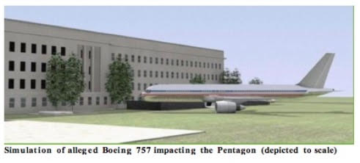
9/11: No Boeing757 Hit the Pentagon
20 July 2018
Mr. President,
According to The 9/11 Commission Report (2004), American Airlines Flight 77, a Boeing 757, was flown into the Pentagon at around 400 mph barely skimming the ground and taking out a series of lampposts on its approach. As a pilot and aeronautical engineer, however, that cannot be correct: high-speed flight in relatively close proximity to the ground is virtually impossible – in any fixed-wing aircraft.
An exception would be cruise-type missiles, whose flying surfaces are more akin to horizontal fins than wings, and thus have extremely high wing loadings (lbs/sf) — much higher even than of ground-attack fighter-bombers.
Commonly invoked photos of aircraft in flight close to the ground do not depict flight at anywhere near maximum speed; they are photos taken of craft flying at greatly reduced throttle settings – which is what actually happens during any landing!
An aircraft’s wing, basically, is an air deflector. As an aircraft moves forward, the wing essentially deflects the resultant airstream downward. This downward deflection of air causes an equal and opposite reaction upward. This upward reaction (equal to the weight of the aircraft when in level flight) is what is termed ‘Lift.’
This downward deflection of air, which occurs along the entire span of the wing, is also what constitutes downwash. This downwash ‘sheet’ has a vertical component that is normal (I.e., at a right angles) to the direction of flight. When an aircraft flies in close proximity to the ground, it is this vertical component of Downwash that causes the ‘cushion’ of air between the wing and the ground.
This “cushion,” when sufficiently energized (by an aircraft’s high speed), behaves much like a pneumatic “spring,” and tends to resist any action against it — such as that caused by a pilot trying to force the aircraft down against it.
In the case of a Boeing 757, given its wingspan of 124 feet, this would equate to roughly 62 feet AGL. Sixty-two feet is a theoretical minimum; a practical minimum would actually be considerably higher.
In a real-world situation (such as allegedly at the Pentagon), a pilot — especially one as demonstrably inept as Hani Hanjour who could barely fly a trainer — probably could not have come within 100 feet of the ground in a Boeing 757 flying at 400 mph.
This means that the “official account” of the Pentagon hit cannot possibly be correct because it violates the laws of aerodynamics. The 9/11 Commission has been playing the American people for saps.
Very respectfully,
Aeronautical Engineer
Reference:
An Aeronautical Engineer, “No Boeing 757 hit the Pentagon”

