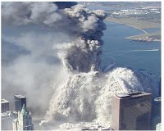
9/11 Twin Towers Collapse and Vaporization Cannot Be Explained by Nano-Thermite Alone
18 July 2018
Dear Mr. President,
Nano-thermite (a finely-granulated version of thermite, an incendiary long used to weld railroad tracks and to disable artillery using thermite grenades) has been oversold by those who claim that it holds the key to understanding how the Twin Towers were taken down. This thesis, promulgated by the lame stream media as the predominant if not exclusive “9/11 truth movement” view, is very easy to disprove, thus further confirming that what you call the “fake news” media is totally complicit in maintaining an official narrative that is false.
It is a law of materials science that, in order for an explosive to destroy a material, it must have a detonation velocity equal to or greater than the speed of sound in that material. Nanothermite does not satisfy that condition for either concrete or steel, which makes it a non-starter for this role.
The speed of sound in concrete is 3,200 meters/second and in steel 6,100 meters/second. The highest possible detonation velocity for nanothermite in the scientific literature is only 895 meters/second – 28% of what is required for concrete, and 15% of what is required for steel.
This means it would not be physically possible for nanothermite to have been responsible for blowing apart the Twin Towers insofar as it cannot blow apart either concrete or steel, the primary constituents.
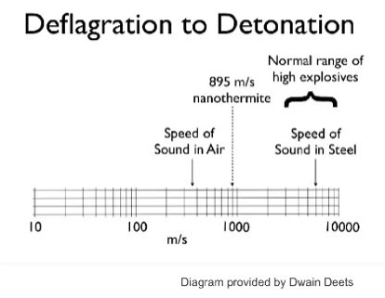
While nanothermite may have been used in an auxiliary role (for the purpose of cutting through specific joints and trusses), its explosive force is only 1/13 that of TNT, which is the universal standard. It would have made no sense to use nanothermite in lieu of other more powerful explosives, which is revealed by the estimate of Neils Harrit, a proponent of the nanothermite hypothesis, that it would have taken from 29,000 to 143,000 metric tons of nanothermite for each tower. Q.E.D.
Other means – not at all investigated by the 9/11 Commission which appears to have been more of a cover-up Commission – were used to achieve the vaporization of the Twin Towers. It remains for you, Mr. President, to fulfil your campaign promise to get to the bottom of this, and give us a new independent 9/11 investigation on the who, why, how, and costs of the 9/11 atrocity.
Very respectfully,
T. Mark Hightower
Reference with additional facts and links: T. Mark Hightower, “Nanothermite: If it Doesn’t Fit, you Must Acquit!” James Fetzer Blog, 26 August 2011

