10 July 2018
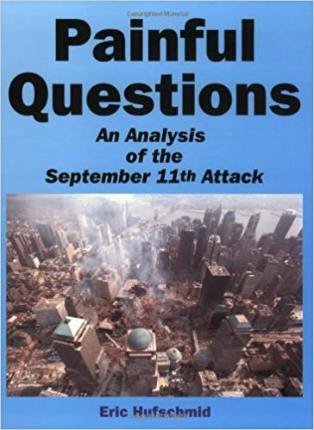
Dear Mr. President,
Many attentive citizens and groups, including Architects and Engineers for 9/11 Truth, have provided ample evidence that Building 7 and the two World Trade Center towers were demolished with explosives, thereby proving that the 9/11 attack was a "false flag" operation, and that the US military started wars in the Middle East with people who had no responsibility for the 9/11 attack. However, our evidence is still being ignored or ridiculed by journalists, government officials, military officials, and school teachers.
There are three negative consequences for America if you, Mr. President, allow the lies about 9/11 – lies that justified a seven trillion dollar war across Central Asia and the Middle East that you yourself have said has given us nothing:
First, you will continue to be opposed by the Deep State that uses the lies of 9/11 to justify more and more money for both a police state at home and elective wars abroad – wars that create new terrorists when we are not funding, equipping, and training the terrorists directly, as with ISIS.
Second, those of your citizens who know the truth will continue to be marginalized, ostracized, and in many cases put out of work as the Deep State seeks to keep their voices from being heard.
Third, the majority of the public, most of whom did not vote for you in 2016, will continue to believe these lies and not see that you are our single best hope for taking down the Deep State and ending the “endless war” that they need in order to continue to loot the USA and the rest of the world.
I wrote one of the definitive books on 9/11, accompanied by a DVD, that others have described as “exhaustive.” There is no question but that 9/11 was an “inside job” but there is only one person, you, Mr. President, who can drive this point home when you give your 9/11 anniversary speech on 11 September 2018.
I, and many other people around the world, have been impressed over and over with your ability to stand up to incompetent and dishonest journalists and government officials. You have caused the expression "fake news" to become popular around the world, and your recent accusation that Maxine Walters has a low IQ is likely to inspire more people to complain about their incompetent government officials. If you would find the courage to make a public statement that the 9/11 attack was a false flag operation, you would be able to put an end to this abuse very rapidly because you would give credibility to the "crazy" conspiracy theories about the 9/11 attack. You would cause people around the world to start discussing an issue that the controlled journalists and think tanks continue to obscure with lies.
Very respectfully,
Eric Hufschmid

