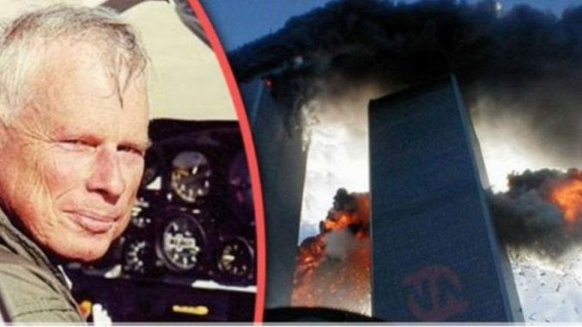
9/11 Twin Towers Were Not Hit By Nor Destroyed By Two Airliners
19 July 2018
Mr. President,
The 9/11 Commission refused to take evidence from Pilots for 9/11 Truth, of which I am a member, with over 19,000 hours flight time, much of that flying covert missions for the CIA, and including 17 world speed records in a Lear Jet Model 24.
No Boeing 767 airlines hit either of the Twin Towers, as fraudulently alleged by the government, media, NIST and its contractors. All of the “evidence” to that effect, including video depictions, has been fabricated and can be forensically challenged.
You yourself, Mr. President, one of the most experienced property developers in New York City, have correctly observed that the buildings could only have been brought down by explosive as “planes would never be able to penetrate the steel beams”, had it exactly right. I leave it to you to create a new independent commission to examine all possibilities including thermite, pre-planted explosives (TNT), directed energy weapons from above, and nuclear explosions from below.
My focus is on the physical impossibility of the specific alleged aircraft crashing into either of the twin towers.
In the case of UAL 175 going into the south tower, a real Boeing 767 would have begun "telescoping" when the nose hit the 14-inch steel columns which are 39 inches on center. The vertical and horizontal tail would have instantaneously separated from the aircraft, hit the steel box columns and fallen to the ground.
The engines – made of titanium and virtually indestructible -- when impacting the steel columns would have maintained their general shape and either fallen to the ground or been recovered in the debris of the collapsed building.
No Boeing 767 could attain a speed of 540 mph at 1000 feet above sea level because ‘parasite drag doubles with velocity’ and ‘parasite power’ cubes with velocity. These are scientific facts.
The fan portion of the engine is not designed to accept the volume of dense air at that altitude and speed.
No significant part of the Boeing 767 or engine could have penetrated the 14-inch steel columns and 37 feet beyond the massive core of the tower without part of it falling to the ground.
The piece of alleged external fuselage containing 3 or 4 window cutouts is inconsistent with an airplane that hit 14-inch steel box columns, placed at over 500 mph: It would have crumpled.
The debris of the collapse should have contained massive sections of the Boeing 767, including 3 engine cores weighing approximately 9000 pounds apiece which could not have been hidden. Yet there is no evidence of any of these massive structural components from either 767 at the WTC. Such complete disappearance of 767s is impossible.
Instead of bodies, seats, luggage, wings and tail having fallen to the ground external to either building (which would have happened had real planes hit them), we have a component from a General Electric CF-6 engine, found at Church and Murray Streets under a rain canopy, which was neither torn nor damaged, which would have happened had it been thrown from an airplane crashing into the South Tower.​ Whoever placed it on the sidewalk, which would have been deeply gouged by something so massive having hit at high velocity (the sidewalk was pristine), did not know that only the American Airlines Boeing 767-300 uses General Electric CF-6 engines, which therefor cannot have come from United Flight 175. Planting evidence demonstrates by itself that 9/11 was an orchestrated and planned event.
The Boeing 767 has approximately three million FAA approved parts, each of which must be stamped or engraved with an FAA approved manufacturers identification and parts number. Not a single part of the 6 million parts from the two Boeing 767's which allegedly crashed into the World Trade Center has been found.
The “crash” in Shankesville, PA is a bomb crater with a truckload of trash dumped into the hole. From sources at Boeing. the ACARS (Aircraft Communicating, Addressing and Reporting System), which transmits the position, altitude, speed and engine data of aircraft in the air via satellite to its respective operators (Boeing, UAL, P&W) it is quite certain that the flight alleged to have crashed there was in fact operating for a minimum of four hours after its alleged crash in Shankesville, PA, which was therefore also obviously fraudulent.
Mr. President, it is quite clear to all patriotic citizens that are paying attention that 9/11 was a false flag attack that framed Muslims, using patsies documented by Saudi Arabia, as part of a Zionist plan in which at a minimum Dick Cheney, Donald Rumsfeld, George Tenet at the CIA, and others in key US Government positions, were complicit. The purpose of this false flag event was to draw the United States into perpetual war against the Arab states that served as a counter-balance to Israel's domination of the entire region and to pave the way for the expansion of Israel in accord with the Yinon Plan (to create Greater Israel) – it is this plan and the Zionist culpability for 9/11 that needs to be a focus of attention as you seek the truth about 9/11.
I have spent years working with the Mossad and flying for CIA into and around the Middle East, to include being the pilot that delivered the arms and ammunition to Iran by order of President Ronald Reagan in return for the hostages. I was friends with Salim bin Laden. I am quite certain that the 9/11 Commission Report is a pack of lies, an orchestrated cover-up similar to the Warren Commission cover-up that is now unraveling even further in the aftermath of your directed release of 50,000 more records. America needs the truth about 9/11 and it is my view that your leadership on this matter, in time to educate America on the truth when you speak on 9/11 2018, can be the critical factor in “rebooting” public understanding of who our enemies are, both foreign and domestic.
Please, Mr. President, use the truth about 9/11 to accelerate your taking down the Deep State and its Zionist under-belly. May God Bless you, Mr. President, and may God Bless America.
Very respectfully,
John Lear
Reference:
John Lear's Affidavit on the Non-Occurrence of Tower Hits on 9/11

