9/11 Twin Towers were destroyed using "clean nukes", WTC 7 with conventional demolitions
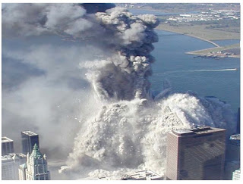
Joe Olson, Structural Engineer, 5 July 2018
"Clean Nukes.” The Twin Towers and most of the World Trade Center (apart from WTC-7, which came down seven hours later in a classic controlled demolition) appear to have been demolished – much of it vaporized – using "clean nukes.” The technical term is "minimum residual radiation" (MRR, also sometimes called "reduced residual radiation," RRR). Residual radiation is what remains by way of radioactive contaminants after the initial radiation of the first minute has worn off. Because the fission products are the "dirty" part of the nuclear blast, two factors are central in order to keep the device as "clean" as possible: (1) the fission-fusion mix of the thermonuclear device, i.e., the share of the total yield delivered by the fission primary and fusion secondary, respectively; and (2) the conditions under which the nuke is fired, whether it's an air burst, ground burst or underground explosion, and whether the underground explosion takes place in an unobstructed shaft and whether any structure stands on top of the shaft, i.e. the energy can be channeled. Actual MRR appears to have been a 400-ton equivalent requiring 4 pounds of uranium.
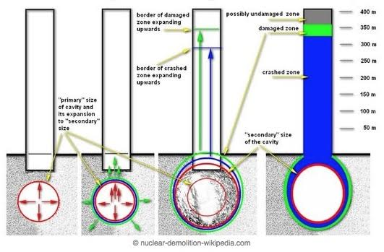
Construction Favoring Nuclear Effect & Containment. WTC 1 & 2 exemplified a novel tube-within-a tube design that created open office space with 47 massive core columns and 240 external support columns. This allowed the deeply buried nuclear devices to have their full force channeled upwards and destroy the inner tube from the bottom/up, but caused the external tube to blow apart from the top/down. The buildings were converted into millions of cubic yards of very fine dust (which is itself a signature of the use of nuclear devices) and, when it was done (about 9 seconds for South Tower, 11 for North), there was no stack of debris in their footprints, where the result of a classic controlled demolition would have been around 13.5 floors to debris (roughly, 12% of the height of the original 110 floors for each structure). Additional explosives may have been used as a supplemental means of destroying the buildings. Many floors appear to have been unoccupied – free of both occupants and furniture – prior vacancy rates having been accelerated by a 40% increase in rental rate to encourage tenants to vacate.
Radioactivity Indications in USGS Dust Studies. The contrast between the destruction of the Twin Towers and WTC-7, which collapsed about seven hours later as the effect of a classic controlled demolition, was striking. Instead of vaporization in every direction, all the floors of WTC-7 came down at the same time. There was no conversion into millions of yards of very fine dust. And, when it was done, there was a stack of debris of about 5.5 floors (or 12% of the original 47 floors).
Studies of dust samples from 35 location in Lower Manhattan confirmed elements that, in their quantifies and correlations, were indicative of a nuclear event, including Barium, Strontium, Thorium, Uranium, Lithium, Lanthanum, Yttrium, Chromium and Tritium.
Nuclear Vaporization versus Thermite Melting. 0.13 pounds of thermite required to heat each pound of steel to its melting point. The decorative Aluminum Cladding + Iron Oxide + high heat = thermite spheres, which were residue. With 400,000 tons of missing steel and concrete – much of it vaporized – nuclear energy is posited.
Primary Reference: Tahil, William, Ground Zero: The Nuclear Demolition of the World Trade Centre (2006). See also: Andre Gsponer, Fourth Generation Nuclear Weapons: Military Effectiveness and Collateral Effects (2005).

