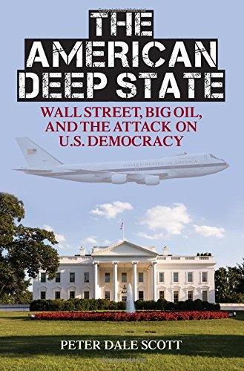
9/11, Dick Cheney & The Hijacking of the U.S. Government
13 July 2018
Mr. President,
As I outline in opening The American Deep State, I have been very concerned by the important and increasingly deleterious impact on American history of what I have called deep events: events, like the JFK assassination, the Watergate break-in, or 9/11, which repeatedly involve lawbreaking or violence, are mysterious to begin with, are embedded in ongoing covert processes, have consequences that enlarge covert government, and are subsequently covered up by systematic falsifications in media and internal government records.
One factor linking Dallas, Watergate, and 9/11, has been the involvement in all three deep events of personnel involved in America’s highest-level emergency planning, known since the 1950s as Continuity of Government (COG) planning, or more colloquially inside the Pentagon as “the Doomsday Project.”
The implementation of COG plans on 9/11 was the culmination of decades of such planning, and has resulted in the permanent militarization of the domestic United States, and the imposition at home of institutions and processes designed for domination abroad.
In short, the COG process – the ultra-secret COG process – has been used even against presidents.
Today, in 2018, I believe more strongly than ever that COG planning, or what the Pentagon called “the Doomsday Project,” is demonstrably the key to America’s response to 9/11: above all, Dick Cheney’s orders to President George Bush and Attorney General John Ashcroft to stay out of Washington, until Cheney and his Chief of Staff David Addington had finished implementing the COG plans Cheney and Donald Rumsfeld had helped develop secretly (even when not in the government) over the preceding two decades.
I believe further that those implemented COG plans, so secret that even responsible Congressional committees have been unable to review them, are the key to post-9/11 features of the deep state, such as warrantless surveillance, warrantless detention, and (as noted above), the permanent and perhaps illegal militarization of the domestic United States.
Very respectfully,
Peter Dale Scott

