Robert Steele: U.S. Attorney Has Received a Petition Demanding 9/11 Investigation
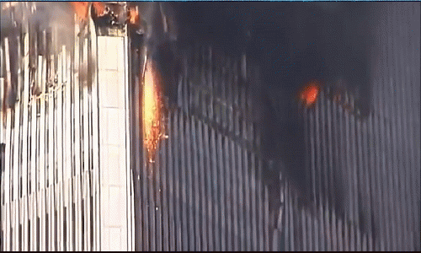
Mr. President,
On 10 April 2018 The non-profit Lawyers' Committee for 9/11 Inquiry delivered a 54-page petition and its 57 exhibits detailing the evidence that explosives were used to destroy the WTC buildings during the attack on Sept. 11, 2001 to the U.S. Attorney for the Southern District of New York.
The Lawyer’s Committee demands that the U.S. Attorney – who works for you – convene a criminal grand jury. The petition's executive summary and full text are posted on the Lawyers' Committee website, as of April 9.
The petition seeks the first major criminal inquiry on the destruction of the Towers and WTC 7. The petition seeks a formal probe of the evidence. Unlike the 9/11 Commission, which avoided serious investigation in all its forms; and unlike civil suits, a criminal grand jury with the full weight of the U.S. Government behind it can obtain all manner of documents and sworn statements.
The 9/11 Commission, issued a report in July 2004 that left many serious researchers and 9/11 victims' family members complaining about many unanswered questions, especially after significant new evidence arose.
It merits comment that all civil claims related to 9/11 have been settled out of court, with the apparent specific intent of avoiding legal discovery.
Mr. President, the families of 9/11, the first responders of New York City, and the public at large have been lied to for over sixteen years now. You promised to get to the bottom of 9/11. Directing that this petition be honored is something you have the power to do and it will take only one telephone call to the Attorney General, Jefferson Sessions. Can we count on you in this matter?
Very respectfully,
Robert David Steele

