Dedication

This civic endeavor – this non-profit educational endeavor – this cry from the heart by scholars, lawyers, former spies, and plain citizens using their common sense – is dedicated to:

…the families of 9/11 who first realized that elements of the US Government (USG) are in the business of false flag operations and fake news;

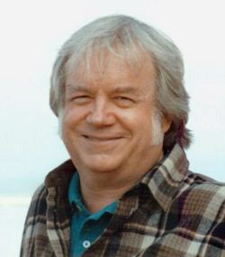

…to Dr. James Fetzer, former Marine Corps artillery officer and professor emeritus whose edited book on Sandy Hook –a triumph of team work and logic – set the gold standard for citizen intelligence applied with common sense in the public interest; and

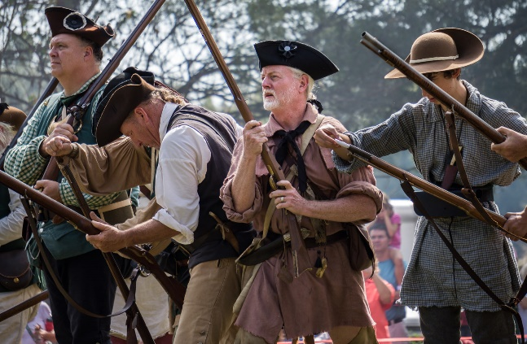
…to the citizens of the United States of America (USA), whose Constitutional right to bear arms is under direct attack by the Shadow Government operating on behalf of the Deep State to plan and execute false flag exercises intended to terrify, confuse, and disarm, while using national security waivers and impunity to lie to the Courts and to the public.

