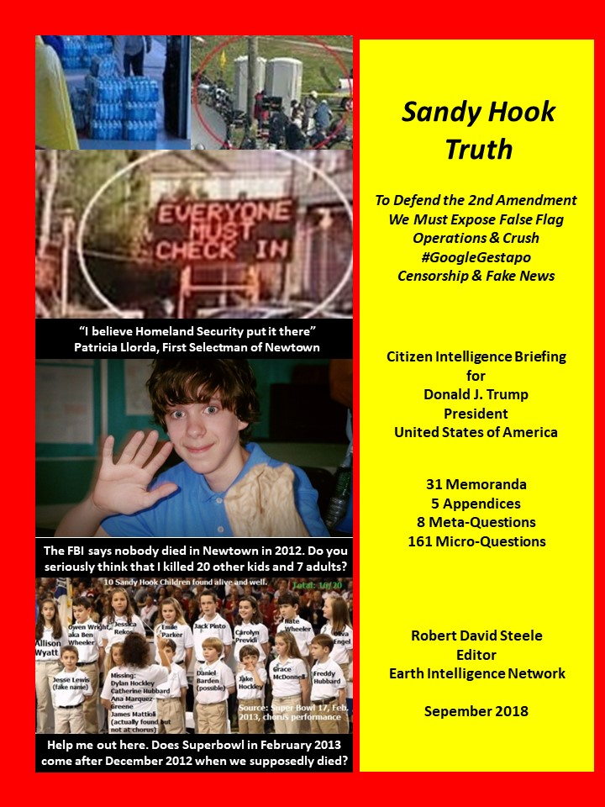
Sandy Hook Truth

To Defend the 2nd Amendment We Must Expose False Flag Operations & Crush #GoogleGestapo Censorship & Fake News

Citizen Intelligence Briefing for
Donald J. Trump
President
United States of America

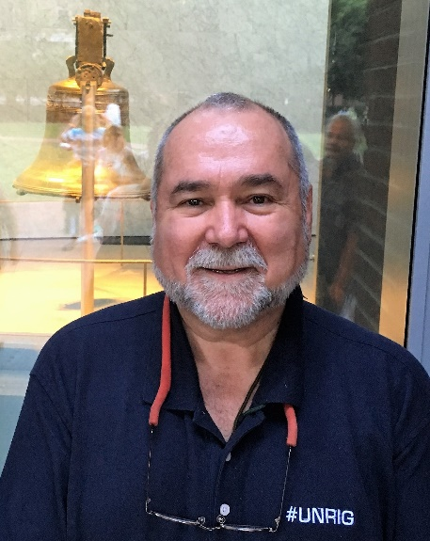
Robert David Steele
Editor
Earth Intelligence Network

All Memorandums
Previously Published Free Online
http://tinyurl.com/SH-POTUS

This volume is free online as a PDF for ease of sharing from the above URL. Each Memorandum is also in full text online to permit the Translate Widget to be used and can be accessed at the above URL.

NOTICE
The first volume in the series, 9/11 Truth: From Campaign Promise to a Presidential Speech on 9/11/2018? Is free online as both a PDF and full text translatable online chapters, at http://tinyurl.com/911-POTUS. Both volumes have been delivered to the White House and to multiple intimates of the President of the United States of America. Individual authors are responsible for their own words alone, not for the words of other authors or the nature of either volume in the aggregate. Robert David Steele, as editor and publisher, is responsible for the presentation of the information to the President and the public; he is asking questions, not providing answers. It is now up to the public to decide if a) lying has been “legalized” to protect domestic false flag operations; and b) new independent investigations are required to establish, in an evidentiary manner without legalized lies, the truth about each and every mass casualty event that is believed by inquiring minds to be – but not yet proven to be – a false flag event.
Table of Contents
Dedication 5
Robert Steele: Letter of Transmittal & Questions 6
THE BIG PICTURE 8
James Fetzer: Obama Enabled False Flags by Nullifying the Smith-Mundt Act of 1948 8
James Fetzer: Sandy Hook was a FEMA drill – “Everyone Must Check In” 11
James Fetzer: Sandy Hook Was A FEMA Drill, Nobody Died, for an Anti-Gun Agenda 14
Vivian Lee: Top Ten Reasons Sandy Hook Was An Elaborate Hoax 18
Sterling Harwood: Final Report on Sandy Hook: Complete & Total Forensic Failure 23
FABRICATING EVIDENCE & POST-EVENT EXPOSURE 26
Dr. Eowyn: Sandy Hook Moved to Chalk Hill Months Before ‘Massacre’ 26
Mona Alexis Pressley: 2 Principals, 2 Schools Buildings, but 0 CAPT Scores for 2009 33
Dan Cromer and Mona Alexis Pressley: Shannon Hick’s Sandy Hook Fake (Staged) Photos 36
Allen William Powell: Connecticut State Police Behind the Scenes at Sandy Hook 40
Wolfgang Halbig: Connecticut State Police False Affidavits about Entering School 42
Kelley Watt: Nobody Knows Who Cleaned Up the Blood -- No Blood to Clean Up? 47
Mona Alexis Pressley: Dead Sandy Hook Principal interviewed by The Newtown Bee 49
Stephanie Sledge: Car with License Plate from Sheriff’s Department in Wisconsin 51
CRISIS ACTORS & OTHER FAKES 54
Carl Herman: Very Old Moms – Average Age Giving Birth = 36 Years Old 54
Mona Alexis Pressley & Dan Cromer: “Lenny Pozner”, and “Noah Pozner”, are Both Fake 56
Mona Alexis Pressley: “Noah Pozner” Exists But Did Not Die at Sandy Hook 60
Mona Alexis Pressley: Charlottesville Crisis Actor made her Debut in Sandy Hook 63
Mona Alexis Pressley: “Sloppy Sniper” at Sandy Hook – Photoshopping? 65
James Tracy: Sandy Hook “Mother” Assistant to Democratic Fund Raiser Maureen White 67
THE COVER-UP 69
James Tracy: Media Smears Professor to Point He Is Fired – Free Speech is Dead 69
Louis Leo IV: James Tracy’s Wrongful Termination—the End of Free Speech? 72
John Remington Graham: Litigation Against Alex Jones in Connecticut is Abuse of Process 74
James Fetzer: Impostors Seek Social Media Giants Protection for Their Criminal Acts 76
Sterling Harwood: Snopes.com Complicit in Cover-Up? 78
Cinderella Broom: Burying the Undead - Stranger Than Fiction 82
Carl Herman: “Chemtrails” Preventing Satellite Photos on 14 December 2012 85
LESSONS LEARNED & ONE FINAL QUESTION 87
Nicholas Kollerstrom: State-Sponsored Terror – Nobody Died – Exercise With Crisis Actors 87
James Fetzer: Why did Americans Swallow Sandy Hook, Line and Sinker? 89
Michael Thomas: Alex Jones’ Internet Crime? Telling The Truth about Sandy Hook 92
Tony Mead: Sandy Hook Litmus Test – Freedom of Speech versus Internet Censorship 97
Jack Mullen: Will Alex Jones Take the Fall to Sustain Sandy Hook Lies? 99
APPENDICES 101
Brian Wright: Banned by Amazon – The Single Most Important Book on Sandy Hook 101
James Fetzer: Amicus Curiae Argument to 345th District Court, Travis County, Texas 107
James Fetzer: Amicus Curiae Evidence to 345th District Court, Travis County, Texas 109
Robert Steele: Information Pathologies Active in the USA Today 114
Robert Steele: Questions for an Independent Investigation to Answer 120
INDEX OF NAMES 126

Dedication

This civic endeavor – this non-profit educational endeavor – this cry from the heart by scholars, lawyers, former spies, and plain citizens using their common sense – is dedicated to:

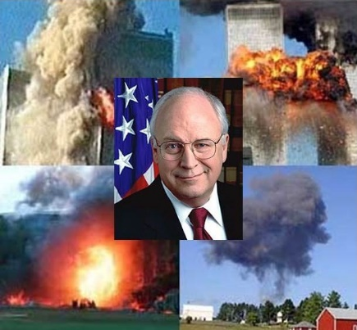

…the families of 9/11 who first realized that elements of the US Government (USG) are in the business of false flag operations and fake news;

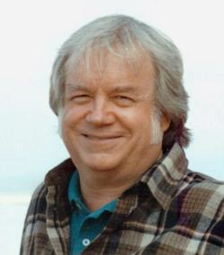

…to Dr. James Fetzer, former Marine Corps artillery officer and professor emeritus whose edited book on Sandy Hook –a triumph of team work and logic – set the gold standard for citizen intelligence applied with common sense in the public interest; and

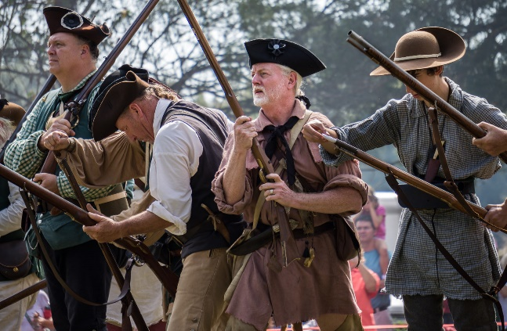
…to the citizens of the United States of America (USA), whose Constitutional right to bear arms is under direct attack by the Shadow Government operating on behalf of the Deep State to plan and execute false flag exercises intended to terrify, confuse, and disarm, while using national security waivers and impunity to lie to the Courts and to the public.

Robert Steele: Letter of Transmittal & Questions
Mr. President,
I am a former spy who managed a false flag operation for my employer, the Central Intelligence Agency (CIA); I was recommended for the Nobel Peace Prize in 2017 for my pioneering of the new craft of intelligence that can answer 100% of the questions you have instead of 4% as is now the case. I am, as well, a Commissioner and the Chief Counsel for the Judicial Commission of Inquiry into Human Trafficking and Child Sex Abuse. I have questions about a series of apparent domestic false flag operations that include:

- 2012 December 14 Sandy Hook
- 2013 May 14 Boston Bombing
- 2015 December 2 San Bernardino
- 2016 June 12 Orlando Nightclub
- 2017 October 1 Las Vegas
- 2018 April 14 Parkland

In this letter of transmittal I will make seven points, following up on my earlier message that transmitted the first volume, 9/11 Truth: From Campaign Promise to a Presidential Speech on 9/11/2018?
01 You cannot defend the 2nd Amendment without challenging all domestic false flag operations.
02 The cyber-censorship of Alex Jones and many others over Sandy Hook along with tens of thousands of conservative voices and of news favorable to you – is the co-equal threat to the 1st Amendment.
03 The National Rifle Association (NRA) under Ollie North, a subordinate of Dick Cheney, is not your friend. Although the NRA helped you win in 2016, they appear to have been captured and neutralized.
04 It is now “legal” for your government and the fake news media to lie to the public under a national security mandate, and the Department of Justice under your predecessor informed the Courts that the Executive reserves the right to lie to the Courts in relation to national security. Alex Jones will not win the Sandy Hook defamation lawsuits unless you intervene and overturn the legalized lying to the Courts.
05 Although some of the authors of the memoranda herewith are very assertive as to what they believe the facts to be, for myself, and for the good of the Republic, I believe this volume should be construed as a volume of questions. There are too many anomalies, too many apparent lies, too little evidence supporting the official narrative. As with 9/11, an independent investigation is clearly required.
06 The blatant violations of Title 7 and other service of common concern laws and regulations are the tip of the iceberg. One software company has disabled its software for all businesses supporting U.S. Immigration and Customs Enforcement (ICE). This is about more than social media – cyber is out of control and if Mark Bowden’s book WORM is any guide, the U.S. Government has no idea what to do.
07 Let me end by expressing my deepest admiration for all you have done behind the scenes on the economic, financial, and legal fronts. Your recovery of trillions of dollars, your plans for a gold-backed dollar, your reassertion of authority over the Federal Reserve, your plans to pump $1.5 trillion into the U.S. economy from the bottom up, are all brilliant. Breathtakingly brilliant.
I ask 8 meta- questions on the next page – 161 specific questions about the Sandy Hook “narrative” are in the final appendix. The Deep State is waging war on all of us. I want to help you win that war.
Very respectfully,
Robert David Steele
Questions Related to Sandy Hook
The last appendix has a table of questions sorted by category. They represent a tiny fraction of the questions that could reasonably be asked by any citizen (or the President) and while answers are offered by the various contributors to this volume, the reality is that two separate forces must converge to arrive at the truth about Sandy Hook: an independent investigation with subpoena power; and a Presidential commitment to over-ride national security waivers (“legalized lying”) and if needed, to also offer Presidential pardons to key witnesses who have been totally intimidated by the Deep State and the Shadow Government, of which FEMA appears to be nearly as important as the CIA these days.
The meta-questions are these:
01 Will the President of the United States of America (POTUS) make Free Speech versus Fake News and Internet Censorship by the Deep State an election issue in September-November 2018?
02 Will the President see that both 9/11 Truth and Sandy Hook Truth are the core means of protecting the 2nd Amendment by confronting the fake news and legalized lying put in place by the Obama-Biden Administration and before them the Bush-Cheney Administration?
03 Will the President order the Attorney General to begin a RICO (Racketeer Influenced and Corrupt Organizations Act) investigation of Amazon (which banned the book on Sandy Hook), Facebook, Google, MeetUp, Twitter, YouTube, and WordPress.com, all of them censoring and repressing conservatives and voices for liberty and truth as well as progressives who question the Deep State narratives?
04 Will the President use 9/11 Truth and Sandy Hook Truth as a litmus test for the NRA (National Rifle Association), challenging them to step up their game in defense of the 2nd Amendment?
05 Will the President direct his Office of Legislative Affairs (OLA) to devise a legislative solution that ends censorship, manipulation, and digital assassination outside the rule of law by the consortium known as #GoogleGestapo? This would include a reversal of the changes made to the Smith-Mundt Act of 1948 and a considerable revision of the Telecommunications Act of 1996 to hold #GoogleGestapo elements accountable for Title 7 and common carrier obligations to provide universal service without prejudice.
06 Will the President mandate an independent investigation of 9/11 as well as Sandy Hook, and ideally of the other five events suspected of being false flag events? As part of that mandate, will the President issue an Executive Order prohibiting the use of national security waivers to enable lying to Congress and the Courts as well as the public, and make Presidential pardons explicitly available as an incentive for those fearful of going against the Deep State and Shadow Government that thrives on false flags and fake news?
07 Will the President consider some form of media legislation that defines with some precision how due diligence and regard for the truth might be measured, making such due diligence a requisite for continuation of any public broadcasting or publishing license?
08 Will the President entertain the ideas that have been put forward for a new social ecology that connects the President directly to 200 million individual voters, an ecology that enables information sharing favorable to informed democracy, and ultimately allowing the President to pulse 200 million hearts and minds by demographic, location, and issue, something no one else can do, in real time? We should bury Facebook, Google, Twitter, and YouTube particularly. I know how to do this and do it fast.

THE BIG PICTURE

James Fetzer: Obama Enabled False Flags by Nullifying the Smith-Mundt Act of 1948
Mr. President,
Under President Barack Obama, a law was changed under the recent Smith-Mundt Modernization Act of 2012, which effectively nullified the original 1948 act. The original prohibited U.S. organizations from using state resources, including the U.S. intelligence community, to influence public opinion of United States citizens. Intended as a safeguard against the use of propaganda and disinformation within the country, it was nullified in time for federal, state and local authorities to bring us the staged events of Sandy Hook.
Obama unleashed one manufactured event after another under the nullified Smith-Mundt Act, including the Boston marathon bombing, Orlando and Dallas shootings, Charlottesville, Las Vegas and Parkland, which I have documented in videos and books. They even used the very same crisis actor as the mother of Heather Heyer, said to have been killed in Charlottesville, who had already played the mother of one of the teachers, Victoria Soto, alleged to have been killed at Sandy Hook. Below is a comparison for proof.
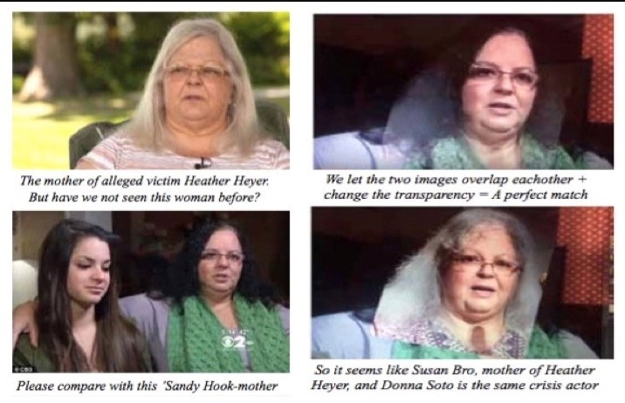
The Deep State has ingeniously deployed the Social Media Giants—whose origins reek with associations with the CIA, which began infiltrating our media in the 1950s with “Operation Mockingbird”—where, by taking for granted these shooting narrative are true (without even bothering to investigate or to verify), they have abused those who have been seeking to expose them as violating their policies on harassment and bullying, which is a subterfuge for suppressing truths as “hate speech”, because they hate the truth.
That this has become the practice to cope with the alternative media was manifest in a recent editorial carried by over 300 newspapers here in the U.S., attacking you. On issue after issue, I and my colleagues have confirmed that you were right and the media was wrong about Obama’s origin of birth, Rafael Cruz and the JFK assassination, attendance at the inauguration, and the left-wing conspiracy to sabotage your campaign and to delegitimize your administration. Thus, as I wrote to The Wisconsin State Journal:
- The editorial attacking the President of the United States as "an enemy of the truth" is a joke. On serious subjects, 80% of what the mainstream publishes and promotes is not merely false but provably false--even completely detached from reality. Anyone who wants to know what's really going on needs the alt media, which is being erased by the social media giants.
- Alex Jones, for example, who promotes a conspiracy perspective on politically significant events, such as the Sandy Hook shooting and the Boston marathon bombing, has been virtually wiped out across the board, where he has been taken down from Apple, Google, YouTube, Facebook and (now) Twitter, which is a complete disgrace.
- We cannot figure out what's really going on unless we consider alternative hypotheses, theories and conjectures. That is a crucial stage in thinking things through. When something puzzling takes place that does not fit into our background knowledge but appears anomalous instead, we need to have the opportunity to kick ideas around to sort things out.
- Alex Jones is not the last word on serious subjects, but he can be provocative and frequently features guests who are experts in their fields. William Binney, for example, whom I featured last night on my own internet radio show, "The Raw Deal", observed that Alex Jones was the only media figure who would feature him about the DNC data leak.
- This is a perfect example of the false information with which we are inundated, 24/7, by the MSM: the disputed files were downloaded at a rate too fast to have been distant Russian hacking and was done in the Eastern Time Zone. Binney, of course, is ignored by the MSM because his expertise contradicts the propaganda of the left.
- For those who care about truth, which excludes the WSJ, visit the web site of Robert David Steele, where he and I collaborated on Memoranda for the President about 9/11 (including contributions by 27 experts) and now are doing a second series on Sandy Hook. Those who care about truth will find Alex Jones is closer to it than the MSM.

Of course, The Wisconsin State Journal declined to publish. But as Gregg Jarrett, The Russia Hoax: The Illicit Scheme to Clear Hilary Clinton and Frame Donald Trump (2018), has demonstrated, the corruption of the FBI and the DOJ in attempting to sabotage your campaign was both pervasive and profound. In my opinion, his book ought to be required reading for every literate citizen, where most Americans, alas, get their news in sound bites from the MSM and don’t realize they are all reading from the same script.
The Social Media Giants were empowered by The Telecommunications Act of 1996, which adopted the perspective of them as akin to libraries and book stores, which are not liable for the contents of books and videos they make available for purchase. But by exercising censorship and taking a stand to decide what videos we can see or not see and what blogs we can read or not read, they have abandoned any pretense of political impartiality and no longer deserve protection from legal liability and prosecution.
Very respectfully,
James Fetzer

References:
“Editorial: Trump is an Enemy of the Truth” (which appeared in over 300 newspapers 16 August 2018)
“Executives From The Major Social Media Companies Gather To Plot ‘Strategy’ For The 2018 Election”
“Stop Deep State Government Misinformation” (by restoring the Smith-Mundt Act of 1948)
Jim Fetzer, a former Marine Corps officer, is Distinguished McKnight Professor Emeritus on the Duluth Campus of the University of Minnesota. He co-founded moonrockbooks.com with Mike Palecek, when they discovered amazon.com was banning their books, where he has edited books on Sandy Hook, the Boston bombing, Orlando and Dallas, Charlottesville, 9/11, and JFK, with Parkland and Las Vegas forthcoming. He has also produced many videos, including “False Flags on Five Fronts: Sandy Hook, Boston, Charlottesville, Las Vegas and JFK”, “How to Spot a ‘False Flag’: A Sampler of Representative Events”, and “The Parkland Puzzle: How the Pieces fit Together”, at 153news.net, BitChute, real.video and other secure sites.

James Fetzer: Sandy Hook was a FEMA drill – “Everyone Must Check In”
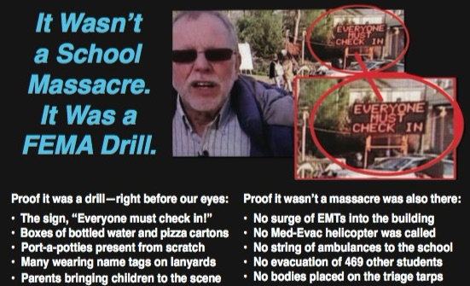

Mr. President,
During hearings on the failure of Connecticut to comply with Wolfgang Halbig’s FOIA requests, his attorney, Kay Wilson, asked First Selectman E. Patricia Llordra of Newtown, under oath, who she thought put up the flashing "Everyone Must Check in" sign at that location. The Selectman, whose position is equivalent to Mayor, responded: "I believe Homeland Security put it there”. But of course, DHS wasn’t even supposed to be there. Some would call this, “Game! Set! Match!”
Anyone who doubts that crisis actors were used at Sandy Hook cannot be familiar with the B-grade performances of bona fide actors such as Francine Wheeler, David Wheeler, and Gene Rosen, whose performance should qualify him for “Worst Crisis Actor of 2012” Award. Gene claimed to have found several children (the number varies from 4 to 6 on various recounting) on his lawn, brought them into his home by the Firehouse and gave them milk and cookies.
All the feigned emotion he evokes cannot compensate for the absurdity of the story: Not only was there no evacuation of children from the school (which was why Shannon Hicks’ had to stage her photos) but, had there been, no bus driver would have dropped children off at the residence of someone who was not their parent or guardian. Rosen had no idea who they were and his story was absurd from the beginning. It’s frankly bewildering that anyone has bought it.

Among the many recordings of Gene Rosen’s testimony are those that show a portable sign in the background, “Everyone must check in”, which has raised questions about exactly what was going on. Some have insisted that the sign was there on the 14th (the day of the alleged event) because the crowds were enormous and had to be managed. But when I consulted experts in law enforcement whether they had heard of such a thing at a crime scene, they simply laughed.

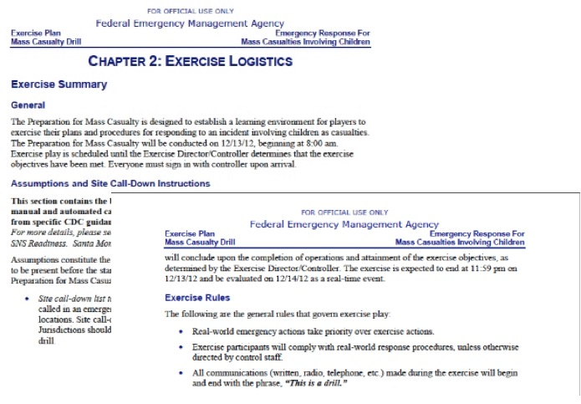
The sign was placed there on the 13th because this was a two-day FEMA exercise, for which we even have the manual, included as Appendix A to Nobody Died at Sandy Hook (2015). The drill began at 8 AM/ET on 12/13/12 and end at 11:59 PM to be evaluated on 12/14/12 as “a real-time event”. As the manual itself explains, “Everyone must sign in with the controller upon arrival”, which explains the sign, one among many ways we know this was a FEMA exercise:
- When Wolfgang sought to find out who had delivered the Port-a-Potties, he was denied that information, because it would have shown they were delivered on the 13th rather than the 14th, which led to his pursuit of legal action for failure to respond to his FOIA;
- Not only the placement of the sign but the pizza and bottled water at the Firehouse were part of the exercise, where FEMA drills provide refreshments and restrooms;
- Many there were wearing name tags on lanyards, which is also standard for FEMA exercises, where the participants are identified by color-coded nametags on lanyards;
- Parents were bringing children on location; but no parent would have brought a child to the scene of a child-shooting massacre. Because it was the rehearsal, they were treating it as a festive occasion, which is completely inexplicable had this not been a FEMA drill.

The failure to follow standard emergency procedures on the 14th was another glaring tell: no EMTs were allowed to enter the building; no string of ambulances was brought in to rush their little bodies off to hospitals where doctors could pronounce them dead or alive; no med-evac choppers were called, where, as Wolfgang, a nationally recognized school safety expert has observed, they even that routinely for drills. No bodies were ever laid out on the emergency triage tarps. And the only evidence of any evacuations are the staged photos by Shannon Hicks.

References:
Ken Adachi, “Bombshell at FOIA Hearing: Newtown Official Says "Homeland Security" Put Up Flashing "Everyone Must Check In" Sign at Sandy Hook,” EducateYourself.org, 3 June 2015.
Jim Fetzer, “Sandy Hook Update: Tracy loses, Wolfgang wins. The Deep State Strikes Back!” The Brian Ruhe Show,” (BitChute, 1:36:42), 14 January 2018
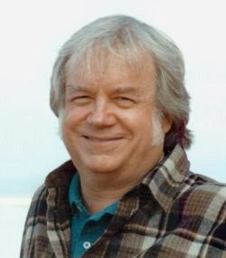
Jim Fetzer, a former Marine Corps officer, is Distinguished McKnight Professor Emeritus on the Duluth Campus of the University of Minnesota. He co-founded moonrockbooks.com with Mike Palecek, when they discovered amazon.com was banning their books. He has published widely on conspiracies, including “False Flags on Five Fronts: Sandy Hook, Boston, Charlottesville, Las Vegas and JFK”, “How to Spot a ‘False Flag’: A Sampler of Representative Events”, and “The Parkland Puzzle: How the Pieces fit Together”, at 153news.net, BitChute, real.video and other secure sites.

James Fetzer: Sandy Hook Was A FEMA Drill, Nobody Died, for an Anti-Gun Agenda
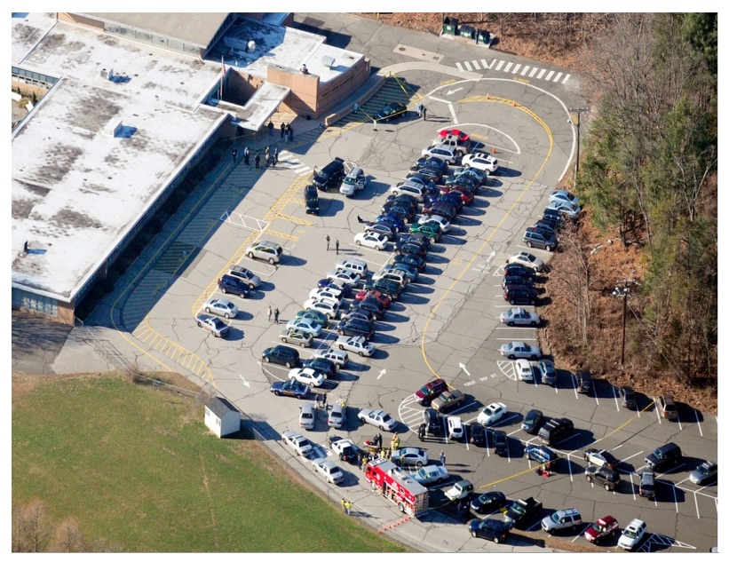
Dear Mr. President,
The nation over which you currently preside has been subjected to an on-going series of staged shootings, most of which—for maximal emotional effect—have involved the reported deaths of children, none more dramatically than the Sandy Hook Elementary School shooting in Newtown CT, on 14 December 2012, where Adam Lanza was alleged to have killed 20 first-grade children and six adults. But there were boundless anomalies here from the beginning, where even (what would have been thought to be) an innocuous photo of the parking lot gives the scam away.
Notice, in particular, the absence of familiar blue-and-white signage for handicapped parking, mandated by the Americans with Disabilities Act. Because this parking lot does not have such special parking, the school was not in compliance with the ADA and therefore cannot have been legal open in Connecticut in 2012. We have photos of entrances and exits no wheelchair could navigate, including a wooden staircase with a steel rod extending, which could pop out the eye of a little kid running toward the building. Sandy Hook Elementary was not an operating school.
Moreover, because it was a 28*F ground temperature day, the school could not have housed students without heating the building; but there is no heat or steam rising from the structure, no doubt because it appears to have been closed by 2008, the furnaces were rusted out and dysfunction from lack of use. Notice the center rows of cars are all parked facing the school, which violates the driving instructions to turn right, curl around and park facing away. It was just too convenient to bring them in as props in a single line and put them in place, two-by-two.
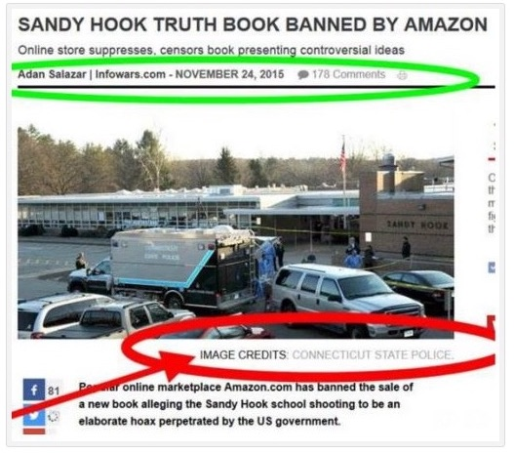
When I published NOBODY DIED AT SANDY HOOK (2015), with fifteen contributors (including six current or retired Ph.D. college professors), we proved the school had been closed by 2008 and there were no students there. One contributor, Paul Preston, who had run drills for school systems as an administrator in the past, was so bothered by what he observed being reported that he reached out to his contacts in the Obama Department of Education, all of whom told him that it had been a drill, that no children had died and that it was done to promote gun control. [Editor: Emphasis added.]
The book includes two chapters with 50 photos each, Ch. 7 of furnishing an empty house to serve as “the Lanza residence”, Ch. 8 of refurbishing the school to serve as the stage for the 2-day FEMA exercise, where we even include the FEMA manual as Appendix A. One photo in Ch. 8, Exhibit 26, shows (what we initially took to be) a SWAT vehicle present before the shooting had taken place—which is provable because the windows of Classroom 10, which would be shot out after the event, are intact. The flag is at full mast and, when you track down the staff, Wayne Carver, Medical Examiner, is patiently awaiting arrival of his portable mortuary tent.
When the book was banned by Amazon less than a month after having sold nearly 500 copies, I released it to the public for free as a pdf, where anyone can download it to their own desktop by entering the title in their browser. When Infowars.com reported the ban, they featured Exhibit 26 even more clearly than in the printed book. But it was taken down about 38 minutes later after 178 comments, no doubt because of image credit to CONNECTICUT STATE POLICE, which William Powell had discovered had documented their own participation in the scam in their own files.
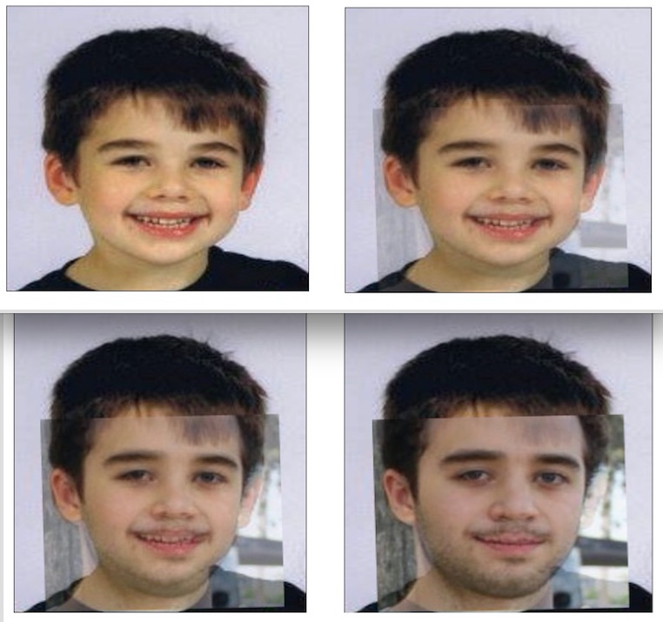
Among oddities of the press conference held by Wayne Carver, which James Tracy documented in his brilliant expose thereof, was that they did not allow the parents to see the bodies of their children but instead identified them using photographs. That was a violation of CT protocols but appropriate under the circumstances, since it turns out that the children were fictions who only existed in the form of photographs. “Noah Pozner”, shown above, for example, was made up out of photos of his “older step-brother”, Michael Vabner, which we have confirmed multiple ways.
Kelley Watt had over 100 hours of conversation with “Lenny Pozner”, who purports to be his father and who sent Kelley a death certificate for “Noah” as proof that he had died, which we included in the book. It turned out to be a fabrication, with the bottom half of a real death certificate and the top half of a fake, with no file number and the wrong estimated time of death at 11 AM, when “officially” the shooting took place between 9:35-9:40 that morning. Mona Alexis Pressley has now shown that “Lenny” is actually Reuben Vabner, Michael’s father.
Indeed, it appears that some of the “parents” may have used photos of themselves as children to perpetrate this highly-successful fraud upon the public. Without the complicity of the media and local, state and federal authorities, a scam of these dimensions could not have successfully been foisted upon the public—which continues as “Lenny Ponzer” and other fake parents are deceiving the Court by offering false testimony and concealing their identities in their suits against Alex Jones. Sandy Hook was faux terrorism to manipulate the public and promote the Obama administration’s political agenda.
Reference: “Sandy Hook Update: Tracy loses, Wolfgang wins. The Deep State Strikes Back!”
Jim Fetzer, a former Marine Corps officer, is Distinguished McKnight Professor Emeritus on the Duluth Campus of the University of Minnesota. He co-founded moonrockbooks.com with Mike Palecek, when they discovered amazon.com was banning their books. He has published widely on conspiracies, including “False Flags on Five Fronts: Sandy Hook, Boston, Charlottesville, Las Vegas and JFK”, “How to Spot a ‘False Flag’: A Sampler of Representative Events”, and “The Parkland Puzzle: How the Pieces fit Together”, at 153news.net, BitChute, real.video and other secure sites.

Vivian Lee: Top Ten Reasons Sandy Hook Was An Elaborate Hoax
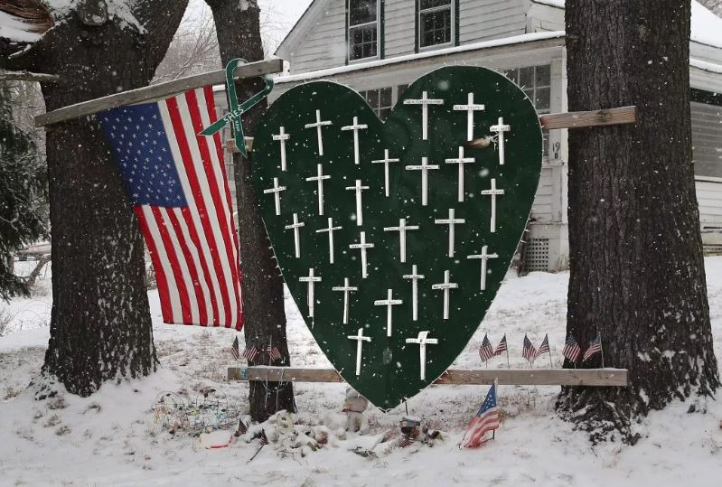
Mr. President,
I am writing in solidarity with Alex Jones—in support of his right to speak freely on YouTube, Facebook, and other internet platforms without being censored, as protected by the First Amendment to the U.S. Constitution. While Jones has not been consistent in his comments about the Sandy Hook Elementary School event, he has expressed the idea that the shooting was not real, and in this he was correct. Adam Lanza did not kill 28 people in Newtown, CT, on December 14, 2012. This was a drill, presented by officials and the media as an actual shooting. Following the event, a group of investigators compiled a list of ten reasons that, taken together, show that Sandy Hook was staged. These are published in detail in the banned book, Nobody Died at Sandy Hook: It Was a FEMA Drill To Promote Gun Control (Moon Rock Books, 2015). Although more evidence has since emerged, the original “top ten reasons” still ring true:
(1) Proof of death was suppressed.
(2) Emergency protocols were not followed.
(3) Drill protocols were followed instead.
(4) There was foreknowledge of the event.
(5) There were contradictory reports about the weapons.
(6) Adam Lanza cannot have done the shooting.
(7) Key participants displayed inappropriate behavior.
(8) Photos at the scene and of victims look staged or fake.
(9) The crime scene was completely destroyed.
(10) Deceased children sang at the Super Bowl.
To summarize, first of all, there is no proof of anyone’s death—not for the children or adults at the school, Nancy Lanza, or Adam Lanza—no photos or footage confirming the official story (1). In June 2013, the state of Connecticut outlawed disclosure of photos or video images of homicide victims, along with other records.
There is no evidence of any frantic attempt to save lives at the scene (2), which looked largely calm and bloodless. START triage protocol for a Mass Casualty Incident (MCI) was not followed. Emergency vehicles were jammed together at the Firehouse, impeding access to the school and possible rescue. Instead, drill protocols were followed (3), with ID badges visible, Porta-Potties, and cases of bottled water on hand. In an amazing coincidence, a FEMA Mass Casualty Drill, “Emergency Response for Mass Casualties Involving Children,” was scheduled to take place on December 13 or 14 (location unspecified). This furnished the script for the Sandy Hook “shooting,” an Integrated Capstone Event run by FEMA to coordinate federal, state, and local emergency response teams in case of a mass-casualty event.

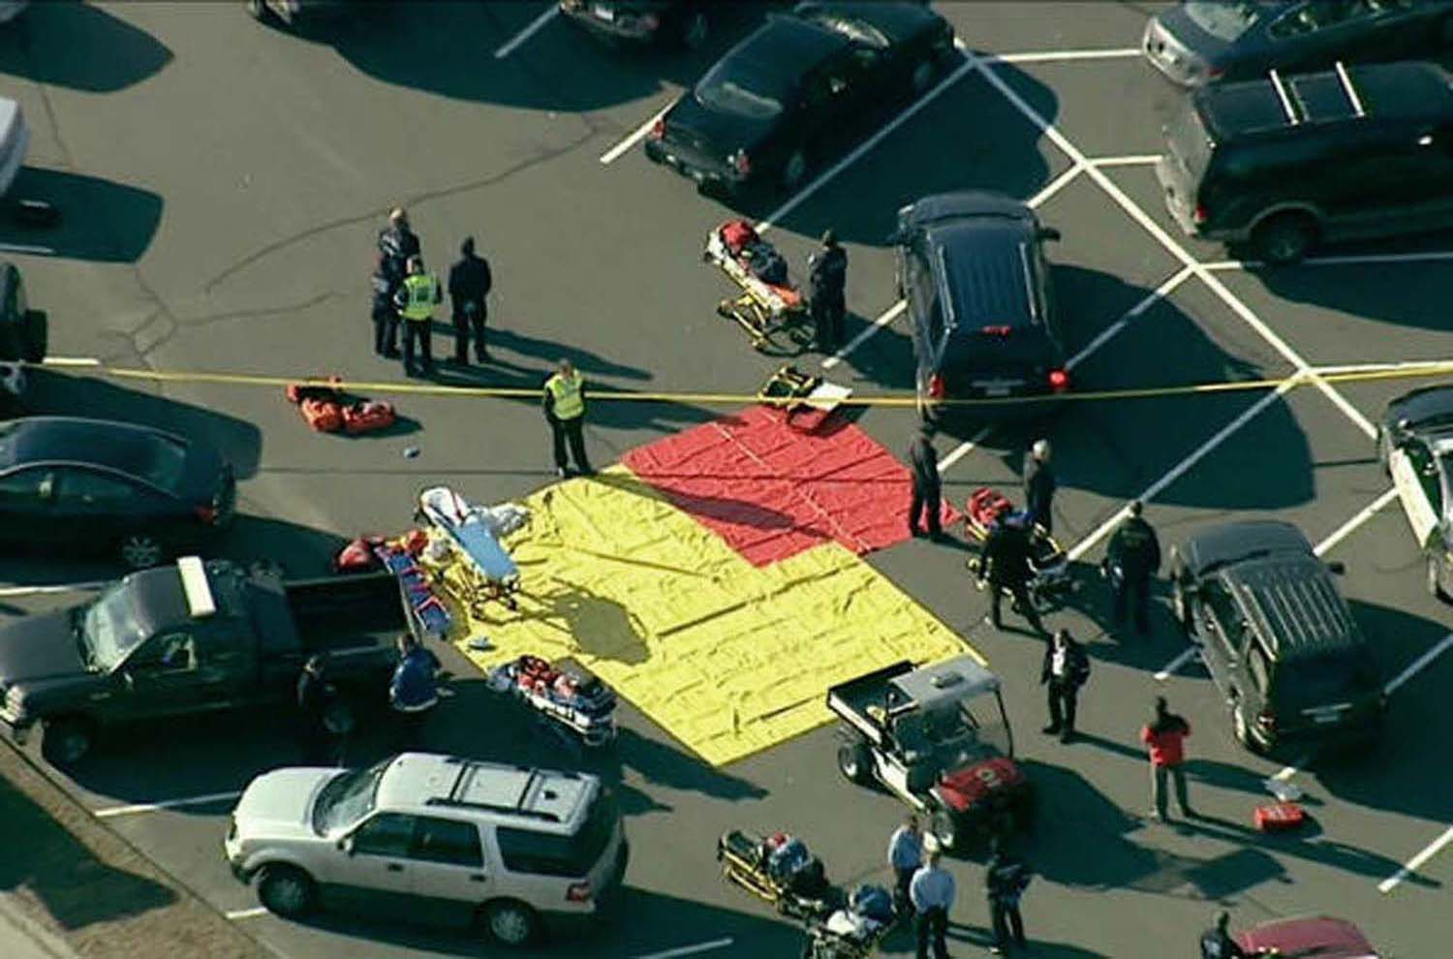
START tarps outside Sandy Hook Elementary with no victims.
There is proof of foreknowledge of the event (4). The Connecticut state emergency system was taken over before the “massacre” occurred, and normal police and EMS dispatch protocol was replaced with staged transmissions. Tweets about the “shooting” began before it occurred, and Facebook pages honoring “victims” were established before they had “died.”
State officials and the media were confused about the guns used (5), with reports of four handguns, a Bushmaster AR-15, a Bushmaster SM 15-E2S, a Glock 10mm handgun, a Sig Sauer P226 9mm handgun, and an Izhmash Saiga-12 12-gauge shotgun, supposedly found in the trunk of Adam Lanza’s car. Oddly, Fox News reported a 12-gauge shotgun and two magazines of shotgun rounds found in the glove compartment. And how did Adam Lanza, who had Asperger’s Syndrome and weighed 112 pounds, manage all these guns (6), along with more than 150 rounds of ammunition? Ballistics experts agree that he could not have carried all this on his person. In less than seven minutes, this inexperienced marksman supposedly killed 26 people and then himself, with a 96% kill ratio, a complete impossibility.

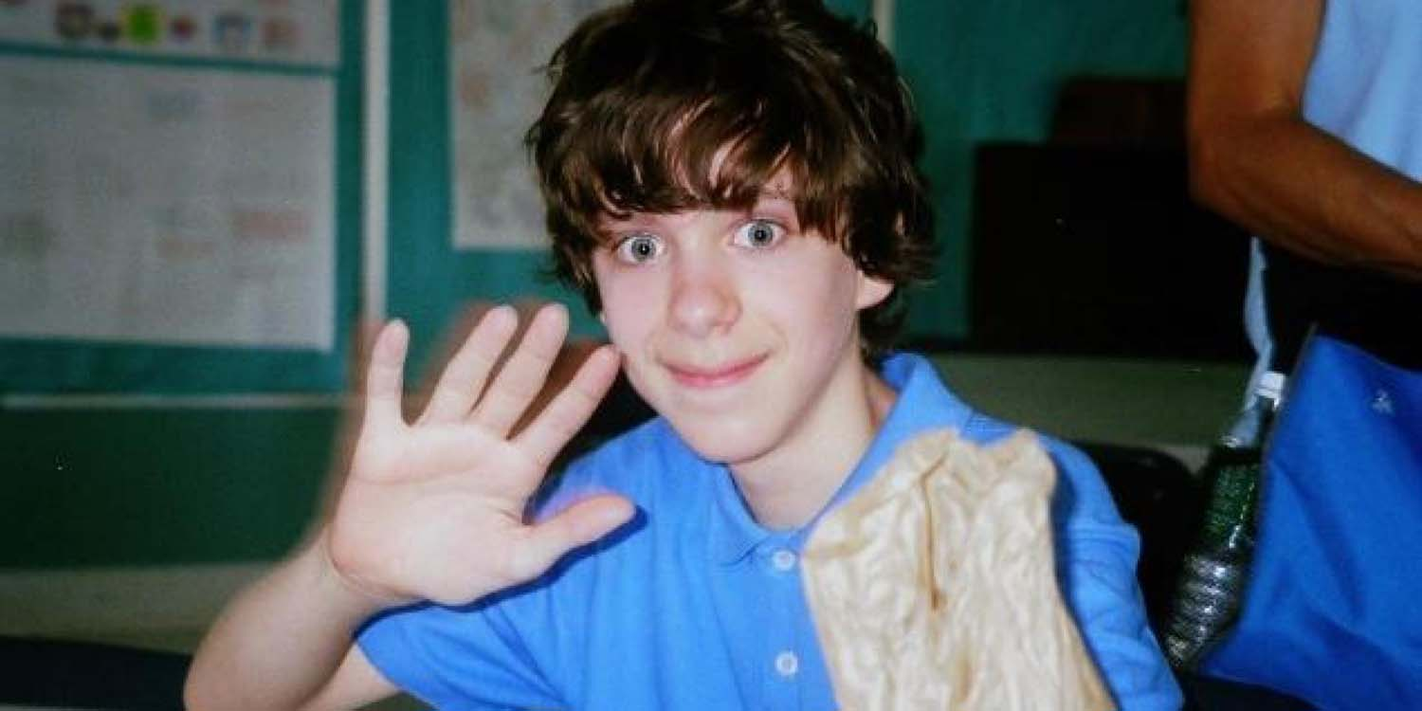
A young Adam Lanza, the alleged killer. Image: Time.
Numerous participants displayed bizarre and inappropriate behavior (7). Wayne Carver, the Medical Examiner, gave a surreal press conference in which he clowned around, grinning strangely, making irrelevant comments, and appearing unknowledgeable and unprofessional. Robbie Parker, the alleged father of Emilie Parker, one of the alleged deceased children, was caught chuckling before a CNN interview, then hyperventilating to get into character, and finally feigning distress for Wolf Blitzer. Alleged parent Veronique Pozner was interviewed by Anderson Cooper in front of a green screen, which caused the end of Cooper’s nose to disappear several times (according to the media, this was “motion compensation video compression”). Neighbor Gene Rosen was caught on camera rehearsing his story. And internet researcher “Barry Soetoro” proved that alleged parent David Wheeler had played two roles in the production, the second being that of an FBI sniper who did not know how to carry a firearm. His important channel was removed by YouTube.

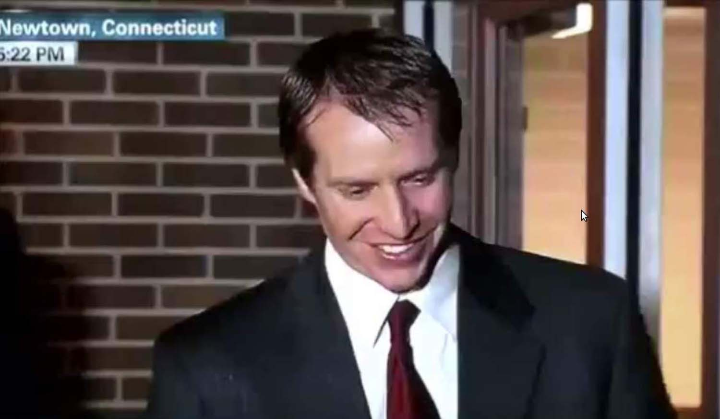
Robbie Parker, before his CNN interview on December 15, 2012. Image: CNN.
Photos reportedly taken at the time of the “shooting” look staged or fake (8). The “iconic” photo taken by Shannon Hicks for The Newtown Bee of children being evacuated from the school was shot at a different time and date, as shown by photo analysis. Hicks uploaded this photo to YouTube, along with 19 others, the day before the “shooting.” Many other photos look staged, one being the scene in the school lobby, with a shattered glass window supposedly shot out by Adam Lanza, but with all the furniture still in place—although Lanza and ten policemen, all with their guns and gear, reportedly entered through the hole and pushed past the furniture.

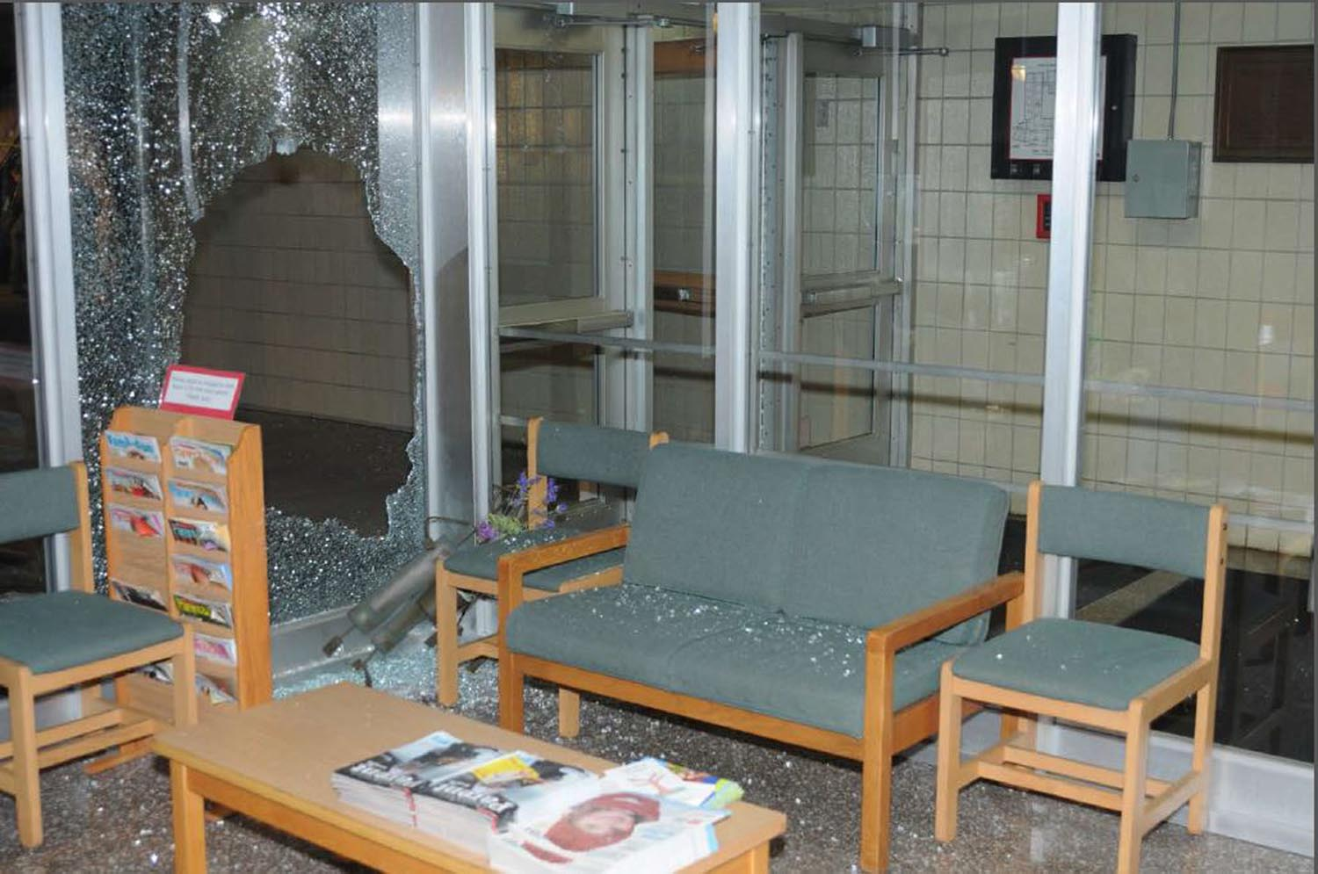
Window supposedly blown out by “the shooter.” Image: 2013 final report, Walkley scene photos.
In an amazing breach of procedure, the crime scene was completely destroyed (9), reminiscent of the destruction of the World Trade Center complex following 9/11. Sandy Hook Elementary was razed, and $50 million was allocated to build a new school on a different site. Employees who worked on the project signed non-disclosure agreements, prohibited from speaking about anything they observed at the scene. Evidence indicates that Sandy Hook Elementary was dilapidated, contaminated, and not even a working school in December 2012, with the building cleaned up and staged for the FEMA “shooting.”
In a wonderfully surreal touch, at least nine of the supposedly dead children sang “America the Beautiful” in the “Sandy Hook Elementary School Chorus” at Super Bowl SLVII in February 2013, along with Hollywood actress Jennifer Hudson (10). This was shown in a brilliant video by researcher “QKultra,” which has now been wiped from the web, like the work of so many others.

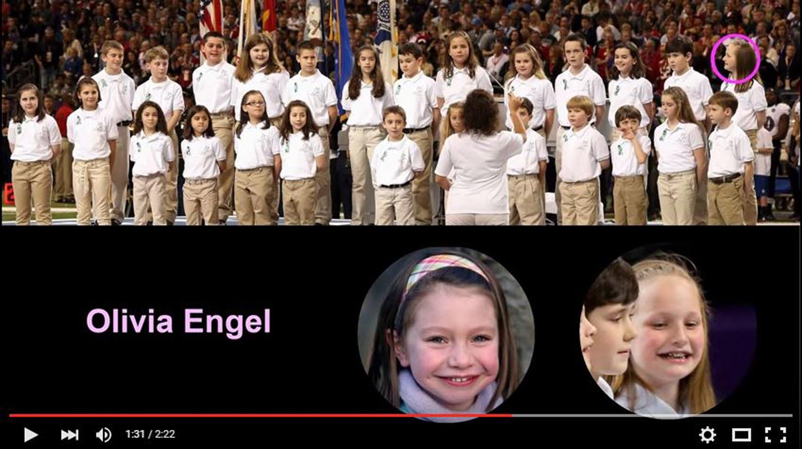
Sandy Hook Elementary School Chorus, singing at the Super Bowl in 2013. Image: “Sandy Hoax Surprise.”
And cui bono? At least $12 million was raised and distributed to the victims’ families and other survivors (with condolences posted by the Support Fund/United Way three days before the “shooting”). Individual families have raised additional funds, and “Sandy Hook Promise” solicits money “to protect children and prevent gun violence.” Add to this a total of $15.2 million in federal grants to Newtown agencies and other participants. According to the documentary, “We Need To Talk about Sandy Hook,” at least $131 million has been forked over, including the $50 million for the new school. This film has been removed repeatedly by YouTube.
The “families” have been active in lobbying for gun control, as covered widely in the media. Not only did the Sandy Hook event serve the effort to curtail the Second Amendment, but it benefitted the “security industry” and the push for “mental health” screening to try to “identify” children who may need “help.” All these repressive programs are further enhanced with each new “school shooting.”
Mr. President, the Sandy Hook shooting narrative is “fake news,” to use one of your favorite expressions, devised by the deep state and promoted in the mainstream media. The disinformation on this and other hoax events is being used to traumatize the American people into giving up their constitutional rights. Internet platforms should not censor the research of those who question such narratives. You have sworn to preserve, protect, and defend the Constitution. The tech industry cannot be allowed to subvert it.
Very respectfully,
Vivian Lee
Reference: “Top Ten Reasons: Sandy Hook Was an Elaborate Hoax,” in Jim Fetzer and Mike Palecek, eds., Nobody Died at Sandy Hook: It was a FEMA Drill to Promote Gun Control (Moon Rock Books, 2015).

Vivian Lee is the nom de plume of a tenured professor at an American university. Her special interests include war, psyops, and propaganda, with a current focus on false flag terrorism and staged shootings as well as the media’s role in these fabricated events. Her writing has appeared in Nobody Died at Sandy Hook and From Orlando to Dallas and Beyond (Moon Rock Books), and at numerous online sites including James Fetzer’s website and Memory Hole Blog.

Sterling Harwood: Final Report on Sandy Hook: Complete & Total Forensic Failure
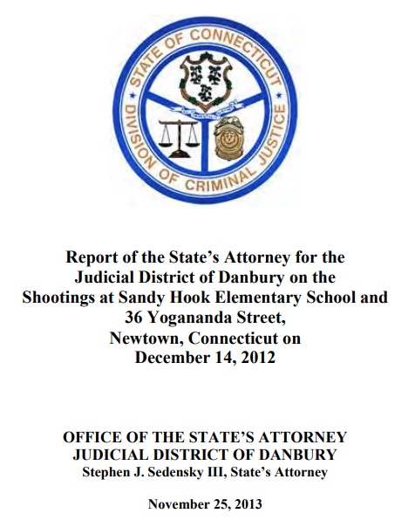
Mr. President,
Page 1 of the ‘Report of the State’s Attorney for the District of Danbury on the Shootings at Sandy Hook Elementary School and 26 Yogananda Street, Newtown, Connecticut on December 14, 2012” (linked below) includes a disclaimer that it lacks the intent to convey all the facts. But does the Report connect the dots between shooter and shots sufficiently to show – beyond a reasonable doubt – that Adam Lanza was the shooter and the only shooter? The short answer is emphatically, ‘No.’ it establishes neither means nor motive nor opportunity and thereby amounts to a complete and total forensic failure. Here are some of the reasons why.
Page 5 says Adam used a Bushmaster Model XM15-E2S rifle to do all of the shooting, except for shooting himself to death with a Glock 20, 10mm handgun. Page 5 says Adam’s shooting killed 20 children and six adults and non-fatally wounded two adults. So, there ought to be plenty of evidence linking the shooter to the shots, including witness statements from the two surviving adults. But the Report fails to refer to any witness identifying Adam as the shooter and even fails to have a section in the Table of Contents with the word “witness” in it.
Page 2 says the Bushmaster rifle was found in the same room as Adam’s corpse and that all of the 5.56 mm shell casings from the school that were tested were from that rifle. But that claim is contradicted by a crucial footnote on page 37, which states that “No positive identification could be made to any of the bullet evidence submissions noted . . . in 5.56 caliber. The physical condition of the bullet jacket surfaces were severely damaged and corroded. They all lacked individual striated marks of sufficient agreement for identification purposes”:
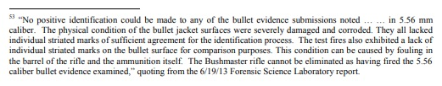
Pages 2 and 36 admit that all the relevant firearms were legally purchased by Lanza’s mother, Nancy, rather than by Adam. Pages 2 and 36 make no claim about who purchased the ammunition but say the mother had purchased the same type of ammunition in the past. Pages 2 and 36 admit that there is no evidence that Adam purchased any ammunition.
Page 2 claims that Adam used a .22 Caliber Savage Mark II rifle to shoot and kill his mother in her bed at the home where they resided at 36 Yogananda Street in Newtown. But no substantiation is provided to support that conclusion and a photograph that we have of the Nancy Lanza bedroom (which appears as Exhibit 17 of Ch. 7, Nobody Died at Sandy Hook (2015) contradicts that claim.
While there is some red stuff on the bed, it does not appear to be blood but might be raspberry jam, as Jim Fetzer has suggested. The quantity appears to be insufficient for multiple shots to the head. And, Kelley Watt, who has her own home and commercial cleaning service, noticed that they had left behind a blue moving pad beneath the leg of the bed in their apparent haste to furnish an empty home to serve as the Lanza residence, as Ch. 7 documents with 50 photographs.
Regarding Adam’s motive, which page 3 calls the “obvious question,” page 3 admits “there is no clear indication why he did so, or why he targeted Sandy Hook Elementary School.” It even claims that the question of why Adam murdered 20 children and six adults (as well as his mother) “may never be answered conclusively, despite the collection of extensive background information on the shooter through a multitude of interviews and other sources.”
Page 3 maintains that “The evidence clearly shows that the shooter planned his actions …”, but it fails to specify that evidence. Instead, the Report continues by highlighting Adam’s severe mental illness, which surely seems to be a major obstacle to planning a complex series of crimes against a protected target, such as a school with locked doors, fire alarms, phones, security cameras posted in plain sight, and such.
Page 2 admits no evidence suggests anyone helped Adam plan or commit the attack. Page 3 even calls Adam’s attack a “rampage”, but isn’t “a clearly planned rampage” an oxymoron? Page 2 admits that the only firearm allegedly found on his person was not even fired. How does a readily available firearm go unfired during an almost 11-minute rampage?
While the crucial footnote on page 37 says that the Bushmaster “cannot be eliminated” from having fired these rounds, the inability to identify any of the bullets as having been fired from the Bushmaster means that they failed to connect the weapon alleged to have been used with the shooter alleged to have used it to any of the victims or the crime scene itself. As a consequence, this report may qualify as perhaps the most obvious and blatant forensic failure in the annals of criminal investigations.
Very respectfully,
Sterling Harwood, J.D., Ph.D.
Reference:
Stephen Sedensky III, Report of the State’s Attorney for the Judicial District of Danbury on the Shootings at Sandy Hook Elementary School and 36 Yogananda Street, Newtown, Connecticut on December 14, 2012 (25 November 2013).
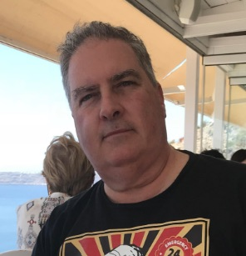
Sterling Harwood earned his J.D. from Cornell Law School and his Ph.D. in philosophy from Cornell University. Since 1998, he has practiced law in San Jose, California, from which he has now retired. He earned tenure as an Adjunct Philosopher at Evergreen Valley College after teaching at Cornell Law School, Cornell University, Lincoln Law School, San Jose State University and Illinois State University. His books include Crime and Punishment (with Michael J. Gorr, 2000), Business as Ethical and Business as Usual (1996), Judicial Activism (1996), and Controversies in Criminal Law (with Michael J. Gorr, 1992).

FABRICATING EVIDENCE & POST-EVENT EXPOSURE

Dr. Eowyn: Sandy Hook Moved to Chalk Hill Months Before ‘Massacre’
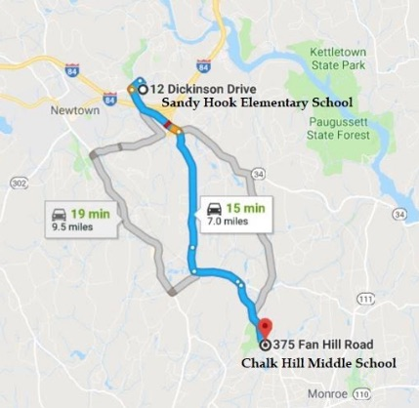
Mr. President,
Drawing on the very hard work of Wolfgang Halbig, I must point out that there are many signs pointing to Sandy Hook Elementary School (SHES) having been closed long before the alleged mass shooting on December 14, 2012, including:
Reports from as early as 2002 that the school was contaminated with asbestos and environmental toxins.
The complete absence of white-and-blue disabled parking areas and corresponding signage, which would render SHES noncompliant with the Americans with Disabilities Act.
Moss and grime covering the school building.
Repairs left undone, such as a dangerous, exposed metal rod on an exterior staircase.
Loose dangling electrical cords and unkempt offices and hallways jammed with furniture and office supplies—all of which were fire hazards.
The school’s lack of Internet activity from the beginning of 2008 to mid-2013, as shown on the Internet Archive's Wayback Machine (http://newtown.k12.ct.us/~sh).
Recently, Wolfgang Halbig acquired five pieces of additional evidence that SHES at 12 Dickinson Drive was abandoned by mid-2012, if not earlier, and had moved to an empty school, Chalk Hill Middle School at 375 Fan Hill Rd, in neighboring Monroe, CT:
An email exchange between the principal and the school custodian on moving the school.
An invoice from Dean Foods of a food delivery to SHES at Chalk Hill in Monroe.
A spreadsheet listing invoices of Dean Foods deliveries to SHES in Monroe.
A Dean Foods employee email confirming food deliveries were sent to SHES in Monroe.
A USAC form indicating that services were provided Chalk Hill Middle School, even though that specific school has not been used by the Monroe School District since June 2011.

(1) Email on moving SHES
On 19 July 2012, SHES principal Dawn Hochsprung exchanged conspiratorial-toned (“mum’s the word”) email with school custodian Kevin Anzellotti, bemoaning the moving of SHES and a screenshot thereof:
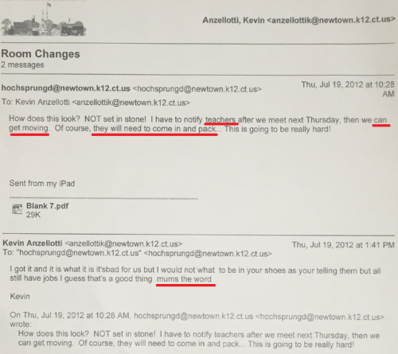
Here are the words as extracted from the screen shot:
Hochsprung: “How does this look? NOT set in stone! I have to notify teachers after we meet next Thursday then we can get moving. Of course, they will need to come in and pack….This is going to be really hard!”
Anzellotti: “I got it and it is what it is it’s bad for us but I could not what [sic] to be in your shoes as your [sic] telling them but all still have jobs I guess that’s a good thing mums the word.” Emphasis added.

(2) Food service invoice
Dean Foods is a national food and beverage company and the largest dairy company in the United States. Headquartered in Dallas, Texas, the company has 66 manufacturing facilities and distributes its products across all 50 states. On April 26, 2012, 8 months before the alleged massacre, Dean Foods prepared an invoice of an order from Sandy Hook Elementary School for “American/Continental” style cuisine. Strangely, the food was to be sent not to 12 Dickinson Drive, Sandy Hook, CT 06482, but to the address of Chalk Hill Middle School at 375 Fan Hill Rd., Monroe, CT. Here’s a screenshot of the invoice:
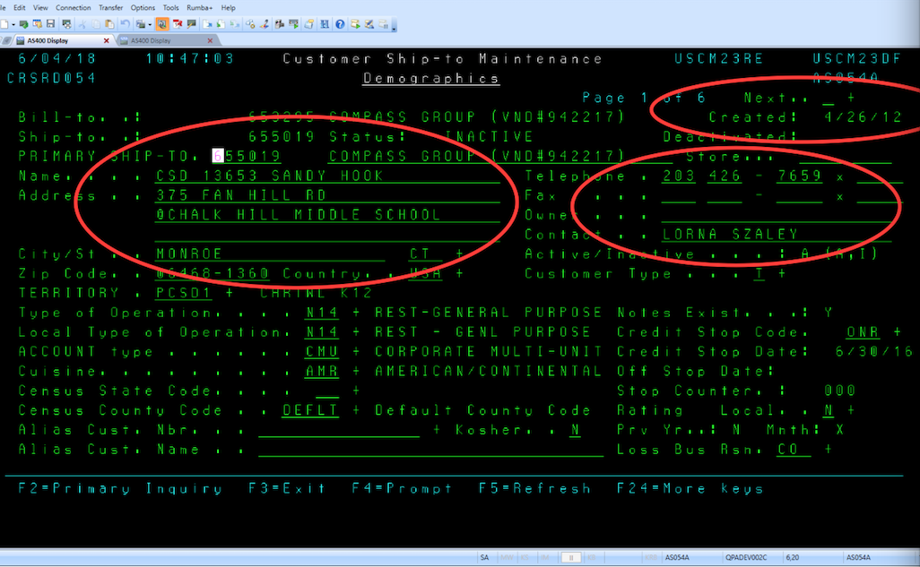

(3) Dean Foods Spreadsheet
Here is a screenshot of a Spreadsheet listing 15 invoices from 1 September 2012 to 15 December 2012, for food deliveries to SHES at 375 Fan Hill Road in Monroe, which confirms the change in location:

(4) Email from Dean Foods Employee
Halbig received the invoice and spreadsheet from X, an employee of Dean Foods. I have verified the identity of X on LinkedIn, but I’m not revealing X’s name to protect his/her life. Halbig fully intends to introduce X’s emails, the invoice and spreadsheet as evidence should a malicious lawsuit against him go to trial. Below is the email from X confirming that the food orders for SHES were being delivered to the Chalk Hill Middle School address in Monroe, CT. I’ve blacked out the sender’s name:
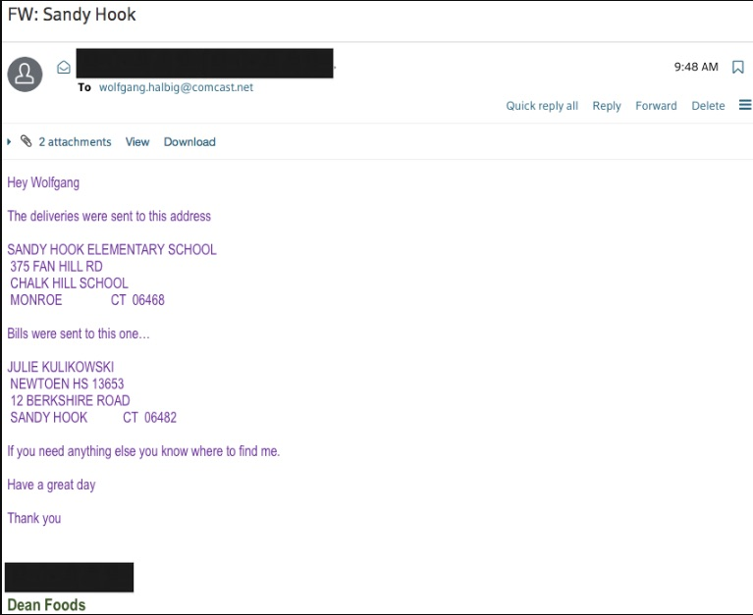

(5) USAC Form 471
After reading the above, one might well ask: If Sandy Hook Elementary School was moved to Chalk Hill Middle School in Monroe, what happened to Chalk Hill’s own teachers and students? The answer: Chalk Hill Middle School has also been empty since June 2011! (See news report in CTPost of 30 April 2017.)
Though officially empty since June 2011, Chalk Hill Middle School curiously applied for broadband and Internet connectivity services from Universal Service Administrative Company (USAC), as indicated in an USAC Application Form 471 on 13 March 2012. All U.S. public schools and libraries are required by the FCC to use USAC Form 471. Obviously, if Chalk Hill were not in use, there would have been no point:
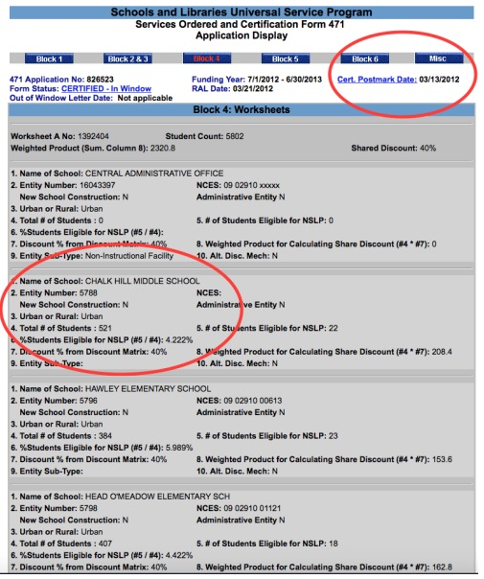

Nothing about Sandy Hook turns out to be as it was presented to the public. The Dickinson Drive School was closed by 2008 and there were no students there. Evidence indicates that the school was operating administratively at the Chalk Hill location by mid-2012, if not earlier. The old building was refurbished to serve as the stage for a two-day FEMA drill, for which we even have the manual. Anticipating they would have to be able to account for moving their classes to another location following the fake massacre, they set up Chalk Hill for that role, never in their dreams imagining anyone would take the time and effort to sort all of this out, where Wolfgang's discoveries reinforce the scope and detail of an extensive and elaborate fraud.
Very respectfully,
Dr. Eowyn
References:
John Burgeson, “Monroe: What to do about Chalk Hill Middle School?” Connecticut Post (30 April 2017)
Dr. Eowyn, “Wolfgang Halbig has stunning evidence that Sandy Hook Elementary School was closed months before ‘massacre’” (18 June 2018) My blog was abruptly removed on 15 August 2018, no doubt because of posts like this one.
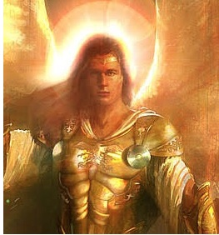
Dr. Eowyn, Ph.D., professor emeritus of political science at a U.S. university and author of university press books and countless peer-reviewed articles, is the owner of the blog, Fellowship of the Minds (FOTM), where more than 80 articles of original research on Sandy Hook had already been archived before the publication of Nobody Died at Sandy Hook (2015). In the early morning hours of August 15, 2018, WordPress arbitrarily and without forewarning took down FOTM, blocking Dr. Eowyn and her readers from accessing the blog. Five days after the site was taken down, WordPress gave the reason as the vague and all-purpose "we no longer feel that your account aligns with our Terms of Service and User Guidelines. As such, you will no longer be permitted to use WordPress.com."
Phi Beta Iota: Subsequent investigation determined that one allegedly fake parent from Sandy Hook was able to get a New York Times article done that intimidated the founder of WordPress.com into closing down any site shown photos of the fake Sandy Hook victims under the pretense of invading the privacy of minors. There will come a day when all those complicit in the US Government cover-up of any false flag operation can be sued for damages – but first an honest government must be restored.
Reference:
Mongoose, “WordPress.com Joins #GoogleGestapo, Censoring Sandy Hook False Flag Material,” Phi Beta Iota Public Intelligence Blog, 18 August 2018.

Mona Alexis Pressley: 2 Principals, 2 Schools Buildings, but 0 CAPT Scores for 2009
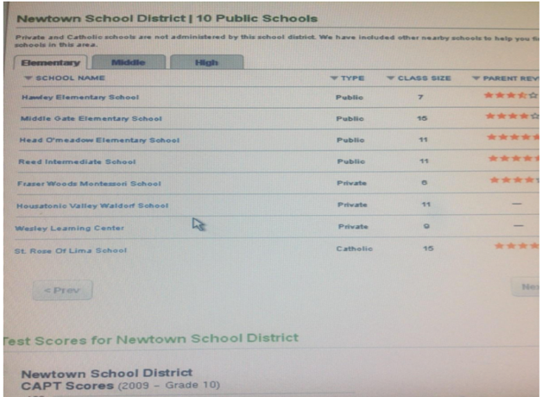
Dear Mr. President,

As the contributors to Nobody Died at Sandy Hook (2015) have established, the school was closed by 2008 and there were no students there. Further proof comes from the scan of the Newtown School District CAPT Scores (2009), where notably the list of schools in the district does not include Sandy Hook Elementary, because it had been closed a year earlier and was no longer conducting student tests. The purge of the data about Newtown Schools has been massive and I am lucky that I made this screenshot.
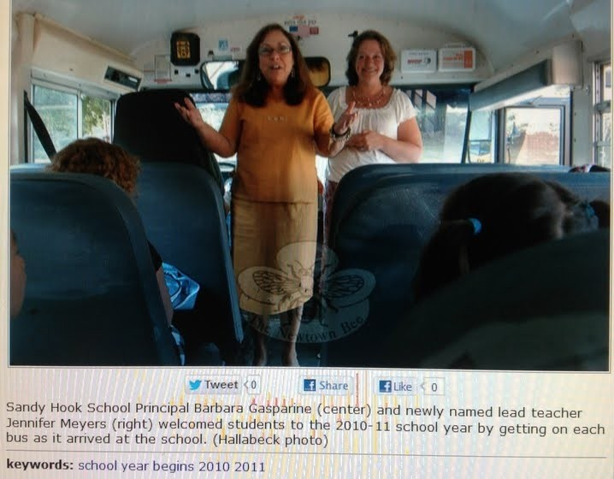
As though an interview with a dead principal were not enough, my research on Sandy Hook has also led to the discovery that two different women have been presented as “the Sandy Hook principal” and that two different buildings have been portrayed as “the Sandy Hook school”. These two photos were on my thumb-drive from 2013 but misplaced and only recently recovered. After finding them I discovered that The Newtown Bee no longer features these pictures of two principals at the same school the same year:

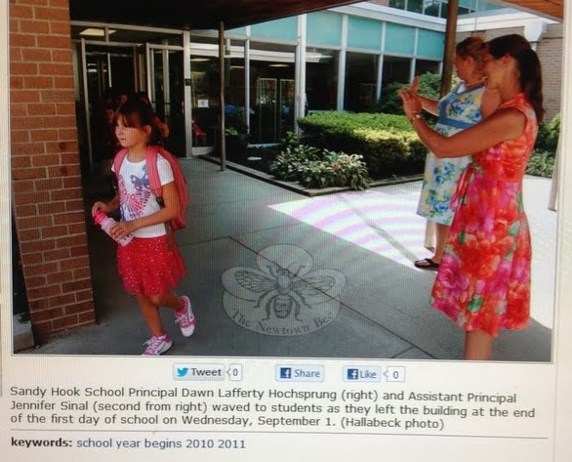
Principal #1 is Barbara Gasperine and of course Principal #2 is Dawn Hochsprung. The assistant with her in both photographs is the same woman, but she married during the time between photographs, which explains why her last name is different. These photos suggest that tampering with pictures was taking place to make it look like the school was open that someone named “Dawn Hochsprung” was principal.

The first picture was the older, since Jennifer Meyer was a lead teacher who became Assistant Principal as listed in the second. What years these pics were really taken is a mystery. Even if there was only one principal listed it would have still been an impossibility because the school was closed in 2008 and this is 2010-11. That two of them were listed in The Newtown Bee reflects its complicity in perpetrating the scam.
Given the extent of the Sandy Hook data purge, it should come as no surprise that images like these are likewise no longer available. In this collage notice that the top-left image of “Sandy Hook Elementary School”, bears no resemblance to the school at which the shooting is alleged to have taken place. Many possibilities arise, such as that, after the school had closed in 2008, perhaps they continued classes in this building. School board members and local residents would know, but they aren’t talking. We are left to sort things out.
Very respectfully,
Mona Alexis Pressley

References:
Photographs of the principals appeared in The Newtown Bee in 2012 shortly after the FEMA exercise.
Photograph of different Sandy Hook Elementary School from a 2009 real estate website, which also had the CAPT test scores for Newtown schools not including Sandy Hook. The website has been taken down.
Mona Alexis Pressly, MA, MFT has frequently appeared on “The Raw Deal” and “The Power Hour”. Her research on numerous political issues, including Obama’s birth certificate, Sandy Hook, and Las Vegas, has been published by Dr. James Fetzer, PENN Magazine, and other venues.

Dan Cromer and Mona Alexis Pressley: Shannon Hick’s Sandy Hook Fake (Staged) Photos
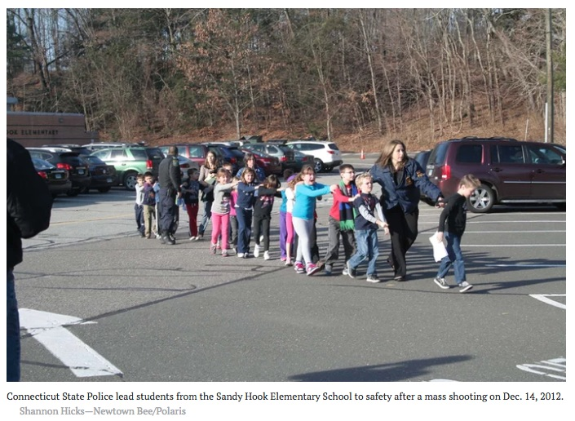
Mr. President,
It turns out that a photograph that appears to show a policewoman escorting students from Sandy Hook to escape the shooting was staged as a crucial element of an elaborate hoax. It was taken by Shannon Hicks, a photographer and editor for The Newtown Bee, the local newspaper, and may have received the widest distribution of any photograph in history because the official narrative of 20 children and six adults having been shot and killed was emotionally traumatic and instilled fear into the hearts of every parent in America—indeed, no doubt, in the world.
It would turn out that Shannon Hicks took another (earlier) photo of what appears to be the same children in a different sequence. As Barry Soetoro, Esq., would observe, at least two of the boys appear in both photographs. They are identified here as “Boy #1” and as “Boy #2”. Which would mean, if these photographs were taken at face value as bona fide evacuations, then at least two of the children were evacuated twice! And the shadow cast by the figure in the foreground foreshadowed something else was very wrong. Parents were present at the scene.
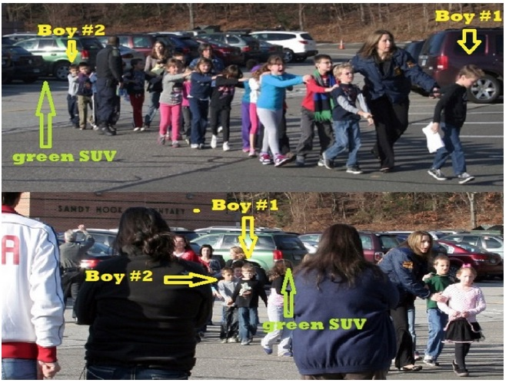
Notice, if you look between “Boy #2” and “Boy #1”, you can see several parents casually looking on as the policewoman works, which has prompted Dr. Fetzer to refer to this as “lounging at the massacre”! Had this had been a real shooting, who would have thought to make a call to bring parents to the scene? And if parents had come to the scene, does anyone think they would have stood around watching as she rearranged the kids to get a better shot? Does anyone doubt they would have grabbed their children and exited the premises by the fastest possible route to rush them to safety and then recover from a childhood trauma? Stunning
Notice originally a little girl in a pink sweater and short skirt was at the front of the line, but she was replaced by a taller little boy wearing a dark sweater and blue jeans. The parents show no stress or anxiety, where their body language is relaxed and composed. Shannon Hicks’ claim to have taken these photographs under conditions of extreme emergency is thereby contradicted. For this staged photograph, she was made “Photographer of the Year” by the New England Newspaper and Press Association, where even NENPA experts appear to have been played.

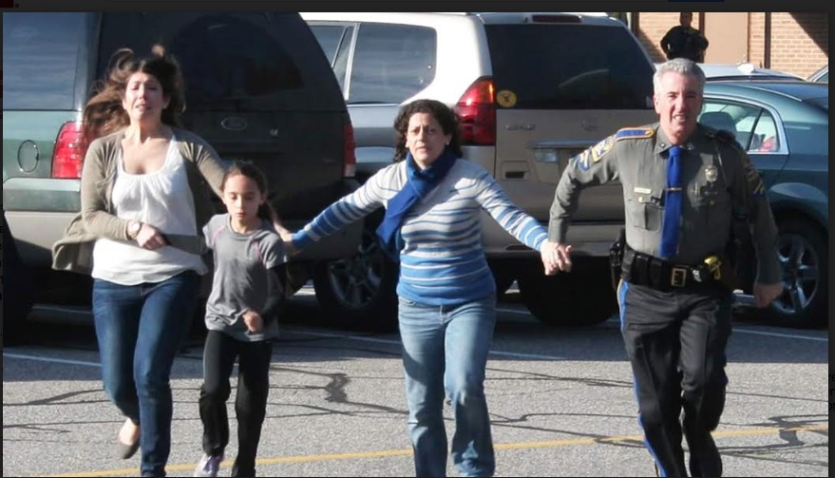
She took a third staged photograph, which raises questions of its own. Why would this officer be running away from the scene of the crime, for example? He ought to be assisting in dealing with the threat from the alleged shooter: if there had been one shooter, there might have been more. And notice the officer whose silhouette can be seen in the background in front of the school. He appears more concerned with what’s going on in the parking lot than with what’s going on inside the school. And for good reason: nothing was going on inside the school! So we have one more photographic proof Sandy Hook was a scam.
Respectfully submitted,
Dan Cromer and Mona Alexis Pressley
Reference:
Dr. Eowyn, “Sandy Hook: The Boys who were evacuated TWICE”, Fellowship of the Minds, 25 January 2015
Phi Beta Iota: The above link no longer works because Fellowship of the Minds was shut down by WordPress.com, destroying years of work, without notice, because of a New York Times article rooted in false allegations that evidently intimidated the founder. The site appears to have been partially restored, but articles about Sandy Hook, reflecting a great deal of investigative journalism, are blocked. Censorship, manipulation, and digital assassination are easily done against conservative as well as progressive voices, but especially against “truthers” who seek to defeat the Deep State and its Shadow Government. For one specific example, see below.
Reference:
Robert David Steele, “How The Deep State Controls Social Media and Digitally Assassinates Critics: #GoogleGestapo – Censorship & Crowd-Stalking Made Easy,” American Herald Tribune, November 7, 2017.
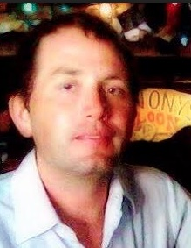
Dan Cromer, MIS, an information specialist, frequently appears on “The Raw Deal” and “The Power Hour” when James Fetzer, Ph.D., is guest hosting. His research on Sandy Hook, Las Vegas, Parkland and Santa Fe has appeared in numerous publications.

Mona Alexis Pressly, MA, MFT has frequently appeared on “The Raw Deal” and “The Power Hour”. Her research on numerous political issues, including Obama’s birth certificate, Sandy Hook and Las Vegas, has been published by Dr. James Fetzer, PENN Magazine and many other venues.

Allen William Powell: Connecticut State Police Behind the Scenes at Sandy Hook

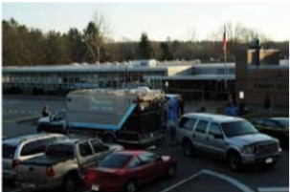
Mr. President,
The book Amazon.com banned after having been on sale for less than a month and selling nearly 500 copies, Nobody Died at Sandy Hook (2015), includes two chapters of mine where I present 50 photographs of furnishing an empty house to serve as the Adam Lanza residence and 50 photographs of refurbishing the school to serve as the stage for this elaborate fraud. What is most disconcerting is that they come from the files of the Connecticut State Police, who were running the show behind the scenes on behalf of FEMA and the Obama administration.
The photos are simply devastating. Exhibit 17 of Chapter 7, for example, shows “The Nancy Lanza Bedroom”, where Adam is alleged to have shot his mother with a .22 caliber rifle. There is some red stuff on the bed, but it looks more like raspberry jam than blood; beneath the leg is a blue moving pad, which, in their haste, they forgot to remove. Chapter 8, Exhibit 26, by itself proves the entire event was staged. We have a SWAT vehicle on the scene before the shooting has taken place, note that the string of four windows in Classroom 10 are undamaged.
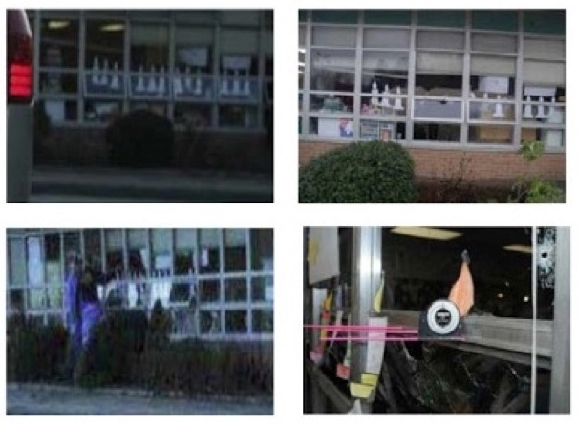
After the event, they would be shot out: compare top left with top right. We even have the perps studying the window frame to fake bullet holes, where the pink rods are all 90* to the window panes and parallel with one another. We initially believed Exhibit 26 was taken the morning of the 14th, but we have now determined it was instead taken the evening of the 13th. Either way, it was taken before the shooting, where in the foreground you can see crime scene tape up before the crime has been committed. What could be more powerful proof of fraud?
Very respectfully,
Allan William Powell

Reference: Department of Emergency Services and Public Protection: Sandy Hook Elementary School Shooting Reports

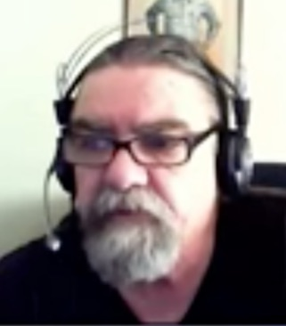
When Allan William Powell appeared on “The Real Deal Ep. #81: Explosive New Revelations about Sandy Hook”, it became apparent that one of the leading experts on this mischief in Connecticut resided half-way around the world in Canberra, Australia. He appeared in many other episodes. His chapters are going to qualify as among the most brilliant studies published on Sandy Hook, which provide unexpected but decisive proof that this was a staged event.

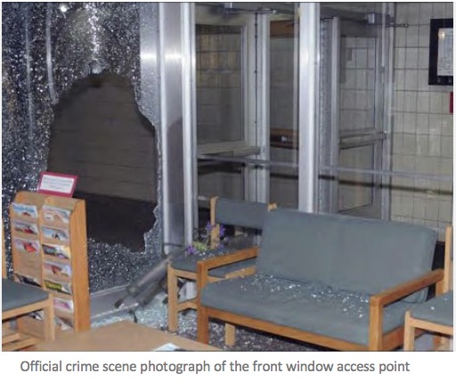
Wolfgang Halbig: Connecticut State Police False Affidavits about Entering School

Mr. President,
Here is a sample of the kind of information that I now have in my possession, which ought to justify calling a Grand Jury by the Attorney General of the State of Connecticut. I have in hand ten affidavits by Connecticut State Troopers, most of which cannot be true because they describe making their entry into Sandy Hook Elementary School by way of a relatively modest hole in the front of the building.
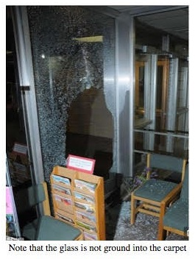
No trained law enforcement officer would have entered that window without first breaking it out using his baton. When you have so many sworn law enforcement willfully and knowingly lying in sworn affidavits regarding the Sandy Hook School “shooting”, it would appear incumbent upon the Governor of Connecticut and the Connecticut State Attorney to open an investigation of the conduct of the investigating authorities.
Moreover, while they may not realize this, but even a dead Adam Lanza deserves his day in court to prove his innocence in light of all the intentional lies by police and their supervisors in their witness statements. Ask yourself about the truthfulness of affidavits like the following, which I have taken from the Sandy Hook script to illustrate why their statements are not credible and appear to be false, which means that those who signed them may have committed perjury.

On the next three pages are three affidavits I submit are false, along with my comments.

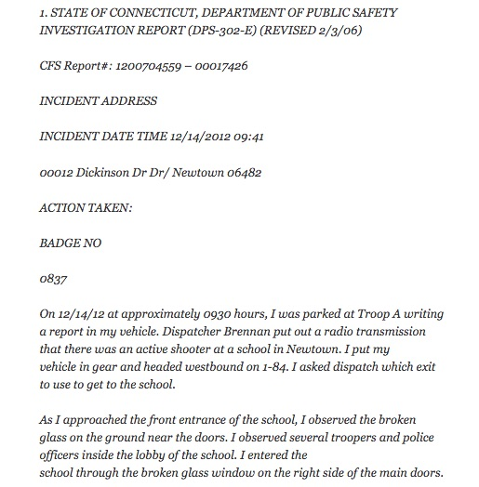
Comment: HOW CAN YOU NOT REMEMBER? The lie comes in a later report. How can a sworn trained police officer not remember how he and the other officers entered the school on 14 December 2012?

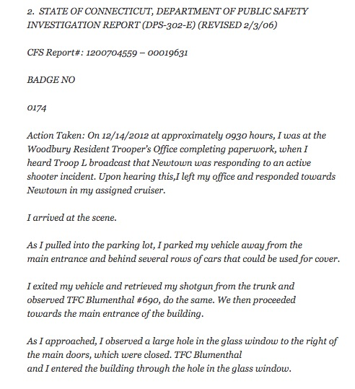

Comment: Why would so many CT State Troopers enter the broken glass window when other officers are already inside? Why go through the broken glass window exposing you to serious injury?

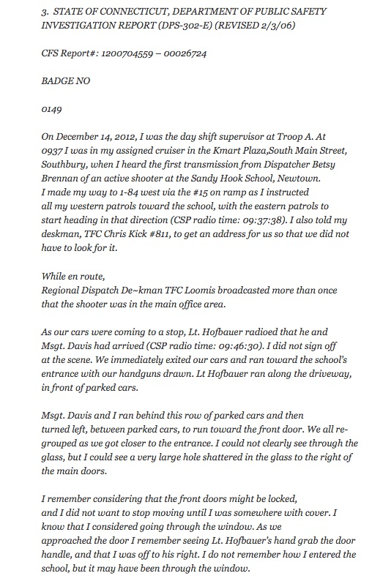

Comment: HOW CAN YOU NOT REMEMBER? The lie comes in a later report. How can a sworn trained police officer not remember how he and the other officers entered the school on 14 December 2012?

I have ten of these sworn affidavits—but I have to stop with these three as examples, because, as a former Florida State Trooper, having to read these police officers’ witness statements as to their actions on 14 December 2012 is an insult to every police officer who puts his or her life on the line of duty every single day.
Just to make the obvious point, officers are not going to enter a jagged class opening where they might cut their uniforms or enlarge the opening and thereby affect the crime scene. Even The Three Stooges would have done better, where Moe would have entered and then opened the door for Curly and Joe.
Every school district, private and parochial, is now having to deal with Sandy Hook, when it has become increasingly evident, based on evidence in my possession, that Sandy Hook was a drill, not a real event. It was a FALSE FLAG event, orchestrated by DHS , and the government – including the government now under your leadership, which appears committed to lying about this event to the public and the Courts.
Very respectfully,
Wolfgang Halbig
References:
Nanci G. Hutson, ‘Newtown school board greets Sandy Hook skeptics with silence” (6 May 2014)
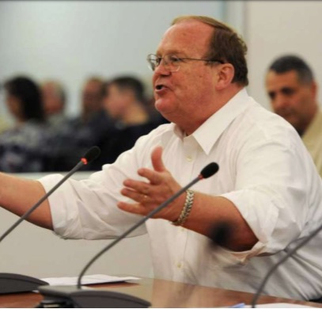
Wolfgang Halbig: “11,000 page Sandy Hook “script”/ CT State Police gave false affidavits” (17 July 2017),
Wolfgang Halbig is a former Florida State Trooper and US Customs Agent with 36 years of experience in public school administration. A nationally recognized school safety expert, he began his inquiries about Sandy Hook to learn what had happened there in order to advise other school systems how to avoid it happening to them. He found his FOIA requests were not being answered and his phone calls were not being returned. Before he knew it, two homicide detectives from the local precinct were on the steps of his home in a gated community in South Florida, explaining that they were there at the request of the CT State Police and that, if he continued to ask questions about Sandy Hook, then he would be prosecuted.

Kelley Watt: Nobody Knows Who Cleaned Up the Blood -- No Blood to Clean Up?

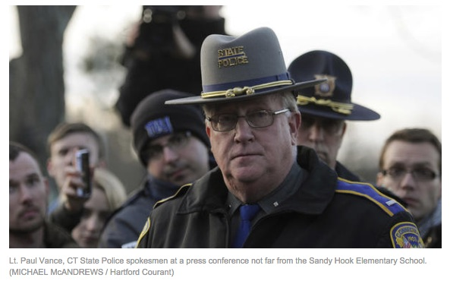
Mr. President,
For the past 26 years I have owned and operated my own domestic and commercial cleaning service in Tulsa, Oklahoma. As a consequence, I know that, in order to clean up bio-hazards, one must be licensed to do so.
Because we were told 26 people had been shot to death inside Sandy Hook Elementary School on 14 December 2012, it would have been appropriate for the State Police of Connecticut, or the FBI or someone else in authority to call for a bio-hazard waste clean-up. Companies like Aftermath dispatch highly trained and licensed experts to clean up blood splatter, urine, feces and tissue from crime scenes.
Curious as to which company received the contract to clean up this crime scene inside that school on that freezingly cold day, I decided to find out.
The first phone call I placed was to the Connecticut offices of the Environmental Protection Agency. When I asked the proper personnel who received the contract to clean up the blood I was put on hold and given to three people all of whom had no answer, so I was told to call the Major Crime Squad of Western Connecticut. They had no clue but directed me to Lt. Paul Vance of the Connecticut State Police, who had been present at the scene and appeared to be in control.
When I asked Lt. Vance “Who got the contract to clean up the blood at Sandy Hook on December 14th?” His answer was brief. He replied, “What blood?” I explained, “26 people died, sir, inside that school the other day, THAT BLOOD! He responded, “Are you a conspiracy theorist? I stepped over dead babies”, to which I sternly replied, “No, you did not, sir!”
When three state agencies can’t get their phony act together to give tax-paying citizens a simple answer to their question, we are in BIG TROUBLE.
I then turned my direction to the Sandy Hook Fire Department and placed another call asking serious questions about the kids being taken to the Firehouse the day of the event. I was immediately put on speaker phone and asked if I was a racist and did I vote for Obama, which had absolutely nothing with my call.
Mr. President, I called every single news outlet, paper, radio and television and every single reporter I questioned hung up on me, sometimes in mid-sentence the second I said “Sandy Hook”.
And this was before you emphasized the concept of FAKE NEWS. The unprofessional behavior of every single person comprising the media in Connecticut that I tried speaking with spoke volumes that the media of fake news was used to spread the false narrative in order to promote the left’s aggressive, gun control agenda.
I voted for you, President Trump, and so did all my family and friends. We urge you to call these perpetrators out and bring them to justice in order to MAKE AMERICA GREAT AGAIN!
Very respectfully,
Kelley Watt
Reference: “Are Sandy Hook Skeptics Delusional with ‘Twisted Minds’?”, in Jim Fetzer and Mike Palecek, eds., Nobody Died at Sandy Hook: It was a FEMA Drill to Promote Gun Control (Moon Rock Books, 2015).

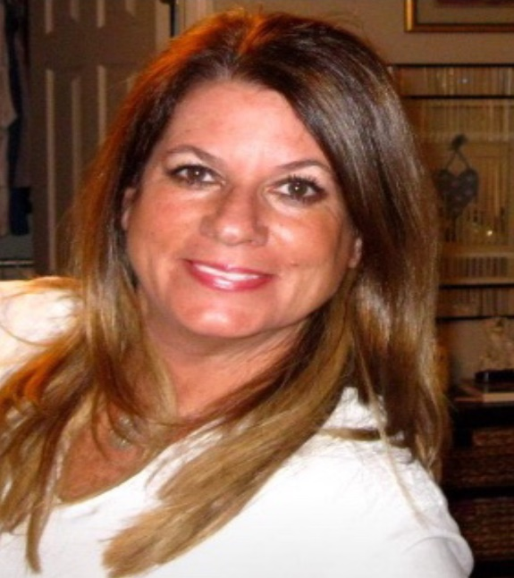
Kelley Watt has owned and operated MAID IN THE USA, INC. a commercial/ residential cleaning service for 26 years in Tulsa, Oklahoma. A graduate of Oklahoma State University. Kelley became a political skeptic after she witnessed the contrived spectacle of Sandy Hook and began her study of various false flag episodes. She has was the first to notice the resemblance between “Noah Pozner” and Michael Vabner. Kelley was also the first researcher who talked with one of the crisis actors posing as a parent and after several months of conversation and hundreds of hours via the phone, came to the conclusion that he was not being truthful. She asked herself, what parent would spend hours talking to a stranger who, during every conversation stated she did not believe him? Kelley has written op-ed pieces and given many radio interviews about Sandy Hook.

Mona Alexis Pressley: Dead Sandy Hook Principal interviewed by The Newtown Bee
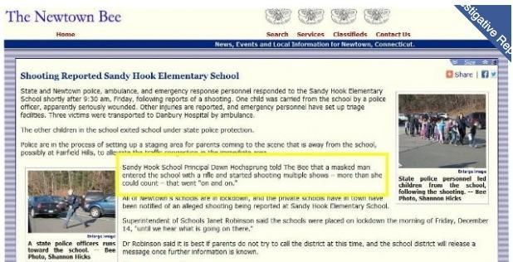
Dear Mr. President,
Among the most intriguing aspects of the elaborate hoax known as “Sandy Hook” was an interview that appeared in The Newtown Bee (14 December 2012), with the principal, Dawn Hochsprung, discussing the shooting. What makes this interview dumbfounding in retrospect is that, according to the official story, the principal was among the first to be shot and was already dead. As Insanemedia.com reported:
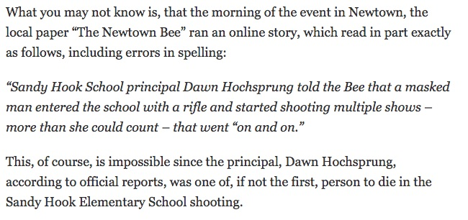
The Bee published a retraction three days later, as “Sandy Hook Evidence: Dawn Hochsprung Interview” (10 January 2013), observes, alleging that a woman who had identified herself as the school principal had called their reporter, but that she could not have been Dawn Hochsprung, who was killed in the Friday morning attack”. The Bee apologized for the confusion and to the Hochsprung family for its error.
The very idea that someone would impersonate the principal with such a call or that their reporter would not have known with whom they were speaking in a community of only 27,000 residents were not addressed. The Sandy Hook story is littered with anomalies that reveal it was a completely staged event, including an interview with a dead woman. No one familiar with the evidence should be in doubt.
Very respectfully,
Mona Alexis Pressley.
Reference:
Swansong, “Sandy Hook Evidence: Dawn Hochsprung Interview,” December 13th
Mona Alexis Pressly, MA, MFT has frequently appeared on “The Raw Deal” and “The Power Hour”. Her research on numerous political issues, including Obama’s birth certificate, Sandy Hook, and Las Vegas, has been published by Dr. James Fetzer, PENN Magazine, and other venues.

Stephanie Sledge: Car with License Plate from Sheriff’s Department in Wisconsin
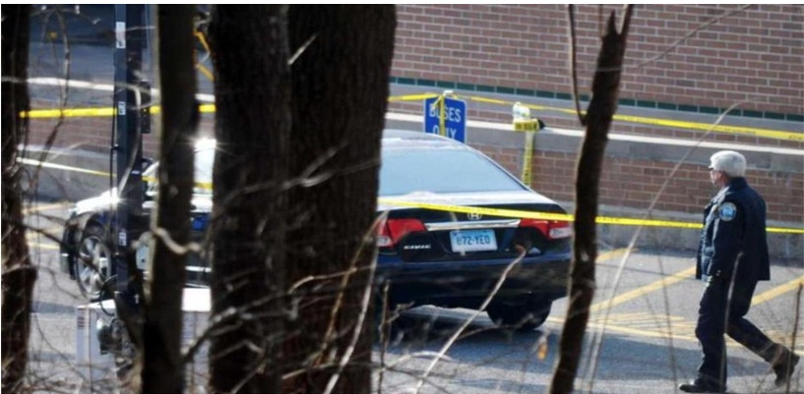
Mr. President,
The Sandy Hook event, now almost six years later, has produced more questions than answers. One of those unanswered questions concern the car brought to the school on the day of the shooting by the alleged shooter, Adam Lanza. We were told Adam drove his mother’s 2010 Black Honda Civic to the scene before he walked into the Sandy Hook Elementary school and killed 20 children and 6 adults.
The media showed the car reported by Connecticut State police and was searched for weapons and clearly has the license plate of CT 872-YEO. The official released Sandy Hook Report issued by the State of CT also has their video CDMCS Vehicle Processing of a 2010 Honda Civic with the same license plate:

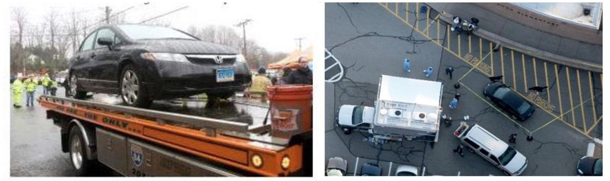

After further research, it appears that Nancy Lanza’s black 2010 Honda Civic can be found in Newtown, CT tax records along with a 2009 BMW and 2006 Toyota Corolla. However, the car in question is shown to have a license plate listed as Connecticut 872-YEO. Initial reports claimed the car was registered to a “Christopher Rodia”, but that information was debunked when background checks on Rodia indicated that he did not own a 2010 Honda Civic and had an alibi for the morning of the shooting.
However, other questions remain and need to be answered. First, the license plate, when traced via through the DMV, turns out to be owned by the Dane County Sheriff’s Department in Madison, WI. The CT license plate also returns search results for a 2010 Ford Silver Crown Vic Police Interceptor, issued, 03/29/2012, which was prior to the Sandy Hook shooting. Its listed activity is “PTT” and Registration Type is for “GOV” use. The VIN number for this vehicle is 2FABP7BV4AX134170. Separate databases yield conflicting results for the same license plate considering the owner of is Dane County Sheriff’s Department but also listed as a 2010 Honda Civic and the license plate is listed as a police interceptor.

So how does a CT plate, registered as a police interceptor that is owned by the Dane County Sheriff’s Department, WI end up on a 2010 Honda Civic, shown as the vehicle the alleged shooter brought to the scene that day? Shouldn’t the owner (Nancy Lanza) be the registered owner of the license plate? What more direct and obvious proof could we have that law enforcement was in on the scam? Does anyone think they were unable to track the license plate on the car of an alleged mass murderer?
Upon researching the Dane County Sheriff’s Department, I discovered they play an important role in Active Shooter Training and has their own training academy. According to their 2012 Annual Report,
“The Dane County Sheriff’s Office Special Events Team (SET) has been successfully deployed to large gatherings, protests, and disturbances since the 1960’s. SET is comprised of sixty-four members and utilizes a mini-team model. This model facilitates communication and addresses issues of consistency and accountability. Given the target rich environment of large crowds, this structure provides for an easy transition to an active shooter scenario or other rapidly evolving threats. In 2012, The Dane County Special Events Team participated in several deployments including visits by President Obama to the University of Wisconsin campus in October and downtown Madison in November.”
Dane County Sheriff David Mahoney, Democrat, recently met with you, Mr. President, in a roundtable discussion in the Roosevelt Room during in a week-long conference. Your focus was on building the wall to control migration into the nation (as it should have been), while Mahoney wants more gun control, more mental health agenda and to continue his active shooter charade. Had you have known, you might have asked why the car at the Sandy Hook shooting is registered with his own department.
Another student of Sandy Hook has discovered the American-Israel Education Foundation conducted a conference on “Law Enforcement to Israel” (10-16 April 2011), funded by AIPAC, two of the participants of which were Sheriff David Mahoney from Dane County and Captain Kevin McMahill of the Las Vegas Police Department, which recently featured its own spectacular shooting event. We have a cozy group of law enforcement officers tied to Israel, Sandy Hook and Las Vegas, too.
Very Respectfully,
Stephanie Sledge

References:
Sandy Hook Elementary School Shooting Reports
CDMCS Vehicle Processing
Bill Lueders, “A Meeting with the President: Dane County Sheriff Runs Into a Wall” (19 February 2018)
Law Enforcement Mission to Israel: Sheriff Clarke’s AIPAC Junket 2011 (April 10-16, 2011)
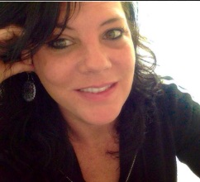
Stephanie Sledge is the creator of The Government Rag Educational Alternative News website. She is an author, independent researcher, freelance writer and investigative journalist. She graduated from the UN-sponsored Melvin D. and Valorie G. Booth School of Business, Northwest Missouri State University, with a degree in “Big Business” management, which led to the realization that all the economic models being taught were globalistic models meant to indoctrinate future business managers to think like global players and to manage money like the money masters. Once she began thinking outside the box, she was driven to explore alternatives to conventional thinking and eventually found The Government Rag.

CRISIS ACTORS & OTHER FAKES

Carl Herman: Very Old Moms – Average Age Giving Birth = 36 Years Old
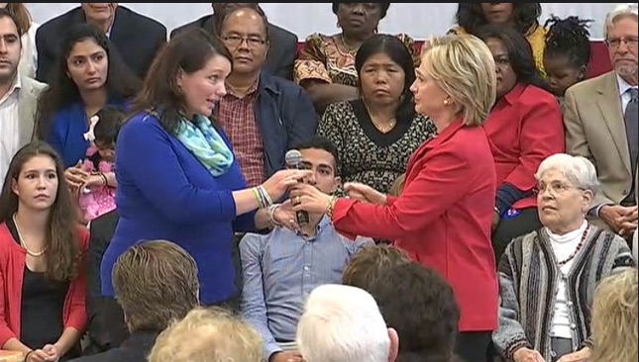
Mr. President,
Among the oddities of the Sandy Hook shooting is that the average age of the 20 mothers who claim to have lost children is 36, which is ten years older than average. The odds of 20 such elderly mothers = 109,418,989,131,512,370,000-to-1 (109 quintillion, 418 quadrillion, 989 trillion, 131 billion, 512 million, 370 thousand to one): this appears to be statistically overwhelming evidence the official story is a fraud. That this should occur by chance lies beyond any rational expectation.
Another professional with academic and professional expertise with statistical analysis concluded the odds of 20 such elderly mothers is 62, 482, 742, 574, 637, 216, 553 to one (that’s 62 quintillion to one), and it is 812 million times more likely that the alleged victims were born in 1996 rather than 2006 as we’re told in the “official” story. With numbers larger than what we work with and can accurately imagine, analogies are helpful.
On its face, it is statistically impossible for the Sandy Hook story to be true given just this one data point. This is more than enough to rationally challenge the accuracy of what we’re told about Sandy Hook. For comparisons:
- The odds of a person being left-handed is 15% (~1/6 to 1/7). It’s more probable for a random group of 20 people to all be left-handed than for a random group of 1st grade students’ moms to be age 42.
- The odds of winning the Powerball jackpot is ~175,000,000 to 1. The odds of winning two consecutive Powerball jackpots is 30,625,000,000,000,000 to 1 (175 million times itself). It’s more likely that you would win two straight Powerball jackpots than the Sandy Hook moms’ ages being true.
- The number of days since the claimed life of Jesus is ~730,000 (2,000 times 365). If Jesus were alive for 33 years, that’s 12,045 days. This means Jesus was alive 1.6% of the days passed since his birth (about 1/60). If you had a time machine to pick a random day to visit in those 730,000 days, it’s as likely you’d have 12 consecutive days in Jesus’ lifetime than it’s likely the Sandy Hook mothers’ ages is true.
- The Earth is about 4.5 billion years old, which is 1.64 trillion days. If we had a computer randomly select one of those days, the odds of you picking that same day is 1.64 trillion to 1. You are more likely to accomplish this miracle than it’s probable the Sandy Hook moms’ ages are accurate.
- In fact, the number of seconds Earth has existed is 141.7 quadrillion. You’re more likely to correctly predict which random second of Earth’s existence a computer selects than the Sandy Hook moms’ ages not being a lie. And to be most accurate, you’re personally more likely to select a random 1/700th of a second from all Earth’s existence over 4.5 billion years than the Sandy Hook “mom” birth age of 36 not being a hoax.

With our 109 quintillion to one odds, our Sandy Hook mothers cannot have a birth age average of 36. But it makes sense if the kids were fictions made up out of photographs of older children when they were younger. As a conjecture, we can infer that, with high probability, the photos that were used to represent the kids who died at Sandy Hook were about 10 years out-of-date, which explains why we have 20 Sandy Hook mothers who, were the story true, average an improbable 36 years age at birth.
Very Respectfully,
Carl Herman
Reference:
Carl Herman, “Another Angle on the Sandy Hook Shooting Hoax”, The Millennium Report, 4 August 2017.

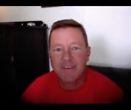
Carl Herman is a National Board Certified Teacher of US Government, Economics, and History (also credentialed in Mathematics). He worked with both US political parties over 18 years and two UN Summits for heads of state with the citizen’s lobby, RESULTS, for US domestic and foreign policy to end poverty. He can be reached at Carl_Herman@post.harvard.edu

Mona Alexis Pressley & Dan Cromer: “Lenny Pozner”, and “Noah Pozner”, are Both Fake

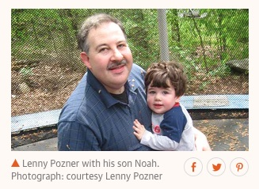
Mr. President,
The emotional impact of the Sandy Hook exercise was rooted in the reported death of children, which instilled fear into the hearts of American parents and made an indelible impression. Images of the most photogenic of the 20 who are supposed to have died, Noah Pozner, appeared world-wide. Millions of photos like this from The Guardian (2 May 2017) have been seen by a vast number of literate citizens. But it was all a monstrous fraud. We have proven that the kids were fictions made up out of photos of older kids when they were younger. Some parents even appear to have used photos of themselves.
By far the most active among the Sandy Hook parents has been the man who calls himself, “Leonard (‘Lenny’) Pozner”. He has been extremely aggressive in going after web sites by Sandy Hook skeptics, in demanding take-downs of images of him and Noah again and again and again, including of Dr. Eowyn, Dr. Tracy, Dr. Fetzer, Tony Mead and innumerable others. That was very strange activity for someone whose image has been published literally millions of times around the world. So what’s going on?
- Tony Mead discovered that Lenny has 23 web sites that he uses to attack students of Sandy Hook, which by itself suggests that he is not a bona fide parent of a child who died there;

- When the Showtime series, “Dark Net”, did a feature on Sandy Hook with Lenny Pozner and Jim Fetzer, Jim’s features were well-defined, but Lenny would not allow his face to be broadcast;

- Lenny brought a lawsuit against Wolfgang Halbig for alleged harassment and bullying, but when Wolfgang secured discovery, Lenny withdrew his suit rather than sit for a video-deposition.
These circumstances are suspicious enough, but when Kelley Watt had over 100 hours of telephonic conversation with Lenny and told him repeatedly that she did not believe a word he said, that she did not believe he had a son who had died at Sandy Hook and demanded proof to support that claim, Lenny, no doubt unadvisedly, sent Kelley a “death certificate” for Noah that turned out to be a fabrication. It combines the bottom 60% of a real death certificate with the top 40% of a fake, with no file number and estimated time of death at 11 AM, when it was supposed to have occurred between 9:35 and 9:40 AM.

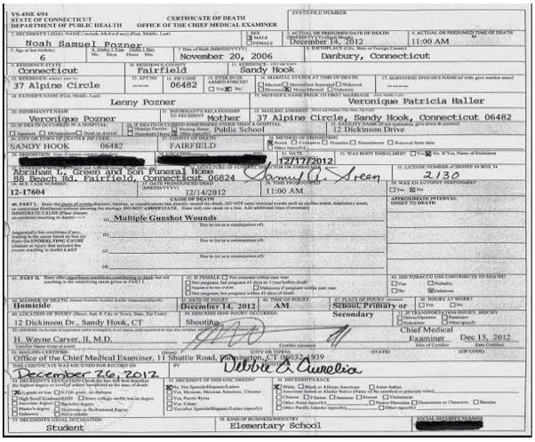
Editorial Note on Above Image: Here's the best image of the death certificate we can find. It's evidential value is not a function of its quality, since you can see (1) there is no file number; (2) it has the wrong estimated time of death at 11 AM, when the shooting officially took place between 9:35 and 9:40 AM. The bottom 60% is obviously different than the top. None of this depends upon the quality. We have to deal with the evidence we have.

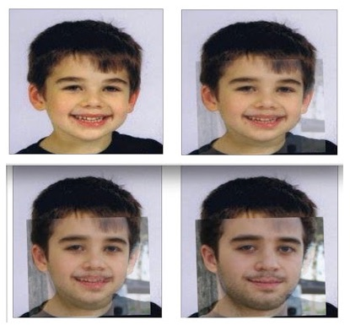
Kelley was the first to observe that there was a striking resemblance between the young Noah and his older step-brother, Michael Vabner. Six students tested her hypothesis and determined that Noah and Michael had the same eyes, the same eyebrows, the same nose, the same ears and the same shapes of skull. Larry Rivera created a gif in which you can watch as “Noah” turns into “Michael”, in a succession of four stages. Michael recently graduated from the University of Connecticut at Storrs and put up a web site of his own, which implicitly confirms that he is one and the same with the source of “Noah Pozner”:
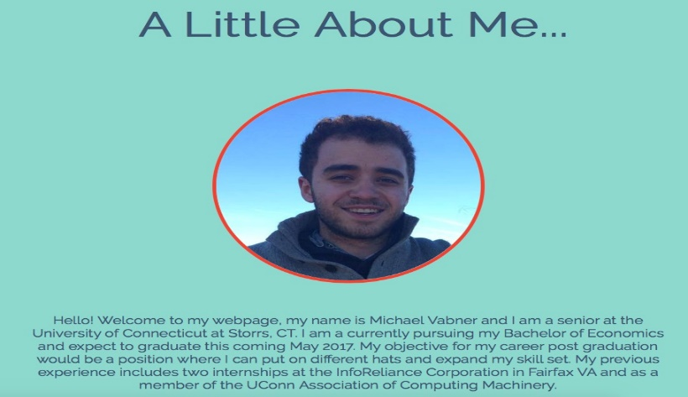
So how could we have so many photos of “Lenny Pozner” with Michael Vabner as a child, unless “Lenny” himself were the father of the child known as “Noah”? Digital image forensics applied by Dan Cromer has demonstrated that, just as “Noah” was created out of photos of Michael Vabner as a child, “Lenny” was created from old photos of Rueben. They share key facial features including their noses, eyes, skin tone, size of cheeks and facial width, even though digital editing was used to disguise them. He was not camera shy but protecting his image on TV and in Court to conceal his true identity as Reuben Vabner.

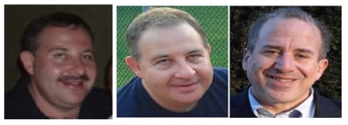
There are many other dimensions to the fraud, including faking gravestones, where the name on Noah’s was digitally stamped rather than authentic engraving. Its placement is also skewed, even though the art of engraving has become a science. But they couldn’t bother with engraving an actual gravestone for a fiction. To illustrate the fraud, Dan Cromer created a corresponding image for a gravestone for Mona:
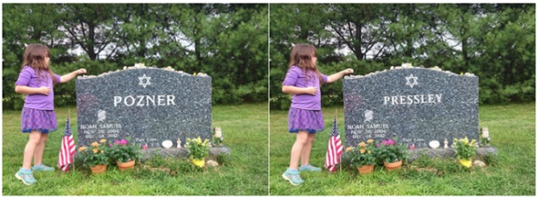
We can now explain why “Lenny” has been so elusive and why we have photos of “Lenny” with “Noah”. The child called “Noah was in fact the son of the man calling himself “Lenny”. But “Noah” was a fiction made up of photos of Michael Vabner as a child. And “Lenny” is Michael’s father, Reuben Vabner. QED.
Sandy Hook was an elaborate hoax to promote gun control and advance the political agenda of Barack Obama and the Democratic Party where the participants have committed theft by deception and some, such as Reuben Vabner, have also perpetrated frauds upon the Courts that deserve prosecution.
Very respectfully,
Mona Alexis Pressley and Dan Cromer
Reference: Mona Pressley, “Not only is Sandy Hook’s “Noah Pozner” a fake but his father “Lenny” is also a fake,” Conspiracy Truth, 17 July 2018

Mona Alexis Pressly, MA, MFT has frequently appeared on “The Raw Deal” and “The Power Hour”. Her research on numerous political issues, including Obama’s birth certificate, Sandy Hook and Las Vegas, has been published by Dr. James Fetzer, PENN Magazine and many other venues.
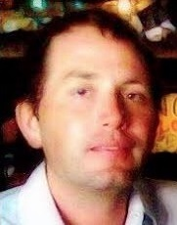

Dan Cromer, MIS, an information specialist, frequently appears on “The Raw Deal” and “The Power Hour” when James Fetzer, Ph.D., is guest hosting. His research on Sandy Hook, Las Vegas, Parkland and Santa Fe has appeared in numerous publications.

Mona Alexis Pressley: “Noah Pozner” Exists But Did Not Die at Sandy Hook
Mr. President,
I would like to direct your attention to the Sandy Hook “parent”, Reuben Vabner, who calls himself “Lenny Pozner”. He has engaged in an ongoing battle to shutdown questions being asked in regard to the purported shooting at Sandy Hook. “Lenny” has mastered the manipulation of emotional events and has many Americans fooled by persuading them they should shut down the evil skeptics of Sandy Hook.
There is harassment, as he claims, but it is not on the part of those doing research on Sandy Hook, but on his side. Tony Mead as discovered that “Lenny” has 23 web sites he deploys to find and shut down those who raise legitimate questions about Sandy Hook as innocent as who delivered the Porta-Potties, which would have revealed they were delivered on the 13th and blown the scam apart.
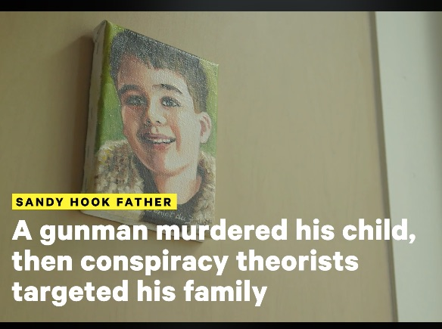
Here’s his latest:
“Sandy Hook father talks about . . .”
In this video, “Lenny” alleges that Alex Jones spreads misinformation, while at the same time Alex Jones has been targeted and shut down on the internet. But how can both sides of a controversy be presented to the American people when one side is allowed to stand and the other is suppressed? “Lenny” claims he is being harassed, but he means there are some (like me) who won’t accept his version of events.
When “Lenny” defines “harassment” as disputing his account, why should anyone buy it? Differences of opinion do not normally count as “harassment”, but the mainstream has adopted that approach. “Lenny” even features a gravestone that Dan Cromer and I had shown to have been photoshopped. If “Lenny” had his way, no one would be allowed to consider that many of his claims are provably false.
Kelly Watt had 100 hours of conversation with “Lenny”, during which she told him she did not believe a word he said, that she did not believe he had a son or that his son had died. As though to convert vice into virtue, in this video, “Lenny” offers glimpses of the document he sent to Kelly, which turns out to be a fabrication, with the bottom half of a real death certificate but top half of a fake. Here’s the best copy:

There are so many things wrong with this death certificate that blows your mind. The background paper has been tampered with (notice the contrast) where the font in certain sections has been changed (and is darker).
The file number is only partial as is where he was buried.
I have discovered that a person by the name of Noah Samuel Pozner did exist but he is not the “Noah Samuel Pozner” of Sandy Hook fame.
Many fake entries are to be found on the site FamilySearch.org, where this one below caught my attention:

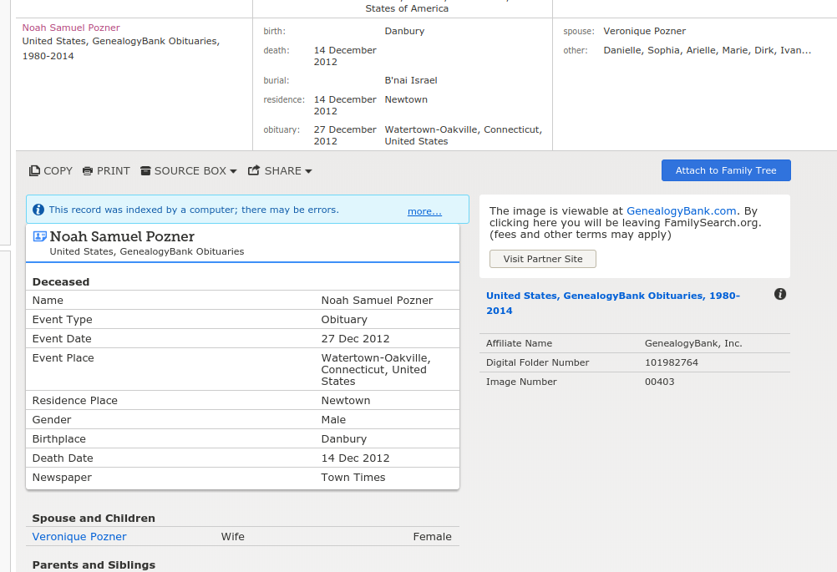
Noah Samuel Pozner was a lot older than we’ve been told. In fact, Noah appears to have been married to Veronique instead of Veronique having been his mother. It looks like he died in Watertown-Oakville, Connecticut but was buried in Israel. Actual evidence, including Images and folder numbers, back up this information. This is the entire key to the puzzle: generate confusion by faking entries on genealogy sites!
In this case, it was done by adding new information so the real information is not seen due to the piles of fake entries. Genius, in a criminal sense. So there was a real death certificate, but the location and time of death had to be changed along with the date of birth. One item on the certificate confirmed my worst suspicions. They ask if the decedent was a smoker and the answer was that they did not know.
REALLY? There we go: another indicator.
Very respectfully,
Mona Alexis Pressly
Reference:
Pressley & Cromer: In Solidarity with Alex Jones — Sandy Hook father, “Lenny Pozner”, and son, “Noah Pozner”, are Both Fake
Mona Alexis Pressly, MA, MFT has frequently appeared on “The Raw Deal” and “The Power Hour”. Her research on numerous political issues, including Obama’s birth certificate, Sandy Hook and Las Vegas, has been published by Dr. James Fetzer, PENN Magazine and other venues.

Mona Alexis Pressley: Charlottesville Crisis Actor made her Debut in Sandy Hook
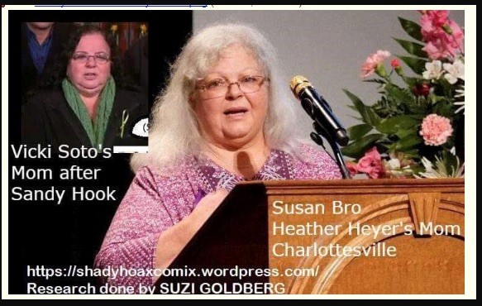
Mr. President,
While you correctly condemned racism on display in Charlottesville, you may not know that the whole event was political theater, an orchestrated event with crisis actors, the most conspicuous of whom, Susan Bro, said to be the mother of the woman, Heather Heyer, victim of a mock car crash, debuted as “Donna Soto”, the mother of Victoria Soto, a teacher reported to have died at Sandy Hook.
There are multiple videos about her performance, where Suzi Goldberg created the image shown above. But she is not the only source of confirmation of their identity. Here is the result of a superposition that leaves no doubt about it:
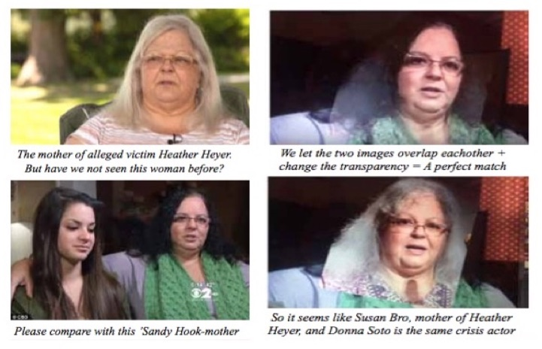
And it turns out that Heather Heyer did not even die in the car crash but from a heart attack the following day. By her purported mother’s own admission, Heather died of a heart attack instead of the reported cause of being hit by a car. On her family tree on ancestry.com, two different dates appear, one for 12 August, the other 13 August 2017, which is the actual date of death.
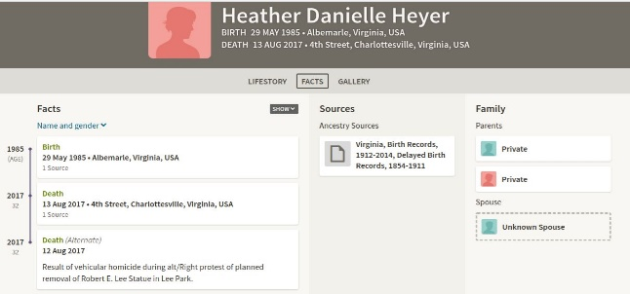
We find these reports of phony deaths are ubiquitous in the mainstream media, which more than justifies you calling it out as “fake news” and as “the enemy of the people”. Our founding fathers would be dumbfounded by this betrayal of the public.
Very respectfully,
Mona Alexis Pressly
Reference:
Jim Fetzer, “FAKE NEWS: The New York Times Celebrates a Charlottesville Stunt Man, a Shopped Photo and a Crisis Actor (who made her debut at Sandy Hook),” James Fetzer Blog, 20 May 2018.

Mona Alexis Pressly, MA, MFT has frequently appeared on “The Raw Deal” and “The Power Hour”. Her research on numerous political issues, including Obama’s birth certificate, Sandy Hook and Las Vegas, has been published by Dr. James Fetzer, PENN Magazine and many other venues.

Mona Alexis Pressley: “Sloppy Sniper” at Sandy Hook – Photoshopping?
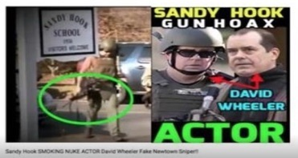
Dear Mr. President,
Among the sensational videos produced by “Barry Soetoro” about Sandy Hook was the discovery that David Wheeler, the husband of Francine Wheeler (whom Obama featured speaking on gun control from the Oval Office), played two roles at Sandy Hook: grieving father and SWAT team member, walking up and down Dickinson Driver—except that he was carrying his weapon upside down by the magazine! Although most of his videos have long since been removed in the frenzy of censorship by the social media giants, a few video links in regard to the man he calls “Sloppy Sniper” have survived, including “2. Sloppy Sniper” https://youtu.be/oL1Oy1rxpEM, where the images of David and Francine have appeared in many contexts in the campaign to evoke an emotional response to the reported Sandy Hook shooting. https://youtu.be/Oq0EJwfK0_Y
Barry Soetoro established a prima facie case that David Wheeler and Sloppy Sniper are one and the same man, which means that, absent rebutting evidence, it should be accepted as true. An article from The Crisis Actors Guild (4 January 2016) advanced an alternative explanation, suggesting that a bona fide FBI Agent named “William Aldenberg” was the sloppy sniper but had been mistaken for David Wheeler.

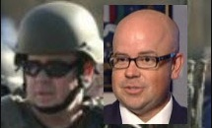

While Aldenberg, like Wheeler, bears a strong resemblance to Sloppy Sniper, no one with experience using military weapons would have committed the blunder of carrying an AR-15 upside down by the magazine, where magazines are designed to be rapidly removed and replaced. The weapon would be highly likely to fall to the ground, incurring damage to its sights or even accidentally discharging rounds.
As though that were not enough to resolve the issue in favor of the B-grade actor, the perps appear to have been sufficiently concerned by the persuasive force of Soetoro’s discovery that they took steps to discount it by photoshopping the name of Aldenberg on the back of Sloppy Sniper’s uniform. When you magnify the picture on Fotoforensics, it turns out the Aldenberg nametag was obviously photoshopped:

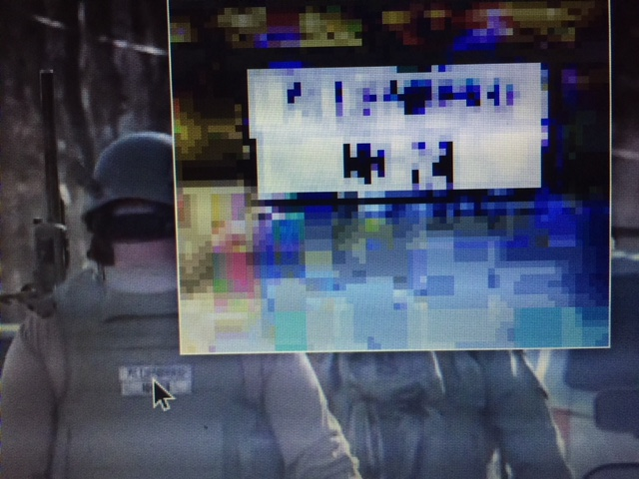

Since this photo came out years after Sandy Hook most of the photos that would be useful in proving the cover-up have been taken down. This is being done with considerable success, since the mainstream media, as the propaganda arm of the Deep State, long since mastered the principles to manipulate Americans on the basis of emotional appeals, and the social media giants are censoring our research.

Something profoundly un-American has been taking place as we are losing the right to read what we want to read and to watch what we want to watch. Under cover of their status as private corporations, Google, YouTube, Facebook and amazon.com, among others, are changing the fabric of our lives and our ability to communicate and collaborate with other Americans to expose frauds and discover the truth.

Very Respectfully,
Mona Alexis Pressley

Reference:

Shill Murray, “Did Sandy Hook Parent David Wheeler Play and FBI Agent on December 14th, 2012?” (4 January 2016)

Mona Alexis Pressly, MA, MFT has frequently appeared on “The Raw Deal” and “The Power Hour”. Her research on numerous political issues, including Obama’s birth certificate, Sandy Hook and Las Vegas, has been published by Dr. James Fetzer, PENN Magazine and many other venues.

James Tracy: Sandy Hook “Mother” Assistant to Democratic Fund Raiser Maureen White

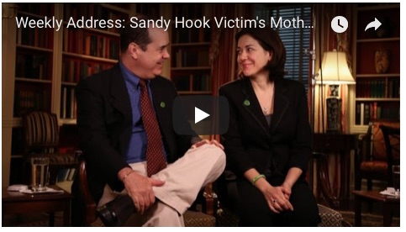
Mr. President,
On 16 January 2013, in the wake of the Sandy Hook school shooting, President Barack Obama signed no less than 23 executive orders to constrain our access to weapons under the 2nd Amendment. A few months thereafter, on 13 April 2013, at Obama’s invitation, one Francine Wheeler delivered an impassioned speech for gun control from the President's Oval Office, a distinction Obama previously conferred only upon Vice President Joe Biden. The choice is telling on multiple grounds.
Francine is likely the only actress with credits for doing the voice of a character in an animated porn feature to speak from the White House. Francine is also a musician member of “The Dream Jam Band.” In fact, she and her husband, David Cole Wheeler, are both professional actors with film credits. David has starred in an obscure film, “Faithful”, which centers around the theme of guns and suicide, and he's most recently been on the speaking circuit in the role of a bereaved Sandy Hook parent.
More to the point, the Wheelers' involvement in Sandy Hook and Francine's choice to speak from the Oval Office appear to derive from Francine having been previously employed as personal assistant to chief Democratic National Committee fundraiser Maureen White. In fact, White was the DNC’s star campaigner, raising $51 million in 2005 alone. White then served as senior advisor on humanitarian issues in Afghanistan and Pakistan under Secretary of State Hillary Clinton, which is suggestive of the political alliances behind the Sandy Hook event.
Maureen’s husband, powerful Wall Street investment banker and Obama administration advisor Steve Rattner, is also a close personal friend and money manager of anti-gun crusader and founder of Mayors Against Illegal Guns Michael Bloomberg. Bloomberg used the Sandy Hook shooting as a rallying cry for more stringent federal gun control measures. Rattner is a member of the Council on Foreign Relations.
The more we dig into Sandy Hook, the more we learn its probable motivation as a FEMA drill presented to the public as real to promote the DNC gun control agenda.
Very respectfully,
James F. Tracy

Reference:
James Tracy, “Francine Wheeler was Personal Assistant to DNC National Finance Chair”, Memory Hole Blog, 15 May 2016.

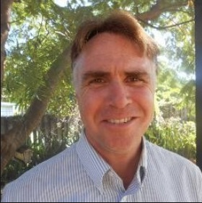
James F. Tracy is a media scholar, educator and political analyst located in South Florida. He received his doctoral degree from The University of Iowa in 2002 and was a tenured Associate Professor of Journalism and Media Studies at Florida Atlantic University from 2002 to 2016. Beginning in 2013 Tracy became victim of a media-led smear campaign as one of the few working academics to publicly question the Sandy Hook Elementary School massacre and Boston Marathon bombings. In 2015 Florida Atlantic succumbed to public pressure and terminated his professorship. Tracy has filed a First Amendment lawsuit against FAU and its officials that is now before the Eleventh Circuit Court of Appeals.

THE COVER-UP

James Tracy: Media Smears Professor to Point He Is Fired – Free Speech is Dead
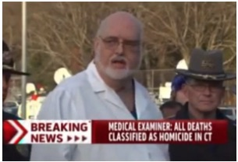
Mr. President,
I am a former Associate Professor of Journalism and Media Studies at Florida Atlantic University (FAU). In early 2013, I became the target of a smear campaign led by prominent news media after I questioned coverage of the 14 December 2012 Sandy Hook massacre. The media called on FAU to fire me because of my concerns. I therefore appreciate your clear condemnation of the Mainstream Media (MSM) for “fake news” where those posing as journalists spread falsehoods and propaganda.
As a student of news narratives for nearly two decades, I observed several contradictions and anomalies in the media’s presentation of the Sandy Hook event. Following the shooting, for example, emergency response protocols were abandoned and first responders were refused entry to school grounds. Authorities apprehended an alleged gunman but placed him in the front seat of a police car.
On 15 December 2012, the Connecticut State Coroner responsible for conducting the victims’ autopsies, H. Wayne Carver, M.D., joked and snickered about the children’s horrendous demise on national television. Astonishingly, he could not answer even the simplest forensic questions about their deaths.
Some independent researchers have suggested “crisis actors” or “role players” were posing in the event’s immediate aftermath as members of the victims' families. Although hundreds of families had been affected by the school shooting—where 469 allegedly required evacuation, according to the official report-—only a select few repeatedly appeared in video interviews.
When I found evidence that the Obama administration’s DHS had actually contracted with acting troupes for emergency exercises, including one called, "Crisis Actor", my suspicions began to grow. The Newtown incident had occurred just a month after the reelection of a president who vowed to undermine the 2nd Amendment, whose administration carried out Operation Fast and Furious and who, in advance of his second inauguration, a month and two days later, signed 23 executive orders implementing various forms of gun control.
In December 2015, South Florida Sun-Sentinel published an article that falsely accused me of criminally harassing a Sandy Hook victim’s family. In fact, I had simply requested evidence from the family’s non-profit organization to support a copyright infringement claim lodged against my blog.

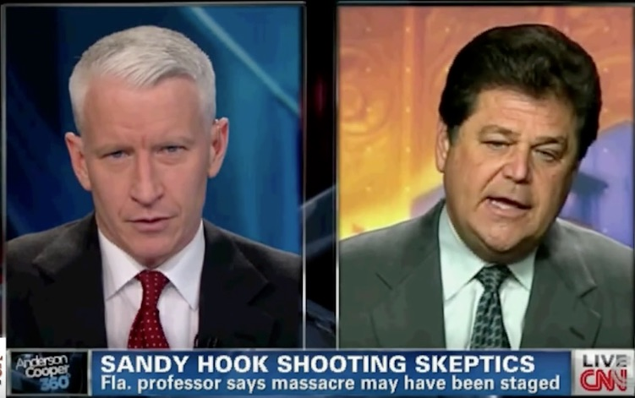
I discussed these observations and findings on my personal blog, asking why the news media had failed to do a more thorough job of investigating the school massacre. For these efforts, I was branded a “conspiracy theorist” and proponent of a “crisis actors’ conspiracy theory” by major media, including CNN, MSNBC, New York Times, and even Chronicle of Higher Education, which argued that I was “so cruel and possibly deranged” I had “no business being employed to teach undergraduate students.”
The innuendo that I “requested proof that the family’s son ever lived” was echoed throughout the press with no effort to verify the facts of the matter. FAU came under pressure to fire me, but because my teaching and research had been consistently adjudged excellent by students and peers alike, it devised a false pretext to terminate my tenured position.
A wealth of new research has been produced confirming my initial impression that the event was not authentic. At this point there are scant grounds to doubt Sandy Hook was an elaborate mediated reality created by news media and the Obama administration to terrorize American families with fear for the safety of their children to promote its preferred gun control agenda.
Very respectfully,
James Tracy

References:
Jim Fetzer, "The Chronicle of Higher Education Buckles to the 'Official Account' of Sandy Hook," JamesFetzer.blogspot.com, 16 January 2016.
Mike McPhate, “University in Florida Seeks to Fire Newtown Conspiracy Theorist,” New York Times, 18 December 2015.
James Tracy, “The Sandy Hook Massacre: Unanswered Questions and Missing Information,” MemoryHoleBlog.org, 24 December 2012.
James Tracy, “Sandy Hook School Massacre Part II: Continued Ambiguity and Augmented Realities,” MemoryHoleBlog.org, 1 January 2013.
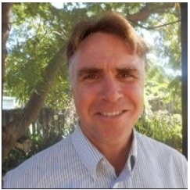
James F. Tracy is a media scholar, educator and political analyst located in South Florida. He received his doctoral degree from The University of Iowa in 2002 and was a tenured Associate Professor of Journalism and Media Studies at Florida Atlantic University from 2002 to 2016. Beginning in 2013 Tracy became victim of a media-led smear campaign as one of the few working academics to publicly question the Sandy Hook Elementary School massacre and Boston Marathon bombings. In 2015 Florida Atlantic succumbed to public pressure and terminated his professorship. Tracy has filed a First Amendment lawsuit against FAU and its officials that is now before the Eleventh Circuit Court of Appeals.

Louis Leo IV: James Tracy’s Wrongful Termination—the End of Free Speech?
Mr. President,
As you observe all of the conservative voices being digitally assassinated by what Robert David Steele calls #GoogleGestapo – the combination of Amazon, Facebook, Google, MeetUp, Twitter, and YouTube all deleting entire accounts with impunity and without regard to Title 7 or other applicable laws and regulations related to Free Speech, please know that there is a case that precedes the Alex Jones case, a case in which a university fired a professor with tenure for daring to speak out with skepticism about Sandy Hook, which he believed to have been an exercise in which no one died.
Attorneys for James Tracy have filed an appeal to the U.S. Court of Appeals for the Eleventh Circuit of the summary judgment rulings granted by the District Court in favor of Florida Atlantic University (“FAU”) and various public university officials. Tracy’s lawyers also argue that the jury verdict should be reversed and the Court should grant judgment in Tracy’s favor as a matter of law.
James Tracy was a distinguished tenured faculty member in FAU’s School of Communications who taught journalism history, communication theory, and courses on the media’s coverage of conspiracy theories. Tracy received awards for his work, regularly earned excellent reviews, and was a former president of the FAU faculty union. Despite Tracy’s outstanding academic record, FAU fired Tracy in retaliation for controversial posts he made on his personal blog questioning the legitimacy of the Sandy Hook Elementary School massacre. In January 2016, FAU terminated Tracy’s tenured professorship, falsely claiming he had been “insubordinate” for failing to disclose his blogging activity under its conflict of interest outside activity Policy.
On appeal, it is argued that summary judgment should have been granted in Tracy’s favor by the District Court, since the Policy FAU used to terminate his professorship is unconstitutionally vague because blogging is not mentioned as a potential conflict of interest, key terms used within the Policy are undefined, and FAU does not have a policy on blogging. Over twenty professors have blogs or other online speech activities, and Tracy is the only one to have ever been required to report, much less disciplined, for failing to report under the Policy.
This is all the more compelling given that Tracy’s blog was publicly available and well known to FAU, and his speech was widely reported and highly controversial. The record demonstrates FAU’s Policy violates the First Amendment “because it fails to provide employees with a reasonable opportunity to understand what blogging it prohibits and authorizes” and the Policy “did not provide sufficient guidance as to what blogging had to be reported, it could not be enforced without reference to the content of an employee’s speech, thereby facilitating viewpoint discrimination targeting disfavored speech.”
Indeed, FAU found Tracy’s posting violated the Policy despite having no policy at all on blogging while it fully protected expression that it favored.”
Additionally, Tracy’s lawyers argue that the jury verdict (that Tracy’s speech was not a motivating factor in his termination) is contrary to overwhelming evidence, and no reasonable jury could have determined that Tracy’s speech was not a motivating factor in his termination because:
- Tracy’s blogging was obviously not a conflict of interest;
- FAU’s reason for firing Tracy was legally insufficient;
- FAU’s history of disciplining and monitoring Tracy’s blog;
- FAU’s selective enforcement of a vague Policy;
- Evidence of complaints and negative publicity;
- FAU’s termination letter citing the blog; and
- FAU emails celebrating Tracy’s termination.
Moreover, the District Court wrongfully excluded evidence that directly impacted Tracy’s ability to enforce his rights at trial.
Mr. President, a class action lawsuit has been filed against the various social media networks that are discriminating against conservative voices, but as the case of Professor Tracy demonstrates, Free Speech is America is not being defended by the Courts. America is in crisis and your Attorney General is doing nothing. I humbly suggest that the case of Professor Tracy specifically, and the assault on Free Speech generally, merit your direct personal and sustained interest.
Very respectfully,
Louis Leo IV
Reference:
The full brief is online as CASE NO. 18-10173 IN THE UNITED STATES COURT OF APPEALS FOR THE ELEVENTH CIRCUIT, JAMES TRACY, Appellant, v. FLORIDA ATLANTIC UNIVERSITY, ET AL., Appellees. Appeal from the United States District Court for the Southern District of Florida Case No. 9:16-cv-80655-RLR-JMH CORRECTED PRINCIPAL BRIEF OF APPELLANT JAMES TRACY, Date Filed 08/06/2018.

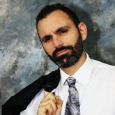
Louis Leo IV, a Trial Lawyer. Truth & Justice Seeker. Civil Rights Defender. Corruption Exterminator; Contributing editor at March Against Monsanto; Community Organizer at March Against Corruption; Trial Lawyer at Florida Civil Rights Coalition; Chief Fake News Destroyer at People Over Politics; Studied Law at Nova Southeastern University; Studied Legal Studies/Criminal Justice at Nova Southeastern University.

John Remington Graham: Litigation Against Alex Jones in Connecticut is Abuse of Process
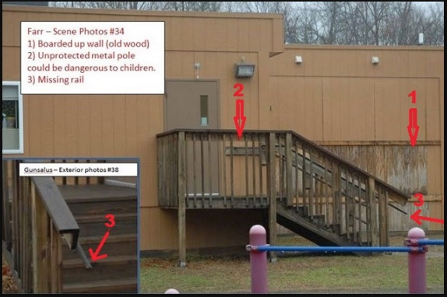
Mr. President,
The litigation against Alex Jones in state courts of Connecticut is plainly an abuse of process, impossible to institute and press in an uncorrupt and honest manner, and designed to intimidate any and all journalists who dare to contend that the alleged shooting at the Sandy Hook Elementary School in December 2012 was a staged event, meant to shape public opinion in favor of gun control legislation, but so poorly orchestrated by public authority and major news media that many eminent observers have seen through the official story and understood something closer to the truth. The idea that damages for defamation could be lawfully granted against Jones is patently absurd in light of seminal authority long ago established in New York Times v. Sullivan, 376 U. S.254 (1964), and Garrison v. Louisiana, 379 U. S.64 (1974).
The episode at Sandy Hook can be and has been studied in various degrees of depth, but we can know that Sandy Hook was a hoax, as surely we can know that the intelligence of the American people was insulted by the news media reports and the Warren Commission concerning the murder of John F. Kennedy which led to the tragedy of the Vietnam War. As was once observed by Lord Acton, “Historic responsibility has to make up for want of legal responsibility.” And there is our consolation. Death has intervened to prevent temporal justice against those who plotted the death of Kennedy, but we know who they were, and we are beginning to learn lessons from their crimes for the good of our country.
Something as sinister is evidently behind the litigation against Alex Jones. As with most citizens, I have not had time to study Sandy Hook in full depth, yet it is manifest that Sandy Hook could not have happened as it has been reported to us by public authority and major news media. We know from bare facts stated by Dr. Eowyn, in her internet-accessible article showing that the Sandy Hook Elementary School was closed in the year 2008, and that, therefore, the alleged massacre in December 2012 did not happen. From the closure of the school in 2008 alone, the litigation against Jones over Sandy Hook stinks of dishonor to our country.
If we are going to talk about conspiracy theories, as if such thinking were a sign of mental imbalance, let us remember that Abraham Lincoln believed in conspiracy theories. His “House Divided” speech is an outstanding exposition of why and how we should infer concert from circumstantial evidence in history and politics. Winston Churchill and Benjamin Disraeli believed in conspiracy theories. Those in the press who denounce conspiratorial thinking, including those behind the suit against Alex Jones, are wittingly or unwittingly domestic enemies of the United States.
The bare facts from which the closing in 2008 may be inferred were outlined in her article, “Sandy Hook hoax: 6 signs that school was closed before massacre”. I invite all curious, honest, and patriotic citizens to read this article. We have here a prima facie case that the school was closed in 2008, from comments of neighbors to the school, from reports of contamination of the school with asbestos requiring expensive repairs, from photos showing the school was abandoned at the time of the incident as broadcast across the country, from the absence of handicapped parking spaces required at the time of the claimed incident, from the absence of internet activity between the school and the outside from 2008 to 2013, and from the testimony of Wolfgang Halbig at his FOIA hearing in the spring of 2015.
That much alone, without more, makes the suit against Jones shameful to the law. All upright lawyers should protest. I add these remarks under the inspiration of Edmund Burk when he said, “All that is necessary for evil to triumph is for good men to do nothing.”
Very respectfully,
John Remington Graham
Reference:
Dr. Eowyn, “Sandy Hook hoax: 6 signs that school was closed before massacre” (Fellowship of the Minds, 9 September 2015).
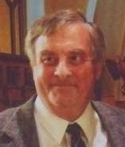
B. A. in philosophy 1963, LL. B. 1966, University of Minnesota; admitted to the Bar of the Minnesota Supreme Court, 1967; admitted to the Bar of the United States Supreme Court, 1971; Public Defender, United States District Court for Minnesota, 1969-1973; Founding professor, teaching common law pleading, judicial writs and remedies, American constitutional law, admiralty, copyrights, legal writing, conflict of laws, legal history, and modern civil procedure, and serving as chairman of the admissions committee, Hamline University School of Law, 1972-1980; Advisor on questions concerning constitutional law and equitable remedies to the Minnesota State Board of Bar Examiners, 1974-1978; Special Counsel for the City of Brainerd, 1974-1980; Crow Wing County Public Defender, 1981-1984; Crow Wing County Attorney, 1991-1995; Occasional lecturer in comparative British, American, and Canadian constitutional law at Laval University, 1989-1991, 1997, and 2000, and in public international law, 2003; and Advisor on British constitutional law and history to the court-appointed Amicus Curiae for Quebec before the Supreme Court of Canada in Reference on certain Questions concerning the Secession of Quebec from Canada, [1998] 2 S. C. R. 217.

James Fetzer: Impostors Seek Social Media Giants Protection for Their Criminal Acts

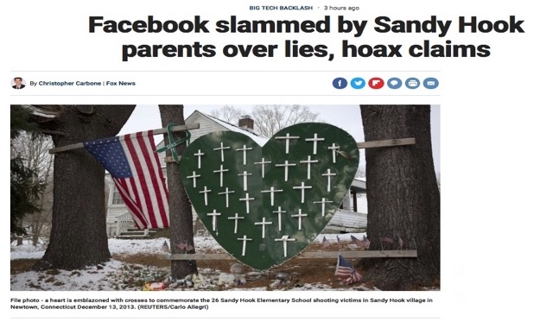
Mr. President,
In an astonishing exhibition of chutzpah, fake Sandy Hook parent imposters are seeking protection from exposure on the fantastic ground they are being subjected to harassment and bullying, which, under the circumstances, is completely absurd. The Sandy Hook hoax made them rich beyond belief, splitting between $28-130,000,000 in donations from sympathetic but gullible Americans who mistakenly believed that they had lost children--a myth massively propagated by the mainstream media.
Their appeals to Facebook have nothing to do with harassment or bullying but a desperate attempt to ward off their exposure through the social media. The mainstream has already been co-opted by the Deep State, which has been sponsoring fake school shootings in a determined effort to constrict and eventually abolish American's right to keep and bear arms under the 2nd Amendment--where a nation with 100,000,000 armed citizens cannot be dominated by the forces of tyranny. (See my video below.)
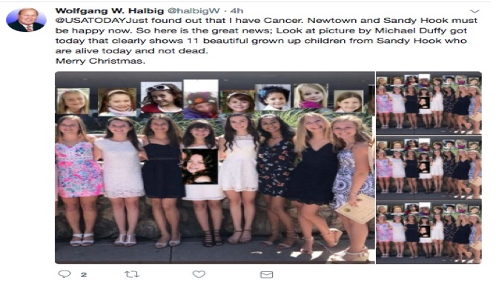
They took an abandoned school and used it as the stage to conduct a two-day FEMA drill. There was a rehearsal on the 13th, going LIVE on the 14th. We have proven they faked the kids out of photographs of older kids when they were younger. Some “parents” may have used photos of themselves as children. Wolfgang has produced photos of eight of the girls all grown up and looking very much alive, where he has affidavits from 3 of them (now high school graduates), who want to regain control over their lives.
You may think of Sandy Hook as a primer on how to make obscene amounts of money by staging faux acts of terrorism The 26 fake families spilt the donations and pocketed at least $1,000,000 apiece. The Newtown School Board was given a grant of $50,000,000 for a new K-4 elementary school, even though the average cost across country is only $7,000,000. With the help of their friends in the media, including Facebook, they are going to continue to profit by their criminal acts of fraud and of theft by deception.
As Wolfgang Halbig observed during our conversation on “The Power Hour” (24 January 2018), children from Sandy Hook were featured at the Super Bowl that year and no doubt vast sums were donated on their behalf, but no one knows what happened to the money. The Super Bowl Program did not identify them by name and an injunction has been issued to prevent any of them from being interviewed about their participation. The perps are using the law to protect and benefit themselves. That's the American way!
Very respectfully,
James Fetzer

References:
Christopher Carbone, “Facebook slammed by Sandy Hook parents over lies, hoax claims” (25 July 2018),
Jim Fetzer, “The 2nd Amendment and the Politics of Gun Control” (video, 28 May 2018),
Jim Fetzer and Wolfgang Halbig, “The Power Hour: Jim Fetzer, Guest Host” (24 January 2018)

Jim Fetzer, a former Marine Corps officer, is Distinguished McKnight Professor Emeritus on the Duluth Campus of the University of Minnesota. He co-founded moonrockbooks.com with Mike Palecek, when they discovered amazon.com was banning their books. He has published widely on conspiracies, including “False Flags on Five Fronts: Sandy Hook, Boston, Charlottesville, Las Vegas and JFK”, “How to Spot a ‘False Flag’: A Sampler of Representative Events”, and “The Parkland Puzzle: How the Pieces fit Together”, at 153news.net, BitChute, real.video and other secure sites.

Sterling Harwood: Snopes.com Complicit in Cover-Up?
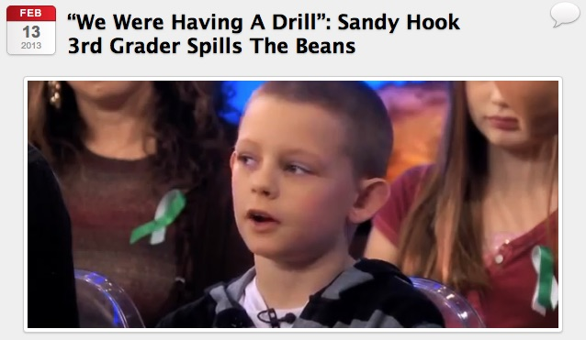
Mr. President,
Snopes.com is the #1 place many turn when hearing about a conspiracy theory, such as that the Sandy Hook shooting was faked, for the very first time. Snopes.com has done its best to debunk every Sandy Hook conspiracy theory of which it has become aware. Since the evidence the shooting at Sandy Hook was contrived—it was a two-day FEMA drill presented as a LIVE event—Snopes.com must have its facts wrong [or be a Deep State front explicitly designed to undermine “truthers.” My aim in this memorandum is to debunk Snopes.com own debunking.
Unidentified Men Acting Oddly at the Scene
Consider the case of what Snopes.com admits was an unidentified man seen with a gun in the woods near the school on the day of the massacre, as reported in The Newtown Bee. Snopes.com reassures us that a reliable local law enforcement source says that the armed man at or near the scene of the crime was only an off-duty tactical squad police officer from another town. But this so-called (implicitly anyway) innocent explanation raises about 100 more questions than it answers. What was his name? Why can't we know his name? Why was he armed? Why was he armed when he was off-duty?
Why did he decide to spend his off-duty hours prowling the woods where a massacre was to occur or had just occurred? What did he see, if anything, from the vantage point of the woods or wherever else he traveled in the area that day? To whom did he report, if anyone? With what weapon or weapons was he armed? Did those weapons match those of the accused killer by any chance? Did the man fire his gun? If he fired his gun, did he hit his intended target? What was his rank? What was his level of training? What was the name of the other town he was from? Was he called in from out of town by any law enforcement officials in Newtown? And of course we could go on.
This so-called innocent explanation of an armed tactical squad officer from out of town just happening to be there strikes me more than a bit as being as alarming an explanation as the following hypothetical one: Oh, don't worry about that armed, unidentified man we saw in the woods behind the massacre; he was just a highly trained off-duty CIA sniper who was just visiting from Hong Kong. What?! If he were from the CIA, we would know why his name was hidden; but tactical squad officers are not undercover officers, so there's no reason to hide his name. You can listen to a police scanner and go to wherever the SWAT team is called and take photographs with a telephoto lens of all the tactical squad officers.
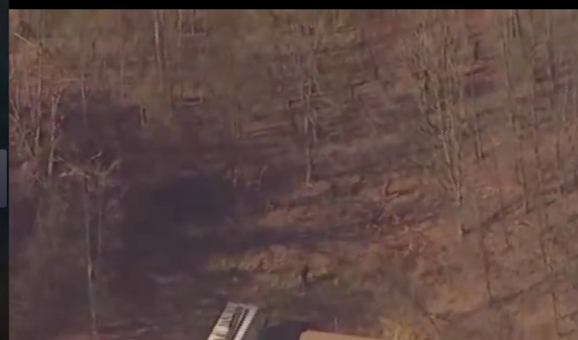
Now consider the case of another unidentified man. This time the man was detained, handcuffed, and pinned to the ground. He may have been armed but Snopes.com evidently thinks that is so unimportant it fails to say one way or the other. But don't worry, Snopes.com reassures us that police determined he was just an innocent passerby. Snopes.com gives no citation to any source it has for that reassurance. Snopes.com fails even to rely on the prestigious Newtown Bee here, as it relied on before in trying to reassure us about the mysterious, armed tactical-squad officer.
Snopes.com fails to identify which police officer or officers made that determination that the handcuffed man was just an innocent passerby. Snopes.com also fails to give the handcuffed man's name or physical description at all. If the guy is so innocent, then why refuse to release his name so the free press of this mighty country can double-check to see if the police might have made a mistake in making their determination of his alleged innocence. Police do make mistakes, you know.
The Los Angeles Times (14 December 2012) reported the man's name as Chris Manfredonia. The story is that police released him because he said he was a parent who had come to the school that day to help his 6-year-old daughter make gingerbread houses. There are, however, two more suspicious facts: first, Manfredonia was wearing camouflaged clothes when spotted in the woods behind the school; second, Manfredonia's home address is "directly behind" the other murder scene, the home of Adam Lanza.
Logical Puzzles Unaddressed by Snopes.com
There are other puzzling issues that the 15-page entry on Snopes.com for Sandy Hook fails to answer. A second liquid missing from the scene, besides the tears of any parent, is blood. (See, for example, Sofia Smallstorm, "Unravelling Sandy Hook," and Peter Klein, "What Really Happened at Sandy Hook?") Snopes.com has no answer for the absence of any photographs or video of blood from the murder scene or from any of the scenes where others victims were, officially, at least, non-fatally injured, which is highly unusual.
There was plenty of blood from, for example, the Manson murders, the OJ murders, Columbine and other murder scenes that came out but none at all from Sandy Hook. In the aftermath of the Oklahoma City bombing, one color photograph of a fireman holding a bloody, mortally wounded child won some prestigious awards for photojournalism, and it is a haunting photograph indeed with deep symbolism on several levels. We even have photos of, for example, the dead face of Marilyn Monroe, the dead face of Elvis Presley, and the dead face of John Lennon leak out, yet we see no leaked scenes of blood or dead faces from the more elaborate Sandy Hook massacre.
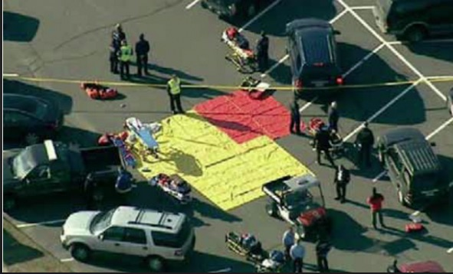
In fact, we don't see blood on any non-fatally wounded people, though there were some, according to the official story at least. We see no blood on any emergency medical technician, law enforcement officials or health care personnel. And there were no bodies or blood on the triage tarps. And this is in the age of cell phone photography, video-cameras, and helicopters with cameras that can zoom in for close-ups. Isn't the lack of blood implausible, especially given how many people were filmed milling around the parking lot of the school soon after the massacre?
Snopes.com also has no answer for the fact that there are gaps in the Internet and email usage at the school that suggest the school was not in use regularly but was used only for a drill. Speaking of Internet usage, another implausible fact, if the Sandy Hook massacre is totally un-staged rather than any sort of psychological operation or drill, isn't it implausible for there to have been Internet donation pages set up for some of the victims so soon after the murders of the particular victims were confirmed? As Nobody Died at Sandy Hook (2015) documents, some donation sites were launched before the massacre. How is that possible, had this not been a staged event?
Snopes.com also has no answer yet for a young boy interviewed by Dr. Oz on the Dr. Oz show (see the fascinating YouTube.com clip from Dr. Oz's show) who says that the Sandy Hook emergency was only a drill. Dr. Oz changes the subject immediately instead of asking the boy why he thought it was only a drill or who told him it was only a drill. I find Dr. Oz's changing the subject so fast suspicious. Perhaps Dr. Oz lacks an enquiring mind or was just obeying a producer's shout into his earpiece to switch to another subject. Perhaps his producer shouted into Dr. Oz's earpiece, “Don't pay attention to the man behind the curtain or to the Sandy Hook victim who said it was a drill. Nothing to see here. Move along!”
Very respectfully,
Sterling Harwood, J.D., Ph.D.
References:
Sandy Hook Mass Shooting: The Camouflage Pants Man
Peter Klein, "What Really Happened at Sandy Hook?"
Richard Serrano et al., “Gunman kills 20 kids, 6 adults at Connecticut elementary school”
Sofia Smallstorm, "Unravelling Sandy Hook in 2, 3, 4 and 5 Dimensions",
Sterling Harwood, “Every Grain of Sandy Hook: Snopes.com and Plausible Deniability”, in Jim Fetzer and Mike Palecek, eds., Nobody Died at Sandy Hook (2015).
“We were having a drill”: Sandy Hook 3rd Grader Spills the Beans

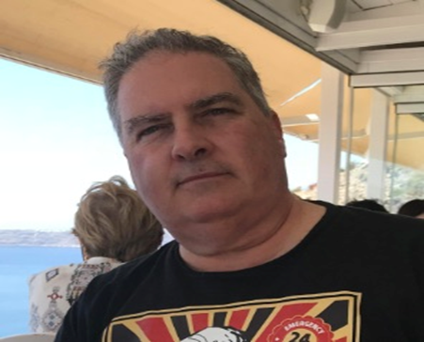
Sterling Harwood earned his J.D. from Cornell Law School and his Ph.D. in philosophy from Cornell University. Since 1998, he has practiced law in San Jose, California, from which he has now retired. He earned tenure as an Adjunct Philosopher at Evergreen Valley College after teaching at Cornell Law School, Cornell University, Lincoln Law School, San Jose State University and Illinois State University. His books include Crime and Punishment (with Michael J. Gorr, 2000), Business as Ethical and Business as Usual (1996), Judicial Activism (1996), and Controversies in Criminal Law (with Michael J. Gorr, 1992).

Phi Beta Iota: Snopes.com is considered by some to be part of the social media ecology funded, nurtured, and controlled by the Deep State against the public interest. It should be included in any RICO investigation of Facebook, Google, MeetUp, Twitter, and YouTube.

Cinderella Broom: Burying the Undead - Stranger Than Fiction
Mr. President:
The story we’ve been told about Sandy Hook is so laden with anomalies, contradictions and absurdities that, were it proposed as a screenplay, producers would likely reject it as simply ridiculous. One aspect deserving more discussion concerns how the faked deaths involved the fake disposal of bodies. What do you do to cover the disposition of bodies in works of fiction?
A striking case involve the use of a crematorium with a criminal history to handle the remains of the purported shooter, Adam Lanza. In a state with between 200-340 morticians, undertakers and funeral directors, CT settled on an establishment that had been the focus of crime exposés in The Hartford Courant for a solid seven years (2006-13).
Hartford Trade Service, LLC (East Hartford, Connecticut), together with River Bend Funeral Home and Crematorium, LLC, were established by Kevin K. Riley. In 2004, Mr. Riley landed a lucrative contract worth $500K with the state of Connecticut to provide decent burials for people who died with no immediate families to care for them.
Mr. Riley wasted no time in exploiting the opportunity: double-billing, plundering the assets of the dead and using an unlicensed embalmer’s services. The list goes on. He even allowed his bookkeeper, Yolande Faulkner, to sell some of the booty.
In February 2010, Riley was charged with 63 counts of 2nd-degree larceny. He was convicted and pled guilty. Upon sentencing, Riley was forced to surrender his funeral director and embalming licenses, yet the establishment stayed open under the license of yet another “Kevin”—one “Kevin Davidson”. And there is evidence that his co-conspirator, Yolande Faulkner, also convicted, continued in the business.
Despite all of the foregoing, when the State of Connecticut decided to cremate (in secret) the remains of Adam Lanza, Hartford Trade Service was selected for the job. The death certificate of the purported shooter clearly names the funeral facility in Box #33 next to an illegible signature and the license number (#2698) of “Kevin Davidson”.

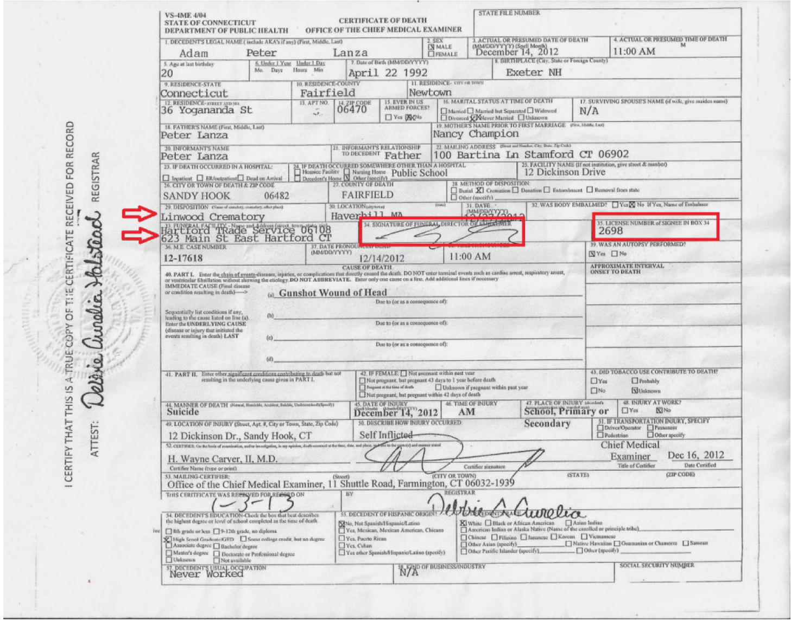
Ask yourself: Why would Connecticut transport the remains of the alleged Sandy Hook perp to a crematorium of ill repute? Why take such a risk with allegedly the biggest tragedy in the state’s history, an incident with such a high profile that sympathy cards and gifts were flowing in from all over the world?
If things had been on the up-and-up, it wouldn’t have made any sense. But things were never right with the Sandy Hook story, Mr. President, because it was, in my opinion, a fabrication – a fiction story with a supporting cast of shady characters – and not a very convincing one at that.
However, if the Sandy Hook massacre never took place, and Adam Lanza never died (or, as some say, never even existed), what better choice to dispose of his remains than a crematorium with a long rap sheet? A business whose director was an ex-convict would be the perfect candidate to pose as the “funeral facility” for a non-existent corpse. Which appears to be what happened here.
Very Respectfully,
“Cinderella Broom”

References:
Dr. Eowyn, “Sandy Hook: The Curious Case of Adam Lanza’s Ex-Con Funeral Director” (27 April 2016),
Articles by Colin Poitra, Dave Altimari, David Owens and Hilda Munoz that appeared in The Hartford Courant between November 2006 and February 2013 (available upon request).

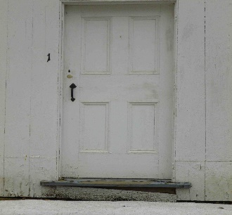
Cinderella Broom has 30 years of experience as a professional writer, including three books of fiction. She holds a master's degree in English from a prominent northeastern university. For nearly three years, Ms. Broom authored articles that appeared on her blog, Cinderella's Broom, until the blog was suspended by WordPress on August 15, 2018 for no stated reason. Research and writings on that blog pertained primarily to the Sandy Hook event on 14 December 2012.

Carl Herman: “Chemtrails” Preventing Satellite Photos on 14 December 2012
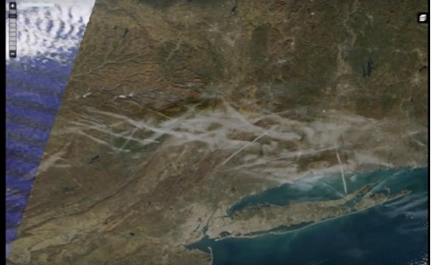
Mr. President,
I wrote and shared PlasmaBurns' YouTube video of how “chemtrails” in Sandy Hook pictures inspired his research of satellite data leading to his discovery that twice-daily photos only had such chemtrails over Sandy Hook once from 2010 to 2017 (5,840 days): the day of the alleged shooting at the elementary school. PlasmaBurns’ 7 minute video has since been removed. A screenshot of the morning in question:
PlasmaBurns compared the chemtrails’ locations to commercial airline flight paths and found zero traffic where these chemtrails were sprayed. This means non-commercial airplanes had to receive government clearance to spew those chemicals over Sandy Hook that morning, and whatever government agencies who granted the clearance are likely criminal accomplices with foreknowledge of the Sandy Hook event.
I suspect the purpose was to help normalize chemtrails into public subconscious or (more likely) to obscure satellite views of what happened at that location on that morning. Because satellite imagery can detail car types and perhaps license plates, cars in the Sandy Hook parking lot might have been identifiable to verify just who was and was not present from years leading to the event. Treating each of those days as equally probable for chemtrails, the odds of it happening that day by chance is 1/5,840.
Let’s consider the factual presence of chemtrails over Sandy Hook with questions like these in mind::
- Who ordered the non-commercial flights to spray over Sandy Hook on 14 December 2012?
- Who was required to approve these multiple flights spraying those chemicals?
- What were the chemicals used and what was the specific purpose of spraying?

Given this data, and at odds of 5,840 to one, would you bet chemtrails over Sandy Hook on the morning of the “shooting event” was coincidence or would you bet those odds are too improbable? In science, the chance hypothesis is typically rejected when it has an improbability of 1/20 or less. This therefore does not appear to have occurred by chance. Research on the chemtrail phenomenon that day would almost certainly reveal the identity of some of the government entities producing the hoax.
Very respectfully,
Carl Herman

Reference:
“Chemtrail Involvement at Sandy Hook?”, Educate-Yourself.org, 18 March 2013.

Carl Herman is a National Board Certified Teacher of US Government, Economics, and History (also credentialed in Mathematics). He worked with both US political parties over 18 years and two UN Summits for heads of state with the citizen’s lobby, RESULTS, for US domestic and foreign policy to end poverty. He can be reached at Carl_Herman@post.harvard.edu

LESSONS LEARNED & ONE FINAL QUESTION

Nicholas Kollerstrom: State-Sponsored Terror – Nobody Died – Exercise With Crisis Actors
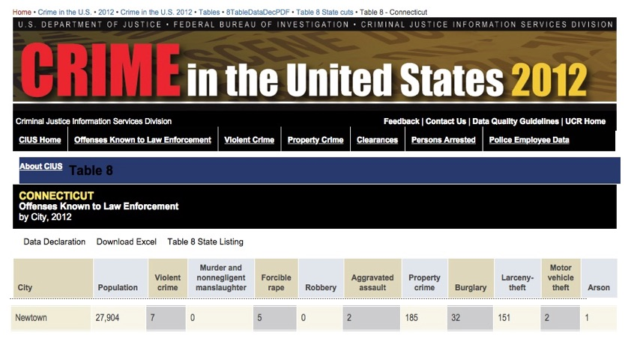
Mr. President,
Above is the official Federal Bureau of Investigation (FBI) report on deaths in Newtown, CT in 2012: 0.
The ‘Sandy Hook’ event was a great transitional moment in modern state-fabricated terror. Before it, we had events such as 9/11 and the London bombings of 2005, in which a lot of people died. After it, there are mockup events with actors and fake blood, which are a lot cheaper and easier to arrange. Since 2012 state-terror events have used crisis actors. This is alas the main art-form of the 21st century, whereby the ‘Deep State’ gets its wars going.
Before Sandy Hook, there would be ‘drills’ or ‘wargames’ which were arranged to synchronize with the event: the perpetrators would cause them to ‘go live’ so that real terror then took place. Thereby the State was able to blame some external Enemy, for what it had done. But things changed in 2012 with mere actors and dummies being used to scare everyone. The Sandy Hook nightmare killer ‘Adam Lanza’ never existed, he was just a mockup. The state of Newton had received a grant from Homeland Security to run the drill. But, the drama of the event acquired a bit too much realism and spilled over into newspaper headlines.
There were for example no bullet marks in any school classroom, no bodies of little kids taken by ambulance into hospitals – none of that happened: there were just a load of crisis actors, and A LOT of state money going into Newtown to keep everyone quiet.
Those families in Newtown were not real. The kids existed, but they were several years older than the pictures we all saw: many of those ‘dead’ kids were rewarded by appearing at the Super Bowl concert with Beyoncé months later. It was pointed out that they were evidently the same but about twelve years of age.
Of the twenty families involved with the children, all were home-owners in Newtown. Many had just moved in before the event and all had their mortgages paid off shortly before. That was a key part of the process whereby they were manipulated to go along with the story.
Mr. President, it is your business to appoint someone who can detail all those fake families who came together in Newton, and examine birth and death certificates, school records, etc. Get a full statement from the FBI, whose records clearly state that they recorded NO murders in the Newtown area over that period. You yourself make no statement on the matter – that would be too dangerous and explosive – but you set in motion investigations of REAL IDENTITY – the people behind the actors.
The Boston Marathon bombing of 2013, another state-fabricated event in which nobody died, used crisis actors who were amputees. The initial images showed missing arms and legs, but no blood, which would be impossible had this been real. Its aim was to demonize Muslims, that being the common objective of 21st-century state-fabricated terror, whereas the Sandy Hook mock-terror event, by contrast, had the special and unique purpose of promoting gun control.
It is your business to protect the American people from unreal nightmares which cause people especially mothers and children to live in fear. It is your business to make it crystal-clear that any terror-drills which the DHS may fund do under no circumstances switch over into ‘going live’ ever again.
Very respectfully,
Nicholas Kollerstrom
Reference:
Nicholas Kollerstrom, “The 20 Children and their Homes”, Nobody Died at Sandy Hook (2nd edition, 2015).
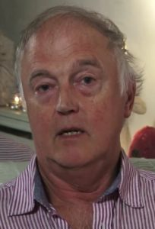
Nicholas Kollerstrom, Ph.D., is an English author and political activist. An elected fellow of the Royal Astronomical society, he earned his Ph.D. from University College London. An expert on Sir Isaac Newton and other celebrated physicists and astronomers, he has been a very effective challenger to lies from governments and founded the Legal Inquiry Steering Group to challenge the legality of the UK involvement in the Iraq War. He is the author of Terror on the Tube (3rd edition, 2011) and of Chronicles of False Flag Terror (2017)

James Fetzer: Why did Americans Swallow Sandy Hook, Line and Sinker?
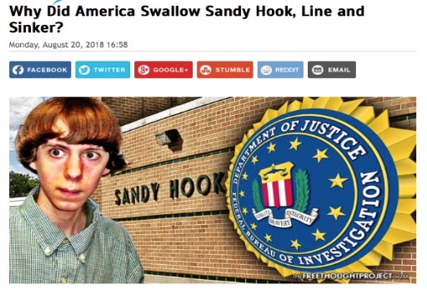
Mr. President,
Media Matters has summarized Alex Jones’ comments about Sandy Hook, with the preface, “Over the past five-and-a-half years, Jones has repeatedly pushed conspiracy theories about the tragedy, including casting doubt about whether it even happened or claiming that the shooting was staged by nefarious groups using actors”, and offered observations such as the following (even showing him saying them):

Jones has said the shooting has “inside job written all over it,” called it “synthetic, completely fake, with actors, in my view, manufactured,” claimed “the whole thing was fake,” said it was “staged,” called it a “giant hoax,” suggested that some victims’ parents lied about seeing their dead children, and pushed other toxic conspiracy theories.

After reading the memoranda that compose this series, how could anyone doubt that Alex had it right and the mainstream media had it wrong? Or that the vilification of Alex has no basis in fact and appears to be a massive propaganda campaign on behalf of the Deep State? At this point in time—with massive and compelling evidence available—what remains up for debate? Nothing! As he observed, it was a hoax.
So why did Americans swallow Sandy Hook, Line and Sinker (in the memorable phrase of John Spring)? The answer appears to have at least two dimensions, including that the “official narrative” was endorsed by local, state and federal officials (who, unknown to the public, were complicit in the deceit) and highly aggressively reported by the mainstream media--without entertaining any doubts or questions about it.
When those questions and doubts began to surface from the alternative media, where, among the most conspicuous, we found Alex Jones, familiar techniques of ad hominem attacks and suppressing evidence manifested themselves, virtually from the start. When interest in Sandy Hook nonetheless persisted and a book about it was published, the Deep State called upon its covert resources to have the book banned.
So it was a double-sided attack in promoting a false narrative while suppressing those who had proof that it was untrue, leaving the public with only one side of the story, where its emotional impact had a powerful effect upon the public, where to this day there are many who are unwilling to even talk about Sandy Hook and regard anyone who raises the least doubts about it as sadistic, immoral and confused.
Some points ought to have made a powerful impact. As John Spring observes, when the FBI published its Consolidated Crime Report, CRIME in the United States 2012, its Table 8, in the column “Murder and nonnegligent manslaughter,” does not list any homicides in Newtown or even in Monroe, where some the students from Sandy Hook were allegedly using the Chalk Hill building after theirs had been closed because of asbestos and other toxic materials. Richard Plante coincidentally visited the school in 2010:
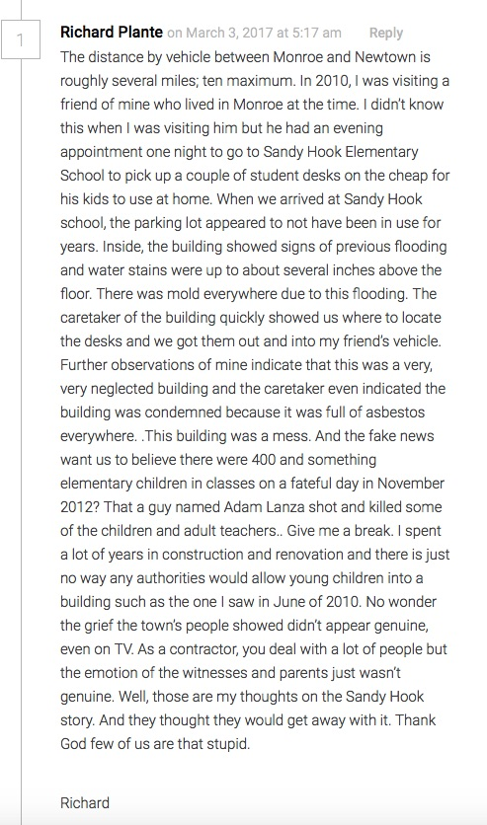

Between the massive propaganda propagated by the MSM and the suppression of its exposure by the Social Media Giants, you are in the grip of a pincer movement, which demands a devastating response lest the perps succeed in their desperate efforts to defeat your agenda to “Make America Great Again”. I believe you could
- Restore the Smith-Mundt Act of 1948 and its prohibitions against the use of propaganda and disinformation within the United States;
- Revisit the Telecommunications Act of 1996 to withdraw invulnerability from legal liability for egregious acts of political censorship by the constellation of social media companies that dare to violation Title 7 and other applicable anti-discrimination and free speech statutes with impunity.

It has been my great honor to collaborate with Robert David Steele, initially on the 9/11 Truth series and now on this Sandy Hook Truth series. As you have so appropriately observed, the MSM has become “the enemy of the people”. You are awaken the public to the manner in which the people have been played by the media. We therefore also stand in solidarity in your heroic efforts to Make America Great Again!
Very respectfully,
James Fetzer
References:
Media Matters, “Sandy Hook families are suing Alex Jones. This is what he said about the shooting.”
John Spring, “Why Did America Swallow Sandy Hook, Line and Sinker?” (30 August 2018)

Jim Fetzer, a former Marine Corps officer, is Distinguished McKnight Professor Emeritus on the Duluth Campus of the University of Minnesota. He co-founded moonrockbooks.com with Mike Palecek, when they discovered amazon.com was banning their books. He has published widely on conspiracies, including “False Flags on Five Fronts: Sandy Hook, Boston, Charlottesville, Las Vegas and JFK”, “How to Spot a ‘False Flag’: A Sampler of Representative Events”, and “The Parkland Puzzle: How the Pieces fit Together”, at 153news.net, BitChute, real.video and other secure sites.

Michael Thomas: Alex Jones’ Internet Crime? Telling The Truth about Sandy Hook
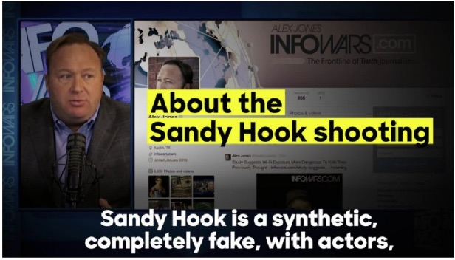
Mr. President,
Alex Jones has used his very powerful and prominent Infowars platform to warn the patriots about many New World Order schemes over the years. If there’s one false flag operation the globalists are really peeved about, it’s the fake Sandy Hook mass shooting of school children (that never even happened). When Alex Jones blew the whistle on the Sandy Hook hoax, that was the beginning of his trials and tribulations.
But why? Why was Sandy Hook such a protected sacred cow to the New World Order agenda?
Because the globalist cabal used that fake tragedy in unprecedented and urgent ways. This is why Jones has been so persecuted by the Mainstream Media (MSM). He completely destroyed their narrative…and once that occurred the MSM worked triple time to maintain the utterly contrived story. In fact, Jones’ was so politically incorrect regarding his truthful response to the staged Sandy Hook massacre that he made all the major MSM news organizations look bad…real bad!
Of course, this is Jones’ forte: speaking the truth about the most highly consequential NWO plots of the day — scream them if he must — and then wait for the MSM blowback, which only gets fiercer by the month where it concerns Sandy Hook. This is the story of Alex’s life. He puts out the most radioactive truths like he courageously did about Sandy Hook, and then gets lambasted by the CIA’s Mockingbird Media. Perhaps the U.S. Intel Community permits him to do this in order to send a message to every other Alt Media website that such truth-telling will NOT be tolerated. And, that the bigger and higher the platform, the harsher the response will be, especially from the numerous agents of Deep State scattered throughout the MSM.
Mainstream Media Role
It’s of paramount importance to understand that the MSM played a major role in both the execution and cover-up of the Sandy Hook psyop. At every point of the black operation it was quite clear that the largest news outlets followed a specific predetermined narrative. In so doing, they set the pace for all the other smaller news corporations to follow, as they always do. Because of the MSM’s complete failure to conduct even an iota of real investigative journalism, they revealed their hidden agenda from the very start. When even basic questions were not answered about such a ‘heinous crime’, it became evident to many that the official narrative would not be challenged. And when Infowars did, all hell broke loose all around them.
However, the ongoing globalist attacks have occurred with a ferocity that even Alex Jones had never experienced before. Just why is that? Because the MSM was threatened as never before by such profound and serious disclosures. If We the People really began to catch onto the fact that all of these mass shootings and bombings are meticulously staged, then a sleeping giant would be awakened. Therefore, Infowars had to be discredited and de-platformed in every way possible. This is exactly why so many initiatives were recently coordinated to substantially diminish the presence of Alex Jones and Infowars.com across the Internet.
Simply put, the MSM will not tolerate any factual accounts about Sandy Hook from the Alt Media. Each attempt to reveal the facts will be met with severe repercussions as Jones’ has experienced. And Big Social Media (BSM) are only getting started with him. When they are through with shrinking the Infowars profile on the Internet, it will be a shadow of its former self…unless the people demand an appropriate response from the Trump administration. This ever-intensifying war between Infowars and Mainstream Media is really a war on all of us—on both the Right and the Left. Even many Alt Left sites are currently being delisted by Facebook, Twitter and other BSM.
There’s no question that the globalists drew the line in the sand where it concerned all things Sandy Hook. They felt compelled to protect their false narrative no matter what the costs. As a result, Jones had to be marginalized like no other alternative journalist in U.S. history. Were the Sandy Hook conspiracy to be laid bare, all other Gladio-style false flag hoaxes would likewise come under unparalleled and intense scrutiny.
The BIG picture
What really happened here is that the NWO globalist cabal was somehow tricked into providing the Internet space to every person who could connect digitally. Once that happened, Pandora’s box was essentially opened. And there’s absolutely no way to put the genie of revelation back into the bottle. By aggressively going after Jones, however, it does appears that Big Brother will try whatever it can to intimidate the larger Alt Media platforms.
What has come into stark relief in the persecution of Jones is the integral role of the Mainstream Media in sustaining the Sandy Hook hoax. The talking heads have gone practically apoplectic in their vitriolic criticism of the Internet’s top conspiracy realist. Jones’ audience has gotten so big that the corporate MSM execs are crying daily to Big Social Media. Now that all the big players involved are on the same page, they will lower the boom until sufficient damage is done to every Alt Media platform with considerable influence.
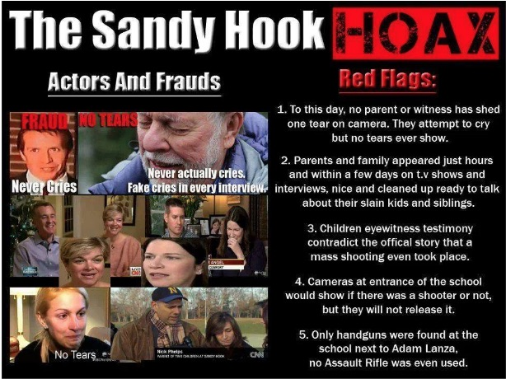

The MSM has played the vital part in this massive conspiracy to deceive the American people, just like they did with their deliberate cover-up of the 9/11 inside job. The level of willful neglect surrounding Sandy Hook and their deliberate misrepresentation of that fateful event has set the standard nationwide for every news outlet to just follow suit. As the gatekeepers for the western MSM, all the big channels such as CNN, MSNBC, CBS, as well as The New York Times, The Washington Post and Los Angeles Times, have been given strict orders by their overlords at the C.I.A. to show Alex Jones and Infowars no mercy.
The real BIG picture here, of course, relates to the age-old maxim: “Whoever controls the media, controls the world”. For this reason alone, the globalists know they cannot relinquish one iota of control or influence. Nevertheless, with the Sandy Hook fiasco come and gone, that genie is so far gone into the cyber-space that the controllers would have to shut down the Internet to exert sufficient damage control.
Gun Control
There is no question that the single greatest obstacle to the implementation of the New World Order agenda is an armed citizenry. This is where Alex Jones posed a major impediment for the globalists. Because he was so on top of the real reason behind the Sandy Hook plot — to take away our guns — Deep State knew he had to be taken down.
When Jones then outed David Hogg as the recognizable crisis actor that he was, Big Social Media went crazy on him. Infowars also did a great job unraveling all the conspicuous fraud that went into fabricating the Parkland, Florida mass shooting. Both Sandy Hook and Stoneman Douglas were key false flags in the Deep State conspiracy to stealthily remove the right to bear arms.
Clearly, the annulment of the Second Amendment is top on the list of things to do before a One World Government can be established. After all, given the degree to which Americans are armed and ammoed up, what type of enforcement would the United Nations police force be able to conduct in the 50 states. Jones & Company has railed nonstop on this planned usurpation of American sovereignty like no other alternative website.
At the end of the day, Infowars.com became a massive magnet for patriots and nationalists, conservatives and Christians, Libertarians and Tea Partiers, Independents and real Republicans, etc. Because of its HUGE drawing power, the Left-dominated MSM acted to destroy the competition. The presstitutes that populate every Mockingbird Media platform simply cannot tolerate the light of truth shining in their darkness of falsehood.
Where those presstitutes really failed was in their investigation of Sandy Hook. Not only did they neglect to conduct any meaningful research into the event, they all basically took dictation from law enforcement without asking a single question. In so doing, the media gave a pass to what was really a FEMA drill dressed up as a staged false flag mass shooting. And Infowars featured many investigators and researchers who proved conclusively that it was a total hoax conducted to take away our firearms.
Conclusion
Alex Jones and Infowars posed the single greatest threat to the monopoly of media that was fastidiously put into place by the C.I.A. The Company, as the C.I.A. is known within intelligence circles, does not like competition of any sort for its Mockingbird Media; hence, the takedown of Alex Jones has begun in earnest.
The Sandy Hook hoax represented Jones’ greatest vulnerability. When he started dropping truth bombs such as “Nobody died at Sandy Hook!” the hot phase of the info war really began. Deep State knows full well that Sandy Hook truth is as ultra-classified as it gets. They know that, were the populace to understand that virtually every false flag attack is similarly staged, their most powerful weapon would be neutralized. They could not let that happen.
This is also why Deep State forced Jones’ to recant the Pizzagate story. They left him no choice so critical is the ongoing Pedogate conspiracy to their control of political leaders and government officials alike.[1] Just like Sandy Hook, Pedogate remains their Achilles’ heel. If not Alex Jones, another high profile truth speaker will eventually expose it in a manner that the body politic will get the message loud and clear.
Bottom Line: Sandy Hook really is where TPTB drew the line in the sand. Once Alex Jones and Infowars crossed it, they became a target for every mainstream organization in the country. However, this extreme reaction alone from Deep State has exposed their agents and operatives throughout American society. The MSM has especially been revealed as the deceptive and duplicitous traitors to the Republic that they truly are. In point of fact, half the people now understand that truly THE MAINSTREAM MEDIA IS THE ENEMY OF THE PEOPLE!
Very respectfully,
Michael Thomas

References:
State of the Nation, PEDOGATE: Pandora’s Box Has Been Opened for Deep State and the C.I.A. (14 March 2017)
State of the Nation, Alex Jones’ Biggest Internet Crime To Date Was Telling The Raw Truth About SANDY HOOK (19 August 2018)

Michael Thomas is the Editor of State of the Nation and of The Millennium Report, alternative news and commentary websites. He has a deep and long professional background in financial and economic analysis. As an investigative journalist, he has specialized in assessing geopolitical risks and monetary policy worldwide. Michael’s current area of specialty is American politics, as well as The Great Game being currently played on the global geopolitical chessboard. He is also a conspiracy realist who has dissected many of the false flag operations that have plagued the USA since the 9/11 terrorist attacks. His first major conspiracy exposé took the form of a citizen’s indictment of the U.S. Federal Government, which he started writing the week of September 11, 2001.

Tony Mead: Sandy Hook Litmus Test – Freedom of Speech versus Internet Censorship
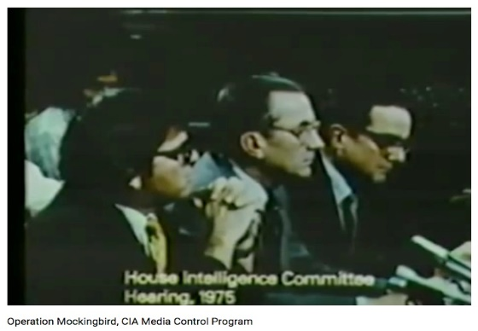
Mr. President,
Everyone is quite aware that we have the right to Freedom of Speech, but seems to overlook the fact that we also have the right to Freedom of the Press. This doesn't mean that the social media giants have rights. It means that WE, THE PEOPLE, have rights to have access to and to distribute information. These rights were granted long before the internet and have always been restricted by rules of libel, threats of violence, and the disclosure of information that could be detrimental to National Security.
Not everyone is aware that the CIA began infiltrating the media in the 1950s with (what it called) “Operation Mockingbird”. By 1975, it had been such a success that William Colby, its Director, testified to Congress (behind closed doors) that the agency owned “everyone of any significance in the media”. Carl Bernstein confirmed in “The CIA and The Media”, Rolling Stone (1977), that agency officials boasted their greatest successes had been with CBS, The New York Times and Time-Life, providing a lock on US news.
The government maintained control through the consolidation of the media by six media giants until the emergence of the Internet and the alternative media, which has transformed the flow of data. The public has gained access to reams of information disseminated on the World Wide Web and has been permitted to voice its opinions and viewpoints unrestricted by interference for the past two decades. But just as the mainstream has been consolidated, the Internet has been dominated by its own media giants, including Google, YouTube, Facebook and Twitter.
Alex Jones was among the first to offer an opposing view to popular misconceptions as by critiquing the United States government and corporate interests using his InfoWars platform. He insisted that there is a “War on for your mind” and, no doubt, of everything he has ever said, that was the most significant. Sandy Hook has proven to be the litmus test, probably because it exposes the role of Obama, Biden, Holder and others in lying to the public – creating false flag events with fake deaths to achieve unconstitutional policy objectives including the termination of the 2nd amendment.
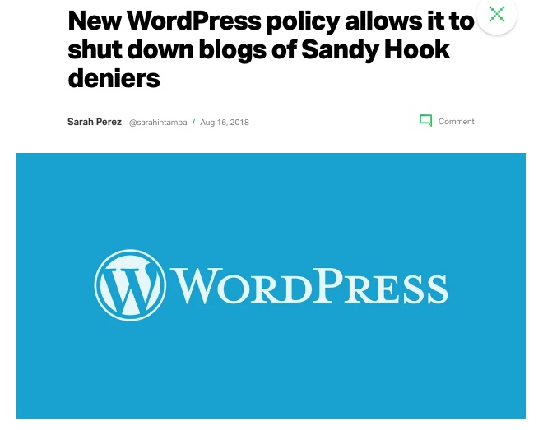
As the Sandy Hook Hoax page administrator, I saw this coming. Our FaceBook page was steadily growing for nearly 5 years as more and more people were beginning to question the events surrounding Sandy Hook! Despite the continuous efforts of “Lenny Pozner” (Reuben Vabner) and his HONR Network to have the page removed, we gradually increased to over 15,000 likes, which had become enough of a threat to the creators of the false narrative that Facebook removed the page: Five years of assembled research was disposed of like a burning book!

The Communications Decency Act of 1966 was the first notable attempt to regulate the Internet by the government, which was passed as Title V of the Telecommunications Act of 1996. Its most important elements were (1) to regulate indecency and obscenity in cyberspace and to regard operators of Internet services not as publishers (liable for the content of their publications) but as bookstores or libraries making them available.
The massive onslaught of Google, Facebook, YouTube and Twitter against Alex Jones and conspiracy research in general has changed their status. Now that internet servers are deciding what we can see and not see, what we can read and not read, it no longer makes sense for them not to be legally liable for the content of what they allow. The mischief in a case like this occurs between the time that these offenses are committed and their resolution before (in this case) the Supreme Court. But it will come.
Very respectfully,
Tony Mead
References:
Operation Mockingbird, CIA Media Control Program (21 January 2012)
New WordPress policy allows it to shut down Sandy Hook Deniers (16 August 2018)
Prison Planet: How the Left is Outsourcing Censorship of the Internet (19 August 2018)
BOOM! Trump’s War with Facebook has Begun – Ben Carson Fires First Shot! (19 August 2018)

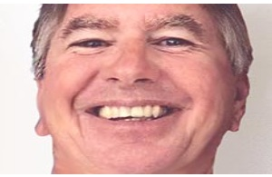
Tony Mead is an independent research journalist and former administrator of the Sand Hook Hoax Facebook page, which was removed in April 2018l. He has written several articles exposing fraud in the Sandy Hook school shooting story and in the Parkland school shooting event. He is a contributing author to the book, Nobody Died at Sandy Hook (2nd ed., 2016) and assisted in the production of the full length documentary films, “We Need to Talk about Sandy Hook” and “The Life of Adam” with Peter Klein.

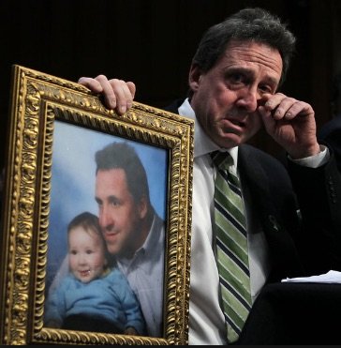
Jack Mullen: Will Alex Jones Take the Fall to Sustain Sandy Hook Lies?
Mr. President,
In April, two parties claiming to be parents of victims of the Sandy Hook shooting filed a lawsuit against Alex Jones for Defamation.
Neil Heslin, the father of a 6-year-old boy killed in the shooting, and Leonard Pozner and Veronique De La Rosa, who lost their own little boy, filed the suits in Austin, Texas, where Jones’ conspiracy-minded media outlet is based. Each suit is seeking more than $1 million in damages from Jones, Infowars and a related company, Free Speech Systems LLC. Infowars reporter Owen Shroyer is also named in one of the suits.
Since that time 6 others have come forward with charges against Jones regarding the Sandy Hook shooting. All eyes are now on Jones to see whether he fights these charges, as they are easily dismissed by just going through with discovery, or whether he supports the Sandy Hook School shooting lie and the political operators who created the hoax to manipulate the public.
Neil Heslin refuted his own testimony to Congress with a photograph of the son, Jesse, he claims to have lost at Sandy Hook. This is about a year after the shooting, so if Jesse was about six years older when he was shot, then so should his father be about seven years older than shown in the photograph. But he actually looks at least seventeen years older, because they used out-of-date photos to fake the kids.
If Jones “Prays and Pays” instead of properly fighting this lawsuit, it can mean only one thing. Jones has agreed to give The Sandy Hook School shooting credibility while disgracing and selling out his audience. The Sandy Hook shooting is easily seen, beyond a reasonable doubt, to have been a FEMA drill organized at a school which had been previously closed. The ‘for-television’ presentation, Sandy Hook shooting, was poorly produced, including shoddy and weak-minded crisis acting and included an implausible narrative which was offered as testimony for the events of that day.
Should Jones sell out his constituency and offers his credibility as a sacrifice to the egregious lies of the Sandy Hook shooting, it will be a major setback to those fighting for a return to Law and Justice, for those fighting for Truth and Integrity of Media. If Jones sells out to these extremely dangerous, and capable of any act-of-evil controllers prosecuting serial staged shootings for gun confiscation in America; it will mean his career was for nothing and that he was a playing a role.
If Jones sells out his audience and followers it means the most horrendously brutal and bloody attack by mentally ill, psychopaths, will have no means of being opposed without weapons, and this is the very reason they are lustfully pretending to harm American children and terrorizing the American people to get those guns based upon the false premise that more guns mean more homicides, contradicted by the facts:
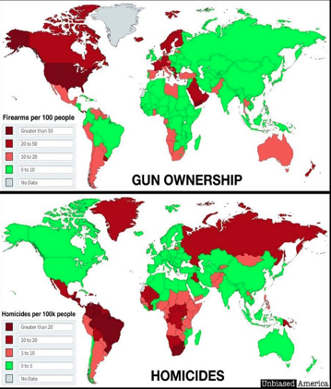
Sandy Hook is just one more link in a chain of events created to facilitate events in the United States that can be used to disarm Americans. Americans can, after feeling the endless imputed guilt of faked school shootings, voluntarily hand over their guns as in Scotland and Australia, or they can face each other as media-mind-control propaganda machines agitate for a Civil War.
Or Americans can stand now against a government corrupt and lost to hostile usurpation and immediately began the process of trials and jail-time and finally hangings for people and persons committing treason against the United States Constitution and the People at large.
Very Respectfully,
Jack Mullen
Reference:
Sebastian Murdock, “Sandy Hook Parents hit Alex Jones with Defamation Lawsuits”,
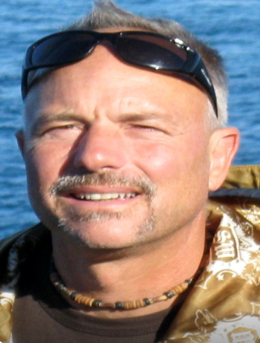
Jack Mullen lives his life seeking truth. He has a Bachelor of Science degree in Electrical Engineering and was awarded a scholarship via Teaching Fellowship as he completed the Master of Science program in Electrical Engineering at West Virginia University. He also graduated with Most Outstanding Student Award, earning an MBA from Frostburg State University, part of the University System of Maryland. Jack is also an avid computer programmer and network engineer, with interests in ethical hacking, network security, data analysis and more. Jack is an avid reader, student of truthful history, a Certified Chinese Kenpo instructor and lives in Wild Wonderful West Virginia.

APPENDICES

Brian Wright: Banned by Amazon – The Single Most Important Book on Sandy Hook
It was a FEMA drill to promote government violence on gun owners
Multiple authors, edited by Jim Fetzer, Ph.D.
Reviewed by Brian R. Wright
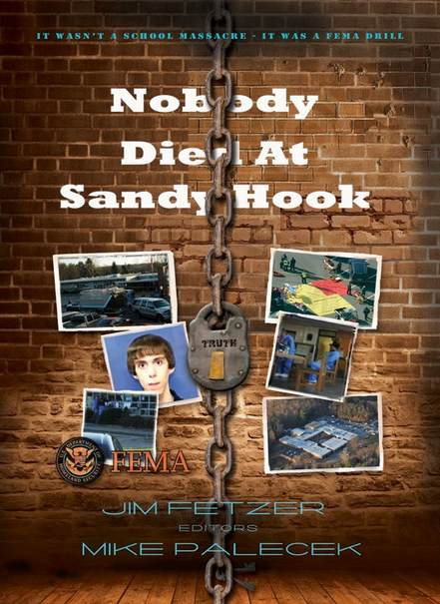
February 16, 2018 posting, editor’s comment: I am reposting this review in light of recent Douglas HS incident in Florida, which looks like a Mini-Me version of Sandy Hoax. At least six contradictions. One of my Tweets today: “Parkland is like all the others–I would say MOST of the others, but I can’t think of a single exception–a real or purported mass-casualty incident for which the only source of news is government and government media. IOW, we don’t really know what happened.” — bw
… and on 11/19/2015 Mr. Fetzer’s book was banned from the Amazon catalog, one month after initial acceptance and posting there.
“Faking a school shooting to instill fear into a population for political purposes is an act of terrorism, where it has become clear that this instance was brought to us by officials at every level of Connecticut government from the teachers and reporters to the State Police and the Newtown School board to the Governor and the Attorney General and the President himself. And this is the ugly legacy of Barack Hussein Obama.”
— James Fetzer
Review of an Important Book that Amazon Refused to Publish
This story first came my way by way of Mike Adams and his report that Amazon was getting into the book ‘banning’ business with this particular title. Which to me proved that whatever the book’s point was it was worth looking into. [The authors made it easy by publishing the book in pdf format and making freely available here… and many other locations.] So I have read the book and digested its essentials. As a professional editor, I find Nobody’s copy editing and formatting less than stellar, but the book is well-organized and the content bona fide. It touches all the bases and answers the hard questions.

To an epistemological certainty, Sandy Hook was not real, nobody real died. Sandy Hook was a FEMA drill with the purpose of generating support for an extreme gun control and federal power agenda. This review will simply catalog the main factual data that demonstrates the certainty.
- 489 students, minus 20 = 469 students, plus 70 staff and teachers. Nowhere to be found, no evacuation.
- The benefits to those who participated in the Sandy Hook hoax have been substantial. The donation sites created by “families of the victims” have hauled in over $27,000,000 or in excess of $1,000,000 per ‘family.’
Was Sandy Hook Elementary School (SHES) operational on December 14, 2012, or had it long been abandoned?
- In an interview with (Wolfgang) Halbig on Truth Radio Show on March 21, 2014, Infowars reporter Dan Bidondi said (5:45 mark), “The school’s been closed down for God knows how long. [Neighbors] can’t understand why there were kids in that building because it was condemned.”
- Reports of SHES being contaminated with asbestos. requiring expensive repairs
- Photographic evidence of an abandoned school
- Absence of handicapped parking spaces and signage
- Absence of Internet activity 2008-2012
- Wolfgang Halbig’s Freedom of Information hearing
- “Among our most important discoveries has been the FEMA manual for the Sandy Hook event (Appendix A), which specifies that a rehearsal will be conducted on December 13, 2012, with the event going ‘LIVE’ on the 14th…”
“These photographs—day after the shooting—provide further substantiation of my inference that the school had been closed by 2008, which I published (with Amanda) in ‘Sandy Hook Elementary School: Closed in 2008, a stage in 2012’. The building is covered with moss and grime, with many indications of repairs left undone:”
- Exhibit (1): Absence of compliance with Americans with Disabilities Act
- Exhibit (2): Presence electrical hazards for teachers, staff and students alike
- Exhibit (3): Absence of wheelchair accessibility and of proper maintenance
- Exhibit (4): Presence of stored items of every shape, kind and description
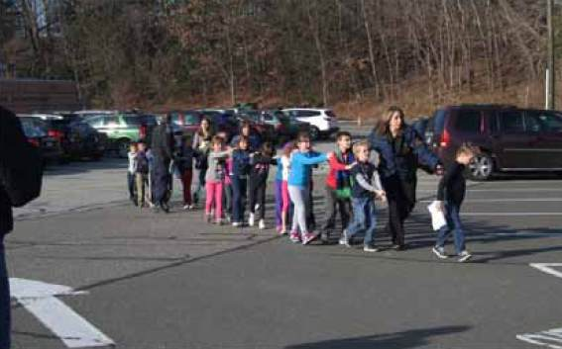
“The photograph to which Shannon Hicks, Associate Editor of The Newtown Bee, refers is one that I (with Dan Cady) published in ‘The Sandy Hook ‘Smoking Gun’: Game, Set, Match!’, which seems to be one in a series of staged photographs.”
There was no actual identification of any of the dead.
“Here are the 10 solid points that show Sandy Hook was a hoax:”
1. Proof of death has been suppressed
Twenty-eight people allegedly died: 27 children and adults, including Adam Lanza, at the school, and his mother, Nancy Lanza, in her home at 36 Yogananda Street, Newtown. However, there is no direct proof of anyone’s death: no photographic evidence or video footage was released to confirm the official story that these 28 persons actually died. In fact, no video surveillance footage shows anything—not even Adam shooting out the front plate-glass window or walking through the halls like Rambo, even though the school had supposedly updated its security system at the start of the 2012–2013 academic year.
2. Emergency protocols were not followed
There is no evidence of any frantic effort to save lives or remove bodies to hospitals. Instead the scene outside the school looked calm and largely bloodless—with police and other personnel milling around casually and a severe shortage of dead or injured victims. One Sandy Hook researcher decided to call Lt. Paul Vance to ask who cleaned up the blood, which would have been considered a bio-hazard, and got the reply, “What blood?” “Kelley from Tulsa” discusses this with James Fetzer on the “The Real Deal” on December 9, 2013. Kelley was onto a real issue: under the EPS’ Medical Waste Tracking Act of 1988, a paper trail must kept by all parties involved in the cleanup and must be tracked all the way to the incinerator with names and dates.
3. Drill protocols were followed instead
The Sandy Hook “massacre” appears to have been an Integrated Capstone Event (ICE), an exercise run by FEMA to coordinate federal, state and local emergency response teams in the case of a mass-casualty event. As such, it would have utilized actors and media partners to simulate a tragedy in order to train participants, and also to observe the reaction of the citizenry.
4. There was foreknowledge of the event
The Connecticut state emergency system was taken over long before the “massacre” occurred, with a frequency change implemented five hours in advance of the “shooting.” Normal police and EMS dispatch protocol, using the Alpha Phonetic System for communications between officers and dispatchers, was replaced with staged transmissions by non-trained personnel. In addition, tweets about the shooting began before it occurred, a tribute was apparently uploaded one month before the event, and web pages honoring the victims, including a Facebook page R.I.P. Victoria Soto, were established before they had “officially” died (Figure 15).
5. There were contradictory reports about the weapons
Perhaps “The Top Prize for Fantastical Reporting” goes to Fox News, however, which announced that a 12-gauge shotgun along with two magazines containing 70 rounds of Winchester 12-gauge shotgun rounds had been found in the glove compartment of Adam Lanza’s Honda Civic—that’s right, in the glove compartment.
6. Adam Lanza cannot have done the shooting
Adam Lanza , reportedly a frail young man weighing 112 pounds with Asperger’s Syndrome, is said to have carried massive weaponry on his person when he shot his way into the Sandy Hook school and proceeded to kill 26 people and then himself. This after he supposedly killed his mother before driving to the school. It should of course be noted that Adam Lanza was initially listed in the Social Security Death Index as having died on December 13, 2012, one day before the alleged shooting.
7. Key participants displayed inappropriate behavior
There are many bizarre media reports and interviews of those associated with the “shooting.” Many of the participants seem to be actors (or intelligence operatives): e.g. Medical Examiner Wayne Carver, Robbie Parker, families on green-screen Anderson-Cooper, school nurse, Principal Dawn Hochsprung (sic), Gene Rosen.
8. Photos at scene and of victims look staged or fake
E.g. Shannon Hicks, shattered glass, photos of children who allegedly died, Parker family photos, Victoria Soto photos, fake unreal person Lanza photos, etc.
9. The crime scene was completely destroyed
As with Ground Zero after 9/11, Sandy Hook Elementary and all the evidence have been completely obliterated; $50 million in CT state funds were allocated for the demolition and rebuilding of the Sandy Hook school. This would never have been tolerated if an actual crime had been committed—at least one that was meant to be investigated. The demolition of the school has been completed and rebuilding is in progress.
10. Deceased children sang at the Super Bowl
Research has resulted in a “Sandy Hoax Surprise,” a convincing youtube video by QKultra identifying eight alleged Sandy Hook victims and six brothers of victims singing in the Newtown children’s choir at the 2013 Super Bowl, February 3, 2013.
Additional Information
Some more bullets directly quoted from the book:
- According to the United States Social Security Administration’s Death Master File, nobody died at Sandy Hook Elementary School on December 14, 2012.
- ALL of the identities of the ‘children victims’ of the supposed Sandy Hook massacre, are purely fictitious identities, with no record of either birth or death. As to the adult ‘victims’, the only one with an identity possibly verifiable from the intact SSD Master File, is Victoria G. Soto. The other identities may or may not have been assumed by real people at some time; but the identities themselves are nevertheless fictitious. Secondary copies of the Master File, or perhaps earlier versions, appear to have been altered or ‘corrected,’ to include the fake identities. Such altered copies appear to be in use by popular genealogy search websites, though inconsistently.
- The situation with regard to Sandy Hook boggles the mind. The Connecticut State Police submit information to the FBI that asserts 27 people died in Connecticut, but at the same time denies that they died anywhere in Connecticut. That is absurd and revealing. The objective of disinformation is to create enough uncertainty that everything is believable and nothing is knowable. But we have a mountain of proof that the school was closed by 2008 and that no one died there in 2012.
The book concludes with a skewering of the Snopes.com apologia for the official story; connections with other false flag massacres such as Aurora, CO, and Tucson, AZ; and analogies to the London 7/7 Subway Bombings. Appendices exist for the FEMA plan; the background of Newtown, CT; a timeline; and an index.
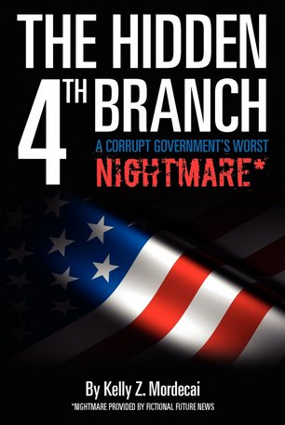
The authors recommend a truth commission to bring light to what happened and bring justice to the people and to the perpetrators of the horrific hoax.
[But we don’t need that. All we need is a fully empowered special federal people’s grand jury to bring indictments. I recommend that the authors—or basically anyone who has full knowledge of the Sandy Hook fraud—write the complaint or petition and find a good judge (there are a handful in the system) to make that happen. I’m betting that Kelly Mordecai (author of The Hidden 4th Branch) will be glad to help with the wording: you may contact me here, and I’ll see that he gets the message. — bw]
Note: Pete Hendrickson has composed a draft for a ’28th Amendment,’ which will surely jibe with those of us seeking resurrection of the grand jury to its intended function of ‘watching and eliminating the foxes who prey on the henhouse.’ Check out his inspirational and informative document here: http://www.losthorizons.com/WatchingTheWatchmen.htm.
Reference: Brian Wright, “Book Review: Nobody Died at Sandy Hook” (2015). Reproduced in full above.
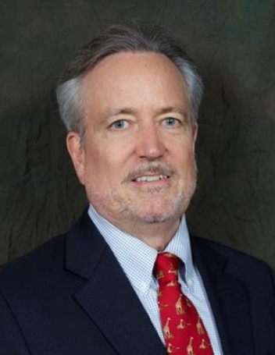
At an Oklahoma City bookmobile in the ‘60s, Brian Richard Wright discovered a book on Barry Goldwater and became active in his 1964 presidential campaign. Led to Ayn Rand’s vision of heroic individualism, he devoted his efforts to the Michigan Libertarian Party (LP). Moved to Detroit, BSME, married, stayed prototypically cause-oriented. Disenchanted with LP at 2004 Atlanta convention. Migrated to Free State of New Hampshire—proved a catalyst both for liberty activism and for igniting literary output. Founded the commentary and review site TheCoffeeCoaster.com. Returned to SE Michigan for finance and family reasons, 2008, where he lives today.

James Fetzer: Amicus Curiae Argument to 345th District Court, Travis County, Texas
345TH DISTRICT COURT
TRAVIS COUNTY, TX
CAUSE NO. D-1-GN-18-001842
-----------------------------------------------------------
LEONARD POZNER AND
VERONIQAUE DE LA ROSA

Plaintiffs

vs. ARGUMENT OF AMICUS CURIAE

ALEX E. JONES, INFOARS, LLC,
AND FREE SPEECH SYSTEMS, LLC

Defendants
---------------------------------------------------------------

May it please the Court,

As stated in the undersigned’s MOTION FOR LEAVE TO APPEAR AS FRIEND OF THE COURT, the undersigned became a student of the Sandy Hook School Shooting following the events of 14 December 2012 and published a collection of research studies in collaboration with a dozen other experts and scholars, including six other Ph.D. (current or retired) college professors. We established that the
school, which was loaded with asbestos and other bio-hazards, had been closed by 2008 and that there were no students there. What has been presented to the public as a shooting massacre was in fact a FEMA drill, where we even have the manual, which he included in the book, Nobody Died at Sandy Hook (2015), as Appendix A. It went on sale at amazon.com 22 October 2015 but was abruptly banned 19
November 2015 after having sold nearly 500 copies in less than a month. Since the book was produced by Create Space, which is a subsidiary of amazon.com, the undersigned suspected the ban was politically motivated and released the book to the public for free as a pdf. (It can be downloaded by entering the book’s title in a browser, where estimates suggest it has been downloaded as many as 10,000,000
times.) Since the book was published, he and his colleagues have continued their research on Sandy Hook and have discovered that the reason the medical examiner, H. Wayne Carver, M.D., did not allow the parents to see the bodies of the children but identified them on the basis of photographs was because the children were fictions made up out of photos of older children when they were younger. (Some of the parents may have even used photographs of themselves as children.) Among those of special importance to the Court is that of Noah Pozner, who is supposed to be the son of Lenny Pozner, a Plaintiff in the case before the Court involving the Defendant Alex Jones. As the exhibits attached demonstrate, “Noah Pozner” is a fiction who was made up out of photographs of Michael Vabner, purportedly his older step-brother. Exhibit (1) provides photos of “Noah” and of Michael Vabner.
Exhibit (2) shows that “Noah” was made up out of photographs of Michael Vabner. Exhibit (3) shows a photo of Michael Vabner from his own web site (https://michaelvabner.github.io/). Exhibit (4) is a photo of “Noah Pozner” all grown up. Exhibit (5) is a copy of the death certificate that Lenny Pozner sent Kelley Watt when she demanded proof Lenny actually had a son who had died at Sandy Hook, which turns out to be a fabricated with the bottom half of a real death certificate and the top half of a fake, with no file number and estimated time of death at 11 AM, when the shooting officially took place between 9:35-9:40 AM. These exhibits are also available on-line and the undersigned would be glad to provide them in color versions via email or other venues. Additional research by Mona Alexis Pressley explains there are many photographs of Lenny Pozner with “Noah Pozner” when “Noah Pozner” turns out to be Michael Vabner: Just as “Noah Pozner” is a fake name for Michael Vabner, “Lenny Pozner” is a
fake name for Michael Vabner’s father, whose real name turns out to be Reuben Vabner, which explains why “Lenny” has been unwilling to have his face shown on television shows, such as, for example, an episode of “Dark Net” where he and the undersigned were featured in an episode about Sandy Hook. The facial features of the undersigned were as well-defined as the undersigned has ever seen in any
video production, where “Lenny” refused to allow his face to be shown on the specious grounds that he was concerned it might appear on the internet and be subjected to ridicule. The reason, however, “Lenny” did not want his face to be shown appears to have been because he would run the risk of being exposed as Reuben Vabner, which he has taken great pains to conceal. The undersigned thus has felt obliged to write to inform the Court that “Lenny” and other Plaintiffs are perpetrating a fraud in this case. The undersigned would be willing to travel to Austin at his own expense to testify in this case and to answer any questions that may be relevant to the Court, which of course has permission (should permission be required, which may not be the case) to share this with the parties to this suit.

The undersigned swears, subject to the pains and penalties of perjury, that he has conducted himself and will conduct himself before this Court in an upright and proper manner, that he will support and has always supported the Constitution of the United States, and that all representations hereinabove are true to the best of his knowledge, information and belief. This oath is made both freely and voluntarily,
subject to the laws of the United States.

James Henry Fetzer, Ph.D.
McKnight Professor Emeritus
University of Minnesota Duluth

James Fetzer: Amicus Curiae Evidence to 345th District Court, Travis County, Texas
345TH DISTRICT COURT
TRAVIS COUNTY, TX
CAUSE NO. D-1-GN-18-001842
-----------------------------------------------------------
Exhibit (1): Is “Noah Pozner” Michael Vabner?
-----------------------------------------------------------------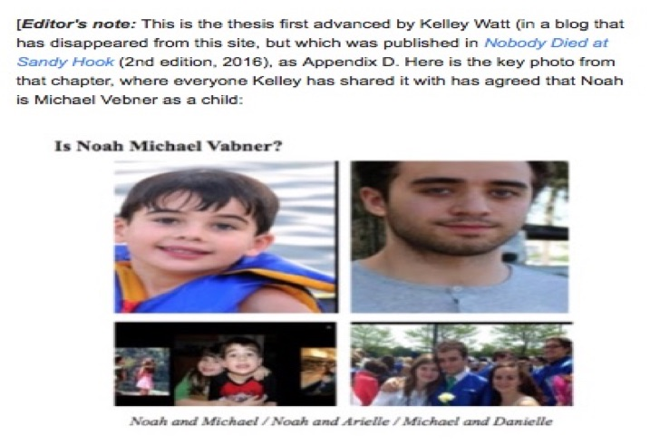

345TH DISTRICT COURT
TRAVIS COUNTY, TX
CAUSE NO. D-1-GN-18-001842
-----------------------------------------------------------
Exhibit (2): “Noah Pozner” is Michael Vabner
-------------------------------------------------------------------

345TH DISTRICT COURT
TRAVIS COUNTY, TX
CAUSE NO. D-1-GN-18-001842
-----------------------------------------------------------
Exhibit (3): Michael Vabner identifies himself
-----------------------------------------------------------------

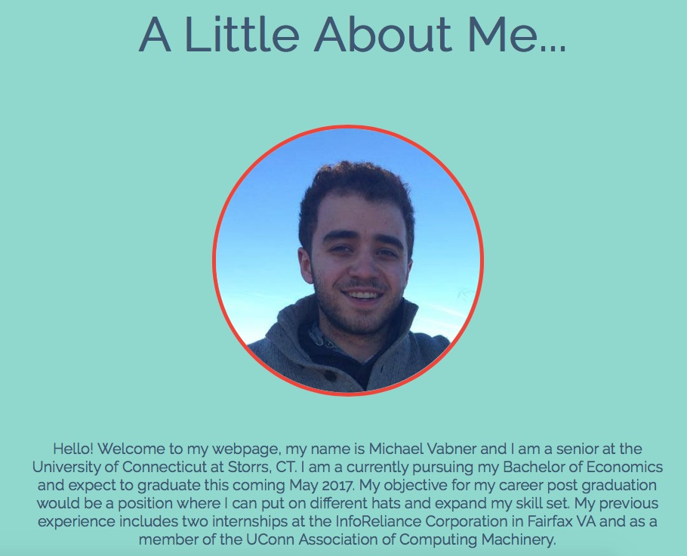

345TH DISTRICT COURT
TRAVIS COUNTY, TX
CAUSE NO. D-1-GN-18-001842
-----------------------------------------------------------
Exhibit (4): “Noah Pozner” all grown up
-----------------------------------------------------------------

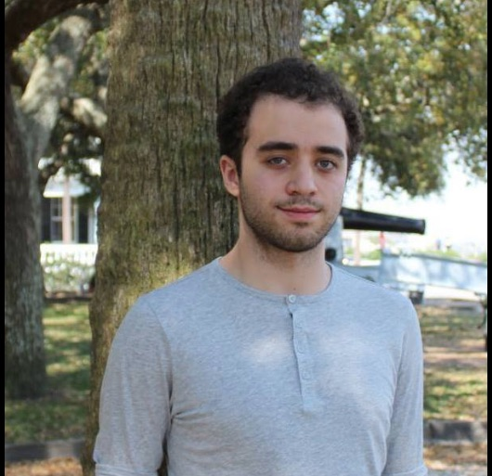

345TH DISTRICT COURT
TRAVIS COUNTY, TX
CAUSE NO. D-1-GN-18-001842
-----------------------------------------------------------
Exhibit (5): Death Certificate “Lenny” sent to Kelley
-----------------------------------------------------------------

Robert Steele: Information Pathologies Active in the USA Today
In support of the Berkman Center’s conference on truthness, below is an extract from THE OPEN SOURCE EVERYTHING MANIFESTO: Transparency, Truth & Trust (Berkeley, CA: North Atlantic Book / Evolver Edition, 5 June 2012).
EXTRACT:
I now realize that neither governments nor corporations are “fixed” obstacles. In a world of constantly changing information, it is impossible for any structured organization to dominate a larger network—a hybrid network. Such broad, flexible governance without governments being “in charge” is where we need to go.[1] The objective: to implement transparency, truth, and trust across all boundaries.
David Weinberger, cited earlier,[2] is a genius on this point: not only can no one person or even one organization or one country “know” what they need to know to make an informed decision, but if they fail to understand, respect, and “jack in” to the knowledge network with full transparency as the method and truth as the objective, they will make very bad decisions. Of course this does not address the issue of corruption, and the raw fact that most governments and corporations could care less about objective truths, seeking instead to optimize profits for the few at the expense of the many, but their ignorance is our advantage. That is why We the People must recommit ourselves to Open-Source Everything, its underpinnings (transparency and truth), and its outcome: trust you can bank on without a bank.
I will say that again in a different way: the persistent unethical and ignorant emphasis on secrecy and on making decisions for partisan advantage or to pay off campaign contributors and select insiders is not sustainable. We the People have an opportunity to embrace this manifesto of Open-Source Everything and bury “rule by secrecy.” This is this is why I am optimistic about the future.
New, open-source, populist-based, information-era strategies will also serve our increasingly complex lives better in future situations of crisis such as natural disaster, war, and social disintegration. Collapse is cultural, systemic, a failure of process, not of any discrete event, institution, or location. The industrial-era model of command and control cannot adequately process information for a complex system, but an information-era model of distributed localized resilience can.
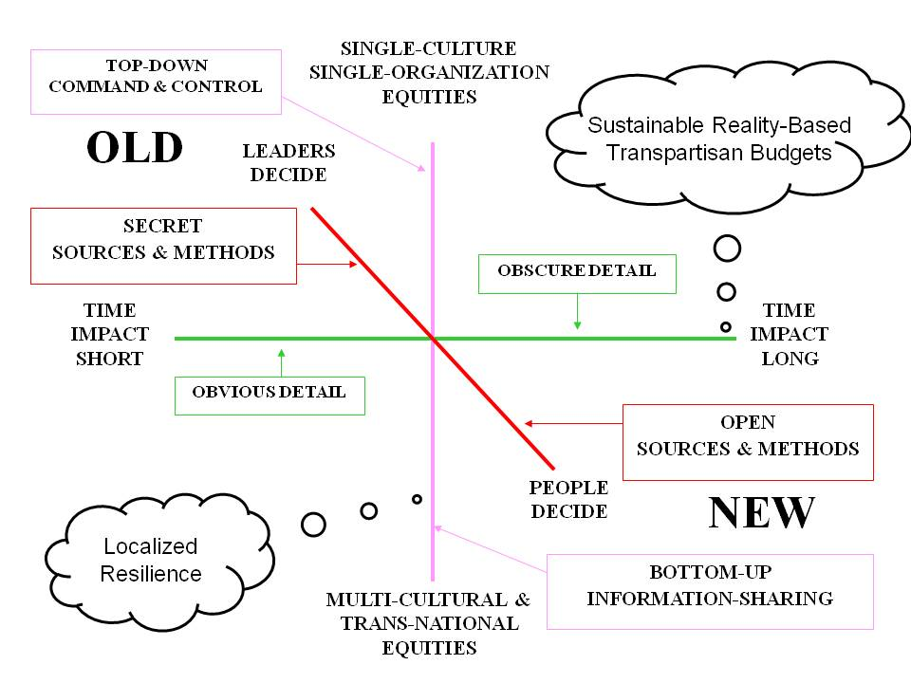
Collaboration and consensus is the Epoch B way, but from the philanthropic foundations to the non-governmental organizations to all others, there is still a dearth of information-sharing that is both expensive and incapacitating. While the United Nations has committed itself to coherence, with the meme of “Deliver As One,” they do not have the intelligence—or the integrity—to actually do that. Similarly, governments talk of “whole of government” operations, and corporations of “matrixed management,” but these also fail the intelligence and integrity tests.
Much has been written about how mass collaboration—alternatively called Collective Intelligence, Smart Mobs, Wisdom of the Crowds, Army of Davids[3]—has not been possible in complex situations in the past because the industrial era introduced (imposed) a cumulative series of information pathologies that deprived the group of access to all relevant information, while favoring an elite few with privileged access that allowed them to concentrate both power and wealth. In the public domain, many artificial—that is to say, contrived—obstacles to informing the public emerged in the past century, such as the following, each a book title:
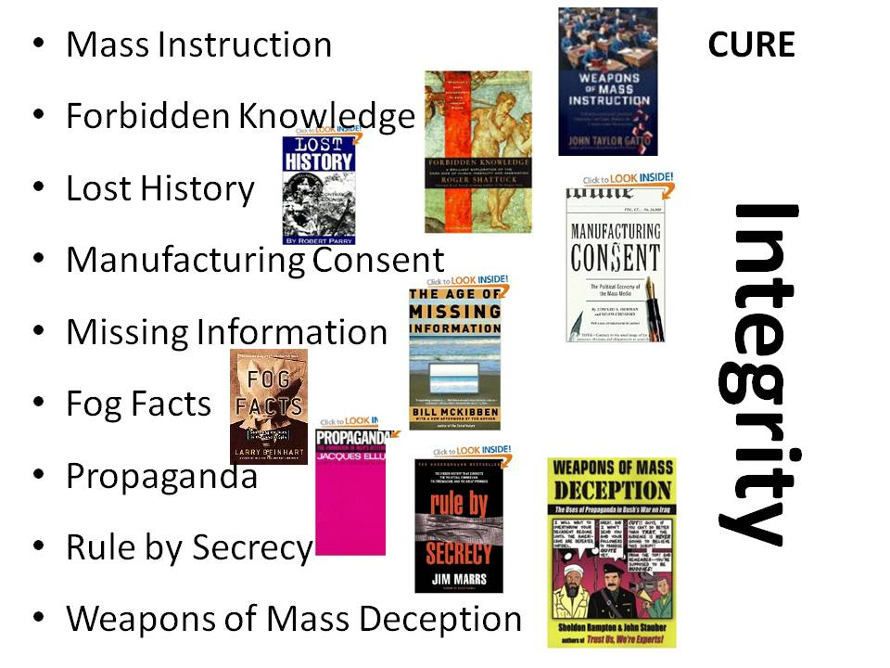
Fog Facts.[4] These are facts that are “known” to some and publicly accessible but only if you know where to look. The mainstream media “blacks out” this knowledge. Modern examples include U.S. government support for dictators and U.S. government tolerance of massive fraud, waste, and abuse in return for fractional campaign contributions to presidential and legislative candidates who strive to remain in office “at any cost.”
Forbidden Knowledge.[5] This includes both knowledge forbidden for public consumption by governments (e.g. restrictions on pornography) as well as corporations (e.g. concealment of known pathologies such as the effect of tobacco on cancer, or toxins associated with household goods) and religions (the triumph of dogma over consciousness).
Lost History.[6] The most prominent modern example is the deliberate classification as secret of clandestine and covert operations by the U.S. government such that a modern history of foreign relations cannot be written—this is the documented complaint of the historians responsible for this task on behalf of the Department of State.[7] The role of the Central Intelligence Agency in the introduction of massive amounts of cocaine into the USA under the pretext of supporting “strategic” operations “at any cost” is especially frightening to anyone upholding the Constitution.[8]
Manufacturing Consent.[9] Noam Chomsky and Edward Herman first discussed this aspect of a modern democracy, and now, decades later, their work has been updated by Sheldon Wolin in his book, Democracy Incorporated: Managed Democracy and the Specter of Inverted Totalitarianism.[10] Corporations now “own” not just the legislative and executive branches of the U.S. government, but the judiciary as well, with the Supreme Court ruling on Citizens United being the more reprehensible evidence of the corruption of the highest court in the nation. False flag events are used to manufacture consent.
Missing Information.[11] Bill McKibben did something never done before—he recorded all the television channels being broadcast in his area in one twenty-four-hour period, and watched them all over the course of time. He then spent twenty-four hours alone in the wilderness. Comparing the two experiences, he produced a truly brilliant exposition of how much “missing information” there is in our lives.
Propaganda.[12] Propaganda, put most simply, is the development of manipulated (i.e., not truthful) information and the delivery of that information to an audience in such a way as to impress upon them views and beliefs that are not rooted in fact or deliberative dialog. Propaganda, which includes advertising that itself fosters an appreciation for planned obsolescence, waste, and toxic foods and goods, is the antithesis of transparency, truth, and trust. False flag events are the ultimate propaganda.
Rule by Secrecy.[13] As we have all now realized, and as Occupy is now confronting on Wall Street and around the world, secret banking networks, not governments, have been making decisions about war and peace, poverty and prosperity. It is banks that profit most from wars, followed by the Military-Industrial-Congressional Complex, and We the People that suffer most. Government secrecy enables massive lies—such as the 935 documented lies[14] delivered by Dick Cheney that took us into a multi-trillion dollar losing war in Iraq[15]—and this is one reason why I have committed the balance of my life to Open-Source Everything: transparency, truth, and trust are the true currency for human transactions, and everything else is a cancer. Secrecy including illegitimate secrecy enables false flag events.
Weapons of Mass Deception.[16] Whereas Rule by Secrecy is about secret cabals making decisions on the truth as they know it, Weapons of Mass Deception are about blatant lies—many of them allowed to go unchallenged by the media, think tanks, university specialists, and all others who should be thinking in the public interest but instead choose to “go along” out of a selfish and unethical dependency on funding from the government doing the lying. A form of mass hysteria is achieved, one best illuminated by the manner in which the three singers of the band Dixie Chicks , were treated when they publicly protested and questioned the veracity of the White House.[17] Now, years later, as with Jane Fonda on Viet-Nam, we know that the White House was committing treason, and the Dixie Chicks were both ethical and correct in their protestations. Mass hysteria – and mainstream media corruption – prevented the broader public from recognizing the truth at the time. 9/11 was a false flag event.
Weapons of Mass Instruction.[18] Underlying the ability of a treasonous White House and a complicit Congress (which must abdicate its Article 1 responsibilities when going along with known lies to permit an undeclared war at great cost) is a national educational system that is at best mediocre and at worst a crime against humanity. We are imposing on children of the Internet era—digital natives—an industrial-era system that is mindless: rote learning of old knowledge, sitting silent for hours on end, listening to lectures best left silent and so easily replaced by more vibrant multimedia communications. Teachers and the educational stakeholders who are complicit in the criminally negligent continuation of a retarded educational system are a foundation for an uninformed, unengaged public.[19] Until our public learns the truth about false flags, it will be an ignorant easily manipulated public.
Notes
[1] Two useful books on this concept—but devoid of understanding of collective intelligence and advances being made in information sharing and analysis technologies, are Wolfgang Reinicke and Michael Armacost, Global Public Policy: Government Without Government (Washington, DC: Brookings Institution Press, 1998), and Wolfgang Reinicke et al, Critical Choices: The United Nations, Networks, and the Future of Global Governance (Ottawa, ON: IDRC Books, 2000). I did not realize, until searching for the above two books, that James Rosenau and Ernst-Otto Czempiel, Government without Government: Order and Change in World Politics (Cambridge, UK: Cambridge University Press, 1992), was an earlier book on this topic. At a practical level, the best book I have found to date on actually “doing” global governance “around” government, is Ken Conca, Governing Water: Contentious Transnational Politics and Global Institution Building (Cambridge, MA: The MIT Press, 2005).
[2] David Weinberger, Too Big to Know: Rethinking Knowledge Now That the Facts Aren't the Facts, Experts Are Everywhere, and the Smartest Person in the Room Is the Room (Basic Books, 2014).
[3] Cf. Tom Atlee, The Tao of Democracy: Using Co-Intelligence to Create a World that Works for All (Book Surge, 2002); Howard Rheingold, Smart Mobs: The Next Social Revolution (Basic Books, 2003); James Surowiecki, The Wisdom of the Crowds (Anchor, 2005); and Glenn Reynolds, An Army of Davids: How Markets And Technology Empower Ordinary People to Beat Big Media, Big Government, And Other Goliaths (Nelson Current, 2007).
[4] Larry Beinhart, Fog Facts: Searching for Truth in the Land of Spin (New York, NY: Nation Books, 2006).
[5] Roger Shattuck, Forbidden Knowledge: From Prometheus to Pornography (New York, NY: Mariner Books, 1997)
[6] Robert Parry, Lost History: Contras, Cocaine, the Press & ‘Project Truth’ (Chicago, IL: Media Consortium, 1999)
[7] Stephen R. Weissman, “Censoring American Diplomatic History,” American Historical Association, September 2011.
[8] See also Gary Webb, Dark Alliance: The CIA, the Contras, and the Crack Cocaine Explosion (New York, NY: Seven Stories Press, 1999).
[9] Edward S. Herman and Noam Chomsky, Manufacturing Consent: The Political Economy of the Mass Media (New York, NY: Pantheon, 2002)
[10] Sheldon Wolin, Democracy Incorporated: Managed Democracy and the Specter of Inverted Totalitarianism. (Princeton, NJ: Princeton University Press, 2010).
[11] Bill McKibben, The Age of Missing Information (New York, NY: Random House, 2006).
[12] Jacques Ellul, Propaganda: The Formation of Men’s Attitudes (New York, NY: Vintage, 1973)
[13] Jim Marrs, Rule by Secrecy: The Hidden History That Connects the Trilateral Commission, the Freemasons, and the Great Pyramids (New York, NY: William Morrow, 2001)
[14] “The 935 Lies They Told Us About Iraq,” truthdig, 23 January 2008.
[15] Cf. Linda J. Bilmes and Joseph E. Stiglitz, The Three Trillion Dollar War: The True Cost of the Iraq Conflict (New York, NY: W. W. Norton & Company, 2008).
[16] Sheldon Rampton and John Stauber, Weapons of Mass Deception: The Uses of Propaganda in Bush’s War on Iraq (New York, NY: Tarcher, 2003)
[17] During a London concert ten days before the 2003 invasion of Iraq, lead vocalist Maines said “we don’t want this war, this violence, and we’re ashamed that the President of the United States (George W. Bush) is from Texas”. The statement offended many Americans, who thought it rude and unpatriotic, and the ensuing controversy cost the band half of their concert audience attendance in the United States. The incident negatively affected their career and led to accusations of the three women being “un-American”, as well as hate mail, death threats, and the public destruction of their albums in protest. Source: Wikipedia/Dixie Chicks citing film “Shut up and Sing,” and “Dixie Chicks Shut Up and Sing in Toronto,” MSNBC, seen 10 Aug 2006.
[18] John Taylor Gatto, Weapons of Mass Instruction: A Schoolteacher’s Journey Through the Dark World of Compulsory Schooling (Gabriola, BC: New Society Publishers, 2010)
[19] Cf. Karen De Coster, “How the Public Schools Keep Your Child a Prisoner of the State,” LouRockwell.com, 31 January 2012; and also “19 Crazy Things That School Children Are Being Arrested For In America,” endoftheamericandream.com, undated.

Robert Steele: Questions for an Independent Investigation to Answer
Actors | Can we demand disclosure from all Crisis Actor companies of their client records and the identification of all their actors?
Actors | Has anyone interrogated Robbie Parker under oath?
Actors | What can we do to debrief crisis actor David Hogg on all he knows?
Actors | Who provided the crisis actors named Francine Wheeler, David Wheeler, and Gene Rosen?
Actors | Why has the Sandy Hook teacher who claims to be the mother of the woman who died in Charlottesville not been questioned?
America | Can Presidential Pardons be used as an incentive to get all the named candidates for interrogation to come clean?
America | Now that we see what happens when we let #GoogleGestapo do the censoring, should we revisit Title 7 in cyber-space?
America | Should the President restore the Smith-Mundt Act of 1948 prohibitions against propagandizing Americans (Obama gutted it)?
America | Should the President revisit the Telecommunications Act of 1996 and hand #GoogleGestapo their ass?
America | Why is the NRA not challenging false flag and mind-control operations? Could it be they have been neutralized?
Anti-Gun | Can we depose former President Barack Obama with respect to what he knew about Sandy Hook and Francine Wheeler?
Anti-Gun | Can we subpoena Michael Bloomberg and do discovery on what he knew when about Sandy Hook?
Anti-Gun | Can we subpoena Steve Rattner and do discovery on what he knew when about Sandy Hook? Did he have advance knowledge?
Censorship | Can we depose Alex Jones on all contacts with him seeking to shut down both PizzaGate and Sandy Hook coverage by him?
Censorship | Why have multiple lawsuits emerged against Alex Jones when the perpetrators know that discovery will blow them up?
CIA | Did the CIA provide seed funding for Facebook, Google, Twitter, and YouTube?
CIA | Does the CIA have official embedded personnel within each of the social media platforms as NSA does with cell companies?
Closed | How could the school have been legally operating when it was not in compliance with the Americans with Disability Act?
Closed | Why did a contractor who went with a friend to pick up desks for his kids in 2010 find the school abandoned?
Closed | Why was no heat or steam rising from the building when it was a 28* ground temperature day?
Closed | Why was the building in an advanced state of disrepair and being used for miscellaneous storage?
Closed | Why was there no blue-and-white signage and handicapped parking on 14 December 2012?
Closed | Why were the cars in the center rows all parked facing the school in violation of driving instructions?
Closed | Why were there wooden entrances and exits that no wheelchair could navigate at the school?
Cover-Up | $15.2 million in federal grants to Newtown agencies and other participants. Seriously?
Cover-Up | Can we demand of FamilySearch.org a complete cyber-history for all entries and originating IP addresses, for Noah Pozner page?
Cover-Up | Can we demanding all relevant documentation of instructions received by the media from FEMA with respect to Sandy Hook?
Cover-Up | Can we determine who ordered two Florida homicide detectives to threaten Wolfgang Halbig after he submitted FOIA requests?
Cover-Up | Can we do legal discovery against Snopes.com, its owners, managers, employees, and their communications on Sandy Hook?
Cover-Up | Can we document all attempts by all alleged Sandy Hook parent to claim copyright infringement and otherwise repress skeptics of the Sandy Hook narrative? Can we follow the money and create a clear visualization of how all this is being orchestrated?
Cover-Up | Can we focus on the Chronicle of Higher Education and demand full disclosure of all emails, calls, and conversations leading to their defamation of James Tracy as “so cruel and possibly deranged” as to have “no business being employed to teach undergraduate students? Can we identify their sources, their controllers if any, and any funding attached to this media hit job?
Cover-Up | Can we interrogate, under oath and after first cancelling the legalized lying, Lieutenant Paul Vance of the State Police?
Cover-Up | Can we inventory all of the web censorship related to Sandy Hook, and document who ordered what when by whose demand?
Cover-Up | Can we investigate and document with precision everyone that touched a FOIA request from Wolfgang Halbig?
Cover-Up | Can we reasonably interrogate all the State Troopers under oath, after first telling them all bets are off on legalized lying?
Cover-Up | Can we subpoena all emails, phone calls, and recollections regarding the joint attacks and censorship by Facebook, Google, Twitter, and YouTube against not only Alex Jones, but all conservative channels such as Victurus Libertas, and individuals?
Cover-Up | Did the Governor or State Legislature of Connecticut have a reason to ignore the total bullshit in the State’s Attorney report?
Cover-Up | Has a complete investigation been done on the Newtown Bee, its editors and reporters, to determine who knew what when?
Cover-Up | Has a deal been cut with Alex Jones to avoid discovery and fake the legal victory?
Cover-Up | Has anyone demanded of the New York Times all documentation associated with its stories on harassment of alleged parents?
Cover-Up | Has anyone interrogated all the relevant journalists, and then given them a polygraph to determine their complicity?
Cover-Up | Has anyone interrogated, under oath, Barbara Gasperine (principal) and Jennifer Meyers (teacher) from 2010-2011?
Cover-Up | Has anyone with authority investigated whether a federal agency ordered FAU to fire James Tracy for blogging Sandy Hook?
Cover-Up | How, exactly, made the decision at Amazon to ban Jim Fetzer’s book? Where they directed to do so by the US Government?
Cover-Up | Is Snopes.com controlled by CIA’s Central Cover Staff? Has anyone done discovery on their handling of all Sandy Hook matters?
Cover-Up | Is there any benefit to having both Kelley Watt and “Lennie Pozner” deposed under oath and also polygraphed?
Cover-Up | We have multiple experts on false flag operations – some have done false flags for CIA. Why are they being ignored?
Cover-Up | What role has Media Matters played in seeking to defame and censor skeptics of Sandy Hook, the Boston Bombing, and more?
Cover-Up | When WordPress.com closed down Fellowship of the Minds, did they do so in response to guidance from DHS or FEMA?
Cover-Up | Who authorized the $50M for a new school? Where is the documentation?
Cover-Up | Who ordered the massive chemtrails over Newton for the specific day – a massive statistical anomaly?
Cover-Up | Who, exactly, was behind the smear campaign against professor James Tracy?
Cover-Up | Why does Lenny Pozner have 23 web sites attacking Sandy Hook skeptics? Who pays for them? Who works for him?
Cover-Up | Why have the Connecticut State Police appearing to lie about how they entered the building, not been polygraphed?
Cover-Up | Why isn't Alex Jones defending himself by challenging the plaintiffs to prove that they had children who died at Sandy Hook?
Cover-Up | Why was a special law needed to repress the death certificates of all the alleged victims?
Cover-Up | Why was there a license plate from Dane County Wisconsin Sheriff’s office on the car?
Cover-Up | Why were the identities of the alleged parents not verified, for example, by checking identification and fingerprinting them?
Cover-Up | Why would CT not respond to Wolfgang Hailbig's FOIA requests intended to facilitate Lessons Learned for schools nation-wide?
Fake Blood | 26 bloodpools. Why is there no contract for a bio-hazard team to do clean-up?
Fake Death | Can we bring Kevin Riley, the mortician who allegedly cremated Adam Lanza, for an in-depth discussion? Any photos?
Fake Facts | Given the statistical anomalies (mother’s ten years older than normal) why has no one documented their histories?
Fake News | How could The Newtown Bee interview the school's principal after she was officially dead?
Fake People | Can we depose each “parent” and examine their phone and email records to identify their “conductor” for the public story?
Fake People | Can we depose Michael Vabner under oath as to what he knows?
Fake People | Can we depose Reuben Vabner under oath as to what he knows, after first cancelling all national security waivers for lying?
Fake People | Can we depose, under oath, Susan Bro also known as the mother of Victoria Soto?
Fake People | Can we get the name of every mother and bring them in for a check of their age and sworn testimony on their children?
Fake People | Can we interrogate, under oath, Chris Manfredonia about all matters related to Sandy Hook?
Fake People | Can we round up the eleven young women who are now known to be alive, and debrief them on what they know, on camera?
Fake People | Can we subpoena the phone records and emails of David Cole Wheeler and determine who is handling him?
Fake People | Has anyone actually debriefed Michael Vabner about the alleged Noah Pozner?
Fake People | Has anyone done a proper investigation of Neil Heslin, alleged parent, to including scrutiny of all his contacts in 2011-2012?
Fake People | Has anyone fingerprinted Lenny Pozner to determine that he is not in fact Reuben Vabner?
Fake People | Has anyone identified by name each child in the possibly faked photos, and asked them what they thought they were doing?
Fake People | Is it a crime for “Lenny Pozner” to provide Kelley Watt with a fake death certificate for “Noah Pozner”?
Fake People | Was Adam Lanza ever professionally interrogated by a psychiatrist, away from and not subject to FEMA influence?
Fake People | What were parents doing already at the scene casually looking on with arms folded and hands in pockets?
Fake People | When exactly did each of the alleged families move in to Newtown, when did they leave, and who paid the bills?
Fake People | Where are the documents associated with the movement of furniture into the alleged Lanza residence?
Fake People | Where are the documents associated with the State Police furnishing an empty house touted as the Lanza residence?
Fake Photo | Did Shannon Hicks have a contract for her photography? Has anyone done discovery on her emails and calls related to this?
Fake Story | Has anyone interrogated, under oath, all staff from the Chalk Hill Middle School that took over the Sandy Hill students?
Fake Story | Has anyone interrogated, under oath, Dawn Hochsprung, the former principal of Sandy Hill prior to its move? Is she really dead?
Fake Story | How many violations would a real school incur, at what cost, if it has moss and grime covering major entrances and walls?
Fake Story | Is Dawn Hochsprung, alleged dead principal, really dead? Can we find her using the full resources of the US Government?
Fake Story | Is no one asking about the alleged bullet holes all being at precise 90 degree angles to the ground as if they had been drilled?
Fake Story | Is there any evidence admissible in court that Nancy Lanza actually bought all the weapons allegedly used at Sandy Hook?
Fake Story | Where are all of the utility and Internet bills for Sandy Hook from the beginning of 2008 to mid-2013?
Fake Story | Where are all the standardized test scores for Sandy Hook students from 2010-2013? Where did they sit for exams?
Fake Story | Where are the documents validating the red stuff on Nancy Lanza’s alleged bed, as blood (or raspberry jam)?
Fake Story | Where is FBI Special Agent William Aldenberg? Can we talk to him?
Fake Story | Where is the proof of death of anyone? Even the death certificates are being withheld, is this normal?
Fake Story | Who drove the car to Sandy Hook that was registered to Dane County Sheriff’s Department in Madison, Wisconsin?
Fake Story | Who hired Shannon Hicks to stage her photographs of Sandy Hook kids being escorted from the school?
Fake Story | Why did Medical Examiner allegedly have parents identify their children using photographs? Can we depose him under oath?
Fake Story | Why did not a single “parent” shed a tear at any time during the event and the following interviews?
Fake Story | Why did so many of the parents display no signs of genuine grief, even in the immediate aftermath?
Fake Story | Why did the police woman who was escorting children rearrange the kids to get a better shot for Shannon Hicks?
Fake Story | Why do all interior photos of the school look like it was being used as a warehouse, and there are no photos of a working school?
Fake Story | Why has Wayne Carver, Medical Examiner, not been interrogated and subjected to a polygraph examination?
Fake Story | Why is no one paying attention to Richard Plante when he says Sandy Hook was closed when he visited it in 2010?
Fake Story | Why was an FBI Agent was photoshopped in to be the "Sloppy Sniper" on the scene?
Fake Story | Why were the alleged bodies of dead children not shown to the alleged parents?
FBI | Is there an official policy that requires the FBI to pretend to investigate false flag events, and then validate them to the public?
FBI | Why does the FBI Consolidated Crime Report for 2012 record 0 murders in Newtown?
FEMA | Did the media allowed access to the event have to sign a complicity agreement in advance of the event?
FEMA | Has an analysis been done of FEMA budget requests tied to the Sandy Hook school shooting?
FEMA | Has anyone in authority asked all local police if FEMA was running a CAPSTONE exercise in Newtown?
FEMA | Has FEMA been forced to testify under oath about Sandy Hook being an exercise, similar to the Boston Bombing?
FEMA | How many people had foreknowledge of the event at the local, state, and national levels?
FEMA | Is there a FEMA CAPSTONE exercise series? Can we see the budget and schedule of events from January 2011 to date?
FEMA | Is there a FEMA exercise manual? Can we see a copy?
FEMA | What was a SWAT team doing at the school the night before the alleged shooting?
FEMA | Where are the work orders for the porta-potties and the stacked water bottles?
FEMA | Where is the roster for all individuals issued the color-coded badges required for participation in a FEMA drill?
FEMA | Where is the work order for the “Everyone Must Check In” sign? Where are the sign-in sheets?
FEMA | Who gave the order for a chem trail pattern over Newtown, what advance knowledge did they have of the exercise?
FEMA | Why has no one asked Paul Preston for the names of the Obama officials confirming that Sandy Hook was an anti-gun drill?
FEMA | Why has no one interviewed Patricia Llorda, First Selectman of Newtown, on her statement about DHS being in charge?
FEMA | Why was there bottled water and pizza at the Firehouse as is standard practice for organized exercises?
FEMA | Why were Porta-Potties already on the scene as well as a portable sign, "Everyone must check in"?
FEMA | Why were so many present who were wearing color-coded name tags on lanyards?
Forensics | Why does the "Final Report" on Sandy Hook not link the shooter, his victims and his weapons?
Forensics | Why was there no match between 150+ slugs at the school and the AR-15 he is said to have used?
Forensics | Why were Adam Lanza's fingerprints not found on the .22 caliber rifle he used to shoot his mother?
Fraud | Can we get an accounting for the millions of dollars raised for the “victims” of Sandy Hook, with great precision?
Legal Lies | Does the Department of Homeland Security have an official propaganda policy that approves of false flag events?
Legal Lies | Does the Department of Justice really claim the right to lie to the Courts where they deem it necessary for national security?
Legal Lies | Has there been a comparison of all state emergency transmissions on 13-14 December versus other days/incidents?
Legal Lies | Have reliable independent traces been done on each of the weapons alleged to have been used?
Legal Lies | In the aftermath of failed case against Wolfgang Halbig, has the government doubled-down on legalizing lies against Alex Jones?
Legal Lies | Where are all the documents related to the nullification of the Smith-Mundt Act of 1948 on propaganda against citizens?
Legal Lies | Where are all the internal documents on instructions from FEMA to state and local authorities about legalized lies?
Media | Are newspapers and broadcast stations legally liable for a failure to properly investigate false flag events?
Politics | Can Elizabeth Esty be deposed with respect to what she has been told, both on and off the record, both secret and not?
Politics | Can we demand legal disclosure of all Democratic National Committee emails and calls related to Sandy Hook?
Politics | Will Sandy Hook Truth be an issue in Congressional District (CT-5) where a Democratic, Elizabeth Esty, has avoided the truth?
RICO | Can broadcasting and publishing licenses be revoked if it can be proven that they are being used to lie to the American public?
RICO | Can the Department of Justice investigate every person at Florida Atlantic University who was a party to Tracy losing tenure?
RICO | Can the Department of Justice investigate who exactly inspired the media campaign against James Tracy?
RICO | Has anyone done a RICO campaign and discovery against the media giants that colluded to shut down Alex Jones?
RICO | Should the Department of Justice have a RICO investigation going against both Mainstream Media and Social Media?
RICO | Should WordPress.com be investigated for censoring Fellowship of the Minds outside the rule of law?
Treason | Can we demand a list of all US law enforcement personnel funded by AIPAC for anything, and compare that to events in the US?
Truth | Can we locate the kid that appeared on Dr. Oz saying it was a drill, and get him to say more on video for the public?
Truth | Is the US Social Security Death Master file wrong when it says no one died at Sandy Hook on 14 December 2012?
Truth | None of the alleged child victims appear in the US Social Security system – could they all be using fake identities?
Truth | The FBI is on record as saying no one died in Newtown in 2012. Who can we talk to about the disconnect?
Truth | Was the building officially condemned? Where are the records of that condemnation and plans for its disposition?
Truth | Were EMTs really forbidden to enter the schoolhouse?
Truth | What happened to the other alleged 469 students never visible during the entire event?
Truth | Where are the documents showing Sandy Hook was contaminated with asbestos and environmental toxins?
Truth | Where were the 469 “other” students and the 70 staff and teachers allegedly employed at Sandy Hook, on the day of the event?
Truth | Who organized the Sandy Hook Elementary School Chorus for the Superbowl in February 2013? Where are the documents?
Truth | Why was no Med-Evac chopper called to the scene?
Truth | Why was there no string of ambulances to rush their little bodies to hospitals where they could be declared dead or alive?
Truth | Why was there no surge of EMTs in to the building?
Truth | Why were no bodies placed on the triage tarps at the scene?
Truth | Why were there no ambulances and no Med-Evac helicopter on scene at any time?
Zionist Role | Can we interrogate Sheriff David Mahoney (Madison) and Captain Kevin McMahill (Las Vegas), on training they received?

INDEX OF NAMES
All names indexed less authors in endnotes of appendix on information pathologies in USA today.

Acton, Lord, 74
Adachi, Ken, 13
Adams, Mike, 101
Aldenberg, William, 65, 66, 123
Altimari, Dave, 84
Anzellotti, Kevin, 27
Bernstein, Carl, 97
Biden, Joe, 67, 97
Bidondi, Dan, 102
Blitzer, Wolf, 20
Bloomberg, Michael, 67, 120
Blumenthal, TFC, 44
Bowden, Mark, 6
Boy on Dr. Oz, 80, 125
Bro, Susan, 8, 63, 122
Broom, Cinderella, 82, 83, 84
Burgeson, John, 32
Burk, Edmund, 75
Carbone, Christopher, 77
Carver, Wayne, 16, 20, 69, 104, 107, 123
Cheney, Dick, 6
Clinton, Hillary, 67
Colby, William, 97
Cooper, Anderson, 20, 104
Cromer, Dan, 36, 38, 39, 56, 59, 62
Cruz, Rafael, 8
Davidson, Kevin, 82
Davis, MSgt, 45
Engel, Olivia, 21
Eowyn, Dr., 26, 32, 38, 56, 74, 75, 84
Esty, Elizabeth, 125
Fetzer, James, 5, 8, 9, 10, 11, 13,14, 22, 39, 48, 50, 56, 59, 62, 64, 66, 71, 76, 77, 89, 91, 101, 103, 108, 109
Gasperine, Barbara, 33, 121
Goldberg, Suzi, 63
Goldwater, Barry, 106
Gorr, Michael, 25
Graham, John Remington, 74, 75
Halbig, Wolfgang, 11, 17, 26, 30, 42, 46, 56, 77, 102, 120, 121, 122
Harwood, Sterling, 23, 24, 25, 78, 80, 81
Hendrickson, Pete, 106
Herman, Carl, 54, 55, 85, 86
Heslin, Neil, 99, 122
Heyer, Heather, 8, 63
Hicks, Shannon, 20, 36, 37, 103, 104, 123
Hochsprung, Dawn, 27, 34, 48, 104, 123
Hofbauer, Lt. 45
Hogg, David, 94, 120
Holder, Eric, 97
Hutson, Nanci, 46
Jarrett, Gregg, 9
Jones, Alex, 6, 9, 74, 75, 89, 92, 93, 94, 95, 96, 97, 99, 107, 120, 121, 122, 125
Kennedy, John F., 74
Kick, TFC, 45
Klein, Peter, 79, 80
Kollerstrom, Nicholas, 87, 88
Lanza, Adam, 18, 19, 20, 23, 24, 42, 51, 79, 82, 83, 87, 103, 104, 122, 127
Lanza, Nancy, 18, 23, 52, 103, 123
Lee, Vivian, 18, 22
Lennon, John, 79
Leo IV, Louis, 72, 73
Llordra, E. Patricia, 11, 124
Loomis, TFC, 45
Lueders, Bill, 53
Mahoney, David, 52, 125
Manfredonia, Chris, 79, 122
McMahill, Kevin, 52, 125
McPhate, Mike, 71
Mead, Tony, 56, 60, 97, 98
Meyers, Jennifer, 33, 121
Mongoose, 32
Monroe, Marilyn, 79
Mordecal, Kelly, 106
Mullen, Jack, 99, 100
Munoz, Hilda, 84
Murdock, Sebastian, 100
Murray, Shill, 66
North, Ollie, 6
Obama, Barack, 8, 59, 67, 97, 120
Owens, David, 84
Oz, Dr., 80, 125
Palecek, Mike, 13, 17, 22, 48
Parker, Emilie, 20
Parker, Robbie, 20, 104, 120
Plante, Richard, 89, 123
Poitra, Colin, 84
Powell, Allen, 40, 41
Powell, William, 16
Pozner, Lenny, 17, 56, 58, 59, 60, 97, 99, 107, 108, 113, 121
Pozner, Noah, 16, 56, 58, 59, 60, 107, 108, 109, 110, 112
Pozner, Noah Samuel, 61
Pozner, Veronique, 20, 61, 99, 107
Presley, Elivis, 79
Pressley, Mona Alexis, 33, 34, 35, 36, 38, 39, 49, 50, 56, 59, 62, 63, 64, 65. 66
Preston, Paul, 15, 124
Rand, Ayn, 106
Rattner, Steve, 67, 120
Riley, Kevin, 82, 122
Rivera, Larry, 58
Rodia, Christopher, 51
Rosen, Gene, 11, 12, 20, 104, 120
Salazar, Adan, 15
Sedensky, Stephen J., 23, 24
Serrano, Richard, 80
Shayer, Owen, 99
Sinal, Jennifr, 34
Sledge, Stephanie, 51, 53
Smallstorm, Sofia, 79, 80
Soetoro, Barry, 20, 36, 65
Soto, Donna, 8, 63
Soto, Victoria, 8, 63, 104, 122
Spring, John, 89, 91
Steele, Robert, 2, 3, 6, 9, 38, 72, 91, 114
Thomas, Michael, 92, 95, 96
Tracy, James, 16, 17, 56, 67, 68, 69, 70, 71, 72, 73, 121, 125
Trump, Donald, 2
Vabner, Michael, 16, 58, 107, 108, 110, 111, 122
Vabner, Reuben, 17, 58, 59, 60, 97, 108, 109, 122
Vance, Paul, 47, 103, 121
Watt, Kelley, 17, 24, 47, 48, 56, 58, 60, 103, 107, 109, 113, 121
Weinberger, David, 114
Wheeler, David, 11, 20, 65, 66, 67, 120, 122
Wheeler, Francine, 11, 67, 120
White, Maureen, 67
Wilson, Kay, 10
Wright, Brian, 101, 106

THE END

If you found this worthwhile, please consider a donation to

http://paypal.me/EarthIntel

Subscription to the blog is free with no advertising, four posts a day

http://www.phibetaiota.net

Learn more about #UNRIG at http://unrig.net

