James Fetzer: In Solidarity with Alex Jones – Barack Obama paved the way for Sandy Hook by nullifying the Smith-Mundt Act of 1948

Mr. President,

Under President Obama, a law was changed under the recent Smith-Mundt Modernization Act of 2012, which effectively nullified the original 1948 act. The original prohibited U.S. organizations from using state resources, including the U.S. intelligence community, to influence public opinion of United States citizens. Intended as a safeguard against the use of propaganda and disinformation within the country, it was nullified in time for federal, state and local authorities to bring us the staged events of Sandy Hook.

Obama unleashed one manufactured event after another under the nullified Smith-Mundt Act, including the Boston marathon bombing, Orlando and Dallas shootings, Charlottesville, Las Vegas and Parkland, which I have documented in videos and books. They even used the very same crisis actor as the mother of Heather Heyer, said to have been killed in Charlottesville, who had already played the mother of one of the teachers, Victoria Soto, alleged to have been killed at Sandy Hook.Below is a comparison for proof.

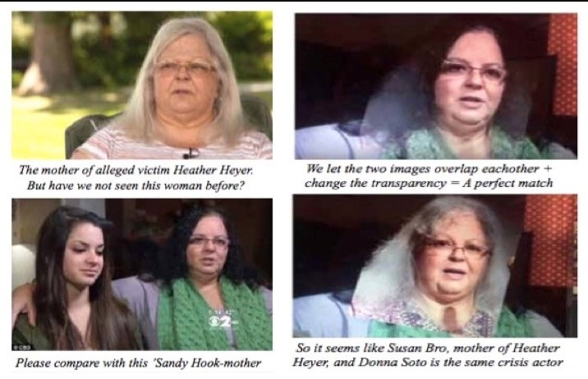
The Deep State has ingeniously deployed the Social Media Giants—whose origins reek with associations with the CIA, which began infiltrating our media in the 1950s with “Operation Mockingbird”—where, by taking for granted these shooting narrative are true (without even bothering to investigate or to verify), they have abused those who have been seeking to expose them as violating their policies on harassment and bullying, which is a subterfuge for suppressing truths as “hate speech”, because they hate the truth.

That this has become the practice to cope with the alternative media was manifest in a recent editorial carried by over 300 newspapers here in the U.S., attacking you. On issue after issue, I and my colleagues have confirmed that you were right and the media was wrong about Obama’s origin of birth, Rafael Cruz and the JFK assassination, attendance at the inauguration, and the right-wing conspiracy to sabotage your campaign and to delegitimize your administration. Thus, as I wrote to The Wisconsin State Journal:

The editorial attacking the President of the United States as "an enemy of the truth" is a joke. On serious subjects, 80% of what the mainstream publishes and promotes is not merely false but provably false--even completely detached from reality. Anyone who wants to know what's really going on needs the alt media, which is being erased by the social media giants.

Alex Jones, for example, who promotes a conspiracy perspective on politically significant events, such as the Sandy Hook shooting and the Boston marathon bombing, has been virtually wiped out across the board, where he has been taken down from Apple, Google, YouTube, Facebook and (now) Twitter, which is a complete disgrace.

We cannot figure out what's really going on unless we consider alternative hypotheses, theories and conjectures. That is a crucial stage in thinking things through. When something puzzling takes place that does not fit into our background knowledge but appears anomalous instead, we need to have the opportunity to kick ideas around to sort things out.

Alex Jones is not the last word on serious subjects, but he can be provocative and frequently features guests who are experts in their fields. William Binney, for example, whom I featured last night on my own internet radio show, "The Raw Deal", observed that Alex Jones was the only media figure who would feature him about the DNC data leak.

This is a perfect example of the false information with which we are inundated, 24/7, by the MSM: the disputed files were downloaded at a rate too fast to have been distant Russian hacking and was done in the Eastern Time Zone. Binney, of course, is ignored by the MSM because his expertise contradicts the propaganda of the left.

For those who care about truth, which excludes the WSJ, visit the web site of Robert David Steele, where he and I collaborated on Memoranda for the President about 9/11 (including contributions by 27 experts) and now are doing a second series on Sandy Hook. Those who care about truth will find Alex Jones is closer to it than the MSM.

Of course, The Wisconsin State Journal declined to publish. But as Gregg Jarrett, The Russia Hoax: The Illicit Scheme to Clear Hilary Clinton and Frame Donald Trump (2018), has demonstrated, the corruption of the FBI and the DOJ in attempting to sabotage your campaign was both pervasive and profound. In my opinion, his book ought to be required reading for every literate citizen, where most Americans, alas, get their news in sound bites from the MSM and don’t realize they are all reading from the same script.

The Social Media Giants were empowered by The Telecommunications Act of 1996, which adopted the perspective of them as akin to libraries and book stores, which are not liable for the contents of books and videos they make available for purchase. But by exercising censorship and taking a stand to decide what videos we can see or not see and what blogs we can read or not read, they have abandoned any pretense of political impartiality and no longer deserve protection from legal liability and prosecution.

Very respectfully,
James Fetzer

References:

“Editorial: Trump is an Enemy of the Truth” (which appeared in over 300 newspapers 16 August 2018)

“Executives From The Major Social Media Companies Gather To Plot ‘Strategy’ For The 2018 Election”

“Stop Deep State Government Misinformation” (by restoring the Smith-Mundt Act of 1948)

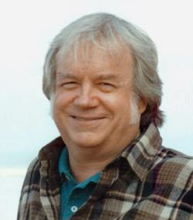
Jim Fetzer, a former Marine Corps officer, is Distinguished McKnight Professor Emeritus on the Duluth Campus of the University of Minnesota. He co-founded moonrockbooks.com with Mike Palecek, when they discovered amazon.com was banning their books, where he has edited books on Sandy Hook, the Boston bombing, Orlando and Dallas, Charlottesville, 9/11, and JFK, with Parkland and Las Vegas forthcoming. He has also produced many videos, including “False Flags on Five Fronts: Sandy Hook, Boston, Charlottesville, Las Vegas and JFK”, “How to Spot a ‘False Flag’: A Sampler of Representative Events”, and “The Parkland Puzzle: How the Pieces fit Together”, at 153news.net, BitChute, real.video and other secure sites.

