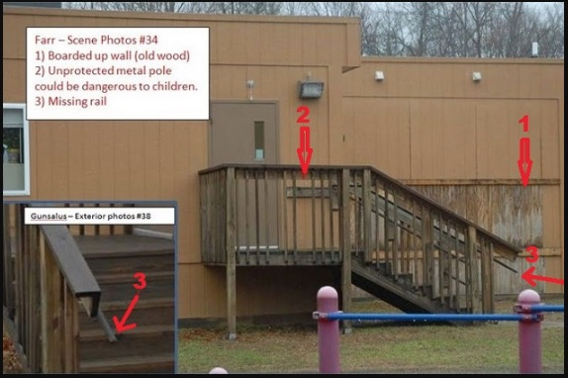
John Remington Graham: In Solidarity with Alex Jones—Litigation Against Alex Jones in Connecticut is Abuse of Process
Mr. President,
The litigation against Alex Jones in state courts of Connecticut is plainly an abuse of process, impossible to institute and press in an uncorrupt and honest manner, and designed to intimidate any and all journalists who dare to contend that the alleged shooting at the Sandy Hook Elementary School in December 2012 was a staged event, meant to shape public opinion in favor of gun control legislation, but so poorly orchestrated by public authority and major news media that many eminent observers have seen through the official story and understood something closer to the truth. The idea that damages for defamation could be lawfully granted against Jones is patently absurd in light of seminal authority long ago established in New York Times v. Sullivan, 376 U. S.254 (1964), and Garrison v. Louisiana, 379 U. S.64 (1974).
The episode at Sandy Hook can be and has been studied in various degrees of depth, but we can know that Sandy Hook was a hoax, as surely we can know that the intelligence of the American people was insulted by the news media reports and the Warren Commission concerning the murder of John F. Kennedy which led to the tragedy of the Vietnam War. As was once observed by Lord Acton, “Historic responsibility has to make up for want of legal responsibility.” And there is our consolation. Death has intervened to prevent temporal justice against those who plotted the death of Kennedy, but we know who they were, and we are beginning to learn lessons from their crimes for the good of our country.
Something as sinister is evidently behind the litigation against Alex Jones. As with most citizens, I have not had time to study Sandy Hook in full depth, yet it is manifest that Sandy Hook could not have happened as it has been reported to us by public authority and major news media. We know from bare facts stated by Dr. Eowyn, in her internet-accessible article showing that the Sandy Hook Elementary School was closed in the year 2008, and that, therefore, the alleged massacre in December 2012 did not happen. From the closure of the school in 2008 alone, the litigation against Jones over Sandy Hook stinks of dishonor to our country.
If we are going to talk about conspiracy theories, as if such thinking were a sign of mental imbalance, let us remember that Abraham believed in conspiracy theories. His “House Divided” speech is an outstanding exposition of why and how we should infer concert from circumstantial evidence in history and politics. Winston Churchill and Benjamin Disraeli believed in conspiracy theories. Those in the press who denounce conspiratorial thinking, including those behind the suit against Alex Jones, are wittingly or unwittingly domestic enemies of the United States.
The bare facts from which the closing in 2008 may be inferred were outlined in her article, “Sandy Hook hoax: 6 signs that school was closed before massacre”. I invite all curious, honest, and patriotic citizens to read this article. We have here a prima facie case that the school was closed in 2008, from comments of neighbors to the school, from reports of contamination of the school with asbestos requiring expensive repairs, from photos showing the school was abandoned at the time of the incident as broadcast across the country, from the absence of handicapped parking spaces required at the time of the claimed incident, from the absence of internet activity between the school and the outside from 2008 to 2013, and from the testimony of Wolfgang Halbig at his FOIA hearing in the spring of 2015.
That much alone, without more, makes the suit against Jones shameful to the law. All upright lawyers should protest. I add these remarks under the inspiration of Edmund Burk when he said, “All that is necessary for evil to triumph is for good men to do nothing.”
Very respectfully,
John Remington Graham
Reference:
Dr. Eowyn, “Sandy Hook hoax: 6 signs that school was closed before massacre” (Fellowship of the Minds, 9 September 2015).

B. A. in philosophy 1963, LL. B. 1966, University of Minnesota; admitted to the Bar of the Minnesota Supreme Court, 1967; admitted to the Bar of the United States Supreme Court, 1971; Public Defender, United States District Court for Minnesota, 1969-1973; Founding professor, teaching common law pleading, judicial writs and remedies, American constitutional law, admiralty, copyrights, legal writing, conflict of laws, legal history, and modern civil procedure, and serving as chairman of the admissions committee, Hamline University School of Law, 1972-1980; Advisor on questions concerning constitutional law and equitable remedies to the Minnesota State Board of Bar Examiners, 1974-1978; Special Counsel for the City of Brainerd, 1974-1980; Crow Wing County Public Defender, 1981-1984; Crow Wing County Attorney, 1991-1995; Occasional lecturer in comparative British, American, and Canadian constitutional law at Laval University, 1989-1991, 1997, and 2000, and in public international law, 2003; and Advisor on British constitutional law and history to the court-appointed Amicus Curiae for Quebec before the Supreme Court of Canada in Reference on certain Questions concerning the Secession of Quebec from Canada, [1998] 2 S. C. R. 217.

