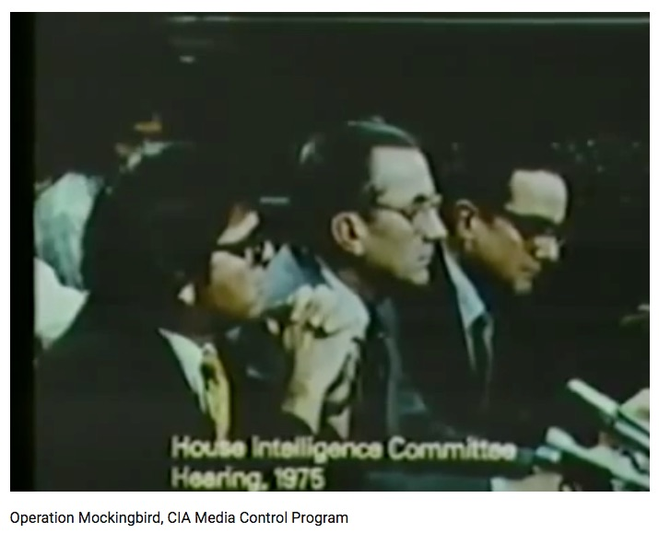
Tony Mead: In Solidarity with Alex Jones – Sandy Hook becomes a Litmus Test pitting Freedom of Speech against Internet Censorship

Mr. President,

Everyone is quite aware that we have the right to Freedom of Speech, but seems to overlook the fact that we also have the right to Freedom of the Press. This doesn't mean that the social media giants have rights. It means that WE, THE PEOPLE, have rights to have access to and to distribute information. These rights were granted long before the internet and have always been restricted by rules of libel, threats of violence, and the disclosure of information that could be detrimental to National Security.

Not everyone is aware that the CIA began infiltrating the media in the 1950s with (what it called) “Operation Mockingbird”. By 1975, it had been such a success that William Colby, its Director, testified to Congress (behind closed doors) that the agency owned “everyone of any significance in the media”. Carl Bernstein confirmed in “The CIA and The Media”, Rolling Stone (1977), that agency officials boasted their greatest successes had been with CBS, The New York Times and Time-Life, providing a lock on US news.

The government maintained control through the consolidation of the media by six media giants until the emergence of the Internet and the alternative media, which has transformed the flow of data. The public has gained access to reams of information disseminated on the World Wide Web and has been permitted to voice its opinions and viewpoints unrestricted by interference for the past two decades. But just as the mainstream has been consolidated, the Internet has been dominated by its own media giants, including Google, YouTube, Facebook and Twitter.

Alex Jones was among the first to offer an opposing view to popular misconceptions as by critiquing the United States government and corporate interests using his InfoWars platform. He insisted that there is a “War on for your mind” and, no doubt, of everything he has ever said, that was the most significant. Sandy Hook has proven to be the litmus test, probably because it exposes the role of Obama, Biden, Holder and others in lying to the the public – creating false flag events with fake deaths to achieve unconstitutional policy objectives including the termination of the 2nd amendment.

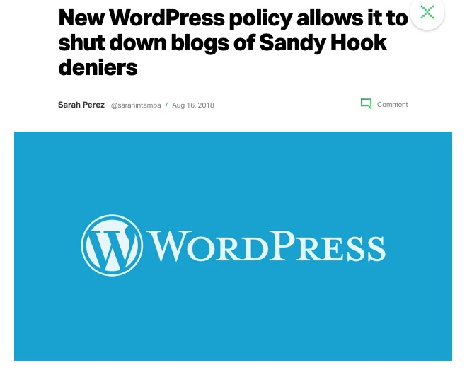
As the Sandy Hook Hoax page administrator, I saw this coming. Our FaceBook page was steadily growing for nearly 5 years as more and more people were beginning to question the events surrounding Sandy Hook! Despite the continuous efforts of “Lenny Pozner” (Reuben Vabner) and his HONR Network to have the page removed, we gradually increased to over 15,000 likes, which had become enough of a threat to the creators of the false narrative that Facebook removed the page: Five years of assembled research was disposed of like a burning book!

The Communications Decency Act of 1966 was the first notable attempt to regulate the Internet by the government, which was passed as Title V of the Telecommunications Act of 1996. Its most important elements were (1) to regulate indecency and obscenity in cyberspace and to regard operators of Internet services not as publishers (liable for the content of their publications) but as bookstores or libraries making them available.

The massive onslaught of Google, Facebook, YouTube and Twitter against Alex Jones and conspiracy research in general has changed their status. Now that internet servers are deciding what we can see and not see, what we can read and not read, it no longer makes sense for them not to be legally liable for the content of what they allow. The mischief in a case like this occurs between the time that these offenses are committed and their resolution before (in this case) the Supreme Court. But it will come.

Very respectfully,
Tony Mead

References:

Operation Mockingbird, CIA Media Control Program (21 January 2012)

New WordPress policy allows it to shut down Sandy Hook Deniers (16 August 2018)

Prison Planet: How the Left is Outsourcing Censorship of the Internet (19 August 2018)

BOOM! Trump’s War with Facebook has Begun – Ben Carson Fires First Shot! (19 August 2018)

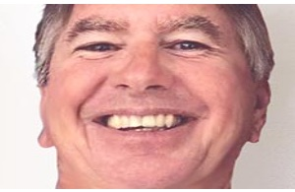
Tony Mead is an independent research journalist and former administrator of the Sand Hook Hoax Facebook page, which was removed in April 2018l. He has written several articles exposing fraud in the Sandy Hook school shooting story and in the Parkland school shooting event. He is a contributing author to the book, Nobody Died at Sandy Hook (2nd ed., 2016) and assisted in the production of the full length documentary films, “We Need to Talk about Sandy Hook” and “The Life of Adam” with Peter Klein.

