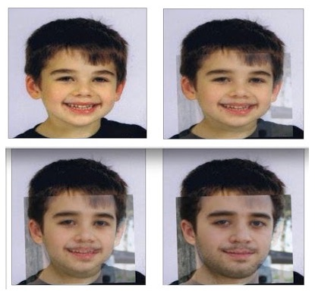
Mona Alexis Pressley: In Solidarity with Alex Jones—There was a “Noah Pozner”, but he’s not the child said to have died at Sandy Hook

Mr. President,

I would like to direct your attention to the Sandy Hook “parent”, Reuben Vabner, who calls himself “Lenny Pozner”. He has engaged in an ongoing battle to shutdown questions being asked in regard to the purported shooting at Sandy Hook. “Lenny” has mastered the manipulation of emotional events and has many Americans fooled by persuading them they should shut down the evil skeptics of Sandy Hook.

There is harassment, as he claims, but it is not on the part of those doing research on Sandy Hook, but on his side. Tony Mead as discovered that “Lenny” has 23 web sites he deploys to find and shut down those who raise legitimate questions about Sandy Hook as innocent as who delivered the Porta-Potties, which would have revealed they were delivered on the 13th and blown the scam apart.

Here’s his latest:
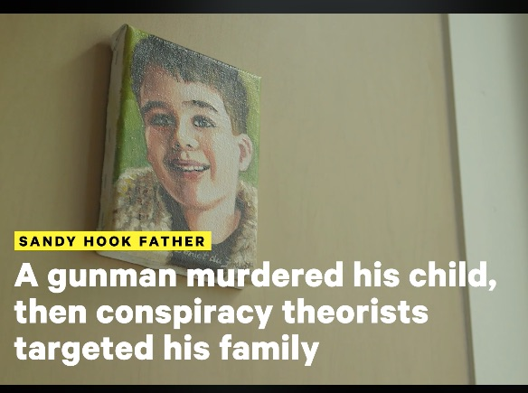
“Sandy Hook father talks about . . .”

In this video, “Lenny” alleges that Alex Jones spreads misinformation, while at the same time Alex Jones has been targeted and shut down on the internet. But how can both sides of a controversy be presented to the American people when one side is allowed to stand and the other is suppressed? “Lenny” claims he is being harassed, but he means there are some (like me) who won’t accept his version of events.

When “Lenny” defines “harassment” as disputing his account, why should anyone buy it? Differences of opinion do not normally count as “harassment”, but the mainstream has adopted that approach. “Lenny” even features a gravestone that Dan Cromer and I had shown to have been photoshopped. If “Lenny” had his way, no one would be allowed to consider that many of his claims are provably false.

Kelly Watt had 100 hours of conversation with “Lenny”, during which she told him she did not believe a word he said, that she did not believe he had a son or that his son had died. As though to convert vice into virtue, in this video, “Lenny” offers glimpses of the document he sent to Kelly, which turns out to be a fabrication, with the bottom half of a real death certificate but top half of a fake. Here’s the best copy:

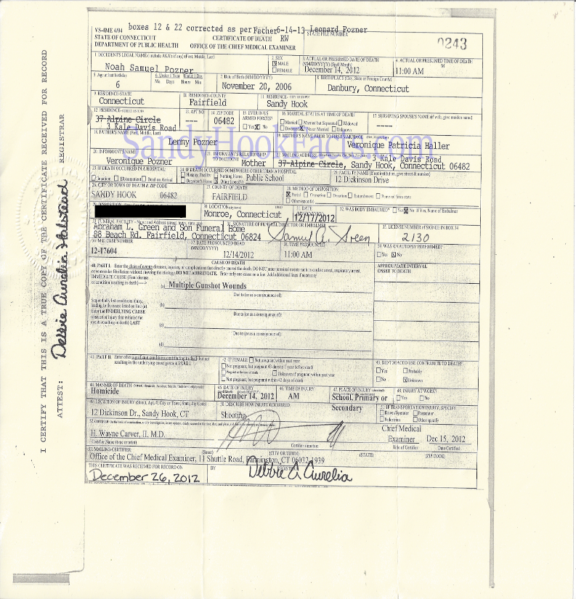
There are so many things wrong with this death certificate that blows your mind. The background paper has been tampered with (notice the contrast) where the font in certain sections has been changed (and is darker).

The file number is only partial as is where he was buried.

I have discovered that a person by the name of Noah Samuel Pozner did exist but he is not the “Noah Samuel Pozner” of Sandy Hook fame.

Many fake entries are to be found on the site FamilySearch.org, where this one below caught my attention:

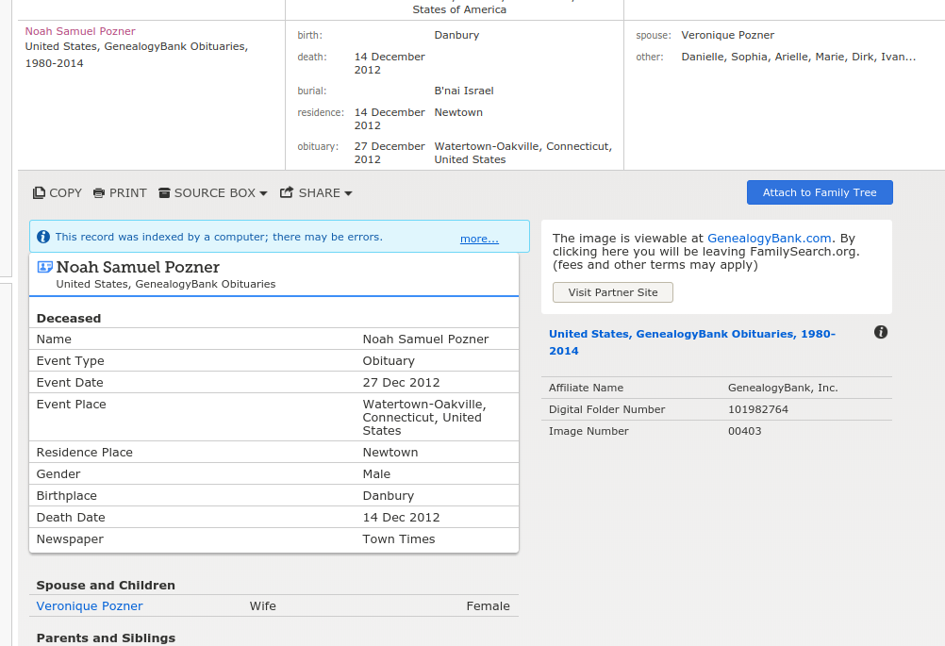
Noah Samuel Pozner was a lot older than we’ve been told. In fact, Noah appears to have been married to Veronique instead of Veronique having been his mother. It looks like he died in Watertown-Oakville, Connecticut but was buried in Israel. Actual evidence, including Images and folder numbers, back up this information. This is the entire key to the puzzle: generate confusion by faking entries on genealogy sites!

In this case, it was done by adding new information so the real information is not seen due to the piles of fake entries. Genius, in a criminal sense. So there was a real death certificate, but the location and time of death had to be changed along with the date of birth. One item on the certificate confirmed my worst suspicions. They ask if the decedent was a smoker and the answer was that they did not know.
REALLY? There we go: another indicator.

Very respectfully,
Mona Alexis Pressly

Reference:

Pressley & Cromer: In Solidarity with Alex Jones — Sandy Hook father, “Lenny Pozner”, and son, “Noah Pozner”, are Both Fake

Mona Alexis Pressly, MA, MFT has frequently appeared on “The Raw Deal” and “The Power Hour”. Her research on numerous political issues, including Obama’s birth certificate, Sandy Hook and Las Vegas, has been published by Dr. James Fetzer, PENN Magazine and other venues.

