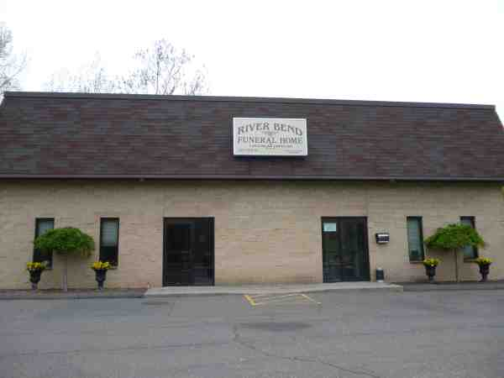
Cinderella Broom: In Solidarity with Alex Jones – Burying the Undead: Sandy Hook was Truly Stranger Than Fiction

Mr. President:

The story we’ve been told about Sandy Hook is so laden with anomalies, contradictions and absurdities that, were it proposed as a screenplay, producers would likely reject it as simply ridiculous. One aspect deserving more discussion concerns how the faked deaths involved the fake disposal of bodies. What do you do to cover the disposition of bodies in works of fiction?

A striking case involve the use of a crematorium with a criminal history to handle the remains of the purported shooter, Adam Lanza. In a state with between 200-340 morticians, undertakers and funeral directors, CT settled on an establishment that had been the focus of crime exposés in The Hartford Courant for a solid seven years (2006-13).

Hartford Trade Service, LLC (East Hartford, Connecticut), together with River Bend Funeral Home and Crematorium, LLC, were established by Kevin K. Riley. In 2004, Mr. Riley landed a lucrative contract worth $500K with the state of Connecticut to provide decent burials for people who died with no immediate families to care for them.

Mr. Riley wasted no time in exploiting the opportunity: double-billing, plundering the assets of the dead and using an unlicensed embalmer’s services. The list goes on. He even allowed his bookkeeper, Yolande Faulkner, to sell some of the booty.

In February 2010, Riley was charged with 63 counts of 2nd-degree larceny. He was convicted and pled guilty. Upon sentencing, Riley was forced to surrender his funeral director and embalming licenses, yet the establishment stayed open under the license of yet another “Kevin”—one “Kevin Davidson”. And there is evidence that his co-conspirator, Yolande Faulkner, also convicted, continued in the business.

Despite all of the foregoing, when the State of Connecticut decided to cremate (in secret) the remains of Adam Lanza, Hartford Trade Service was selected for the job. The death certificate of the purported shooter clearly names the funeral facility in Box #33 next to an illegible signature and the license number (#2698) of “Kevin Davidson”.

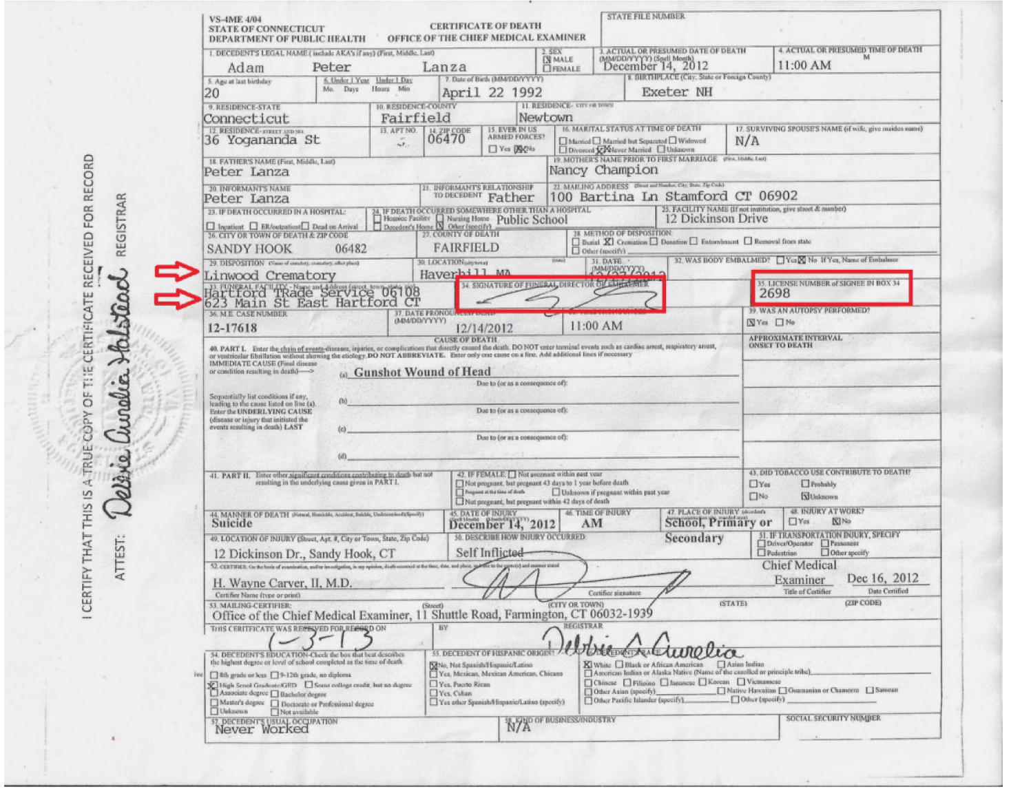

Ask yourself: Why would Connecticut transport the remains of the alleged Sandy Hook perp to a crematorium of ill repute? Why take such a risk with allegedly the biggest tragedy in the state’s history, an incident with such a high profile that sympathy cards and gifts were flowing in from all over the world?

If things had been on the up-and-up, it wouldn’t have made any sense. But things were never right with the Sandy Hook story, Mr. President, because it was, in my opinion, a fabrication – a fiction story with a supporting cast of shady characters – and not a very convincing one at that.

However, if the Sandy Hook massacre never took place, and Adam Lanza never died (or, as some say, never even existed), what better choice to dispose of his remains than a crematorium with a long rap sheet? A business whose director was an ex-convict would be the perfect candidate to pose as the “funeral facility” for a non-existent corpse. Which appears to be what happened here.

Very Respectfully,
“Cinderella Broom”

References:

Dr. Eowyn, “Sandy Hook: The Curious Case of Adam Lanza’s Ex-Con Funeral Director” (27 April 2016),

Articles by Colin Poitra, Dave Altimari, David Owens and Hilda Munoz that appeared in The Hartford Courant between November 2006 and February 2013 (available upon request).

Cinderella Broom has 30 years of experience as a professional writer, including three books of fiction. She holds a master's degree in English from a prominent northeastern university. For nearly three years, Ms. Broom authored articles that appeared on her blog, Cinderella's Broom, until the blog was suspended by WordPress on August 15, 2018 for no stated reason. Research and writings on that blog pertained primarily to the Sandy Hook event on 14 December 2012.

