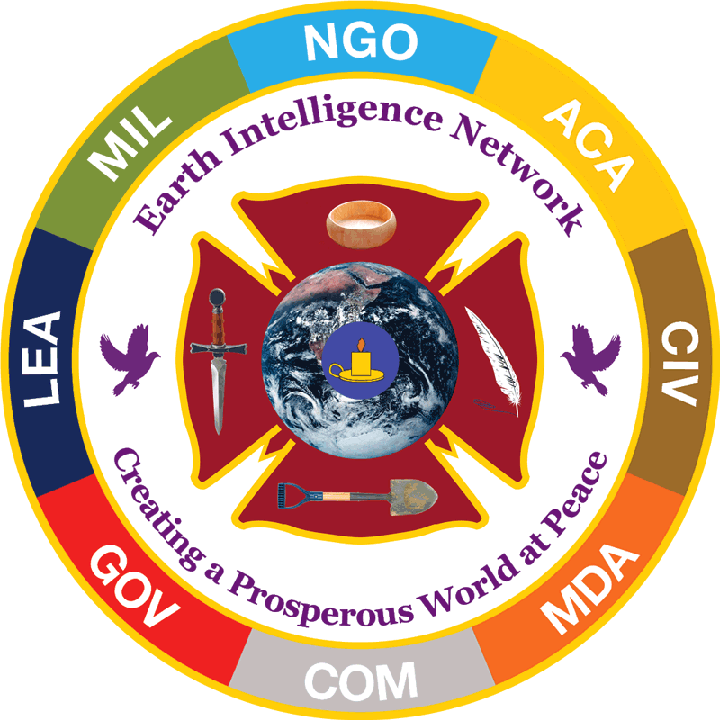 | Earth Intelligence Network  Public Intelligence in the Public Interest  EIN 20-82586516 501c3 170b1Avi from 12 January 2007  15 October 2018
Ten Threats  Poverty  Infectious Disease  Environmental Degradation  Inter-State Conflict  Civil War  Genocide  Other Atrocities  Proliferation  Terrorism  Transnational Crime  Twelve Policies  Agriculture  Diplomacy  Economy  Education  Energy  Family  Immigration  Justice  Security  Society  Water  Eight Challengers  Brazil  China  India  Indonesia  Iran  Russia  Venezuela  Wild Cards (e.g. Turkey)  Five Methods  1. Balanced Open Budgets  2. No Borrowing  3. Grand Strategy  4. Eradicate 50% Waste  5. President Leads Public with Education – Fireside Chats | Madame and Gentlemen,  The President promised to get to the bottom of 9/11. We know he knows that 9/11 truth – and Sandy Hook truth – will be on the table in 2020. As a former spy who managed a false flag operation for the CIA. I and my many colleagues wish to alert you to five things you can do now – three executive, two legislative – to “defuse” the false flag situation that is going to explode in everyone’s face as we move toward 2020. Books about “legalized lying” by the government – including the Department of Justice – are now common. I believe I am showing you a path toward healing.  1. HS: Sponsor a public conference on false flag operations to clear the air.  2. HS: Forbid FEMA from doing any more false flag operations at any level.  3. DOJ: Commission criminal grand juries for both 9/11 and Sandy Hook.  4. Re-legislate Smith-Mundt prohibition against propagandizing the public.  5. Legislatively forbid the use of national security warrants to “legalize” lies to the Court and public by federal, state, and local officials and contractors. I favor a blanket pardon for those who lied under warrant in the past.  This letter and both of the enclosed volumes may be obtained in electronic form via email request. The volumes themselves are easily downloaded as PDFs at http://tinyurl.com/911-POTUS and at http://tinyurl.com/SH-POTUS. The President and select intimates received both volumes via registered mail on 8 August and 8 September 2018. My intent here is to give you a better sense of what the informed public knows, and urge you to act now. I particularly ask that FEMA not be allowed to do any more exercises that alarm the public with a false narrative. Legalized lies undermine the President and make a mockery of both “justice” and “security.”  Sincerely yours,  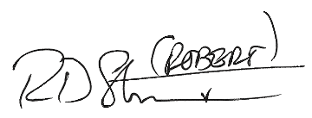  Robert David Steele (Vivas)  Chief Enabling Officer (CeO)  ADDRESS REDACTED  EMAIL & CELL NUMBER REDACTED  http://robertdavidsteele.com http://phibetaiota.net http://unrig.net

DISTRIBUTION

Executive
The Honorable Jefferson Sessions
Attorney General of the United States
Constitution Avenue, NW
Washington, DC 20530-0001

The Honorable Kirstjen M. Nielsen
Secretary of Homeland Security
245 Murray Lane SW
Washington, D.C. 20528-0001

Legislative

Chairman Chuck Grassley (R-IO)
Senate Committee on the Judiciary
224 Dirksen Senate Office Building
Washington, DC 201510

Chairman Bob Goodlatte (R-VA-06)
House Judiciary Committee
2138 Rayburn House Office Building
Washington, DC 20515

Chairman Ron Johnson (R-WI)
Senate Committee on Homeland Security
340 Dirksen Senate Office Building
Washington, DC, 20510

Chairman Michael McCaul (R-TX-10)
House Committee on Homeland Security
2001 Rayburn House Office Building
Washington D.C. 20515

