The Second American Revolution – Reflections on the Near Future
Professor Igor Panarin is correct – absent a counter-revolution, the USA will disintegrate.
Robert David Steele
MAY 2019 ADDENDUM: These reflections, published free online in November 2018, can in the light of recent events be read in the context that it is now clear that President Donald Trump is moving ahead with Global Currency Reset initiatives, and that we can expect the initiatives I outlined below prior to his massive 4th of July celebration. He continues to resist on disclosure, perhaps believing that free energy (ET/UFO disclosure) and Zionist perfidy (9/11 disclosure) are best left to the second term. I continue to give our President the benefit of the doubt while producing a weekly Election 2020 report free online.
If he cancels the federal income tax (substituting the transaction tax applied to all transactions including stock and currency transactions) and announces a student education and elderly health debt jubilee, he is locked in. Yet to be settled are the issues of Free Speech, Right to Bear Arms, and the cutting of the federal budget in half starting with defense, which is 50% waste and cannot win wars.
I will continue to do what I can to support the President from the sidelines, including a constant challenge to Zionist lies and the creation of an open path to direct dialog between President Trump and the leadership of Iran; publishing my articles censored by the Zionists via #GoogleGestapo (see especially TRUMP vs. THE DEEP STATE: Recent Reflections of a Former US Spy & Marine Corps Officer (Trump Revolution Book 35), and planning for Web 3.0 where Bill Binney’s Thin Thread, Satoshi’s advanced crypto, and the ideas I have accumulated and developed from many others, will deliver a truth channel that cannot be censored or manipulated: Ed Jewett: GoogleNews Bias Robert Steele: Lawsuit & Displacement of #GoogleGestapo with Four Nested Capabilities (Web 3.0).
God Bless America – and every person of faith who rejects Zionism, Nazism, Satanism, and the predatory cosmic elements that are now on the run – good is in triumph. St.
God Bless America!

Free Online: http://tinyurl.com/Steele-2ndAmRev
Professor Igor Panarin, a most distinguished Russian intelligence officer and strategic forecaster, is the dean of the Russian school for future diplomats. I salute his work, and particularly admire and wish to support his idea of a joint Russian-American information-analytical anti-crisis centre. Here and now I will focus on his prediction, in 1998, that the United States of America (USA) would disintegrate by 2010, and be Balkanized into five regions as shown below.
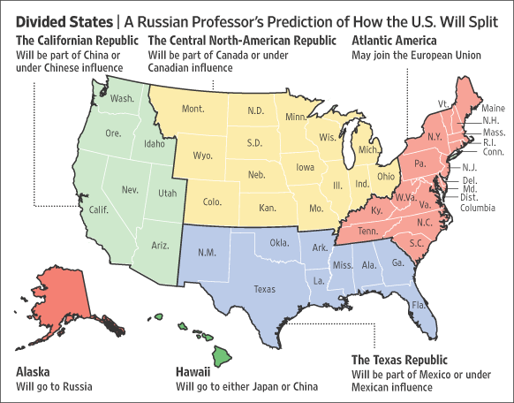
IMAGE CREDIT: Wall Street Journal
Focusing only on the fundamentals – a dysfunctional election system that disenfranchises 70% of the eligible voters; a wanton citizenship system that has granted US citizenship to as many as 5 million Chinese ready to vote as directed in future elections; a dollar that is not backed by anything combined with a criminal banking system; a water, food, and air system that is toxic by design, creating fat stupid people; and an information ecology that is completely controlled by the Deep State and Shadow Government to the point that fake news is now the national standard – Professor Panarin is correct. The USA should have disintegrated in 2000 when the Bush Crime Family was known to have stolen the Presidential election; in 2001 when the Bush Crime Family and the Zionists executed the 9/11 false flag operation in planning since 1989; in 2003 when the Bush Crime Family invaded Iraq on the basis of 925 lies; in 2005 when Hurricane Katrina – which may have been created with geoengineering – demonstrated the abject incapacity of the federal government to rescue those in obvious distress; in 2007 when illegal immigration peaked at 11 million (and those are just the ones that have been counted); in 2008 when the criminal US banking system imploded only to be saved without reason by the federal government at taxpayer expense; in 2010 when the Transportation Security Agency (TSA) was first given authority to do intrusive body searches of anyone anywhere – and particularly including small children; and so on.
What Professor Panarin under-estimated from his distant observation post in Russia are four things:
01 The historical self-sufficiency in cultural and economic terms of the “nine nations of North America” as shown below.
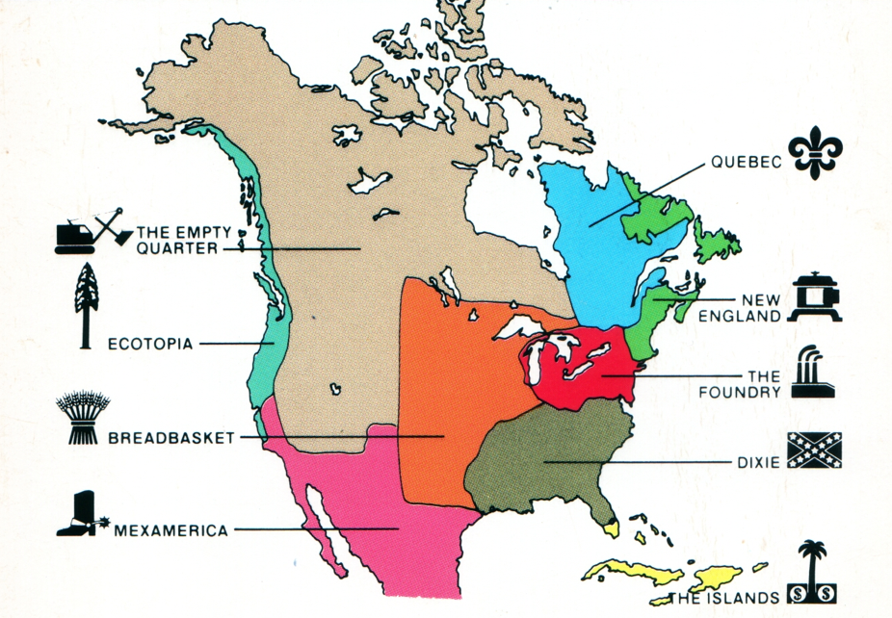
IMAGE CREDIT: Big Think
02 The degree to which Zionists control every aspect of the information ecology in America – education, entertainment, mainstream media, social media. They need a USA able to wage elective wars because the Balkanization of the Middle East – Plan Yinon – will not happen if the USA is Balkanized;
03 The degree to which forces of good – spiritual, patriotic, financial, military forces of good – recognized 9/11 for what it was, and immediately began a twenty-year plan to dismantle the Deep State and the Shadow Government that declared itself on 9/11, an atrocity that still defines the USA today; and
04 The degree to which Native American tribes will be able to restore their sovereignty over lands that are still available in part because of the federalization of so much land in Alaska and west of the Mississippi as shown below (which is to say, over 80% of the land west of the Mississippi).
IMAGE CREDIT: Wikipedia
Had Hillary Clinton won as planned by the Deep State, using election fraud such as she used to steal thirteen primary elections from Bernie Sanders, I believe there would have been a military coup d’état at some point, or an assassination. Hillary Clinton, as I stated in my open letter to then Director of the Federal Bureau of Investigation (FBI), is the ultimate manifestation in one person of treason, pedophilia, electoral fraud, and charity fraud. She is not hanging from a tree today because Donald Trump is extremely clever, and understands that Dick Cheney must hang first (for 9/11), to eliminate any possible criticism of partisan bias.
The odds of Donald Trump winning the election were 200-1 at worst, 20-1 at best. He did not want to win, he did not expect to win, and he – and his wife – were both dismayed when they actually won and won in a manner that could not be over-turned by the Supreme Court.
Once he won, however, the White Hats that were almost certainly contemplating a coup or an assassination of a known traitor had she won, had another option: help The Donald take down the Deep State. It is extremely relevant that both General Secretary Xi Jinping and President Vladimir Putin were intimately appraised of the treason, pedophilia, and fraud represented by Hillary Clinton, and that they almost certainly communicated to President Donald Trump the immediate benefits of forming a triumvirate able to restructure the international financial system (which is to say, put down the Rothschilds, the Vatican, and the Chabad Zionists not to be confused with Jews); able to unify and denuclearize the Koreas; and able eventually to denuclearize the Middle East starting with Zionist Israel. The reality of the power of three specific men who trust and respect one another more than they trust or respect their own staffs filled with apparatchiks and opportunists, cannot be over-stated.
From where I sit there is much to be said for a modified restored USA. If the USA is to avoid being Balkanized by external evil powers – I do not refer to China or Russia or even Mexico, the latter master of combining legal and illegal immigration to achieve co-equal status for Spanish at Home Depot and across the USA) – but rather to the Deep State that uses Central Banks to manage and the upper ranks of secret societies to fix and bribe and blackmail.
The following four things need to happen if the USA is to avoid fulfilling Professor Panarin’s prophecy:
01 Election Reform – we must restore integrity to how we elect.
02 Intelligence Reform – we must restore integrity to how we decide.
03 Tax Reform – we must restore integrity to how we fund government operations.
04 Economic Reform – we must displace private banking and restore integrity to our financial affairs.
What all four reforms have in common is that they terminate the “top down” control of the USA by the Rothschilds, the Vatican, and the Chabad Zionists, and they reinstate the grass roots “bottom up” common sense and wisdom of the crowds. The era of the 1% abusing, genociding, and stealing from the 99% is drawing to a close.
There are two reasons “top down” control of the many by the few is failing. The first is that the Internet has empowered the many with the ability to share ground truth that easily demonstrates the falsity of most of what is being offered to the public by the Mainstream Media (MSM), the government, and corporations. It is no longer possible to propagandize the public into abject silence and manufactured consent. The second is the increasingly visible failure of top down planning in the USA – across all policy areas the public is seeing the divide between the 1% and the 99% grow, and for the first time in modern history, the average US citizen knows with certainty that life for their children is going to be harder, more impoverished, than it has been for them.
We are entering an era where autonomous, decentralized, distributed, localized governance and economics is the only sustainable form of governance and economics. Elinor Ostrom received a Nobel Prize in Economics for her book Governing the Commons: The Evolution of Institutions for Collective Action, a book which made two points: first, that only the locals know enough to make sensible regulations (e.g. for protecting local fisheries); and second, that only the locals are present in sufficient strength and dispersion to enforce those regulations with justice and balance. She did not make the third obvious point: that regulations suitable for one local area are rarely suitable for another. “One size fits all” imperial mandates from above generally cost more, and do more damage, than bottom up self-governance.
The other major change that I see today is the demise of secrecy as a social control factor. Although secrecy is now pervasive, not only across the US Government but across banking, commerce, industry, and even non-governmental organizations, it is no longer effective in keeping the absurdities and atrocities associated with secret programs away from the public. We are in the age of the whistleblower in which the combination of a Julian Assange with a Seth Rich or Bradley (Chelsea) Manning, or The Guardian with Edward Snowden, can completely expose, overnight and to hundreds of millions, the reality of very expensive mass surveillance activities that are totally outside the rule of law.
Election Reform
The USA is not a democracy. Seventy percent of the public is disenfranchised – half of the public does not vote at all due to a combination of voter suppression campaigns and the realization that the entire system is rigged. Within the fifty percent that vote, just under half – the small parties and Independents – cast votes that do not count because only the two parties that “own” the electoral system can win, using a combination of money, voters who can be relied to vote one way or the other, and election machines that are so compromised that the winner can be determined before the first vote is cast.

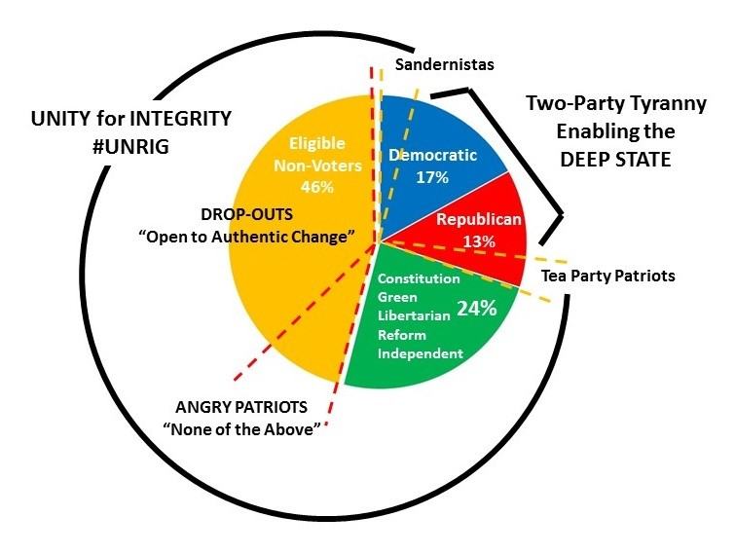
IMAGE CREDIT: Earth Intelligence Network
It is a very common mistake – perhaps even a deliberately contrived mistake – to distract people with the idea that there is a single “fix” to a thoroughly dishonest controlled election system. Holistic analytics demand that the entire system be examined, so as to identify each of the specific deficiencies that in the aggregate make it impossible to have an honest government in the USA that makes evidence-based decisions in the public interest.
Since 2010 – the year in which Professor Panarin forecast the dismantling of the USA (his prediction is still valid, he just underestimated the strength of the Zionist parasite keeping the USA propped up) – I have studied the work of thousands of activists, citizens, lawyers, and even the occasionally honest politician such as Patrick Buchanan, John Edwards, Gary Hart, Ralph Nader, and Ross Perot – each destroyed by the Deep State as soon as they appeared viable.
Below are the twelve specific reforms that must be made to the US electoral system if we are to restore integrity to how we elect and hold accountable our public officials.
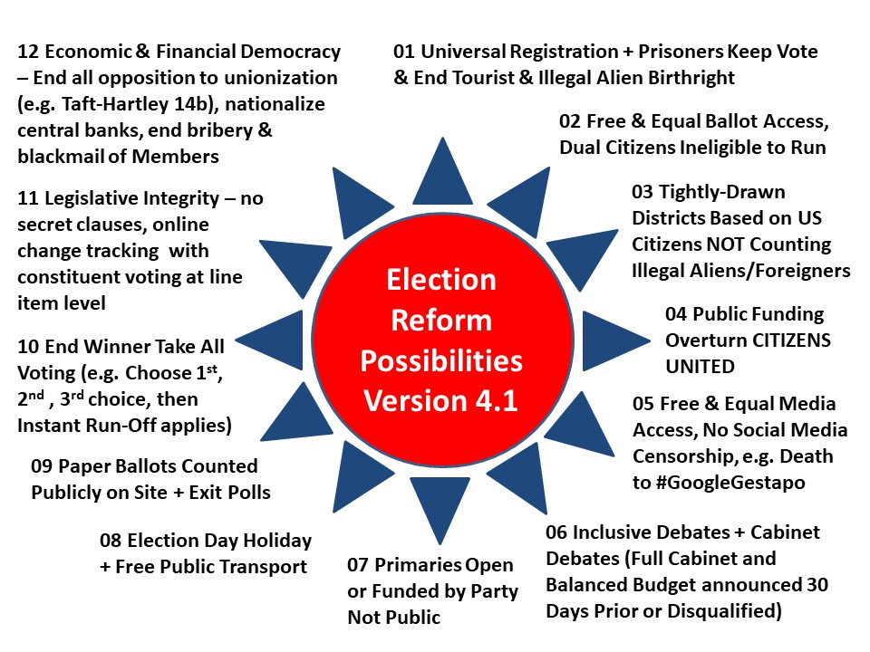
IMAGE CREDIT: Earth Intelligence Network Updated May 2019
There are two aspects of the above constellation of reforms that I am sure Professor Panarin would appreciate.
First, election reform must connect all citizens with all information at all times while eliminating the many opportunities for fraud that exist within “controlled” systems.
Second, the combined aspects of prisoners keeping the vote (the USA has the largest prisoner population in the world, many of them “monetized” by corrupt prosecutors and judges), and ending birthright citizenship acquired via tourism or illegal alien status of the parents, looms as a huge strategic imperative. Estimates vary, but given the propensity of the Chinese to take the long view, and the laxity of US attention to organized tourist births, it is not unreasonable to start worrying now about the possibility of five million Chinese-Americans being directed to manipulate a US election by order (placed into exactly the right districts, they can be decisive, especially if combined with influence over all other Americans of Chinese heritage or dependent on Chinese largesse).
Intelligence Reform
Properly defined, intelligence is about decision-support (the outputs) and it should not be confused with secret collection or covert action (the inputs). Suffice to say that in the USA, the secret intelligence community costs over $100 billion dollars a year but delivers, according to General Tony Zinni, USMC, then Commanding General of the US Central Command, “at best” 4% of what a major commander needs. Put another way, the President and major commander are not getting 96% of what they need to know to make sound strategic, operational, tactical, and technical decisions, and the lower commanders and civilian branch and division chiefs are not getting any intelligence support at all.
Speaking only of the US system, there are three reasons why US secret intelligence stinks:
01 The system is focused on budget-building, not on mission accomplishment.
02 US politics is “pay to play” rather than evidence-based – no one is held accountable for not knowing.
03 Secrecy is used to avoid accountability, not to protect sources and methods all too obvious to all.
Below is a graphic showing the relative standing of the US secret intelligence community in relation to both the threats that we must address (US spies focus only on two of the ten threats – inter-state conflict and terrorism – both of which are largely funded by the US and Zionist Israel (the latter at US taxpayer expense)); and the open source methods that the secret world refuses to respect because they are not expensive enough and cannot be secretly manipulated.
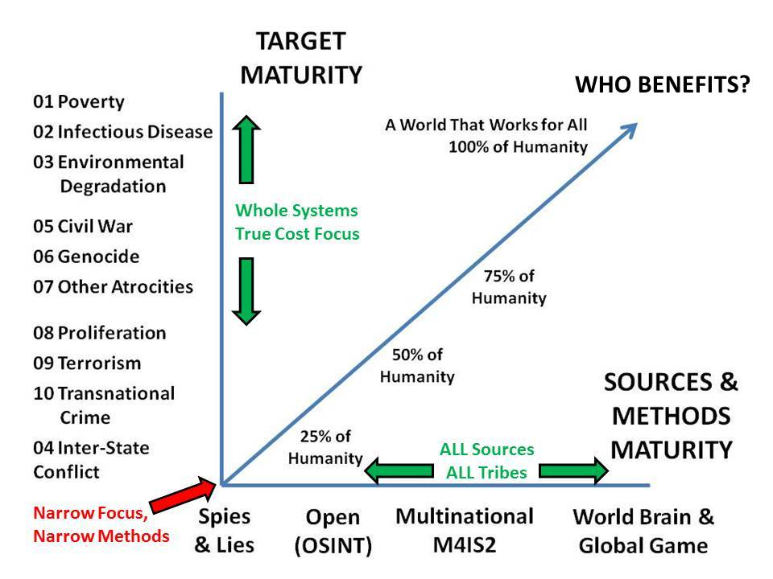
IMAGE CREDIT: Robert David Steele
I am very much interested in Professor Panarin’s idea for a joint Russian-American information-analytical anti-crisis centre, I would expand that to include the Chinese as co-founders and many other countries as contributing affiliates, and would offer my concept of an Open Source Agency (OSA) for consideration. I know with absolute certainty that we can create a prosperous world at peace, a world that works for 100% of humanity if we can a) restore integrity to the governance processes of the USA and b) create a joint total information network among China, Russia, and the USA, mostly open but with some also shared very ruthless secret counterintelligence and direct assassination capabilities in relation to organized crime including Deep State and Shadow Government crime.
Tax Reform
The 16th Amendment to the US Constitution permits the federal government to collect taxes from individual citizens residing in each of the fifty nominally sovereign states. This Amendment is not only in contradiction to the original Constution, it may not have been properly ratified and could be overturned without having to secure a 34 state majority. The 17th Amendment, which converted Senators from being the representatives of their individual sovereign states to being elected by an easily manipulated public, also appears to not have been properly ratified and is therefore subject to rapid repeal. In combination with the nationalization of the Federal Reserve, a parasitic device created by the Deep State to loot the US public treasury with impunity, it is possible to restore fiscal integrity rather quickly.
Governments should not be borrowing money and a case could be made for reneging on all existing debts to banks (not to other governments).
Taxes should be collected in relation to specific transactions at the point of sale, rather than on incomes and estates. The Automated Payment Transaction (APT) Tax devised by Professor Edgar Feige remains the single best solution with the added advantage of being a bottom up solution that increases by several orders of magnitude the revenue for all levels of government as shown below.
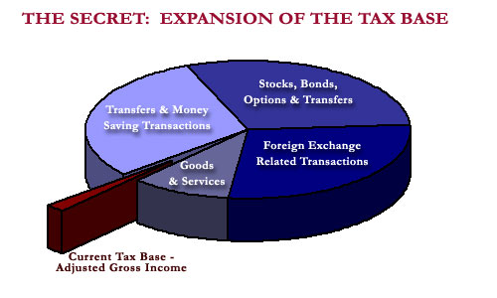
IMAGE CREDIT: APTTax.com
For the USA to achieve fiscal integrity we must repeal the 16th and 17th Amendments, nationalize the Federal Reserve, and implement the APT Tax.
A major benefit of the APT Tax, if the tax rate is set by public ballot, is that it discourages elective wars. For war to be declared, not only must Congress authorize the war, but the citizens must vote for the higher tax rate necessary to pay for the war, and the sovereign states must agree to the federal budget for the war.
Economic Reform
Although I list this one last, it is actually the one that appears to be occurring first, at least at the strategic government level – it will take twenty five years to restore economic democracy and fairness to Native Americans and blacks and other disadvantaged demographics. Economic reform is also the domain in which I am not expert (as I am not expert in relation to tax reform). I am anticipating major economic and financial corrections in the second two years of President Donald Trump’s Administration.
As best I can tell, the National Economic Security and Recovery Act (NESARA), proposed legislation in the 1990’s (coincident with the reign of the greatest modern criminal in US history, George H. W. Bush and his virtual Vice President Dick Cheney who may still today be in charge of the Shadow Government serving the Deep State) was never introduced and therefore not enacted. It’s proposals include an end to the federal income tax (substituting a national sales tax), an end to compound interest on secured loans, and a return to gold or gold and silver backed currency leading to zero inflation (inflation being a constant tax on the working class) and a more stable economy; and also a debt jubilee.
While never considered by the US Congress, these ideas have taken on a life of their own in two ways:
First, as a massive conspiracy/fraud that has persuaded hundreds of thousands of decent people to buy Iraqi Dinar, Vietnamese Dong, and Zimbabwean Zim in the belief that those currencies (e.g. a note for one million Zim) would be restored to their face value by some economic miracle associated with a greatly distorted narrative rooted in the original NESARA concept; and
Second, as an actual menu of economic and financial reforms to be implemented by President Donald Trump during his first term in office, including the nationalization of the Federal Reserve; the distribution of perhaps $1.5 trillion dollars across the US economy in a bottom-up manner using over 5,000 “agents” empowered to spend billions of dollars each on new jobs and new construction; the introduction of a gold-backed dollar; and a debt jubilee in the amount of $3 trillion (student debt, elderly medical debt, small business and family credit card debt). There are weak signals that the President has succeeded in forcing the Deep State and its banking agents to return up to $15 trillion of the $43 trillion known to have been stolen from the US Treasury and US public through various means including outright theft from the Department of Defense (DoD) and the Department of Housing and Urban Development (HUD); sub-prime mortgages, putting blacks in prison to redline their real estate for upscale development; and legalized crime including massive trade in drugs, guns, gold, cash, and small children (utilizing US military bases as smuggling points with the full complicity and active engagement of elements of the US military, particularly the US Air Force, and the Central Intelligence Agency (CIA).
The “underbelly” of what some call the “Global Currency Reset” (or GCR) has three other factual underpinnings:
First, the US Treasury and the Federal Reserve (the front for private banking) have been running massive scams and orchestrated cons in which they have taken gold from both countries and individuals and issued notes (many of them due immediately after 9/11) only to call the notes, when presented for proper redemption, “fakes.” The Federal Reserve has issued Fed Safe Keeping Receipts to Swissindo / God Sky Earth Trust, to take just one example of many, only to default on them as each came due. There are trillions of dollars in legitimate bonds floating around that cannot be redeemed because the thieves are in charge of the banks. How President Donald Trump will deal with them is yet to be determined. The single greatest betrayal was in relation to the loan to the USA from Indonesia via what is known as the Green Hilton Agreement.
Second, considerable amounts of gold were stolen by the Japanese, largely from China and the Chinese diaspora, and buried along with jewels and cultural treasures, in Korea, Indonesia, and the Philippines. Some of that gold was recovered by Ed Landsdale and General Douglas MacArthur and turned into the Black Lily fund that was used by the CIA as an off-budget source of money with which to restore fascism to Germany, Italy, and Japan as well as to empower dictators world-wide; all of that gold is now in play. It must be said that there are much greater stores of gold, particularly in China, India, and Indonesia, that were not captured by the Japanese and buried and that comprise the bulk of the Asian collateral apart from the stolen gold yet to be recovered.
Third, there is a Russian collateral, mostly real estate, that is little understood by most, but equal to the gold-based collateral from China and the rest of Asia.
Completely apart from the NESARA tracks, brilliant ethical citizens such as Ellen Hodgson Brown have documented the ethical, legal, practical value of public banking such that the crimes now common to the banking world and legalized by a totally corrupt Department of Justice (DoJ) and ignored by a pathetically underperforming Federal Bureau of Investigation (FBI), are no longer possible.
Put most simply, everything about how we manage our economic and financial affairs is a lie. Depressions are manufactured and manipulated, as is the US stock market. We are long overdue for a cleansing of the entire system.
Integrated Reform
Where all four of these reforms come together is in relation to the citizen’s daily economic and political activity. As Elinor Ostrom and Nassim Nicholas Taleb have documented so well – and others such as Richard Wolff who focused on restoring democracy to the workplace have also documented – imperial federalism and top-down predatory capitalism do not work. They are not sustainable. What works is a structured transparent confederacy where all decisions are localized, distributed, and transparent.
While my focus is on the USA, I cannot overlook the fact that George H. W. Bush and his agents such as Buzzy Krongard, John Brennan, and William Browder, undertook a Gold War against Russia, one that created a Russian oligarchy and criminal class far more powerful and subversive than common organized crime as we have known it. It is to President Vladimir Putin’s credit that he was able to save Russia from these oligarchs who are nothing more that traitors working for the American white collar criminal class, and I for one support the extradition of William Browder – and Buzzy Krongard and John Brennan – to Russia for processing by the Russian judicial system.
China, Russia, and the USA are all implementing economic reforms while overlooking electoral, intelligence, and tax reforms. I humbly submit that my essay on America has value for China and Russia and other countries. A nation’s best defense is an educated citizenry – Thomas Jefferson said that; and an educated healthy public is the root source and sustainment of national power. There is much we can do together, and to that end, I strongly support direct and constant collaboration at the executive level among General Secretary Xi Jinping, President Vladimir Putin, and President Donald Trump.
May 1,000 years of peace and prosperity be their legacy to mankind. I will do what I can here in the USA working with deeply honorable individuals such as Cynthia McKinney and Jesse Ventura.
Who Cares?
Within the USA, it is not yet certain there is a sufficiency of demand across the public for any sort of reform. At this time politics is successfully contained to the two-party tyranny, the fake news media, and the Deep State pulling the strings behind the scenes.
Outside the USA, no country including China or Russia appears to see any value in educating the US public with a truth channel such as does not exist within the USA.
President Trump appears too busy – understandably so – to be engaged in the first three reforms (electoral, intelligence, taxation), or in creating a truth channel – a two-way truth channel – that connects him to all 200 million eligible voters and allows him to hear from them via a Presidential dashboard that aggregates their thoughts by demographic, location, and issue.
What Next?
My best guess is that President Trump will be challenged in the Republican primary season by several individuals who represent the Deep State business as usual model (John Kasich, Jeff Flake) and by at least one individual – myself – who will demand of the President commitments on election, intelligence, and tax reform as well as hold the president accountable for not fulfilling on his promises to get to the bottom of 9/11, leave the North Atlantic Treaty Organization (NATO) and withdraw US forces from the Middle East and elsewhere.
Whether President Trump wins the Republican nomination or not, I see a clear opportunity for a coalition team to win in 2020. A Democrat cannot win, especially if the President passes an election reform act in 2019. Imagine a coalition team, nominally independent but comprised of a nationally-known individuals from each of the two main parties, each of the small parties, and the Independents. Each individual will run for the nomination of their respective party; if they lose they will continue to represent that party within the team.
Imagine this team naming a coalition cabinet and publishing a balanced budget while challenging the president to do the same. Imagine this team having a website (alt-gov.net) in which every major political, economic, and social issue of note is put before the public for a non-binding online vote, with a strongly financed effort to get 100 million citizens to visit the website to vote? Imagine this team having enough money and the organization that money can buy to deliver an email or a postcard to every single eligible voter in the USA?
As my friend Alvin Toffler liked to say, Leon Trotsky was famous for saying “you may not be interested in war, but war is interested in you.” I have modified that to say “you may not be interested in the truth, but the truth is interested in you.”
Change is coming. It will be rooted in truth and focused on creating a prosperous world at peace.
Educating and respecting the average citizen – and ensuring that cultural and ethnic integrity are protected going forward – are central to peace among nations and prosperity for every community.
President Donald Trump can get with the program – and be the greatest president ever – or he can muddle through the balance of his term and our coalition team will finish the job from 2020 onwards.
I articulate these thoughts with love and respect for the President – tough love, and unconditional respect.
Notes

Editors, “Igor Panarin,” Wikipedia, undated, accessed 20 November 2018.
Professor Panarin first mentioned the idea at a conference in Austria and then wrote about it in Izvestia, as described in Anonymous, “The End of the USA?,” Orthodoxengland.org.uk, undated, accessed 20 November 2018. The first significant notice of his idea in the USA was Andrew Osborn, “As if Things Weren't Bad Enough, Russian Professor Predicts End of U.S.,” Wall Street Journal, 29 December 2008, and then in Patrick Ottenhoff, “Map of the Day: Ex-KGB Analyst Predicts Balkanization of U.S.,” The Atlantic, 29 June 2010.
Robert Steele and Cynthia McKinney, “Former Representative and Intelligence Official Team Up to Unrig Elections,” Independent Voter Network, 26 September 2018.
Alison Singh Gee, “Chinese birth tourism: pregnant women in California’s ‘maternity hotels’ given voice in empowering novel,” Post Magazine, 31 August 2018; and Matt Sheehan, “Born In The USA: Why Chinese ‘Birth Tourism’ Is Booming In California,” Huffington Post, 1 May 2015. The number is a combination of birth tourists returning to China and Americans of Chinese original remaining in the USA. This point is made largely to support President Donald Trump correct interpretation of the Constitution – as defined by the author of the relevant Amendment, birth citizenship is not a right of those over whom the USA does not have legal jurisdiction, i.e. foreign diplomats, tourists, and illegal aliens. Cf. Robert Steele, “Letter to Atlantic Monthly – The Supreme Court Makes Mistakes & Can Be Bought UPDATE 1: CRS Legal Sidebar Gets It Wrong,” Phi Beta Iota Public Intelligence Blog, 22 October 2018.
The references are legion. Here are just two: Karen Feldscher, “Unsafe levels of toxic chemicals found in drinking water of 33 states,” The Harvard Gazette, 9 August 2016; and Food & Water Watch, “Toxic Oilfield Wastewater Used to Grow California Food, Including Organics,” PRNewswire, 23 January 2018.
Christopher J. L. Murray, Marie Ng, and Ali Mokdad, “The vast majority of American adults are overweight or obese, and weight is a growing problem among US children,” Institute for Health Metrics and Evaluation, undated, accessed 22 November 2018; and Lance Welton, “Why Is Intelligence Declining? Our Rulers Don’t Want You to Know,” Unz.com, 21 August 2018.
Robert Steele, “How The Deep State Controls Social Media and Digitally Assassinates Critics,” American Herald Tribune, 7 November 2017. See also Robert Steele, “Itemization of Information Pathologies,” Phi Beta Iota Public Intelligence Blog, 3 March 2012.
Greg Palast, The Best Democracy Money Can But: The Truth About Corporate Cons, Globalization, and High-Finance (Plume, 2004); a summary review is free online. Al Gore was bribed by Warren Christopher to not fight the Florida theft orchestrated by Jeb Bush who as governor removed 50,000 individuals, mostly blacks and leftist whites, from the voter rolls prior to the 2000 election. As I have it from someone who was in the room, Christopher told Gore “if you fight this you will never get a corporate speaking fee in your life; if you accept it as being within the bounds of reasonable dishonesty, you will be worth $100 million within the decade.” And so it came to pass.
Robert Steele (Contributing Editor), Memoranda for the President, 9/11 Truth: From Campaign Promise to a Presidential Speech on 9/11 2018?, Earth Intelligence Network, 2017; certified delivered to the White House on 8 August 2018. At the link, in addition to a downloadable PDF the individual memoranda are also in full text online for ease of use of the foreign language translation widget.
Charles Lewis, 935 Lies – The Future of Truth and the Decline of America’s Moral Integrity (Public Affairs, 2014); a summary review is free online.
Chris Edwards, “Hurricane Katrina: Remembering the Federal Failures,” CATO Institute, 27 August 2015; Editors, “Katrina victims blame racism for slow aid,” NBC News, 6 December 2005.
Jens Manuel Krogstad, Jeffrey S. Passel, and D’Vera Cohn, “5 facts about illegal immigration in the U.S.,” Pew Research, 27 April 2017.
Nick Mathiason, “Three weeks that changed the world,” The Guardian, 27 December 2008. The banking industry is legalized crime, and the Central Banks are the “capos” for the Rothschilds, the Vatican, and the Chabad Zionist Cult that comprise the highest level of the Deep State. Banking recessions are contrived – it is now known that the Great Depression of the USA was planned by the banks with the complicity of Democratic President Franklin Delano Roosevelt; this is ably documented in Wayne Jett, The Fruits of Graft: Great Depressions Then and Now (Launfal, 2011); a summary review is free online.
Jim Bovard, “After pointlessly groping countless Americans, the TSA is keeping a secret watchlist of those who fight back,” Los Angeles Times, 28 May 2018; Abrigail Miller, “Furious passengers dub the TSA's new 'invasive' pat-downs 'legalized groping',” Daily Mail, 7 March 2017; Angela T. Rye, “Dear TSA: The country is not safer because you grab vaginas,” CNN, 22 December 2006.
Joel Garreau, The Nine Nations of North America (Avon Books, 1982); a summary review is free online.
James Petras, The Power of Israel in the United States (Clarity Press, 2006), a summary review is free online; and Paul Findley, They Dare to Speak Out–People and Institutions Confront Israel’s Lobby (Chicago Review Press, 2003), a summary review is free online. The real power of Israel is best understood by focusing on how they use people like Jeffrey Epstein to entrap and blackmail politicians, judges, and others in pedophilia and murderous pedophilia; and the ease with which they persuaded George H. W. Bush, Dick Cheney, the Governors of New York and New Jersey, and the Mayor of New York City, that the Twin Towers – condemned in 1989 – could be converted from a commercial insurance fraud demolition to a “new Pearl Harbor” as a pretext for war in the Middle East. On Epstein see Epstein @ Phi Beta Iota; on 9/11 see Robert Steele (Contributing Editor), Memoranda for the President, 9/11 Truth: From Campaign Promise to a Presidential Speech on 9/11 2018?, Earth Intelligence Network, 2017; certified delivered to the White House on 8 August 2018. At the link in addition to a downloadable PDF, the individual memoranda are also in full text online for ease of use of the foreign language translation widget.
Israel Shahak and Michel Chossudovsky, “’Greater Israel:’ The Zionist Plan for the Middle East,” Global Research, 3 March 2013.
This is not documented publicly despite a great deal of public speculation. As the author understands the situation from direct conversations with retired officers including retired New York Police Department (NYPD) detectives, 9/11 shocked a substantial portion of our senior military officers – everyone had understood that George H. W. Bush was a master criminal and that the Central Intelligence Agency (CIA) and Federal Bureau of Investigation (FBI) were not just dysfunctional but in a state of treason. The US Navy “Graybeards” are said to be the lead element, with “White Hats” from the U.S. Army and selected others working for fifteen years toward either a military coup d’état, or – when Donald Trump emerged as a possibility – a “restoration” President. The Q Anon phenomenon, which may show the hand of LtGen Michael Flynn, USA (Ret.), has inspired a narrow band of patriots, but the President has failed to communicate with and mobilize a larger mass beyond his original base. The President has had some very substantial successes but the Mainstream Media (MSM) controlled by the Deep State and its Zionist underbelly refuses to report them – hence the success of the Trump revolution is in doubt even if his re-election in 2020 is virtually assured. Cf. Paul Bedard, “Trump’s list: 289 accomplishments in just 20 months, ‘relentless’ promise-keeping,” Washington Examiner, 12 October 2018; and David Smith, “'He'll be re-elected': Trump and allies tout the sweet smell of 2020 success,” The Guardian, 13 October 2018.
Chris McGreal, “US should return stolen land to Indian tribes, says United Nations,” The Guardian, 4 May 2012; Timothy Snyder, “The US government should cede territory back to Native Americans,” The Guardian, 28 April 2018.
Axel Geijsel and Rodolfo Cortes Barragan, “Are we witnessing a dishonest election? A between state comparison based on the used voting procedures of the 2016 Democratic Party Primary for the Presidency of the United States of America,” White Paper, 7 June 2016.
Robert Steele, “Certified Letter to James Comey – Pedophilia, Electoral Fraud, Treason, Charity Fraud,” Phi Beta Iota Public Intelligence Blog, 5 November 2016.
Robert Steele, Donald Trump, The Accidental President — Under Siege! A Soft Coup Rages within a Closed Rigged System… (Trump Revolution 05), Phi Beta Iota Public Intelligence Blog, 12 November 2016. See also Robert Steele, “Fire & Fury Confirms The Accidental President UPDATE 6: UNHINGED? The Full Review,” Phi Beta Iota Public Intelligence Blog, 4 January 2018.
Robert Steele, “Is Zionism Over? From Korea to Syria to the Latest #GoogleGestapo Purge, President Donald Trump’s Divorce from Zionism Appears Increasingly Possible,” American Herald Tribune, 4 March 2018; Robert Steele, “Xi, Putin, and Trump for Life – A Few Thoughts — What If We Could Bury the Deep State & Create Peace & Prosperity for All?,” American Herald Tribune, 22 March 2018; Robert Steele, “The Princess and the Spy: A Conversation about the Unification of the Koreas – Could General Secretary Xi Jinping and President Donald Trump Earn the Nobel Peace Prize in 2019?,” American Herald Tribune, 31 March 2018; Robert Steele, “Koreas Unite, Denuclearize: Middle East Next – after a Global Financial Re-Set – Ideas for Iran,” Russian International Affairs Council, 2 May 2018; Robert Steele, “Peace in the Middle East: Denuclearizing Israel, Restoring Palestine, and More,” Russian International Affairs Council, 18 May 2018; Robert Steele, “A Roadmap for US-Russia Relations – An American View,” Russian International Affairs Council, 25 July 2018.
The single best reference on the Deep State remains – by the scholar who first popularized the term in English after drawing on a Turkish reference – Peter Dale Scott, The American Deep State – Wall Street, Big Oil, and the Attack on US Democracy (Rowman & Littlefield, 2014), a summary review is free online. See many references with links at Deep State @ Phi Beta Iota.
Cf. Matt Taibbi, Griftopia: Bubble Machines, Vampire Squids, and the Long Con That Is Breaking America (Spiegel & Grau, 2010), a summary review is free online.
Elinor Ostrom, Governing the Commons: The Evolution of Institutions for Collective Action (Cambridge University Press, 1990, a summary review is free online. More recently, Nassim Nicholas Taleb has produced Skin in the Game: Hidden Asymmetries in Daily Life (Random House, 2018), summary review free online; and ANTIFRAGILE: Things That Gain From Disorder (Random House Trade, 2014), summary review free online. Both books make the case for bottom up sovereignty – localized, distributed authority where everyone is held accountable by people they know.
Governments do not “govern” rather they administer, and very badly. There is no government today that makes evidence-based decisions – all governments are generally rooted in two political parties that take turns while shutting 70% of the population out of the political process entirely, and legislative and executive decisions are sold to the highest bidder. Holistic analytics, true cost economics, and Open Source Everything Engineering (OSEE) are unknown to all governments at all levels, which is a tragedy in as much as all three applied together would fulfil all seventeen Sustainable Development Goals (SDG) within twenty years at ten percent of the cost of the current failed Western economic model that is 90% profit and 50% waste. Cf. Robert Steele, “Healing the Self & Healing the World: The Open Source Way,” Phi Beta Iota Public Intelligence Blog, 2 September 2017 no longer available where previously published in Defence and Intelligence Norway, 13 September 2017; Robert Steele, “Concept for a Post-Western Economic-Engineering Paradigm: How Putin-Modi and Xi-Trump Can Save Humanity with Open Source Everything Engineering (OSEE),” Russian International Affairs Council, 5 April 2017; Robert Steele, For the President of the United States of America Donald Trump: Subject: Eradicating Fake News and False Intelligence with an Open Source Agency That Also Supports Defense, Diplomacy, Development, & Commerce (D3C) Innovation to Stabilize World. Earth Intelligence Network, 2017; Robert Steele, Letter to Secretary-General of the United Nations Antonio Guterres, “Subject: Achieving the Sustainable Development Goals (SDG) with Open Source Everything Engineering (OSEE),” January 2, 2017; “Open Source Everything Engineering (OSEE) — a Nordic Manifesto,” Phi Beta Iota Public Intelligence Blog, 15 April 2016; “Open Source Everything Engineering (OSEE) – Creating the Academy, Economy, Government, and Society of the Future,” Phi Beta Iota Public Intelligence Blog, 5 April 2016.
Amy Baker Benjamin, “The Many Faces of Secrecy,” William & Mary Policy Review, 8.2, 2017.
DJ Pangburn, “Whistleblower Exhibition Exposes Surveillance Age Vigilantes,” Vice, 4 August 2017 and Suelette Dreyfus, “Chelsea Manning and the rise of 'big data' whistleblowing in the digital age,” Phys.org, 5 September 2018.
Daniel Kreps, “Jimmy Carter: U.S. Is an ‘Oligarchy With Unlimited Political Bribery’,” Rolling Stone, 31 July 2015.
Robert Steele and Cynthia McKinney, “Former Representative and Intelligence Official Team Up to Unrig Elections,” Independent Voter Network, 26 September 2017.
Robert Steele, with Foreword by Cynthia McKinney, #UNRIG: Beyond Trump & Sanders (Earth Intelligence Network, 2017); Robert Steele, RIGGED: Twelve Ways the Two-Party Tyranny Rigs the US Electoral System to Block Out Independents, Small Parties, and 70% of the Eligible Voters (Trump Revolution Book 4) (Earth Intelligence Network, 2016).
Tony Zinni, “Background & Confirmation of the 4% “At Best” Quote on Secret versus Open Sources,” Phi Beta Iota Public Intelligence Blog, 30 December 2012, and “Graphic: Tony Zinni on 4% ‘At Best’,” Phi Beta Iota Public Intelligence Blog, 7 December 2010.
Robert Steele, “Intelligence for the President–AND Everyone Else,” CounterPunch, 1 March 2009. See also Robert Steele, “On Defense Intelligence: Seven Strikes,” CounterPunch, 2 July 2014.
There are numerous books on secrecy and the abuse of secrecy. I was honored to be invited to give testimony to both a Presidential Commission and a Senate Commission on this matter. Robert Steele, “SOURCES AND METHODS: A PRIMER FOR CONGRESSIONAL INQUIRY,” Washington, DC: US Senate, The Moynihan Commission on Protecting and Reducing Secrecy, 16 March 1996; and Robert Steele, “Testimony to Presidential Inter-Agency Task Force on National Security Information,” Washington, DC: Department of Justice, 9 June 1993.
Rather than list my eight books and many articles, briefings, chapters, monographs, and testimony relevant to this section, I will simply point to my personal web page, http://robertdavidsteele.com where everything I have written is catalogued and generally also available free online, and cite just one recent capstone publication, Robert Steele, “Intelligence at a Cross Roads: To Be Or Not To Be (Review of Principled Spying by David Omand and Mark Phythian),” American Herald Tribune, 25 June 2018.
Robert Steele, For the President of the United States of America Donald Trump: Subject: Eradicating Fake News and False Intelligence with an Open Source Agency That Also Supports Defense, Diplomacy, Development, & Commerce (D3C) Innovation to Stabilize World. Earth Intelligence Network, 2017.
William Benson, “Assertion That 16th & 17th Amendments to the Constitution Were Not Ratified by Enough States UPDATE 1 Adds 16th Amendment Information,” Phi Beta Iota Public Intelligence Blog, 14 October 2018.
William J. Hermann, Jr. “Frequently Asked Questions,” APTTax.com, undated, accessed 22 November 2018.
I agree with Peter Dale Scott – Dick Cheney appears to have used, and may still be using, the super-secret Continuity of Government (COG) program to control the Shadow Government. Peter Dale Scot, “Memorandum for the President: 9/11, Dick Cheney, & The Hijacking of the U.S. Government,” Phi Beta Iota Public Intelligence Blog, 13 July 2018.
The best clarification is offered by Judge Anna von Reitz, “GESARA and NESARA and NO-SERA About 90% Correct,” FourWinds10.com, 29 October 2016. The most positive and misleading summary is provided by Alcuin Bramerton, “NESARA announcements expected in 2018,” AlcunBramerton.Blogspot.com, 13 November 2018. Worth reading for its links is Editors, “NESARA,” Wikipedia, undated, accessed 23 November 2018. I am personally familiar with four individuals who are part of President Trump’s bottom-up $1.5 trillion initiative and believe that President Trump will announce and implement multiple revolutionary economic and financial reforms in the very near future. NO SERA is Spanish for “won’t happen.”
There is a remarkable parallel in timing and context between the fraudulent and the real, always the sign of a good “con.” Most of the con side is “too good to be true.” The most viewed web site for this aspect is Judy Byington, “Restored Republic via a GCR,” IntelDinarChronicles.Blogspot.com, updated daily, accessed 23 November 2018. GCR stands for Global Currency Reset.
Catherine Austin Fitts, “Constitutional Dangers, $21 Trillion in Missing Money,” Phi Beta Iota Public Intelligence Blog, 7 January 2018; and Catherine Austin Fitts, “Elites Stole $50 Trillion, Investing in Space War, Using Crypto to Keep Public Out of Gold, Silver, and Land,” Phi Beta Iota Public Intelligence Blog, 18 June 2018.
Most information about what is going on behind the scenes has not been published. Among the indicators are Ellen Brown, “Trump’s War on the Fed,” Phi Beta Iota Public Intelligence Blog, 4 November 2018; Robert Steele, “Meet Judy Shelton, Trump Advisor on Gold-Backed Dollar,” Phi Beta Iota Public Intelligence Blog, 30 August 2018; Mongoose, “President Trump Taking Over Federal Reserve…,” Phi Beta Iota Public Intelligence Blog, 27 July 2018; Wayne Jett, “Trump Can Save Capitalism By Ending Federal Reserve and Mercantilism (Throw in a Balanced Budget and a Gold-Backed Dollar For Best Results),” Phi Beta Iota Public Intelligence Blog, 10 July 2018; Lance Schuttler, “Liens on Federal Reserve, Trump Plan for Gold Standard? Are Trump, Xi, and Putin Collaborating Secretly Against the Deep State?,” Phi Beta Iota Public Intelligence Blog, 11 May 2017; Neil Keenan, “Gold War – The Global Financial System Is About To Shift,” Phi Beta Iota Public Intelligence Blog, 12 October 2016; Berto Jongman, “Sorcha Faal (David Booth) on Donald Trump as Andrew Jackson Reprise, Battle to the Death with Federal Reserve, Vatican, CIA, and the Deep State,” Phi Beta Iota Public Intelligence Blog, 29 February 2016.
Here I draw on three personal contacts who have provided me with compelling evidence including copies of the original Treasury letters.
Cf. “The Green Hilton Agreement:Geneva 1963,” Bibliotecapleyades.net, 28 November 2008: Lance Shutter, “The Connection Between 9/11, JFK and The Global Collateral Accounts,” The Mind Unleashed, 9 November 2015. A general search for <Green Hilton Agreement> will find many links. Some dispute this, I do not. The use of the 9/11 event to destroy (or claim destruction of) financial records including massive repayments due on 12 September 2001 is overlooked by most.
Sterling and Peggy Seagrave, Gold Warriors: America's Secret Recovery of Yamashita's Gold (Verso, 2003), a summary review is free online; and Jonathan Nashel, Edward Landsdale’s Cold War (University of Massachusetts, 2005), a summary review is free online. Landsdale was the father of the modern false flag operation, using fake guerrillas killed by a CIA asset, a Philippine Army Captain, who was then glorified into the Presidency. The Gold Lily Fund was used to create the North Atlantic Treaty Organization (NATO) GLADIO stay-behind capability staffed by Nazis and used to create murderous false flag campaigns, such as the fake Red Flag terrorist group used to help elect anti-communist fascist leaders in Italy in the 1960s. Cf. Fred Burks, Prescription for a World Crisis. Global Outlook, Issue 13 Annual 2009, False Flag Operations, How Wars Are Started By False Flag Operations (Global Outlook, 2009), a summary review is free online. See also False Flag @ Phi Beta Iota.
From a source with direct access: The Russian collaterals are equally important. Codename White Spiritual Boy is key on this. He is a Russian general AND more recently was bestowed an honorary Chinese generalship. He is currently working with the Chinese to align all appropriate protocols in order to receive his signature. His signature represents BOTH the Indonesian gold and the Russian land collateral, conjoined by recent treaty.
Ellen Hodgson Brown, The Public Bank Solution: From Austerity to Prosperity (Third Millenium Press, 2013); see also Ellen Brown @ Phi Beta Iota.
Elinor Ostrom, Governing the Commons: The Evolution of Institutions for Collective Action (Cambridge University Press, 1990, a summary review is free online. More recently, Nassim Nicholas Taleb has produced Skin in the Game: Hidden Asymmetries in Daily Life (Random House, 2018), summary review free online; and ANTIFRAGILE: Things That Gain From Disorder (Random House Trade, 2014), summary review free online. Both books make the case for bottom up sovereignty – localized, distributed authority where everyone is held accountable by people they know.
Richard Wolff, “Democratic Capitalism,” Phi Beta Iota Public Intelligence Blog, 14 February 2015 with links to his major works; and more recently, Richard Wolff with Chris Hedges, “On Contact: The Coming Collapse of the American Economic System,” Russia Today, (YouTube, 28:27), 1 April 2018.
Fred Burks, “Memorandum for the President: Evidence 9/11 Used to Launder $240 Billion in Covert Securities in a Covert Economic War (Gold War) Against Russia,” Phi Beta Iota Public Intelligence Blog, 9 July 2018; Mongoose, “9/11 – Gold War Against Russia, Buzzy Krongard, Brown & Root, Bush Crime Family, Dick Cheney, and More..,” Phi Beta Iota Public Intelligence Blog, 16 February 2017; Martin Armstrong and Robert Steele, “The Real Story on Bill Browder, Gold War Against Russia, CIA Asset John McCain’s Magnitsky Act,” Phi Beta Iota Public Intelligence Blog, 25 July 2018; Betty Boop, “WIlliam Browder Gold War Criminal On Video – The Real Magnitzky Story As Known To The Trump Family,” Phi Beta Iota Public Intelligence Blog, 16 August 2018; Joe Olson, “Yaacov Apelbaum on The Mechanics of Democratic Deception — an OSINT Case Study of the Christopher Steele Dossier Against Donald Trump — Includes Browder Gold War Magnitsky McCain Connections,” Phi Beta Iota Public Intelligence Blog, 16 August 2018; and Eleutheria, “BrowderGate Deepens — on INTERPOL Most Wanted List, Free Book, Deep Covert Gold War Doo Against Russia,” Phi Beta Iota Public Intelligence Blog, 18 August 2018.
The Magnitsky Act is what money can buy when the US Congress has no integrity at all – “pay to play” as President Trump has stated. President Putin is entirely correct in asking that William Browder be extradited to Russia for interrogation, but he should not limit himself to Browder: Buzzy Krongard and John Brennan were the ones actually managing the program at the director of President George H. W. Bush and with the complicity of then CIA Director George Tenet – all of them should at a minimum be interrogated under oath in the USA by INTERPOL.
Hans Morgenthau, Politics Among Nations: The Struggle for Power and Peace (McGraw-Hill, 2005).
Cf. Robert Steele, “The Princess and the Spy: A Conversation about the Unification of the Koreas – Could General Secretary Xi Jinping and President Donald Trump Earn the Nobel Peace Prize in 2019?,” American Herald Tribune, 31 March 2018; Robert Steele, “Xi, Putin, and Trump for Life – A Few Thoughts — What If We Could Bury the Deep State & Create Peace & Prosperity for All?,” American Herald Tribune, 22 March 2018; and Robert Steele, “Is Zionism Over? From Korea to Syria to the Latest #GoogleGestapo Purge, President Donald Trump’s Divorce from Zionism Appears Increasingly Possible,” American Herald Tribune, 4 March 2018.
Robert Steele, “Trump Truth Channel UPDATE Add Donald Trump Junior Tweet on Need for an Alternative & Class Action Lawsuit Against #GoogleGestapo,” Phi Beta Iota Public Intelligence Blog, 30 August 2018, updated.

