INTERVIEW
Is Jared Kushner a Traitor Who Must be Fired and Jailed?
Review of the New Book Kushner Inc. – Greed, Ambition, Corruption.
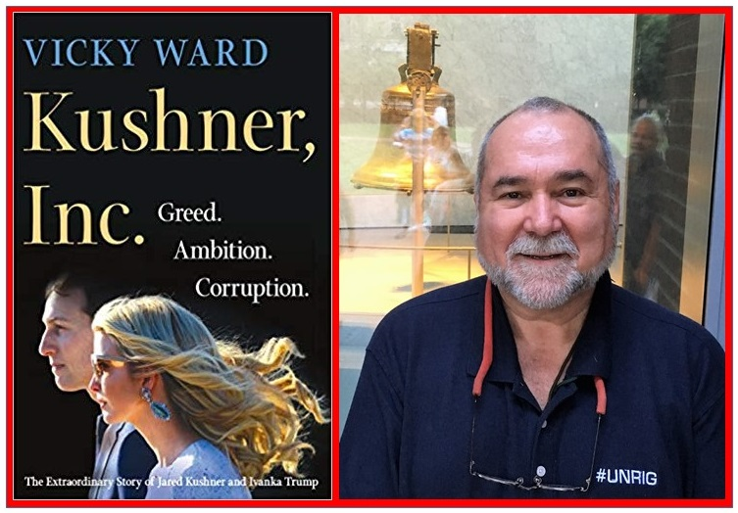
by Javad Heirannia
Q. You are the top non-fiction reviewer that we know of, with over 2,500 reviews posted across 97 categories of non-fiction. Last month we did an interview entitled “Understanding Donald Trump and the White House: A few books” (Tehran Times, 13 February 2019). Two years ago you did the first book review essay on the man himself, “UNHINGED? Donald Trump, His Family, His Appointees, & Everyone Else” (San Francisco Review of Books, January 2017). How do those essays and books bear on your review of Kushner, Inc. Greed. Ambition. Corruption (St. Martin’s Press, 2019)?
A. The first essay reviewed Fire & Fury, by Michael Wolff, which was a character assassination book that was mostly untrue – Kushner, Inc. is a character assassination book that appears to be mostly true. To offset Fire & Fury I also reviewed Let Trump By Trump by Cory Lewandowski and David Bossie, and Understanding Trump by Newt Gingrich. My conclusion is that our President is extraordinarily intelligent, intuitive, and authentic and that the Deep State will stop at nothing to terminate his presidency.
The second essay, which I was glad to have published in the Tehran Times, focused more on the dysfunctionality of the White House, including a Vice President that is known to be in constant betrayal of the President’s trust, a series of Chiefs of Staff that lacked the balls to help the President clean house, and a terrible mélange of misfits from Zionist neocons to political hacks to wife beaters to children. That essay reviewed The Shadow President by Michael D’Antonio and Peter Eisner, FEAR by Bob Woodward, Let Me Finish by Chris Christie, and Team of Vipers by Chris Sims.
Although the last three books addressed the damages being done to the President and to the US Government and the US public by Jared Kushner and his wife, the President’s daughter by his first of three wives, Kushner, Inc. is so detailed, so compelling, and so full of evidence of actual crimes committed by Kushner – Ivanka (not to be confused with her mother Ivana) comes across more as witless than as a criminal – that the book confirms my view that Jared Kushner will soon be indicted and of no use at all to Saudi Arabia and Qatar as well as Israel.
Q. Here is a quote from the beginning of your review as published at your blog:
This book provides the public with – in effect – a national counterintelligence threat study on a single individual who is, apart from being completely incompetent – an active traitor who is in active violation of multiple financial fraud, tax evasion, and real estate compliance laws. Kushner is, among many odious things including being an agent of more than one foreign power, a slum lord suing his impoverished tenants in New York and Baltimore for sums that are beneath contempt. In passing it reveals his wife, the President’s daughter, for the vacuous entitled beauty that she is.
What are the major points of the book that cause you to conclude that Jared Kushner’s life is over?
A. Every chapter in this book contains gems. Some of the most important information is fragmented across the book. For example, the single most important conclusion I drew from the book is that Robert Mueller appears to have referred the known crimes of Jared Kushner in relation to serving as an unregistered agent of multiple foreign powers and being a principal in violation of multiple real estate, financial, zoning, and tax compliance laws, to a conventional U.S. Attorney. The President has two choices: he can try desperately to delay publicity about this until after the 2020 election or – my recommendation – he can immediately expel Jared Kushner from the White House and I would go so far as to say the President should encourage his daughter to demand a divorce now and rescind her conversion.
No one else has done what the author of this book, Vicky Ward, has done – this is a counterintelligence study suitable for a President – indeed, it is the kind of deep look that should have been done as soon as Jared Kushner’s intentions toward Ivanka were known. In one book the author has exposed the criminal norm to be found among many – perhaps not all – Orthodox Jews who believe that goyim and non-religious state rules can be ignored; summarized the routine persistent crimes as well as the suspected mental instability of Charlie Kushner the felon father; and made it clear that Jared Kushner has committed multiple crimes across many legal domains, to include fronting for his father, a felon, in acquiring 666 Fifth Avenue, and taking what is clearly a billion dollar bribe from Qatar – a 99 year lease paid in advance for an over-priced building with many problems.
The amount of detail in this book is quite extraordinary, to include Jared Kushner’s willful violation of all applicable regulations with respect to official communications – using WhatsApp and other means not approved to communicate with the princes of Saudi Arabia and Qatar would put any other person in jail without bond, immediately.
The role of Jared Kushner in the firing of James Comey is documented for the first time by this book, and that is important because it suggests that Kushner will face an obstruction of justice charge at some point.
The fact of Corey Lewandowski receiving $500,000 a month (a month!) from Qatar is significant at multiple levels – it suggests that Qatar is targeting our President via multiple channels, perhaps realizing that Kushner’s head may be on a chopping block, and it raises the question of whether Cory Lewandowski might be an FBI informant against both Kushner and Qatar.
Q. At one point in your review you state, and I want to quote you here for the exact spirit of your insight:
Ivanka may or may not know this: Kushner almost certainly does not love her. She is a shiksa, a tool toward power, and however much she might try to comply with conversion, she is his shiksa to the end, her wealth being his to steal and dispose of over time. The children are half-breeds, not of a bloodline Jewish mother, to be sidelined when the time is right [this observation of mine is not in the book].
After making it clear that this observation is not based on the book, you go on to suggest that this was an arranged marriage, contrived by the Mossad with the assistance of Jeffrey Epstein and Ghislaine Maxwell. Can you comment further?
A. I struggled with this – it was one of two major areas where the book is weak. The author, while capturing some very important detail about Ivanka, details that make it clear she is amorally ruthlessness; totally blasé with respect to embracing financial fraud and dealing with criminal elements world-wide; completely ignorant about the fundamentals of any business; and willing to lie for effect – did not cover her love life before Jared Kushner, a love life that included Nat Rothchild, who clearly decided not to pursue her for marriage.
How Orthodox Jews and Chabad Zionists see the gentiles – goyim – and gentile women – shiksas – is so vitally important to terminating the Zionist parasite in America that I felt this point had to made. Ivanka was clearly drawn to the family life represented by the Kushners – bad as it was it was better than what she had with Ivana and The Donald – but I doubt that she understands the cold-hearted amoral evaluation of her by Jared Kushner as a path to power and wealth he is not capable of earning for himself. I could be wrong but based on the book’s deep documentation of Kushner’s amorality and transactionality, I am compelled to suggest that he sees her as a shiksa, which is a synonym for a debased woman of no account who can be willfully taken advantage of. This has to be said.
At the same time, it is essential to back-track, including NSA traffic analysis, to evaluate the role played by Mossad agents Jeffrey Epstein and Ghislaine Maxwell, herself the daughter of Robert Maxwell, the Zionist super-spy who led the cyber-penetration of all US communications and computing systems. I believe that both Ivanka and Chelsea Clinton were profiled, and that by order of Benjamin Netanyahu, a series of “chance encounters” were orchestrated until a Jewish husband was assured in both instances. I believe both these marriages were “arranged” as an act of state – a subversive act of state.
There is, however, a very strange twist. When I sent my long review out for comment, I immediately received this photograph of Ivanka at an early age (before her nose job and breast implants) with the comment: “Ivanka might actually be from a Khazar Jewish bloodline, which would make her ‘conversion’ a massive Chabad joke on the planet.” I have no idea myself, from where I sit they deserve to work out their life as they wish, but they should not be allowed to screw up the White House and our President’s attempts to dismantle the Deep State of which Zionist Israel is a major foundation and enforcer.
Q. What was the other major weakness in the book?
A. Kusher’s role in destroying the Transition Team led by Chris Christie, and his act of absolute betrayal of the President in trashing the twelve volumes of planning that hundreds of Trump loyalists worked on, was the single most terrible thing anyone has done to our President – worse than the Russian witchhunt. Chris Christie appears to have turned down the Chief of Staff role precisely because Jared Kushner and Ivanka were so clearly set on being the Prince and Princess in power. Had President Trump kept them in New York and allowed Christie to do his job, I believe the President would have had both a great deal more stability and gravitas in office in his first two years, and three times the accomplishments in that time. My separate review of Christie’s book, Let Me Finish, is an excellent complement to my long review of Kushner, Inc.
Q. You state early in your review that the couple are Democrats, not Republicans, and cite the book as documenting that the Kushner family is loyal to Bill and Hillary Clinton, not to Donald Trump. What else can you say about this?
A. There was a time when I thought Ivanka had enormous potential as a cross-over or bi-partisan figure who could blend the attractiveness of the Kennedy’s to the ideological fervor of the Reagan Republicans. That was before I understood her shallowness. Not only does the book make it clear that the Kushners do not read, but there is one telling anecdote about Ivanka not knowing the difference between a liberal and a libertarian, being obstinately certain at a described dinner party that they were the same thing. From climate change to immigration to birth control, they are liberals, not conservatives. And that is without stating the obvious, which is documented in the book: Kushner considers Benjamin Netanyahu to be his boss, not President Donald Trump.
Q. Any parting thoughts?
A. One major point that I would like to make, out of respect for Donald Trump Jr. and Eric Trump, as well as First Lady Melania Trump whom I deeply admire. Ivanka is clearly an “enfant terrible” who has learned how to manipulate her father, and she has placed those skills in the service of a man-child who is an agent of multiple foreign powers. Kushner is shown in this book to be the enemy of the Trump family, and Donald Trump Jr. particularly. There is no member of the Trump family Kushner would not sacrifice to avoid being held accountable himself, and that is the note I want to end on: Jared Kushner is Donald Trump’s Judas.
Read the full long review.

