Saving America – Saving Capitalism. Start with the Truth.
Ray Dalio is a Patriotic Genius – Can Lionel Inspire the President & the Public?
Robert David Steele
Bottom line up front: no amount of truth is going to get past the White House Deep State filters unless we can mobilize a special channel. Lionel of LionelMedia.com is that channel. This article has an audience of one.
I was educated by Ray Dalio’s recent publication of Why and How Capitalism Needs to Be Reformed (Parts 1 & 2), an earnest and learned exposition I would not have noticed were it not for Zero Hedge, which continues to offer a brilliant potpourri of useful daily insights. These two posts alerted me to Ray Dalio’s manifesto:
- "The American Dream Is Lost" - Ray Dalio Tells '60 Minutes' Why American Capitalism Must Be Reformed
- Ray Dalio Warns Of "Revolution" Unless America Can Fix Inequality
In brief, this patriotic genius who has made a great deal of money for himself and others by working hard and thinking clearly, focuses on the productive individual (generally enabled by a good education in the context of a good family) who is incentivized to work hard in a culture replete with fairness that fosters innovation and teamwork and is generally devoid of bureaucracy, corruption, debt, and excessive profit-taking as the expense of the worker, who is the root of all productive enterprise.
He makes the point that capitalists are not inherently evil, they simply follow the money and in modern history the money has been generated around four core practices far removed from the reality of human productivity and potential:
- Technologies have replaced people [without regard to the true costs to community & country]
- Companies have migrated to cheaper people away from their home country [without resistance]
- Central banks [private enterprises] have made financial gamesmanship more profitable than real work [to the point that it is 5X more profitable to cheat at numbers than invest in real things]
- Policy makers have focused on budgets instead of return on investments [they lack intelligence]
There is no substitute for reading him in the original, including his 2017 treatise, 133 pages, Productivity and Structural Reform: Why Countries Succeed & Fail, and What Should Be Done So Failing Countries Succeed, see especially the table of factors to be calculated on page 30 and pages 44, 46 and 52 respectively scoring India, China and Thailand almost totally in the green. I note with interest that Mexico is fifth in future growth productivity (estimated), after India, China, Thailand, and Singapore. Russia and Brazil and the Koreas are in the second rank but substantially superior to the USA.
Others have made similar points in the past, but others have not had Donald Trump as a President and a growing chorus of populist voices demanding an end to the Deep State and the Shadow Government that have subverted the Constitution and shut down government Of, By, and For We the People while also creating a mass surveillance virtual prison camp society of dumbed-down drugged-up peons. Below are my reviews of the books by John Bogle (RIP) and William Greider, followed by my two master lists of reviews pertaining to our negatives and our potential positives.
- Review: The Battle for the Soul of Capitalism
- Review: The Soul of Capitalism–Opening Paths to a Moral Economy
- Worth a Look: Book Review Lists (Negative)
- Worth a Look: Book Review Lists (Positive Future-Oriented)
It is in the above context that I take Bernie Sanders and the Democrats and their latest line, “capitalism sucks,” with a bit of reserve. Richard Wolff is the only serious person on the left mounting a reasonable critique of capitalism and his emphasis on democracy in the workplace – the workers must have a vote in the workplace – is where I will meet intelligent Democrats – all three of them – halfway. Actress Alexandria Ocasio Cortez (AOC) is throwing out such moronic lines I sometimes wonder if she is actually working for The Donald and this is his way of being spectacularly funny while planning the demise of the Deep State and its Zionist underbelly.
Where we can all agree is that capitalism needs fixing but where I want to make a contribution is in pointing out that capitalism cannot be fixed unless we first fix how we elect and oversee our national, state, and local representatives.
Let me also say clearly that anyone (this includes Bernie Sanders and Elizabeth Warren) who suggests that higher taxes on the wealthy are “the” fix is either seriously stupid (unlikely), or seriously crooked (quite certain). This is not about an “income gap.” This is about – as our President said during the campaign, a “rigged system” in which every aspect of our lives is stacked against the 99% and in favor of the 1% -- that that includes admissions to the best schools, regardless of your grades.
And now one final point before I discuss what the President can do to fix all this. I thank my friend and colleague Wayne Jett, author the book I review below, for pointing out that what we have today is not capitalism, it is mercantilism: elitist cronyism that stifles competition – and the cronies are both in and out of government. The same corruption that prevents enforcement of existing reasonable laws enables the rigged system – a rigged system that includes the manipulation of interest and foreign exchange rates as well as price fixing and tax fraud on a scale that would make Satan proud.
- Review: The Fruits of Graft
Across every mega-industrial domain from agriculture to banking to defense to housing to manufacturing and medicine and science, we have monopolies, price fixing, and collusion – yes, that word made so famous by the Russian witch-hunt that I was among the first to discredit – between Congress, industry leaders, the media, academicians, and even labor union leaders who refuse to properly represent the workers. I stood up for the President when both James Clapper and John Brennan were lying their asses off to Congress and the public, and I will say right now that Russia is not our enemy, the Deep State is our enemy, and what I propose below will help bury the Deep State.
- 20161230 Robert Steele: US IC Allegations Against Russians Are Crap — Our Own Traitors, Not the Russians, Are the Real Enemy, Fake Evidence & Fake News – UPDATE 22
- 20170109 Robert Steele: The Soft Coup Collapses – Blackmail Revealed – What Next? CIA was bluffing, produced no evidence – Russians did not “hack” the election. Is this the beginning of the end of the Deep State in the USA? Can Trump clean house & wage peace? (Trump Revolution 06)
This is the political landscape we are dealing with, where fully 70% of the eligible voters are disenfranchised. Those who are elected by the 30% whose votes “count” in our rigged system are either corrupt before they begin running – groomed to run – or corrupt by the end of their first year – if not from bribes and blackmail, then from lies and exhaustion.
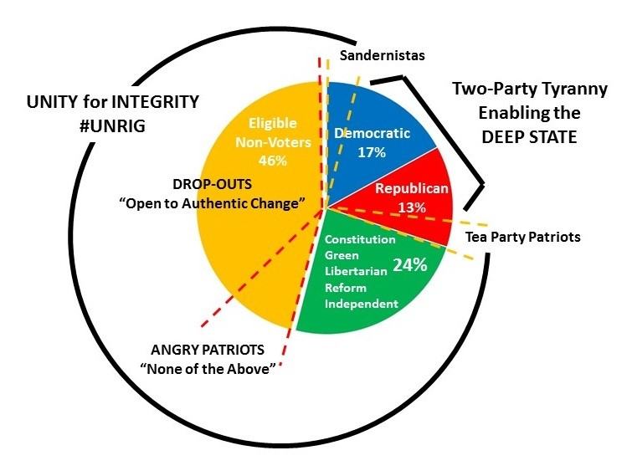
This is my foundation – this has been my foundation since I first supported our President with my article “Counter-Coup: How Trump Can Win” (CounterPunch, August 2015) – for arguing that our President cannot be the greatest President ever unless he first re-integrates many more eligible voters and ends the ability of one party to control “pay to play” legislation whether at the national, state, or local level.
Until every voter is both educated and engaged; and until every official is accountable to voters for every line of legislation and unable to “sell” any form of influence or artifact, we will continue to have a “rigged system” across the board and capitalism cannot be fixed.
We must first fix the fundamentals – voters and the people they elect and how those people are overseen by voters. If we do this we will at the same time set the stage for cutting the federal government in half, nationalizing the federal reserve, ending federal income taxes, restoring state sovereignty, legalizing marijuana, ending all forms of crime including pedophilia, and fixing capitalism.
Allow me to elaborate briefly.
Long ago, in 1976, I published a graduate thesis on the preconditions of revolution, updating it for the Marine Corps University in 1992 and again for myself in 2011, most recently re-publishing it in 2018 as a short white paper, Revolution Now! Thinking About Revolution in the USA (Trump Revolution Book 23), available at both Amazon Kindle and free online. The one-page graphic, recently updated to put every aspect of the USA in the red, is free online. That was the high level mechanical view of how five different domains – political-legal, socio-economic, ideo-cultural, techno-demographic, and natural-geographic – must ALL be nurtured in a holistic fashion if one is to be “civilized” – to be a good steward of the present and set the stage for advanced by others in the future.
It was not until 9/11, a modern atrocity “made in the USA,” that I began to reflect more deeply on the three facets of national health that are not discussed by Ray Dalio. Ray Dalio’s ideas are necessary and implementable in the near-term by President Donald Trump, but they are not sustainable without embedding three additional domains:
- Civic engagement – 100% informed participation, fully transparent legislation at all levels
- Holistic analytics – decision-support with integrity about everything – end the culture of secrecy
- True cost economics – community, ecological, human health, local to national true costs (water, energy, toxins, displacement) of every product, every service, every policy, every behavior
Below is a graphic I produced in 2002, updated in 2011 for an article in Greater Democracy, “Citizen in Search of a Leader,” when I realized it was impossible to achieve national security reform without first achieving intelligence reform, which in turn depended on governance reform, which in turn depended on electoral reform – hence my focus today on #UNRIG: Unity for Integrity (Election Reform Act Proposed).
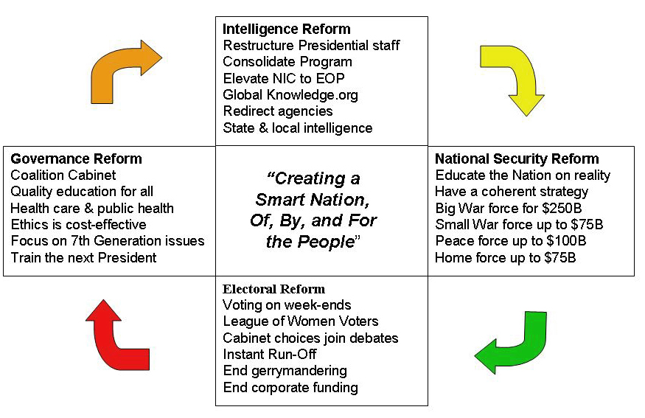

I bring this up now because I believe that President Donald Trump is going to make a fundamental mistake in the next year, and assume that because the Democrats have devolved into what Michael William Lebron (popularly known as Lionel of LionelMedia.com fame) calls, a “dissembled cuckoo’s nest of fractious freneticism, a frisson folly of foundering falderol,” he can coast.
Not only can President Donald Trump not coast, he must lead, and Ray Dalio provides half the plan. I provide the other half. The President is running at 33% on his promises, and the biggest failed promise, on 9/11 disclosure, is right up there with his gratuitous giving of the Golan (it is not his to give) to Israel.
Add to that the President’s insanely ignorant sponsorship of 5G, a genocidal and ecocidal technology that will fry your balls (or vagina) and explode your poodle (which is why Palm Beach has banned 5G) and you have an opening for a “None of the Above” candidacy.
Not Howard Schultz, but imagine some combination of Patrick Buchanan, Cynthia McKinney, Ron Paul, Dennis Kucinich, Jesse Ventura, Ralph Nader, Jill Stein, Lisa Kennedy Montgomery, General Tony Zinni, Admiral William McRaven, and you get the idea. A coalition cabinet with a balanced budget and a clear policy to restore communities, families, schools, and socio-economic ecologies of prosperity, and you have a potential upset of the Presidential applecart.
Add two full-time on-staff comics, one playing Bernie Sanders and (in drag), AOC, the other dedicated to representing our President in all of his potentially comic magnificence, and it’s game over.
With such a crew I could fill a different football stadium, every single night, between now and Election Day 2020. The videos, both of the individual presentations and in the aggregate, will very quickly amass 180 million views in the USA and call into question every detail of the President’s current program and future campaign. Never mind that the Democrats are in chaos – the President’s program is not all it could be.
I have no doubt such a program could attract $1 billion in funding (50 million x $20 each never mind a few billionaires that share Dalio’s and my concerns) and challenge the President in every single Congressional District.
My goal is to press the President to win big, not to defeat the President. This is no time to coast!
To use a golf analogy the President should recognize: he is playing with three clubs: a #3 wood, a nine-iron, and a putter. He has left all the other clubs behind.
Apart from truly superb macro-economic and financial initiatives whose benefits will soon be even more apparent to the general public, his Cabinet and his so-called intelligence community are among the most ignorant in the history of the USA – they are ignoring eight of the ten threats to the Republic (eleven if you count moral & spiritual decline); failing to do holistic analytics and true cost economics across the twelve core policies including Family and Society as tangible national “goods,” and oblivious to my latest focus, Open Source Everything Engineering (OSEE), which can give the President and the Republic the wall and the infrastructure and local factories everywhere, at 10-20% the cost of the criminally financialized Western model we use now.
I will briefly address each in turn.
#UNRIG – Unity for Integrity (Election Reform Act Proposed)
Neither the Democrats, with their HR 1 “For the People” act that sets the stage for non-citizens to vote (they have given up on extending the vote to sixteen year olds that cannot drink, drive, or fight), nor the President, with his failed commission on voting fraud that ignored everything else, have been serious about election reform. The two-party tyranny that fronts for the Deep State and enables the Shadow Government wants to keep 70% of the public disenfranchised.
I should not have to point this out, but I feel I must: the Republican Party is every bit as great a threat to democracy as is the Democratic Party. Neither wing of the two-party tyranny is friendly to the President.
Below is a living diagram of twelve specific reforms – note that the last one is economic democracy such as Richard Wolff has been advocating – that reflects the work of thousands of activists over two decades, all of whom have been “divided and conquered.” From the League of Women Voters (who allowed the presidential debates to be stolen from them (I would have cancelled sex in America before I allowed that to happen) to the National Association for the Advancement of Colored People (NAACP) to Voto Latino, every single so-called public advocacy group has allowed itself to be marginalized and ignored on this fundamental common right of all US citizens regardless of race, creed, color, or economic status.
To unrig the system – to unrig the government, the economy, our schools, our society, we need (subject to a national conversation about each of these in detail):
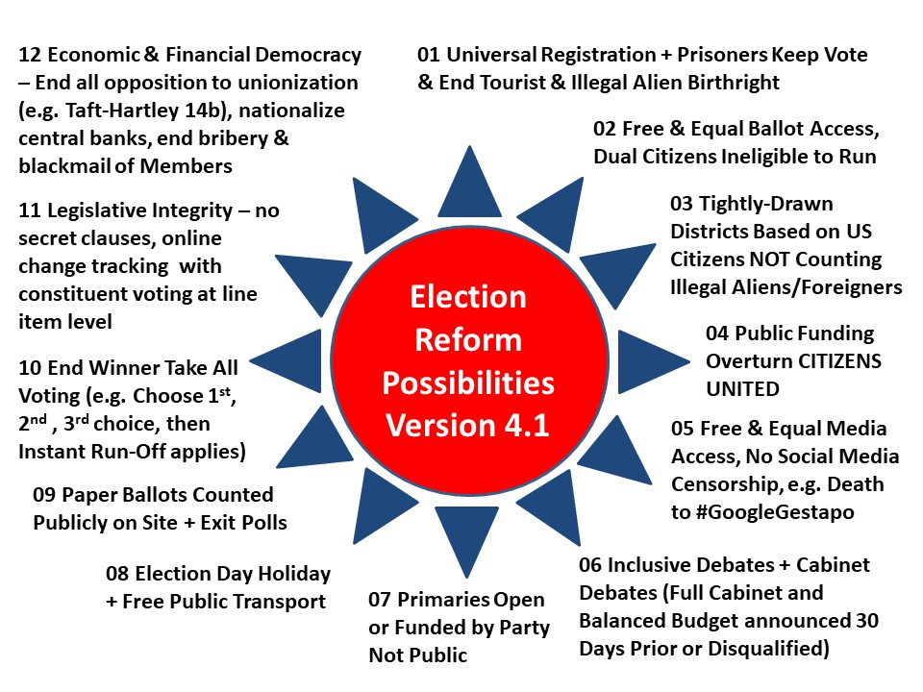
An obvious example of an item that could be modified is the first: prisoners could lose their vote while incarcerated, but once they have served their sentence, have their vote reinstated. This is a national conversation that only the President can lead, must lead.
If President Trump wants to expand his base to include members of small parties – notably the Constitution and Libertarian parties; and if President Trump wants an honest Congress to work with in his second term, which is to say a Congress that is one third NOT Republican or Democratic such that no one party can sustain a “pay to play” legislative process, THEN he has no alternative but to ask Senator Rand Paul (R-KY) to introduce this Act for passage prior to the summer recess and the 4th of July celebrations this year.
Properly led, there is no reason for all twelve reforms not to be implemented in time for November 2020, cutting off corporate and SuperPAC funding on 1 January 2020 and impacting on all Congressional races as well.
My personal goal, apart from seeing the President re-elected in landslide, is to see a Congress elected that cannot be bribed or blackmailed or lied to, and cannot be controlled by one party alone. A Congress committed to evidence-based decision-making in the public interest.
I must emphasize that election reform is needed at the local and state levels, not only the national level. When half of our states have passed laws that forbid state jobs or state contracts to anyone unwilling to sign a loyalty oath to the Zionist state of Israel, then our country is in enemy hands at every level.
The President must double-down on America First (i.e. NOT Israel First), and go after every Member of Congress that has sworn an oath to the American Israel Public Affairs Committee (AIPAC) – an unregistered agent of a foreign power – to place Israel’s interests ahead of America’s, as Speaker of the House Nancy Pelosi. de facto Vice President of the USA for Israel Chuck Schumer, and all but five by my estimate, of the Members, have done.
That having been said, here is the substance necessary to Make America Great Again (MAGA).
Holistic Analytics – Intelligence Reform
I have spent a lifetime as an intelligence professional, and been very successfully marginalized by the Deep State and Shadow Government because the US secret intelligence community is their agent and not at all interested in serving a catalyst for national prosperity and global peace. On the contrary, the US secret intelligence community is the greatest threat to democracy and prosperity at home and to peace abroad. Ron Paul is among the very few who understand this.
My many books, chapters, articles, monographs, official studies, and testimony are all free online. What I will do here is provide two graphics in one – a summary of the problem with our “decision-support” enterprise that spends all its time and money on mass surveillance at home and regime change abroad, with regular forays into drone assassination as well as torture & rendition and the smuggling of drugs, guns, gold, cash and small children. The Director of National Intelligence (DNI) is a castrated eunuch – I favor the tautological redundancy in his case – and the President must realize he is being “shlonged” every single day by the so-called “national intelligence enterprise,” despite the recent criminal referrals by the estimable Congressman Devin Nunes (R-CA-22). We have barely begun to grasp the enormity of the treason embedded in the US secret intelligence world today. Mr. President, we can fix this fast!
- Review: TAVISTOCK INSTITUTE – Social Engineering the Masses by Daniel Estulin
- Reviews on Assassination of JFK
- Worth a Look: Book Reviews on Intelligence (Most)
- Worth a Look: Books on Government Secrecy

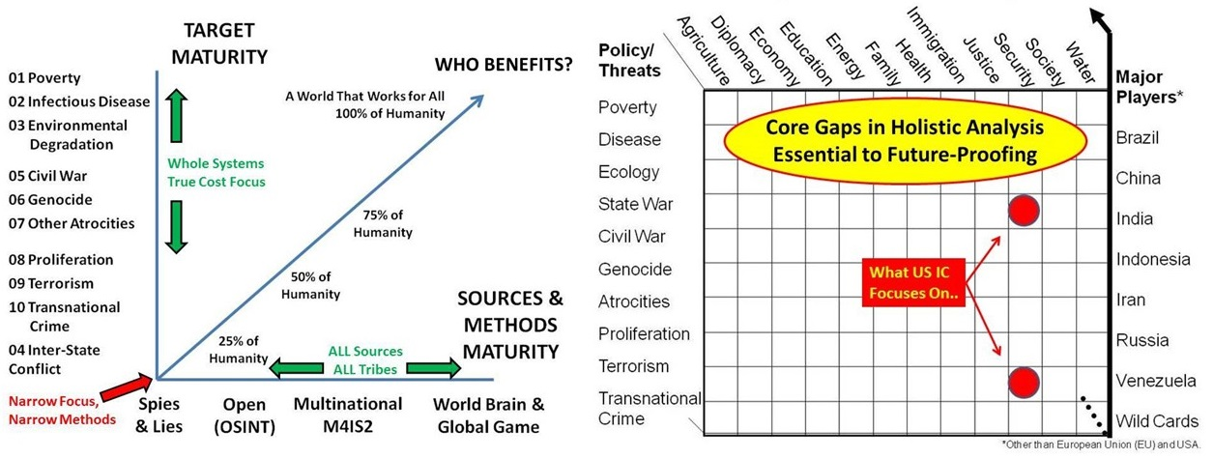
Put simply, intelligence (decision-support) can cut the cost of government in half and increase by a factor of ten what we can do with the resources we do choose to apply. I share with Ray Dalio an appreciation for using Return on Investment (RoI) as a metric, while adding to his vision my own contributions in the way of holistic analytics, true cost economics, and Open Source Everything Engineering (OSEE) – the Presidential Memorandum is on the table and being ignored despite the fact that the Office of Management and Budget (OMB) has twice approved the idea at a start of $125 million toward $2 billion a year at Full Operational Capability (FOC) for an Open Source Agency (OSA).
I am quite certain I can reduce the size and cost of the US secret intelligence community by up to 70%, delivering those savings back to the US Treasury for redirection as the President might see fit; and I am quite certain that with a properly functioning US not-so-secret intelligence community, I can help the President reduce the cost of the government by up to 50%, starting with the Departments of Agriculture, Defense, and Health & Human Services.
True Cost Economics
True Cost Economics (TCE) has in the past been confused with Ecological Economics (EE), the seminal contribution of one of my mentors, Dr. Herman Daly. In fact it is more than that. One of the few to understand the socio-cultural aspect has been Rosabeth Moss Kanter, whose book published in 2000 remains a standard – and add to that – from the same era two decades ago, E. O. Wilson and Harlan Cleveland and my best speaker ever, Alvin Toffler, and you have the makings of a “Smart Nation.”
- Review: World Class–Thriving Locally in the Global Economy
- Review: Consilience–The Unity of Knowledge
- Review: The Knowledge Executive–Leadership in an Information Society
- Review: Powershift–Knowledge, Wealth, and Violence at the Edge of the 21st Century
I will make two points before providing a summary graphic. First, government regulation from the top down, done by ignorant bureaucrats with no “skin in the game,” is the absolute worst thing you can impose on any community. A Nobel Prize in economics was awarded to Elinor Ostrom for showing that only the locals know enough to make sensible local regulations, and only the locals are present with a sufficiency of both knowledge and time on the spot to enforce the regulations consistently. Nassim Nicholas Taleb – one of my favorite modern authors and a Ron Paul favorite as well – arrives at similar but more nuanced conclusions.
- Review: Governing the Commons: The Evolution of Institutions for Collective Action
- Review: Skin in the Game – Hidden Asymmetries in Daily Life
- Review: ANTIFRAGILE – Things That Gain From Disorder
And second, the alternative to government regulation of minutia – regulation too easily skewed in a “pay to play” system where deficiencies and beneficial alternatives can both be ignored for a price – is true cost economics delivered to an engaged informed public. Below, with a tip of the hat to JZ Liszkiewicz for the research that took one year (arriving at reliable generic true cost information is not easy), is how I would do that. The concept for the hand-held app is my own, but it will take years to create the database. Most people do not understand that we process 1% of what we collect which is 1% of what is written or spoken which is in turn 1% of what is known. From Amazon to IBM to Google to Microsoft (Oracle is now officially dead), the cloud is like the drunk looking for keys under the streetlamp. In relation to what we can and should have available to every citizen as a hand-held education-intelligence-research “noosphere,” we are as retarded as if our stupidity were elaborately contrived by the Deep State – by design, for centuries. That may actually be the case!
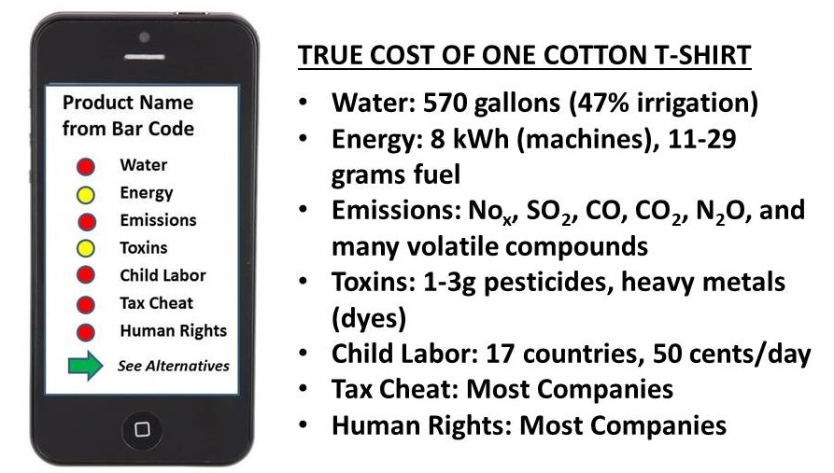
We can do better. Educating citizens one hand-held image at a time will, overnight, put a third of our corporations – the most predatory – out of business while spawning multiple new industries that will offer displaced workers more righteous work. All without government regulation or expensive litigation (which takes decades only to end up with a slap on the wrist).
Screwing the world – screwing humanity – is today “just business” and the fines imposed by governments – on those rare occasions when we get to that point – are a trivial “cost of doing business.”
An educated citizenry – educated workers who are also educated informed consumers – will revitalize capitalism overnight. All we need is leadership able to integrate intelligence, integrity, and imagination.
This is how one becomes the greatest President ever. By empowering the public with the ability to elect an honest transpartisan Congress that cannot be bought off after the fact, and itself empowered with a national intelligence community able to provide decision-support on every threat, every policy, every cost.
Election reform; holistic analytics; true cost economics – all do-able now, with the added bonus of Open Source Everything Engineering (OSEE) as the cherry on top, enabling infrastructure and community construction gains as a fraction of the cost of the current corrupt Western economic model.
This is also how we Make America Great Again, and ensure that the Trump Revolution lasts 1,000 years.
I have a simple motto: “The truth at any cost lowers all others costs.”
Please, Mr. President, give the truth a chance.
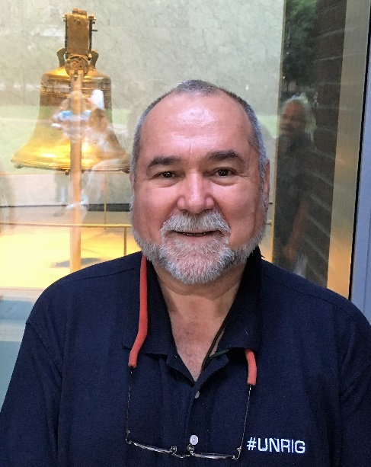
Robert David Steele, born in New York on 16 July 1952, is a resident of the Commonwealth of Virginia. The son of an oil engineer (Exxon) and grandson of an oil field foreman (Humble Pipe), he earned an AB from Muhlenberg College (Political Science, thesis on home/host country issues with multinational corporations); an MA from Lehigh University (International Relations, thesis on predicting revolution); and an MPA from the University of Oklahoma (Public Administration, thesis on strategic information mis-management inimical to national security and prosperity). He is also a distinguished graduate of the US Naval War College. He served the US Marine Corps as an infantry, intelligence, and S-1/Adjutant officer (personnel & security), on active duty for four years and reserve duty for sixteen years. In 1979 he was selected for the Central Intelligence Agency (CIA) clandestine service, and was a spy for nine years, five of them in three back-to-back overseas tours, one of them in a combat zone and the other as one of the first two CIA officers responsible for penetrating terrorist organizations. He left CIA by invitation to co-create the Marine Corps Intelligence Activity (MCIA) where he pioneered the first ever study to produce strategic acquisition generalization, Planning & Programming Factors for Expeditionary Operations in the Third World (MCCDC, 1990). As a result of this experience he realized that the US secret intelligence community produces “at best” 4% of what the President and other decision-makers need, and pioneered the still immature discipline of Open Source Intelligence (OSINT). Today he is the Chief Enabling Officer (CeO) of Earth Intelligence Network, a non-profit educational enterprise, and Open Source Everything, Inc., a new C Corp pioneering Open Source Everything Engineering (OSEE). He is an avid reader with over 2,500 published reviews across 97 categories of non-fiction, and enjoys off-shore sailing and racketball when circumstances permit. Learn more about him at https://robertdavidsteele.com.

