Did Satanist Macron Burn the Heart of Humanity to Save Himself and the Deep State?
Notre Dame False Flag Event
April 18, 2019
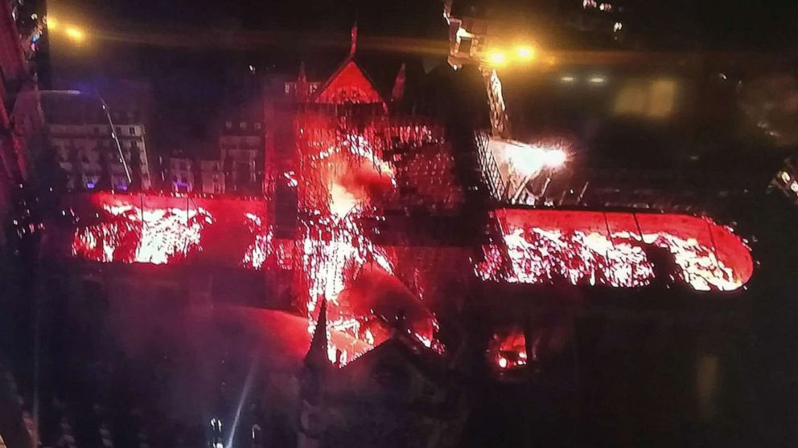
TEHRAN - Robert David Steele, a former Marine Corps infantry officer and CIA spy as well as an activist for Open Source Everything Engineering (OSEE), regularly answers questions for Tehran Times.
Interview by Javad Heirannia
Q. In your earlier interview on the “New Zealand False Flag Event,” (Tehran Times, 20 March 2019) you provided links from your CIA past with false flags and your publications about false flag events. Here today, we would ask, what is your high level understanding of the Notre Dame event?
A. I have published a lengthy post with graphics and links that is available to your readers at “Notre Dame Cathedral Burning False Flag, Complicity of Pope, Organized by Macron, Merkel, & May, Each a Satanist, Goal of Saving EU & Central Banks UPDATE 6,” Phi Beta Iota Public Intelligence Blog, 16 April 2019. My primary source is the shadow foreign minister of France, but I also include information from multiple other sources.
I asked that the above photograph be used, instead of my face, to make the point that the entire roof was burned simultaneously so as to show this “burning cross” into the Heavens. This was a Satanic ritual desecration of the “heart” of Christianity, a desecration equivalent to what the Zionists plan for Jerusalem by other means.
Let’s start with the fact that Notre Dame is owned by the state, not the church; the fact that the building has been virtually condemned (as were the Twin Towers in New York from 1988); and the fact that the state has been refusing pleas from the Church to fund the renovations necessary to keep the site safe for citizens and tourists, while protecting the priceless artifacts. We have learned that Notre Dame is not insured by any commercial organization – the state of France “self-insures.”
Now let’s add to that the desperate situation of the Deep State and particularly the European Union (EU), the Central Banks, and the individual governments of France (Macron), Germany (Merkel), and the United Kingdom (May) – all three of the latter individuals are alleged Satanists and pedophiles, and very much in the service of the Deep State.
The coincidence of Notre Dame burning on the same date as the sinking of the Titanic – long said to be a Jesuit initiative to wipe out the leaders of the wealthiest families opposed to the creation of Central Banks – and the coincidence of Michelle Obama passing by Notre Dame on a river dinner cruise as it burns, were instantly noted in France. It is known that the Rothschilds had a suite overlooking 9/11 and took their breakfast on the balcony during that event; it is reported that Barack Obama was hired by the Rothschilds to represent them during the ongoing Global Currency Reset (GCR), and that is why he stayed in Washington rather than return to Chicago. The Rothschilds own the Obamas.
We have a Jesuit in France, citing the Church staff at Notre Dame, stating plainly that the fire was intentionally set; we have the fact of a token restoration on-going with the vital side effect of removing all precious artifacts from the building prior to the fire; we have the fact of the police and fire departments making a pretense of saving France’s most epic cultural – not just religious – monument while letting it burn; we have the unverified but reported and believed story of two people found dead inside, each with two bullets in each of their heads; and we have these two additional facts:
01 As a result of this contrived atrocity, Macron has been able to avoid public discussion of the unfavorable outcome to him of the recent debate with the Yellow Vests and is in the process of repressing further Yellow Vests demonstrations that are among other things demanding the exit of France from the EU; and
02 We have a European election coming up in May that the EU expected to lose – the EU is over, individual states are ready to follow the British out, and the Deep State is now desperate. This planned atrocity may delay the demise of the EU by a year.
In conclusion, here is what my French source is predicting: that Germany particularly, along with the British (and perhaps against the will of their publics) will quickly offer to pay for the restoration of Notre Dame as a gesture of unity, and this “we are one with Notre Dame” campaign will be intended to save the positions of Macron, Merkel, and May, and to save the EU as well as the Central Banks.
The burning of Notre Dame is the Reichstag equivalent for France – a false flag intended to keep the criminal EU together for another year of looting and warmongering.
Q. Is it possible to investigate such matters? How do you anticipate such an investigation might go?
A. There are early signs that the “investigation,” which will be totally controlled, will “blame” the restoration firm for being careless. My French source has already established there was no electricity in the area where the fire is alleged to have started. Looking at the manner in which the roof burned so quickly, what I see is a 13th century wooden rooftop that was sprayed lightly with incendiary fluid or powder. I attribute the two dead to an attempt to stop the initial deliberate fire setting.
Indeed, as I was responding to your question, the Chief Architect of Notre Dame publicly stated this was not an accident; that there was no welding or other possible cause; and that 800-year-old wood is like petrified rock, impossible to burn unless an accelerant is added. Others have commented on the possibility of a Directed Energy Weapon (DEW) being used, in addition to pre-applied accelerants, to ensure the entire roof burned all at once in the shape of a cross visible from outer space. This was a Satanic false flag ritual burning of a holy site.
Any serious investigation would look at every minute of every day of Macron’s last ninety days, every phone call, every text, every email, and quickly show the network of collaboration including the Pope, himself accused of being a Satanist, Merkel, and May, and probably very senior Freemasons and Knights of Malta as well as Jesuits, all of whom have sworn oaths of loyalty to the Deep State and against individual Republics or sovereign states such as Iran or the USA.
This will not be properly investigated by the state. Like the assassination of John F. Kennedy, like 9/11, like Charlie Hedbo and other false flag events around the world, the state will try to cover this atrocity up and use it to serve the needs of the Satanists and the Deep State.
HOWEVER, I have just learned that there are some extremely wealthy people who are not part of the Deep State Rothschild network that controls Macron the alleged Satanist and pedophile — are so utterly angry about this that they have sworn to spare no expense, no effort to get to the bottom of this one. NATO GLADIO (the neo-Nazi stay-behind network that morphed into false flag leftist terrorism to promote authoritarian fascist governance and police powers) is now on the list of suspected collaborators. I have to say, unlike 9/11 where the people are sheep and the media and FBI (Robert Mueller) were totally complicit in the cover-up, this one is different. This may end up being the tie-breaker that puts the populists — and their new-found very wealthy very angry friends — over the top against the Deep State in Europe — this will impact heavily on every country in Europe starting with Belgium and Italy and Germany. It could bring down the British government as well.
Q. You say that you and Asian secret society sources believe the Pope is complicit. What is the context within which a Pope would want to collaborate in the destruction of the single most sacred Catholic monument in the world?
A. This event is connected to the recent release of Julian Assange from captivity. Although there are varying accounts of the degree to which Assange may have in the past been controlled by the Mossad and CIA, all signs point to his having been rescued by order of President Donald Trump, for the purpose of coming to the USA where he will testify to Congress, receive a Presidential pardon, and be put into a very comfortable witness protection program. Assange will, apart from exonerating Russia in relation to SpyGate, bury the British, the Germans, and the Vatican. I am uncertain of what he has on Macron.
As best I can tell from my support for the writing of the book, Pedophilia & Empire: Satan, Sodomy, and the Deep State, by Joaquim Hagopian, and my related efforts as Chief Counsel serving the Judicial Commission of Inquiry into Human Trafficking and Child Sex Abuse, and in light of the recent trial and incarceration of Vatican number two Cardinal Pell, it is increasingly obvious that the entire rank and file of the Vatican complex are variously complicit in high crimes and at a minimum in covering up for those committing atrocities against children. These high crimes include not just forced sexual abuse, but also the torture and murder of children in Satanic rituals not unique to the Catholic Church. Indeed, Mormons, Jews and Protestants also are reported to be abusing, torturing, and murdering children with impunity – and have done so for generations.
I believe that the wheels of history are finally bringing the Zionists as well as the Catholic Church down. The Mormons and others will be “collateral damage.” I heard testimony in London from former Netherlands banker Ronald Bernard, and I have formed two impressions: first, that the Catholic Church, the Rothschilds, and all the national secret intelligence services that are completely controlled by Freemasons and Knights of Malta and other more Satanic secret societies, are feeling very exposed with public awareness of their high crimes now spreading. They sense the end is near. More practically, here in the USA I am seeing a very sharp reduction in financial donations to the Catholic Church – they are in trouble financially and the day will come when victims begin going after the Papal Treasury and all of the priceless artifacts buried in the tunnels under the Vatican.
Q. You say in your post that you prayed at Notre Dame. How do you feel about the state of the world and the meaning of the burning of Notre Dame for all of us?
A. I believe the world is at war at three levels – secular, ecological, and spiritual. The Deep State is losing all three of those wars because the public is awakening. At the secular level the public is realizing that wars and scarcity and interest rates and everything else about the failed Western economic model is contrived to enrich the 1% and both control and impoverish the 99%. At the ecological level, despite the best efforts of the Zionists to control information in the mainstream media and across the social media platforms where the Anti-Defamation League (ADL) serves as the “secret police” or Gestapo against truth, 5G has become the rallying cry that climate change could not be. The public understands that 5G is a technology whose primary purpose is genocide and ecocide along with control – apart from its murderous effects against living tissue, 5G enables the rationing of cash, energy, food, and water at the individual level. 5G will be an election issue in the USA in 2020 and Donald Trump will lose if he does not reverse his position on this matter. Finally, at the spiritual level, I believe that the indigenous peoples are rising, the connection between the indigenous peoples and Mother Earth and the positive energy of the cosmos is growing stronger after centuries of dilution by Zionist attacks against the family, community, and safe practices (farming, sex, everything).
Q. What can Iran do, or Turkey, or Russia, or Malaysia, or Indonesia, or India? What is your vision for the future of the Middle East and the future of humanity?
A. We need Web 3.0, a distributed web that cannot be censored, that is rooted in open source technology that is freely available to the public. A Malaysian prime minister called for a Muslim press service years ago, because he correctly understood that the Western media is controlled and full of lies. We need an Open Source Agency (OSA) in each region that is responsible for historical truth, for holistic analytics, for true cost economics, and for ending the practice of selling our children’s future for the sake of corrupt capitalism profiting the 1% here and now at the expense of all humanity. We need to apply my vision of Open Source Everything Engineering (OSEE) – nine major domains and twenty-seven sub-domains – to lift the five billion poor – the 99% -- at 10 percent to 20 percent the cost of the failed and corrupt Western economic model. I would be glad to see the Persian (mostly Muslim) and Ottoman (mostly Muslim) and Byzantine (mostly Christian) Empires achieve a renaissance with my ideas. Peace and prosperity are possible on a foundation of truth combined with free energy and clean water for everyone, something I know how to achieve.
Your readers can learn more at https://robertdavidsteele.com and https://phibetaiota.net.

