No War on Iran If Rouhani “Makes the Call”
His Call Could Trigger the Firing of Bolton, Pompeo, and Perhaps Abrams
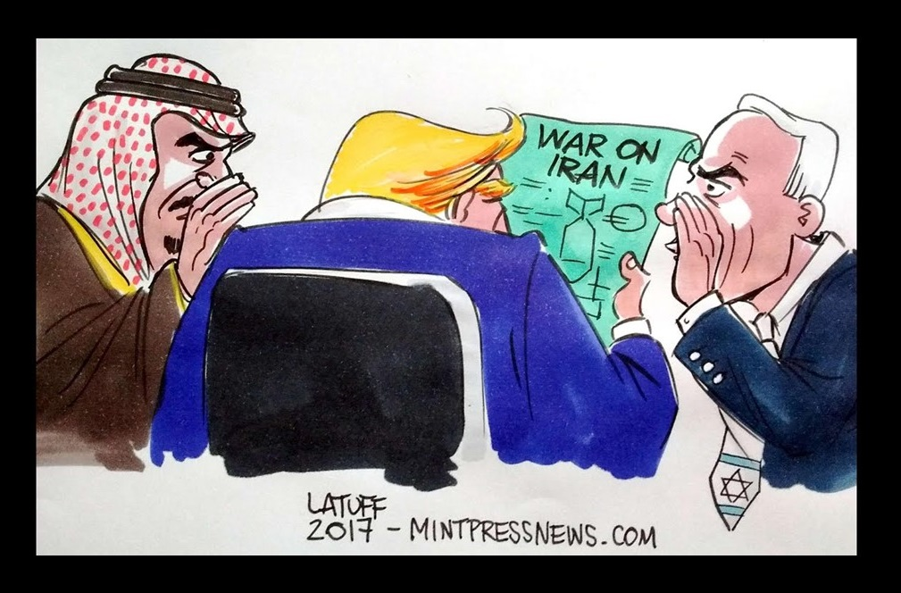
Robert Steele as interviewed by Javad Heirannia
Q. You were interviewed by Russian national television recently, contradicting everything the Russians believe from the fake news media, for example, that 120,000 troops are on their way to the Middle East, and you made a key point about how President Hassan Rouhani can influence this situation with one telephone call. Can you summarize for our readers what you said to the Russians?
A. While I was glad to see Russian national television take an interest in my thoughts, I was appalled that they actually believe the lies that appear in the US media. I also want to point out that I have been working toward peace with Director General Andrey Kortunov of the Russian International Affairs Council, who communicates with his counterparts in Tehran. When our respective presidents were together at the United Nations, we tried very hard to get Rouhani to reach out to Trump with a three-minute video suggesting a one-on-one conversation in New York, or a presidential summit in Istanbul that would include the Presidents of Turkey and Syria. More recently, and I believe the article has been forwarded to the Ministry of Foreign Affairs in Tehran from Moscow, I published “Helping Iran Make the Call” at the Russian International Affairs Council.
Apart from completely destroying the media story about the US getting ready to wage war on Iran – I would point your readers to an excellent article by Tom Rogan of the Washington Examiner, “Here's how you'll know we're about to go to war with Iran — right now, we're not,” I made the point to the Russian audience – and once the clip is posted to YouTube will continue to make the point to the international audience, that all President Rouhani has to do is “make the call.” He needs to use the number that Donald Trump has provided to the Swiss Embassy that is managing Iranian interests in Washington, DC, and “make the call.” Our President has made it quite clear that he now doubts the integrity of both Secretary of State Mike Pompeo and National Security Advisor John Bolton, and he does not wish to go to war against Iran, a case made in a New York Times article, “Trump Tells Pentagon Chief He Does Not Want War With Iran.”
I made one other point in the Russian television interview that I hope they have broadcast, which is that “the enemy of my enemy is my friend” in other words our President is totally aware that Zionist genocidal apartheid criminal Israel (not to be confused with the Jewish people all over the world) is our enemy. Our President knows that the Zionists have committed 34 acts of domestic subversion and direct war that have sabotaged our economy, government, and society, and that we must, as Greg Felton has put it in his most valuable book, The Host & The Parasite: How Israel’s Fifth Column Consumed America, rid ourselves of the Zionist parasite. Q, our President’s voice in the wilderness has said “Zionists last.” This is because the Zionists are so powerful in the USA, with bribery, blackmail, and lies so powerful, that we cannot get rid of them until after the President is re-elected.
I concluded my interview, they may not use this but it is a very important point: the only thing our President hates more than being ridiculed by the Democrats, is being ignored by specific world leaders that he wants to talk to. For various reasons Trump cannot call Rouhani. Rouhani has to call Trump.
Q. From an Iranian perspective, calling the President of the United States might appear to be a signal of weakness, of subservience to his will, an appeal for “mercy” in the face of both the deep-seated hatred of Israel and Saudi Arabia for Iran, and the considerable military power of the United States.
A. When I broke the story in the American Herald Tribune in March 2018 about the unification of the Koreas and our President’s role in guaranteeing the success of what started as a Chinese initiative under General Secretary Xi Jinping (the two articles are “Is Zionism Over? From Korea to Syria to the Latest #GoogleGestapo Purge, President Donald Trump’s Divorce from Zionism Appears Increasingly Possible” published on 4 March 2018 and “The Princess and the Spy: A Conversation about the Unification of the Koreas – Could General Secretary Xi Jinping and President Donald Trump Earn the Nobel Peace Prize in 2019?” published on 31 March 2018) I was ridiculed and called a lunatic. Now of course everyone knows that I had better sources, accurate sources, and this will come to pass.
The same is true of my understanding of the Middle East. Iran cannot and should not under-estimate or disregard the anger growing within the USA as well as in other countries such as the United Kingdom, where there is a huge backlash against both the Zionists over-playing their anti-Semitic lies and their gun control agenda, and the problems we are having with Muslim men that rape women with impunity, none of them from Iran – they are all from Arab and North African dictatorships that bribed European leaders in the late 1990’s when the Barcelona Agreements were drawn up.
Our President is a genius and he knows vastly more than most realize, to include everything there is to know about free energy and the pioneering work of Nicolas Tesla, whose papers were processed by Trump’s uncle. In our President’s second term, free energy is going to emerge and it will change the face of the planet.
Our President knows that Iran is vastly bigger and more capable than Iraq, where we could not win a war, and a hundred times stronger than the Taliban where we would not win a war either, never mind that we went in to both countries on the basis of 935 lies. I simply do not think that our President – or the Chief of Staff of the US Army (who is designated the next Chairman of the Joint Chiefs of Staff) – will fall prey to these lies, but our President needs a call from President Rouhani to “take over” the Iranian matter directly, and hopefully to also use that as a foundation for firing Pompeo and Bolton and ideally also Elliott Abrams, the Zionist war criminal of Central American notoriety that Pompeo was bribed to let back into office.
It is my personal opinion that our President, in conversation with his only two true peers on the planet, President Vladimir Putin and General Secretary Xi Jinping, has an appreciation for how Iran and Turkey and Egypt are not only re-emergent, but are essential to creating peace on earth.
It is my personal opinion that our President, as loyal as he might be to his most precious daughter Ivanka, understands that Jared Kushner is the “Clown Prince” and a criminal as well, like to follow his father Charlie Kushner into prison. The Kushner plan for the Middle East is crap. It should be buried.
With the utmost respect for Iran, with the greatest of devotion to my own President, and an absolute commitment to restoring the rule of law in the USA and around the world, I can only urge the President of Iran to “make the call.”
There is no downside.
Q. Are you familiar with the distinction between the roles and authorities of the Supreme Leader versus the President? Are there any challenges or opportunities here that must be addressed?
A. This is a brilliant question because this is how the American traitors will sabotage any call if Iran agrees to make the call. Everyone here who pays attention to the Middle East understands that the Supreme Leader of Iran is both the absolute religious authority and also the secular head of state, while the President is more like a “chief of staff” who administers the state on behalf of the Supreme Leader in collaboration with the Parliament, also subject to the Supreme Leader’s authority.
If I were advising the President I would urge him to begin any conversation with the President of Iran by acknowledging the authority of the Supreme Leader and expressing his appreciation for the permission that the Supreme Leader must certainly have provided before the President was allowed to make the call. Bolton – Zionist tool that he is – will try to play to the President’s ego and suggest that the President should either insist on talking directly with the Supreme Leader or not mention the Supreme Leader at all.
We in America have a great deal to atone for in relation to Iran. The role of the CIA in restoring the Shah of Iran, creating the secret police, and overturning the results of a democratic election in Iran (and so many other countries) is now well known. Our President understands this and he is at this moment thinking about a total transformation of the US intelligence and counterintelligence communities, to include the radical deconstruction of the CIA, NSA, and FBI, all of which spied on him during the campaign.
There could be no finer moment for a reconciliation call between our two presidents. I would also observe that because President Rouhani has been an economic trade negotiator, academic, diplomat, and nuclear negotiator he is – apart from his fluency in English – the perfect person for this first conversation that should be focused on getting to a face to face meeting with no witnesses.
The day will come when our President pays proper respect to the Supreme Leader. Right now, our priority must be to castrate the Zionists attempting to start a war with Iran on the basis of lies and ham-fisted false flag attacks, the last one probably done by the Arabs controlled by the Zionists. By all that is holy, I pray the Supreme Leader will agree with my line of reasoning, and give his blessing to President Hassan Rouhani so that he may “make the call.”
Q. I am skeptical about our officials being able to reach the actual American President. I believe that even if they call the number, they will be blocked by Bolton, lectured, and will never succeed in reaching the President of the United States. What do you say to that?
A. You are correct to be cautious. Bolton is a despicable man – he has been called, on the record by Larry Flynt, a pedophile, rapist, and swinger. Just today my colleague Dr. Steve Pieczenik released a video calling Bolton both a coward and an idiot while also calling Pompeo out for being largely worthless with no serious accomplishments to his name. Be assured, the President understands all this. There is a simple strategy for assuring that President Trump will “take the call:”
First, make a public announcement at the same time that the call is scheduled by the Swiss on behalf of the Iranians. Make it clear it is a presidential call and Iran’s president will only come to the telephone if his counterpart comes to the telephone. Ideally schedule the call for a week-end when the President is at Mar-A-Lago and more relaxed.
Second, record the call so that if Bolton or anyone else refuses to put the call through, the recording can be played for the public, or given exclusively to Lou Dobbs, whom our President respects and watches without fail.
Third, since the call will be intercepted by the Zionists as well as the National Security Agency (which will immediately share the recording with the British, French, and Germans whose leaders are all “dead men walking” as I put it in my Russian article), use the call to establish presidential rapport and start the process of arranging a face to face meeting with no witnesses. It is helpful that President Rouhani is fluent in English. I promise you, there are thoughts our President needs to share, now, that cannot be spoken or written such that others are privy to them – they must be face to face with no witnesses.
Q. Do you have any parting thoughts?
A. It is my view that the Palestinians have died in Gaza the way Christ died on the cross – for all of us. We are all Palestinian now. Peace in the Middle East – along with free energy and the eradication of the Zionist parasite in every country where it is a subversive element – and the nationalization of all Central Banks (our problem, not yours), are essential first steps toward creating a prosperous world at peace, a world that works for the 99%. My own eight-point plan for Middle East peace is to be found at “Peace in the Middle East: Denuclearizing Israel, Restoring Palestine, and More” as published at the Russian International Affairs Council (it should be obvious to all that I am censored in the USA, where the Zionists control all media).
New York Magazine has published “Trump Is Now Our Best Bet for Avoiding War.” While well-intentioned, that is not correct. Our best bet for avoiding war is for our two presidents to be in direct communications. The power to make that happen is now with the President of Iran.
Please, President Rouhani, “make the call.” Our President is sitting there waiting for your call, of this I am certain. May God Bless America, and Iran, and all people of faith who reject Satanism in all its forms.
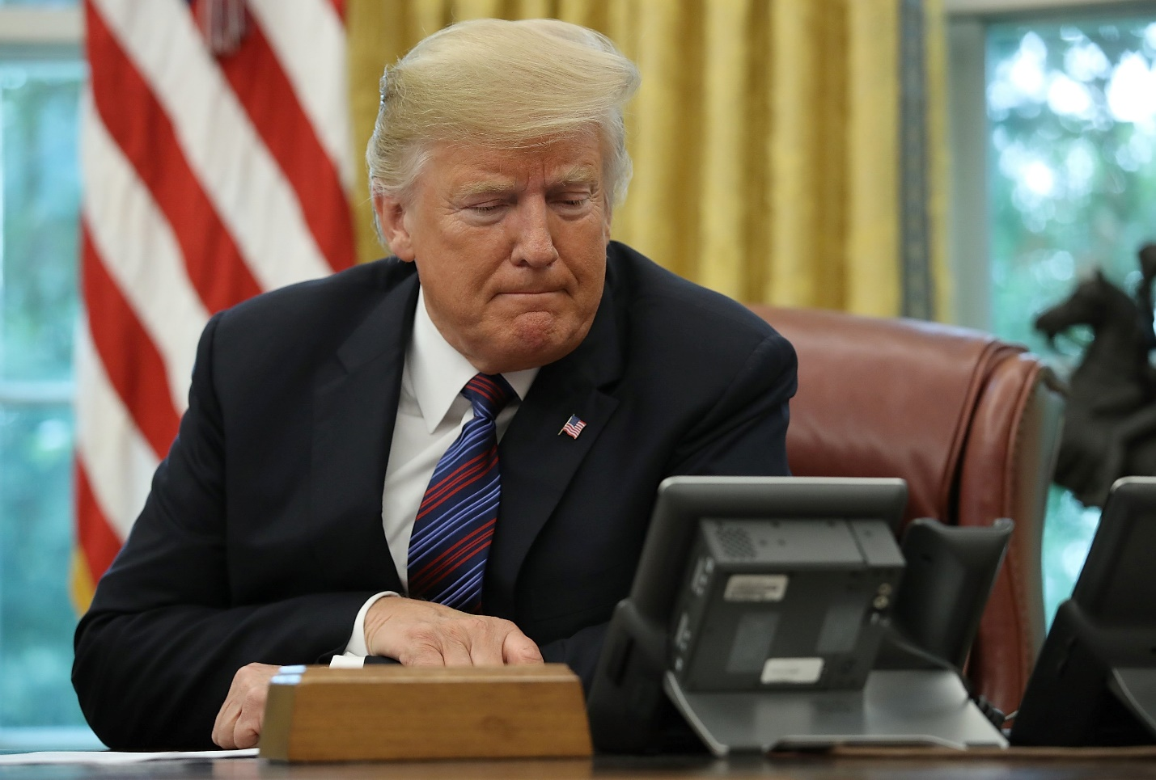
IMAGE CREDIT 1: https://www.mintpressnews.com/
IMAGE CREDIT 2: http://time.com

