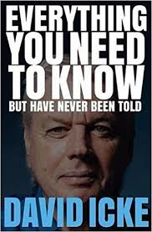
SUMMARY & REVIEW
David Icke, Everything You Need to Know But Have Never Been Told (David Icke Books, 2018). 741 pages.
6 Star: Measured Revelation on the War Between Humanity and the Satanic Deep State
Reviewed by Robert David Steele
This is a summary review of a 741 page book that is so very important, so comprehensive, that I feel compelled to go far past my normal 4-6 page review and offer the enlightened and skeptical readers a 40 page summary with quotes and links.
I am the author of this review, I have previously published it free online at my personal blog site Phi Beta Iota, and I have given myself permission to publish this review at Amazon for those that love Kindle as a channel.
My INTENT is to inspire purchase of the book even if only to browse multiple chapters. David Icke has produced a master work. The index alone is an education.
There are three kinds of holistic thinking: secular, ecological, and cosmic. With the exception of David Icke I know of no one, anywhere, who actually thinks holistically at all three levels (I fall short at the cosmic level).
While this book is a monster to read at 741 pages, it is most ably put together with eighteen chapters that I will summarize individually, each chapter liberally illustrated with graphics from his epic personal appearances that are now intellectual and spiritual “rock star” events. If the Pope worshiping Satan on Easter Sunday is the pinnacle of evil, then David Icke saying “We are One – BE the God Particle” is the cosmic “absolute good” and alternative to the evil represented by the Zionists, the Vatican, and the varied secret societies who thrive on chaos, on war, on human suffering and human trafficking, on fear & hate energy.
I think so very much of this man and his mind that I am adding to the end of this review links for each of his prior books and major DVDs. This one book is a capstone work and the one book to read if you read only one, but a case could be made for working one’s way through the entire collection, notably The Perception Deception, Children of the Matrix, and Truth Vibrations. At the end of this review I also list three books in addition to this one that “blew my mind open,” and multiple books on the nemesis, information pathologies.
Please do not make the mistake of treating this long summary as a substitute for reading the book. I write summary reviews for myself, as memory aids, and in this instance decided to write a summary review ten times longer than usual precisely because there is ten times more useful information in this book than in any conventional book. This book is a life-changing transformative capstone work.
I will offer a personal qualifier and a general bottom line up front. I am a professional intelligence officer and voracious reader with a gift for holistic analytics, I have never sought to be read into either theological or extraterrestrial matters but sense that on balance, the failure of the first and the reality of the second can no longer be ignored. As for this book’s bottom line: evil in any form – terrestrial or extra-terrestrial, appears to thrive on contrived anguish, chaos, fear, misery, suffering, and above all, war. We the People have been willfully stupid in abdicating our humanity and failing to apply our intelligence, integrity, and imagination every waking moment. Virtually every public official is a treasonous toad and we are long overdue for a “We Are All Palestinians, We Are All Yellow Vests” awakening across the West.
This book by David Icke inspires me to try harder at secular reform (#UNRIG), at ecological reform (open source agencies doing true cost economics and open source everything engineering to lift humanity up at a fraction of the cost of the failed corrupt Western economic, financial, and political model), and to recognize that I am weak on cosmic reform, lacking in the infinite love domain. I believe in Truth & Reconciliation – and have for some time – but am simply not ready to forgive those who have sought to destroy humanity – including genders, families, communities, and moral values – with impunity and malice aforethought. We are all emerging from a virtual gulag – a virtual prison camp well-represented today by our militarized police raiding homes to enforce single vaccination orders.
The USA specifically has lost its ethics, lost its mind, lost its way. It is our honor, our sacred duty, to do what we can to reverse centuries of manufactured depravity including the legalization of drugs and pedophilia.
Chapters as Summarized with Quotes & Comments
Executive Summary by Robert David Steele 3
Preface 4
Chapter 1: The Biggest Need to Know 4
Chapter 2: The Inversion 4
Chapter 3: Log In / Log Out 5
Chapter 4: One Big Problem 6
Chapter 5: Archon Visitations 8
Chapter 6: Software Elite 9
Chapter 7: Mind Control and Shapeshifting ‘Royals’ 11
Chapter 8: Casting the Spell 11
Chapter 9: Holding the Spell 16
Chapter 10: Advancing the Spell 19
Chapter 11: Terrified of Truth 21
Chapter 12: Before Your Very Eyes 23
Chapter 13: War, War, War – We Love It 25
Chapter 14: Saying the Unsayable 27
Chapter 15: Is It Hot or Is It Me? 30
Chapter 16: The Assimilation 31
Chapter 17: Synthetic Human 33
Chapter 18: Perceptions of Freedom 35
Postscript 37
References 38

Executive Summary by Robert David Steele
USA and Earth are emerging from centuries of alien (Reptilian) capture of the 1%, who are in essence “possessed,” and have structured every aspect for human civilization from education and government to banking, commerce, and media, such that everything we are being told is a lie. Good news up front: enough people have “woken up” to the point that Earth generally, and the USA particularly, have reached a tipping point toward good – toward a consciousness override that reinstates heaven on earth.
The threat to humanity is pervasive and multi-faceted. It includes the following specific on-going threats (in alphabetical order) that must be stopped immediately:
- Central Bank (private control of money) that lies, cheats, and steals from the public
- Contrived active shooters, false flag mass casualty events, and wars, all to instill fear & hate
- Electromagnetic pollution that kills brain cells and mutates other cells – 5G is ecocide & genocide
- Food and medicine designed to sterilize and reduce testosterone
- Government budget mis-allocating 70% of our disposable funds to a military that cannot win wars
- Government bureaucracy and regulation designed to impoverish and colonize counties and states
- Immigration and “multiculturalism,” a deliberate attack on the ethnic integrity of the Republic
- Information censorship and control under the Zionist schema for destroying the USA – “political correctness” is one aspect of the censorship regime, direct digital censorship, data manipulation, and digital assassination of conservative voices by Silicon Valley firms (#GoogleGestapo) the other
- Mind-control, once the purview of the CIA and NASA, now broadly available across private sector
- Moral decline in which “anything goes” including pedophilia, transgenderism, & Satanism
- Poisoning of air, food, land, and water – chemtrails and geoengineering are crimes against humanity
- “Progressives” as a class of “useful idiots” that have become so stupid as to be a danger to society
- Religions as both a form of perception control and identity management – religions that blindly support the Zionists committing crimes against humanity abroad while also subverting the US economy, US government, and US society, are especially threatening to the stability of the USA
- Secret societies such as the Freemasons and Knights of Malta who manipulate information and outcomes to achieve results that favor the 1% at the expense of the 99%
The solutions available to the public generally and the President specifically should he choose to prove me right and the author wrong about the President’s plans and intentions for America, include:
- Creation of national truth channel and Web 3.0 that cannot be censored or manipulated
- Disclosure of 9/11 and Zionist culpability for most aspects of that false flag event
- Disclosure of free energy and termination of secrecy associated with stellar civilization technology
- Distribution of decision-making and regulatory regimes back to the counties and states – localization
- Freedom to bear arms including concealed carry, and freedom of assembly without constraint
- Freedom of speech enforced across all domains and particularly within the social media
- Public focus on the heart chakra and broad public refusal to accept censorship & control
- Termination of all US wars and military actions overseas, close all bases, end all military subsidies
- Termination of blackmail of US politicians and others via special debriefings & Presidential pardons
- Termination of income tax, substitution of the transaction tax to empower individuals over banks
- Termination of militarization of the US police, prohibit Zionist training and support to US police

Preface
David Icke’s mind was open to messaging, and he found himself through Betty Shine, a psychic who shared words from others. Bottom line: we are all energy, we are all one, most of us are living in a manufactured un-reality that profits from slavery and suffering. Open mind, be free.

Chapter 1: The Biggest Need to Know
Albert Einstein and Nicolas Tesla had it right – everything is energy, what we manifest as reality is merely energy interpreted as being in a form (energy moving so slowly it seems to be static). We are one in the ideal, in a state of perfect health and happiness in the ideal, but everything about our un-reality in focused on making us unhealthy and unhappy. Infinite Love is the only truth, everything else is an illusion.
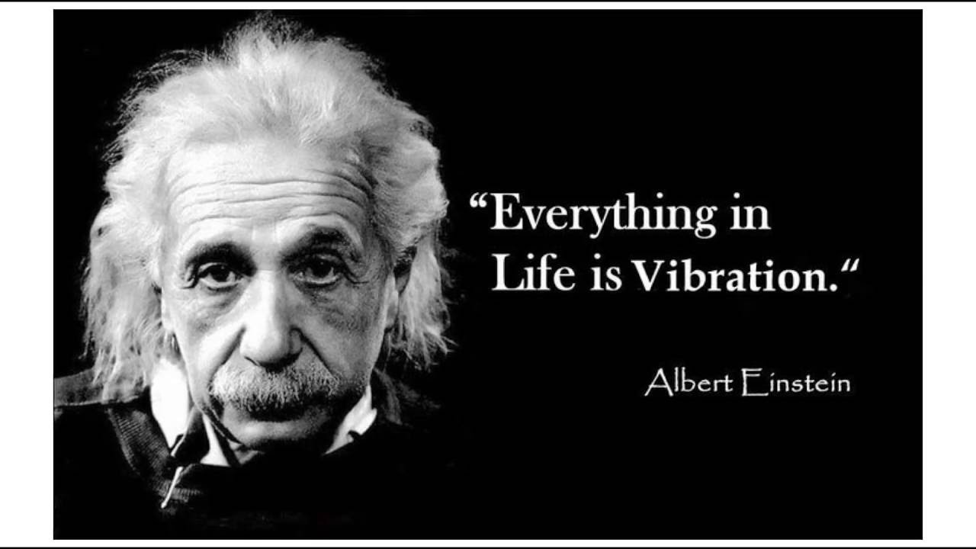
Quantum computing has no limits and is capable of programming – representing – infinite universes.
The Earth is alive in every possible sense – exchanging complex information across every living being – at the same time that malignant forces have sought to dumb down humanity and limit it to five senses consistent with the un-reality that has been created to cage humans and extract negative energy from them.
The control of humanity is rooted in effort to control all perception and imprison humans in a un-reality where un-real bankers, doctors, lawyers can operate with impunity, exploit humans, and keep humans from fulfilling their destiny as cosmic wells of empathy and imagination.
In a scalar field there is no space and no time in the un-real sense that has been articulated by corrupt and incomplete science. Healing is about information and frequencies, not about contrived and very expensive medications for conditions resulting from contriving poisoning of air, land, food, and water.
Prayer and the paranormal are connected – good energy, the right frequencies, can accomplish miracles.
QUOTE (55): The entire System, no least ‘education’, is specifically structured to maintain this delusional status quo in which sight, hearing, touch, taste and smell are the arbiters of everything. Those what see beyond the illusion are called mad, bad or dangerous…
Rationality rooted in conventional accepted understandings is isolated from the larger reality, out of context, and made possible by closed minds rather than open minds.

Chapter 2: The Inversion
Our reality is inverted as was anticipated in George Orwell’s Nineteen Eighty-Four. Lies are put forward as the truth, war is put forward as the peace, thieves in high places are put forward as trusted leaders.
The author does not use this quote, from Barbara Honegger whom I know:
“We’ll know our disinformation program is complete when everything the American public believes is false.”
—CIA Director William Casey at an early February 1981 meeting of newly elected President Reagan
I will confess to my deep naiveté while serving as a spy for the CIA, and my anguished awakening decades after leaving that organization. Most of the good people in that organization – and certainly not the public -- have no idea of the depth and breadth of the evil being done by rogue elements of the CIA (and other rogue elements of the US Government).
This is the chapter where the author introduces Reptilians and Grays and other forms of non-human life, and it is also the chapter where he tears down religions as forms of organized mind-control and praises the Gnostics for recognizing that the Cosmos is God, we are all God particles, and anyone seeking to put a religion and dogma and intermediaries between each human and the whole, is part of the Satanic plot to downgrade humanity from a very special source of energy with empathy, free will, and imagination, into “batteries” feeding the Satanic need for adrenochrome (blood infused with adrenaline caused by torture, ideally young blood from young children) and the negative psychic energy of mass fear.
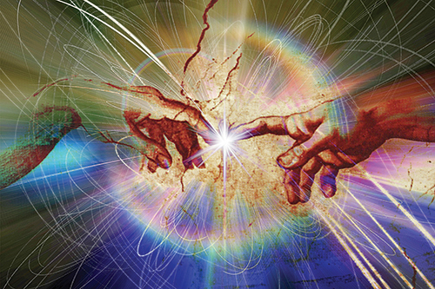
I learn that the possible reason the Royal Library of Alexandria was burned to the ground is that it was the repository for the Gnostic wisdom contradictory to and against the Roman Catholic Church particularly and other religious movements generally.
The possibility that our un-reality is an “error” resulting from fallen angels with imbalanced energy forms and impure thoughts is explored, as is the creation of a whole slew of Archons as “enforcers” and manipulators responsible for harvesting humans in the most negative manner possible. I am quite drawn in by the author’s focus on the difference between hate energy frequencies and love energy frequencies, and the desperate need of the Satanists for hate energy.
This chapter discusses the Gnostic view of the body as a prison – the objective is to move to higher consciousness and escape the prison – and the importance of the heart over the brain as the source of love and healing and imagination.
Ending on a most positive note that has been decades in the making, the author concludes that a great awakening is taking place, the veil is lifting, truth vibrations and collective consciousness are ascendant, and the Satanic control system is tumbling down.

Chapter 3: Log In / Log Out
The author is certain in his own mind that we live within an incredibly advanced version of a virtual reality game, in the sense that we “decode” information as energy with the consequence that we “experience” the reality that we are decoding – with the author stressing throughout the book that we have been retarded by design, pushed back from our inherent ability to do telepathy and so much more. “Matter” is explained by the author, backed up by Albert Einstein, as “energy in slow motion.”
Across the book, not only in this chapter, I am constantly impressed by the author’s integration of substantive work by others – this is a book of informed research, not a blithering blast of opinion.
Among the intriguing suggestions that the author puts forward here and then surfaces again in later chapters is the idea that on the one hand, what we have today in the way of information technology is retarded by design; and on the other hand, that there are bridges in existence today, perhaps in the Deep Underground Military Bases (DUMB), that are preparing to unleash a next generation of the flawed code, in which billions of humans are eradicated, transgenders and artificial insemination by direction are the order of the day, and obedience to authority – Satanic authority – is automatic.
This chapter discusses DNA (Deoxyribonucleic acid is a thread-like chain of nucleotides carrying the genetic instructions used in the growth, development, functioning and reproduction of all known living organisms and many viruses) and by coincidence today I also learn of a most intriguing video that outlines how all the ancestry DNA companies are actually correlating DNA with social media profiles, selling DNA health profiles, and more, to the point that these DNA samples could ultimately lead to decisions on which humans, with precision, should be “suicided” if not sterilized. Great fun.
QUOTE (104): There is no ‘nature’ – it is a simulation of ‘nature’ based on a multi-leveled ‘software’ program that controls humanity mentally, emotionally, and ‘physically’.
QUOTE (104): The scientific mainstream is specially structured to stop the truth coming out.
QUOTE (107): The Universe is an enormous electrical system of communication that in so many ways reflects that of a computer because this is what it is – a quantum computer far beyond anything that human science has begun to understand.
QUOTE (109): The body is an electrical communication system.
This is where the author begins to discuss in earnest two of what may be the central issues of the next decade:
01 Can we achieve a “consciousness override” against “bad” programming that seeks to dumb us down?
02 Can we stop 5G and geoengineering and other “bad” electromagnetic capabilities that treat humans as disposable beasts of burden (or fear & loathing batteries for evil ones) and sharply limit the emergence of human cosmic consciousness?

Chapter 4: One Big Problem
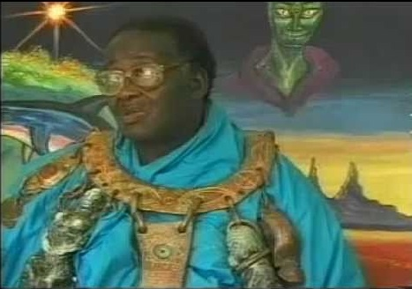
This is the chapter where I am completely out of my comfort zone but the author is compelling and careful in his articulation of the roles played by Saturn (including its energy and information “rings” that some believe are being created by machines in place right now, literally writing the “code” into the rings that in turn generate the “wi-fi” signals to Earth using the Moon as a transponder), and how the entire world went haywire around 4,000 BC, centered in the Middle East such that war became the default instead of heaven on earth and peace among all.
In this chapter the author draws ably on both personal conversations with Zulu wise men repeating stories passed down through the ages, and the documented investigations of others from archeologists to astronomers. As someone who is supposed to be expert at evaluating “sources and methods” I give the author a solid “A” for this entire book, each chapter, and his sources as itemized.
There is a lengthy discussion of Saturn as having been our sun prior to 4,000 BC, and then there was some kind of big bang and everything changed, including the position of Saturn and the emergence of the moon as an artificial craft that began geoengineering earth in negative ways.
The rings around Saturn could be – some credible observations are cited to this effect – be artificial and created by huge “electromagnetic vehicles” spewing out plasma. Others more technically grounded than I can evaluate all of this, for me it is quite simple: I find this author credible.
The Nazis, the breakdown of the human mind (once unified between left brain focused on details and right brain focused on context), the emergence of war rather than peace as the default condition of man, are discussed.
QUOTE (131): A left-brain disconnected from the picture-seeing right hemisphere is a perceptual prison cell.
I am reminded of so many books that bear on this without regard to Satanic or extraterrestrial influences, I will just point to the lists here: Consciousness & Social IQ (300); Cosmos & Destiny (39); Intelligence – Collective and Quantum (120); Nature, Diet, Memetics, & Design (259); Philosophy (166); Religion and the Politics of Religion (133); True Cost and Toxicity (158); Truth and Reconciliation (120); Values, Ethics, Sustainable Evolution (334); Voices Lost (Indigenous, Gender, Poor, Marginalized (242).
QUOTE (138): There is no matter. There is only light and sound. Albert Einstein.
This is a long chapter with a great deal of mathematics and symbology. This is where I begin to understand the author’s passionate contempt for Zionism, which he equates to Satanism. The author takes pains to connect Freemasonry and Kabballah Judaism (the Satanic cult not to be confused with normal Judaism) as well as the Owl of Saturn and the Bohemian Grove. While the author does not focus on Nazism and the manner in which the Nazi leadership cut a deal with the USA and emigrated to the USA (taking over CIA and NASA) as well as to Argentina and the Arctic, when we rewrite history honestly I am certain we will see the modern intersection between Zionism and Nazism.
Pages 157-159 make a case for shutting down the European Organization for Nuclear Research (CERN), and are coincident with other sources I have read that suggest that CERN is one experiment away from vaporizing Earth as we know it.
Pages 159-168, to the end of the chapter, discuss the Moon as an artificial and largely hollow object playing a very negative role against the Earth. The quotes are spectacular, and include official government statements as well as Zulu and other indigenous statements all of which add up to Earth was heaven before the Moon, then it became hell as the Moon began manipulating weather, moods, and more.

Chapter 5: Archon Visitations
This is a relatively short chapter that avoids extensive discussion of extra-terrestrials per se, but makes the point that Earth – and the forms we “see” manifested on Earth, is a “billionth of a pinhead” in relation to the larger Universe. The primary point in this chapter as I understand it is that about 6,000 years ago we had a cataclysmic invasion by negative energy forces that turned paradise into hell in order to create massive amounts of fear & loathing to feed themselves – both in terms of energy and in terms of actually feasting on humans processed in murderous rituals. The author provides ample quotes from astronauts and others who deliberately or inadvertently violated their non-disclosure agreements and have confirmed, publicly, the ubiquity of extra-terrestrial craft and beings, not only in outer space, but right here on earth.
QUOTE (176): Extraterrestrial races are at war with each other (Reptilians-Nordics are one example) and behind wars on Earth. Human elites and military insiders are working with extraterrestrials – especially Reptilian – and this is the source for most advanced technology (designed for enslavement as we shall see). There are human-ET underground bases on Mars.
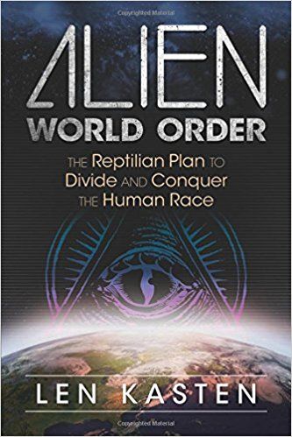
Earlier he writes to Reptilians having underground bases around the Earth, connected by very high speed tunnels. I have seen other books, and photographs, that suggest that the author is on solid ground in advancing these views, which he has documented more deeply in earlier books. From my own reading I offer Review: Our Universal Journey + Extraterrestial RECAP.
The author introduces in this chapter his view that “transhumanism” is the endgame of the Reptilians, and defines that in various places as the complete elimination of the sexual differences between men and women, the conversion of the population into a controlled artificially-inseminated “on demand” herd in much smaller numbers than we have now, all under total mind-control (this is where 5G comes in, one reason I believe 5G must be a major issue in the 2020 election in the USA).
I hesitate to summarize this chapter – it merits a full reading. It’s most important point to me is that Reptilians and the hybrid humans they control are vicious, emotionless, without empathy, pathological liars who absolutely believe we humans are their goods to be disposed of as they wish, including in murderous rituals preceded by torture.
QUOTE (193): The reptilian brain doesn’t want you to be different. It wants you to conform and acquiesce to hierarchy and authority. It hates being seen as weird and would never want to be a maverick who thinks and acts outside of the box.
Resistance is NOT futile – you CAN refuse to be assimilated.

Chapter 6: Software Elite
This chapter and the next are “on the edge” even with me, but I have to give the author credit for making sense in an insane world. I take everything he writes with great seriousness and I believe that his view is one that everyone needs to consider whether they ultimately agree or not. I am inclined to agree.
“Reptilian shapeshifters,” like “conspiracy theorist” and “fake news,” are “shut-down” terms intended to censor by diminishing and marginalizing those who contemplate the esoteric and paranormal.
QUOTE (195): Shapeshifting works on the same principle as demonic possession.
QUOTE (196): Archons [are] a robotic race of ‘artificial intelligence’ which can imitate by not innovate.
The author makes an excellent case for considering the possibility that most elites – including Royals and US presidents (or Vice Presidents with the actual power) – are psychopaths who have been possessed. They are a hybrid in some fashion. I for one believe in this possibility, excluding John F. Kennedy, Jimmy Carter, and Donald Trump. [The author is vitriolic on Trump, I have more faith in Trump and those behind Trump – by 2024 we will know which of us had better sources and instincts on this one point.]
QUOTE (200): As the colonialists officially departed they left behind their bloodlines and secret society and satanic network through which they manipulate events. . . . The British Empire never ended, it just went underground. The United States may fire most of the bullets [today] but where and when they are fired is decided by the bloodline inner circle in Europe.
The author discusses the overall structure of control, both secret societies and the overt elements with secret components, in this chapter. This is the chapter that establishes that Zionism (not to be confused with Judaism) is the ultimate enemy of all humanity.
The author equates Zionism with Rothschildism. I am not so sure. I believe that the descendants of Caesar and the Vatican have at least co-equal status if not superior status, and the jury is still out on whether the British Royals are above or below the Rothschilds. As an intelligence professional, I would rather put all three under the microscope and not focus exclusively on Zionism alone.
The author covers in summary fashion the use of secret bloodlines and “crypto-Jews” who publicly converted to Christianity (particularly to the Jesuit order) and to Islam (particularly to Wahhabism) so as to manipulate those religions as part of the larger plan for global domination and the subversion of humanity as a whole.
Satanism is the over-arching “faith” of the elite.
QUOTE (210): The philosophy of anything goes is at the centre of all that they do. This ‘anything’ includes paedophilia, sacrifice, and incest. Depravity to Frankists is a form of worship while compassion and empathy are sacrilege.
I am absolutely convinced that the Democratic approval of pedophilia – and particularly the manner in which California is now teaching pedophilia in schools as a “normal” sexual orientation – demands the eradication of this political leadership but would hasten to add that the Republicans in Name Only (RINO) are just as evil and also need to be eradicated. Herbert Marcuse called this “repressive tolerance.” The elite seek to destroy communities, cultures, ethics, families, nation-states, in order to eliminate the cohesion that comes from goodness at the local to national levels.
QUOTE (211): Our world is controlled and manipulated by those for whom the reversal and inversion of everything good is their very religion.
Sabbaean Frankism is the inner core of Revisionist Zionism and Zionism owns Wahhabism.
I am persuaded that the day must come when both Zionist Israel and Wahhabist Saudi Arabia are “put down,” and the holy cities of Jerusalem, Mecca, and Medina all liberated and made international zones of faith that are completely demilitarized.
The author summarizes earlier lengthier works on the intersection of Reptilian-hybrid bloodlines, elite Satanic rituals, and the torture of children to produce adrenochrome, and their murder with impunity. I also recommend Joaquim Hagopian’s book being offered free online in chapter form, Pedophilia & Empire: Satan, Sodomy, & The Deep State.
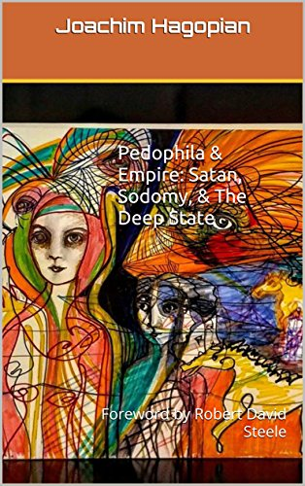
QUOTE (217): …the energy of children before puberty is the most prized by Archons and Archontic Reptilians.
The author goes on to explain that the traumatization and torture of children, not just sodomy but actual instrumental torture most cannot begin to imagine, is how they literally suck the life force out of children – this is separate from the trauma imposed on children intended to mature into sex slaves and controlled assets of the Empire.
From Jimmy Savile to Jeffrey Epstein to the British Royals and US presidents to the upper levels of the military in the US and the UK, the author is provocative in describing a range of human trafficking and child sex abuse and Satanic ritual murder so deep, so broad, that one must consider the mainstream media and the US and UK intelligence agencies to be actively criminally complicit in this local to global crime against humanity.
QUOTE (227): Satanism is fascism.
I helped shape this book by West Point graduate Joachim Hagopian, now up to Chapter 25, both free online and via Amazon Kindle at 99 cents each, access all of it via http://tinyurl.com/pedoempire. In brief, everything I have ever read supports this author’s views.

Chapter 7: Mind Control and Shapeshifting ‘Royals’
This chapter opens with a summary of CIA’s MKULTRA mind-control program and Project Monarch. It omits mention of the National Aeronautical and Space Agency (NASA) investments in this same area – the alert reader will recollect that the Operation Paperclip Nazis were evening distributed between CIA and NASA. For a complete indictment of NASA, see a book the author recommends that I have reviewed, Cathy O’Brien’s TRANCE: Formation of America. I learn something I did not know: that the US Army Chemical Corps Special Operations Division has been heavily engaged in mind control operations that I consider to be torture and a crime against humanity – and certainly treason in the context of the US Constitution.
The author draws a distinction between mind-controlled assets who can be used for sexual pleasure, assassination, or other dirty deeds, and mind-controlled celebrities and politicians (I would include judges and prosecutors).
Citing a specific witness, the author provides such terrible specific indictments of the British Royals that I wonder why he has not been suicided – perhaps because they don’t care or assume that no one will ever believe this. I have difficulty with this, but there is enough here to warrant containment and interrogation of all those named.
There is a lot here about Bill Clinton, Al Gore, the Rockefellers, and the Rothschilds, including secret family lines and planned incest and inter-breeding, I will leave it to the interested reader to buy the book and delve in to the details. Zionist Alan Greenspan emerges in this section as vastly more evil and vastly more powerful than any other US person including all presidents required to bow to him.
The subordination of world banking (and all secret intelligence agencies) to Satanic influences is described in this chapter, to include testimony from Ronald Bernard, whose live testimony I heard in London in April 2017 in my capacity as Chief Counsel for the Judicial Commission of Inquiry into Human Trafficking and Child Sex Abuse. As with all institutions, this generally refers to the 10% at the very top, not the 90% good people trapped in each of these institutional and unwitting of their ultimate evil.

Chapter 8: Casting the Spell
Having set the stage with the first seven chapters, here we enter the heart of the matter, the means by which the 99% are held spell-bound in a fake reality far removed from the boundless possibilities – from a prosperous world at peace, a world that works for all, as “crazy person” Buckminster Fuller once envisioned.
QUOTE (251): Perception is everything. Minds must stay closed to prevent the exposure of the world and reality as it really is.
QUOTE (252) Each generation is perceptually programmed by previous generations and by peer pressure from their own generation.
QUOTE (253) Programming is most effective when the population is in a state of fear or trauma.
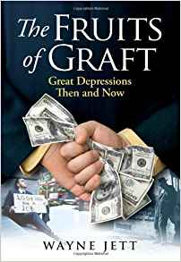
I agree with the author in his focus on the 1920’s as the time when modern programming and the total enslavement of the 99% by the 1% began. This is when the Rockefellers and Carnegies took over both public education and public transport in the USA, and when planning for the Great Depression – a contrived depression designed by the banks with the complicity of two US Presidents – began (see Wayne Jett’s Fruits of Graft).
The author focuses on the Rothschild Zionist Frankfurt School (later followed by the Tavistock Institute).
QUOTE (254): These were some of the Frankfurt School’s ambitions to transform human society (you might recognize them): Creation of racism offences; continual change to create confusion; teaching of sex to young children (it now happens as young as four); huge immigration to destroy national identity; promotion of excessive drinking; emptying of churches (undermining any form of social cohesion and community0; a legal system with bias against victims of crime; dependency on the state or state benefits (then removing them once dependence was achieved); control and dumbing down of the media; encouraging the breakdown of the family.
I find the author compelling in his articulation of how the state is intent on stealing our children – not just their minds but often their bodies, with state institutions devoted to tearing children away from their parents for sale into pedophilia markets, use in genetic experiments, or simply as fodder for the broken society. I find it especially troubling that the state – and I certainly see this across the USA – is intent on criminalizing the slightest expression of anger or disobedience by a child to the point of labeling them a problem, hence their parents a problem, hence state authority to “deal” with the problem.
The author makes reference to medical fascism, with reference to the secret vaccination courts and the ability of the state to compel the medical poisoning of children with vaccines known to contain the ingredients for both autism and sterilization.
QUOTE (258): Satanic and paedophile rings infiltrate every area of society – including the judiciary.
A section entitled “Schools: Programming prisons for kids” says it all. Many others have written to the fact that schools were redirected in the 1920’s from teaching the basics – reading, writing, arithmetic – to dumbing everyone down and instilling automated obedience to orders and a general lack of initiative. Leading to memorize and pass rote tests – and to show a willingness to embrace advanced programming – became the measure of “success.” I have reviewed many books in this arena, one that stands out is Gordon MacKenziel’s Orbiting the Giant Hairball–A Corporate Fool’s Guide to Surviving with Grace with two profound insights: our schools beat creativity out of our children, and our corporations suppress individual ideas and any attempts at diversity.
New to me, and useful in its concise and clear presentation, is the direct relationship between left-brain “fact” thinking and right-brain “context and creativity” thinking. The first is both what the 1% want from its 99% serfs, and what alien artificial intelligence “computes.” The second is uniquely human and not easily engaged by those who would diminish all that is so special about humanity.
QUOTE (265): McGilchrist says the left-brain is knowledge of the parts while the right-brain is wisdom about the whole.
As someone who has been making a big deal about the need for holistic analytics and true cost economics as well as Open Source Everything Engineering (OSEE) as an alternative to our corrupt toxified stovepipes of evil, this resonates with me. Monsanto does not want you knowing that everything you eat contains RoundUp, which causes cancer – two court cases finally validated that long-fought claim, thousands more cases remain and will be inevitably delayed. The law is used to delay and conceal the obvious. Similarly, false flag events from 9/11 to Notre Dame to the attacks on the churches in Sri Lanka that remind me of CIA bombings of churches and monasteries in Viet-Nam, are all “dots” (or lies) that are supposed to be taken at face value. We are not supposed to be connecting the dots and concluding that our governments are committing treason and lying to us every single day in service to the 1% and the central banking elites that treat all of us as disposable goods.
I am reminded by the author that “play” as well as art and music and sport, are all right-brain activities, and that no brain will mature without giving equal time and exercise to both sides of the brain in full measure. Here is the killer quote from Kyung Hee Kim, professor of education at the College of William and Mary, with inserted brackets from the author:
QUOTE (269): A massive decline of creativity [right brain] as children have become less emotionally expressive [right brain], less energetic, less talkative and verbally expressive, less humorous [right brain], less lively and passionate [right brain], less unconventional [right brain], less apt to connect seemingly irrelevant things [right brain], less synthesizing [right brain] and less likely to see things from a different angle [right brain].
Rules are madness – top-down madness.
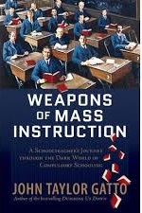
QUOTE (270-271): Education is all a giant hoax to pass off programming as learning.
He quotes Peter Gray, a Boston College psychology professor:
QUOTE (271): The available evidence suggests quite strongly that school is bad for children’s mental health. Of course, it’s bad for their physical health, too; nature did not design children to be cooped up all day at a micromanaged sedentary job.
John Taylor Gatto totally agrees, see his book, Weapons of Mass Instruction. My other books on education, including a book by Derek Bok on the commercialization of universities to the point that they are worthless to society at large, can be found here: Education (General) and Education (Universities).
The author discusses home schooling and self-directed learning as well as something being tried in India now, very narrowly focused schools that issue certificates leading to applied jobs rather quickly, instead of diplomas – society needs all forms of education.
I have two thoughts: the first is that any society that gives up the one income family and deprives children of a stay at home parent is destined to hollow out; and the second if that I have long thought we need to allocate our children’s time across three domains: group learning of the basics and group laboratory time; free play including “walk-abouts;” and apprenticeships in the trades (high school summers) and professions (college summers). Universal service (shared boot-camp followed by time in armed forces, peace corps, or first responders at home) is part of my vision for resurrecting the soul of America.
This chapter is particularly strong in outlining how “intelligent idiots” (the term has been popularized by Nicholas Nassim Taleb in his book Skin in the Game but is rooted in an earlier term “intelligent stupidity” coined by G. Bernanos and F. Schuon). Taleb documents the degree to which top-down bureaucracy and hierarchy separate well-paid imbecils from the consequences of their actions – in the absence of bottom-up accountability, this leads to “pay to play” legislative systems that are toxic to humanity.
He calls into question the intelligence, integrity, and imagination of every profession, among which I would single out politicians, judges, journalists and broadcast script readers, and senior government officials as particularly venal. They are all going through the motions. They are NOT making evidence-based decisions in the public interest, but rather decisions of profit and convenience for them as individuals.
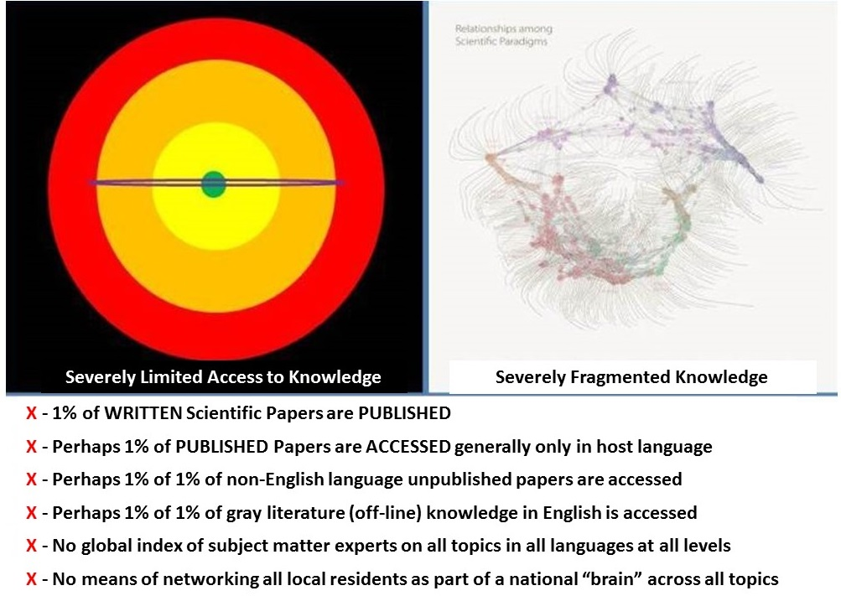
I have done more than most to connect the following points: we process less than 1% of what we collect; we collect less than 1% of what is published; what is published is less than 1% of what is written, particularly when providing for both foreign language publications, gray literature, and tacit unpublished knowledge not yet codified, and what is written is less than 1% of what is known.
1% of 1% of 1% of 1%. This is not an indication of intelligent life on Earth.
QUOTE (282): Central to the whole delusion is to persuade people that they ‘get it’ when they don’t even begin to ‘get it.”
The author begins to make his case here for rejecting the “social construction of reality” by the 1% and their Archon masters, and instead recognize the possibilities without limit of humans who see themselves as individual God particles who are “One” with the cosmos.
QUOTE (284): Fear is the currency of control.
QUOTE (285): The System is specifically designs to generate maximum fear, anxiety, and stress…”
QUOTE (286): A fundamental foundation of the entire hoax is inverting human perception to make insane appear sane and sane appear insane.
The author ties the control of fear, the control of perception, and the control of money creation together, and then goes on to describe how the religions are explicitly designed to both subdue human consciousness and to divide and conquer. In passing he notes the growing majority of Jews who reject Zionism and the Zionist criminal state as explicitly not part of Judaism the faith.
QUOTE (292): We fix the money hoax or nothing can change.
QUOTE (295): Any religion that has to employ violence and intimidation to maintain its control clearly does not believe in the power of its arguments to promote itself.
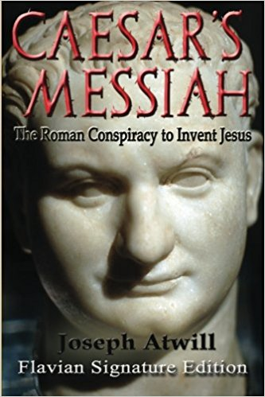
Pages 297-298 provide the single most concise indictment of Christianity – and the Catholic Church particularly – that I have ever read. The author gives credence to Joseph Atwill’s book, Caesar’s Messiah: The Roman Conspiracy to Invent Jesus. I cover many others books on the myths and mis-steps of religion in Worth a Look: Book Reviews on Religion & the Politics of Religion.
If money is about enslavement, then religion is about de-humanization to justify genocide and other atrocities – from the Crusades and the Inquisition to the genocide of indigenous peoples worldwide to what is being done still today to the Palestinians, religion is about genocide.
QUOTE (299): Once you have a belief in God-given superiority you can mentally dehumanize non-believers and justify any scale of horror against them.
The author ends on a positive note: each person has the power to reject falsity and take back the power of their own mind, their own beliefs, their own behavior. He concludes that vast numbers are waking up and the possibilities for humanity are swinging back toward the infinite.

Chapter 9: Holding the Spell
This is a critical transition chapter that explains how the programming of children in state-managed schools, combined with the programming of children and adults through Deep State manage media including movie, enables a control over information that is totalitarian in effect. As we have all seen recently with #GoogleGestapo (Amazon, Facebook, Google, MeetUp, Twitter, YouTube and others such as Reddit, Wikipedia, and WordPress), this control is both totalitarian and predatory – conservatives and progressives objecting to the official narrative are being deplatformed or digitally assassinated.
Since the Google – NSA relationship became so well known, a new axis of evil has emerged, between Amazon, the CIA, and the US military. Individual information is now in enemy hands in every sense of the word.
QUOTE (303): To create and maintain a perception deception requires by definition control of information.
Six corporations in league with secret intelligence agencies control all forms of media from mainstream to social. The author does not get into the minutia that I myself have experienced, where the Anti-Defamation League (ADL) is the common element in defining and enforcing censorship practices (I write to that here: “How The Deep State Controls Social Media and Digitally Assassinates Critics: #GoogleGestapo – Censorship & Crowd-Stalking Made Easy,” American Herald Tribune, 7 November 2017.
The author celebrates over several pages the integrity and public declarations of Udo Ulfotte, author of Journalists for Hire: How the CIA Buys the News, concluding:
QUOTE (306): This is what the mainstream media really is – psychological warfare on the public.
I find it fascinating that there are just three copies of the above book in English available at Amazon, all for $600 or more – evidently someone has gone to a great deal of trouble to buy up all the rest. Of course Amazon, with its $600 million CIA contract, is not at all eager to offer it in a low-cost reprint.
As a former CIA clandestine operations officer who refused an assignment to Covert Action Staff (CAS) where all this media manipulation nominally takes place, I personally believe that CIA is a wedge in the pie of control, but banks, foundations, the Zionists and the Vatican and others, are all part of a larger mosaic of control, CIA is not the monolith. All secret intelligence services, all secret societies including particularly the Knights of Malta and the Freemasons, are part of this larger Deep State web of control.
Especially important in this chapter is the author’s emphasis on how the public must be constantly exposed to trauma to keep them unsettled and susceptible. As someone who managed a false flag event for the CIA, and who has published compelling in this domain including two widely read collections, 9/11 Truth: From Campaign Promise to a Presidential Speech on 9/11 2018? (Earth Intelligence Network, 2018) and False Flag Attacks: A Tool of the Deep State (Trump Revolution Book 12). Amazon Kindle, June 8, 2017 I will say with absolute certainly that virtually every “active shooter” and every so called “mass casualty event” is a false flag – a state-sponsored false flag event.
This chapter provides substantive examples, one featuring Robert F. Kennedy, Jr. and his efforts to expose the danger to children particularly and humanity generally of vaccines and toxic medications, of how the pharmaceutical industry (to which one could add the banking industry, the military-industrial complex, and more) control the “news.” Tell the truth, get fired. All those employed in this industry understand that.
The author briefly discusses the alternative media, and is adamant that Donald Trump is a Manchurian candidate whose anti-system rhetoric is manufactured by the Zionists that control him. I am not so sure. Q has said “Zionists last,” I am among the top published critic of the Zionists (always careful to distinguish between the Zionist genocidal apartheid criminal state of Israel and the Judaic faith) and my reading is that Trump knows that he must expose the Zionists for 9/11 and expel the Zionist parasite from the USA. If he does not do this, I believe forces have been set in motion that will do so with or without him, and this includes over 75 million armed Americas, including 22 million veterans, who fully understand that it is the Zionists pushing for the termination of the 2nd Amendment and the confiscation of guns, because they want to completely subvert the US public and avoid any risk of an armed uprising.
The author maintains, and time will tell if he is correct, that Donald Trump is the ultimate “fake news” and a pretender who is merely extending the Deep State and Zionist control of the USA for another two terms. I will meet the author half-way by including here my favorite cartoon that I used in a published “Memorandum for the President of the United States of America, Subject: Election 2020, Jarvanka, MoveOn Boycott of AIPAC, and Your Legacy,” American Herald Tribune, 22 March 2019.
I believe that the Zionists must be, as Q has stated, the last to be taken down. That comes in the second term. If our President fails to do this, then God Bless Him, he has made it possible for others to do so.
Several pages discuss various forms of fake news, including pseudo-alternative media websites that are in the business of earning revenue by creating completely false stories to earn revenue via click bait.
I am much taken with the author’s clear denunciation of individual Zionists by name, including Larry Page and Sergei Brin (Google), Susan Wojcicki (YouTube), and Mark Zuckerberg (Facebook). He does not mention Jack Dorsey (Twitter) but Jeff Bezos gets some very serious attention across the book and would agree – based on what I know about Amazon – that it is the new Central Bank for the digital world and totally inimical to the public interest – Amazon is new digital police state.
Pages 325-330 discuss monetization (and shadow banning or de-monetization) and the censorship cabal. The author makes it quite clear that all of the elements of what I call #GoogleGestapo are in an active conspiracy with the Deep State and the Shadow Government to censor all forms of truth that dispute the official narrative. He does not mention MeetUp or PayPal but he should – they are totally integrated parts of the Anti-Defamation League’s Zionist conspiracy to promote lies and suppress the truth – MeetUp closed down #UNRIG, a $77,000 paid professional network of 435 MeetsUps, at the same time that it waived fees for 1,087 #RESIST MeetUps. The difference: #UNRIG stands for America First, not Israel First, and the ADL is the co-sponsor of all 1,087 #RESIST MeetUps – the waiver of fees is in my view an illegal undeclared campaign contribution of at least $225,000 to the Democratic Party, similar to the millions that Google donated in kind to Hillary Clinton with manipulated search results. There should be a Racketeer Influenced and Corrupt Organizations Act (RICO) investigation of all of these people along with the ADL, why there is not is a question only the President of the United States can answer.
A thread that runs throughout the book and is very visible here is how “political correctness” is used to allow atrocities on the left (Muslim men of color raping white women with impunity, leftist sympathizers being allowed to write in Facebook that murdering white women might be even better, so no more “entitled” white boys will be born) while censorship is used to shut down any competition of ideas from the right, no matter how civil or how ably documented.
QUOTE (333): ...’progressive’ academia and swathes of the ‘progressive student population have been lured into states of what I can only perceive as forms of mental illness.
QUOTE (335): Around a hundred websites dominate Internet traffic. Zionist-controlled Google has 1.2 trillion searches a year; Google-owned YouTube has more than a billion active users per month; and Zionist-controlled Facebook, which also owns Instagram, WhatsApp and so much more, claims two billion active users. I am guiding people to some YouTube videos in t is book because its domination means that is the only place you can see them. We seriously need another mass video platform that believes in freedom not censorship.
Displacing #GoogleGestapo has been my focus ever since the Zionists attacked #UNRIG and myself six ways in ninety days, and I am confident this can be done, particularly if President Trump fires Twitter and starts issuing his own Trumpets on a 200 million person pilot that Kim.com and a few other people I know decide to create – if Alibaba and Yandex agree to pay, it’s game over. The Zionists – and their social media pimps – have overplayed their hand. Just for grins, here’s the planned billboard (I still plan to do this) that got their attention.
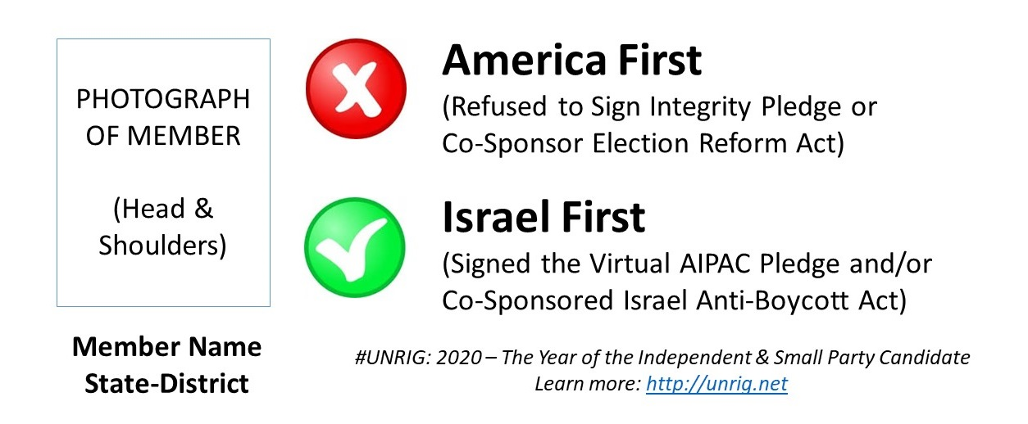
QUOTE (338): Jonathan Taplin reveals the scale of domination in his book, Move Fast and Break Things: How Facebook, Google, and Amazon Cornered Culture and Undermined Democracy. . . . Taplin writes: “Not since Rockefeller and J. P. Morgan has there been such a concentration of wealth and power . . . and the enormous unprecedented fortunes created by the digital revolution have done much to increase inequality in America.”

Chapter 10: Advancing the Spell
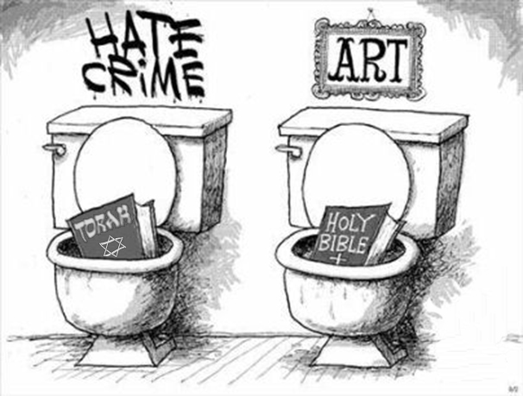
“Political correctness” as a massively planned and perfectly executed local to global Psychological Operation (PSYOP) in the heart of this chapter.
QUOTE (339): Political correctness is an El-lite tool for getting the target population to silence and censor itself so they don’t have to.
Keeping the pubic in a state of fear is part of keeping them “in line” with “approved” dogma.
QUOTE (340): The term progressive describes a mental and emotional state of such self-centric self-delusion that it skewers and invests reality in the extreme. Progressives think they are (a) anti-Establishment and (b) liberal; but they are neither. Progressives are the new Establishment and crucial to the social engineering networks which instigated political correctness to manipulate the population to censor itself.
What the author does not address in this chapter is that the liberals are also the key means by which the Deep State advances what Herbert Marcuse called “repressive tolerance” which is code for “anything goes” which is code for turn everybody into a transgender pervert that loves pedophilia and bestiality. That leads to the destruction of the family, community, and nation-state, in that order.
There is overlap between this chapter and a book I recommend and review under references, TAVISTOCK INSTITUTE – Social Engineering the Masses by Daniel Estulin — Deep State Playbook, I again stress that the reader of this review should be buying the book being reviewed, it is a tour of the horizon like no other.
The author clearly and concisely reviews the Zionist Rothschild sponsored Frankfurt School and its vision for criminalizing all manner of normal behaviors and beliefs, while devising the NewSpeak that destroys freedom of speech and freedom of thought. The author touches on what may be the “third rail” of US politics other than anti-Zionism, and that is the very deliberate assault on white people, and white males particularly – and white males armed under the Second Amendment most especially – as the enemy to be vanquished.
The author excels at summarizing victimhood as a strategy for dividing and conquering, for turning normal people into quivering masses of stupidity begging for the militarization of the police, welfare, and state control. I personally am disgusted by the degree to which we have debased the family and the two-gender society – California seems to be particularly perverted and it is no coincidence that Hollywood and the Hollywood pedophiles including Harvey Weinstein are there – but the author does this topic justice and I suspect there is no similar account to be found anywhere else.
QUOTE (346): They [the Deep State and the Zionists] want to breed weak people easily offended and not strong people who couldn’t care less what anyone says about them.
Political correctness is censorship. Political correctness is the tyranny of the progressives who are in fact merely stupid tools for the 1%. This is particularly visible on university campuses where speakers with views that contradict the official narratives are banned. Universities are no longer centers of competing ideas, they are more like advanced soft prisons where good behavior leads to a degree that is largely worthless.
QUOTE (349): The whole point of political correctness is to delete free and open inquiry.
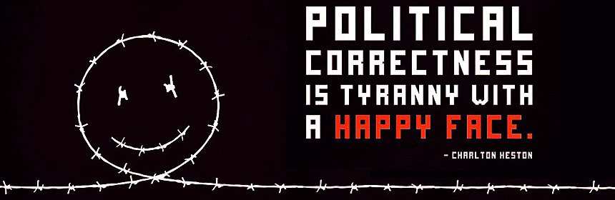
I particularly like how the author shows clearly that victimhood is embraced by weak minds and shallow souls as a form of me-ism, of gaining attention for a collage of mediocrity that would otherwise be beneath contempt, at the same time that they that those that “support” them are “virtue-signaling,” itself a selfish act.
Particularly powerful, and citing Jacques Barzun, the author emphasizes that political correctness is about organizing hate, not facilitating tolerance.
All white men should read this chapter carefully, it is a manifesto for truth and liberation. The author documents the insanity of the extremists on the left who go so far as to suggest that white people should lose the right to vote.
It gets worse. This chapter includes a long section on linguistic policing, I would call it linguistic perversion. People are getting fired in California for not calling transgender freaks by their preferred pronoun whatever that might be, at the same time that old men are being allowed to self-identify as seven year old girls and play naked with girls of that age. I don’t make this stuff up. See the author’s own documentation of this on page 365.
QUOTE (361): Ridiculousness rules and word bans for 99.4 percent of the population justified by the need not to upset 0.6 percent?
The author uses the term “infantilization” to cover the regression of intelligence and the loss of integrity and imagination at the university level and within state governments staring with (my focus) California.
The author also makes the point that issues like transgenderism are being grown by the government. Kids in his generation and mine did not have this issue. This is an imposed artificial perversion that is being spread as part of a deliberate campaign to fragment society and destroy the family.
Great discussion of triggering, which is code for university administrators with no balls allowing piss—ant students with no brains to freak out over shit they do not understand, at great expense to everyone.
Generation Ritalin (drugging the young to create supplicant adults), demonizing the old and mobilizing the young too stupid to know they are being manipulated, and fat stupid aging leftists who see nothing at all insane about vilifying normal middle-aged white men going about their business.
This chapter ends on a positive note. I really do want to stress that as thorough as this book is in relation to threats, it is also a consistently positive book.
QUOTE (380): Let us not forget, however, that there are still significant numbers of young people who have not fallen for The Program in all its forms and can see what the snowflakes cannot. They must stand together with the rest of us and not be bowed into silence by PC extremists.
I totally agree.

Chapter 11: Terrified of Truth
QUOTE (383): Political correctness is not about ending discrimination but about manipulating the target population to silence the target population to protect the perception deception and its Postage Stamp mentality. Peter Tatchell is right that bigotry should be dealt with by debate and information not censorship.
I would observe that the deliberate avoidance of holistic analytics and true cost economics by academia, commerce, government, and the media is a form of censorship. They do not want us to know what it actually costs in terms of family, community, national, social, and ecological loss that is inherent in predatory capitalism.
This article includes compelling information about both the anti-Semitism industry (a fake news industry) and the anti-holocaust denial industry (also a fake news industry) to which I would add the observation that they are both criminal network because they raise funds on the basis of lies while defaming good people like David Icke and persistently doing “tortuous interference” which is a federally-actionable crime, against people trying to offer truthful information to the public.
QUOTE (388): Zionist censorship doesn’t deal in facts, only slogans and abuse, because it knows where open debate and discourse will lead.
I will mention here that I knew Ernst Zundel and his wife, both passed now, and found his victory over the Zionists in Canadian court cases compelling – Auschwitz, to take one example, for forced by facts to reduce from 6 million to 1.5 million the number of dead (still overstated, the Red Cross total is under 300,000), and it is now compelling known that a) most Jews (and Germans) died from starvation, typhus, and allied bombing and b) the Zionists refused to take the Jews offered an exit – all of them – for the bargain price of $3 million – the Zionist leaders WANTED hundreds of thousands of Jews to die so that they could CREATE the holocaust myth. It merits comment that the Zionist Wikipedia page on Ernst Zundel is full of lies and does not properly credit him with his extraordinary accomplishments at documenting the truth and demonstrating that the narrative about gas ovens is a total fabrication.
Today of course the Zionists censor everything about their genocidal activities against the Palestinians, but I am pleased to say there is at least one book being translated into many languages that exposes the Zionist state for what it is, Professor Gary Fields’ book ENCLOSURE: Palestinian Landscapes in a Historical Mirror
Useful information is presented about how Zionists censor universities around the world to avoid having students understand both Zionist lies about the holocaust, and Zionist lies about the atrocities they commit today against the Palestinians.
The author makes, as I do, a sharp distinction between Zionists and Jews.
QUOTE (394): We are not talking about Jewish people as a whole, but a cabal who have as much contempt for Jewish people in general as they do for everyone else.
This chapter includes coverage of the Zionist-driven censorship being carried out by Amazon, Facebook, Google, and YouTube, as well as the role of the ADL as the global secret police in charge of censorship in each country on behalf of the Zionists.
Of grave concern – the author touches on this but it is not a major theme – is the Zionization of the US police who are trained and brainwashed in Israel (other sources document the Zionist perception of the public, as being taught to US police, as “cockroaches”) and the pervasive bribery and blackmail of US Members of Congress as well as the subversion of Senior Executive Service (SES) officers in the Executive.
Zionist censorship is not only about Israel – it seeks to create an overarching capability that allows it to remove any statement in any medium that it judges to be “inaccurate” or even “irrelevant” to public discourse and debate – this is nothing less than the “full Soviet” program that Facebook represents so well today.
QUOTE (405): The Archonic Reptilian control system is a multidimensional, multileveled, multi-faceted and absolutely incessant perceptual onslaught on the human mind to create fragmentation of thought and emotion and to implant a sense of powerless isolation. People are isolated from other ways of looking at the world and this creates the desired perceptual stagnation.
QUOTE (408): The Internet was supposed to be an extension of freedom but through algorithms and control by global Web corporations this can now be seen as a temporary illusion as censorship becomes the norm. The Net was sold as a means of free communication when the idea was to create a vehicle for total surveillance that so dominated public discourse as other sources disappeared that they could control everything that people say, see and hear by direct algorithmic censorship.
This chapter includes an excellent discussion of Problem-Reaction-Solution (PRS) as the protocol by which the Deep State seeks to subvert the entire world, the Global War on Terror (GWOT) being a classic example of how false flag operations and fake news instill fear that then justify unconstitutional mass surveillance, the militarization of the police, and total control over the populace, to include confiscation of guns because “only” the police can protect the public, the public cannot be trusted with guns.
The Zionists and the Deep State that uses the Zionists (and the Freemasons and Knights of Malta and other secret societies) FEAR an armed informed engaged public that they have succeeded in creating an uninformed disengaged public, now they need to disarm the last bastion of freedom, those who still have guns and a semblance of intelligence and integrity and imagination.

Chapter 12: Before Your Very Eyes
This chapter begins a major new section in the book where the author begins to provide context with the early observation that context changes everything. Events and facts known or experienced in isolation from one another tell a completely different narrative when grasped as a whole.
The author himself states that his life’s work – over 30 years of free thinking – has been about himself grasping context, and then sharing it with others.
QUOTE (416): There are planned to be only three basic levels of ‘human’ society -- the one percent, those serving them in the police / military control structure, and everyone else enslaved in poverty and dependency.
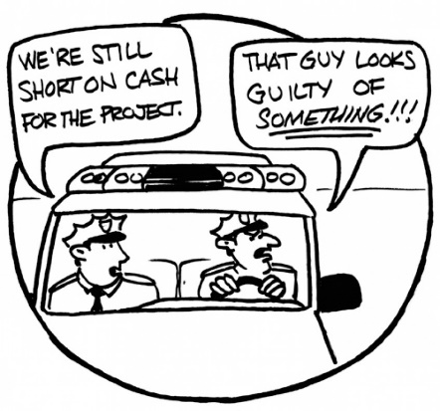
This chapter includes a discussion of how banks are stealing money from their depositors, and how the police are stealing more from the public than actual criminals.
QUOTE (418): The state stealing of people’s money and assets is becoming quite a theme given that in 2014 law (lawless) enforcement seized more property from Americans than burglars did -- $5 billion worth against $3.5 billion. They are doing this through ‘civil asset forfeiture’ laws that allow property to be taken without any charges or proof of any crime.
This chapter also discusses world government and the role that a “cashless” economy plays in enabling total surveillance. While I do not think this will come about and I do not think barter can be banned – this is among other things so entrenched in Africa it is called “System D,” the author makes some important points such that I for one am compelled to list three things essential to our future:
01 Freedom of information in all respects to include the protection of historical information
02 Freedom to bear arms without restrictions so that we can if necessary subdue the police
03 Freedom of assembly and transactions in anonymity, i.e. both barter and crypto
The author is concerned about superstates and the North Atlantic Treaty Organization (NATO) turning into a world army (to which I would add and a world terrorist organization sponsoring false flag events to justify “occupation”). I personally think the tide has turned, and populism and free information are on the rise.
There are two psychological aspects in this chapter that merit notice:
01 The change in the psychological profile for new police recruits, seeking to attract psychopaths who will follow orders and treat the public as cockroaches to be controlled – the Zionists are very much behind this aspect
02 The desired psychological profile for the public, a dumbed-down drugged-up public that will follow orders and self-censor, totally in fear that the combination of political correctness and mass surveillance will lead to their being impoverished or sent to prison – China is having a good try at this one now.
QUOTE (433): World leaders are just puppets that can do anything from in-the-know (the few) to those doing whatever it takes to secure and retain political power for its own sake (the many) to complete idiots being controlled by their ‘advisors’ (depressingly many). Real power knowingly connected to the Archonic Reptilian Spider does not put itself on public display where it can be identified and targeted.
The author comes to the same conclusion about political parties that I and Cynthia McKinney came to when we were on the road today: parties are a way of negating the individual. Cynthia and I agreed on
“People not parties” and on each candidate being committed to being authentic, inclusive, and truthful.
That will not happen without a truth channel that cannot be censored (including fund-raising that cannot be stopped, I view with grave concern the deplatforming of conservative and independent candidates – literally killing their constituency outreach AND their fund-raising – a form of digital assassination, and done with total impunity – President Trump is doing nothing at all about this.
QUOTE (436): A political system offering an alleged ‘choice’ for a population of 326 million has installed the following last six presidents: Ronald Reagan, who was suffering from dementia while still in office, abused mind-controlled women and whose military actions and covert support for others make him a war criminal; Father George Bush, the drug-running, child-abusing serial killer, CIA Deep State operative and war criminal; Bill Clinton, Bush family friend and drug-running partner, serial abuser of women and war criminal; Boy George Bush, a manchild with arrested development verging on the illiterate, and war criminal; Barack Obama, front man fraud, Mr. Change-Nothing and war criminal; Donald Trump, insider playing outsider, reality TV star and war criminal before he completed 100 days in office.
On pages 436-443 the author destroys the Trump Administration with a particular focus on very specific Zionists appointed to key positions, and the very specific Israel First (not America First) policies that they have put into place. While I am still holding out for our President showing a new side in his second term, the author pulls no punches in describing what most of the world sees: Trump as a Zionist tool.
Then he moves on to Europe where I completely agree with his severely critical comments.
QUOTE (443): The Spider and its Web have hijacked the term ‘progressive’ and used it as cover for fascism and mass murder and to sell its extremist placemen and women in political office as ‘the middle ground,’ ‘centrist’ and ‘moderate.’
QUOTE (446): Simple blackmail is a constantly-used method of controlling politicians to make sure they follow your agenda to the letter even if they may not agree with it. Paedophilia is massively used to do this with politicians and other influential people provided with children while hidden cameras are running.

Chapter 13: War, War, War – We Love It
QUOTE (448): The United States spends enough on ‘defence’ to provide every homeless American with a one-million dollar home.
While war is a profit center and the 1% make a great deal of money from war and its contrived chaos, war is about much more than just money.
QUOTE (451): War allows Archontic Reptilian bloodlines to remove problem governments and leaders, rewrite the map, acquire more land and resources and dramatically speed the centralization of global power. The process of replacing tribes with nations and nations with superstates has largely been achieved through war.
I draw the reader’s attention to the three recommended books at the end of this review on the urgency of restoring distributed power, distributed decision-making. Globalization and centralization are death.
For those that do not read widely the book over all (and this chapter in particular) is a marvelous primer on “connecting the dots” between banks, political power, depravity and blackmail, war, and the constant attacks on humanity with vaccines, toxins, broadcast media and more. A section on false flag operations that references 9/11 specifically appears here.
George Soros receives his fair share of attention as a propagandist and war criminal.
Multiple pages with coherent detail make the point that there are four state-sponsors of terrorism in the world that work as one: the UK and USA, Zionist Israel, and Saudi Arabia. I would add Qatar to the list.
The book is very current (as of 2019) and this chapter includes solid coverage of the fake wars against Libya and Syria, the role of the four state sponsors of terrorism in setting up White Helmet false flag attacks and the fake terrorist group ISIS.
QUOTE (487): The United State and the West protect their own lies from public exposure by controlling any investigation into claims.
I would add with grave concern that as long as President Donald Trump fails to hold #GoogleGestapo accountable for its Zionist-controlled censorship, data manipulation and digital assassination (deplatforming) of conservatives and independents, we must all be worried about the possibility that President Trump really is controlled by the Zionists, as opposed to biding his time which is what I hope for.
We know for a fact that the 9/11 Commission was a Zionist-controlled farce, and even such men of honor as Lee Hamilton were intimidated into remaining silent when it mattered most, during the Commission’s actual theatrical performance.
I have to disagree with the author on the matter of Donald Trump. While the author has a visceral hatred for the Present, and takes pains to defame, diminish, and disrespect the President, there are enough errors in the author’s account to put this specific aspect of the book into question.
QUOTE (491): Trump has a notoriously short attention span and interest in detail and this makes him so easy to manipulate.
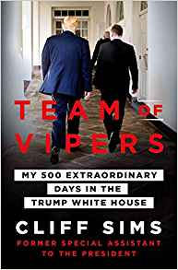
I find this specific comment to be unfounded and offer the following quote from Jack Welch, and link to my published review of books about Donald Trump and the White, in opposition.
“They can say what they want about him, but I don’t know if any president has been more prepared to sit in that room and talk business. It was like talking to a peer, not a politician. Hell of a meeting.”
Jack Welch on Donald Trump, in Chris Sims, Team of Vipers, page 132, as posted at Review: Team of Vipers – My 500 Extraordinary Days in the Trump White House by Cliff Sims and also published within Robert Steele with Javad Heirannia, “Understanding Donald Trump and the White House: A few books,” Tehran Times, 13 February 2019. PBI BackUp
David is a towering intellect and this labor of mine – a full two weeks of my life in the reading of his 748-page book and crafting of what will be a 30+ page summary to open his thoughts to those that will not have the fortitude to get to a book of this magnitude – is a work of respect. On Trump, I believe David is wrong and ask him to give the man a chance – four more years.
The chapter concludes with some insights on Freemasonry and World War III that are priceless and alone worth the price of the book. Make no mistake, my summary is written to drive people to read the entire book, in no way is my summary (4% at best of the total content) a substitute for the book itself.

Chapter 14: Saying the Unsayable
QUOTE (503): War today cannot not be divided from terrorism. It never could in truth because all war is terrorism, but I mean in the modern definition of killing civilians in public places and making nowhere safe in the minds of the population.
QUOTE (503): Terrorism is now an excuse for war and invasion. Terrorism perpetrated by West-create psychopaths under names such as ISIS an al-Qaeda has been increasingly employed to terrify the public; generate ongoing fear and anxiety (food, low-vibrational states) and justify the deletion of our basic freedoms and privacy to ‘protect the country from terrorism.’
QUOTE (503) These attacks are carried out by a combination of mindless idiots with no idea who their real masters are; those under alter-compartment mind-control; and covertly by psychopathic military intelligence networks which then blame ISIS and other groups and individuals.
This entire chapter but especially pages 503-511 is a marvelous “Red Pill” exercise on false flags, never mind that he calls me David instead of Robert when he quotes me. His review of false flags and how they are organized and then investigated by the very organizations that sponsored the false flags in the first place, is in my view authentic and authoritative and should be believed in contrast to the official narratives, all put forward by lying sacks of shit that are either morons or so deeply corrupted as to be worthy of immediate execution.
I will take this opportunity to revise my original quote. I did say that “In the United States every single terrorist incident we have had has been a false flag, or has been an informant pushed on by the FBI.” I will revise that now to add the word “virtually:”
“In the United States virtually every single terrorist incident we have had has been a false flag.”
I include mind-controlled active shooters, generally multiple shooters with one patsy being killed.
One book not in the author’s bibliography (sadly he does not provide endnotes but I believe they are available from his research team if official testimony where invited) is by Trevor Aaronson as I review it below.
Review (Guest): The Terror Factory – Inside the FBI’s Manufactured War on Terrorism
What I have done, as a CIA clandestine operations officer who actually managed a false flag event for the CIA (no one died in mine – false flag means nothing more than “not as it appears”), is published books, chapters, articles, and posts on false flags, and I hope they have served and will continue to serve the public. Two publications delivered to the White House, Congress, and the Attorney General include:
Memoranda for the President: 9/11 Truth – http://tinyurl.com/911-POTUS
Memoranda for the President: Sandy Hook Truth – http://tinyurl.com/SH-POTUS
I will emphasize my view that the Department of Homeland Security (DHS) is owned by and used by the Zionists as a means of militarizing our police, monitoring our communications, and advancing a gun-confiscation agenda that must be opposed. I favor the complete abolition of DHS and the radical containment of the Federal Emergency Management Agency (FEMA) that morphed from disaster relief to concentration camps and train cars with shackles for 5,000 (under Reagan) to today’s FEMA that is primarily in the business of managing false flag operations from Sandy Hook and the Boston Bombing, Orlando and beyond.
I will note that after I send my Sandy Hook volume to the White House FEMA appears to have suspended its blatant operations, and the Zionists have been forced to stage their own false flag events at synagogues and schools (e.g. Parkland) in Zionist controlled territories with a blind eye from the FBI.
In my view, 9/11 disclosure is central to eradicating the Zionist parasite from the USA, and full disclosure of all false flag and mind-controlled active shooters is central to neutralizing the Deep State and Zionist campaign to militarize the police, institutionalize mass surveillance while confiscating all weapons, and ultimately neutralizing the US Constitution and the Bill of Rights.
Below is my most important graphic on false flag analysis, all my work on false flags can be found free online at https://robertdavidsteele.com and https://phibetaiota.net.
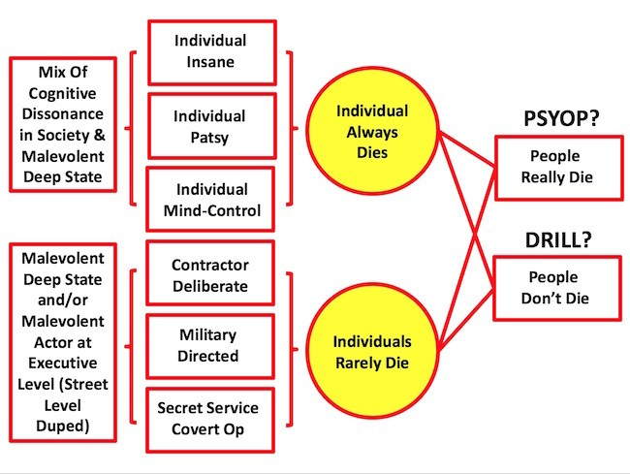
As I stated very clearly when speaking to thousands at the Rolling Thunder celebrations before the Lincoln Memorial, the National Rifle Association (NRA) is a fraud. You cannot defend the Second Amendment without taking on the fake news false flag narrative.
This chapter (Chapter 14: Saying the Unsayable) also addressed the manufactured exodus of angry unemployed Muslim men who rape women across Europe with impunity.
The author excels at highlighting in a most compelling manner the real reasons why the 1% arranged for the bribery of the leaders of the United Kingdom, France, and Germany particularly [generally the big event was the Barcelona Agreements in the 1990’s]:
01 to eradicate national ethnic and cultural identity with “multi-culturalism
02 to deepen and broaden “us versus them” divide & conquer identity politics and economics
03 as a profit center – there is money to be made, both legally and illegally, in dealing with migrants
04 as a source of children for pedophilia and for Satanic ritual torture, blood drinking, and sacrifice
The author is correct in my view when he equates Wahhabism with Zionism, and Zionism to Jesuit Catholicism, and the three pillars of ideological evil in the world, with the 1% (Caesar’s descendants, the Rothschilds, the British Royal Family) above them, and the Central Banks and secret intelligence agencies and secret societies particularly the Freemasons and Knights of Malta, as the street power.
QUOTE (518-519): Sharia law is Wahhabism which is Saudi Arabia which is Israel with is Revisionist Zionism which is Sabbatean Frankism which is Satanism.
The author states – and I have made this point myself in interviews in Denmark and Norway – which the Nordic official embrace (entirely contrary to the will and interest of the public) of unlimited immigration has been a disaster. This is correct. He goes on…
QUOTE (519): Political correctness is there to censor exposure of what is really happening long enough for the end goal to be achieved with minimum challenge.
Sweden, where Malmo, the Muslim rape of non-Muslim women capital of the world is to be found, is in most desperate straits. 5,000 criminals, 200 networks, 61 “no go” zones, and 80% of the police force thinking about quitting because they are not allowed to do their job and not given the power they need to do their job – because, I would add, their politicians are not only being bribed, but probably also being blackmailed with videos of each politician doing bad things to small children, a Zionist specialty (Jeffrey Epstein is merely the tip of the iceberg, there are tens of thousands like him doing the same thing all over the world, all in service to Zionism and the Deep State).
QUOTE (527): Once ethnic minorities decide elections any claims to equal treatment across the entire community are over.
The chapter concludes with excellent section on the manipulation of human emotion by the emotionless Archonic El-lite, the vital role that George Soros has played in bringing down Europe with open borders intended to spread crime and perversion and hate, a side bar on Bill Gates as equally evil with his support of eugenics through contaminated vaccines that also sterilize, and more.
For those that do not have the time, money, or energy to buy and read the entire book I would say this: buy the book and read chapters 13 and 14 and also Chapter 18 and the Postcript. This summary review is a window into the book, not a substitute for the book (or for hearing the author in person). 30 years acquired wisdom in one very low cost book!

Chapter 15: Is It Hot or Is It Me?
This chapter, which I will not summarize in detail, covers the global warming hoax, depopulation and population control strategies, and the related matter of geoengineering.
The author leaves no doubt at all that the United Nations and all national government agencies cannot be trusted to tell the truth.
This is a compelling chapter that is academically sound – unlike the paid for lies that come out of the universities – and it stands as a reference. It is chapters like this that cause me distress over the lack of endnotes, but with the book running so long just for the body, the decision to eschew endnotes is understandable.
QUOTE (570): The global warming hoax is political and financial and not environmental.
I would go step further and this is an area the author does not cover: if We the People demanded and also engaged in holistic analytics and true cost economics, 90% of what is offered to us in the way of products and services would be refused. The key to creating heaven on earth is not government regulation that can be manipulated, but proper public education without the censorship and manipulation that is now embedded in all academic, commercial, government, media, and non-profit “information.”

Chapter 16: The Assimilation
This is the chapter that begins to wrap up the book, focusing on how humans are being subjugated and controlled (to include being lied to about everything) such that human emotion, human imagination, human innovation, human will, are subordinated to an artificial intelligence “matrix” in which we are fed what “we need to know” never mind that it is wrong and that transhumanism is nonhumanism.
I totally agree with the author’s condemnation of the various technical leads in the US Government including the Defense Advanced Research and Projects Agency (DARPA) and of course NASA and CIA’s Intelligence Advanced Research Projects Activity (IARPA) all three dominated by the post WWII Nazi agenda that is now embraced by the Zionists who have – my opinion – merged with the Nazis under Archon direction to be the catalyst for all chaos, evil, and fear on the planet.
The author fear the world brain or global brain more than I do in part because he correctly fears a world in which the artificial dominates the human, but I see a world in which the human will dominate the technical and we will have augmented human intelligence, computer-assisted human collective intelligence, not the “singularity” that eradicates humanity in favor of robots.
5G is in this chapter and I completely agree, referring readers to the many posts, 5G @ Phi Beta Iota – while there are strong rumors that President Donald Trump has a plan and technology for neutralizing 5G and jumping ahead to 9G with benign energy transfers that do not produce radiation sickness in humans (as is now happening in aircraft where radiation sickness presents as if it were the flue and is mis-diagnosed).
The author presents his views on what I call #GoogleGestapo, focusing on Facebook and Google particularly, and is convinced they were all created by the US secret intelligence world in collaboration with the Zionists precisely to achieve total information control under the guise of the free market.
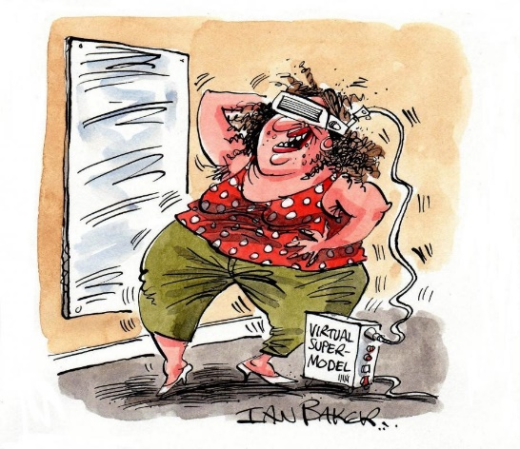
He discusses Artificial Intelligence (AI) – what I call Artificial Stupidity – and believes as I do that we cannot allow technology to run amok as we have – with out of control algorithms and massive mountains of code that we do not document, do not understand, and cannot control.
QUOTE (585): There is another option to avoid an AI takeover – stop creating the technology that allows AI to control everything including human perception.
I have not seen the author discuss ethics and crypto very much, but would observe that as Bill Binney and I and a few others discuss the creation of Web 3.0 explicitly intended to displace #GoogleGestapo, we are seeing, as I said to the Singularity Weblog, that “ethics is an operating system,” and that there are ways to weave ethics and crypto together so as to achieve what Kaliya “Identity Woman” Young calls the four foundations for individual sovereignty in cyberspace: anonymity, identity, privacy, and security.
The author provides an all too brief discussion of the sharp contrast between the AI approach to humanity that seeks to assimilate humans into a non-human non-emotional non-imaginative “borg,” and the original state of humans as God particles, as part of a cosmic infinite one in which each human was a state of perfect energy, with telepathy, infinite life, and more.
We are at a satanic fork in the road. Bite the AI apple and go into the Garden of Satan, or fight to keep our humanity and reinstate our ability for infinite love, infinite being, in harmony with all.
In discussing nano-technology the author recounts a conversation with a CIA scientist in the 1990’s who spoke to him of the insertion of nano-chips into people through vaccination programs. I have spoken with others about this and what I found encouraging is that the nano-chips appear to have been defeated by the human body – they have generally, not always, been treated as foreign bodies and neutralized.
The author assumes that the secret intelligence world and the Deep State behind it already has access to 100% of the data, and while that may be true, my impression is that we are still processing 1% of what we collect, collecting 1% of what is published which is 1% of what is written which is in turn 1% of what we know. Certainly that could be a cover story, but I for one believe we have time to take down the US secret intelligence community, push back on the Deep State’s plans for a total surveillance society, and reinstate humans and the 99% as the core for advancing peace and prosperity for all.
This chapter includes a discussion of the role of chemtrails and the metals that are being put into the human body through various means, all intended to make the human body more susceptible to radiation control and neutralization.
QUOTE (596): Tests have shown chemtrails to contain aluminium, barium, radioactive thorium, cadmium, chromium, nickel, mould spores, yellow fungus mycotoxins, polymer fibres and so much more in cumulatively lethal concentrations for human health.
QUOTE (596): Aluminium is a brain toxin and chemtrails are a major contributor to the explosion of Alzheimer’s and dementia in genera since they began to appear.
Bees are cited by the author as one of the first casualties, and our canary in the coal mine.
A fascinating discussion, including detailed photographs of metallic fibers in human bodies, is provided, related to Morgellons or “the chemtrail disease.”
I am familiar with motes (dust that contains a complete command and control, communications, computing, and intelligence sharing suite of tools embedded within it), but this one long quote is in my view essential as a testament to the utility of the entire book, here the author is citing as the source of this quote an article at www.cidpusa.org (Chronic inflammatory demyelinating poly radiculo neuropathy – an alternative health site publishing information the medical-military-industrial complex does not want people to receive):
QUOTE (601): Morgellons appears to be a communicable nanotechnology invasion of human tissue in the form of self-assembling, self-replicating nanotubes, nanowires, and nanoarrays with sensors. Other nano-configurations associated with Morgellons disease carry genetically-altered and spliced DNA or RNA … The Morgellons nanomachines are configured to receive specific tuned microwave, EMF and ELF signals and radio data … We do know that Morgellons is commonly found in all body fluids, orifices and often even hair follicles, and are believed to routinely achieve total body systemic penetration.
I will make just two comments:
First, above is the plan, and it is not working. Despite the horrible cost to humanity in terms of Alzheimers, Parkinsons, Mad Cow, and other diseases related to the bestiality of our scientific experimentation and ignorance, we seem to be surviving the assault and the Deep State is not on schedule.
Second, holistic analytics and true cost economics will defeat all of this within two years. I want to do for humanity, in all languages, what David has done in one book for a few thousand of us. An Open Source Agency can publish the truth about everything, in all languages, and change markets overnight. Below is what a true cost app might look like after the phone takes a photo of the bar code:
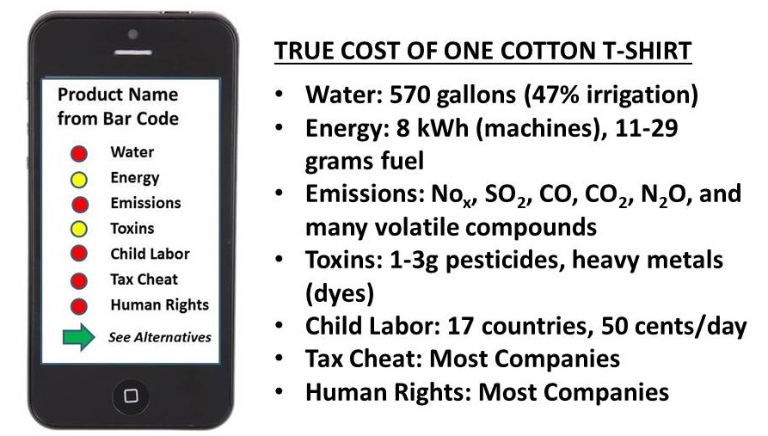
I love this book – it is a necessary call to arms. I am myself very confident that humanity is going to prevail and that in the next eight years we will defeat the 1%, end war, and re-evolve rapidly.

Chapter 17: Synthetic Human
This chapter provides a useful overview of where we are – at least in the public domain, not within the Deep Underground Military Bases (DUMB) or at our bases in outer space – on the matter of synthetic humans – synthetic tissue, synthetic blood, synthetic nerves, etcetera. GNA (Glycerol Nucleic Acid) is the synthetic counterpart to DNA.
The author folds into this chapter the related issues of children being separated from their families, and transgender encouragement. In an earlier chapter he wrote to people eventually being “assigned” to housing and being forced to share housing with strangers, all to break down trust and increase snitching.
QUOTE (609): We are witnessing the fusing and confusing of gender identity in preparation for the non-gender, no-sex, synthetic designer human.
I will go on record and say that I consider both pedophilia and transgenderism to be threats to national security that must be stamped out.
QUOTE (610): A major pillar of the no-sex human is the end of masculinity through the suppression of the male hormone testosterone.
He also discusses the collapsing sperm rates, especially among whites, the ethnicity that appears to be most threatening to the Archons and the Deep State and the Zionists. They want pussies with no facial hair that cannot fight and cannot fuck, as their subjects. His detailing of the chemicals being put into our air, food, and water is horrifying.
QUOTE (617): Humanity is being divided and ruled by smart technology designed to make us anything but smart.
The second half of the chapter completes the overview of how humans are being castrated by wearables, Wi-Fi, radiation from all sources including especially 5G and hidden microwaves and now, the grand finale, a “space fence” being billed as protection against asteroids when in fact it is intended to be able to execute any person (or group of people) by name and DNA signature, anywhere on Earth.
Here again we see the contrast between the 1% Deep State plan to subjugate us to their amoral technical matrix, versus our inherent capacity, increasingly repressed since the World Wars planned and funded by the Zionists and the Vatican, for Infinite Awareness.
His section on “Saturn Earth” is truly frightening and communicates the concept of all of us wearing the equivalent of an electronic dog collar, each subject to being told what to do, what to think, how to feel, and being subject to shock therapy when non-compliant, and execution when convenient to the 1%.
Peter Thiel is featured in this chapter and very dirty and very dangerous.
The chapter winds toward a fascinating conclusion with the sub-title, “The Cull.”
QUOTE (635): The most obvious expression of the cull is dramatically falling sperm counts, but there are many other ways that humanity is being prepared for a massive reduction in its numbers.
He documents corn seed that sterilizes; the Food and Drug Administration (FDA) making it illegal to publicize this information; and the fact that contraceptive drugs are being delivered through the water supply through urine (we do not cleanse our water of pass-through drugs).
Vaccines are criminally insane, I agree, and so are Genetically Modified Organisms (GMO) that totally screw up the genetic system of their human consumers.
In passing he makes the point that robots (e.g. robot policemen) will only see the dots, not the context. You will not be treated fairly, in context, by a robot policeman.

Chapter 18: Perceptions of Freedom
QUOTE (649): There is much we can do – like change everything – but only with a fundamental transformation of human perception and self-identity.
QUOTE (649): Almost the entirety of human society is an amalgamation of religious worship, mostly not recognized as such, and all founded on illusion.
Worth a Look: Book Reviews on Religion & the Politics of Religion
The author is not suggesting that the faithful abandon their faiths, but rather that they challenge themselves, question their beliefs, and see if those beliefs actually contribute to their being all they can be.
QUOTE (651-652): People might further question if their faith has a record of making the world a nicer, freer, more loving place or whether it plays a frontline role in control of perception and the suppression of free speech, free thought and free choice without pressure, imposition, or intimidation.
The author is strong in articulating how each of us is unique and therefore a unique part of the Infinite Whole.
The middle of the chapter is an indictment of progressives.
QUOTE (657): Progressives overwhelmingly look the other way in the face of migrant crime, gangs and no-go areas because it requires a break-out from group-think into nice bloke and what a bastard. Those who are supposed to support women’s rights will therefore ignore migrant rapes on the grounds that they breach the group-think concept leaving them no choice but to choose one group over another instead of thinking individually.
The balance of the chapter – absolutely essential reading – is about breaking the cycle that the 1% favor, the cycle of protest and violence. The author is eloquent – Gandhiesque – in his articulation of the power of love and non-violence in both behavior and internal mental and emotional balance.
QUOTE (662): Love breaks the circuit and takes away the power of any adversary while rage just further empowers them. Albert Einstein said: Everything is energy and that’s all there is to it. Match the frequency of the reality you want and you can’t help but get that reality. It can be no other way. This is not philosophy. This is physics.
One could say this is quantum cosmic physics.
The author compares Martin Luther King with the sharply failed Black Lives Matter and Antifa movements that promote division and violence, and the author emphasizes King’s focus on no masters – no hierarchies. See the three books I recommend at the end on localized distributed power.
QUOTE (666): Mass non-cooperation is far more effective than only protest.
QUOTE (669): No positive change is possible without a total transformation in humanity’s self-identity.
QUOTE (671): Expanded awareness is about celebrating infinite diversity and not fusing into one neutral blob.
QUOTE (673): Collective senses of isolation and division are called wars, class, race, religion, haves and have nots. When we see each other as One – literally expressions of the same Infinite Awareness – that sense of reality must, repeat must, become our experienced reality. … Divisions can only be healed when divisions are no longer perceived. They are but illusions to keep us apart.
The author is of the view that experience is not random – good, bad, indifferent, experience is unique to each of us and the clay within which we can mold our emergent potential.
Our health is as much mental and emotional as it is physical. The author discusses how unbalanced emotions generate distorted electrical and electromagnetic signals and fields that scramble the body’s internal communications system.
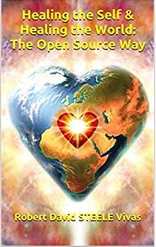
The chapter concludes with a strong manifesto celebrating the heart over the brain, context over detail.
QUOTE (678): The power of the heart is central to everything with regard to healing the distortion and reversing the inversion. Usurping the heart (love, infinite insight) with the brain (thought) and the belly (emotion) is the distortion and is the inversion – or at least a reflection of the Archontic distortion and inversion.
QUOTE (679): The hijacking of human perception and so human reality has been achieved primarily by closing the heart vortex or chakra. Gnostic knew this and the Apocryphon of John says: ‘And they closed their hearts, and they hardened themselves through the harness of the counterfeit spirit…’ The head thinks but the heart knows and ‘thy’ don’t want us to know.
I have always been a fan of Ying / Yang and balanced opposites, and I am reminded of a superb book pointing out why women should rule the world – they are more compassionate and rule from the heart, not the head, which all too often is “black and white” for the wrong reasons.
Review: Mapping the Moral Domain: A Contribution of Women’s Thinking to Psychological Theory and Education
See also:
Review: The Compassionate Instinct–The Science of Human Goodness
Review: Conscious Evolution: Awakening Our Social Potential
QUOTE (682): Love in its true sense is not fluffy and naïve. We must remember that. It does what it knows to be right and part of that is refusing any attempt by others to impose their will individually or collectively. Don’t mess with love in its Infinite sense. It is not to be messed with because it doesn’t take no for an answer when no is the wrong answer.
QUOTE (682): All faiths, religions and beliefs must stop seeking to achieve pre-eminence or force their beliefs on others especially children. The arrogance of such ambition knows know limits or bounds.
QUOTE (689): Humanity is where it is because we have forgotten who we are. We have given our minds away to illusion and fake rulers whose power comes only from the power we hand to them. If the Archonic Reptilian force could walk in and take over then they would have by now. They have a frequency limitation which means they can only control us when human minds and perceptions are held fast in the frequency band that they can manipulate. A common theme of ancient and modern accounts of Archontic entities is that they are terrified of humans waking up to our true nature and power because they know their game would then be over. The solution, therefore, is to withdraw from that band by withdrawing from our perception of Phantom Self and entering the high-frequency state of Infinite Self.

Postscript
QUOTE (690): The real target of the Antifa deception is freedom of opinion and expression which the anti-fascist fascists and their ‘progressive’ sheep-like, child-like mobs are set on deleting on behalf of their Archontic masters.
QUOTE (691): The simple and blatant technique is to label anyone defending freedom of speech as a Nazi and so demonize the very concept of freedom of speech.
QUOTE (691): History is history – the good and the bad – and to erase history is not to learn from it.
QUOTE (692): All opinion that is deemed not acceptable to the book-burning fascism of political correctness is now considered ‘hate’ as a matter of course to justify, increasingly through violence, its censorship.
The author does well here at calling out both the Anti-Defamation League (ADL) and the Southern Law Poverty Center (SPLC) as the Zionist-controlled censorship tools that they are.
In a discussion about global reality – not actually touching on the genocidal apartheid criminal activities of the Zionist state of Israel, but rather about their global efforts to censor the author – he says:
QUOTE (693): Exposing the truth about world events is, of course, the problem and everything else is an effort to demonize and discredit my information.
The author takes pains to distinguish between Reptilians and Jews – he is focused on REPTILIANS – and their Zionist tools – NOT on Jews per se. Zionists are not Jews and most Jews reject Zionism.
I do NOT agree with the author, citing an individual who worked for the CIA but was never a clandestine operations officer or even a manager, when he says that CIA controls the military-industrial complex and just about everyone else. My experience, both within CIA and outside of CIA, is that CIA is a tool of the Deep State, not the Deep State itself.
The bibliography is disappointing and I am quite sure it does not represent the full breadth of the author’s reading nor that of his research team.
The index is superb and was most helpful to me in checking to see if I had overlooked anything. Really important world-changing books such as this demand a good index, and that is what I read first.
The author has been afforded an opportunity to alert me as to errors in my summary, as well as omissions. Any mistakes are my own – I have done my very best to honor this brilliant man with a deep reading of his work and the longest summary that I have ever written in my life.

References
REVIEWS BY ROBERT STEELE
Here are three other books that opened my mind beyond the normal.
- Review: TAVISTOCK INSTITUTE – Social Engineering the Masses by Daniel Estulin — Deep State Playbook
- Review: Trance: Formation of America
- Review: Project Human Extinction – The Ultimate Conspiracy
Here are a few books on information pathologies where I have spent much of my time.
- Review (Guest): Propaganda–The Formation of Men’s Attitudes
- Review: Fog Facts –Searching for Truth in the Land of Spin
- Review: Forbidden Knowledge–From Prometheus to Pornography
- Review: Lost History–Contras, Cocaine, the Press & ‘Project Truth’
- Review: Manufacturing Consent–The Political Economy of the Mass Media
- Review: Rule by Secrecy–The Hidden History That Connects the Trilateral Commission, the Freemasons, and the Great Pyramids
- Review: The Age of Missing Information
- Review: Weapons of Mass Deception–The Uses of Propaganda in Bush’s War on Iraq
- Review: Weapons of Mass Instruction
Here are my two best lists of lists of book reviews about our past, present, and future circumstances.
- Worth a Look: Book Review Lists (Positive Future-Oriented)
- Worth a Look: Book Review Lists (Negative Status-Quo)
Here are books I have reviewed related to extraterrestrial matters, but I have no direct knowledge and am not sufficiently familiar with the possibilities to be reliably conversant.
https://phibetaiota.net/category/reviews/intelet/
And finally, here are three books that confirm by view that humans are intended to self-govern at the LOCAL level, in a DISTRIBUTED fashion, rejecting all forms of top-down imperial governance.
- Review: Governing the Commons: The Evolution of Institutions for Collective Action
- Review: Skin in the Game – Hidden Asymmetries in Daily Life
- Review: ANTIFRAGILE – Things That Gain From Disorder
All of my reviews, sorted into both lists and by category, are easily accessed at
https://phibetaiota.net/reviews/.
My three core websites: https://robertdavidsteele.com, https://phibetaiota.net, https://unrig.net.
On the next page, to honor David Icke and his signal contribution to the awakening of humanity, are links to his previously published books and DVDs. His website is a bit cluttered but certainly worthy of regular visit. (https://www.davidicke.com/). I tried to subscribe but it did not “take.”
BOOKS BY DAVID ICKE
- 2016 Phantom Self (And How to Find the Real One)
- 2015 Human Race Get Off Your Knees – The Lion Sleeps No More
- 2013 The Perception Deception
- 2012 Remember Who You Are: Remember Where You Are and Where You Came From
- 2008 Lifting the Veil: Interview of David Icke by Jon Rappoport
- 2007 The David Icke Guide to the Global Conspiracy (and how to end it)
- 2005 Infinite Love is the Only Truth, Everything Else is Illusion
- 2004 …And The Truth Shall Set You Free – 21st century edition
- 2003 Tales from the Time Loop: The Most Comprehensive Expose of the Global Conspiracy Ever Written and All You Need to Know to Be Truly Free
- 2002 Alice in Wonderland and the World Trade Center Disaster
- 2001 Children of the Matrix: How an Interdimensional Race has Controlled the World for Thousands of Years-and Still Does
- 1999 Heal the World: David Icke's Do-It-Yourself Guide to Human & Planetary Transformation
- 1998 The Biggest Secret: The Book That Will Change the World
- 1998 I Am Me – I Am Free: The Robots’ Guide to Freedom
- 1994 Truth Vibrations: From TV Celebrity to World Visionary
- 1994 The Robots’ Rebellion: The Story of the Spiritual Renaissance
- 1990 It Doesn’t Have To Be Like This: Green Politics Explained
DVDS BY DAVID ICKE
- 2010 Live at Oxford Debating Society
- 2010 Beyond the Cutting Edge - Exposing the Dreamworld We Believe to be Real
- 2005 Revelations Of A Mother Goddess
- 2005 From Prison to Paradise
- 2004 The Reptilian Agenda
- 2004 The Freedom Road
- 2004 Secrets of the Matrix
- 2004 Freedom or Fascism: the Time to Choose
SIDEBAR ON ARCHONS
Cornerstone article. Search for archon at http://prepareforchange.net/.

