Robert David Steele
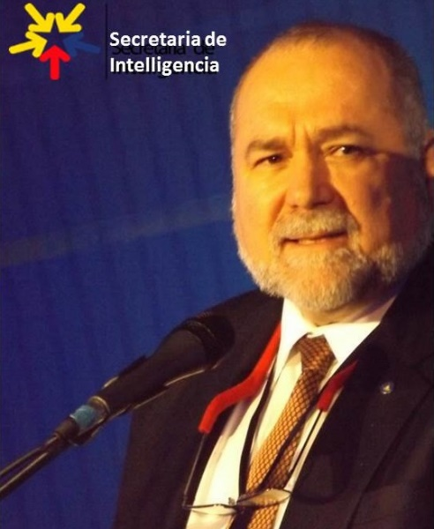
Robert David Steele is the conceptualizer of integrated election reform (#UNRIG) and the integration of holistic analytics, true cost economics, and Open Source Everything Engineering (OSEE) such that we can achieve a prosperous world at peace at 10-20% the cost of the failed Western economic model burdened by banks and lawyers.
He is the pro bono Chief Enabling Officer (CeO) of Earth Intelligence Network, a 501c3 devoted to teaching holistic analytics (HA), true cost economics (TCE), and open source everything engineering (OSEE) and now also CeO of Open Source Everything (OSE Inc.), a for-profit that seeks to help all countries — America first if Donald Trump will listen — create a prosperous world at peace, a world that works for 100% of humanity, at 10% of the cost of the failed Western economy.
In 2017 he was recommended for the Nobel Peace Prize, a prize he hopes to help President Donald Trump win if the President will implement the ideas being offered to him in the here and now.,
The first step is the creation of an international Open Source Agency for local to global information-sharing and sense-making as well as OSEE innovation.
#UNRIG Election Reform
- Memorandum for the President: Trump Triumph
- Core Article on Election Reform by Robert Steele & Cynthia McKinney
- #UNRIG Official Website
Open Source Everything Engineering (OSEE)
- Creating a Post-Western Independent Internet
- Healing the Self & Healing the World: The Open Source Way
- Concept for a Post-Western Economic-Engineering Paradigm: How Putin-Modi and Xi-Trump Can Save Humanity with Open Source Everything Engineering (OSEE)
- For UN SecGen – Achieving SDG with OSEE
- D3C Presidential Innovation Memorandum 3.3
- Open Source Everything Engineering (OSEE) – A Nordic Manifesto
- Open Source Everything Engineering (OSEE) – Creating the Academy, Economy, Government, and Society of the Future
- Open Source Intelligence Done Right – Lecture to the Royal Danish Defence College
- The Ultimate Hack: Resilient Villages, Smart Cities, Prosperous Nations at Peace — and Unlimited Clean Water
- Marcin Jakubowski: Open Source Everything Engineering (OSEE) is 10-20% the Cost of Industrial-Era Engineering
INTELLECTUAL PRODUCTION:
- Articles & Print Interviews
- Audio-Visual Interviews
- Books including 9/11 Truth & Sandy Hook Truth
- Chapters
- Kindles
- Monographs
- Testimony
BLOG: Phi Beta Iota Public Intelligence Blog is where he curates over 80 contributors who believe that the truth at any cost lowers all other costs.
AUTHOR: Eight books on intelligence reform, two on electoral reform, multiple Kindle Shorts as well as articles, chapters, lectures, monographs, online posts, and testimony. His work is informed by being a top reviewer for non-fiction, respecting the work of other authors, publishing over 2,500 reviews in 98 categories of non-fiction reading.
SPEAKER: Co-Founder of the Information Warfare Conference, founder of the Open Source Solutions Conference, invited lecturer world-wide on topics of Cyber, Open Source Intelligence (OSINT), (All-Source) Intelligence Reform, and Applied Collective Intelligence inclusive of holistic analytics, true cost economics, and Open Source Everything Engineering (OSEE) focused on achieving the Sustainable Development Goals (SDG).
PUBLIC SERVICE: USMCR Infantry, Adjutant, Intelligence 1976-1996; CIA Clandestine Service 1979-1988; USMC Civil Service 1988-1993, #2 civilian in USMC Intelligence, responsible for creating the Marine Corps Intelligence Activity; CEO Open Source Solutions, Inc. 1993-2010, responsible for creating the Open Source Intelligence (OSINT) discipline world-wide, training over 7,500 mid-career officers from across 66+ countries; CeO Earth Intelligence Network, 2006 to date. External Researcher, US Army Strategic Studies Institute (SSI), 1998 to 2017. Now leading the OSINT Done Right – Active OSINT movement as well as a campaign to create Open Source Agencies and Open Source Everything Engineering (OSEE) Innovation Centres where desired. As of 1 January 2018 he is the Chief Counsel and a Commissioner for the Judicial Commission of Inquiry into Human Trafficking and Child Sex Abuse, part of the treaty-mandated International Tribunal for Natural Justice also nurturing a free book online, Pedophilia & Empire: Satan, Sodomy, & The Deep State.
CITIZEN: As a citizen he has created #UNRIG, a non-profit civics education campaign, and has worked with Cynthia McKinney to create an educational movement (not a party), We the People – Unity for Integrity, being the unification of the populist right and left with people of color, Latinos, and all small parties and Independents, to restore integrity to the US Government via an Election Reform Act whose short title is the Integrity Act. Citizens of all countries are invited to visit our #UNRIG website and donate, receiving a certificate as a Founding Citizen (US and Global versions available).
LEGAL: The federal judge has ruled against all motions by Goodman & Negron. We proceed toward a federal trial for defamation and conspiracy as well as tortuous interference against #UNRIG and our educational non-profit campaign for election reform.

