ANSWERS

#BORG — the ultimate enemy is not Zion or Russia or China but the BORG
While I have no direct knowledge I am persuaded by the varied books I have read and more recently by the people I actually know including David Icke, that there are no fewer than twenty-six stellar civilizations, some evil, some good; that Earth has been under the control of relatively evil forces that made a Satanic pact with economic and political and religious authorities ready to profit from betraying humanity; that in 2012 we passed a tipping point and forces for good converged; and that ultimately the future of the Earth depends on all of us coming together as a single Earthly and human civilization with ethics and free will, with intelligence, integrity, and imagination, to advance beyond our local roots. To this end, full disclosure by all governments in mandatory.
Selected References:
Review: Project Human Extinction – The Ultimate Conspiracy
Review: Everything You Need to Know But Have Never Been Told by David Icke
Review: Our Universal Journey + Extraterrestial RECAP

#GoogleGestapo – the New Fascist Mafia Spy Network
I coined the term #GoogleGestapo when the Anti-Defamation League (ADL), the Zionist secret police, orchestrated a complete take-down of my non-profit educational campaign, #UNRIG (intended to achieve integrated election reform in order to end the control of our Congress by a foreign power, the Zionist state of Israel, which also controls 27 of our legislatures and brags that it will bag the rest). #UNRIG was destroyed six ways in ninety days, including
- Over 90 videos defaming me and false accusing me, without evidence, of charity fraud
- Over 400 organized trolls seeking to intimidate and mis-inform my interviewers while seeking to close my two funding channels – they succeeded on the first front and failed on the second.
- Media hit job led by Media Matters falsely claiming that I had said there were child sex slaves on Mars, with stories in The Daily Beast and The Washington Post, replayed internationally, with my being defamed and falsely accused to millions.
- MeetUp Pro Account termination of #UNRIG, a $77,000 paid account at the same time that the ADL co-sponsored with MeetUp 1,087 #RESIST MeetUps for whom all fees are waived – a form of illegal undeclared donation to the Democratic Party and the Clinton Crime Family.
- Denial of Service Attacks that took my webistes, primarily the blog https://phibetaiota.net, down for nine days – I have since spent thousands in donations to ensure this never happens again.
- False reports from hundreds of trolls to Kaspersky, Norton, and others, falsely stating that my websites were pornographic, such that we were blacklisted, a form of tortious interference that is a federal crime (and trolls make it conspiracy, so triple damages).
Censorship, the manipulation of trends and surveys, and the digital assassination of people, generally conservative but including some progressive voices that challenge official narratives, is only half the story. #GoogleGestapo is the new National Security Agency (NSA), and spies on everyone all the time, illegally exploiting personal and business information online for competitive advantage, generally for Zionist Israel and the MEGA Group of Zionist billionaires that are funding the subversion of the USA for the benefit of Zionist Israel.
#GoogleGestapo consists at one level of Amazon, Apple, Facebook, Google, MeetUp, Twitter, YouTube, and lesser such as Reddit, Wikipedia, and WordPress. Virtually every platform, every software service, has built-in backdoors and can be used to both spy on – and interfere with – legitimate operations.
This problem is not unique to the USA, although Zionist Israel derives its greatest benefit in the USA. This is a global problem and impacts on Third World countries, not only the Western World. China and Russia are absolutely correct to be articulating the need for a post-Western economy and a post-Western Internet that cannot be manipulated for the advantage of the Deep State. and its Zionist underbelly.
Selected References:
Robert Steele: How the Deep State controls social media and digitally assassinates critics – #GoogleGestapo – Censorship & Crowd-Stalking Made Easy (Trump Revolution 17)
#GoogleGestapo: Censorship & Surveillance (Including Amazon, Facebook, Google, MeetUp, Twitter, YouTube, Wikipedia) – UPDATE 6
Zero Hedge: US Retailers With $1.5 Trillion In Sales Demand An Antitrust Probe Of Amazon And Google #GoogleGestapo
#GoogleGestapo Posts @ Phi Beta Iota
Penguin: Displacing #Google Gestapo — Some Apps
Robert Steele: Plans for Displacement of #GoogleGestapo UPDATE 2
Ed Jewett: GoogleNews Bias Robert Steele: Lawsuit & Displacement of #GoogleGestapo with Four Nested Capabilities (Web 3.0)
1994 Sounding the Alarm on Cyber-Security

$21-43 trillion dollar theft by Deep State from US Treasury/US economy
Most educated observers have known for a long time that the Federal Reserve is a criminal organization representing private banks and the Rothschild/Chabad & Vatican criminal complex, rather than a US Government organization serving the public. Similarly, educated observers have understood that inflation is a form of taxation on the public at large.
At the same time many have recognized over time that the federal income tax, and executive borrowing in our name, mortgaging future generations for present waste, fraud, and abuse, are very wrong. Despite clear evidence that 50% of all government programs are comprised of fraud, waste, and abuse, two aspects of federal-private banking criminality have been overlooked until recently.
First, criminal elements within the US Government, primarily in the Department of the Treasury and the Central Intelligence Agency, have long controlled vast treasures in illicit gold and illicit earnings from drug smuggling, gun sales not approved by Congress, and human trafficking. The Black Lily fund morphed into the Black Eagle Trust, and both have been used over time to wage war – war not approved by Congress, -- against all manner of “enemies” including Russia. The Gold War against Russia managed by George Tenet, Buzzy Krongard, and John Brennan on behalf of the Bush Crime Family, is noteworthy for not having led to direct war – Russian forebearance is to be admired.
Second, and only recently come to light, has been the theft of what is now believed to be $43 trillion dollars (up from $21 trillion and inclusive of accumulated interest) from the US taxpayer, via contrived theft largely done via the US Department of Defense (DoD) and the US Department of Housing and Urban Welfare (HUD). While there are clear indications that some – perhaps even the bulk – of this money has gone to pay for a secret space force not authorized by Congress and therefore clearly unconstitutional – the bottom line is that the money has been stolen from the public, without accountability, and we have a right to demand that money back, with interest and penalties.
Although Catherine Austin Fitts has done much to publicize the latter, the real work was done by Michigan State University scholars.
It is my personal belief, based on some personal accounts I have received, that President Donald Trump has succeeded in recovering $15 trillion of the stolen money (much of which is nothing more than digital accounting with no assets backing it up), and this together with his direct engagement with China and Russia and others on the creation of the post-Deep State economic order, will lead to peace and prosperity for the USA and all others over time.
Selected References:
Robert Steele: The Second American Revolution – Reflections on the Near Future UPDATE 2
Fred Burks: Memorandum for the President: Evidence 9/11 Used to Launder $240 Billion in Covert Securities in a Covert Economic War (Gold War) Against Russia
Review: Gold Warriors–America’s Secret Recovery of Yamashita’s Gold UPDATE to Add Links to CDs
Yoda: The Secret Gold Treaty – How the Cabal Got It All….
Martin Armstrong & Robert Steele: The Real Story on Bill Browder, Gold War Against Russia, CIA Asset John McCain’s Magnitsky Act
Mongoose: 9/11 Gold Collateral Account Back Story — Black Eagle Trust, Two Books
Robert Steele: Snap-Shot on Gold & Off-Ledger Accounts
Gold War Act II: Gold Standard 29 MAR 2019? Comment: Seven Kinds of Gold Including Bunkered, Fake, & Stolen UPDATE 1: Zero Hedge Focus
Eleutheria: BrowderGate Deepens — on INTERPOL Most Wanted List, Free Book, Deep Covert Gold War Doo Doo Against Russia
Betty Boop: WIlliam Browder Gold War Criminal On Video – The Real Magnitzky Story As Known To The Trump Family
MSU scholars find $21 trillion in unauthorized government spending; Defense Department to conduct first-ever audit
Catherine Austin Fitts with Greg Hunter: Elites Stole $50 Trillion, Investing in Space War, Using Crypto to Keep Public Out of Gold, Silver, and Land
Catherine Austin Fitts with Greg Hunter: Government Moving Massive Amounts of Money to the Dark Side…
Catherine Austin Fitts with Dark Journalist: The Secret Space and Underground Programs, the Alternative Deep State Budget Based on Drug Trafficking and Mortgage Fraud
Catherine Austin Fitts with Greg Hunter: Saving Pension Funds, Investing in the Public, Getting Our $40 Trillion in Stolen Money Back While Restoring the US Constitution
Catherine Austin Fitts with Dark Journalist: Constitutional Dangers, $21 Trillion in Missing Money

911-what happened, who did it, why has Trump not disclosed the truth?
Planning for 9/11 started in 1988 when the Twin Towers were condemned with a final pull-down deadline of 2007, and the Environmental Protection Agency (EPA) forbade controlled demolitions as the means because of all the asbestos and other toxins. This made the Twin Towers, owned and operated by the Port Authority of New York and New Jersey (PANYNJ) immediately liable for $2 billion in deconstruction costs. This appears to be have been briefed to the Zionists and to Dick Cheney, and it was immediately seen as an opportunity – to convert the liability into insurance fraud with the active complicity of American International Group (AIG) a mega insurance company beyond the rule of law with Central Intelligence Agency (CIA) connections yet to be fully documented, of Dick Cheney before the fact, and of Robert Mueller after the fact. Controlled demolitions were used, directed energy and nuclear may have been used; the Pentagon was fake holes blown from the inside out, and internally installed demolitions – the Pentagon murdered its own, in part to cover up the investigation in to the mssing $2.1 trillion. I will not repeat what I organized in 28 memoranda for President Donald Trump, below are the master post and the individual chapters. If and when President Trump fulfils his promise from February 2016 to do 9/11 disclosure, Dick Cheney and Robert Mueller will hang by the neck until dead, along with Larry Silverstein, Lex Wexner, and several others – this will also lead to the expulsion of the Zionist parasite from the US economy, US government, and US society. If President Trump will not finish this job this will be one of my twelve promises to the American people when I run for the Presidency in 2024.
9/11 matters because it is the ultimate lie and last final desperate attempt of the Deep State and its Zionist underbelly to create a police state within the USA (including a very strong gun confiscation agenda rooted in more localized false flag operations) and a state of endless war abroad. 9/11 disclosure is the ultimate “Red Pill” and it troubles me that those who claim to be red pilling the public refuse to be serious about 9/11 and the many Zionist strikes since the USS Libery.
Master References:
Memoranda for the President on 9/11: Time for the Truth — False Flag Deep State Truth! UPDATE 17: Israel Did It
47 Zionist Strikes (Zionism is Not Judaism)
Chapters Free Online:
#911Truth
Donald Trump: A Promise About 9/11 Truth
Letter of Transmittal by Editor
Robert Steele: 9/11 Truth Letter of Transmittal
Overview & Call for A Presidential 9/11 Truth Summit
David Ray Griffin: Memorandum for the President: Proposal for a Presidential 9/11 Truth Summit
Eric Hufschmid: Memorandum for the President: Please Find the Courage to Declare 9/11 a False Flag Operation
James Fetzer: Memorandum for the President: Three Proofs We Have Not Been Told the Truth About 9/11
Sander Hicks: Memorandum for the President: 9/11 Truth Can Unite the Public Against the Deep State
Robert Steele: U.S. Attorney Has Received a Petition Demanding 9/11 Investigation
Robert Steele: Memorandum for the President: 9/11, Domestic False Flag Operations, and Your Legacy
Who Did It?
Christopher Bollyn: Memorandum for the President: 9/11 and the War on Terror: Israel’s History of False Flag Operations against the U.S.A.
Victor Thorn: Memorandum for the President: The Zionist Role in Planning, Funding, and Controlling 9/11
Steve De’ak: Who Knew What When? The New York City Cover-Up…
Nicholas Kollerstrom: Memorandum for the President: 9/11 an Inside Job, Osama Bin Laden Framed, FBI Aware
Why?
Tom-Scott Gordon: Memorandum for the President: 9/11 WTC Towers Condemned Before 9/11, Cost to Dismantle $2B+, 2007 Deadline, Known to Rudy Giuliani (Mayor of NYC from 1994 – December 2001)
Fred Burks: Memorandum for the President: Evidence 9/11 Used to Launder $240 Billion in Covert Securities in a Covert Economic War
See references for Greater Israel / Yinon Plan
How?
Peter Dale Scott: Memorandum for the President: 9/11, Dick Cheney, & The Hijacking of the U.S. Government
Susan Lindauer: Memorandum for the President: CIA’s Advance Knowledge of 9/11 Date Including Nuclear Possibilities
Ed Jewett: Memorandum for the President: 9/11 – The Zionist-Rothschild Use of Agents – Ashton Carter and Philip Zelikow Particularly
Scott Bennett: Memorandum for the President: How 9/11 Was Funded – The Man Behind the Missing $2.3 Trillion
Kevin Barrett: Memorandum for the President: Muslims Were Framed for 9/11 – Fake News MSM Silences Us
Thermite?
Richard Gage: Memorandum for the President of the United States: 9/11 Anomalies Not Addressed by the 9/11 Commission as Identified by AE911Truth
Pre-Planted Explosives?
T. Mark Hightower: Memorandum for the President: 9/11 Twin Towers Collapse and Vaporization Cannot Be Explained by Nano-Thermite Alone
Barbara Honegger: Memorandum for the President: Pre-Planted Pentagon Explosives Went Off Almost Eight Minutes Prior to Any Alleged Impact on the Building
Nuclear?
Gordon Duff, 9/11 NYC Was a Nuclear Event Crafted by Israel and Saudi Arabia with Help and Cover from Dick Cheney
Joe Olson: Memorandum for the President: The Twin Towers were destroyed using “clean nukes”, WTC 7 with conventional demolitions
Directed Energy?
Judy Wood by Robert Steele: Memorandum for the President: The Twin Towers Were Vaporized by Directed Energy Weapons
No Airplanes?
John Lear: Memorandum for the President: 9/11 Illusions of Airplanes from Hollywood or US Air Force Holograms?
John Lear: Memorandum for the President: 9/11 Twin Towers Were Not Hit By Nor Destroyed By Two Airliners
Aeronautical Engineer: Memorandum for the President: No Boeing 757 Hit the Pentagon
Epilogue
A. K. Dewdney: Memorandum for the President: 9/11 Gratuitously False Narrative on Use of Cell Phones
Greg Felton: Memorandum for the President: 9/11 Zionism’s Great Feeding Frenzy – The Parasite Eats the Host
References
The Zionist Plan — The “Greater Israel” or Yinon Plan
Remember the USS Liberty!
Review: Enclosure – Palestinian Landscapes in a Historical Mirror
Zionism in America – 18 Strikes and Counting
CIA and the Deep State – A Threat to the President & The Republic
Index
9/11 Memorandums for the President: Index

Abortion as a window into the soul of society: what are the true costs?
I have been a party to two abortion decisions – in the first, I not only consented but actively embraced in the abortion of a child by my long-time college sweetheart because I was headed into the Marine Corps as an infantry officer and she was headed for a PhD in Russian Studies at an Ivy League University. I often regret that decision. I did not repeat the mistake and today am the proud father of three young men. For me abortion boils down to how one views society, community, family, and personal relationships.
There are two competing views: the first and more traditional holds that sex should be a privilege of marriage; that men and women were intended to procreate and should not seek to constrain their fertility; and that sex outside of marriage is a sin at multiple levels. The second is vastly more libertine and says that anything goes and you should be free to have sex with anyone (or any child or any beast) anytime, without consequences. Herbert Marcuse calls this “repressive tolerance.” When “anything goes” there are no values that serve as a framework for trust and respect and stability.
I consider abortion to be settled law in that the first tri-mester belongs to the mother, and immediate abortion is totally called for in the case of rape. What troubles me beyond the libertine views on sex is the degree to which there has been active endeavor by CIA and others, to feminize men, butch up woman, and create transgender children that whine a lot and expect government handouts as their due.
This is nothing less than subversion – the views of the extreme left are in my view subversive, ill-considered, and must be attacked with engaged informed objection. This is of course why we are being censored. The Deep State wants subjects, not citizens, and sexual as well as drug liberation is one way to get a public that is dumbed down, drugged up, and too stupid and inert to resist assimilation to the Borg. The true cost of abortion without limits is the death of family, community, and society.
Liberal abortion, like pedophilia and bestiality and alcohol and legalized opiods and government drug smuggling and human trafficking, is a step toward the loss of our soul. Below is my 2008 summary on the issue of abortion, showing key terms and where other candidates stood as well as my own position.
Abortion Proposed: Strongly support pro-life choices, but woman ultimately decides. Praise Supreme Court Justice Clarence Thomas for his Stare Decisis judgment on Roe v. Wade. Life does begin at conception; mother’s rights end with start of second tri-mester.
Key Terms: Clinic Access; Cloning; health issue (pro-choice); Human Life Amendment; Human Life Bills; informed consent; Judicial Activism; moral issue (pro-life); Parental Consent; Partial-Birth Abortion; Right to Choose; Right to Life; rights of the mother; rights of the unborn; Roe v. Wade; RU-486; Stare Decisis; States’ Rights; Stem Cells; Strict Constructionism; viability’ of the fetus

Democrats | Republicans | GOP/Green
Edwards: Right to choose; partial birth ok | Huckabee: Outlaw all abortions | Paul: Life begins at conception; no stem cells
Clinton: Safe, legal & rare | Keyes: Strongly pro-life | Romney: Sanctity of life; but was pro-choice
Obama: Yes on Roe; yes on stem cells | McCain: Pro-life | Nader: Let women decide
Graphic Copyright © 2008 The Speakout Foundation and OnTheIssues.org used with permission.
Selected References:
Review: TAVISTOCK INSTITUTE – Social Engineering the Masses by Daniel Estulin — Deep State Playbook
Betty Boop: France Legalizes Pedophila — Any Child, Any Age UPDATE 1 Comment, Pedos are People Poster, Marcuse on “Repressive Tolerance”
Mongoose: Q as Town Crier — The War in Washington Against The Deep State, Zionists, & Cult of Molech and Ball — Abortion, Mind Control, Pedophilia, Satantic Ritual Abuse
Review: The Conservative Sensibility by George F. Will – Handbook for an American Renaissance

Alternative everything especially health — holistic health, self, all, Earth
This is not my area of expertise but I am a huge fan of Mike Adams, of Traditional Chinese Medicine (TCM), and of holistic health. Below is a graphic that illustrates my intellectual interest in holistic health:
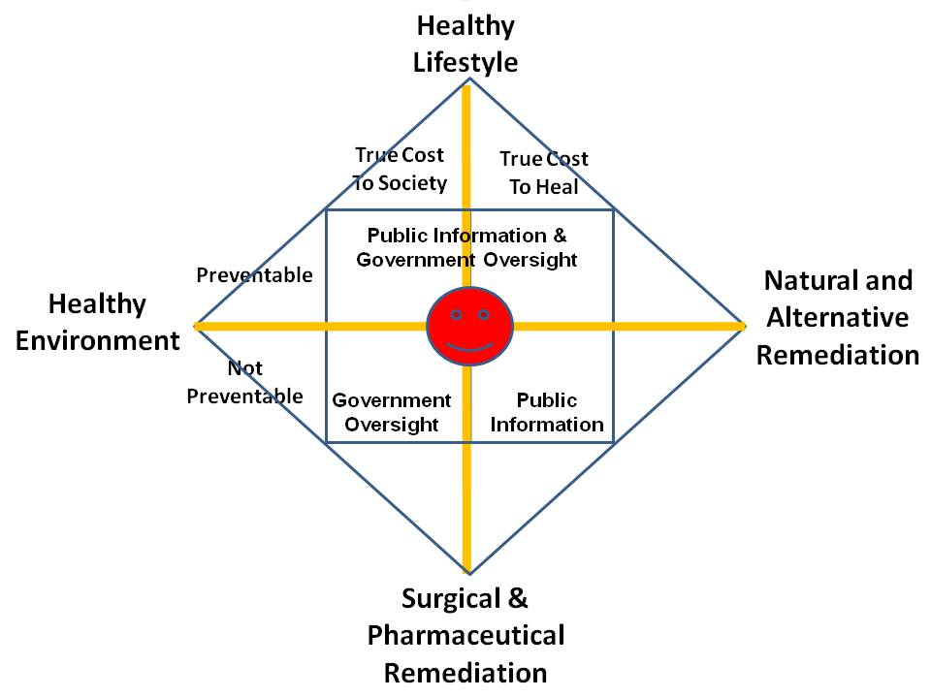
Our entire system in the West, and the USA worst of all, is focused on treating the human as a guinea pig for untested or even known to be toxic vaccinations and medications including opiods. It is insane to insure unhealthy lifestyles – we could balance the federal budget oversight if we did not insure stupid fat people for lifestyle diabetes. We do not hold anyone including airlines and building managers or city managers, for healthy lifestyles, for healthy environments, and we actively repress – to the point of murdering them – successful proponents of natural and alternative remediation.
It is of course both stupid and expensive to remove nutrients from food, substitute poisons, and then sell supplements and antidotes to address the manufactured crisis.
I must also emphasize that we are retarded – maliciously so—with respect to mental health. We have 75,000 veterans with amputations, 275,000 veterans with Post Traumatic Stress Disorder (PTSD), and 22 veterans a day committing suicide. Add up all the alcoholics and opiod and illegal drug abusers and you have a very sick society – by design. Our government lacks intelligence, integrity, and imagination – our government should be abolished and re-booted, the two-party tyranny has run us into a death spiral.
Master References:
2013 Robert Steele Foreword to NATO Book on Public Intelligence for Public Health
2011 Hacking Health (Briefing on Holistic Health Analytics)
Robert Steele: Healing the Self & Healing the World – The Open Source Way (Trump Revolution 14)
Additional References:
Alternative Cures: The Most Effective Natural Home Remedies for 160 Health Problems (Paperback)
Eagle: Empowering Your Health – Beyond Monsanto, Rockefeller and the American Medical Association
Koko: Healing Plan for Humans
Owl: Big Pharma Attacks Alternative Medicine
Jon Rappoport: Healthy School Food Ends Health & Behavioral Issues
Josh Kilbourne: 21 Graphic Depictions of US Health Costs Compared to Other Nations + Health Fraud RECAP
Review: American Healthcare A Moderate Approach
Review: Internet-Based Intelligence in Public Health Emergencies – Early Detection and Response in Disease Outbreak Crises
Review: Your Third Brain – The Revolutionary New Discovery to Achieve Optimum Health
SchwartzReport: Health — and Kindness — Are A) Vital Part of Socio-Economic & Ideo-Cultural Health and B) Destroyed by Legalized Financial Corruption
SchwartzReport: Nobel-Level Break-Through on Back Pain and 10 Health Benefits of Marijuana
Worth a Look: elev3n – gateway to holistic health & wellness
Yoda: Mike Adams of Natural News on How Zionist-Controlled Social Media Enterprises Seek Extermination of Conservative and Alternative Voices

Archeological discovery of giant remains?
This is not an area where I have focused but I do have a few links below. I respect the work of David Icket, Joseph Farrell, and others, and I take it as a given that everything is energy, life manifests in all forms, and there no more oddity about giant beings than there is about microscopic beings.
Selected References:
Dr. Joseph Farrell, Genes, Giants, Monsters, and Men — the Cosmic War Continues Around Us
Ed Jewett: Review of Genes, Giants, Monsters, and Men – The Surviving Elites of the Cosmic War and Their Hidden Agenda by Joseph P. Farrell
RESTORED Above Majestic: Produced by Corey Goode & Jordan Sather Directed by Roger Richards Summary Review by Robert Steele
Review: Everything You Need to Know But Have Never Been Told by David Icke
Review: Our Universal Journey + Extraterrestial RECAP

Arrests based on sealed indictments — no re-election without arrests
Here again I have no direct knowledge but I do have an opinion. In my view there are easily 5,000 core “traitors” across the USA, including selected Governors and state legislators as well as judges and prosecutors and of course celebrities, media anchors, and corporate as well as non-profit chiefs. Perhaps 500 of them – even as few as 100 of them – have real power.
In my view all of the sealed indictments are intended to neutralize the massive networks of treason, pedophilia including murderous pedophilia, and white collar crime including opiods. The sealed indictments are a form of guillotine hanging over the heads of people who have provide useful information, avoid being an obstacle to our investigations, and ultimately be redeemed.
I am huge on Truth & Reconciliation. I believe that every person who has been bribed and blackmailed bv the Mossad, CIA, FBI, or NSA should be given a Presidential Pardon contingent on their providing complete information on who bribed or blackmailed them, when, and what they did in violation of the law and their Oaths of Office, because of the bribery or blackmail.
For me the real truth-teller with President Donald Trump is whether he honors his promise to do full disclosure on 9/11, combined with his opportunity to do full disclosure on everything we have gotten from both the Jeffrey Epstein case, and the other investigations into human trafficking across the USA.
Selected References:
Memoranda for the President on 9/11: Time for the Truth — False Flag Deep State Truth! UPDATE 17: Israel Did It
Robert Steele: Epstein Not Dead, Witness Protection + Dead = Two-fer?
SPECIAL: Zionism in America – Murderous Pedophilia Entrapment – The Nine Veils of Evil [Update 36 to the Mossad-Epstein Story]
Tom Luongo: Epstein Peak Swamp? Zionist Strike 44 UPDATE 50 Epstein Not Dead?
Trump Report Card by Paul Adams
Robert Steele: Washington Examiner on Trump’s Successes (Vastly Superior to What the White House Communications Team Can Produce)

Attorney General William Barr — is he controlled opposition? Bushie?
There are two views on the Attorney General. One view takes note of his lurid past during which he has provided legal cover toward taking down pedophilia investigations, gotten presidential pardons for war criminals, and generally been a tool of the Deep State. The second view is that he is exactly what an embattled President needs – he knows the job, he knows how to work Congress and the law, and he makes the President more powerful. I find it significant that the President has not only passed an Executive Order on human trafficking but that he has delegated to the Attorney General the authority to declassify anything. In light of Sidney Powell’s book, Licensed to Lie, and our certain knowledge that secrecy (classification of information) has been used to conceal crimes by the Department of Justice under then President Barack Obama, as well as the CIA, FBI, and NSA – and perhaps elements of the Departments of State and Defense.
Selected References:
Phantom Phixer: Donald Trump Vindicated – FBI Source Since 1981 [Also Connects Mueller to Trump and Barr in a Surprisingly Good Way]
Zero Hedge: Disclosure Declassification Begins — Trump Empowers Barr over FBI, CIA

Background checks for all politicians, no exceptions
It now appears certain that Representative Ilhan Omar committed immigration fraud, marrying her brother and otherwise committing crimes to secure admission to the USA. I agree that this should be a requirement, and that no politician should have automatic access to classified information simply by virtue of their being elected.
However we also have the problem of who polices the police. It is clear that we have massive illegal programs, secret space programs, deep underground military bases, genetic and mind-control experiments and more, so I think we have a very long way to go before we can clean up all elements of our society.

Biomorphing, Cloning, Inter-Species Hybrid Experimentation
Based on various books – I have no direct knowledge – it appears that extraterrestial trade in humans has been going on for a very long time, and the human, animal, and extraterrestial genetic and hybrid experiments are going on, none of these authorized by Congress. The appears to be a long-standing program of creating “super human” pilots and others, as well as age regression and mind-control and other stuff. While I cannot provide any evidence, there is enough in the open literature to persuade me that it should be a presidential priority to identify and eradicate all such programs.
Selected References:
Review: Project Human Extinction – The Ultimate Conspiracy
Review: Everything You Need to Know But Have Never Been Told by David Icke

Budget Lies – Standard 56 Ends Public Access to Reliable Data
I have long been astonished as the ease with which the Deep State has been able to hijack the US Government via the Shadow Government that is enabled by the two-party tyranny, so as to not only loot current taxpayers, but also mortgage the future of future taxpayers with outrageous borrowing. Constitutionally the US Government is not supposed to be borrowing – it should be issuing currency backed by the full faith and credit of the USA. Both the 16th Amendment (income tax) and 17th Amendment (Senators elected by popular vote) are in my view unconstitutional and were not properly ratified and should be – after determining if that latter assertion is true – nullified.
In principle, not only should the federal government be required to operate under a balanced budget, but it is a budget that should be approved by the Senators in their capacity as representatives of their sovereign states, not as populist representatives.
It is quite clear that 50% if not more of the US Government budget is fraud, waste, and abuse, and I consider it outrageous for the US Department of Defense to be consuming over 60% of the disposable funds in any given year. It is also clear that the “black budgets” have grown to the point of being a clear and imminent threat to the integrity of the US Government and a threat to the US public.
Legalizing lying has no place in government. Infinite entitlements also have no place in government. As George Will has put it so well in his recent book, we have become a national of infantilized dependents.
Selected References:
Graphic: US Military 61% of 2015 Disposable Budget
Graphic: Pentagon Budget Fraud — Lies as Treason
Steven Aftergood: It Is Official: Federal Government Can Lie in Budget Statements
Marcus Aurelius: Six Items on Defense Budget Madness
Catherine Austin Fitts: Now Legal for US Government to Lie About Money at Line Item Level — Government Budget is Now Completely Unreliable
Catherine Austin Fitts with Dark Journalist: The Secret Space and Underground Programs, the Alternative Deep State Budget Based on Drug Trafficking and Mortgage Fraud
Nori Huddle: Assassination of NATO Chief Auditor to Conceal €250 Black Budget for NATO-Sponsored Terrorism — Media Black-Out Occurring by Design
Wayne Jett: Trump Can Save Capitalism By Ending Federal Reserve and Mercantilism (Throw in a Balanced Budget and a Gold-Backed Dollar For Best Results)
Berto Jongman: John Whitehead Reviews the the US Budget and What It Says About America and Americans
Berto Jongman: 7 Incredible Ways the Pentagon Mismanages Its Massive Budget
Laurence Kotlikoff: US Senate Told US in Worse Fiscal Shape than Greece + David Walker & Balanced Budget
Jon Rappoport: Is the NSA manipulating the stock market? Is this creating a black off-budget slush fund for the Pentagon?
Robert Steele: REVOLUTION!: How Donald Trump Can Win and Govern by Championing Electoral Reform, a Coalition Cabinet, a Balanced Budget, and a Constitutional Convention in 2018 (Trump Revolution 01)
Winslow Wheeler: Graphics Lie — and Tell the Truth — a Comparative Commentary on the Actual US Defense Budget from 1947 to Date

Catastrophic Infrastructure Failures (Dams, Electrical, Nuclear)
I think of dams in three ways:
01 They tend to be badly built, as we saw with the Army of Engineering dams that failed New Orleans. When they fail, they fail catastrophically for all who live downstream.
02 They screw up nature. In those instances where dams have been removed, all manner of new life and newly fertile soil have resulted.
03 They compound the threat of nuclear disaster from nuclear plans that will be flooded and will fail as Fukushima failed.
Selected References:
Graphic: US Nuclear Risk in Relation to Dam Failures
Graphic: US Nuclear Plants in Flood Zones
Graphic: US Nuclear Plants in Earthquake Zones
Graphic: Earthquake Basics, Nuclear Insanity
Graphic: Nuclear Plants & Seismic Zones (Global)
Graphic: Nuclear Plants & Seismic Zones (USA)

Censorship Against Alternative Open Source Everything
Although I was aware of the Palestinian genocide and also of the excessive power of the Israeli lobby within the US Congress, it was not until the Anti-Defamation League (ADL) attacked me, #UNRIG, and in passing, The Honorable Dr. Cynthia McKinney, six ways in ninety days, that I understand that the Zionists are the enemy, not China, Iran, or Russia. Although I wrote the original letter to the White House in 1994 warning that cyber-vulnerability was certain and that we needed to spend one billion dollars a year to “secure” the cyber-frontier, and I was familiar with this domain in part because the CIA built the Artificial Intelligence Staff around me in 1986, it was not until the Zionists attacked me and I studied their attacks that I understood the degree to which Zionists control ALL US communications and computing. See my response to #GoogleGestapo above for the original detail. Today I understand that the Zionists and the Deep State are doing two terrible things against us: on the one hand, censoring all conservative points of, and on the other, promulgating filth and sickness (e.g. the normalization of pedophilia) as well as inciting race wars and gender wars that are contrived, so as to keep us all in a state of distraction and fear.
Open Source Everything Engineering (OSEE) is a direct threat to the power of empire for the simple reason that on the one hand it can connect all minds to all information in all languages all the time, and thus enable informed self-governance; and on the other hand, it can lift the five billion poor – including the poor across America – for 10-20% the cost of the failed Western economic model that is 50% waste and 90% profit for the banks. Below are four graphics that sum up the brilliant possibilities of combining the income of the five billion at the bottom of the pyramid (income that is four times greater than the income of the one billion at the top) with OSEE:
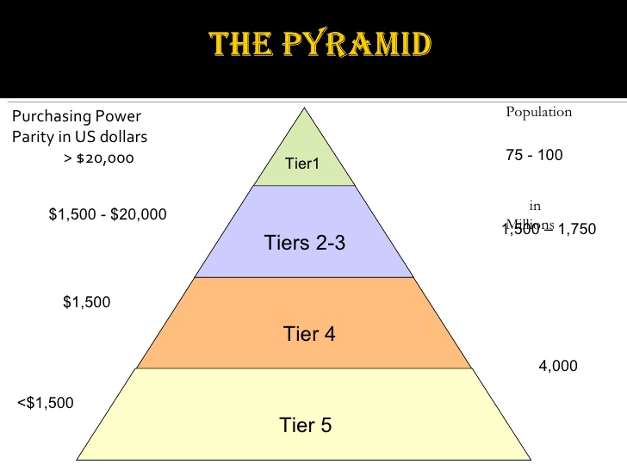 | 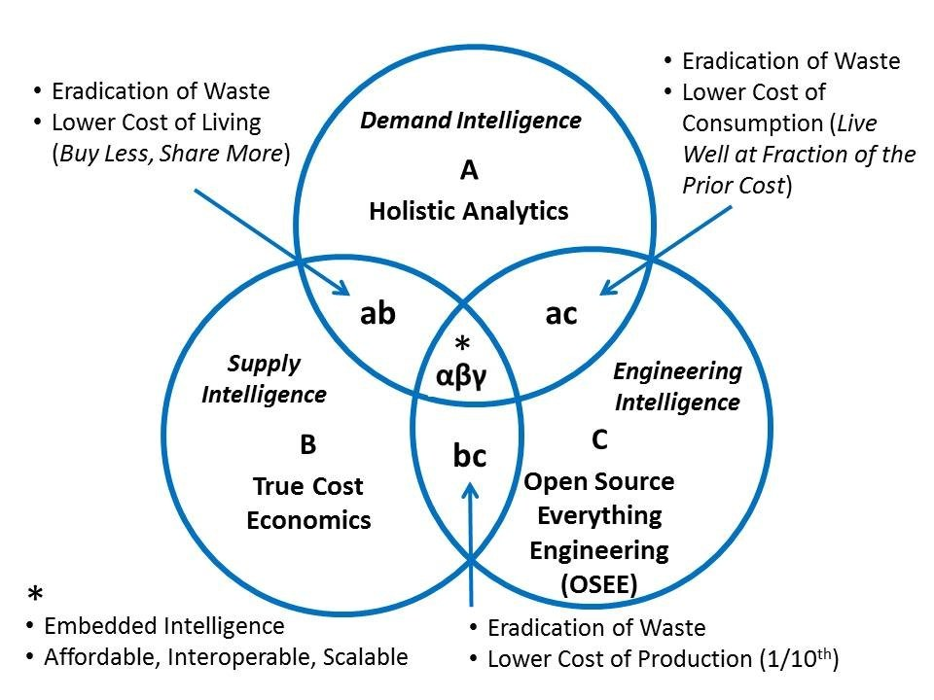
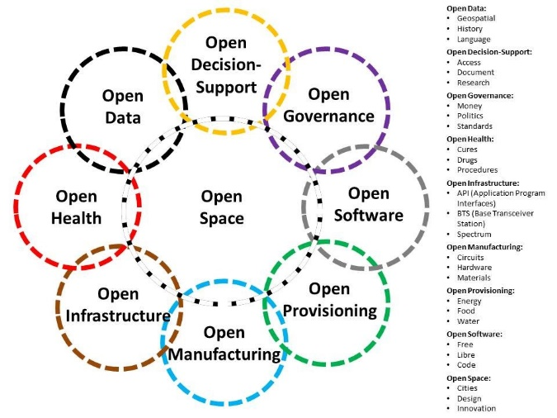 | 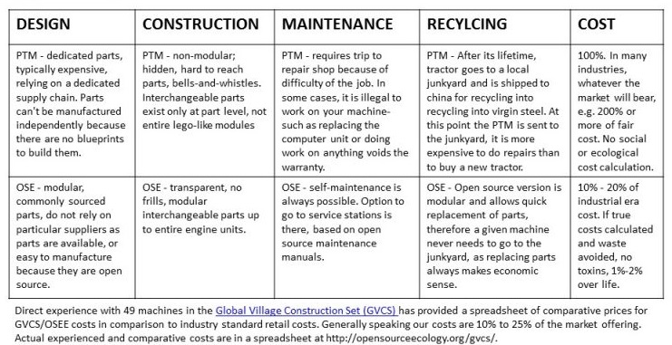

Bottom line: censorship is how the Deep State and Shadow Government ‘manufacture consent” and keep from the public the fact that the public is being abused, genocided, and looted.
Selected References:
Review: The Fortune at the Bottom of the Pyramid
MEMORANDUM FOR THE PRESIDENT: Eradicating Fake News and False Intelligence with an Open Source Agency That Also Supports Defense, Diplomacy, Development, & Commerce (D3C) Innovation to Stabilize World

Cheating Culture — Lies as a Standard (History, Politics, Science)
When I was a professional intelligence officer employed by CIA, it never occurred to me to question the sources and methods. It was not until I co-founded the Marine Corps Intelligence Activity (MCIA) as the Special Assistant to the Director and also for a time the Deputy Director, that I understood that the secret world is largely worthless. I not only pioneering the modern Open Source Intelligence (OSINT) discipline – sadly CIA killed that baby at birth, no one does it right anywhere – but I took an interest in “information pathologies” that are holding all of us back from achieving a prosperous world at peace. Easily 50% if not more of everything we are taught is a lie, and lies are accepted because the Deep State has achieved the standard of complete inversion – war is peace, lies are truth, values are relative.
Selected References:
Graphic: Information Pathologies
Graphic: Human Information Pathologies
Robert Steele: Itemization of Information Pathologies
Reflections on Information Pathologies & Organizational Intelligence — Why Predictive Analytics on Industrial Era Data is Fraud, Waste, & Abuse
Worth a Look: Book Reviews on Disinformation, Other Information Pathologies, & Repression

CIA illegal penetration of all local, state, and national agencies
It was not until I read the work of Mike Rupport, formerly of the Los Angeles Police Department, and listened to Governor Jesse Ventura, that I understood that CIA is operating massive illegal domestic networks that have penetrated every statehouse, courthouse, and schoolhouse. CIA is the Deep State’s “fixer” along with secret societies at the upper levels (Freemasons, Knights of Malta, Opus Dei, others).
There is no question but that a future President is going to have to understand a massive housecleaning that is relatively easy to achieve provided that the National Security Agency (NSA) is under complete control, and a military counterintelligence division can be mobilized – the FBI cannot be trusted, it is itself compromised.
Yes, CIA was instrumental in assassinating John F. Kennedy.
Selected References:
Douglas Valentine with Sibel Edmonds on CIA as Organized Crime
Mongoose: The CIA Takeover of America in the 1960s Is the Story of Our Times Review of A Lie Too Big To Fail: The Real History of the Assassination of Robert F. Kennedy, by Lisa Pease
Pedophilia & Empire: Satan, Sodomy, & The Deep State – Chapter 9: Military-CIA Mind Control, Torture, Pedophilia and Satanic Sacrifice
Review: Crossing the Rubicon–The Decline of the American Empire at the End of the Age of Oil (Paperback)
Review: Dark Alliance–The CIA, the Contras, and the Crack Cocaine Explosion
Review: Lost History–Contras, Cocaine, the Press & ‘Project Truth’
Review: The Devil’s Chessboard – Allen Dulles, the CIA, and the Rise of America’s Secret Government
Review: TAVISTOCK INSTITUTE – Social Engineering the Masses by Daniel Estulin — Deep State Playbook
Review: The Family Jewels – The CIA, Secrecy, and Presidential Power
Review: Trance: Formation of America
Reviews on Assassination of JFK
Worth a Look: Douglas Valentin on The CIA as Organized Crime – How Illegal Operations Corrupt America and the World

Climate hoaxes — cooling, warming, denial of Sun’s importance
From where I sit global warming is a hoax and Tom Steyer is a retard. The sun and its changes are what cause global-scale changes in warming and cooling. I certainly agree there is more we could do to reduce operational level warming, but at the strategic level we should be focusing on underground cities, free energy instead of fossil fuels, and other common sense measures.
It is of course insane, and a crime against humanity, to practice geoengineering and electromagnetic pollution including 5G which is a genocidal and ecocidal technology.
Selected References:
Wayne Jett: 5G + GeoEngineering = Genocide
Berto Jongman: China’s Mind-Blowing Weather Modification, Geoengineering, & ELF Transmitter Projects!
Berto Jongman: Climate Change / Geoengineering Refugees
Berto Jongman: Geoengineering and Weather Control — Another Deep State Tool
Berto Jongman: Geoengineering Confirmed by CIA Director, No Longer a “Conspiracy Theory”
Owl: Dane Wigington on Geoengineering with Microwaves Causing Earthquakes
Owl: NASA – Global Warming from Solar Activity
Jon Rappoport: Is Donald Trump Right About the Climate Change / Global Warming Hustle?
Al Rozich: Beyond Global Warming — Other Inconvenient Truths with Focus on Water
Chuck Spinney: Global Warming as Scam Cover-Up Distracting from Massive Water Theft Now
Chuck Spinney: Judith Curry on Global Warming Debate and Politics Over Science
Chuck Spinney: Is Global Warming Religion or Science?
Review: The Real Global Warming Disaster
Yoda: Video (1:08:56) World-Renowned Doctor Addresses Geoengineering Dangers
Yoda: Chemtrails — the Secret War That Militarizes Climate Change with Geoengineering – Free Movie (1 Hour)

Constitution of the USA Not Being Defended
This one really upsets me. For all of the good that President Donald Trump has done, he appears to be deliberately NOT defending the Constitution and particularly the 1st, 2nd, and 4th Amendments.
- 1st Amendment – Zionist Censorship
The censorship, manipulation of data and surveys, and the active digital assassination of conservative voices and values across all social and mass media platforms controlled by the Deep State and its Zionist underbelly is the full equivalent of the book burnings and witch hunts of the Catholic Inquisition. Nothing could be more harmful to the pursuit of happiness – the pursuit of a prosperous Republic at peace, than the deliberate censorship of our American conversation.
- 2nd Amendment – False Flags and Red Flags
President Trump will not be re-elected if he continues to speak as he has recently about red flag laws. Red Flag laws do NOT provide for due process. The person being disarmed is not notified in advance and is not given an opportunity to challenge the accusation or their accuser. This is a star chambers matter in which an idiot judge issues a summary judgement without ever looking at the person being accused, and a SWAT team then attacks the person and either disarms them, or kills them, as occurred recently in Maryland.
- 4th Amendment – Unreasonable Search & Seizure from NSA to TSA
NSA has been doing illegal mass surveillance since 9/11, and continues to do so today, augmented by Zionist-controlled programs installed across all law enforcement communications and computing via the Department of Homeland Security (DHS) that was created by ubber-Zionist (himself a participant in 9/11) Michael Chertoff. What Robert Maxwell, Zionist super-spy did in the 1980’s with PROMIS software has been taken to the next level by Israeli software companies given privileged access to the basements of all of our local, state, and national agency offices as well as all of our communications and computing companies.
TSA has, thankfully, backed off from its criminally insane project to hand search individual of interest at the departure gates – individuals who have already been through airport security. I was personally abused by a moron TSA officer with psychopathic tendencies his boss could not control; he had his hands on my balls solely because he had the power to do so. Now however TSA is on a major budget-building exercise (Chertoff again, this time with G4S a commercial company controlled by Zionists) intent on putting TSA scanners at bus terminals, train stations, and even shopping malls. The electromagnetic pollution from TSA is barely less criminal than their push for unreasonable search and seizure everywhere. The President might as well order us to dispense with wearing clothing.
Selected References:
#UNRIG Shout Out to President Trump
Betty Boop: Dear TSA Are We to Be Naked From Now On?
Graphic: TSA Checkpoint – Perversion at Multiple Levels
Journal: TSA Clears Illegal Immigrants To Work At NY Airport–Accepts False ID’s, Grants “Trusted Agent” Full Access
Mini-Me: Navy Dependant Put on No-Fly List for Critical Views – Stranded for Five Days in Hawaii – No One In TSA Able to Think or Over-Ride?
Mini-Me: TSA Cost $1.2 Billion a Year, Harming Air Travel Volume, Killing 1,200 a Year on the Roads
“Nation-wide Revolt” on the Excesses of the Transportation Security Administration (TSA)
Paul Craig Roberts: FBI Should be Repudiated by President Trump for Targeting Truthers UPDATE: Corbett Report Slams FBI
Paul Craig Roberts: ObamaCare — and TSA Searching Traffic on Easter Sunday
Robert Steele: 15 Constitutional Amendments — Protect, Modify, Cancel — UPDATE 1
SchwartzReport: Criminal Insanity in America – TSA, Monsanto, Scientologists
Yoda: Supreme Court to Hear 1st Amendment Case Against #GoogleGestapo
Yoda: Has Trump Abandoned His Base? 1st and 2nd Amendments Are In Jeopardy-Where’s Trump?

Dams as a scam and a danger
See Catastrophic Infrastructure.

Decision-Support Corruption — separate analysis from collection?
I’ve written eight or more books on this topic, all of them free online, and many posts as well. In a nutshell, decision-support is the proper term for what intelligence (as in the intelligence discipline) is supposed to be doing. Instead the Deep State organized secret intelligence to be a multi-faceted criminal network that focuses on secret collection that it does not process while ignoring open source information in all languages and mediums, and spending most of its time and energy during really stupid things across the not-so-covert arena including rendition & torture, drone assassination, and regime change….and we suck at it, witness how Cuban intelligence in Venezuela handed us our ass.
Here are the elements of decision-support that coincide with the intelligence process but are totally corrupted in practice:
01 Requirements definition, what do you need to know when in what level of detail?
02 Collection management, who knows what you need to know, how do you go get it?
03 Processing, both automated and human with tools for thinking that do not exist
04 Analysis, by humans across multiple subject matter areas, language and culture qualified ha ha
05 Production, getting the core of the discovery into a form a busy decision-maker can grasp
06 Follow-Up, what did we miss, what question did we not ask, repeat…
Now here are three graphics on just how fucked up the US secret intelligence world is:
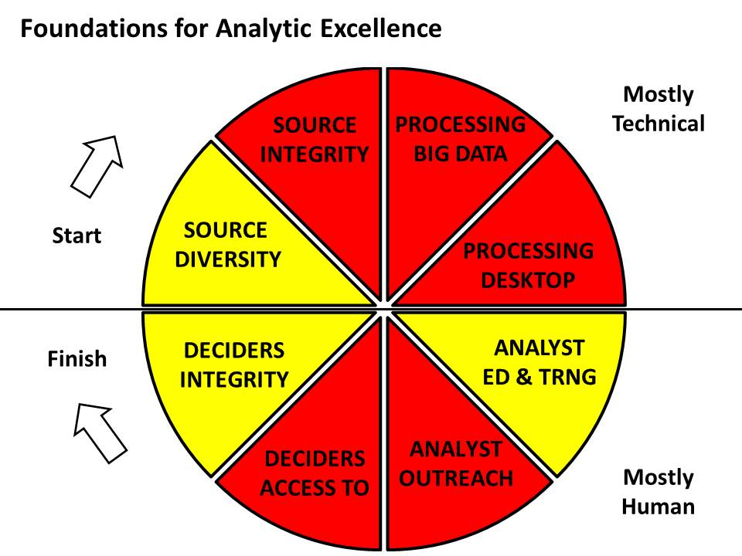
The below set of tools, defined by Diane Webb, Dennis McCormick, and Gordon Oehler at CIA’s Office of Scientific & Weapons Research (OSWR) still does not exist today because the Deep State does not want you to have what Howard Rheingold in the 1980’s called “tools for thinking.”
They want us stupid, entertained, unquestioning, unable to connect the dots, accepting total idiocy from the mainstream and social media in a constant churn whose entire purpose is to keep us from thinking.
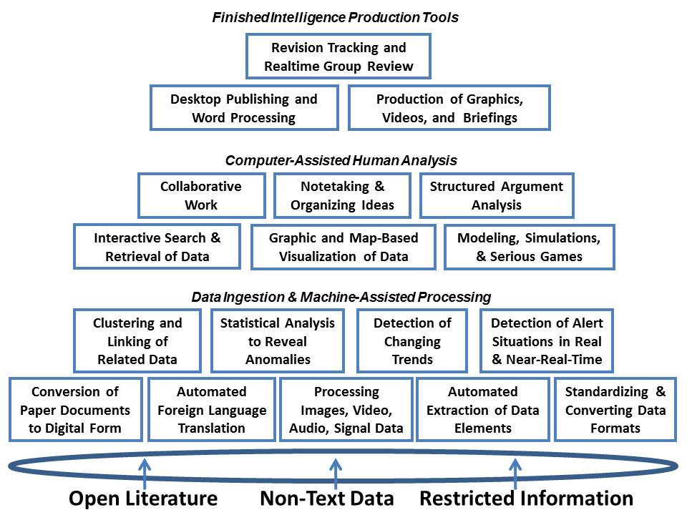
And finally, here is the larger context in which we can see how morally and intellectually impoverished the secret intelligence world is.
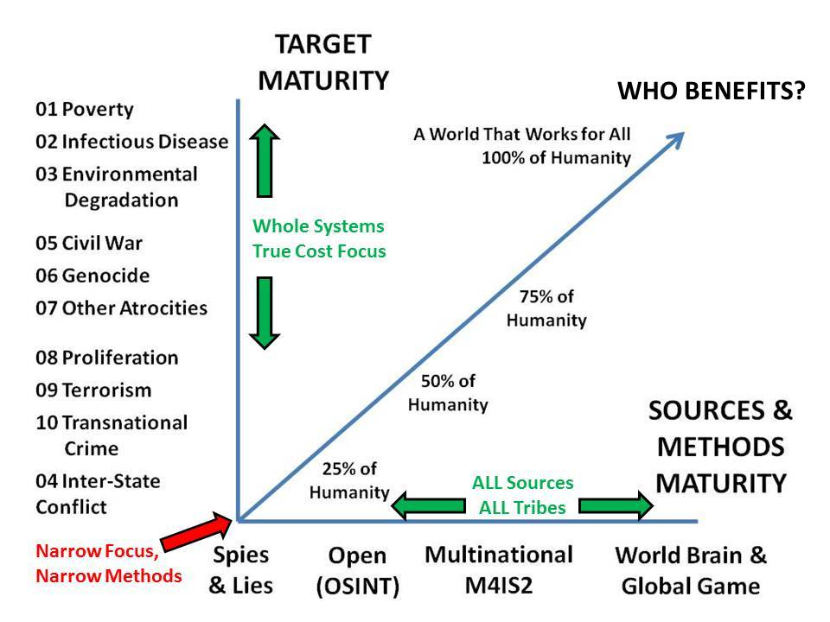
Selected References:
1989 Webb (US) CATALYST: Computer-Aided Tools for the Analysis of Science & Technology
Review: Tools for Thought–The History and Future of Mind-Expanding Technology
Robert Steele: Core Works UPDATED with 21st Century University
Robert Steele: Intelligence at a Cross Roads: To Be Or Not To Be… Review of Principled Spying by David Omand and Mark Phythian

Deep State Defined – Deep State Methods of Control
Peter Dale Scott is the original scholar defining the deep state, a term he took from a Turkish publication as preferable to his prior use of deep power, representing unelected power not easily visible to the public and actually controlling elected officials. The Deep State consists of the 1% of the 1% at the very top – the Rothschilds, Chabad Cult, the Vatican particularly the Jesuits, the descendants of Ceasar said to be organized as a P2 Lodge, and the British elite, themselves a whole owned subsidiary of the Rothschilds and Chabad through intermarriage, bribery, and blackmail in which pedophilia, murderous pedophilia, and Satanic Ritual Abuse (SRA) including blood drinking and fetus and body part eating, appear to have been used over centuries to “own” the British elite.
The Deep State controls the world through Central Banks that are privately owned and operated, not government banks as too many assume, and secret societies, particularly the Freemasons, Knights of Malta, Opus Dei, and others. I like to emphasize that most organizations consist of 90% good people trapped in a bad system, and often unwitting.
The Deep State uses blackmail, bribery, and control of election processes (including electronic voting machines that were designed to designate the winner before the first vote is cast, through the use of fractional voting (there are many books on this now) to create two-party tyrannies in each country, such that a majority of the voters are disenfranchises and elections can be used to put into power people whom in most cases are already controlled before they are elected and if not, soon brought under control.
The Shadow Government consists of those individuals in local, state, and federal government who are controlled by the Deep State and routinely betray their country, state, county, and the public is concealing information, covering up crimes, and achieving outcomes that are not in the public interest. A simple example, one common to Baltimore, New York, and San Francisco, is the granting of public land and tax exemptions as well as pollution waivers to corporations controlled by the Deep State, foregoing massive public revenue, in return for outright bribes, sometimes in the guise of consulting commissions, to the public officials who go along with what is nothing more than legalized crime.
Much has been made of the military-industrial complex and the Senior Executive Service (SES) or in the secret world, the Senior Intelligence Service (SIS). There is no question but that both have great influence and the power to do things that are not approved by Congress and are often out-right crimes. The secret space program and DUMBs are illegal programs – they were never authorized by Congress and funds were never appropriated. The Shadow Government can not only loot the public treasury, it has access to vast sums of illicit money from stolen gold as well as human trafficking drug trafficking, and the sale of guns (or in the case of Israel, controlled nuclear technology).
It merits comment that roughly 90% of our Congress has sworn an oath to Israel First not America First, and roughly 10% of our SES/SIS are dual Israeli-US citizens and therefore de facto agents of a foreign power.
The reference below is my treatment for a documentary series on the Deep State that I have wanted to do, the History Channel had a look but was afraid to engage the truth – they can do aliens but they cannot do the Deep State.
Selected References
Robert Steele: Deep State, the Documentary Series
Deep State @ Phi Beta Iota

Deep Underground Military Bases (DUMB), WTF?
This is not something about which I have direct knowledge but all of my non-fiction reading confirms that there are numerous deep underground military bases, and there may be many high speed tunnels using anti-gravity technology to move mass over long distances faster and cheaper than anyone might imagine.
I note with interest the degree to which the federal government has taken over most of the last West of the Mississippi. I believe this is partly to accommodate very large missile and stealth testing, and partly to house underground bases and cities. Our sovereign states have a right to take back their lands; we also have a right as a public to demand a complete inventory of all programs – both underground and off-planet, that have been funded without Congressional authorization and appropriation.

Democracy Lost — How States & Public Were Gutted
I have published on this topic, as have others, please see below.
Selected References
2015 Steele on Democracy Lost – “OUT OF CONTROL: Can Open (Public) Power Effect a Non-Violent Revolution?”
Open Power: Democracy Lost & Found Essay, Book Review Blurbs and Links [Updated 3 MAR 2015]
Worth a Look: Book Reviews on Democracy Lost & Found
Democracy Lost @ Phi Beta Iota

DHS/FEMA/TSA – the New Gestapo Ready to Kill Patriots?
There is absolutely no question in my own mind but that Dick Cheney is the most famous America traitor since Benedict Arnold, and was responsible for enabling 9/11 and overseeing the creation of the Patriot Act well in advance of 9/11, to create a police state at perpetual war.
There is also no question in my own mind – absent direct knowledge but with a great deal of reading and observation – but that Michel Chertoff, a proven Zionist, created DHS in Benjamin Netanyahu’s image, to join CIA and NASA as Deep State control elements with the Zionists using DHS to advance the false flag operations via FEMA (after Obama, a Manchurian Candidate, repealed that aspect of the Smith-Mundt Act that forbade lying to Americans, and also institutionalized the federal “license to lie” to the Courts that upholds the false flag narratives with national security warrants that threaten those who tell the truth with life in prison or instant assassination); to train police in Zionist methods being used against Palestinians – we are all Palestinian now, which is why Zionist-trained police refer to us as “cockroaches”); and to take over control – secret cyber access -- to all judicial and law enforcement communications and computing across 18,000 jurisdictions. I cannot over-state the degree of evil embedded in DHS. It should be abolished.
It is also relevant to note that the Mossad (as well as major crime families including Clintons, Bushes, and the traditional Italian and Russian mafias) have complete impunity in carrying out assassinations across the USA; the compromised local sheriffs and local media cover these up, and when someone like Gary Webb comes along, they simply kill them and pretend it was suicide – with two bullets in his head.
Finally you have Private Military Contractors, notably Blackwater or whatever its cover name is, as well as Dynacorps. Dynacorps is not only trafficking in small children using US military bases and aircraft, it is controlled by the Zionists, it is their de facto private army and also their de facto guerrilla force “behind enemy lines” (We are the enemy in their mind) right here in the USA.
Selected References:
Review: Licensed to Kill–Hired Guns in the War on Terror (Hardcover)
Review: Licensed to Lie – Exposing Corruption in the Department of Justice by Sidney Powell (Trump Revolution Book 41) with Mike Flynn As Current Victim of Unethical Prosecutors
Stephen Lendman: Police in the USA – License to Kill [with Impunity]
Mongoose: Is AIG Part of the CIA, Part of the Deep State, or Just Plain Evil? UPDATE 3 Mark Gaffney 3 Part Series
DHS @ Phi Beta Iota
FEMA @ Phi Beta Iota
PMC @ Phi Beta Iota
TSA @ Phi Beta Iota

Directed Energy — Is Judy Wood on Target?
In my own mind the exclusive use of military-grade thermite in the 9/11 atrocity does not stand up to scrutiny. Directed energy and nuclear are the other two alternatives. I reviewed her book very favorably, and have also published 28 memoranda on 9/11. Gordon Duff has published most of the information on the nuclear option. I find it telling that Benjamin Netanyahu mentioned the nuclear aspect in his 1990’s book, and that Israel has long had access to the US nuclear program to steal nuclear triggers and materials, most recently with Jeffrey Epstein appearing to have recruited Bill Richardson when he Secretary of Energy.
I do believe we have directed energy weapons and possibly a directed energy satellite as well as stealth aircraft that can do directed energy (e.g. against Paradise California where vehicles and houses burned while most trees did not, and those trees that did appear to have burned from inside out).
I also believe that the electromagnetic spectrum has been weaponized, and directed energy now goes from vaporizing mass to wreaking havoc on individuals at the DNA level and including the Voice of God.
Selected References:
Judy Wood by Robert Steele: Memorandum for the President: 9/11 Twin Towers Were Vaporized by Directed Energy Weapons
Review (Guest): Where Did the Towers Go? Evidence of Directed Free-energy Technology on 9/11
Mongoose: Directed Energy Weapons and 9/11 Twin Towers…
Joseph Olson: 9/11 Nuclear – The Unequivocal Story
Rebecca Campbell: Directed Energy Weapons = Forest Fires That Cut Houses in Half, Do Not Burn Trees
Gordon Duff: 9/11 Nuclear New Release of Previously Censored Information Indicting Dick Cheney, Benjamin Netanyahu for US Nuclear Material Theft & Proliferation
Gordon Duff: 9/11 Nuclear Index of Articles
Francois Roby: 9/11 Nuclear Demolition
Q Anon on 9/11 Nuclear…
Directed Energy @ Phi Beta Iota
9/11 Nuclear @ Phi Beta Iota

Drone Assassination — Because We Can…
I abhor CIA’s drone assassination program. It should be transferred to the Pentagon at the same time that all our overseas bases, including “covert” drone bases, are closed down.
Selected References:
Robert Steele: UNHINGED: drone assassination – American suicide
Berto Jongman: CIA’s Secret Torture Sites & the Competing CIA and DoD Drone Assassination Programs
Drone Assassination @ Phi Beta Iota

Earth Hollow, Earth Concealing Water Deep Underground?
I have no direct knowledge but noticed the below references, and have heard from others that there are a number of specialists who are quite certain that there are vast reservoirs of water (“three times the volume of all the oceans”) within the Earth. I myself am focusing on using free energy to desalinate ocean water, converting the brine into sodium bicarbonate.
Selected References:
New Scientist (2014): Massive 'ocean' discovered towards Earth's core
Live Scientist (2007): Huge 'Ocean' Discovered Inside Earth

Election Manipulation: 2 Countries, 12 Methods
I was one of the first, along with Bill Binney, to recognize the Russian election interference hoax, now known to be contrived and therefore treason by then President Barack Obama and senior officials in the Department of Justice, CIA, FBI, and NSA. It took too long to put this treason down
In my experience, there are only two countries that are routinely and comprehensively interfering with US elections and those countries are Zionist Israel and Great Britain, whose elite has become so compromised through contrived intermarriage as to no longer represent the good people of Great Britain. I now publish a weekly series, Election 2020, that includes a section on Zionist election interference. In my view AIPAC and the ADL should lose their non-profit status and be obliged to register as agents of a foreign power, at the same time that our president needs to implement the twelve reforms I have aggregated from hundreds of others who in turn drew on thousands. The below graphic is the only authentic, comprehensive chart in existence for restoring integrity to our elections. This matters because the Deep State and its Zionist underbelly control all our elections, and also shut 70% of the voting public out from both office and vote.
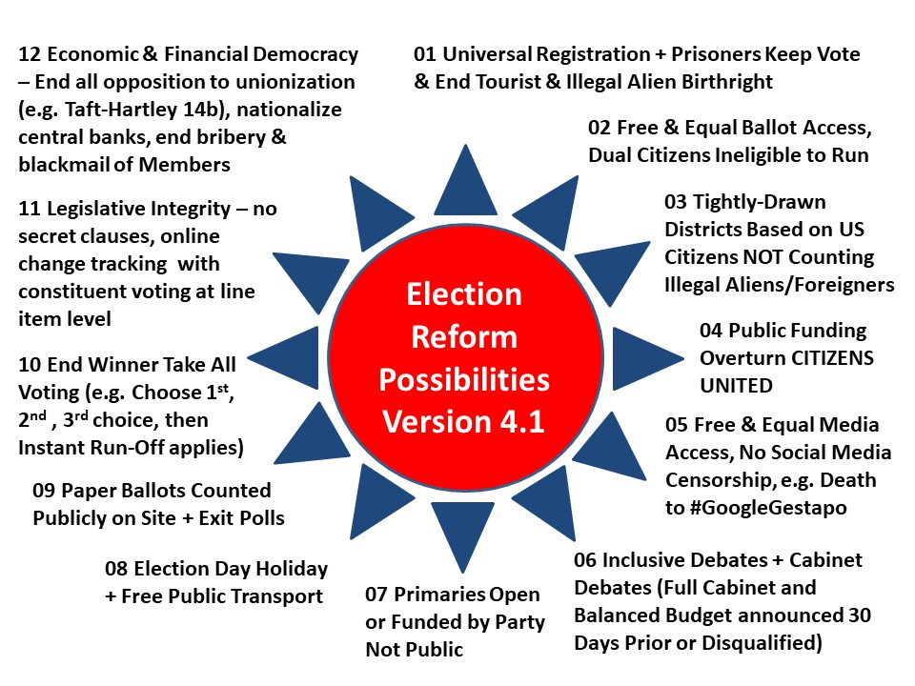
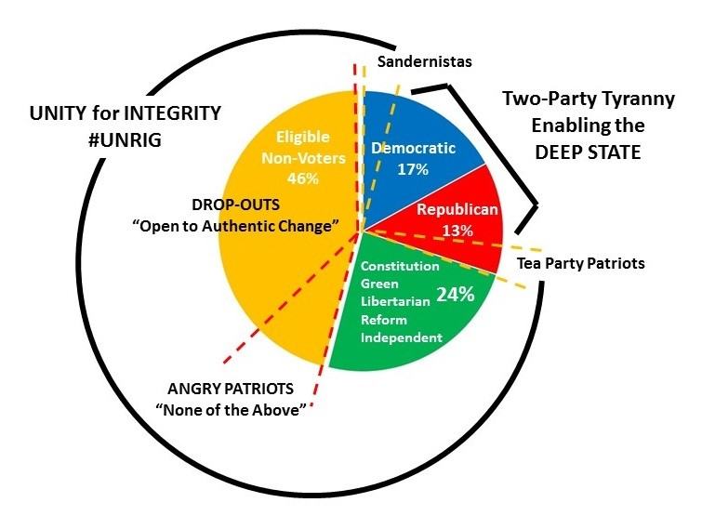

Selected References:
Robert Steele: The Soft Coup Collapses – Blackmail Revealed – What Next? CIA was bluffing, produced no evidence – Russians did not “hack” the election. Is this the beginning of the end of the Deep State in the USA? Can Trump clean house & wage peace? (Trump Revolution 06)
Robert Steele: US IC Allegations Against Russians Are Crap — Our Own Traitors, Not the Russians, Are the Real Enemy, Fake Evidence & Fake News – UPDATE 22
Robert Steele with Hanne Nabintu Herland: Need for US Election Reform (#UNRIG), Web 3.0
Robert Steele: Zionist Strike 37 – US Senate Select Intelligence Committee Probing Israeli Interference in 2016 Election — Probably Using NSA’s Parallel Construction Investigation Ordered by Attorney General…
Mongoose: Is Clinton in the Kill Zone? Huber Investigation Popping on 13 March? FISA DECLAS Taking Down British Government and MI-6 Interference in US Election?
Gordon Duff: Mueller Dropping Russia, Focusing on Israeli & Saudi Interference in US Elections?
Mike Krupa: Vatican Interference in US Election — Call for Investigation [Plus Kellyanne Conway on Media Bias Seeking to Manipulate Election]
Wayne Madsen: CIA Interference in US Election is Without Precedent – Blackmailing McCain & Graham
Election Reform @ Phi Beta Iota
Open Power @ Phi Beta Iota

Electromagnetic / 5G Ecocide & Genocide
I was the first that I know of, in 1993, to point out the dangers of electromagnetic pollution (in my invited rant to Paul Allen’s INTERVAL think tank), and also the first to warn the White House, in 1994, that they needed to spend $1B a year (in 1994 dollars) on cyber-integrity. The Russians have long been known to have electromagnetic emissions controls and shields ten times tougher than ours. There is no question but that our irresponsibility with respect to electromagnetic emanations is harming both people and animals – 5G appears to be the ultimate manifestation and is assuredly genocidal and ecocidal while taking the ability to target individuals to new levels.
Selected References:
1993: God, Man, & Information – Comments to Interval In-House (Full Text Online)
1994 Sounding the Alarm on Cyber-Security
Electromagnetic @ Phi Beta Iota
5G @ Phi Beta Iota
Mind Control @ Phi Beta Iota

Extra-sensory perception/Deep State efforts to dumb down
I have no direct knowledge but I completely buy into the non-fiction books by individuals such as David Icke and David Wilcock, and I have also talked with retired NASA scientists at the PhD and beyond level who assure me that the emerging public understanding of 26 dimensions and up is on target; that there is a “K” band that allows stuff to be teleported (e.g. throw a fork through a window); and I believe that between extraterrestial reverse engineering and black budget innovation there are some astonishingly power capabilities such as remote viewing, and some equally dangerous capabilities that should be brought under control.
Selected References:
Review: Project Human Extinction – The Ultimate Conspiracy
Review: Everything You Need to Know But Have Never Been Told by David Icke
Review: The Source Field Investigations – The Hidden Science and Lost Civilizations behind the 2012 Prophecies, by David Wilcock
Review: TAVISTOCK INSTITUTE – Social Engineering the Masses by Daniel Estulin — Deep State Playbook
Ed Jewett: Book Review – Microcosm and Medium by Joseph Farrell — A Mind Control Prophylactic
Reference: Entangled Minds, Extra-Sensory Perception
SPECIAL: Robert Steele in Tehran Times on Full Disclosure (Extraterrestials, No Nuclear War, End of the Deep State?) UPDATE: Front Page Print Edition, Info to President Trump
Berto Jongman: US Army Major Ed Dames on ‘Psychic Espionage
Pedophilia & Empire: Satan, Sodomy, & The Deep State – Chapter 9: Military-CIA Mind Control, Torture, Pedophilia and Satanic Sacrifice
John Maguire: YouTube (20:35) Disentangling the Quantum Enigma

Extra-Terrestrial & Secret Patent Technology (Free Energy)
All of the literature now points clearly to our having been in contact with extraterrestrials since the 1930’s and prior civilizations before that. There appears to be no question but that we have combined reverse engineering with guided innovation as well as outright theft and repression of publicly devised solutions (Tesla, others). There are over 6,000 secrecy orders (some so secret they are not even counted) that our president has promised to declassify. Among them free energy stands out as the game changer, because that makes possible both enormous savings in not having to extract and transport fuels, but it also opens up the possibility of unlimited desalinated water and the population of desert lands that are now too costly to inhabit.
Selected References:
Steven Aftergood: 5,792 Secrecy Orders on Inventions
Hans Kern Interviews Robert Steele for Rag ‘n Rock: World Brain II.0 or How We Should End Secrecy and Learn to Harness the Hive Mind
Yale The Politic: The Intelligence Gathering Conundrum + Toxic Secrecy RECAP
Free Energy @ Phi Beta Iota

False Flag Operations — How, Why, Who Benefits?
I ran a false flag operation for the CIA. The term originated in maritime warfare where pirates and enemies would fly the flag of their prey (hence false flag) until they go close enough for a surprise attack. There are many false flag events now known to be false flag events, which is to say, they are carried out by someone other than the claimed perpetrator, generally to achieve a shift in public perception that would not happen otherwise. False flags and lies have been used to start wars, from the Maine boiler explosion to 9/11.
Selected References:
Free Online:
Memoranda for the President on 9/11: Time for the Truth — False Flag Deep State Truth! UPDATE 17: Israel Did It
BLOCKED BY AMAZON: Memoranda for the President on Sandy Hook Truth — Jeff Bezos and Amazon Must be Included in the Class Action Lawsuit
Robert Steele: False Flag Attacks – A Tool of the Deep State (Trump Revolution 12)
Robert Steele: The Syrian Missile Attack — Theatrics & House Cleaning? False Flag Attack Organized by McCain, Brennan, McMaster, Funded by Saudi Arabia and Israel? (Trump Revolution 10)
Robert Steele: The Orlando Mass Casualty Event A False Flag Drama, Atrocity, or Hybrid?
Robert Steele: Was Paris 11/13 a False Flag Event? A Matrix for Evaluating Possibilities
False Flag @ Phi Beta Iota
Amazon:
Steele, Robert. 9/11 Truth: From Campaign Promise to a Presidential Speech on 9/11 2018? (Earth Intelligence Network, 2018)
Steele, Robert. TRUMP vs. THE DEEP STATE: Recent Reflections of a Former US Spy & Marine Corps Officer (Trump Revolution Book 35), Amazon Kindle, Earth Intelligence Network, 1 May 2019
Steele, Robert. Sandy Hook Truth: Memoranda for the President of the United States of America (Trump Revolution Book 34), Earth Intelligence Network, September 2018.
Steele, Robert. 9/11 Truth: From Campaign Promise to a Presidential Speech on 9/11 2018? (Trump Revolution Book 33) Amazon Kindle, Earth Intelligence Network, 28 July 2018.
Steele, Robert. False Flag Attacks: A Tool of the Deep State (Trump Revolution Book 12). Amazon Kindle, June 8, 2017.
Steele, Robert. The Syrian Missile Attack – Theatrics & House Cleaning?: McCain, Brennan, McMaster Behind False Flags? Funded by Israel & Saudi Arabia? (Trump Revolution Book 10). Amazon Kindle, April 11, 2017.

False, Reductionist Medicine & Science — Institutionalized Lies
Fake news is accompanied by fake history, fake medicine, fake science, and of course outright lies from every form of organization. As Dennis Prager wrote recently, lies become common currency when truth is not a value. I did not start to wake up until after I left the CIA, and I began to wake up in earnest when the Zionists attacked #UNRIG six ways in ninety days and I realized they are the main enemy (not to be confused with decent Jews). Now I see that most of what we have been taught is a lie, and most of what we are being told – including about our education, our government, our food, our medicine – is a lie. The Center for Disease Control (CDC) is an especially evil enterprise, serving as a marketing arm for a very corrupt and unprofessional medical industry that is striving to make vaccines mandatory when they are either not needed, or actually cause the disease or autism or both. Vaccines are also used to sterilize and infantilize, feminize, and otherwise incapacitate otherwise healthy humans.
An Open Source Agency (OSA) such as I propose would have an Information Bureau with many divisions, including one to rewrite history, another to do quality control on medicine, and so on. What we have today is a massive lack of intelligence with integrity across the board.
Selected References:
Robert Steele: How the Deep State controls social media and digitally assassinates critics – #GoogleGestapo – Censorship & Crowd-Stalking Made Easy (Trump Revolution 17)
David Icke: The Khazar Hoax — Zionist Israel’s Fake History (YouTube, 44:24)
Mongoose: Fake History – systematic and methodical theft and destruction of history
SchwartzReport: Fake Medicine More Lucrative than Cocaine — Failure of Governance on a Global Scale
#GoogleGestapo @ Phi Beta Iota
Autism @ Phi Beta Iota
CDC @ Phi Beta Iota
Fake News @ Phi Beta Iota
Vaccine @ Phi Beta Iota

FBI, NSA use of parallel construction to violate legal protections
I am blessed to know both Bill Binney and Sidney Powell, both of them skilled, one from the NSA side the other from the prosecution and defense side, with what is known as parallel construction. This is where the FBI and NSA use mass surveillance and warrantless wiretapping to violate the 4th Amendment against unreasonable search & seizure, and then with that information, they miraculously “find” reasons to create a legal case. Such misbehavior is known as “fruit of the poisoned tree” and is supposed to result in a complete dismissal of charges because they are rooted in violation by the government, but more often than not these days judges are compromised, often by Mossad, CIA, FBI, and NSA blackmail, and they go along. The government also conceals exculpatory information, known as Brady material, because government representatives lack integrity, are not being held accountable by the judiciary or Congress, and consider themselves above the law. Matt Taibbi and George Will have both written to the injustice in our legal system. It merits comment that whites are now suffering the injustice of an unjust legal system, something blacks have understood for centuries.
Selected References:
Review: Licensed to Lie – Exposing Corruption in the Department of Justice by Sidney Powell (Trump Revolution Book 41) with Mike Flynn As Current Victim of Unethical Prosecutors
Sidney Powell: Video Speaking at CATO on Licensed to Lie
DefDog: Judge Slams Mueller for Lies & Misrepresentation and Lack of Evidence — Should Robert Mueller be Indicted?
Caitlin Johnstone: Prosecuting Assange Sets Stage for Silencing All Journalists Comment by Robert Steele on National Security Warrants Compelling Lies
Robert Steele: Zionist Strike 37 – US Senate Select Intelligence Committee Probing Israeli Interference in 2016 Election — Probably Using NSA’s Parallel Construction Investigation Ordered by Attorney General…
SchwartzReport: NSA as Foundation for Police State with Comment on “Parallel Construction”

Fox News — Are they controlled opposition?
Yes. The only thing worse than Fox is CNN. I consider Tucker Carlson one of the only serious journalists at Fox. The manner in which Fox mis-handled the Epstein story tells you all you need to know about Fox being totally compromised.
Selected References:
Robert Steele: My Dream — Trump to Fox “You’re Fired”
Robert Steele: Neil Cavuto (Fox News) and Mike McCaul (R-TX, DHS) Are Bushies — Their Broadcast Just Now Was Defamatory, False, and Reprehensible UPDATE 2 Texas Drug Racket?

Genetically Modified Organisms Killing Humanity
It is a sign of our society’s sickness that first we take all the nutrients out of our foods, inserting instead poisons, then sell the nutrients as supplements and vitamins, and finally modify the foods so that a) seeds commit suicide and cannot be used for new harvests and b) genetically modified organisms do bad things to your gut. This is not my area of interest but it is clearly wrong and needs to be stopped.
Selected References:
Jon Rappoport: GMO Big Lie Outed by National Academy of Sciences (NAS), Censored by Mainstream Media (MSM)
SchwartzReport: GMOs Associated with 22 Diseases
GMO @ Phi Beta Iota

Geo-Engineering (ChemTrails, Morgellons, Artificial Moon, Saturn)
Others are vastly more qualified than I; below are some references. I completely agree with both the need to stop human geoengineerings being carried out by the US Air Force and others; and also the dangers associated with whatever might be going on in the rings of Saturn. Full disclosure by the President is necessary, across the board.
Selected References:
Yoda: Chemtrails — the Secret War That Militarizes Climate Change with Geoengineering – Free Movie (1 Hour)
Yoda: Video (1:08:56) World-Renowned Doctor Addresses Geoengineering Dangers
RESTORED Above Majestic: Produced by Corey Goode & Jordan Sather Directed by Roger Richards Summary Review by Robert Steele
Review: Everything You Need to Know But Have Never Been Told by David Icke
Review: The Ascension Mysteries Revealing the Cosmic Battle Between Good and Evil by David Wilcok
Review: Our Universal Journey + Extraterrestial RECAP
Ed Jewett: Review of Genes, Giants, Monsters, and Men – The Surviving Elites of the Cosmic War and Their Hidden Agenda by Joseph P. Farrell
Chemtrails @ Phi Beta Iota
Geoengineering @ Phi Beta Iota

Glyphosate as Ligend — true cost, kills plants, debilitates humans
What impresses me is that the beer industry refuses to use wheat that has had Round Up used at any stage of the process.
Selected References:
Graphic: Glyphosate A Crime Against Humanity
Koko: List of Food & Beverages Containing Cancer-Producing Monsanto Glyphosate
Glyphosate @ Phi Beta Iota

Healing with computers and energy waves
If Einstein is correct and everything is energy, then energy is clearly going to be relevant to both causing harmful vibrations in the force and its manifestations including humans, animals, and plants; and in healing. I have read and heard about this. I believe it. I have no direct experience. I was very impressed by David Wilcock’s account of Russian work with pyramids, and remember that in Singapore in the 1960’s milk was delivered in pyramid shaped containers that kept it fresh in the tropical heat for a week.
Selected References:
Mongoose: Scalar Wars, Free Energy, Healing
Review: The Source Field Investigations – The Hidden Science and Lost Civilizations behind the 2012 Prophecies, by David Wilcock
Review: The Ascension Mysteries Revealing the Cosmic Battle Between Good and Evil by David Wilcok
Review: Selected by Extraterrestial My life in the secret world of UFOs, think-tanks and Nordic secretaries by William Mills Tompkins
Review: Our Universal Journey + Extraterrestial RECAP
Robert Steele: Healing the Self & Healing the World – The Open Source Way (Trump Revolution 14)

Health Secrets — Hidden Good Technologies, Hidden Hazards
Apart from a massive need to stop doing so much harm across our agriculture and food and “medical” industries, there are clearly both very power alternative natural medicines including the highly sophisticated Traditional Chinese Medicine (TCM), and secret anti-aging and healing technologies including the ability to generate entire new limbs. President Trump has said that he intends to remove the secrecy orders on patents. We shall see. From where I sit our greatest challenge is mental health. We are now in a situation where the Deep State and Zionists are telling us that everything that is true is a lie, and we are insane for believing otherwise. That will lead to gun confiscation, chipping, and perpetual slavery.
Selected References:
Steven Aftergood: 5,792 Secrecy Orders on Inventions
Natural News @ Phi Beta Iota

Humanity as a Cosmic Experiment in Free Will and Soulcraft
I don’t have much to offer here other than to say that I believe it, and I also believe that the core energy source for humanity is individualism operating in family and community. Ethnic cohesion matters, nationalism matters, keeping cultures and languages alive matters. The attempts to impose globalization, normalization (e.g. of pedophilia), transhumanism, artificial intelligence, all of this is evil.
Selected References:
2014 Robert Steele Answers to Richard Olivier on 21st Leadership with Annotated Bibliography & Links
Jack Mullen: The Next American Revolution – Freedom from Zionist Genocidal Apartheid Criminal Israel
Journal: Statecraft, Soulcraft, & Well-Being
Review: Christianity, Evolution and the Breath of Life
Review: Never Play Dead – How the Truth Makes You Unstoppable by Tomi Lahren
Review: The Conservative Sensibility by George F. Will – Handbook for an American Renaissance
Review: The Politics of Happiness–What Government Can Learn from the New Research on Well-Being
Review: Statecraft as Soulcraft
Review: Lee Camp Moment of Clarity – The rantings of a stark raving sane man
RESTORED Above Majestic: Produced by Corey Goode & Jordan Sather Directed by Roger Richards Summary Review by Robert Steele
Victuras Libertas (Angie & Jim) Interview John McAfee — Outlaw for Freedom
Worth A Look: Free PDF Outwitting the Devil
Yoda: Zionist Strike 41 – CRY FREEDOM from Zionist Israel — Zionist Minister Bragging in NYC About Controlling 27 US States and National Elections?
Zero Hedge: Are We Really Free in the USA?
Zero Hedge: What Would A Free Society Actually Look Like?
Book Review Categories Focused on Goodness
Complexity and Resilience (200)
Consciousness & Social IQ (300)
Cosmos & Destiny (39)
Democracy (277)
Electoral Reform USA (17)
Environment – Solution (161)
Information Society (260)
Intelligence – Collective and Quantum (120)
Intelligence – Public (341)
Intelligence – Spiritual (13)
Intelligence – Wealth of Networks (91)
Leadership (84)
Nature, Diet, Memetics, & Design (259)
Philosophy (166)
Religion and the Politics of Religion (133)
Survival & Sustainment (132)
Technology – Biomimicry and Clean (37)
True Cost and Toxicity (158)
Truth and Reconciliation (120)
Values, Ethics, Sustainable Evolution (334)
Voices Lost (Indigenous, Gender, Poor, Marginalized (242)
Water, Energy, Oil, Scarcity (120)

Immigration Contrived & Enabled as a Threat
In 2002 I predicted the illegal immigration breakout. Subsequently I have learned that both US and European leaders have taken huge bribes from the Arabs particularly, but from Latin American crime families as well, to enable massive illegal immigration, even to the point of using US military aircraft to ferry in tens of thousands of Syrian and other refugees who are then released into the night, undocumented, to make their own way – ultimately contriving false documents with the aid of “sanctuary” cities and churches. It is a crime to aid an illegal alien – this is called complicity. The Deep State and its Zionist underbelly have for centuries practices the art of divide and conquer, and they use open borders and “multiculturalism” as a means of breaking down ethnic and national cohesion in the countries they seek to dominate – in sharp contrast, the Zionists particularly, maintain very aggressive exclusionary policies (e.g. Israel is a Jewish state, an apartheid state) at the same time that they practice genocide on the Palestinian – no open borders or multiculturalism allowed in Israel!
Selected References:
2002: Robert Steele Graphic Predicting Illegal Immigration Break-Out
Ann Coulter: How we became the world’s suckers on immigration
Anthony Judge: African Immigration Forced Into Europe — 12 Strategic Questions for European Leaders
Berto Jongman: Creating a Military-Industrial-Immigration Complex
Chuck Spinney: Deadly Blowback from Neo-Imperial Wars (Terrorism and Illegal Immigration) Place Europe at Risk
Graphic: State Costs of Illegal Immigration
Journal: Muslim Tide Arousing US Heartland Anger But Loss of Moral Legitimacy Via Israel and Loss of National Intelligence Shackles America
Mongoose: How Eisenhower Solved Illegal Immigration with 1,075 Border Patrol Agents (Hint: He Castrated Employers of Illegals and Their Political Pals)
Mongoose: The Barcelona Agreement to Flood Europe with Arab/African Muslim Refugees — Treason by Leaders Across the West!
Owl: Muslim Sexual Deviance & Misbehavior now Epidemic Across Europe
Owl: Political Cover-Up of Epidemic Potential of Illegal Aliens – Medical Staff at Immigration Camps Threatened with Arrest
Review: God’s Terrorists – The Wahhabi Cult and the Hidden Roots of Modern Jihad
Review: While America Sleeps–How Islam, Immigration and Indoctrination Are Destroying America From Within
Review: While Europe Slept–How Radical Islam is Destroying the West from Within (Hardcover)
Steven Aftergood: CRS on Immigration Policy — Only 10% of Employers Participate in Alien E-Verify
Worth a Look: Melting Pot or Civil War — The Truth About Illegal Immigration Of, By, and For the 1%

Intelligence without Integrity — 4% Useful, 96% Criminal
I have written many books, monographs, and chapters as well as articles on this. I have also written a great deal on how to do it right. You can also search Phi Beta Iota for individual intelligence agencies and disciplines (e.g. HUMINT, IMINT, SIGINT, OSINT).
Selected References:
Publications
Articles
Book Derivatives
- Books in Print
- Chapters
- Kindle Shorts
- Reviews
Monographs
Official Studies
Op-Eds
Selected Posts
Theses & Papers

Mandela Effect, Alternative Memories, Past/Parallel Lives?
I have no knowledge but it makes sense to me. It everything is energy and there are communications channels that are faster than the speed of light, then Western “science” is way behind the indigenous leaders with their oral histories, and the monks. I respect and embrace the wisdom and research of authors such as Icke and Wilcock on this topic.

Military Bases as Lily Pads for Smuggling Everything, Children
Although Cynthia McKinney took Donald Rumsfeld on about Dynacorp and military child trafficking, I seem to be the one who has connected the dots and pointed out that virtually every form of smuggling is done by rogue elements of the US Government using military bases (both abroad and at home) and military or contractor aircraft with military missions. The CIA really got into the drug smuggling and money laundering business as a result of Viet-Nam, Afghanistan became a replay. As a general rule, secret intelligence agencies, even those with the best of intentions, appear to have become the primary means by which evil elements within any government are able to engage in all manner of global criminal activity as well as domestic assassination, compromise, and theft.
Selected References:
Steele, Robert with Mohsen Abdenmoumen, “In Depth: Robert David Steele” (editor’s misleading title: “Robert David Steele: CIA Uses 1000 of US Overseas Bases to Facilitate the Smuggling of Drugs, Cash, Gold, Guns, and Small Children for the Elite”), American Herald Tribune, 20 February 2017.

Mind-Control/TI Voice of God, Subliminal Media, Psycho-Police
I have not studied these topics in detail but am satisfied that both the CIA and NASA – both home base to the many Nazis brought in from WWII – have been very active in this area, and the US military is also working Voice of God and other psycho-dramas. I continue to believe that covert action, which seeks to make people act against their best interests – is not in America’s interest.
Selected References:
Fred Burks: Washington Post Reveals Secret Technology to Project Voices in People’s Heads
Review: TAVISTOCK INSTITUTE – Social Engineering the Masses by Daniel Estulin — Deep State Playbook
Review: Trance: Formation of America
Mind Control @ Phi Beta Iota

Money, Monetary Policy, Value vs. Inflation & State Theft
NOT my area of expertise but over time I have learned to respect the work of Martin Armstrong, Ellen Brown, Wayne Jett, and others. I have focused my reading on the corruption of capitalism and a few books stand out, all of which persuade me that the Federal Reserve must be nationalized – become a public bank with the US Post Office again serving as a trusted place for people to do banking that is not manipulated and cannot be stolen by private interests – but as Wayne Jett has pointed out, the Federal Reserve notes were issued by private banks, not the US Government, those are private debts to the public that should not be excused.
Monetary policy is one small part of a much larger complex of policies that need to be studied and managed holistically. Every threat, every policy, every true cost has to be calculated, integrated, and balanced. This is not something we know how to do because everything is stovepiped and fiefdoms are allowed to dig in and “own” policy domain (e.g. the way the Zionists “own” US national security policy that is always Israel First, not America First).
I have the impression President Donald Trump is strong in this area, he has stopped the decades of abuse of America and its workers by foreign countries cheating us in every possible way, I believe he will achieve additional successes in a second term.
Selected References:
Charles Hugh Smith: The Erosion of Everyday Life Under Cartel Capitalism aka Mercantilism
G. Edward Griffin with Michelle Holiday: Truth Exposed – The End of the Dollar, the End of the Federal Reserve?
Judy Shelton to Fed, Asset-Backed Currency on 4th of July, and More….
Robert Steele: Judy Shelton Is Right — Gold-Backed Currencies Now!
Robert Steele: Meet Judy Shelton, Trump Advisor on Gold-Backed Dollar UPDATE 1: Trump On the Record / Global Currency Reset
SPECIAL: Judy Shelton Rocks – Recent Interview
Rand Clifford: The Federal Reserve Caused the Great Depression
Robert Steele: Saving America – Saving Capitalism. Start with the Truth.
Review: Skin in the Game – Hidden Asymmetries in Daily Life
Review: The Fruits of Graft
Review: The Soul of Capitalism–Opening Paths to a Moral Economy
Review: The Battle for the Soul of Capitalism
Review: STOP, THIEF! The Commons, Enclosures, and Resistance
Wayne Jett: USA Main Street Mugged by Wall Street Mercantilism (Crony Monopoliges) — What We Have Today is NOT Capitalism
Wayne Jett: One Fed Two Debts — US Owes Fed and the Fed Owes Us — GOOD NEWS AMERICA!
Wayne Jett: Federal Reserve is America’s Largest Debtor – President Donald Trump Should Hold Them Accountable (Nationize the Fed but Do NOT Nationalize their Debt)
Worth a Look: Book Reviews on Bankruptcy of US Economy, Federal Reserve Malfeasance
Zero Hedge: Judy Shelton (Sound Money Gold Advocate) to Federal Reserve? Robert Steele: Global Currency Reset This Week & Next?

Moral Decline — Liberalism “Anything Goes” As a Threat
Review: 935 Lies – The Future of Truth and the Decline of America’s Moral Integrity

National Rifle Association (NRA) – Are they controlled opposition?

Natural Law and Inalienable Rights (Including Fetal Lives)

Nuclear power plans subject to flooding — Armageddon soon?

Pedophilia & Empire, Pedophilia Overview, Pedophilia Entrapment

Propaganda Operations Legalized by Smith-Mundt Revision

Religions as Forms of Control, Abuse, & Mis-Direction

Rendition & Torture Operations

RICO against social media violators (FAANG, #GoogleGestapo)

Satanists & Satanic Ritual Abuse, Torture & Adrenochrome

Traitors Among Us – Use DNA Tests to Verify Claimed Origins?

True Cost Economics & Western Predatory Capitalism

TRUMP: is he a Zionist puppet?

Truth at any cost lowers all others costs — Robert’s motto

United STATES of America — terminate “the corporation”

USA in State of Emergency legalizing domestic war crimes?

Vaccine Hazards — Politicians Practicing Medicine w/o License

Waste — 50% of the Western Economy – Venn Diagram

Water as the New Gold, Already Stolen, Recover with Free Energy

Weapons of Mass Instruction — Why Schools Are Killing Humanity

Zionism versus Judaism — Zionist Strikes, #UNRIG, Peace in ME

