The End of American Exceptionalism? The End of US Bases Overseas? The End of Israel? Trump 2020?
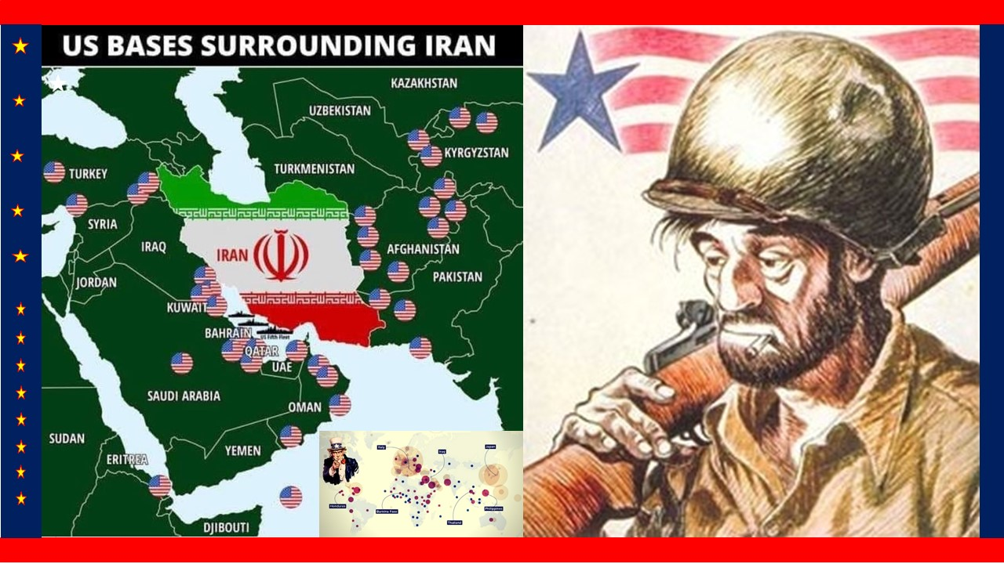

As soon as I started seeing headlines in Israel asking if Trump could be trusted, I started to wonder if we are headed toward some kind of radical shift in the Middle East (such as the end of Israel), that would be accompanied by a radical shift in US foreign policy (such as the closure of all our military bases) and a radical change in the US domestic political scene (such as the end of the Democratic Party and the full exposure of the Zionist occupation forces that planned and executed both 9/11 and the many pedophilia entrapment operations across the USA, of which Jeffrey Epstein is merely the best known. I engaged a person who wishes to remain anonymous in conversation, and below are the questions they asked, with my answers.
Q. President Trump visited Afghanistan on 28 November, and claims peace talks with the Taliban have re-started. Henry Kissinger, the same man who predicted the end of Israel by 2022, has declared US “exceptionalism” to be over, and China to be the full equal of the USA. Your thoughts?
A. It was my privilege to serve in Afghanistan in 2013, as a contractor analyst for a Special Forces unit responsible for “big picture” evaluations. It was immediately clear to me that the government would not sign the Base Security Agreement; that Abdullah Abdullah, a Tajik pretending to be a Pashtun, was a world-class thief (as was Karzai), and that the Pashtuns own the country and there is no material difference between the Taliban and the Pashtun. They defeated the British, they defeated the Russians, and they have defeated the Americans. President Trump gets that – he also knows that the Chinese are years ahead of us in exploiting the rare earth minerals in northeastern Afghanistan; while the Pakistani military are creating new billionaires by processing Afghan opium into #4 heroin – opium not grown under the Taliban, but restored as a cash crop by the USA (our banks are desperate for drug money as a form of liquidity, and illicit cash funds illicit activities by rogue elements of the US military and CIA). We will leave Afghanistan soon militarily. I am not sure the President has been briefed on how the Afghans hate the Chinese and would rather have someone else working the rare earths. It is possible Iran will again extend north, too few know that Herat in Afghanistan was once the capital of the Persian Empire.
Henry Kissinger, the man who killed 20,000 additional US troops by sabotaging the Paris Peace Talks for political gain, only to accept the same terms four years later, has always been, apart from nakedly amoral, one of America’s best analysts. When he chooses to tell the truth, he is one of the best minds we have. The comment you refer to was made in November and featured in the Russian propaganda outlet Strategic Culture with the headline, “Henry Kissinger Gets It… US ‘Exceptionalism’ Is Over.” American exceptionalism ended when we fled Viet-Nam on 29 March 1973. I lived in Saigon from 1963-1967 as the son of an oil executive engineer; today I realize that CIA bombed monasteries and churches to inspire hatred; that Ngo Dinh Diem was a despot with a murderous sister, and that we really went into Viet-Nam to “use up” our military so we would have to buy it again. Iraq was a similar misadventure, indeed all of our misadventures in the Middle East are summed up by our President, who has said “we spent seven trillion dollars there, and have nothing to show for it.” He is right. We will leave the Middle East, and Israel will cease to exist, if not by 2022, then by 2026.
Q. Iran is surrounded by 44 US military bases, and all indications are that President Trump is continuing to support Benjamin Netanyahu and Zionist Israel – while his son-in-law continues to be an almost satanic presence – as well as a laughingstock – in the White House. What is the basis for your confidence in relation to the closing of US bases overseas – including those surrounding Iran, and the end of Israel?
A. Allow me to answer that question at three levels – political, political, and political. At the first political level our President appears to be acutely aware that 22 million US veterans are angry – many of them are impoverished, unemployed, and mentally distressed, with over 75,000 amputees and 250,000 diagnosed as mentally disabled. Tulsi Gabbard, while a fraud in some ways, has captured the anti-war sentiment across America. America First means not Israel First and it means a growing public demand for an end to war as a racket, a phrase popularized by Marine Corps General Smedley Butler. President Trump knows that Michael Bloomberg can buy victory in 2020 – moderate Republicans are prepared to vote for Bloomberg despite his many elitist positions harmful to the average American, and Bloomberg could outspend Trump three to one. Bloomberg, with financial backing from another billionaire, Tom Steyer, is not the man that Trump is, but he has bigger pockets and a better campaign staff. The President, does, however, have fourteen initiatives he can take in 2020, so I continue to believe he will win in the Mother of All Landslides.
At the second political level, represented by Trump’s demand that South Korea pay for the US presence in Korea (a similar demand appears to have been made toward Japan), US bases overseas are not affordable any more. As the US economy “resets” we need to bring those troops and their wallets and all associated jobs – several million jobs counting local support jobs – back to America.
At the third political level, I believe that President Trump has already “made the deal” with General Secretary Xi Jinping and President Vladimir Putin, and everything we see that simulates friction over trade, Hong Kong protests, Syria, is just that: simulation. The over-all deal has been made. The one big regional deal that remains to be made is with the Supreme Leader of Iran. I was deeply moved and impressed by the Supreme Leader’s recent comments as featured in Tehran Times on 15 November 2018, “Leader: Elimination of Israel doesn’t mean elimination of Jewish people.” Our President knows that Israel is an invented state; that Truman and Churchill were bribed to approve it over the objections of all American experts who knew this would lead to 200 years of regional instability. He knows – as the Supreme Leader has made clear – that restoring Palestine to the Palestinians in no way reduces the prosperity and peace available to Jews who remain in Palestine.
There is now increasing recognition in the USA that Israel and the Deep State are using multiculturalism, open borders, poisoning, and cultural warfare to destroy the USA from within. This story is best told by Professor Kevin MacDonald in his book The Culture of Critique.
When Israel starts to ask the question, “Is Trump the Biggest Threat to Jews?,” we are making progress.
Let me end by pointing your readers to two books, one by David Vine and one by myself, that establish the practical political, economic, and cultural reasons for closing all US bases overseas.
David Vine, in BASE NATION: How U.S. Military Bases Abroad Harm America and the World (Metropolitan Books, 2015) is one of the most patriotic and practical books I have read out of over 2,000 non-fiction books that I recently discussed in a lecture now on video. Here are seven specifics from that superb book:
01 Drawing on RAND and former senior Department of Defense leaders, the author shows how any given base overseas costs at least twice what it would cost, per year, if it were located in the USA
02 The effectiveness costs of destroying the military’s ability to do its own logistics including combat and support engineering, in favor of private military corporations (PMC).
03 The internal social costs of a constantly deployed military include truly horrific internal rapes — not just men of women but men of men — and an aggregation of pathologies that I find worthy of an immediate shut-down.
04 The external social costs of this same deployed military are huge — from entire cities devoted to prostitution around the largest of US base networks (Korea and Germany stand out) to criminal relationships carried over from one command to the next. External costs also include inflated land prices, distortions in local and national government spending (e.g. granting land and waivers to US forces in lieu of pursuing the public interest).
05 The opportunity costs to American society of misdirected spending on the military are very well covered by the author, and merit careful study. These opportunity costs span both the alternatives in the way of poverty remediation, expenditures on domestic infrastructure, education, and family services, health care, are more; spending by troops and the military within the US domestic economy instead of foreign economies; and tax avoidance by the PMCs.
06 The outright waste cost of a system that is out of control — the military simply does not do cost-benefit analysis and — my own comment here, has no strategy because it lacks intelligence with integrity.
07 The total cost of Empire — the vast costs, including the four trillion dollar war that destabilized Iraq and began the unraveling of the Middle East, Central Asia, and North Africa. The author offers less in this area than I would have liked as context, but his focus is on bases and their direct costs.
The balance of my review of this superb book is free online.
My own book, delivered to the White House in four copies on 29 November 2019, and to the Secretary of Defense, the Secretary of the Army, eleven Army generals, one Marine Corps general, and one Admiral on 2 December 2019, is REINVENTING NATIONAL SECURITY: Grand Strategy, Global Reality, and the U.S. Army -- Everything Our President Is Not Being Told (Trump Revolution 45). This book is available as a full-color printed book, as an electronic book, and also free online in its original three-monograph form as published by myself after the sponsor of the work, the US Army’s Strategic Studies Institute, paid me and then censored the work -- they refused to publish it for all the wrong reasons. My letter of transmittal to the President is a matter of public record, make of it what you will.
Q. Would you mind sharing the text of your letter and the distribution list here, with our readers?
A. I would be glad to share this. A complete copy of the letter including the single graphic worthy of a President or Supreme Leader, and the distribution list is online at Robert Steele: Open Letter to the President: Reinventing National Security – New Book.
Here are two quotes from the letter:
There are two keys to taking down the Deep State: the first is to reduce the secret IC by 70% while also moving the NIC to the EOP and creating the Open Source Agency (OSA) that CIA has fought me on since 1988. You can apply the savings toward retraining all those let go (a “soft landing” as you cut the size of government) while also creating real jobs in the heartland.
The second key is the closing of all our bases overseas – stop being everyone else’s Army and bring those dollars (and jobs) home. There is a role for DoD here at home – a return to the Home Guard concept. Congress will go along if you show that transformation can be job and revenue neutral state by state and district by district. We need to stop letting the Deep State treat DoD as its piggy bank and enforcer – war is a racket, and only you can stop that racket. I seek to help you. You cannot Make America Great Again without first dealing with the endless-war/regime-change complex that also uses our bases as lily pads for human and drug trafficking.
I have done all I can to serve my country. I am not sure President Trump can survive the traitors and mediocrities that surround him, but I pray for his re-election and his triumph. If he does not finish the job others – including myself – can and will, from 2024 onwards. The die is cast.
Let me also encourage your readers to consider the possibility that President Trump is managing our exit from the Middle East in a most brilliant manner that the Supreme Leader would find encouraging. Here is the one article I have been able to discover that articulates the genius behind the complex moves being made by our President:
Sylvain LaForest, “About Trump,” Oriental Review, 15 November 2019
Q. I see now that I have not asked about the 2020 election and how you see things developing. Can you share your appreciation for the current impeachment process and projected 2020 electoral process?
A. Gladly. While I remain very concerned by our President’s failure to connect with blacks, Latinos, women, the young, and the old, on balance he appears headed for a landslide victory, in part because the Democratic Party is now in complete disgrace over the impeachment witch-hunt that followed the Russian witch-hunt, and in part because of the mediocrity of all of the Democratic candidates including Michael Bloomberg, whom I like personally but who lacks the charisma and populist instincts of Donald Trump.
Let’s start with the contrast that is about to be drawn between Adam Schiff, a Zionist tool who is probably being bribed if not blackmailed over all of the pedophilia and murderous pedophilia going on in his Los Angeles District, and John Durham, who is about to bring criminal indictments in the Russian witch-hunt case. I am expecting at least six criminal indictments that will wreak havoc with the Shadow Government and particularly those traitors in the Department of Justice, the CIA, and the FBI, who organized a deliberate coup against our President, beginning with illegal surveillance and a collaboration with the British intelligence services, approved by the Prime Minister, that can only be described as wicked. The special relationship with the British may be OVER.
The Democrats are now panicking, and starting to speak of censure instead of impeachment at the same time that our President is demanding that they impeach him so he can mount a defense including witnesses under oath, a defense that will surely increase the number of citizens who favor our President over his detractors while also leading to more criminal indictments.
The evidence against Joe Biden and his son Hunter Biden continues to mount, there is an equal amount of evidence with respect to criminal enrichment by Hillary Clinton and Nancy Pelosi, 2020 may be the year in which the Democratic Party not only loses the House, but loses a third of its House seats to Tea Party Republicans, Libertarians, and Independents. If the President were to embrace #UNRIG and level the playing field in time for Libertarians and Independents to be elected in 2020, not only will he win in the Mother of All Landslides himself, but the Democratic Party will be destroyed once and for all.
He may not be impeached – over ten Democrats in the House whose Districts love Trump now realize they could lose re-election in 2020 if they vote for impeachment. Even if he is impeached, the Senate proceedings will further undermine the Democratic Party and never lead to conviction.
More troubling is a recent attempt to poison President Trump and put Mike Pence in power. Thankfully this failed – Pence is a lazy hypocrite and Zionist tool known to have stabbed our President in the back with major donors. He should be dismissed in favor of Dr. Cynthia McKinney as a unity vice president. It is even possible the British were parties to the recent poisoning, which appeared to be rooted in the use of polonium, the same poison used in the British false flag assassination of long-forgiven Russian defector Alexander Litvinenko.
There are for me three uncertainties going forward into 2020.
The first is the President himself. He does not have a great team of campaign strategists and communicators, he is carrying the entire campaign on his own shoulders. He has no surrogates of note for reaching out to blacks, Latinos, students in debt, elderly in debt, and suburban as well as rural women who do not in any way identify with #UnwantedIvanka. I believe in our President and I believe he can do fourteen different things in the months leading up to Election Day. I do not think he will take on the Zionists – including 9/11 disclosure and Epstein disclosure – until after re-election but I want to make a critical observation: Zionist money is now out of favor, and Jewish voters are now liberated from Zionist command – Elizabeth Warren’s criticism of Israeli settlements is the truth-teller on this point. She is saying she does not want nor need Zionist money, and is confident of receiving Jewish votes regardless of how Zionist Israel might wish to oppose her advancement.
The second is Michael Bloomberg. If Bloomberg were to follow my playback at the same time that the President refuses to entertain a black female vice president, #UNRIG, and a unity Cabinet of real people instead of fellow billionaires, Bloomberg can buy the election with ease. A Bloomberg-Gabbard ticket would be competitive, but President Trump should destroy both of them if he is at his best. A Bloomberg-McKinney ticket would be harder to beat – but McKinney favors President Trump, so it is a real frustration to me that those who “guard” the President are keeping him from talking to her by lying to our President about her – they will do anything to keep him from having an authentic female colored vice president respected by blacks, women, and progressives across the USA.
Third and last is the Libertarian Party. I consider their leadership myopic and self-destructive and have had this discussion with John McAfee, their most prominent candidate for the presidential nomination. Because the Libertarian Party is the only party that is capable of getting their candidate on every one of the fifty state ballots, it is the only party remotely capable of winning against the two-party tyranny that rigs the system to shut out 70% of the voters. Sadly, my efforts to get the Libertarians to embrace #UNRIG, create a unity ticket with the Greens, and announce a coalition cabinet and balanced budget have failed. They could still surprise me – a Jesse Ventura – Cynthia McKinney Libertarian ticket would change the dynamics of the election and force Trump to make concessions or guarantee a victory for Bloomberg.
On balance, I believe that President Trump will triumph, not only in re-election, but in what he does in his second term. I have listed fourteen things that I think he is already doing or that I would like to see him doing, and that list has proven quite popular, both as a video and as an online post.
VIDEO: Former CIA Spy Talks Debt Jubilee, Arrests, Free Energy, Global Currency Reset | Robert David Steele
POST: Robert Steele: Q Anon What Next? Marshall Masters on The Drip, The Filth, & The Noose — Salute to Sidney Powell, Comment on Epstein Case, List of 14 Presidential Initiatives UPDATE: Video & Related Links

