by Robert David Steele
Trump Peace Plan – Sheer Genius – Israel Gone by 2022
January 31, 2020 International
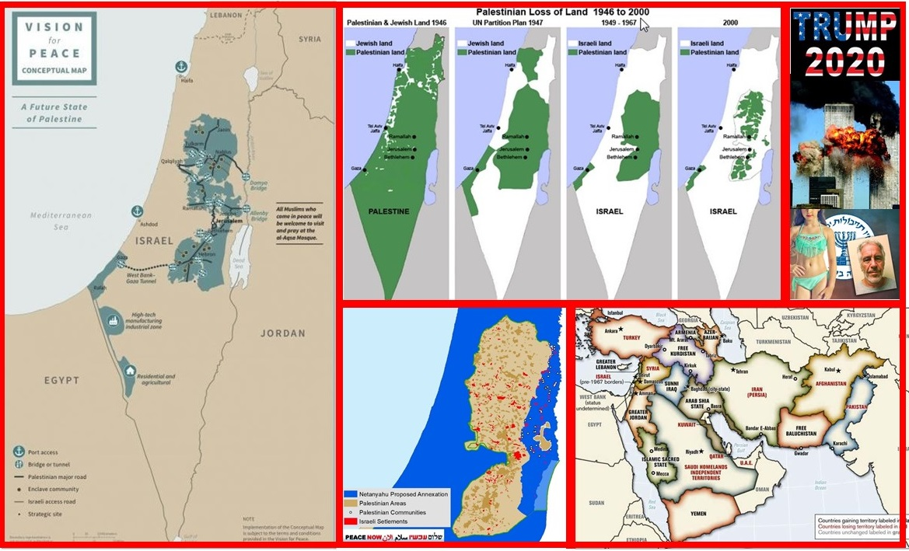
TEHRAN - Robert David Steele, a former Marine Corps infantry officer and CIA spy as well as an activist for Open Source Everything Engineering (OSEE), contributes regularly to Tehran Times.
President Donald Trump is a genius. The “new” Palestine Peace Plan is a promising first step toward the restoration of Palestine in President Trump’s second term, when he can fulfil his most important promise to all Americans, one subtly made by Q Anon: “Zionists last.”
Our President knows full well that the Zionists were responsible for 9/11, with planning beginning in 1988 when the Twin Towers were declared a hazard that must be manually dismantled by 2007. The owners – the States of New York and New Jersey, desiring to avoid a $2 billion dollar bill, began conspiring with Larry Silverstein, who briefed Benjamin Netanyahu who briefed Dick Cheney who ordered planning to begin for the 2001 false flag event that I document in the 28 memoranda by 26 expert witnesses delivered to President Trump on 8 August 2018: 9/11 Truth.
Our President is also fully familiar with the Mossad pedophilia entrapment and blackmail rings used to control US politicians, judges, prosecutors, media voices, and celebrities. I have documented the Nine Veils of Evil represented by the Ghislaine Maxwell – Jeffrey Epstein pedophilia network, which is but one of over fifty such networks managed by the Mossad in collaboration with rogue elements of the CIA and the FBI – the same rogue elements that traffic in small children, drugs, guns, cash, and gold, to create the massive off-budget funds used to nurture the Deep State’s transnational criminal operations.
It is a huge mistake to react to the President’s notional peace plan as if it were real, or in isolation from the looming demise of Zionism. 9/11 and pedophilia disclosures are going to make every Jew in America immediately denounce Zionism and call for the eradication of every organization representing Zionism. The American Israel Public Affairs Committee (AIPAC) and the Anti-Defamation League (ADL) – like the social media services they control – are going to face massive public condemnation, and massive legal actions to include loss of non-profit status and formal designation as agents of a foreign power (pending the demise of Israel) and anti-trust, Title 7, and tortious interference civil lawsuits from all those censored, defamed, and deplatformed – digitally assassinated – by what we in the USA call #GoogleGestapo.
As soon as the impeachment trial is over, I predict that President Donald Trump will file a federal lawsuit for defamation against unregistered but obvious Zionist agents Chuck Schumer, Adam Schiff, and Jerry Nadler, as well as a selection of those who have been cyber-stalking the President with broadcast defamatory statements, such as Yale psychiatrist Bandy Lee; specific media personalities and their guests at CNN and MSNBC; and the social media platforms that have been censoring and misrepresenting the President while nurturing cyber-stalkers against the President. People are going to lose their jobs, their wealth, and their medical licenses when this battle is finally won.
The peace plan in its present form, written by Zionists for Zionists, is offensive in every possible respect and should be rejected: it entrenches unequal rights and validates annexation, both crimes against humanity by any possible measure. The Jordan Valley in particular – as with the Golan Heights – should be off limits to Zionist incursion. It is bad enough that the Zionists have been stealing water from the Jordanian aquifers for decades, using long underground pipes that cross beneath the border. The one important assistance that the USA could have offered is not present: 100 water desalination plants favoring the Palestinians who remain under a water siege – a form of collective punishment that is a war crime. Jordan, Iran, Syria, and Russia should plan for the use of force against Zionists moving into the Jordan Valley, and against Zionists who refuse to withdraw from the Golan Heights belonging to Syria.
The economic offerings are ludicrous and will never materialize. Iran and Palestine are absolutely in the right in continuing to demand an end to the Zionist state of Israel and complete restoration of the entirety of Palestine to the Palestinians, with the rights of Jews guaranteed within that construct.
It is a mistake to consider the peace plan in isolation from the historical reality that Palestine was stolen from the Palestinians, who are correct to reject it, and in isolation from the many regional issues – including boundary adjustments – that must be addressed as a whole. As I wrote in “Peace in the Middle East: Denuclearizing Israel, Restoring Palestine, and More,” for the Russian International Affairs Council, 18 May 2018:
Everybody has this wrong – Trump is not bluffing and he is not Netanyahu’s puppet. What has really happened here is that Xi, Trump, and Putin agreed over a year ago to take down the Deep State. The denuclearization of Korea, combined with the destruction of old banking order, will be followed by the denuclearization of Israel and the restoration of Palestine. We are at the beginning of a 1,000 year period of peace and prosperity for all.
I go on to list eight topics that must be addressed together, first by the leaders of Iran, China, Russia, and the USA and then in a larger setting with the leaders of Egypt, Jordan, and Turkey as well as the leaders of the Gulf States and the always hostile and challenging Saudi Arabia:
1. Denuclearization of the Middle East including Israel
2. Peace between the Sunnis and the Shi’ites
3. Jerusalem and perhaps Mecca as international cities
4. Restoration of Palestine
5. Creation of a Kurdish Confederacy (no changes to existing national borders)
6. Repatriation of all unemployed Muslims from Europe back to Arabia, and reparations for Iraq
7. Creation of a post-Western post-fossil fuel economy with unlimited desalinated water
8. Creation of a regional Open Source Agency and network with information and engineering bureaus sufficient to create prosperity for all at 10% the cost of the failed Western economic paradigm.
From where I sit, the matter of Palestine is not negotiable, and the Supreme Leader’s clear distinction between Jews welcome to remain in Palestine and the Zionist state of Israel (an invented state that needs to be terminated) is a vital enabler of a final accord. Henry Kissinger said this would happen by 2022. I believe President Trump is aware of the need to meet that timeline.
I have included a map of the Zionist settlements within what little territory has been left to Palestine to make the point that if Palestine were to be restored to the Palestinians, such settlements would no longer be incursions, but rather starting points for extending the same level of infrastructure and investment to all Palestinians.
I say it again: President Trump is stringing the Zionists along until after he wins re-election. In his “art of the deal” delay and deception are critical when you are not ready to “make the deal.” He cannot “make the deal” until after he is re-elected. It is not enough to reject this plan, it is vital that the Palestinians, supported by other countries, come back with a larger peace plan that is obviously more achievable, more honorable, and more sustainable. Shine a light on the criminal insanity of the Trump Peace Plan.
President Trump knows this is a stupid plan. He knows his son-in-law is in everyone else’s pocket.
What President Trump needs from Iran and Turkey among others, is a context for “making the deal” in a way that the American public can understand, presented with such publicity that the American media, controlled by the Zionists, cannot mis-represent the alternative.
The truth about Israel, and the truth about Saudi Arabia, is not visible to the American public. The truth about Israel arming the Kurds and destabilizing Iran, Iraq, Syria, and Turkey with Kurds, is not known. The truth about Saudi Arabia and Wahhabism – a form of Zionism that needs to be eliminated – is not known. The Saudi atrocities in Somalia and Yemen are not known. The state-sponsorship of terrorism by Israel and Saudi Arabia (and Qatar by some accounts) is not known.
President Trump is a businessman, and the American people want peace and prosperity. The truth about the role played by commerce from China to Iran and Turkey and beyond – the role played by the Silk Road and now by the Internet in facilitating commerce that flourishes in peace – is not understood by the American public. The US Government itself has been slow to understand that China has installed the Internet and cellular communications across Africa and the Middle East and Central Asia and that this is a victory that American bluster, American guns, and American lies are not going to over-turn.
Pepe Escobar is one of the most gifted observers of the region who is writing in the English language, and I offer below two quotes from his recent “Why the New Silk Roads are a ‘threat’ to US bloc:”
What the New Silk Roads are proposing is wide-ranging, economic, interlinked integration from East Asia, through Central Asia, to Iran, Iraq and Syria all the way to the Eastern Mediterranean. Just like the Ancient Silk Roads. No wonder vested War Party interests are so uncomfortable with this real peace “threat.”
No wonder strategic fear was glaringly visible at the NATO summit in London last month, which called for ratcheting up pressure on Russia-China. Call it the late Zbigniew “Grand Chessboard” Brzezinski’s ultimate, recurrent nightmare.
Within a few years, I anticipate that Chinese and Russian and Iranian influence based on commerce and communications backed up by next generation defensive umbrellas and offensive electromagnetic scalar time-energy weaponry the US is not ready to match, will allow peaceful resolution of the Palestinian and Kurdish matters. I pray that the Sunni-Shia divide is resolved, and that the Wahabbists follow the Zionists into oblivion. In many ways the Zionists are a “mini-me” of the failed UK and US empires. The Vietnamese beat the Americans with the tunnels of Cu Chi and bare feet combined with iron will, the Czechs beat the Russians (power of the powerless), the Afghans beat both the Russians and the Americans, and Iraq is about to finally rid itself of the American occupying Army (the rockets into the US Embassy were fired by American collaborators as a false flag).
The USA is in grid-lock because of the traitors in the Democratic Party and the media who work for the Deep State and are continuing to try to over-turn the results of the last election and prevent what I am predicting, a landslide victory for President Trump in 2020. His successes – over 289 of them by one account – have been hard-fought and achieved in the face of every possible opposition up to and including at least twelve assassination attempts. Iran – and the Palestinians – will benefit from a Trump victory in 2020 and should keep this strategic perception firmly in mind going forward.
What would help our President now, in my view, is a strong counter-offensive aimed at the American public. This counteroffensive should challenges President Trump to fulfil his promise to disclose 9/11 truth and challenge President Trump to fully disclose all that we know about the hundreds of US politicians (mostly Democrats) and others entrapped by Jeffrey Epstein with pedophilia videos. Such a campaign should also strive to graphically, viscerally, compellingly, illuminate for Americans the war crimes of the Zionists and the plight of the Palestinians along with the war crimes of the Saudis and the plight of the Yemenis while publicizing the truthful books that are a stake in the heart of Zionist Israel, books such as Enclosure – Palestinian Landscapes in a Historical Mirror, Against Our Better Judgment – The Hidden History of How the U.S. Was Used to Create Israel, The Invention of the Land of Israel: From Holy Land to Homeland, The Culture of Critique, and We Will Not Be Silenced – The Academic Repression of Israel’s Critics.
In my view, the new peace plan should be welcomed for what it is – a throw-away – and rejected. Palestine and Iran should now propose a new larger peace summit with the leaders of China, Russia, and Turkey as well as Syria and Jordan – and perhaps others as observers, certainly including the Kurds – and begin to hammer out a holistic sustainable peace plan that will show the latest “offer” to be a farce.
Peace in the Middle East – and the restoration of Palestine – are both inevitable. I believe our President understands that. His first term has been focused on survival, and on setting the stage for the elimination of the Deep State and the Shadow Government and the traitors such as Chuck Schumer, Adam Schiff, and Jerry Nadler – each a Zionist traitor, not just a traitor. His second term will be focused on rebuilding America. To do that he needs to reinvent national security, beginning with the closure of all US bases overseas, bringing all our troops home, and freeing America of foreign entanglements and distractions, as our first President George Washington so wisely advised. Somewhere in there I want to help our President reinvent intelligence and reinvent engineering – we can achieve a post-Western economy for the 99% at 10% the cost of the failed Western economy of waste and banking profit, using Open Source Everything Engineering (OSEE). Iran should become a leader in the OSEE domain.
I realize that superficially it appears that our President is continuing to grovel before the Zionists. I think not. The tide in America has turned. The center of gravity in the near term is the American public. It would help if President Trump were pressured to abandon the Zionists sooner than later, and also challenged on why he continues to refuse to defend the US Constitution (1st, 2nd, 4th Amendments particularly) and why he refuses to implement #UNRIG electoral reform so that the 70% of the US voters who are shut out of the election process are given voice – if we are to have peace around the world, we must take down the two-party tyranny that fronts for the Deep State, and that can only be done through electoral reform. President Trump knows all of this, but he is being mis-led by Republicans who assure him of victory if he sticks with his old, white, heartland base. Others disagree – Tucker Carlson for one, top Republican pollster Andrew Garfield for another – Zionist Michael Bloomberg could still win with a combination of money and a female as token vice president. President Trump needs a “wake up call” on this point; it may be that President Putin, prompted by the Supreme Leader, could deliver such a call.
President Trump will continue to do theatrics with the Zionists until they are such an obvious political liability within the USA that he is able to dump them. The Democratic candidates for the presidency are rejecting Zionist money and keeping Jewish voters – this is a message President Trump needs to hear more directly from every leader desiring Middle East peace.
The initiative, in my view, is now with Iran. If Iran will nurture Iraq, balance the Turks, and (with Turkey and Iraq and Syria) find a solution for the Kurds, we will by 2022 cut the Saudis and the Zionists off from US funds and military assistance, and deliver on Palestine with the Golan Heights returning to Syria. In the meantime, reject the peace plan and label it for what it is: a delusional theatrical mélange of unrealistic as well as unethical proposals of no merit.

