NATO 2040:
Intelligence (Decision-Support) as Root for Transformation
Robert David Steele
Executive Summary
This white paper outlines how Intelligence (Decision-Support) can help the North Atlantic Treaty Organization (NATO) transform itself from a reactive conventional military instrument of the Member States; and instead become a central unifying strategic force for waging peace, achieving prosperity, and ending war in all its forms. NATO can be greater than the sum of its parts.
Transformation can be job and revenue neutral within each Member State – hence politically doable.
NATO must first come to grips with its lack of organic intelligence capabilities, particularly access to Open Source Information (OSIF) and its inability to produce Open Source Intelligence (OSINT) sufficiently compelling to impact on strategic, operational, tactical, and technical (acquisition) planning, programming, budgeting, and execution (PPBE) among each of its Member States.
$2 billion a year is on the table with the Under Secretary of Defense for Intelligence (USDI) for an Open Source Agency OSA) that both creates the modern OSINT discipline, and provides a context for radical improvement in classified collection, processing, and all-source analysis. It is within NATO’s power to propose to USDI an executive agency role for the Atlantic Transformation Command (ACT) of NATO, that would immediately yield $25M per year Initial Operating Capability (IOC) under Joint Forces Command / 2nd Fleet with a facility in Dam Neck, Virginia, toward $200M per year Final Operating Capability (FOC) in Dam Neck, with access to another $800M per year in OSINT and Human Intelligence (HUMINT) capabilities – including private sector investigative and analytic capabilities – world-wide.
Two appendices are provided to illuminate the value of this long-recommended but also long-contested approach to “intelligence done right” – Application A on Four Forces, and Application B on Waging Peace. Presidential and USDI briefing materials on an OSA are available separately.
Table of Contents
Intelligence (Decision-Support) – Intelligence Done Right 2
Appendix A: 4 Threat Classes, 4 Type Commands, 4X the Impact 17
Appendix B: Waging Peace – Faster, Better, Cheaper? 24
Glossary 30
Endnotes 31

Intelligence (Decision-Support) – Intelligence Done Right

Executive Summary
The lack of organic intelligence capabilities has proven to be a substantial handicap for North Atlantic Treaty Organization (NATO) leaders as they have sought to transform NATO in preparation for the future. NATO, while it is an alliance of its Member States, is also a separate international organization. To be ready for Future Operational Environment (FOE) 2040 NATO must be able to create strategy, guide the acquisition of inter-operable force structure, plan operational campaigns, and execute fire & maneuver of combined arms forces both in and out of area.
The lack of organic intelligence capabilities has proven to be a substantial handicap for North Atlantic Treaty Organization (NATO) leaders . . .
In the ideal, NATO could take the lead in transforming intelligence such that it provides a common foundation for Member State strategy, acquisition, operational planning, and integrated intelligence support to tactical operations.
Among the transformative shifts that must take place within the discipline of intelligence if NATO is to benefit, are from collection (inputs) to timely relevant decision-support (outputs); from an obsession with technical and digital to respect for human and situational; from focusing only on state-based military threats to all threats including non-state non-military threats; from secrecy to openness; and from planning for the worst-case to shaping – and achieving – the best case.
$2 billion a year is immediately available for an Open Source Agency (OSA) from the Under Secretary of Defense for Intelligence (USDI), a substantial portion of which could be allocated to the Atlantic Transformation Command (ACT) and the Joint Forces Command (JFC), to create a Multinational Decision Support Center (MDSC), perhaps located at Dam Neck.
The greatest transformation challenge for NATO is intellectual, not financial and not physical. This paper spends time on holistic analytics, true cost economics, and multi-level analytics precisely because none of the Member States do holistic analytics or true cost economics or multi-level analysis.
The greatest transformation challenge for NATO is intellectual, not financial and not physical.
NATO’s transformation must be rooted in a transformation of NATO’s mind-set. That transformation must begin with the transformation of intelligence, starting with the analytic model for “doing” NATO intelligence. An autonomous intelligence capability will make NATO priceless to its Member States in ways never before considered.
Transformation can be job and revenue neutral across all political jurisdictions. This paper shows NATO how to use OSINT to achieve transformation, and how to get the USA to pay for the transformative intelligence while also considering an American transformation – the USA, like NATO, needs four forces after next, not one. ACT can take the lead in transforming everything.
Data, Languages, Tribes
Data is any raw single piece of information in a particular medium (imagery electronic, written or spoken word), most often not in digital form and often in a language other than English (over 20 languages really matter, along with Arabic in 11 major and 19 minor dialects.
Data and information are accessed and viewed by eight different information “tribes,” each of which has its own unique mix of sources, cultural and intellectual filters, processing tools, and constituencies. The eight information “tribes” in alphabetical order are: Academic, Civil Society (including Labor and Religion), Commerce especially Small Business, Government especially Local, Law Enforcement, Media including Bloggers, Military, and Non-Profit.
Without exception, all of these tribes are operating on 1% to 2% of the relevant information.
Without exception, all of these tribes are operating on 1% to 2% of the relevant information. In the case of both big business and big government, it is documented that they collect 1% of what is published, and process only 1% of what they collect. What is published is generally 1% of what is written which is generally 1% of what is known and not written or published.
Information
Information is data that has been collated and put into a generic form for access by many. Information is generally generated, and access, by domain – academic disciplines, commercial categories, government policy domains, military mission areas – and not integrated across domains.
Intelligence
Intelligence, properly understood, is a synonym for decision-support. It should not be confused or conflated with covert operations that are best left to special operations.
A generic secret product is classified information, not intelligence (decision-support). Decision-support exists when the process of intelligence has been utilized to answer a specific question by a specific decision-maker or decision-making group.
A generic secret product is classified information, not intelligence (decision-support).
The process of intelligence consists of requirements definition (what do we need to know), collection management (where can we find, get, buy, or steal what we need to know), processing, analysis, and dissemination.
Decision-support in needed by NATO leaders – and their Member State leaders but the two are not the same – at the strategic, operational, tactical, and technical (acquisition) levels.
The traditionally acknowledged collection disciplines include Human Intelligence (HUMINT), Signals Intelligence (SIGINT), and Imagery Intelligence (IMINT). A new discipline of Measurements and Signatures Intelligence (MASINT) is as yet largely unproven. A mixed discipline, Open Source Intelligence (OSINT) is both a sub-set of each of the classified disciplines, and an all-source discipline in its own right.
It is widely acknowledged that the Member State intelligence communities, the USA in particular, are weak at real-time threat detection; do not do all-source processing; have severely deficient cadres of relatively young analysts lacking in real-world experience; and also lack access to decision-makers as needed to both find out what they need to know, and to deliver answers to those questions.
For NATO leaders to appreciate why they need their own organic NATO intelligence capability, they must first confront the failure of the Member States in this mission area. More specific criticisms will be provided in the pages that follow but for now by way of introduction:
At the end of it all, classified intelligence provided me, at best, with 4% of my command knowledge.
General Tony Zinni, USMC, then Commanding General, U.S. Central Command
The National Security Agency processes less than 1% of what it collects.
William Binney, former Chief Technology Officer, National Security Agency
Below is a table summarizing a book-length evaluation of US secret intelligence capabilities as of 2000. Nothing of substance has changed since then, if anything, US intelligence is less capable today. In the table below the first grade is against conventional denied area state targets. The second grade is against unconventional emerging threats including Third World states and non-state actors.
 | Direction |  | Collection |  | Analysis |  | Dissemination
 | Old | New | Old | New | Old | New | Old | New
Strategic | C | D | B | C | D | F | D | F
Operational | C | D | D | F | B | C | B | C
Tactical | D | F | C | D | D | F | D | F
Technical | B | C | B | C | C | D | B | D
Figure 1: US Intelligence Performance Evaluation Matrix
Strategic Level
Direction. No tracking system for consumer satisfaction, no automated integrated multi-discipline requirements databases, non-traditional (i.e. non-military) consumers not well-represented.
Collection. Superb but ossified capability with limited ability against emerging threats.
Analysis. Cut-and-paste community consisting of the “green and the gray”—the new and the old with the middle having quit long ago—most with no idea of life overseas and no foreign area or foreign language skills.
Dissemination. Cumbersome compendiums of limited utility to day-to-day decisions, laboriously created over time and very very classified, a bore to read and often too much (security) trouble to bother getting.
Operational Level
Direction. Self-imposed over-emphasis on “worst-case” threats continues, with a complete lack of focus on such basics as Third World mapping or Third World communications intelligence.
Collection. Virtually no support for human contingency requirements, limited low intensity conflict indications & warning capability. No real access to indigenous foreign-language open source information.
Analysis. High motivated and responsive analysts in the joint intelligence centers.
Dissemination. Excellent dissemination from national to theater headquarters level, very poor capability to support theater (forward), Joint Task Force commanders, or Country Team members.
Tactical Level
Direction. From whom? How? At the mercy of national capabilities not designed to support the tactical commander, with a theater staff between the tactical units and the national organizations.
Collection. Adequate organic capabilities with the exception of wide-area imagery surveillance, ground reconnaissance skills (basic patrolling, adequate numbers of remote ground sensors) appear to be very weak; completely inadequate prisoner handling and interrogation capabilities.
Analysis. Mixed bag, with personnel generally consumed by volumes of traffic and additional duties—they are overloaded with raw classified data and have very mediocre hardware and software.
Dissemination. Secondary imagery dissemination problems will be fixed eventually but the lack of a realistic communications architecture to support multi-media intelligence broadcasts as well as digital mapping data suggest this will be a showstopper for some time to come. Vulnerability to high energy radio frequency and other information warfare techniques will persist.
Technical Level
Direction. The mechanisms are well-established and the scientific and technical analysts know how to get what they want but they do not always ask the right question.
Collection. Very good against denied areas, less so against emerging technical powers, our present-day allies, and non-governmental groups.
Analysis. Too much emphasis on technical countermeasures and single system threat assessments. Virtually no strategic generalizations to support cost savings in major acquisition areas.
The deficiencies of the Western intelligence services are much greater than suggested above for four simple reasons:
01 No Western leader makes a major acquisition decision (or major combat commitment decisions) on the basis of intelligence. Decisions are made on a “pay to play” basis, with political contributions and other incentives yielding, in the USA, a 750% return ($750 in government contracts for every $1 spent on lobbying). Henry Kissinger is famous for having accurately stated:
Intelligence is not all that important in the exercise of power, and is often, in post of fact, useless.
02 The Western intelligence services do not do holistic analytics or true cost economics – no attention is given to generating decision-support that would inspire investments in what Commandant of the Marine Corps Al Gray called necessary “peaceful preventive measures.”
03 Western intelligence deliberately ignore open sources of information, and in the US at least, overt human experts who do not have national security clearances, and indigenous experts who are not “agents” of the clandestine service; are explicitly proscribed – off limits!
04 All-source sense-making tools do not exist at either the organizational or desk-top analytic level.
We need not belabor the failure of Western intelligence (as decision-support) here, but two points should be made before we go on to discuss low-cost rapidly-achievable NATO solutions.
First, it is absolutely essential that national security make the moral and intellectual leap to a mind-set that appreciates that in the 21st Century there are no boundaries, and the state is in competition with banks and religions on the one hand, and criminal networks and ethnic demographic bubbles on the other. Intelligence (decision-support) must be able to access all sources in all languages on all topics, do holistic analytics with true cost economics for current, near, and long-term challenges, and shape the future.
Second, the private sector is no better off than government. Below is a previously-published appraisal of the eight failure zones for both public and private intelligence.
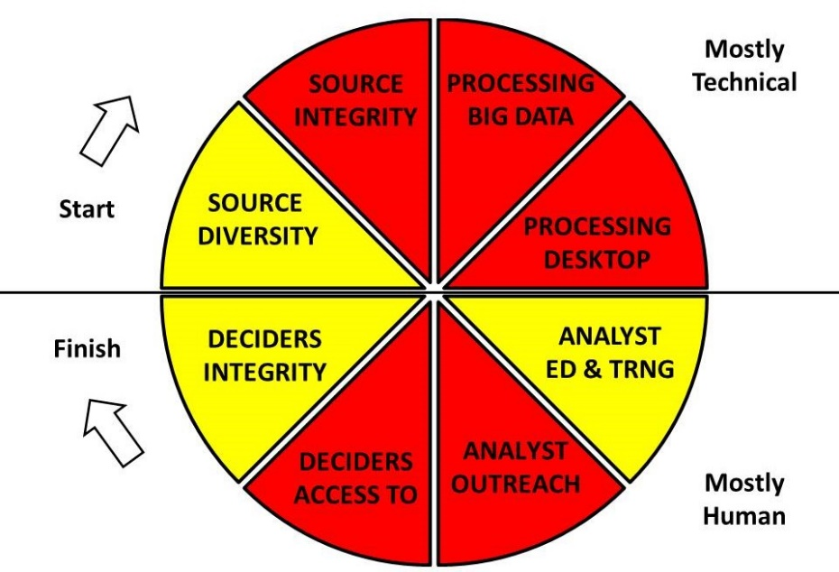
Figure 2. Flawed Analytic Foundations Common to Both Government and Private Sector
It is helpful, as we transition toward recommended solutions, to take heed of the words of Senator Sam Nunn (D-GA), then Chairman of the Senate Armed Services Committee (SASC):
I am constantly being asked for a bottom-line defense number. I don’t know of any logical way to arrive at such a figure without analyzing the threat; without determining what changes in our strategy should be made in light of the changes in the threat; and then determining what force structure and weapons programs we need to carry out this revised strategy.
The West has failed, despite the best efforts of many including the Commandant of the Marine Corps, Al Gray, in 1989, to properly evaluate the threat and propose a new holistic approach to intelligence that can illuminate and justify funding for “peaceful preventive measures.”
NATO is ignoring eight of the ten high-level threats to its Member States.
There are ten high-level threats to humanity, and the West – and NATO – are spending liberally on just two of them. NATO is ignoring eight of the ten high-level threats to its Member States.
01 Poverty  02 Infectious Disease  03 Environmental Degradation  04 Inter-State Conflict  05 Civil War | 06 Genocide  07 Other Atrocities (e.g. Human Trafficking)  08 Proliferation  09 Terrorism (mostly state-sponsored)  10 Transnational Crime
Figure 3: Ten High-Level Threats to Humanity
Below is a holistic analytic model that illuminates the kind of integrated “all threats all policies all costs” approach to intelligence that is needed for any organization that aspires to be a dominant force in the affairs of its Member States and the security of the planet in 2040.
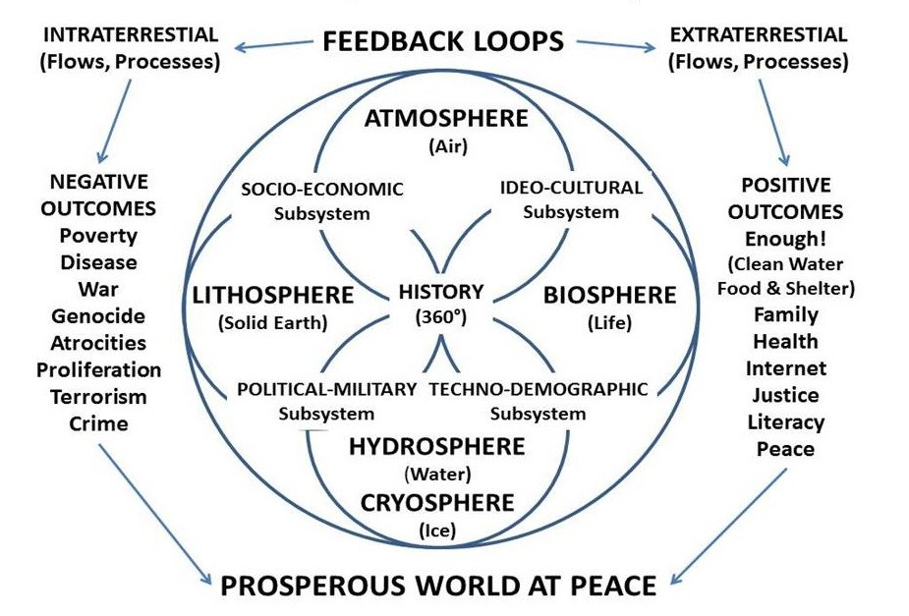
Figure 4: Necessary Holistic Analytic Approach to Total Security
Total Security demands that Member States consider all domestic threats to their state of being, as well as all policies and costs – including peaceful preventive measures – that can avoid war and achieve victory with fighting – the acme of skill.
Here is an alternative concept for a holistic NATO analytic model, this one developed within the Marine Corps Intelligence Activity (MCIA) in 1988. Civil and geographic factors matter greatly.
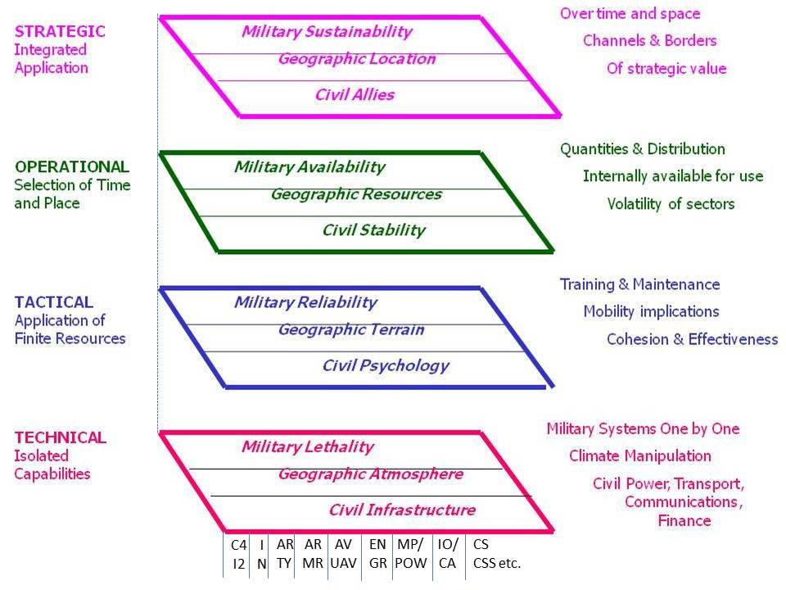
Figure 5: USMC Analytic Model Integrating Mission Area & Operating Environment
In relation to the above, the Marine Corps, in the process of producing its original intelligence product, Planning and Programming Factors for Expeditionary Operations in the Third World, devised “strategic generalizations” about the current and future operational environment that continue to be ignored today.
The standard aviation day is hot and humid, not warm and not humid, as the Western powers assume. This means that aviation can fly half as far, lift half as much, and loiter half as long.
There is no cross-country mobility to speak of across most of the expeditionary environment, and line of sight distance is under 1,000 meters less the Middle Eastern desert. This means that vehicles without tracks, and very expensive weapons systems optimized for 3,000 meters kill ranges, are both inappropriate.
Most airfields have Maximum On Ground (MOG) capabilities of 1-3, while most ports have shallow drafts and poor piers and no shore lift – at the same time that most bridges have a maximum bridge loading capability of 30 tons. This means that we need many more lift aircraft, much lighter systems, and the option of parachuting entire brigades into place – tracked bridges, not wheel brigades.
The above analytic model makes the point that geographic and civil factors must be co-equal to military factors when thinking about the FOE and how to devise a strategy, an inter-operable multi-national acquisition and sustainability plan, multi-national operational campaign plans, and inter-operable integratable multi-national tactical maneuvers, particular those requiring supporting fires.
. . . geographic and civil factors must be co-equal to military factors . . .
Here is the third and final illustration of a needed change in the Member State and NATO analytic model.
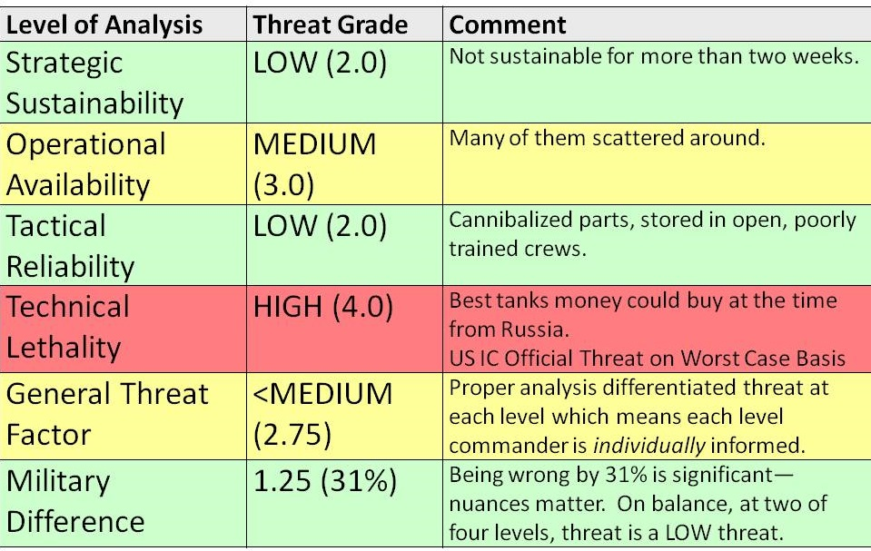
Figure 6: Holistic Threat Analytics Ends the Focus on Technical Worst Case Threats
The threat changes depending on the level of analysis. This particular graphic was created to demonstrate why the US emphasis on Libyan tanks as a worst-case threat was wrong. At the time they were the best tanks money could buy, but when evaluated at the strategic, operational, and tactical levels, they dropped from high (4.0) to low-medium (2.33 or 2.0 low if rounded down). Even factoring in the 4.0 for a total average of medium (2.75 or 3.0 if rounded up) this is an error of 31% -- a one-third error – in evaluating the threat with technical blinders ignorant of holistic analytics. What this means, at root, is that we are spending too much money on heavy, sophisticated technical systems we cannot deliver, cannot maintain, cannot replace in the face of battle attrition, and generally do not need,
The threat changes depending on the level of analysis.
The transformation of intelligence must precede and make possible the transformation of NATO, not only of NATO’s existing military force, but the transformation of NATO to expand with three additional new forces, ideally centered on a new Inter-Agency Development Command (IADC) funded by the Americans that makes possible Whole of Government strategy, operations, and tactics.
Intelligence (Decision-Support)
It is possible that NATO could become a pioneer as well as a multinational center of excellence for both 21st Century intelligence, and for the manner in which 21st Century intelligence might drive grand strategy, Whole of Government force structure and both domestic and foreign investment programs, and new forms of multinational engagement centered on HUMINT and Information Peacekeeping (PKI) that produces indigenous stabilizing wealth while stopping the local incentives for illegal immigration into Europe – a major 21st Century threat that will explode toward 2040.
$2 billion a year is available for an Open Source Agency (OSA), one fifth of which -- $200M at Final Operating Capability (FOC) – could be placed at Dam Neck under Joint Forces Command (JFC) / 2nd Fleet oversight.
$2 billion a year is available for an Open Source Agency (OSA) . . .
NATO – ACT – could start its own transformation by helping create Open Source Agency (OSA) as a foundation for transforming both overt and covert HUMINT, with $200 million a year for ACT achievable.
NATO – ACT – could start its own transformation by helping create an Open Source Agency.
What might such a transformation look like?
Below are two “orientation” graphics that represent over a quarter century of reflection.
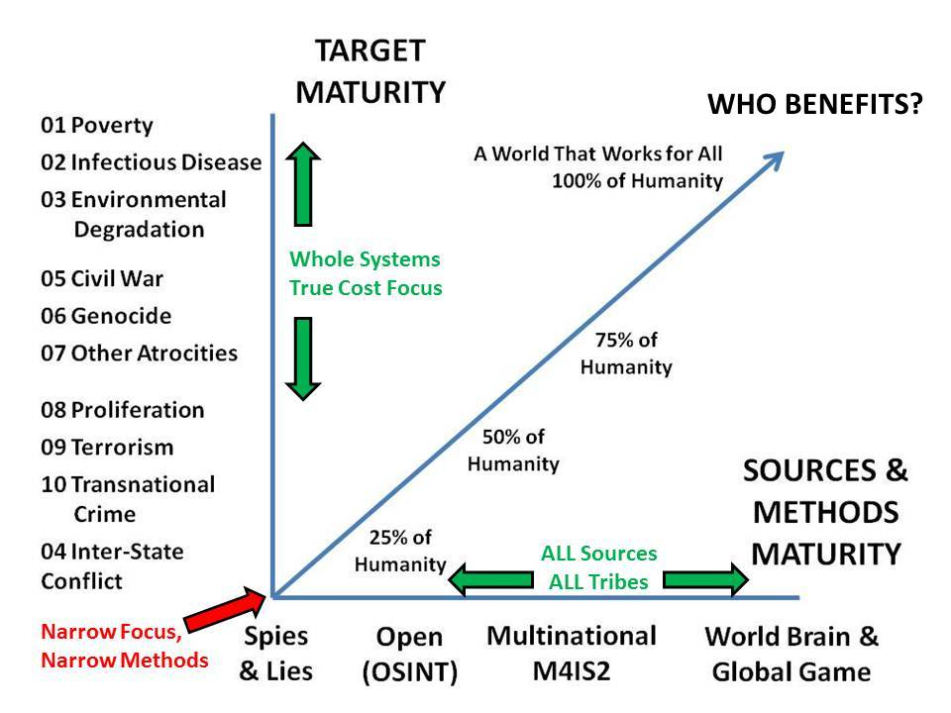 | 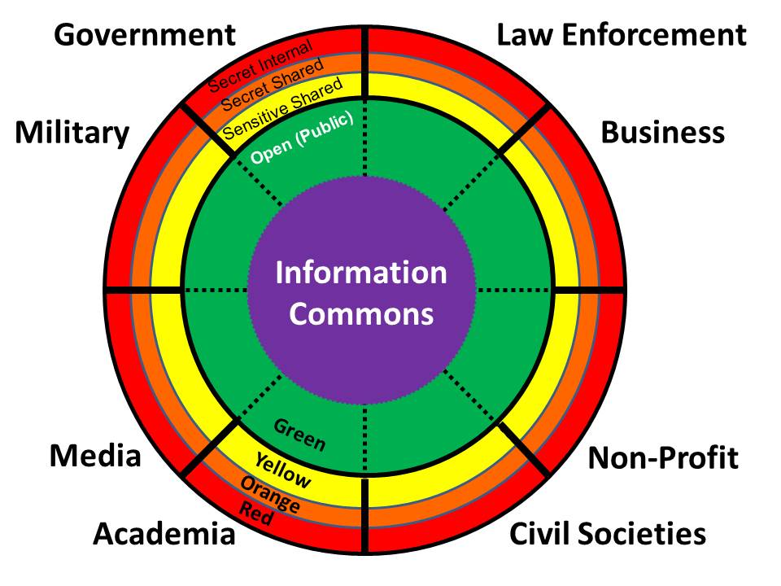
Figure 7: Needed Transformation from Secret to Open, From Military Alone to All Together
Below is a depiction of the degree to which OSINT can address the Essential Elements of Information (EEI) about each of the ten high-level threats to humanity listed in Figure 1.
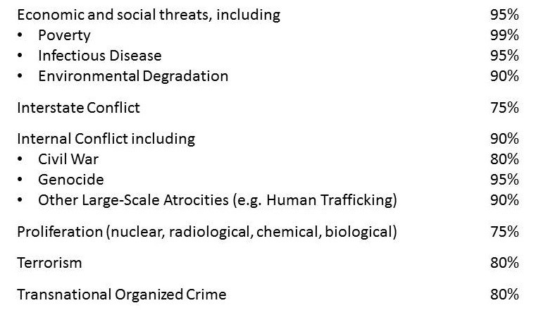
Figure 8: Evaluation of OSINT Utility by the Founder of the Modern OSINT Discipline
NATO (ACT) could take the lead in properly defining HUMINT as all humans, and in developing new means of integrating overt and covert HUMINT for NATO and is Member States’ advantage.
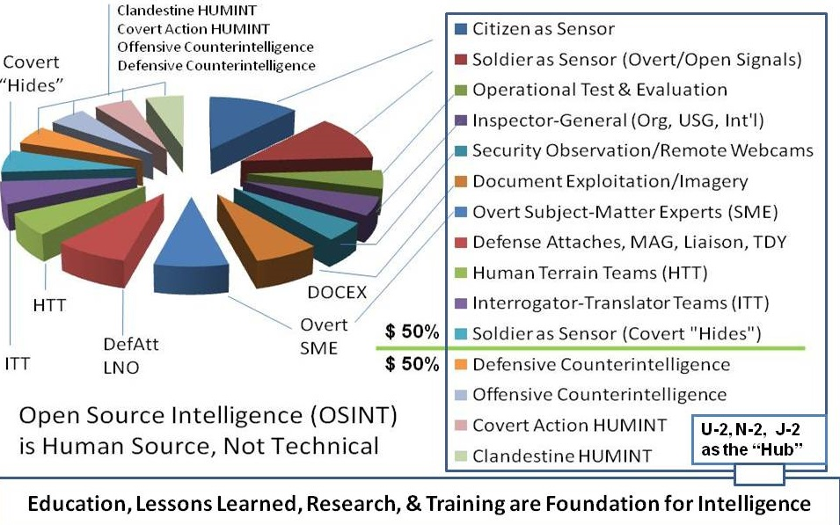
Figure 9: Concept for 21st Century Integrated Human Intelligence (HUMINT) Management
It could be possible that NATO, and the ACT particularly, could be ideally suited to create the world’s first true multinational AND Whole of Government intelligence center able to exploit all human sources both within each Member State’s “eight tribes” of intelligence (academic, civil society, commerce, government, law enforcement, media, military, and non-profit) and within the same “tribes” in each country in the FOE that is of interest.
ACT is particularly interesting for three reasons:
- It has a complete all-source top secret / sensitive compartmented intelligence staff and center;
- It could bring together one person from each NATO/PfP country to serve as cadre for a new OSINT Centre that covers the eleven unclassified slices of HUMINT; and
- Military Construction (MILCON) would allow the new OSINT Centre to be constructed at Dam Neck, which is under the leadership oversight of ACT Joint Forces Command (JFC) double-hatted as Commander, U.S. 2nd Fleet.
Below is a depiction of what the world’s first Multinational Decision Support Centre (MDSC) might look like, alongside a depiction of how that center could advance all-source intelligence and Whole of Government decision making with particular focus on making investment decisions that favor peace over war – the near-real-time provision of OSINT to the US and NATO Member “high side” and the ability to “reach back” to funded military hubs in each country that access all eight tribes of information.
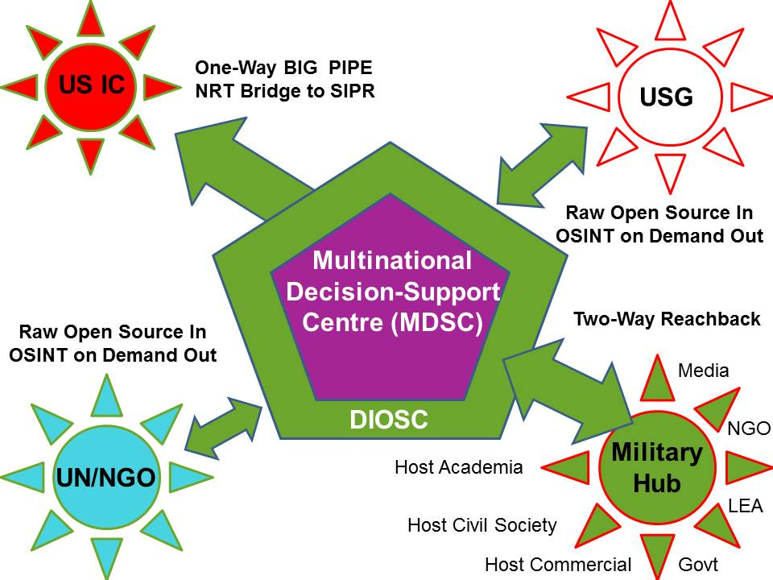 | 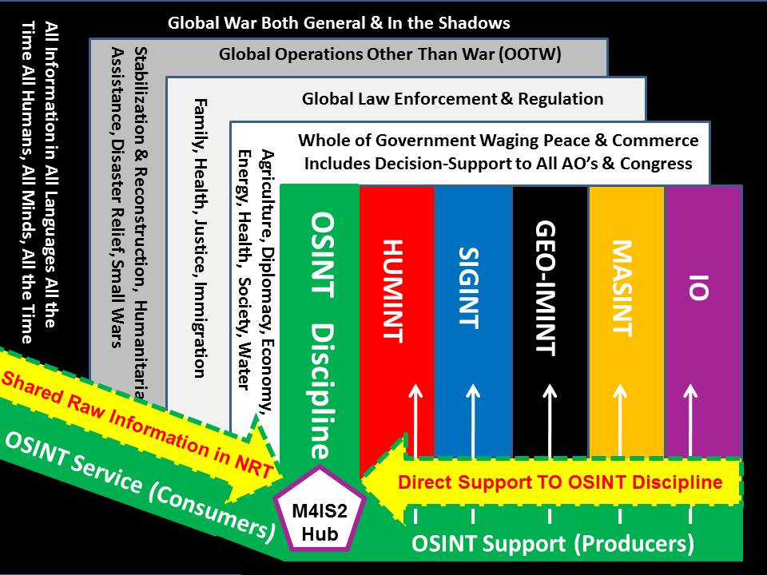
Figure 10: Multinational OSINT Centre Supporting Whole of Government/All-Source
Imagine such a capability – multinational in every possible respect – generating unclassified decision support (intelligence is supposed to be defined by the outputs, not the inputs) on the Middle East, able to integrate and make sense of all information in all languages and mediums, create timelines, plot it all on a map AND be able to share the products with both executive and legislative officials, the public, and the media – including the public and the media in the countries being studied.
Secrecy is how we protect misbehavior, not sources and methods.
Secrecy is how we protect misbehavior, not sources and methods.

Openness – the truth – is how we ground our strategy, operations, tactics, and technical force structure – acquisition – in reality.
Openness – the truth – is how we ground our strategy, operations, tactics, and technical force structure – acquisition – in reality.
The graphic below is a final illustration of a service that a NATO MDSC could provide to all Member States as both a “home base” pilot project and as a model for Member States to emulate.

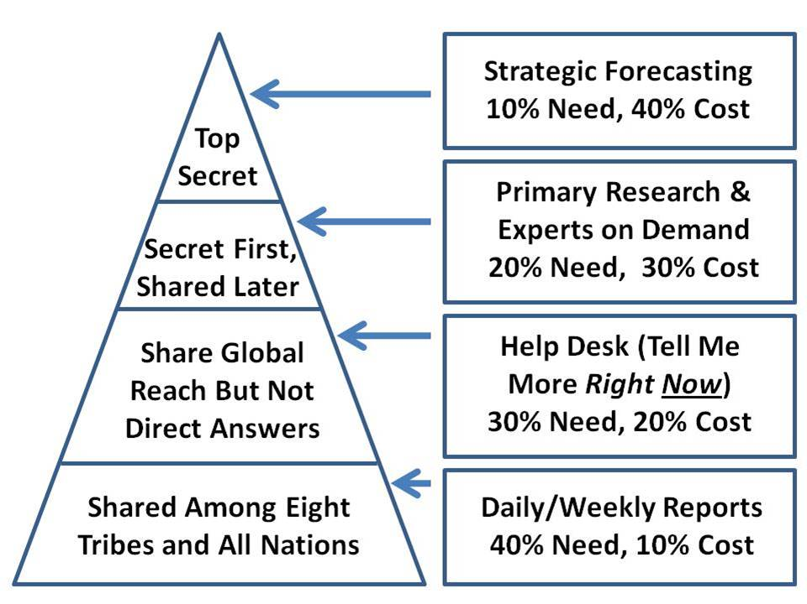
Figure 11: The Herring Triangle of Functionality Needs versus Relative Cost
The current situation in Eastern Europe, Central Asia, and the Middle East illuminates a complex reality that NATO is simply not ready for today and unlikely to be ready for in 2040 absent a complete transformation. NATO cannot isolate Russia or stop China’s commercial advances. NATO has an information-sharing problem with Turkey and is over-extended across Eastern Europe and into Central Asia and the Middle East. This paper, together with its companion, is intended to afford NATO an opportunity to create a new intellectual foundation for the future.
Transformation Requires Education of Both Voters and Legislators
A signal advantage to NATO/ACT having a MDSC is that it can generate products that are both unclassified, and politically and economically valuable to leaders of every NATO Member State.
A major short-coming of the secret intelligence world is that it does not produce intelligence (decision support) that can be used with the public or with all legislators or with the media.
At the same time, the NATO educational ecology has failed to produce a homogeneous alumni group or shared organizational culture across all participants from all Member States.
An opportunity exists to create new means of doing intelligence-driven strategy and intelligence-driven acquisition such that huge financial savings can be achieved on the military side while freeing up equivalent amounts for investments in peaceful preventive measures, which was precisely the point being made by the Commandant of the Marine Corps in 1989. This can at the same time create a unifying mind-set and culture for NATO.
We have wasted 30 years. Shall we not waste the next 30 years?
Now is the time for NATO to help the USA – and other Member States – get a grip on reality such that they all recognize that FOE 2040 is about creating a prosperous world at peace – a world that works for all; it is not about assuming the worst and preparing for more war in more places.
Financial Transformation
Below is depicted a comparison of what is being spent on war versus the costs of achieving all of the Sustainable Development Goals.
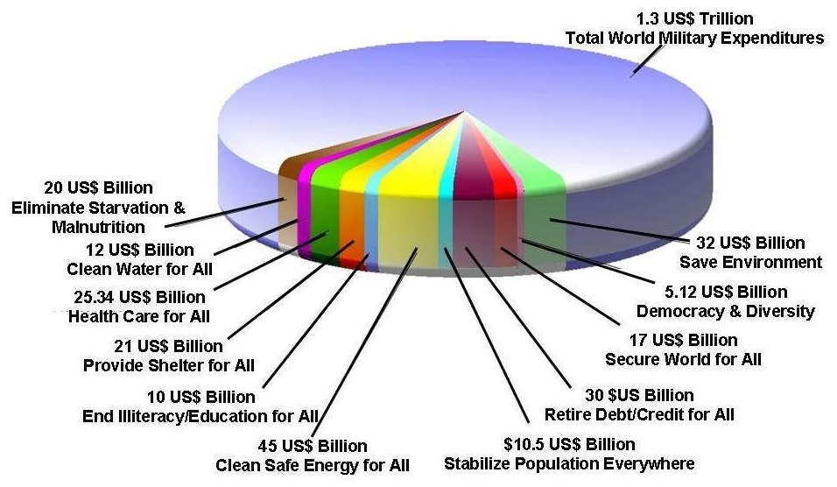
Figure 12: Baseline Comparison of Expenditures on Waging War versus Creating Peace
Although dating to 2007, more recent studies confirm the conclusion that we can end war by spending roughly one quarter of what we spend on war, on peace instead.
We do not do this for three simple reasons:
- war concentrates profit for the 1% while peace distributes profit across the 99%;
- governments are corrupt, selling out to the recipients of taxpayer-dollars; and
- publics are both uneducated by mediocre schools and distracted by sophisticated mass media and social media controlled by the 1% -- this is by design.

The military-industrial complex is its own worst enemy. In its obsessive focus over budget share, it has destroyed the “seed corn” that is to be found everywhere else – public education, public health, public employment – all others government mission areas have been “starved” to feed the Big War beast.
The military-industrial complex is its own worst enemy.

National Security Transformation
The easiest path toward redirecting dollars from war to peace may be to create an Inter-Agency Development Command (IADC), essentially CINCPEACE.
The easiest path toward redirecting dollars from war to peace may be to create an Inter-Agency Development Command (IADC), essentially CINCPEACE as depicted in Figure 3, and finally commit to moving at least $125B a year (US only, goal should be $500B a year from all Member States) toward meeting all seventeen of the Sustainable Development Goals (SDG) within 20 years.
Return on Investment (ROI) & True Cost Economics (TCE)
As the public becomes more aware of the realities that the controlled Western media has been loath to reveal – the raw fact that there is no Return on Investment (ROI) for what we spend on the military, and the military is the largest polluter on the planet, creating further horrifying true costs for the military-industrial complex – there is going to be a demand to terminate public funding for militaries that are both a burden on society, and cannot win wars.
There are exactly two solutions that NATO should consider as it prepared for the inevitable public backlash: first, it can work with its Member States to eradicate waste from military programs, to include the elimination of redundancy; and second, it can radically expand programs that do show a return on investment (diplomacy, development, commerce), managing a measured transfer of resources from spending on war, which should be reduced by 50%, to spending on peace, which should be increased by the transfer of that 50% savings, with no net loss to the military of total dollars.
Put another way, the military – NATO – must diversify its portfolio if it is to survive the crash of the war market.
NATO needs to reduce waste, eliminate redundancy, and radically expand invests in waging peace . . .
Put another way, the military – NATO – must diversify its portfolio if it is to survive the crash of the war market.
It is vital that NATO and member nation leaders note that this transformation is job and revenue neutral across all political boundaries – there is no reduction in the totality of the defense budget, it is simply reallocated to create the four forces after next within a new NATO integrated grand strategy.
…transformation is job and revenue neutral across all political boundaries – there is no reduction in the totality of the defense budget…
Black Swans, Gray Swans, & White Swans
Within the next five to ten years changes – and disclosures – are going to turn our world right-side up and inside-out. Three areas in particular stand out:
01 The intersection of biology and energy, including electromagnetic radiation in all its forms, is sharply illuminated as the “way of the next war” in Wuhan, China. NATO is not ready for biological warfare and NATO is not ready for electronic warfare such as the Iranians and Russians have mastered with energetics, scalar (time-energy), and gravitobiology. As a side note, the first bloc to offer free and safe Internet and global to local cellular access to the 99% across the Southern Hemisphere will rule the world commercially and cultural. China appears to be the victor already.
02 Free energy is known to be readily attainable and the days of its being repressed are over. The first bloc to offer free energy and related benefits such as unlimited desalinated water to the 99% across the Southern Hemisphere is likely to be the next global super-power.
03 Extraterrestrial contacts, technologies, and issues are almost certain to be disclosed over the next several years. NATO has no space force and appears to have no access to Member State capabilities and Member State intelligence in this domain. It may be that NATO could serve as a foundation for creating a disclosure campaign plan that is coincident with NATO’s emergence as a pioneer in Whole of Government and Inter-Agency Development Command (IADC) operations.
The world appears to be on the verge of a massive positive shift toward peace and prosperity for all. This will leave NATO, with its emphasis on war and military spending, dead if not derelict. Now is the time for NATO to get a grip on reality. The OSA funded by USDI will help.
The world appears to be on the verge of a massive positive shift toward peace and prosperity for all. This will leave NATO, with its emphasis on war and military spending, dead if not derelict. Now is the time for NATO to get a grip on reality.

Appendix A: 4 Threat Classes, 4 Type Commands, 4X the Impact
Executive Summary
In the main paper, the urgency of an autonomous self-sufficient intelligence operations capability for NATO is documented. This appendix utilizes the known threat – 80% of which is not addressed by existing NATO capabilities – to propose a radical transformation of NATO from one conventional military force to four distinct forces, each tailored to a type threat, that will enable NATO to both shape the future with peaceful preventive measures, and be ready for the complexities of 2040. Multiple strategic studies have documented the need for this transformation.
If NATO embraces this vision (of four type commands), it will have four times the impact by 2040.
If NATO embraces this vision, it will have four times the impact by 2040. In the conclusion to this appendix reference is made to the need for NATO to properly evaluate three types of terrain as it moves toward 2040: physical terrain, human-cultural terrain, and bio-spiritual-electromagnetic terrain. These conclusions are independent of whether NATO remains a proxy of and dependent on the US military, or becomes a genuine European defense command against all enemies in all forms.
High-Level Threats & High-Level Challenges
There have been only two major studies in the past twenty years that have been holistic. The table below lists their complementary findings side by side.
GROUP ONE (Sharing Our Planet)  Global Warming; Biodiversity and ecosystem losses; Fisheries depletion; Deforestation  Water deficits; Maritime safety and pollution  GROUP TWO (Sharing Our Humanity)  Poverty; Peacekeeping-conflict prevention; Combatting terrorism; Education for all; Global infectious diseases; Digital divide; Natural disaster prevention and mitigation  GROUP THREE (Sharing Our Rule Book)  Reinventing taxation; Biotechnology rules; Global financial architecture; Illegal drugs; Trade-investment-competition rules; Intellectual property rights; E-commerce rules; International labor and migration rules | 01 Poverty  02 Infectious Disease  03 Environmental Degradation  04 Inter-State Conflict  05 Civil War  06 Genocide  07 Other Atrocities (e.g. Human Trafficking, Child Sacrifice)  08 Proliferation  09 Terrorism  10 Transnational Crime
Figure A1: Global Challenges & High-Level Threats to Humanity
If NATO wishes to be relevant and effective in 2040, it must consider the reality that eight of the ten high-level threats to humanity are not military, and that ignoring those eight is what spawns and perpetuates Inter-State Conflict and Terrorism. NATO can be larger than the sum of its parts by helping Member States reallocate (not reduce) resources among Diplomacy, Development, Defense, and Commerce (D3C) while serving as a hub for integrated D3C campaigns.
NATO can be larger than the sum of its parts by . . . serving as a hub for integrated D3C campaigns.
Four Threat Classes
The distinction between conventional and emerging threats was first published in 1989, and among the four threat classes in 1992. The Americans have refused to take emerging threats seriously, or to invest in tailored force structures for three of the four threats, because they were “not an expensive enough problem.” Until true cost economics is part of intelligence, we will continue to miscalculate.
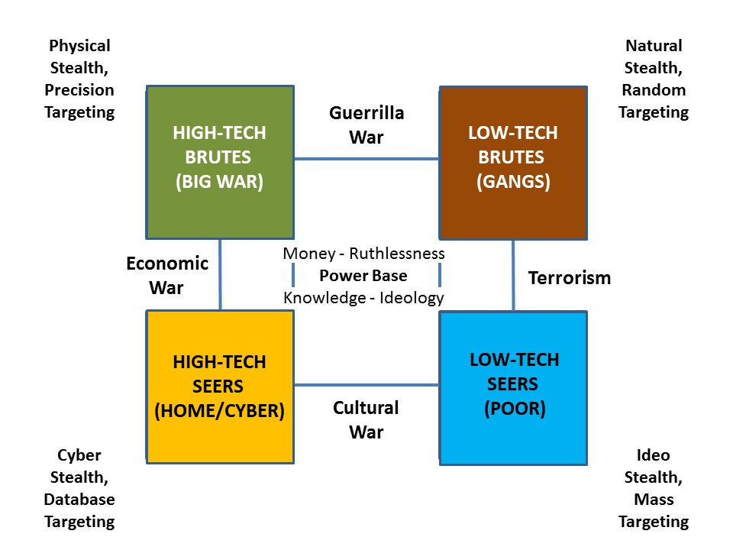
Figure A2: Four Threat Classes
The Mid-Life Crisis
Today, in 2020, NATO must address the reality that on the one hand President Donald Trump considers NATO to be a waste of US taxpayer dollars, particularly since the European members are getting a “free ride,” and on the other hand, NATO cannot win wars against the “heathen” in Afghanistan or Iraq or Libya or Syria, and much less so against China or Russia, both of which are armed with supersonic missiles and electromagnetic weaponry including scalar time-energy intervention weapons. Both are also dominating the Arctic while winning the peace from Central Asia down to Africa by investing in One Belt One Road commerce with a cyber overlay – e.g. China, not Europe, owns the Internet and cellular communications across, Africa.
NATO cannot survive as a military network focused only on Big War. It can, however, transform into a command & control network for Whole of Government and multinational endeavors capable of orchestrating all policies and capabilities (non-military particularly) against all threats.
NATO cannot survive as a military network focused only on Big War.
Four Type Commands
Below is a concept for transforming NATO (as well as US and other Western militaries) such that it can address each of the four type threats with a type command.
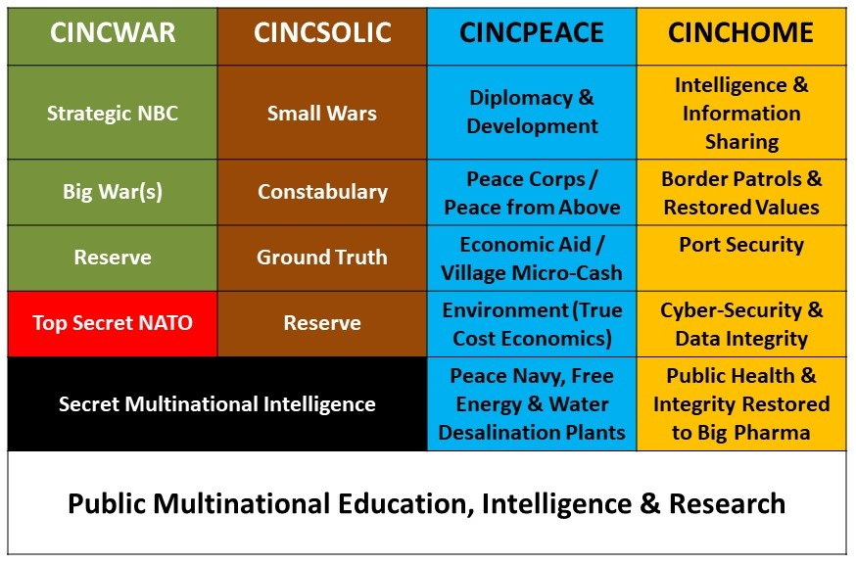
Figure A3: Four “Type” Commands to Defeat Four Threats Within Unified Grand Strategy
Devised in the early 1990’s, this concept was rejected in the USA because waging peace has two major flaws: first, it is not considered an expensive enough problem, and second, its corollary, unlike war, the profits from peace (which are greater in the aggregate than the profits from war) are spread across the public and not concentrated within banks and the military-industrial complex. Homeland Security was not considered – until 9/11 – to be a proper “profit center.”
Although Special Operations have grown since 9/11, our Special Operations Forces (SOF) now suffer from two major problems: first, they have lost the skill-sets associated with “White” SOF and morphed almost exclusively into anti-terrorist hunter-killer teams; and second, the force is exhausted, diminished, and today filled with too many young people right out of basic training.
No one is managing these four forces coherently. They do not have a grand strategy, an integrated force structure architecture, or an integrated budget. Their communications, computers, and information-systems are not interoperable within any one country, much less across the coalition.
If NATO wishes to be effective – and in existence – in 2040 – it has no alternative but to persuade the Member States that NATO needs four forces after next, not one.
NATO needs four forces after next, not one.
Public education – the public is the foundation for national power – is the common factor upon which all four forces depend for their future funding and manning and effectiveness.
Reality Merits Attention – Three Terrain “Types”
None of the NATO Member States appears to take into account the actual terrain that forces will have to fight on – not only physical terrain, but also cultural terrain and biological-spiritual-electromagnetic terrain. Only one study is known to have been done in the USA, completed in 1990 as Planning and Programming Factors for Expeditionary Operations in the Third World, updated by its original study director in 2019, REINVENTING NATIONAL SECURITY: Grand Strategy, Global Reality, and the U.S. Army -- Everything Our President Is Not Being Told. The below table is a summary of what NATO is not planning for because it does not have its own organic intelligence capabilities, and no way of influencing Member States toward reality-based force structure and acquisition:
Physical Terrain | Human-Cultural Terrain | Bio-Spiritual-EM Terrain
Aviation day hot & humid  Aviation MOG 1-3  Hydrography/ports limited  Mountains & jungles matter  Bridge loading <30 tons  Tracks needed for 80% land  Line of sight <1000 meters | 40 countries Arab/Islamic  Non-western political-legal  Non-western socio-economic  Non-western ideo-cultural  Non-western technologies  Non-western demographics  Local knowledge | Biological immunity  Biological vulnerability  Spiritual immunity  Spiritual vulnerability  Electromagnetic immunity  Electromagnetic vulnerability  Bio-Spiritual-EM convergence
MOG: Maximum On Ground -- EM: Electromagnetic
Figure A4: Three Terrain Types Vital to Planning & Programming for 2040 Force Structure
Information Operations (IO), discussed in a second companion paper, is impacted by and embedded in all three of the above terrain types. The ability to communicate is affected by physical terrain, particularly defilade; by cultural characteristics that may render most Western concepts inoperable (for example, showing illiterate people with printed flyers); and by the mix of biological, spiritual, and electromagnetic capabilities and circumstances that we do not understand as well as the Russians – energetics and scalar time-energy as well as gravitobiology are at this time well beyond the ability of NATO to comprehend, much less compete with.
It is not enough to embrace the concept of four forces after next – the reality of these three terrains – the last one well beyond Top Secret and not briefed to NATO – demands deep study and then the development of unconventional and often non-military capabilities able to achieve early warning, shape the environment, avoid conflict, and achieve allied goals without fighting.
The Wuhan Coronavirus – Prototype War
The Wuhan coronavirus is a manifestation – a prototype – of how wars will be fought in the future without, generally speaking, the use of conventional forces such as NATO has emphasized.
Biological warfare – a vaccine mutation bio-engineered in China from a virus stolen from a Canadian biowarfare facility – electromagnetic warfare – the impact of 5G in both lowering citizen host immunity and making the virus worse once acquired – and information warfare – the utterly exaggerated Western media coverage very likely directed by the cover media influence arms of MI-6 and CIA – have all come together to create the perfect storm.
The virus is not as virulent as SARS and it will peak soon. Its economic and social impact will go on for some time. There are even rumors of insider trading by those who knew in advance.
NATO (ACT) must pay careful attention to what is called gravitobiology – the intersection of biowar and electromagnetic war inclusive of scalar (time-energy) capabilities.
NATO (ACT) must also become acutely aware of the fourth leg of the stool – human consciousness in multiple forms including acts of peace, prayer, manifestations of love, and spiritual good intentions. These are no longer in the “woo woo” domain – these are tangibly documented means of healing individuals, communities, and nations.
NATO (ACT) must get a grip on biological warfare, spiritual warfare, electromagnetic warfare, and information warfare, as a whole.
The bill has come due.
NATO (ACT) must get a grip on biological warfare, spiritual warfare, electromagnetic warfare, and information warfare, as a whole.
Conclusion
One means of thinking about transformation, to include the commissioning of new Innovation Centre working groups able to integrate not only NATO participants but participants from outside NATO and outside the government-military complex, is to embrace a matrix consisting of
- Four War Types (War, SOLIC, Peace, Homeland)
- Four Levels of Analysis (Strategic, Operational, Tactical, Technical (Acquisition)
The fastest way to overcome opposition to any discussion about reducing NATO’s over-all conventional military capabilities can be addressed in two ways:
First, transformation can and must be job and revenue neutral across all political boundaries. This is essential to achieve acceptance among Parliamentary and Congressional bodies.
Second, savings achieved in the eradication of the 50% waste that is characteristic of the conventional military burdened with six contractors per soldier, are not given up, they are re-directed toward new conventional capabilities (such as a 450 ship US Navy as the core for a 1,000 ship NATO navy), and the three new type commands and their capabilities.
Below is a depiction of what this might mean for NATO at the four levels of analysis across the four “type” commands, if embraced by NATO leadership as helpful in migrating toward winning 2040.
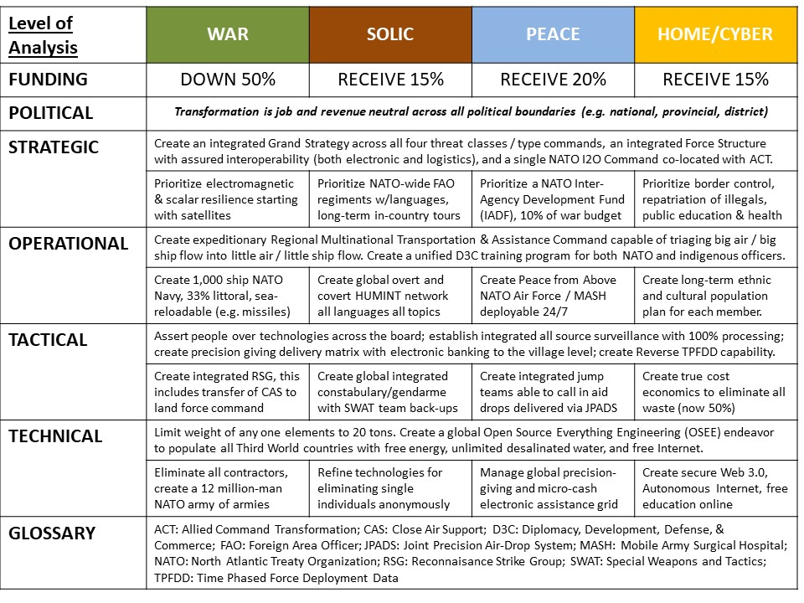
Figure A5: Transformation Vision for NATO 2040
The intent of the above – which is merely a starting point from which knowledgeable NATO officers can depart – is to make NATO central to what the Americans call D3C: Diplomacy, Development, Defense, & Commerce, for the Alliance as a whole. Using its superior I2O, NATO can become a service of common concern to each Member State, and help achieve information-sharing and sense-making on a scale never before achieved by anyone.
The Margin of Victory
The decisions made today – strategic decisions and acquisition decisions particularly – will determine if we win or lose in the future – in 2040.
We have lost all our recent wars – and will lose any wars we fight in the next twenty years – because of bad decisions made twenty years ago.
The fact is that our world is which the current “powerless” public has almost unimaginable co-creative powers beyond the comprehension of many. Ethics is an operating system, and ethics is, in the end, more powerful than any combination of money and weaponry.
This is also a world in which the standard aviation day is hot and humid (we build to warm and not-humid meaning that by design our aircraft can carry half as much half as far and loiter half as long as “the book” says they will – and this is on top of the 60% of 60% availability that is standard because of maintenance issues).
It is a world in which the average bridge-loading limit is 30 tons, there is no cross-country mobility (meaning that vehicles without tracks will be immobilized), and the average line of sight distance is under 1,000 meters.
Finally, it is a world in which asymmetric means – many of them non-military – can incapacitate conventional militaries. The current cost ratio is running about $1 for those who oppose us, against $500,000 for our side. This is not a sustainable exchange rate.
From a strictly practical point of view – and I made this point in 2002 – it is far cheaper to assist the Third World in achieving peace and prosperity – with justice for all – so that its public stays home and does not seek to migrate into Europe or to the USA or Australia.
NATO is its present form is dead. If NATO embraces the vision of creating four integrated forces after next to deal with the four threat classes as a whole, then NATO will be greater than the sum of its parts – Member State contributions – and rise to a new level of effectiveness in 2040.
Four threat classes; four type commands; four times the impact.

Appendix B: Waging Peace – Faster, Better, Cheaper?
Executive Summary
$100 million dollars will buy 1 complex weapons unit; or 1,000 diplomats; or 10,000 Peace Corps volunteers; or 1 million cubic meters of desalinated water; or 1 day of war over water.
$100 million dollars will buy 1 complex weapons unit; or 1,000 diplomats; or 10,000 Peace Corps volunteers; or 1 million cubic meters of desalinated water; or 1 day of war over water.
The primary failure of governments – including the governments of the Member States of NATO – is the inability to integrate holistic analytics and true cost economics in order to arrive at a Planning, Programming, Budget, and Execution (PPBE) strategy for Whole of Government (WoG) strategy, acquisition of force structure, and integrated D3C operations such that we win by not fighting – we wage peace to achieve prosperity for all.
Peace is cheaper than war, and produces more profit than war. The problem is that war benefits the 1% in a concentrated fashion, while the benefits of peace are distributed across the entire population of all countries party to the peace.
If we spent a fraction of the time, energy, intellect, and money on waging peace instead of waging war, we would generally not fight wars and the world would be both prosperous and peaceful. War is a profit center for the 1%, as are poverty, infectious disease, and other high-level threats to humanity. Despite the fact that peace (and its attendant prosperity) are vastly more profitable than war, that profit is distributed across the 99%, not concentrated within the 1%, and that is the reason that war is endless – the 1% can afford to bribe legislators at the same time that the 99% has abdicated its civic duty to be engaged and informed about all public matters.
Open Source Intelligence (OSINT) – public decision-support rooted in holistic analytics and true cost economics – can educate Member State and target country publics, and proliferate Open Source Everything Engineering (OSEE), which allows the five billion poor to achieve a Western quality of life for 10% to 20% the cost of the failed Western economic model rooted in proprietary technologies, 50% waste, and 90% profit margins for the banks and their 1% owners.
Open Source Everything Engineering (OSEE) . . . allows the five billion poor to achieve a Western quality of life for 10% to 20% the cost of the failed Western economic model
The military-industrial complex, and legislators, can be persuaded to try winning without fighting if the transformation of NATO and of Member State militaries can be job and revenue neutral across all industrial sectors and political jurisdictions – this makes transformation both politically possible and economically attractive.
. . . the transformation of NATO and of Member State militaries can be job and revenue neutral across all industrial sectors and political jurisdictions . . .

Naked NATO
NATO is very much like an Emperor with no clothes for three reasons.
1. It lacks its own intelligence capabilities and adds no intelligence value to any strategic, operational, tactical, or technical (acquisition) discussion among Member States.
2. It never achieved its originally intended political capabilities, which are owned and operated by the European Union (EU).
3. In over-emphasizing conventional military capabilities and in being a party to the violation by the Member States of the promise to Russia to not recruit Eastern European states, NATO has become nothing more than a military-industrial marketing tool with two significant disadvantages: it is failing to achieve any kind of cultural coherence or unity of effort across what is now a mélange a infinie; and it has failed to recognize the urgency of inspiring Member States to prepare to address the 80% of the threat that is neither military nor conventional.
Naked Member States
Member States are naked as well – in the case of the USA, it has a military that consumes 60% of its disposable annual federal budget, is 50% waste, and cannot win wars, even against the tribes of Central Asia and the Middle East; in the case of Europe the Member States are giving lip service to their military obligations to NATO, and assuming that the US military is the primary defense against Russia rather than a reserve.
Member States are also naked because of two forms of corruption. The first is centered on the Barcelona Agreement of 1995 that enabled the massive illegal immigrant invasion, an agreement that is said to be based on massive bribes to European leaders from Arab dictators. The second, and the USA is particularly guilty of this, is the stove-piping of government such that each mission area from agriculture to energy to health to security, is managed in complete isolation from all other mission areas. Security is the one that has the most money, and it is “locked in” on the worst possible combination of heavy, expensive, vulnerable systems that are not interoperable, are easily decapitated, and take money away from everything else. Neither Return on Investment (RoI) nor True Cost Economics (TCE) are considered by the national managers of the national budget.
In general terms, the violent threat is as follows:
- 10% - State versus State
- 15% - Gang Wars, Genocide, Decolonization
- 25% - Inter-Ethnic Tribal Civil Wars
- 50% - State versus Nation (1% versus 99%)
NATO and the Member States are complicit in the perpetuation of roughly 40 dictatorships, particularly in the Middle East and including the apartheid genocidal State of Israel that is illegally occupying the Palestinian homeland. It is these dictators, in combination with covert operations such as drone assassinations wiping out entire wedding parties, predatory capitalism treating poverty as a profit center (as well as infectious disease and environmental degradation), who are creating the one threat we cannot handle: masses of illegal immigrants.
Observing the Obvious
The below graphic shows the ten high-level threats to humanity along with the twelve core policy domains that any government must manage to assure both peace and prosperity.
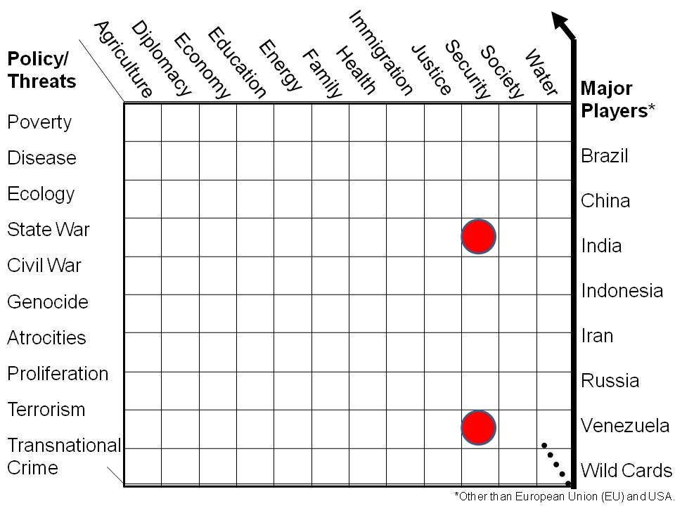
Figure B1: Threats and Policies Not Now Addressed in a Holistic Balanced Manner
The two red dots are where all the money is spent – and most of that money makes the threats worse, not better. Everything else receives lip service. Since the money is being spent on conventional military and secret intelligence capabilities that are used in a reactive fashion (or in the case of the secret intelligence world, element that are busy starting wars, arming insurgent groups, and sponsoring terrorists as part of a global destabilization campaign that serves elite interests), this means that no money of note is being spent on peaceful preventive measures abroad, or on buffering at home – ensuring sustainable agriculture, energy, and health, for example, while blocking all illegal aliens and eradicating all white collar and black collar criminals, elite pedophiles, and traitors. We are simply not serious about governance in the public interest!
Below are illustrated global threats to local survival, and homefront vulnerabilities known since 1989 when the Commandant of the Marine Corps, General Al Gray, called for a complete reinvention of intelligence in order to better allocate resources and justify “peaceful preventive measures.”
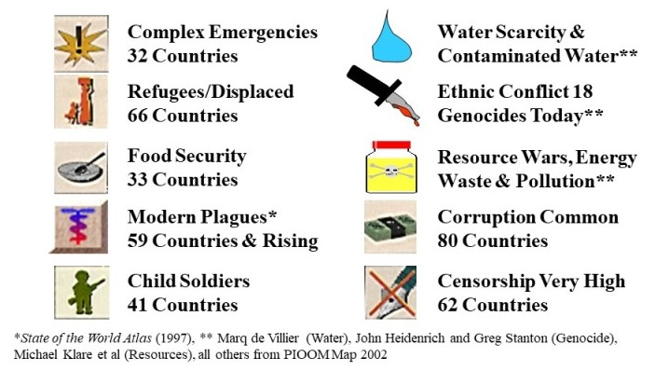 | 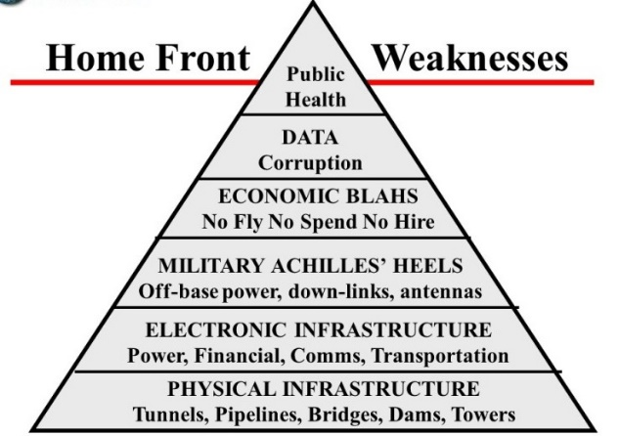
Figure B2: Global Threats & Homeland Vulnerabilities Not Adequately Addressed
Now here, repeated from the final figure in the main text, is the comparison of what it costs to create a massive global military that cannot win wars, versus what it would cost to achieve all of the Sustainable Development Goals (SDG) within two decades.
Figure B3: Baseline Comparison of Expenditures on Waging War versus Creating Peace
Diplomacy, Development, Defense, and Commerce (D3C)
While the concept of Diplomacy, Development, and Defense (D3) has been well-established within the USA since 2012, its follow-on concept, adding Commerce, while favored by the Obama Administration, never took root. This concept remains vitally important, particularly in light of the success of the Chinese in creating the One Belt One Road initiative, using commerce as a foundation for securing deep access and influence around the world, with a cyber-overlay – Chinese communications and Chinese Internet service providers equates to Chinese eyes and ears everywhere.
D3C is the starting point for justifying a NATO approach to USDI for funding an OSA; and the OSA is what will help NATO – and ACT particularly – document the transformation paths toward four type commands and a fully integrated campaign plan for both homeland security within each Member State, and the achievement of the SDG within both Member States and all other countries now exporting crime, disease, and illegal aliens into Member States.
It must be repeatedly stressed that the intent here is not to reduce the amount of money we spend across D3C, but rather to migrate a sufficiency of that money to the three other type commands, and an IADC (for the USA at least) that has at least $150 billion a year to spend waging peace.
Transformation must be understood – and executed – as job and revenue neutral across all political jurisdictions. Major corporations that lose jobs related to war should gain jobs related to peace. An entire new continuing education industry can be created overnight that gives millions of war-related employees a year of full salary combined with all expenses paid for retaining, and in some instances, two or three years of retraining.
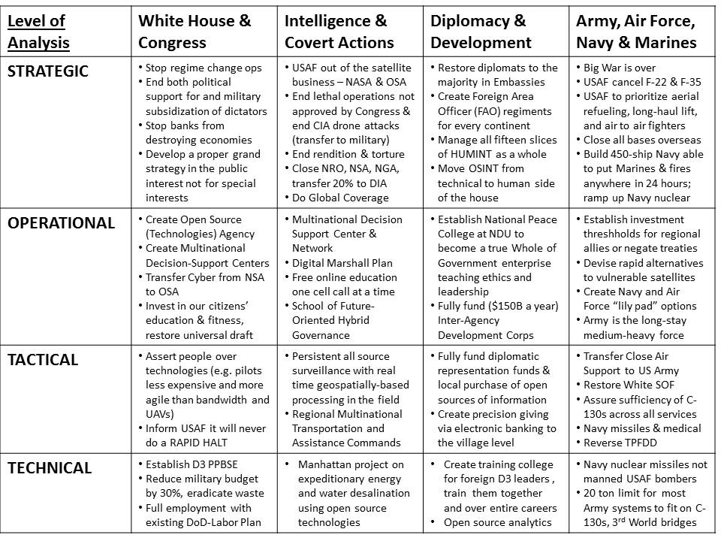
Figure B4: USA Grand Strategy Less Commerce
It must be emphasized that all foreign assistance of the traditional sort (“taking money from the poor in a rich country to give to the rich in a poor country”) must be terminated. Assistance in the future must be delivered to the village level in the form of both direct electronic funds assigned to individuals, and materials and knowledge needed to implement OSEE.
Information Operations (IO), 5G, and Web 3.0

Could NATO Be the Catalyst for Member State Change?
It may not be possible to change Member States and how they approach national-level spending but the growing populist demands for radical change are a sign that there is both a need and a possibility.
The single most important aspect to stress over and over again is that transformation can be job and revenue neutral across all political boundaries.
The 1% have enough; it is the politicians who depend on “incentives” from private sector parties and foreign governments that are going to fear change. It is vital that the need for change and the benefits from change be fully briefed to all Member State publics and all Member State executives and legislators as well as media and other influencers (e.g. labor unions, religions).
The OSA is both the means for creating public intelligence (decision-support) essential to creating an appreciation for why NATO matters as a change agent also adapting to reality; and as a means of promulgating OSEE, which allows for the lifting up of the five billion poor at a fraction of the cost of the failed Western economic model.

Glossary

5G Fifth Generation Communications
ACT Allied Command Transformation
ARMR Armor
ARTY Artillery
AV Aviation
C4I2 Command & Control, Communications, Computing, Intelligence & Interoperability
CA Civil Affairs
CAS Close Air Support
CIA Central Intelligence Agency
CINC Commander in Chief
CS Combat Support
CSS Combat Service Support
D3C Diplomacy, Development, Defense & Commerce
DefAtt Defense Attache
DEVGRU Development Group also known as Seal Team Six
DOCEX Document Exploitation
EE Expeditionary Environment
EEI Essential Elements of Information
EM Electromagnetic
ENGR (Combat) Engineering
EU European Union
FAO Foreign Area Officer
FOC Final Operating Capability
FOE Future Operational Environment
HTT Human Terrain Team
HUMINT Human Intelligence
I2O Intelligence & Information Operations
IADC Inter-Agency Development Command
IMINT Imagery Intelligence
IN Intelligence
IO Information Operations
IOC Initial Operating Capability
IPK Information Peacekeeping
ITT Interrogation-Translation Team
IW Information Warfare
JFC Joint Forces Command
JPADS Joint Precision Air Drop System
LNO Liaison Officer
M4IS2 Multi-National,Agency,Disciplinary, Domain) Information-Sharing & Sense-Making
MAG Military Advisory Group
MASH Mobile Army Surgical Hospital
MASINT Measurements & Signatures Intelligence
MCIA Marine Corps Intelligence Activity
MDSC Multi-National Decision-Support Center
MOG Maximum On Ground
MP Military Police
NATO North Atlantic Treaty Organization
NDU National Defense University
NMITC Navy Marine Corps Intelligence Training Center
OMB Office of Management and Budget
OOTW Operations Other Than War
OSEE Open Source Everything Engineering
OSIF Open Source Information
OSINT Open Source Intelligence
PfP Partnership for Peace
PKI Peacekeeping Intelligence
POW Prisoner(s) of War
PPBE Planning, Programming, Budgeting, Execution
ROI Return on Investment
RSG Reconnaissance Strike Group
SASC Senate Armed Services Committee
SDG Sustainable Development Goals
SIGINT Signals Intelligence
SME Subject Matter Expert
SOF Special Operations Forces
SOLIC Special Operations Low Intensity Conflict
SWAT Special Weapons and Tactics
TCE True Cost Economics
TPFDD Time Phased Force Deployment Data
UAV Unmanned Aerial Vehicle
USA United States of America
USCENTCOM United States Central Command
USDI Under Secretary of Defense for Intelligence
USG United States Government
USSOCOM United States Special Operations Command
WH White House
WoG Whole of Government

Endnotes

The author is a former Marine Corps infantry officer and then a US spy with three overseas clandestine tours and three Washington tours in counterintelligence, satellite futures, and advanced information technology; followed by being the senior civilian responsible for creating the Marine Corps Intelligence Activity (MCIA) from 1988-1993. He went on to train over 7,500 mid-career officers from across 90 countries in Open Source Intelligence (OSINT) and “intelligence done right.” His most recent work includes the book, Robert Steele, REINVENTING INTELLIGENCE: 30 Years in the Wilderness (Trump Revolution 46) (Amazon CreateSpace, Earth Intelligence Network, 2019); and the lecture commissioned by the Danish Ministry of Defence in 2016, “OSINT Done Right,” Phi Beta Iota Public Intelligence Blog, 7 February 2016. He is the most published intelligence practitioner-reformer in the English language. His personal web page is https://robertdavidsteele.com.
Robert Steele, On Intelligence: Spies and Secrecy in an Open World (OSS Inc., 2001)
Al Gray (Ghost-Written by Robert Steele), “Global Intelligence Challenges in the 1990’s,” American Intelligence Journal, Winter 1989-1990, pp. 37-41. At the time General Gray was the Commandant of the Marine Corps, and the author was the second-ranking civilian in Marine Corps intelligence. Below are the differences between conventional and emerging threats: Conventional Threat – Governmental – Conventional/Nuclear – Static Orders of Battle – Linear – Rules of Engagement (ROE) – Known Doctrine – Strategic Warning – Known Intelligence Assets Emerging Threat – Non-Governmental – Non-Conventional – Dynamic or Random – Non-linear – No constraints (ROE) – Unknown doctrine – No established I&W net – Unlimited 5th column
Robert Steele, “Foreword,” in Stephen E. Arnold, CyberOSINT: Next Generation Information Access, Harrods Creek, KY: Arnold Information Technology, 2015.
Robert Steele (Study Director) with BDM Corporation, Overview of Planning and Programming Factors for Expeditionary Operations in the Third World, Quantico, VA: Marine Corps Combat Development Command, March 1990.
The model and its findings are discussed in Robert. “Intelligence Support for Expeditionary Planners,” Marine Corps Gazette, September 1991, pp. 73-79; “The Asymmetric Threat: Listening to the Debate,” Joint Force Quarterly, Autumn/Winter 1998-1999, pp. 78-84; and Robert. “First to Fight, but Not Fighting Smart: a Skeptical Assessment of Marine Corps Effectiveness in the 21St Century,” Marine Corps Gazette, May 1999.
Please refer to the companion white paper, Robert Steele, NATO 2040: Four Threat Classes, Four Type Command, Four Times the Impact (Innovation Centre, ACT, 15 February 2020).
After 30 years of being blocked by CIA, the author is finally making some progress on the need for an Open Source Agency (OSA) approved multiple times both by the Office of Management and Budget (OMB) and USDI, in all cases at $125M Initial Operating Capability (IOC), toward $2B a year Final Operating Capability (FOC). Most recently USDI has been told in an internal draft memorandum that the ideal distribution of these funds would be as follows: - National Defense University, with a focus on Whole of Government & Multinational IO - Advantage: close to WH, USDI, supports education, research, Whole of Government ops - Allied Command Transformation, node to be located at Dam Neck near DEVGRU and NMITC - Advantage: supports transformation, multinational, acquisition, and DEVGRU/NMITC - MacDill under joint SOCOM-CENTCOM oversight with cells at each of the other strategic commands - Advantage: supports warfighting directly with particular attention to GWOT and OOTW - A White House cell of six people, and a fifth cell of six people pending further discussion.
The calculation of $200 million a year (with an initial year of $25 million) is based on a concept that would divide the total funds equally among five elements as listed in Note 7.
It merits mention that holistic analytics and localized situational awareness cannot be achieved by technical disciplines. Only HUMINT can bring together indigenous observers with the “feeling in the fingertips” and Subject Matter Experts (SME) who are published (generally academics and non-profit authors) or present (field personnel from commerce, government, labor unions, media, and more). The Western “way” of intelligence is not only deficient for its emphasis on technical collection that is not processed, but for its insistence that most humans that it deals with must either be covert “agents” managed by clandestine officers, or “cleared” citizen SME. They are excluding 99% of the overt humans with relevant information, and 99% of the information that is not in their own language or in easy to access digital form.
This was created by Mr. Jan Herring, the first National Intelligence Officer for Science & Technology in the USA, and shared directly with the author in the 1990’s. This common sense approach to assuring timely answers for decision-makers, and the cost calculations, have not been grasped by any government or organization that we know of.
Robert Steele, NATO 2040: Four Threat Classes, Four Type Command, Four Times the Impact (Innovation Centre, ACT, 15 February 2020).
Copyright Medard Gabel, former assistant to Buckminster Fuller, of Big Picture, Small World (Media, PA).
Cf. Guido Schmidt-Traug, “Investment Needs to Achieve the Sustainable Development Goals,” Sustainable Development Solutions Network, United Nations, 12 November 2015; Camilla Schippa, “War costs us $13.6 trillion. So why do we spend so little on peace?” World Economic Forum, 8June 2016; Mara Niculescu, “Impact Investment to close the SDG funding gap,” United Nations Development Programme, 13 July 2017; and Matt Agorist, “Just 3% of What the US Spends Destroying Countries Could End Starvation—On the Entire Planet,” Free Thought Project, 23 January 2020;
Such a command could reasonably create five new flag officer billets within the US military, and fifteen new flag officer billets to be filled by other NATO Member States. Regional IADC sub-commands could be two-star commands with civilian counterparts from the diplomatic and commerce corps at the deputy assistant secretary level.
Cf. Greta Zarro, “Fouling Our Own Nest & Draining Our Wallets: It’s Time to Divest from Endless Wars,” CounterPunch, 31 January 2020.
A starting point can be found in the works of former US intelligence analyst Thomas Bearden, such as his books Fer de Lance, The Excalibur Briefing, Gravitobiology, and Energy from the Vacuum.
The USA and China are competing to proliferate their version of 5G communications – and the right to listen in on all content carried by their communications – around the world. China appears to have already won this competition in the Southern Hemisphere. Not addressed by either competitor is the growing public refusal to allow 5G as a weaponized electromagnetic system to be continued; growing public concerns over the electromagnetic “soup” that is lowering human immunity everywhere (making us more vulnerable to biological failure both natural and contrived); and the emergence of balancing positive energy forces that could make 5G safe for both humanity and all other living things.
Cf. Mongoose, “While US Wastes Blood & Treasure on Elective Wars, China Is Building the Internet for the Whole Earth,” Phi Beta Iota Public Intelligence Blog, 29 January 2020.
Robert David Steele, NATO 2040: Intelligence (Decision-Support (Earth Intelligence Network, 2020).
Most recently, Robert Steele, REINVENTING NATIONAL SECURITY: Grand Strategy, Global Reality, and the U.S. Army — Everything Our President Is Not Being Told (Trump Revolution 45) (Amazon CreateSpace, Earth Intelligence Network, November 2019) – the three monographs comprising the book are also available free online at https://tinyurl.com/Steele-GOARMY.
Jean-Francois Rischard, HIGH NOON: 20 Global Problems, 20 Years to Solve Them (Basic Books, 2002); my review “7 Star Life Transformative Holistic Analysis,” Phi Beta Iota Public Intelligence Blog, 29 March 2003; and High-Level Panel on Threats, Challenges, and Change, A More Secure World: Our Shared Responsibility (United Nations, 2004); my review “Seminal Work that Redirected My Life,” Phi Beta Iota Public Intelligence Blog, 8 May 2008.
Due regard has been placed in studying existing NATO documents, such as Framework for Future Alliance Operations: 2018 Report (Allied Command Transformation, 2018) as well as related US Department of Defense (DoD) and US Army documents, particularly those of the Futures Command. All such documents are “first-rate” within their mandate, but totally focused on anticipating and confronting problems, not on anticipating and remediating solutions that allow NATO – as Sun Tzu suggested, to defeat the enemy without fighting. The Vietnamese beat the Americans with the tunnels of Cu Chi and bare feet combined with iron will, the Czechs beat the Russians (power of the powerless), the Afghans beat both the Russians and the Americans, and Iraq is about to finally rid itself of the American occupying Army (the rockets into the US Embassy were fired by American collaborators as a false flag). Two references are offered for a strategic perspective: Douglas Macgregor, Margin of Victory: Five Battles that Change the Face of Modern War (Naval Institute Press, 2016); and REINVENTING NATIONAL SECURITY: Grand Strategy, Global Reality, and the U.S. Army — Everything Our President Is Not Being Told (Trump Revolution 45) (Earth Intelligence Network, November 2019).
Al Gray (Ghost-Written by Robert Steele), “Global Intelligence Challenges in the 1990’s,” American Intelligence Journal, Winter 1989-1990, pp. 37-41. At the time General Gray was the Commandant of the Marine Corps, and the author was the second-ranking civilian in Marine Corps intelligence. Below are the differences between conventional and emerging threats: Conventional Threat – Governmental – Conventional/Nuclear – Static Orders of Battle – Linear – Rules of Engagement (ROE) – Known Doctrine – Strategic Warning – Known Intelligence Assets Emerging Threat – Non-Governmental – Non-Conventional – Dynamic or Random – Non-linear – No constraints (ROE) – Unknown doctrine – No established I&W net – Unlimited 5th column
The four threats were conceptualized for a course developed by the author, “Intelligence and the Commander,” Command & Staff College, Marine Corps University, Quantico, VA, AY 92-93, and have been depicted in many publications since then.
In 2005 the author drafted the first intelligence appraisal on Somali piracy for USCENTCOM J-2 Plans, and it was sent to US Special Operations Command (SOCOM) and US Navy Irregular Warfare for action. In 2008 the author asked both commands why they had not responded and their answer was identical: “it was not an expensive enough problem.”
Russian advances in mathematics and scalar time-energy weaponry have been severely over-looked, perhaps even repressed, in the West. The following works are particularly important to NATO’s understanding of the ultimate threat: Thomas Bearden, Fer De Lance: A Briefing on Soviet Scalar Electromagnetic Weapons (Cheniere Press, 2002); Thomas Bearden, Energy from the Vacuum: Concepts & Principles (Cheniere Press, 2004); Thomas Bearden, Gravitobiology: A New Biophysics (Cheniere Press, 2003); and Thomas Bearden, Excalibur Briefing: Explaining Paranormal Phenomena (Strawberry Hill, 1988). A distinct but complementary contribution is that of David Wilcock, THE ASCENSION MYSTERIES: Revealing the Cosmic Battle Between Good and Evil (Dutton, 2017).
Cf. Robert Steele, From Arctic to Arabian Sea and West by Southwest: A Concept for Uniting China, India, Iran, & Russia with Open Source Innovation, American Herald Tribune, 10 September 2019; and Pepe Escobar, “Why the New Silk Roads are a ‘threat’ to US bloc,” The Saker, 26 January 2020, where he says this specifically: What the New Silk Roads are proposing is wide-ranging, economic, interlinked integration from East Asia, through Central Asia, to Iran, Iraq and Syria all the way to the Eastern Mediterranean. Just like the Ancient Silk Roads. No wonder vested War Party interests are so uncomfortable with this real peace “threat.” No wonder strategic fear was glaringly visible at the NATO summit in London last month, which called for ratcheting up pressure on Russia-China. Call it the late Zbigniew “Grand Chessboard” Brzezinski’s ultimate, recurrent nightmare.
Robert Steele, “NATO 4.0: Key Challenges AND Solutions,” NATO Watch, 30 July 2013, is also available in full text online as “Reflections on NATO 4.0 – Key Challenges and Solutions,” Phi Beta Iota Public Intelligence Blog, 11 July 2013.
Early works along these lines include Robert. “Intelligence in the 1990’s: Recasting National Security in a Changing World,” American Intelligence Journal, Summer/Fall 1990, pp. 29-36; “Applying the ‘New Paradigm’: How to Avoid Strategic Intelligence Failures in the Future,” American Intelligence Journal, Autumn 1991, pp. 43-46; “Reinventer Le Renseignement: Vision et Strategie / Reinventing Intelligence: The Vision and the Strategy,” International Defense & Technologies, December 1995; “The Asymmetric Threat: Listening to the Debate,” Joint Force Quarterly, Autumn/Winter 1998-1999, pp. 78-84; “Virtual Intelligence: Conflict Avoidance and Resolution through Information Peacekeeping,” Journal of Conflict Resolution, XIX/1, Spring 1999, pp. 69-105; and “Threats, Strategy, and Force Structure: An Alternative Paradigm for National Security,” in Steven Metz (ed.), Revising the Two MTW Force Shaping Paradigm, Carlisle, PA: Strategic Studies Institute, U.S. Army War College Press, 2001, Chapter 9, pp. 139-163.
Robert with BDM Corporation, Overview of Planning and Programming Factors for Expeditionary Operations in the Third World, Quantico, VA: Marine Corps Combat Development Command, March 1990.
Robert, REINVENTING NATIONAL SECURITY: Grand Strategy, Global Reality, and the U.S. Army — Everything Our President Is Not Being Told (Trump Revolution 45) (Amazon CreateSpace, Earth Intelligence Network, November 2019).
“Strategic generalizations” about physical, human-cultural, and bio-spiritual-EM terrain should be a foundation for the design and acquisition of force structure, but this is not the case today. It never occurred to the US Army, for example, to contrast 70 tons armor and artillery systems with an Air Force that cannot move them and expeditionary environment constraints including bridges that cannot handle more than 30 tons on average. Two early articles are Robert Steele, “Intelligence Support for Expeditionary Planners,” Marine Corps Gazette, September 1991, pp. 73-79; and Robert Steele, “First to Fight, but Not Fighting Smart: a Skeptical Assessment of Marine Corps Effectiveness in the 21St Century,” Marine Corps Gazette, May 1999.
The companion paper will address this aspect in an introductory fashion. The author has published multiple books on information operations and the new craft of intelligence. His books are at https://tinyurl.com/steele-print.
It merits comment that NATO and the West – less Russia – have ignored electromagnetic emissions – electromagnetic pollution – at the consumer electronics and general systems level, while developing geoengineering, mind control, and electromagnetic assassination weaponry at the highest levels of classification beyond Top Secret. For an open source understanding of where the Russians are, see the works of Thomas Bearden, such as Fer de Lance (Cheniere Press, 2002); Excalibur Briefing: Explaining Paranormal Phenomena (Strawberry Hill Press, 1988); Gravitobiuology (Cheniere Press, 2003); and Energy from the Vacuum (Cheniere Press, 2004). David Wilcock provides an excellent overview of advanced Russian mathematics with energy and extraterrestrial aspects in The Ascension Mysteries (Dutton, 2016).
This graphic is an adaptation of the core graphic summarizing the three-volume monograph series funded by the US Army Strategic Studies Institute and subsequently published as REINVENTING NATIONAL SECURITY: Grand Strategy, Global Reality, and the U.S. Army — Everything Our President Is Not Being Told (Trump Revolution 45) (Earth Intelligence Network, November 2019). NATO needs to prepare for the day when there are no US bases anywhere, and NATO is completely independent of the US military and US arms manufacturers.
Cf. Douglas Macgregor, Margin of Victory: Five Battles that Change the Face of Modern War (Naval Institute Press, 2016); and REINVENTING NATIONAL SECURITY: Grand Strategy, Global Reality, and the U.S. Army — Everything Our President Is Not Being Told (Trump Revolution 45) (Earth Intelligence Network, November 2019).
Robert Steele, The New Craft of Intelligence: Personal, Public, & Political–Citizen’s Action Handbook for Fighting Terrorism, Genocide, Disease, Toxic Bombs, & Corruption, Open Source Solutions, Inc., 2002.
Al Gray (Ghost-Written by Robert Steele), “Global Intelligence Challenges in the 1990’s,” American Intelligence Journal, Winter 1989-1990, pp. 37-41.
As first used together in Robert Steele, “The New Craft of Intelligence: How (the Department of) ‘State’ Should Lead,” Secretary of State Open Forum, Department of State, Washington, D.C. 24 March 2004.
© Medard Gabel. While this is dated 2007, it is still the best depiction available. More recent calculations on the cost of achieving all SDG goals is provided in Guido Schmidt-Traug, “Investment Needs to Achieve the Sustainable Development Goals,” Sustainable Development Solutions Network, United Nations, 12 November 2015; Camilla Schippa, “War costs us $13.6 trillion. So why do we spend so little on peace?” World Economic Forum, 8June 2016; Mara Niculescu, “Impact Investment to close the SDG funding gap,” United Nations Development Programme, 13 July 2017; and Matt Agorist, “Just 3% of What the US Spends Destroying Countries Could End Starvation—On the Entire Planet,” Free Thought Project, 23 January 2020.
Cf. Diplomacy, Development, Defense Planning Guide, US Agency for International Development, 15 May 2013. The D3 concept has most recently been addressed in Beth Cole, “Fostering Diplomatic-Defense-Development (3D) Cooperation in Responding to Complex Crises,” United States Institute for Peace, 6 December 2017. As a general observation the 3 D’s work simultaneously but not collaboratively, and usually in reactive rather than preventive mode.
Cf. “Foreign Aid Is Taking Money From Poor People in Rich Countries and Giving it to Rich People in Poor Countries,” LearnLiberty.org, 8 September 2016.

