Posted on 2020/03/26

Robert Steele: Open Letter to Jeff Bezos on Censorship
Commerce, Corruption, IO Deeds of War, IO Impotency
Dear Mr. Bezos,
Your organization is censoring Kindles and CreateSpace publications that seek to communicate truthful information about the COVID-19 virus and the complex motivations behind that virus.
In censoring my proposed print publication on Ascension Christianity, I received the following explanation:
“Ascension Christianity” (ID: PRI-AMRETJYSB9D)
We’ve reviewed your book again and are upholding our previous decision to not offer your book for sale on Amazon.
Due to the rapidly changing nature of information around the COVID-19 virus, we are referring customers to official sources for health information about the virus. Please consider removing references to COVID-19 for this book.
Your platform, your rules, never mind the 1st Amendment, Title 7, or the public interest.
I would like however, to point out four things:
01 From a practical business standpoint, you are losing money by failing to publish materials — whether 100% accurate or not — that are of very high interest to a public willing to pay (and being in lock-down, having the time to read). Under the Communications Decency Act, you are indemnified for any content issues. What part of that are your managers not getting?
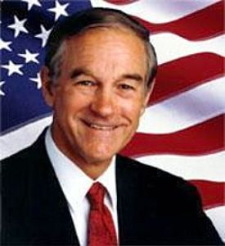
02 The “official sources” are all wrong. From Dr. Ron Paul to Dr. Shiva Ayyadurai to Martin Armstrong to hundreds of others, we have irrefutably established that the official sources are wrong.
Ron Paul: The Coronavirus Hoax
Dr. Shiva Ayyadurai, MIT PhD on Fake Pandemic #coronavirus #falseflag @POTUS
03 If you really believe that your organization should publish only information that is consistent with “official source” narratives, then you need to go into your databae and scrub just about every book on WWI, WWII, the Korean War, the Viet-Nam War, and every false flag event from the USS Liberty to 9/11 and beyond. Then you can start on all the books that challenge official domestic narratives, such as Matt Taibbi’s Griftophia and Sidney Powell’s Licensed to Lie.
04 Your implementation of this new policy of compliance with official lies is spotty. While you blocked the print version of Ascension Christianity, the Kindle version was published, shot to #22 in Process Theology, and is today #2 in Process Theology. I challenge you to either take down the Kindle, or publish the hard copy. I recommend you stop your people from being stupid on this — you are in the business of publishing, not the propaganda business, and your current policies are hurting your bottom line as well as your social standing. As your favorite President, President Barack Obama once said “Don’t do stupid shit.”
I was the capstone speaker to the Amazon Developer Conference in 2007. You were inspired by my ideas, to the point of filing patents in 2008 that can be directly traced to the first half of my presentation on processing. I make no complaint and no claim. Sadly, you completely missed the second half of my presentation which is the half that really mattered. I invite you to watch the movie again, and would be glad if you felt moved to re-consider those ideas. Anytime you want to build and then monetize the World Brain at the micro-cash for micro-citation level, I am available to help you.
2007 Steele @Amazon — Robert Speaks, Amazon Files Patents…. Movie, Graphics, Script
Your approvals system has other problems — my best-seller on the China Wuhan crisis was taken down three times, restored twice, because of trolls. You should not remove materials that meet your guidelines, long after the fact of their being approved and best-sellers particularly. Your system also causes every change to the detail page to trigger a completely new review that consumes your resources. I wonder if you have become too big to scale without losing quality control?
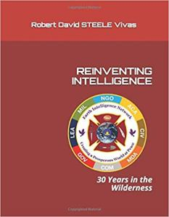
You are probably aware that PayPal and others are sneaking up on you with the intent of terminating your ability to extort manufacturers and offering the equivalent of one click shopping with no additional data entry across all vendor platforms, making your integrated system a dinosaur. You may be aware that there is a huge new localization movement that is going to change how people build and buy.
You may or may not be aware that at the end of the day, as my friend Alvin Toffler used to say, information is the only thing you can sell over and over and over again and still have the original. Have someone print out a copy for you of my book on Reinventing Intelligence — you are not going to win the JEDI lawsuit in a substantive way – Microsoft sucks but they integrated existing client servers and you did not — but if you really want to go to the next level, I can help.
I make you an offer: unblock the three or four things I have with you now (out of over 70 publications) and give me an hour of your time in Seattle and I will come — at my expense — and give you a master class in the domain where I am the top mind on the planet. There are things we can do together. All you need to do is listen.

With best wishes,
Robert David Steele
https://robertdavidsteele.com

ORIGINAL with active links for each graphic:
https://phibetaiota.net/2020/03/robert-steele-open-letter-to-jeff-bezos-on-censorship/

