https://video.foxnews.com/v/6214769762001#sp=show-clips
Chinese govt has removed this video. This copy is from Tucker Carlson show. Carlson includes commentary which is quite insightful.
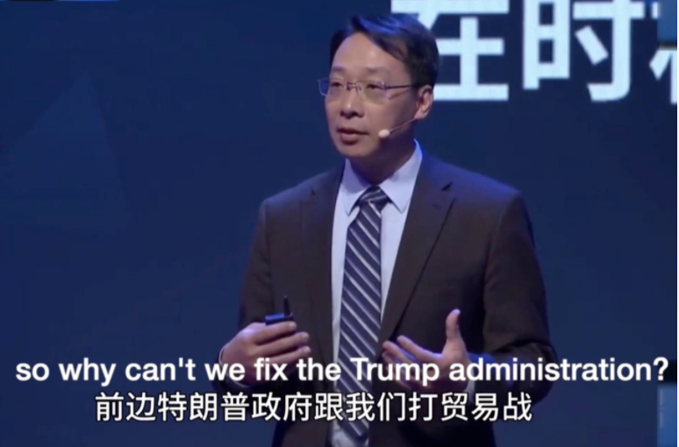
The speech by Di Dongsheng, a professor of international relations at Renmin University, was delivered in November, and boosted Monday after Fox News host Tucker Carlson talked about the remarks and Trump tweeted a clip. Di, who was speaking at an annual event hosted by the nationalistic Chinese website Guan Video, bragged about Beijing’s sway over Wall Street and Biden’s son Hunter and said: “Biden is back! Our old game is back.”

Tucker: America's political elite have been working on behalf of China
Dec. 08, 2020 - 9:09 - 'Tucker Carlson Tonight' host calls out powerful lawmakers for standing by while Beijing harmed US
Carlson seized on the comments on his Monday broadcast as proof that U.S. elites have been working on behalf of China. By Thursday, video of the talk had been removed from Chinese social media and video platforms.
Di said that China “used to know people at the top” in the U.S. financial world. “We have a network of ‘China’s old friends’ on Wall Street, who had access and control over the D.C. politicians,” Di said, adding that those connections failed to help during the trade war because “Wall Street can’t control Trump.”
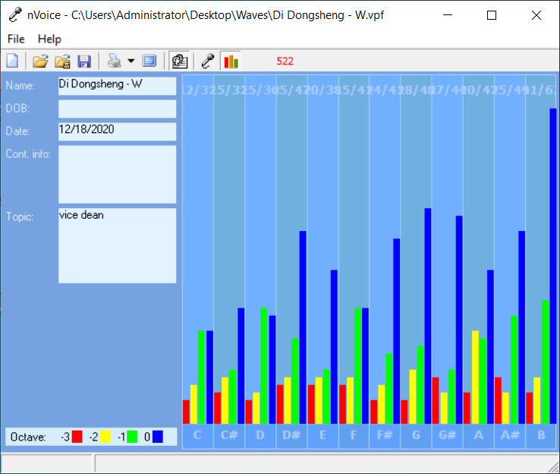
Using his wave file indicates that his speech is designed to evoke an emotional response “for the people” for a physical action. The action is a plan designed to manipulate the people through information. This is not an intellectual endeavor that you would expect from an academic presentation. The note of “E” words dominates.

Most active octave is CONTROL using words. With a omnipotent perspective deal with control of information.

Weakness: not knowing what the physical plan really are. This person did not conceive the plan. Very little self-ego involved. Emotion is used to deliver a multi layered, well thought plan.

Lots of naïve showing. He is not the leader here and does not know how he fits into the plan or even what the entire plan is.
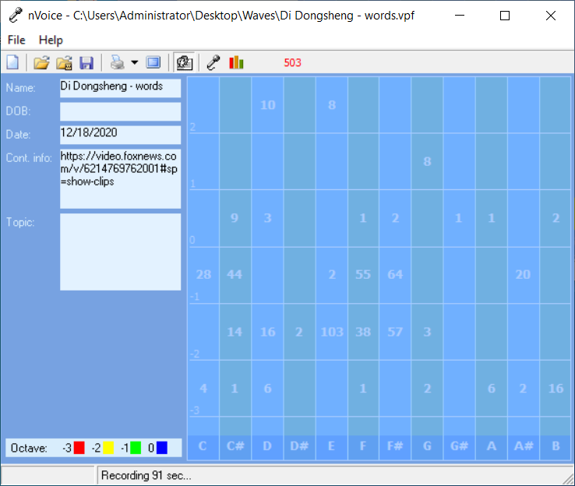
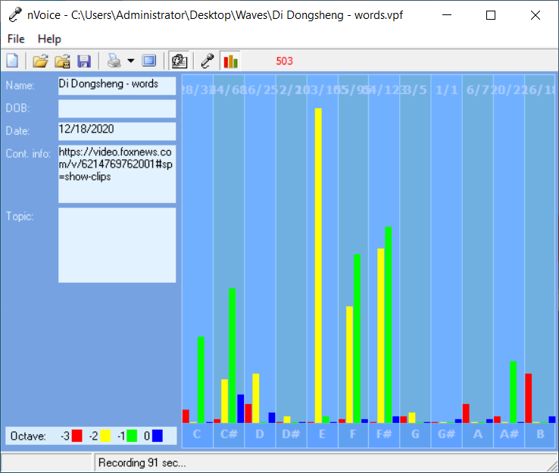

Senate Joins House in Passing Stopgap Bill: Congress Update
Treasury Proposes Crackdown on Virtual-Currency Transfers
Republican Threatens ‘Brawl’ on Biden’s EPA, Interior Picks
Bidens to Get Vaccine Monday, Harris and Husband Following Week
The incident illustrates the difficulty Biden faces crafting a China policy, after months of efforts by Trump and his supporters to paint the former vice president as soft on Beijing. Such comments by a high-profile Chinese academic could add to the pressure on the incoming administration to take a harder line.
Di suggested that Biden’s son Hunter was a path to influence over the incoming president, feeding a narrative pushed by Trump and his supporters during the campaign. “We just need to toss out some olive branch to signal some good will,” Di said.
Guan Video caters to young Chinese nationalists with programs on politics and foreign affairs that are widely watched on Chinese social media platforms. Global Times Editor-in-Chief Hu Xijin, who also spoke at the Guan Video event, dismissed Di’s claims, commenting multiple times on Trump’s tweet.
“There are some Chinese scholars who like to brag and spice-up tales about their ties with high-level figures to seek attention and promote oneself,” he wrote. “It’s unserious to judge China-U.S. relations with stories told by these kind of people.”
The dustup comes after Chinese Foreign Minister Wang Yi, addressing the U.S.-China Business Council last week, said the world’s two biggest economies needed to work together to create a favorable atmosphere for public opinions on bilateral ties.
They need to “eliminate soil for lies and disinformation” to “form a correct understanding of China-U.S. relations,” Wang said.
— With assistance by John Liu, and Jing Li
UP NEXT

Biden’s Transition Team Protests Pentagon’s Halt in Briefings
Have a confidential tip for our reporters?
GET IN TOUCH
Before it's here, it's on the Bloomberg Terminal.
LEARN MORE
LIVE ON BLOOMBERG
Watch Live TVListen to Live Radio

Politics

Biden’s Transition Team Protests Pentagon’s Halt in Briefings
Jennifer Epstein and Peter Martin
December 18, 2020, 10:42 AM EST Updated on December 18, 2020, 1:35 PM EST

Spokesman cites ‘isolated resistance’ by political appointees

Acting defense chief Miller describes it as a ‘holiday pause’
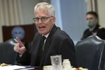
Acting Defense Secretary Christopher Miller

Photographer: Alex Wong/Getty Images

LISTEN TO ARTICLE

1:50

SHARE THIS ARTICLE

Share

Tweet

Post

Email
President-elect Joe Biden’s transition team criticized what Acting Defense Secretary Christopher Miller called “a holiday pause” in briefings to prepare for the new administration.
The halt announced on Friday came after the Defense Department said it was cooperating fully in the delayed transition that’s under way across the federal government with just over a month before Biden’s inauguration on Jan. 20.
“We were concerned to learn this week about an abrupt halt” in cooperation, Yohannes Abraham, a Biden spokesman, said at a briefing on Friday. He said the move reflected “isolated resistance in some quarters, including from political appointees within the Department of Defense.”
Miller described the halt in cooperation in a statement as having been “mutually agreed upon,” but Abraham said there was no such agreement. Axios, which reported on the move earlier, cited a defense official it didn’t identify as saying workers were feeling overwhelmed by the number of meetings.
Asked if the Pentagon was not being truthful in claiming a mutual agreement, transition spokeswoman Jen Psaki replied: “I don’t think we need to communicate that. I think you can make your own judgments.”
“As of today, we have supported 139 interviews sessions, more than 200 DoD personnel, 161 requests for information, and disclosed thousands of pages of non-public and classified documents, exceeding prior transitions,” Miller said in his statement. “At no time has the department canceled or declined any interview.”
President Donald Trump named Miller and other loyalists to top Defense Department jobs in acting roles after firing Defense Secretary Mark Esper last month.
“No department is more pivotal to our national security than the Department of Defense, and a failure to work together could have consequences well beyond January,” Abrahams said, while acknowledging “constructive cooperation within many departments and agencies.”
— With assistance by Anthony Capaccio
Have a confidential tip for our reporters?
GET IN TOUCH
Before it's here, it's on the Bloomberg Terminal.
LEARN MORE
LIVE ON BLOOMBERG
Watch Live TVListen to Live Radio

Terms of Service Do Not Sell My Info (California) Trademarks Privacy Policy ©2020 Bloomberg L.P. All Rights Reserved
Careers Made in NYC Advertise Ad Choices Contact Us Help
Your monthly limit of free con

